Supplementary file
Figure S1. Flowchart of study selection process.
RCT, randomized controlled trial.
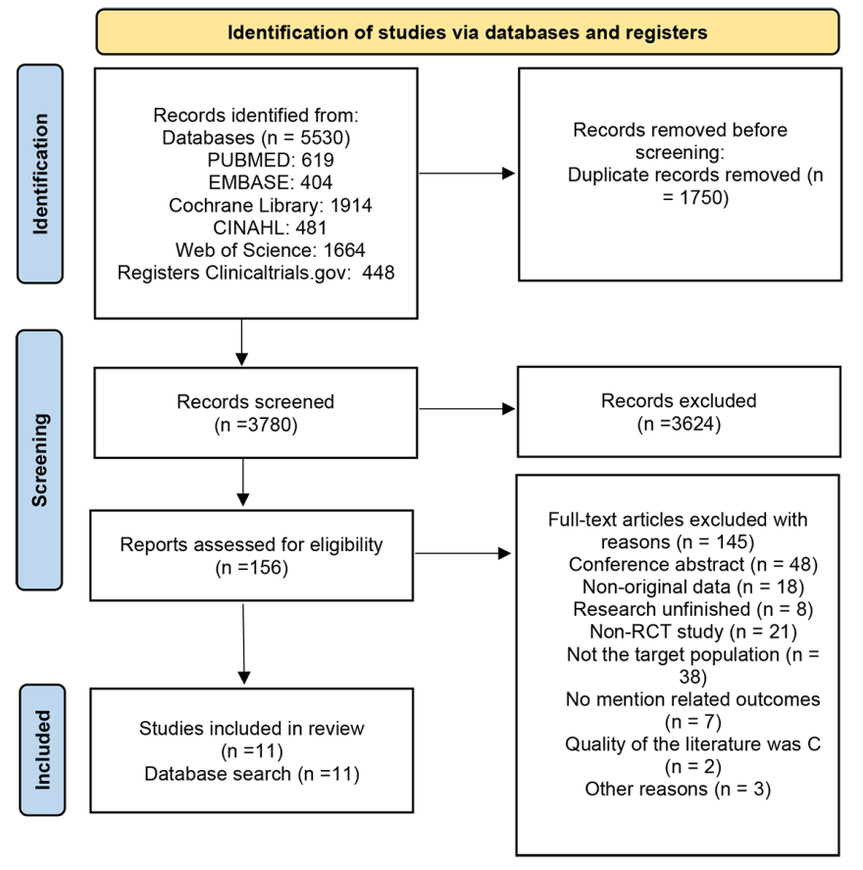
Figure S2. Risk of bias summary: review authors' judgements about each risk of bias item for each included study.
