Supplementary Appendix

Supplementary Table 1. Reasons for repeat flexible sigmoidoscopy.

Reason for repeat flexible sigmoidoscopy | Number of repeat examinations, n (%)*†
Poor bowel preparation | 1 693 (89.2)
Warfarin/aspirin | 72 (3.8)
Pain | 32 (1.7)
To find polyps seen previously | 11 (0.6)
Check excision site | 7 (0.4)
Difficult polypectomy | 5 (0.3)
Bleeding | 3 (0.2)
Fainting/vasovagal | 2 (0.1)
Technical problem with equipment | 2 (0.1)
Safety of polypectomy | 1 (0.1)
Difficult to retain air | 1 (0.1)
Unknown | 69 (3.6)
Total | 1 898 (100)
*1 810 individuals received multiple FS examinations (1 724 had two exams, 84 had three exams and two had four exams) and all repeat examinations are included.
†Because of rounding, percentages do not total to 100.0.

Supplementary Table 2. Protocol guidelines for the categorisation of bowel preparation quality.

Bowel preparation category | Definition
Excellent | No stool or fluid present.
Good | Some residual liquid or stool present but removable by suction, allowing a completely reliable examination.
Adequate | Examination accomplished, but with difficulty due to residual stool. The reliability of the examination is suboptimal.
Poor | The examination could not be performed satisfactorily due to the presence of excess faeces.

Supplementary Table 3. Endoscopist variables by endoscopist for negative examinations*.

Centre† | Negative examinations,  n (%) | Bowel preparation quality‡ |  |  |  | Insertion  time (mins)‡ | Withdrawal  time (mins)‡ | Segment reached‡ |  |  |  |  | Patient pain‡
 |  | Excellent  n (%) | Good  n (%) | Adequate  n (%) | Poor  n (%) | Median (IQR) | Median (IQR) | RM/RS/  SC  n (%) | SD  n (%) | DC  n (%) | SF  n (%) | TC/HF/ AC/ CM/TI  n (%) | None  n (%) | Mild  n (%) | Quite a lot  n (%) | Severe  n (%)
1 | 2 024 (8.5) | 811 (40.2) | 1 083 (53.7) | 124 (6.1) | 0 (0) | 2.10 (1.63-2.83) | 1.25 (0.98-1.58) | 17 (0.8) | 148 (7.3) | 1 125 (55.6) | 657 (32.5) | 77 (3.8) | 543 (27.4) | 1 047 (52.9) | 322 (16.3) | 68 (3.4)
2 | 2 345 (9.8) | 1 321 (56.8) | 693 (29.8) | 247 (10.6) | 63 (2.7) | - | - | 19 (0.8) | 696 (29.8) | 1 340 (57.3) | 236 (10.1) | 46 (2.0) | 1 055 (45.7) | 1 138 (49.2) | 111 (4.8) | 7 (0.3)
3 | 2 075 (8.7) | 955 (46.2) | 766 (37.0) | 344 (16.6) | 4 (0.2) | 2.58 (2.08-3.00) | 1.83 (1.42-2.08) | 3 (0.1) | 410 (19.9) | 1 588 (76.9) | 16 (0.8) | 47 (2.3) | 859 (42.8) | 979 (48.8) | 154 (7.7) | 15(0.7)
4 | 1 721 (7.2) | 1 174 (68.2) | 326 (18.9) | 197 (11.4) | 24 (1.4) | 1.45 (1.03-2.07) | 0.88 (0.65-1.27) | 4 (0.2) | 451 (26.2) | 1 171 (68.0) | 62 (3.6) | 33 (1.9) | 808 (48.2) | 797 (47.6) | 68 (4.1) | 3 (0.2)
5 | 1 801 (7.5) | 606 (33.9) | 663 (37.0) | 483 (27.0) | 38 (2.1) | 2.97 (2.13-3.93) | 2.38 (1.90-3.06) | 0 (0) | 417 (23.2) | 1 202 (67.0) | 148 (8.2) | 28 (1.6) | 380 (21.6) | 1 007 (57.2) | 327 (18.6) | 45 (2.6)
6 | 1 887 (7.9) | 850 (45.3) | 638 (34.0) | 383 (20.4) | 4 (0.2) | 1.68 (1.30-2.22) | 1.02 (0.75-1.47) | 2 (0.1) | 154 (8.2) | 1 536 (81.9) | 52 (2.8) | 131 (7.0) | 255 (13.7) | 1 048 (56.5) | 486 (26.2) | 66 (3.6)
7 | 1 793 (7.5) | 1 183 (66.1) | 352 (19.7) | 239 (13.4) | 15 (0.8) | 2.75 (2.12-3.65) | 1.00 (0.74-1.38) | 24 (1.3) | 470 (26.2) | 1 101 (61.4) | 68 (3.8) | 129 (7.2) | 319 (18.2) | 1 008 (57.4) | 374 (21.3) | 55 (3.1)
8 | 2 094 (8.8) | 1 046 (50.3) | 594 (28.6) | 428 (20.6) | 10 (0.5) | 2.28 (1.67-3.12) | 1.95 (1.52-2.57) | 5 (0.2) | 134 (6.4) | 1 761 (84.1) | 108 (5.2) | 85 (4.1) | 410 (20.0) | 1 077 (52.6) | 477 (23.3) | 84 (4.1)
9 | 1 627 (6.8) | 156 (9.6) | 974 (59.9) | 489 (30.1) | 6 (0.4) | 1.82 (1.30-2.57) | 1.45 (1.08-1.98) | 5 (0.3) | 563 (34.6) | 895 (55.0) | 80 (4.9) | 83 (5.1) | 476 (29.8) | 881 (55.1) | 214 (13.4) | 28 (1.8)
10 | 1 692 (7.1) | 775 (45.9) | 433 (25.6) | 475 (28.1) | 6 (0.4) | 3.88 (2.92-5.50) | 1.68 (1.17-2.55) | 1 (0.1) | 530 (31.4) | 898 (53.2) | 106 (6.3) | 154 (9.1) | 306 (18.5) | 920 (55.7) | 368 (22.3) | 59 (3.6)
11 | 1 481 (6.2) | 268 (18.2) | 660 (44.7) | 545 (36.9) | 3 (0.2) | 2.63 (2.03-3.53) | 1.92 (1.37-3.13) | 6 (0.4) | 462 (31.2) | 642 (43.3) | 193 (13.0) | 178 (12.0) | 365 (25.3) | 838 (58.1) | 229 (15.9) | 10 (0.7)
12 | 1 845 (7.7) | 1 015 (55.1) | 496 (26.9) | 319 (17.3) | 11 (0.6) | 2.03 (1.53-2.70) | 1.27 (0.98-1.68) | 3 (0.2) | 587 (31.8) | 1 166 (63.2) | 71 (3.9) | 17 (0.9) | 319 (17.7) | 1 014 (56.2) | 433 (24.0) | 39 (2.2)
13 | 1 546 (6.5) | 390 (25.2) | 404 (26.1) | 716 (46.3) | 36 (2.3) | 2.62 (1.82-3.73) | 2.02 (1.49-2.67) | 2 (0.1) | 486 (31.5) | 428 (27.7) | 529 (34.2) | 100 (6.5) | 512 (33.8) | 835 (55.2) | 150 (9.9) | 16 (1.1)
Total | 23 931 (100) | 10 550 (44.3) | 8 082 (33.9) | 4 989 (20.9) | 220 (0.9) | 2.33 (1.65-3.25) | 1.48(1.02-2.13) | 91 (0.4) | 5 508 (23.1) | 14 853 (62.2) | 2 326 (9.7) | 1 108 (4.6) | 6 607 (28.2) | 12 589 (53.8) | 3 713 (15.9) | 495 (2.1)
Abbreviations: AC=ascending colon. CM=caecum. DC=descending colon. HF=hepatic flexure. HR=hazard ratio. IQR=Interquartile range. Mins=minutes. RM=rectum. RS=recto sigmoid. SC=sigmoid colon. SD=sigmoid descending. SF=splenic flexure. TC=transverse colon. TI=terminal ileum.
*Negative examinations are defined as no distractions present in the colorectum, including no cancer or polyps detected and no biopsies performed.
†Centre is ranked in ascending order by endoscopist ADR.
‡90 missing values on bowel preparation quality; 9 717 missing values on insertion time; 9 733 missing values on withdrawal time; 45 missing values on segment reached; 527 missing values on patient-reported pain.

Supplementary Table 4. Patient-reported pain and insertion time by extent of examination in negative examinations*.

 | Females† |  |  | Males† |  |  | All participants†
Segment of the bowel reached | Number of examinations, n (%) | Quite a lot or severe patient pain‡  n (%) | Insertion time (mins)§  Median (IQR) | Number of examinations, n (%) | Quite a lot  or severe patient pain‡  n (%) | Insertion time (mins)§  Median (IQR) | Number of examination, n (%) | Quite a lot  or severe patient pain‡  n (%) | Insertion time§  Median (IQR)
RM/RS/SC | 51 (0.4) | 16 (31.4) | 2.34 (1.52-3.86) | 40 (0.4) | 4 (10.0) | 1.42 (1.00-2.25) | 91 (0.4) | 20 (22.0) | 1.97 (1.42-3.43)
SD | 3 536 (29.3) | 1 002 (28.3) | 2.65 (1.85-3.75) | 1 844 (16.3) | 365 (19.8) | 2.43 (1.70-3.35) | 5 380 (23.0) | 1 367 (25.4) | 2.58 (1.80-3.62)
DC | 7 162 (59.4) | 1 491 (20.8) | 2.37 (1.68-3.25) | 7 370 (65.2) | 918 (12.5) | 2.08 (1.52-2.93) | 14 532 (62.2) | 2 409 (16.6) | 2.22 (1.58-3.07)
SF | 1 020 (8.5) | 158 (15.5) | 2.37 (1.75-3.45) | 1 255 (11.1) | 101 (8.0) | 2.14 (1.58-2.90) | 2 275 (9.7) | 259 (11.4) | 2.23 (1.67-3.15)
TC/HF/AC/CM/TI | 287 (2.4) | 66 (23.0) | 3.23 (2.33-4.55) | 795 (7.0) | 81 (10.2) | 2.52 (1.90-3.50) | 1 082 (4.6) | 147 (13.6) | 2.67 (1.93-3.82)
Total | 12 056 (100) | 2 733 (22.7) | 2.47 (1.75-3.45) | 11 304 (100) | 1 469 (13.0) | 2.17 (1.57-3.02) | 23 360 (100) | 4 202 (18.0) | 2.33 (1.65-3.25)
Abbreviations: AC=ascending colon. CM=caecum. DC=descending colon. HF=hepatic flexure. IQR=Interquartile range. Mins=minutes. RM=rectum. RS=recto sigmoid. SC=sigmoid colon. SD=sigmoid descending. SF=splenic flexure. TC=transverse colon. TI=terminal ileum.
*Negative examinations are defined as no distractions present in the colorectum, including no cancer or polyps detected and no biopsies performed.
†Includes participants with data on segment of the bowel reached and patient pain (45 participants were missing data on segment reached and 527 participants on patient pain; these values are not mutually exclusive).
‡P-value from test for trend was <0.001.
§Includes participants with data on segment of the bowel reached, patient pain and insertion time (n=13 888; 7 100 females and 6 788 males).

Supplementary Table 5. Reaching the splenic flexure in negative examinations* by age, sex, bowel preparation quality, and pain.

 | All eligible participants: Full dataset analysis (n=23,886)† |  |  |  | Participants with complete data on all variables: Complete-case analysis (n=23,273)‡
 | n (%)§ | Examinations to reach the SF  n (%) | Univariable  OR (95%CI) | p-value¶ | n (%)§ | Examinations  to reach the SF  n (%) | Univariable  OR (95%CI) | p-value¶ | Multivariable  OR (95%CI)** | p-value¶
Total | 23 886 (100) | 3 434 (14.4) |  |  | 23 273 (100) | 3 349 (14.4)
Age (IQR), years | 60.3 (57.9-62.8) | 3 434 (14.4) | 0.99 (0.98-1.00) | 0.06 | 60.3 (57.9-62.8) | 3 349 (14.4) | 0.99 (0.98-1.00) | 0.07 | 0.99 (0.98-1.00) | 0.14
Sex | 23 886 (100) | 3 434 (14.4) |  | <0.001 | 23 273 (100) | 3 349 (14.4) |  | <0.001 |  | <0.001
Males | 11 558 (48.4) | 2 096 (18.1) | 1 |  | 11 258 (48.4) | 2 044 (18.2) | 1 |  | 1
Females | 12 328 (51.6) | 1 338 (10.9) | 0.55 (0.51-0.59) |  | 12 015 (51.6) | 1 305 (10.9) | 0.55 (0.51-0.59) |  | 0.57 (0.53-0.62)
Bowel preparation quality | 23 797 (99.6) |  |  | <0.001 | 23 273 (100) |  |  | <0.001 |  | <0.001
Excellent | 10 532 (44.3) | 1 611 (15.3) | 1 |  | 10 315 (44.3) | 1 575 (15.3) | 1 |  | 1
Good | 8 069 (33.9) | 1 165 (14.4) | 0.93 (0.86-1.01) |  | 7 894 (33.9) | 1 142 (14.5) | 0.94 (0.86-1.02) |  | 0.93 (0.86-1.02)
Adequate | 4 978 (20.9) | 638 (12.8) | 0.81 (0.74-0.90) |  | 4 861 (20.9) | 623 (12.8) | 0.82 (0.74-0.90) |  | 0.79 (0.71-0.87)
Poor | 218 (0.9) | 10 (4.6) | 0.27 (0.14-0.50) |  | 203 (0.9) | 9 (4.4) | 0.26 (0.13-0.50) |  | 0.25 (0.13-0.50)
Patient pain | 23 360 (100) | 3 357 (14.4) |  | <0.001 | 23 273 (100) |  |  | <0.001 |  | <0.001
None | 6 597 (28.2) | 1 111 (16.8) | 1 |  | 6 578 (28.3) | 1 109 (16.9) | 1 |  | 1
Mild | 12 561 (53.8) | 1 840 (14.6) | 0.85 (0.78-0.92) |  | 12 508 (53.7) | 1 835 (14.7) | 0.85 (0.78-0.92) |  | 0.90 (0.83-0.98)
Quite a lot | 3 708 (15.9) | 366 (9.9) | 0.54 (0.48-0.61) |  | 3 694 (15.9) | 365 (9.9) | 0.54 (0.48-0.61) |  | 0.61 (0.54-0.69)
Severe | 494 (2.1) | 40 (8.1) | 0.44 (0.31-0.60) |  | 493 (2.1) | 40 (8.1) | 0.44 (0.31-0.61) |  | 0.53 (0.38-0.73)
Abbreviations: CI=confidence interval. OR=odds ratio. SF=splenic flexure.
*Negative examinations are defined as no distractions present in the colorectum, including no cancer or polyps detected and no biopsies performed.
†Includes participants with data on segment reached (45 participants were missing data on segment reached).
‡89 missing values on bowel preparation quality; 526 missing values on patient-reported pain (these values are not mutually exclusive).
§All n and percentage except the entry for age, which is median and interquartile range.
¶P-values were calculated with the likelihood ratio test.
**Multivariable model includes age, sex, bowel preparation quality and patient-reported pain.

Supplementary Table 6. Detection of multiple and/or advanced distal adenomas by patient factors and endoscopist variables.

 | All eligible participants: Full dataset analysis (n=34 139) |  |  |  | Participants with complete data on all variables: Complete-case analysis (n=19 333)*
 | n (%)† | Participants with multiple and/or advanced adenomas detected at baseline  n (%) | Univariable  OR (95%CI) | p-value‡ | n (%)† | Participants with multiple and/or advanced adenomas detected at baseline  n (%) | Univariable  OR (95%CI) | p-value‡ | Multivariable  OR (95%CI)§ | p-value‡
Total | 34 139 (100) | 1 588 (4.7) |  |  | 19 333 (100) | 919 (4.8)
Age (IQR), years | 60.3 (57.9-62.8) | 1 588 (4.7) | 1.04 (1.02-1.06) | <0.001 | 60.5 (58.0-62.9) | 919 (4.8) | 1.04 (1.02-1.07) | <0.001 | 1.04 (1.01-1.06) | 0.005
Sex | 34 139 (100) | 1 588 (4.7) |  | <0.001 |  |  |  | <0.001 |  | <0.001
Male | 18 127 (53.1) | 1 159 (6.4) | 1 |  | 10 315 (53.4) | 656 (6.4) | 1 |  | 1
Female | 16 012 (46.9) | 429 (2.7) | 0.40 (0.36-0.45) |  | 9 018 (46.6) | 263 (2.9) | 0.44 (0.38-0.51) |  | 0.58 (0.49-0.68)
Family history of CRC | 32 356 (94.8) | 1 519 (4.7) |  | 0.017 |  |  |  | 0.023 |  | 0.025
No | 28 663 (88.6) | 1 316 (4.6) | 1 |  | 17 123 (88.6) | 792 (4.6) | 1 |  | 1
Yes | 3 693 (11.4) | 203 (5.5) | 1.21 (1.04-1.41) |  | 2 210 (11.4) | 127 (5.7) | 1.26 (1.04-1.52) |  | 1.27 (1.03-1.55)
Centre | 34 139 (100) | 1 588 (4.7) |  | <0.001 |  |  |  | <0.001 |  | 0.002
1 | 2 413 (7.1) | 72 (3.0) | 1 |  | 1 607 (8.3) | 39 (2.4) | 1 |  | 1
2¶ | 3 438 (10.1) | 125 (3.6) | 1.23 (0.91-1.65) |  | - | - | - |  | -
3 | 2 674 (7.8) | 110 (4.1) | 1.39 (1.03-1.89) |  | 1 452 (7.5) | 43 (3.0) | 1.23 (0.79-1.90) |  | 1.02 (0.64-1.64)
4 | 2 131 (6.2) | 77 (3.6) | 1.22 (0.88-1.69) |  | 1 452 (7.5) | 54 (3.7) | 1.55 (1.02-2.36) |  | 1.63 (1.03-2.57)
5 | 2 466 (7.2) | 142 (5.8) | 1.99 (1.49-2.65) |  | 1 844 (9.5) | 98 (5.3) | 2.26 (1.55-3.29) |  | 1.01 (0.67-1.52)
6 | 2 733 (8.0) | 90 (3.3) | 1.11 (0.81-1.52) |  | 1 579 (8.2) | 44 (2.8) | 1.15 (0.74-1.78) |  | 1.08 (0.67-1.72)
7 | 2 516 (7.4) | 97 (3.9) | 1.30 (0.96-1.78) |  | 1 741 (9.0) | 71 (4.1) | 1.71 (1.15-2.54) |  | 1.24 (0.80-1.92)
8 | 2 839 (8.3) | 124 (4.4) | 1.48 (1.10-2.00) |  | 1 486 (7.7) | 73 (4.9) | 2.08 (1.40-3.08) |  | 1.18 (0.77-1.81)
9 | 2 493 (7.3) | 127 (5.1) | 1.75 (1.30-2.34) |  | 1 617 (8.4) | 81 (5.0) | 2.12 (1.44-3.13) |  | 1.69 (1.11-2.58)
10 | 2 532 (7.4) | 144 (5.7) | 1.96 (1.47-2.62) |  | 1 578 (8.2) | 84 (5.3) | 2.26 (1.54-3.33) |  | 0.94 (0.61-1.44)
11 | 2 324 (6.8) | 131 (5.6) | 1.94 (1.45-2.60) |  | 1 202 (6.2) | 77 (6.4) | 2.75 (1.86-4.08) |  | 1.21 (0.79-1.85)
12 | 2 799 (8.2) | 143 (5.1) | 1.75 (1.31-2.34) |  | 2 214 (11.5) | 122 (5.5) | 2.34 (1.63-3.38) |  | 1.31 (0.88-1.96)
13 | 2 781 (8.1) | 206 (7.4) | 2.60 (1.98-3.42) |  | 1 561 (8.1) | 133 (8.5) | 3.74 (2.60-5.39) |  | 1.71 (1.15-2.54)
Bowel preparation quality | 33 609 (98.4) | 1 515 (4.5) |  | 0.68 |  |  |  | 0.004 |  | <0.001
Excellent | 14 573 (43.4) | 663 (4.5) | 1 |  | 7 819 (40.4) | 363 (4.6) | 1 |  | 1
Good | 11 692 (34.8) | 520 (4.4) | 0.98 (0.87-1.10) |  | 6 922 (35.8) | 321 (4.6) | 1.00 (0.86-1.16) |  | 0.72 (0.60-0.86)
Adequate | 7 060 (21.0) | 315 (4.5) | 0.98 (0.85-1.12) |  | 4 553 (23.6) | 227 (5.0) | 1.08 (0.91-1.28) |  | 0.55 (0.45-0.67)
Poor | 284 (0.8) | 17 (6.0) | 1.34 (0.81-2.19) |  | 39 (0.2) | 8 (20.5) | 5.30 (2.42-11.61) |  | 3.53 (1.45-8.56)
Insertion time | 20 371 (59.7) | 1 004 (4.9) |  | <0.001 |  |  |  | <0.001 |  | <0.001
<2.00 mins | 7 357 (36.1) | 281 (3.8) | 1 |  | 7 014 (36.3) | 253 (3.6) | 1 |  | 1
2.00-2.59 mins | 6 198 (30.4) | 304 (4.9) | 1.30 (1.10-1.53) |  | 5 894 (30.5) | 282(4.8) | 1.34 (1.13-1.60) |  | 1.32 (1.09-1.59)
3.00-3.59 mins | 3 412 (16.7) | 184 (5.4) | 1.44 (1.19-1.74) |  | 3 221 (16.7) | 164 (5.1) | 1.43 (1.17-1.75) |  | 1.40 (1.12-1.75)
$≥$4.00 mins | 3 404 (16.7) | 235 (6.9) | 1.87 (1.56-2.23) |  | 3 204 (16.6) | 220 (6.9) | 1.97 (1.64-2.37) |  | 1.83 (1.47-2.28)
Withdrawal time | 20 326 (59.5) | 998 (4.9) |  | <0.001 |  |  |  | <0.001 |  | <0.001
<2.00 mins | 10 625 (52.3) | 134 (1.3) | 1 |  | 10 204 (52.8) | 126 (1.2) | 1 |  | 1
2.00-2.59 mins | 3 672 (18.1) | 104 (2.8) | 2.28 (1.76-2.96) |  | 3 479 (18.0) | 93 (2.7) | 2.20 (1.68-2.88) |  | 2.23 (1.68-2.94)
3.00-3.59 mins | 1 837 (9.0) | 82 (4.5) | 3.66 (2.77-4.84) |  | 1 740 (9.0) | 75 (4.3) | 3.60 (2.69-4.82) |  | 3.58 (2.66-4.82)
$≥$4.00 mins | 4 192 (20.6) | 678 (16.2) | 15.11 (12.50-18.25) |  | 3 910 (20.2) | 625 (16.0) | 15.22 (12.52-18.50) |  | 14.31 (11.62-17.61)
Segment reached | 34 075 (99.8) | 1 587 (4.7) |  | <0.001 |  |  |  | 0.001 |  | 0.98
RM/RS/SC | 128 (0.4) | 5 (3.9) | 1.11 (0.45-2.73) |  | 53 (0.3) | 2 (3.8) | 0.98 (0.24-4.06) |  | 0.79 (0.18-3.43)
SD | 7 510 (22.0) | 266 (3.5) | 1 |  | 4 447 (23.0) | 171 (3.8) | 1 |  | 1
DC | 21 327 (62.6) | 1 016 (4.8) | 1.36 (1.19-1.56) |  | 11 840 (61.2) | 566 (4.8) | 1.26 (1.05-1.49) |  | 1.01 (0.83-1.23)
SF | 3 462 (10.2) | 195 (5.6) | 1.63 (1.35-1.96) |  | 2 062 (10.7) | 124 (6.0) | 1.60 (1.26-2.03) |  | 0.95 (0.71-1.26)
TC/HF/AC/CM/TI | 1 648 (4.8) | 105 (6.4) | 1.85 (1.47-2.34) |  | 931 (4.8) | 56 (6.0) | 1.60 (1.17-2.18) |  | 0.97 (0.69-1.36)
Patient pain | 33 323 (97.6) | 1 539 (4.6) |  | 0.09 |  |  |  | 0.009 |  | 0.41
None | 9 563 (28.7) | 477 (5.0) | 1 |  | 4 937 (25.5) | 274 (5.5) | 1 |  | 1
Mild | 17 859 (53.6) | 816 (4.6) | 0.91 (0.81-1.02) |  | 10 561 (54.6) | 490 (4.6) | 0.83 (0.71-0.96) |  | 0.88 (0.75-1.04)
Quite a lot | 5 224 (15.7) | 222 (4.2) | 0.85 (0.72-1.00) |  | 3 378 (17.5) | 138 (4.1) | 0.72 (0.59-0.89) |  | 0.84 (0.67-1.06)
Severe | 677 (2.0) | 24 (3.5) | 0.70 (0.46-1.06) |  | 457 (2.4) | 17 (3.7) | 0.66 (0.40-1.08) | - | 0.86 (0.51-1.47)
FS occurrence** | 34 139 (100) | 1 588 (4.7) |  | 0.0001 |  |  |  | - |  | -
First group 500 | 5 410 (15.8) | 199 (3.7) | 1 |  | - | - | - |  | -
Later groups 500 | 28 729 (84.2) | 1 389 (4.8) | 1.33 (1.14-1.55) |  | - | - | - |  | -
Abbreviations: AC=ascending colon. CI=confidence interval. CRC=colorectal cancer. CM=caecum. DC=descending colon. FS=flexible sigmoidoscopy. HF=hepatic flexure. Mins=minutes. OR=odds ratio. RM=rectum. RS=recto sigmoid. SC=sigmoid colon. SD=sigmoid descending. SF=splenic flexure. TC=transverse colon. TI=terminal ileum.
*1 783 missing values on family history of CRC; 530 missing values on bowel preparation quality; 13 768 missing values on insertion time; 13 813 missing values on withdrawal time; 64 missing values on segment reached; 816 missing values on patient-reported pain (these values are not mutually exclusive).
†All n and percentage except the entry for age, which is median and interquartile range.
‡P-values were calculated with the likelihood ratio test.
§Multivariable model includes age, sex, family history of CRC, centre, bowel preparation quality, insertion time, withdrawal time, segment reached and patient-reported pain.
¶Centre 2 was omitted from the complete-case analyses due to a lack of recorded information for insertion or withdrawal times, as this information was not required until partway through the trial at which time centre 2 had already completed recruitment.
**Order of occurrence of FS examination was omitted from the complete-case analyses due to a lack of recorded information for insertion and withdrawal times for the category ‘first group 500’; this information was not required until partway through the trial at which time each endoscopist had already completed 500 examinations.
Supplementary Figure 1. Cumulative distal colorectal cancer incidence in all eligible participants by patient factors and endoscopist variables (the full dataset).

A.
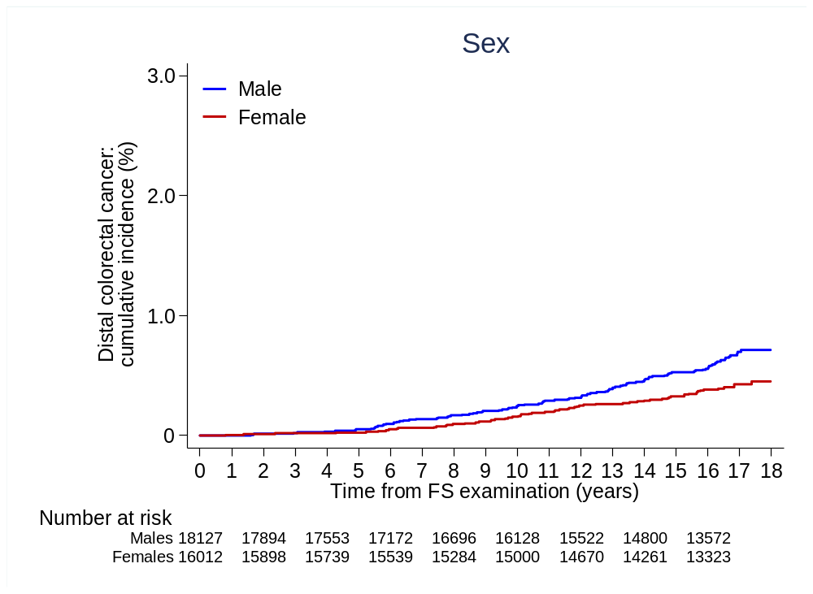

B.

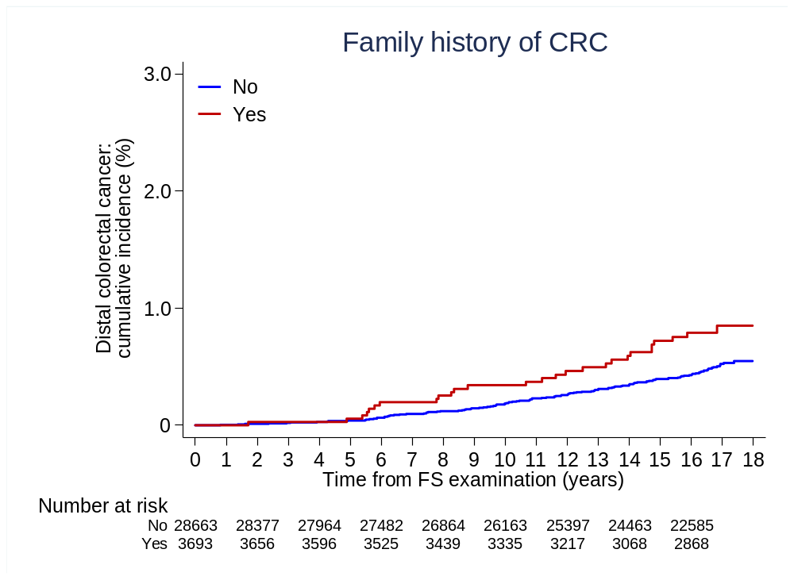

C.

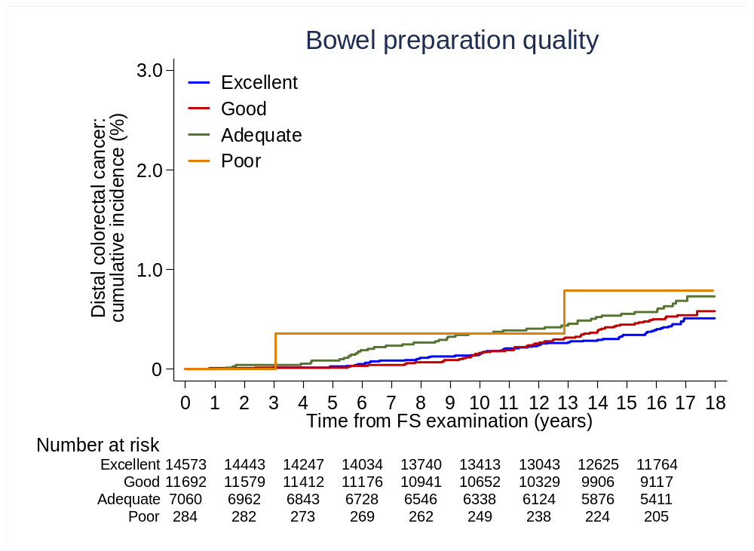

D.

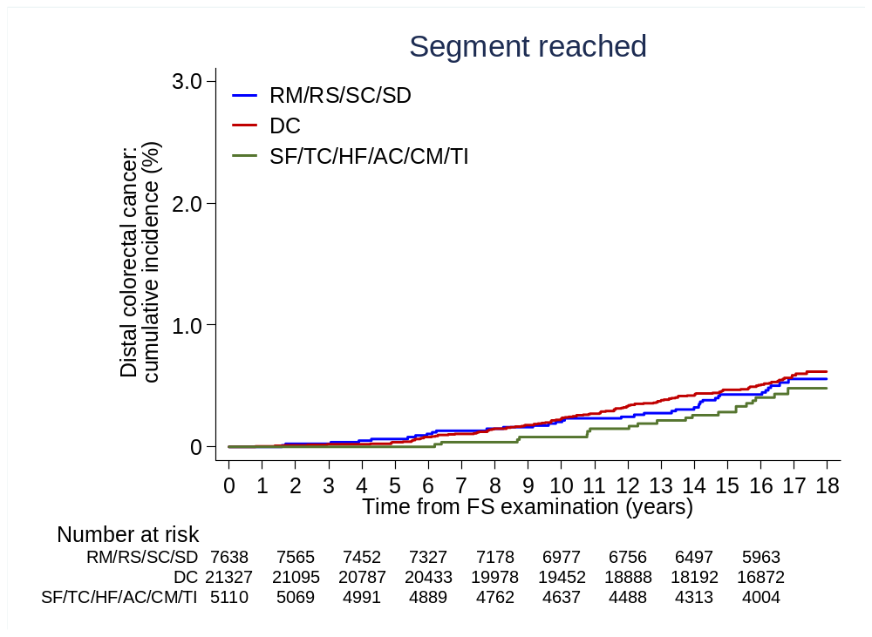

E.

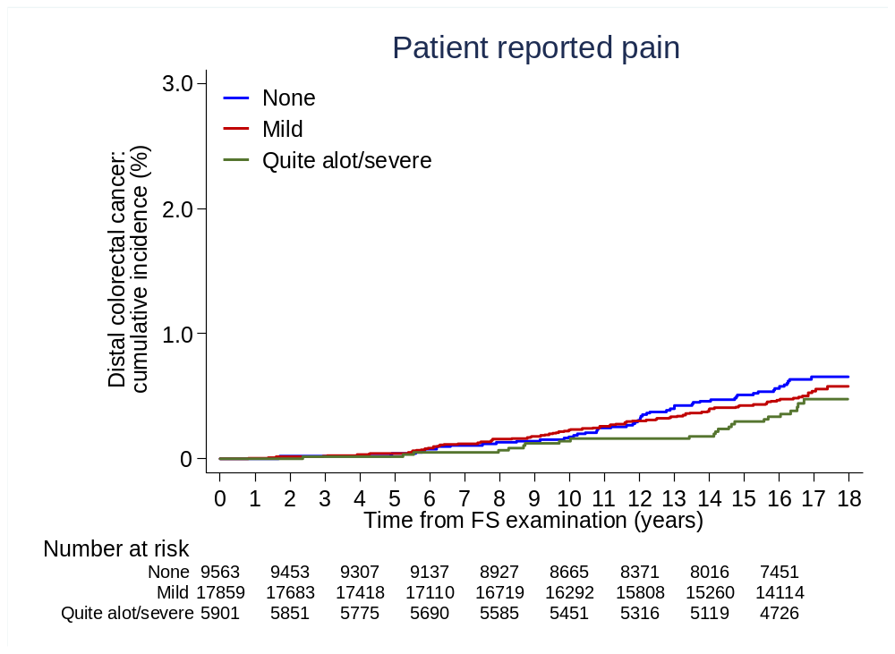

F.

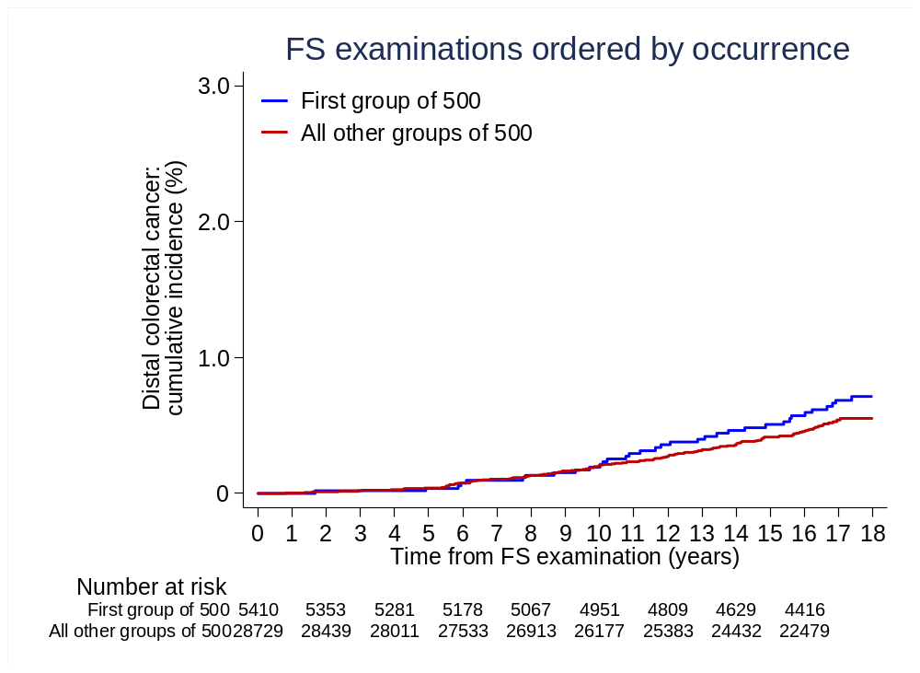

G.

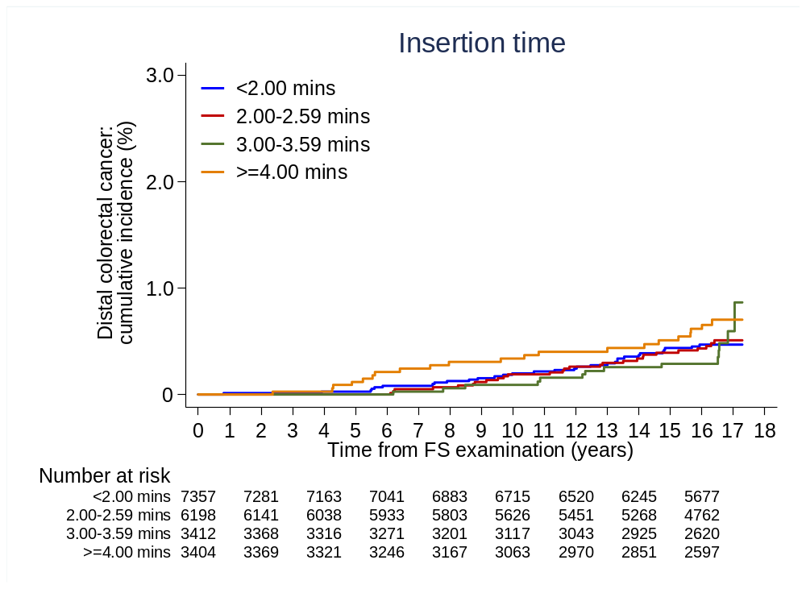

H.

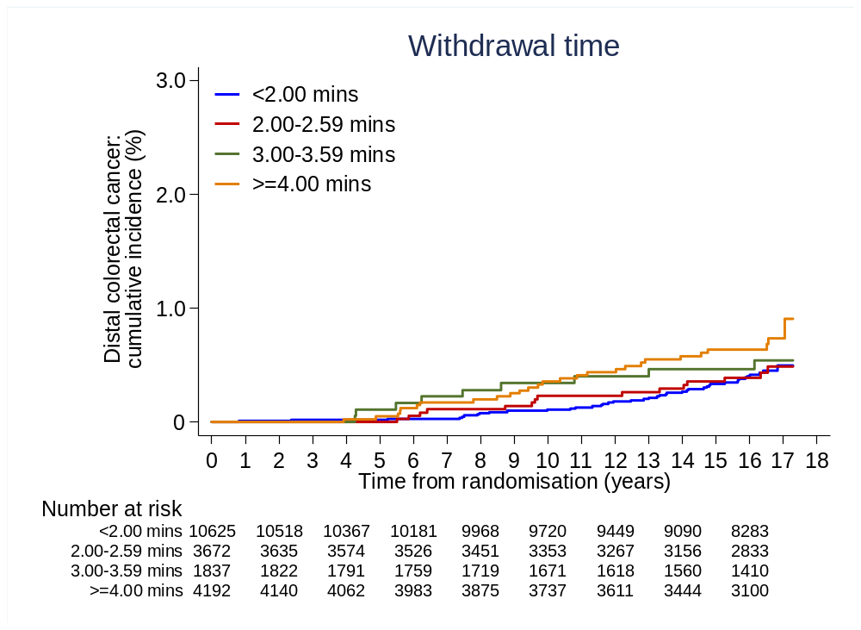

I.

