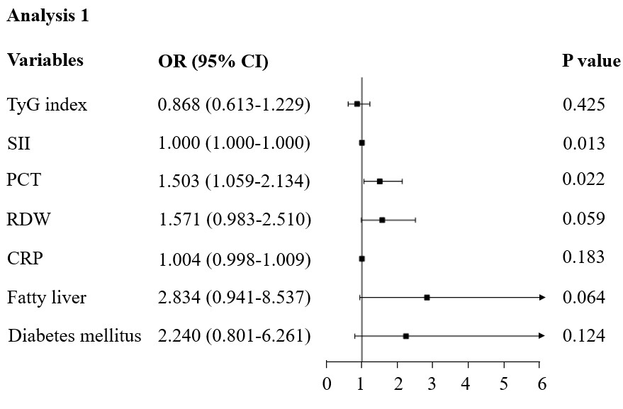
Supplementary Figure 1: Forest plot showing the results of multivariate logistic regression analysis 1.

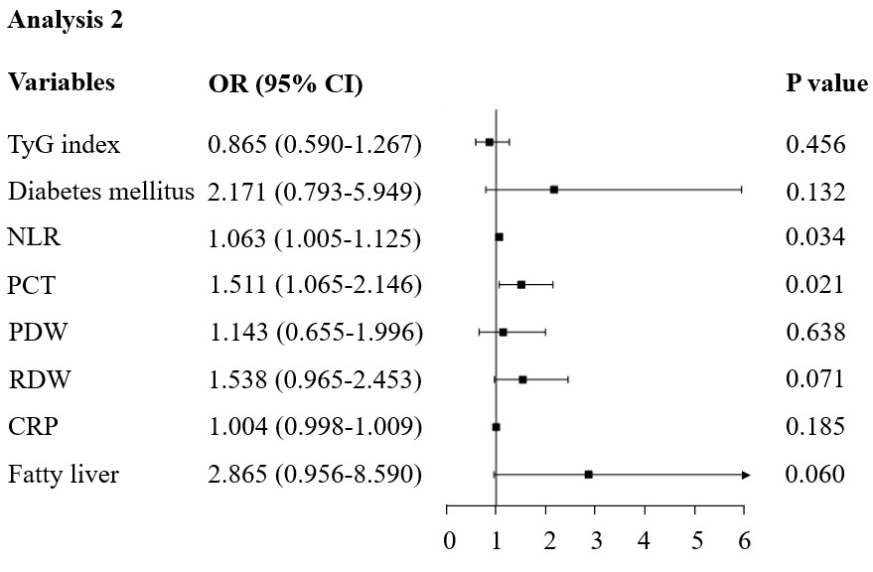
Supplementary Figure 2: Forest plot showing the results of multivariate logistic regression analysis 2.

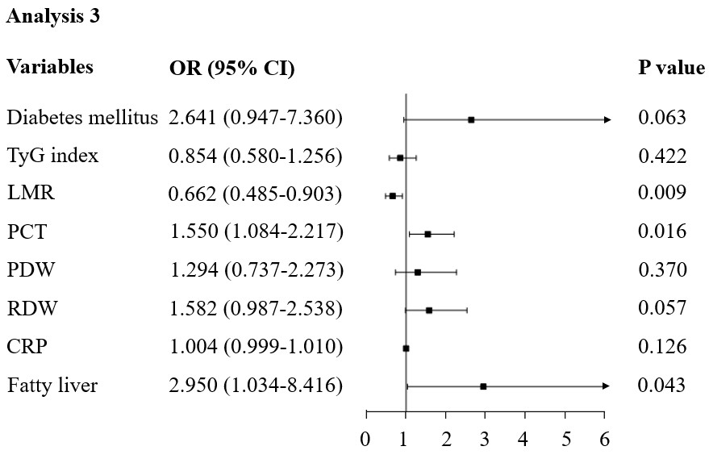
Supplementary Figure 3: Forest plot showing the results of multivariate logistic regression analysis 3.

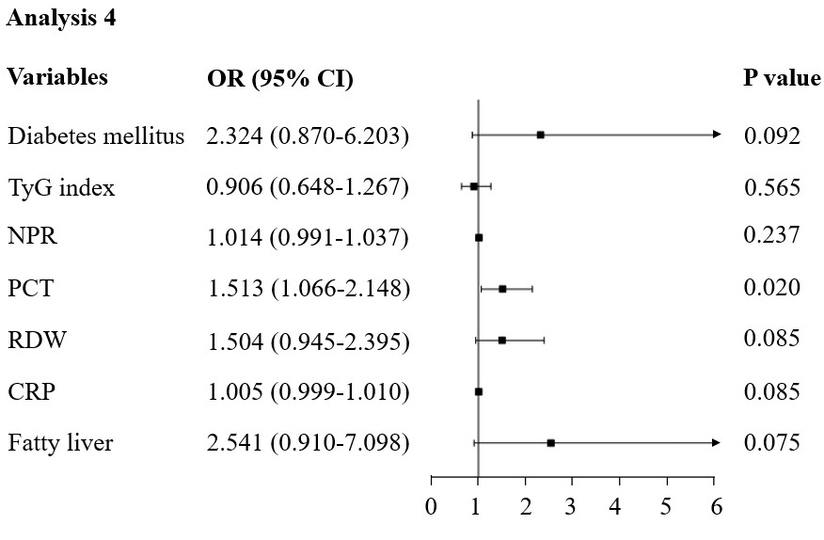
Supplementary Figure 4: Forest plot showing the results of multivariate logistic regression analysis 4.

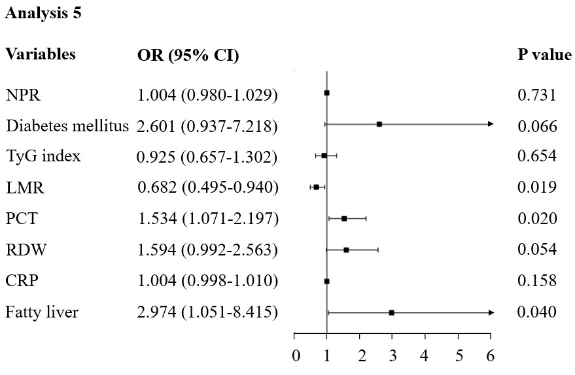
Supplementary Figure 5: Forest plot showing the results of multivariate logistic regression analysis 5.

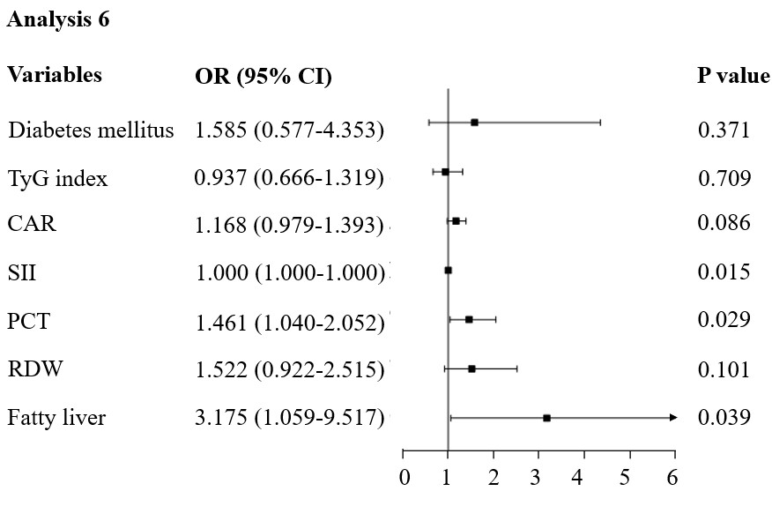
Supplementary Figure 6: Forest plot showing the results of multivariate logistic regression analysis 6.

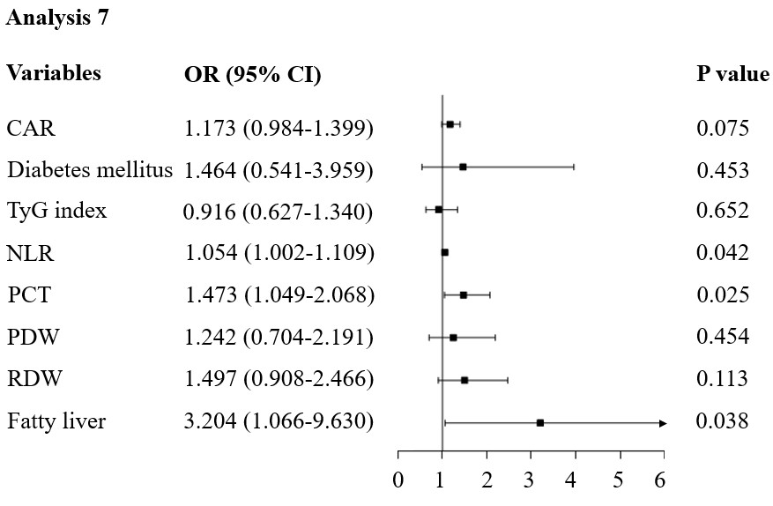
Supplementary Figure 7: Forest plot showing the results of multivariate logistic regression analysis 7.

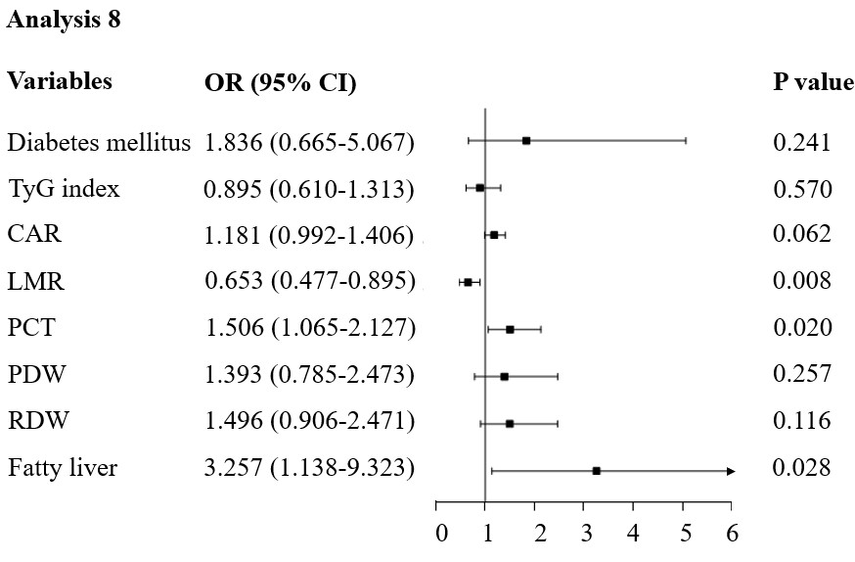
Supplementary Figure 8: Forest plot showing the results of multivariate logistic regression analysis 8.

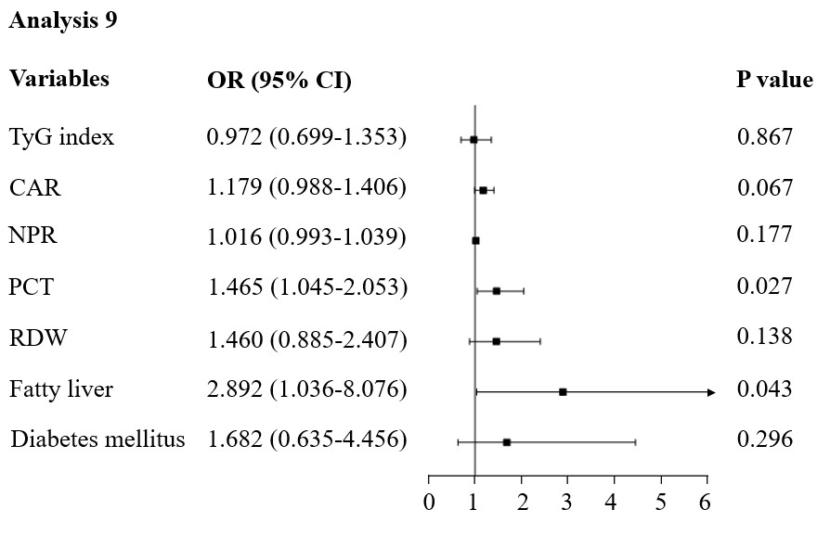
Supplementary Figure 9: Forest plot showing the results of multivariate logistic regression analysis 9.

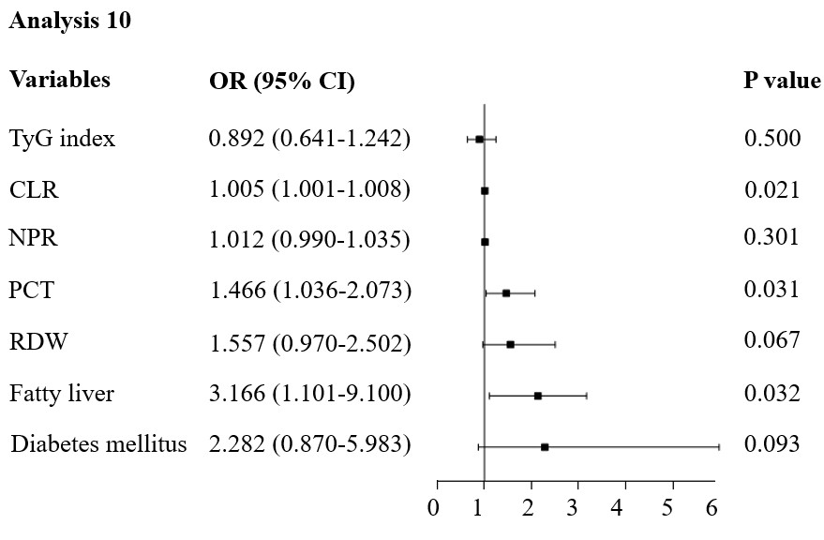
Supplementary Figure 10: Forest plot showing the results of multivariate logistic regression analysis 10.

