Appendix 1
Supplemental Table 1
CLINICAL TRIALS
PubMed (2012-2022)
1 ("Non-alcoholic Fatty Liver Disease"[Mesh]) OR (NAFLD)) OR (Nonalcoholic Fatty Liver Disease)) OR (Fatty Liver, Nonalcoholic)) OR (Liver, Nonalcoholic Fatty)) OR (Nonalcoholic Fatty Liver)) OR (Nonalcoholic Steatohepatitis)) OR (Steatohepatitides, Nonalcoholic)) OR (Steatohepatitis, Nonalcoholic)
2 ("Probiotics"[Mesh]) OR "Prebiotics"[Mesh]) OR "Synbiotics"[Mesh]) OR (microbial agent)) OR (probiotic supplements)) OR (Probio*)) OR (Lactobacillus)) OR (Lactobacilli)) OR (Acidophilus)) OR (Bifidobacterium)) OR (Bifido)) OR (Enterococcus)) OR (Enterococci)) OR (Escherichia coli)) OR (Saccharomyces)) OR (Bacillus)) OR (VSL#3)) OR (Rifaximin)) OR (Neomycin)) OR (Norfloxacin)) OR (Vancomycin)) OR (Metronidazole)) OR (Prebio*)) OR (Fructan*)) OR (Oligofructose)) OR (Fructo*)) OR (Fructooligosaccharide)) OR (Fructo-oligosaccharide)) OR (Synbio*)) OR (Boulardii)
3 ("Randomized Controlled Trial" [Publication Type]) OR (random allocation)) OR (double-blind)) OR (Placebo)) OR (Randomly)) OR (randomized)) OR (clinical trial*)) OR (RCT)) OR (Random*)
Strategy of search | Results
1 AND 2 AND 3 | 458
Web of Science (2012-2022)
1 TS= (Non-alcoholic Fatty Liver Disease OR Non alcoholic Fatty Liver Disease OR NAFLD OR Nonalcoholic Fatty Liver Disease OR Fatty Liver, Nonalcoholic OR Liver, Nonalcoholic Fatty OR Nonalcoholic Fatty Liver OR Nonalcoholic Steatohepatitis OR Steatohepatitides, Nonalcoholic OR Steatohepatitis, Nonalcoholic)
2 TS= (Probiotics OR Prebiotics OR Synbiotics OR microbial agent OR probiotic supplements OR Probio OR Lactobacillus OR Lactobacilli OR Acidophilus OR Bifidobacterium OR Bifido OR Enterococcus OR Enterococci OR Escherichia coli OR Saccharomyces OR Bacillus OR Rifaximin OR Neomycin OR Norfloxacin OR Vancomycin OR Metronidazole OR Prebio* OR Fructan* OR Oligofructose OR Fructo* OR Fructooligosaccharide OR Fructo-oligosaccharide OR Synbio* OR Boulardii)

3 TS= (controlled clinical trial OR random allocation OR double-blind; singled-blind OR Placebo OR Randomly OR randomized OR clinical trial* OR RCT OR Random*)
Strategy of search | Results
1 AND 2 AND 3 | 834
Embase (2012-2022)
1 (‘Non-alcoholic Fatty Liver Disease’:ab,ti OR ‘Non alcoholic Fatty Liver Disease’:ab,ti OR ‘NAFLD’:ab,ti OR ‘Nonalcoholic Fatty Liver Disease’:ab,ti OR ‘Fatty Liver, Nonalcoholic’:ab,ti OR ‘Liver, Nonalcoholic Fatty’:ab,ti OR ‘Nonalcoholic Fatty Liver’:ab,ti OR ‘Nonalcoholic Steatohepatitis’:ab,ti OR ‘Steatohepatitides, Nonalcoholic’:ab,ti OR ‘Steatohepatitis, Nonalcoholic’:ab,ti)
2 (‘Probiotics’:ab,ti OR ‘Prebiotics’:ab,ti OR ‘Synbiotics’:ab,ti OR ‘microbial agent’:ab,ti OR ‘probiotic supplements’:ab,ti OR ‘Probio’:ab,ti OR ‘Lactobacillus’:ab,ti OR ‘Lactobacilli’:ab,ti OR ‘Acidophilus’:ab,ti OR ‘Bifidobacterium’:ab,ti OR ‘Bifido’:ab,ti OR ‘Enterococcus’:ab,ti OR ‘Enterococci’:ab,ti OR ‘Escherichia coli’:ab,ti OR ‘Saccharomyces’:ab,ti OR ‘Bacillus’:ab,ti OR ‘Rifaximin’:ab,ti OR ‘Neomycin’:ab,ti OR ‘Norfloxacin’:ab,ti OR ‘Vancomycin’:ab,ti OR ‘Metronidazole’:ab,ti OR ‘Prebio*’:ab,ti OR ‘Fructan*’:ab,ti OR ‘Oligofructose’:ab,ti OR ‘Fructo*’:ab,ti OR ‘Fructooligosaccharide’:ab,ti OR ‘Fructo-oligosaccharide’:ab,ti OR ‘Synbio*’:ab,ti OR ‘Boulardii’:ab,ti)
3 (‘controlled clinical trial’:ab,ti OR ‘random allocation’:ab,ti OR ‘double-blind; singled-blind’:ab,ti OR ‘Placebo’:ab,ti OR ‘Randomly’:ab,ti OR ‘randomized’:ab,ti OR ‘clinical trial*’:ab,ti OR ‘RCT’ OR ‘Random*’:ab,ti)
Strategy of search | Results
1 AND 2 AND 3 | 487
Cochrane (2012-2022)
1 (Non-alcoholic Fatty Liver Disease OR Non alcoholic Fatty Liver Disease OR NAFLD OR Nonalcoholic Fatty Liver Disease OR Fatty Liver, Nonalcoholic OR Liver, Nonalcoholic Fatty OR Nonalcoholic Fatty Liver OR Nonalcoholic Steatohepatitis OR Steatohepatitides, Nonalcoholic OR Steatohepatitis, Nonalcoholic)
2 (Probiotics OR Prebiotics OR Synbiotics OR microbial agent OR probiotic supplements OR Probio OR Lactobacillus OR Lactobacilli OR Acidophilus OR Bifidobacterium OR Bifido OR Enterococcus OR Enterococci OR Escherichia coli OR Saccharomyces OR Bacillus OR Rifaximin OR Neomycin OR Norfloxacin OR Vancomycin OR Metronidazole OR Prebio* OR Fructan* OR Oligofructose OR Fructo* OR Fructooligosaccharide OR Fructo-oligosaccharide OR Synbio* OR Boulardii)
3 (controlled clinical trial OR random allocation OR double-blind; singled-blind OR Placebo OR Randomly OR randomized OR clinical trial* OR RCT OR Random*)
Strategy of search | Results
1 AND 2 AND 3 | 303

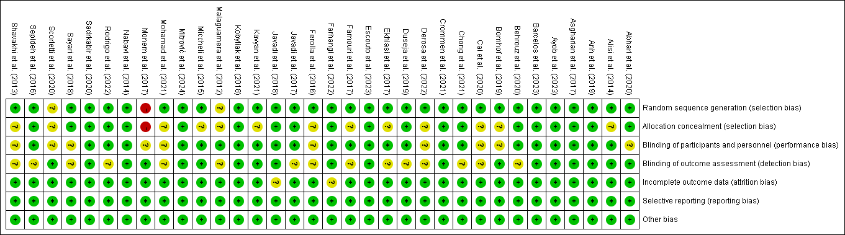
Supplementary Figure 1. Review authors' judgements about each risk of bias item for each included study.

Supplemental Table 2
Primary outcomes for NAFLD
Outcomes | No of Participants  (studies)  Follow up | Quality of the evidence  (GRADE) | Relative effect  (95% CI) | Anticipated absolute effects
 |  |  |  | Risk with Control | Risk difference with Primary outcomes (95% CI)
Firbrosis | 339  (6 studies) | ⊕⊕⊕⊕  HIGH |  |  | The mean firbrosis in the intervention groups was  0.31 standard deviations lower  (0.52 to 0.09 lower)
Steatosis | 205  (5 studies) | ⊕⊕⊕⊝  MODERATE¹  due to inconsistency | OR 1.15  (0.61 to 2.18) | Study population
 |  |  |  | 717 per 1000 | 27 more per 1000  (from 110 fewer to 130 more)
 |  |  |  | Moderate
 |  |  |  | 652 per 1000 | 31 more per 1000  (from 119 fewer to 151 more)
AST | 1515  (26 studies) | ⊕⊕⊕⊕  HIGH |  |  | The mean ast in the intervention groups was  0.36 standard deviations lower  (0.56 to 0.15 lower)
ALT | 1501  (27 studies) | ⊕⊕⊕⊝  MODERATE²  due to inconsistency |  |  | The mean alt in the intervention groups was  2.84 standard deviations lower  (3.39 to 2.29 lower)
*The basis for the assumed risk (e.g. the median control group risk across studies) is provided in footnotes. The corresponding risk (and its 95% confidence interval) is based on the assumed risk in the comparison group and the relative effect of the intervention (and its 95% CI).
CI: Confidence interval; ALT: alanine aminotransferase; AST: aspartate aminotransferase; OR: Odds ratio.
GRADE Working Group grades of evidence
High quality: Further research is very unlikely to change our confidence in the estimate of effect.
Moderate quality: Further research is likely to have an important impact on our confidence in the estimate of effect and may change the estimate.
Low quality: Further research is very likely to have an important impact on our confidence in the estimate of effect and is likely to change the estimate.
Very low quality: We are very uncertain about the estimate.
¹ 95% confidence interval over the null line.
² Point estimates were highly variable among studies.

Secondary outcomes for NAFLD
Outcomes | No of Participants  (studies)  Follow up | Quality of the evidence  (GRADE) | Relative effect  (95% CI) | Anticipated absolute effects
 |  |  |  | Risk with Control | Risk difference with Secondary outcomes (95% CI)
ALP | 338  (8 studies) | ⊕⊕⊕⊝  MODERATE¹  due to inconsistency |  |  | The mean alp in the intervention groups was  0.79 standard deviations lower  (1.5 to 0.08 lower)
GGT | 860  (15 studies) | ⊕⊕⊕⊝  MODERATE¹  due to inconsistency |  |  | The mean ggt in the intervention groups was  0.22 standard deviations lower  (0.56 lower to 0.11 higher)
BMI | 1058  (19 studies) | ⊕⊕⊕⊕  HIGH |  |  | The mean bmi in the intervention groups was  0.52 standard deviations lower  (0.93 to 0.1 lower)
HDL | 1307  (20 studies) | ⊕⊕⊕⊕  HIGH |  |  | The mean hdl in the intervention groups was  0.09 standard deviations lower  (0.31 lower to 0.12 higher)
LDL | 1242  (19 studies) | ⊕⊕⊕⊝  MODERATE¹  due to inconsistency |  |  | The mean ldl in the intervention groups was  0.13 lower  (0.24 to 0.02 lower)
TG | 1493  (24 studies) | ⊕⊕⊕⊕  HIGH |  |  | The mean tg in the intervention groups was  0.22 standard deviations lower  (0.42 to 0.02 lower)
TC | 1281  (21 studies) | ⊕⊕⊕⊝  MODERATE¹  due to inconsistency |  |  | The mean tc in the intervention groups was  0.19 standard deviations lower  (0.48 lower to 0.09 higher)
hs-CRP | 637  (12 studies) | ⊕⊕⊕⊝  MODERATE¹  due to inconsistency |  |  | The mean hs-crp in the intervention groups was  0.46 standard deviations lower  (0.86 to 0.05 lower)
LPS | 115  (3 studies) | ⊕⊕⊕⊝  MODERATE²  due to inconsistency |  |  | The mean lps in the intervention groups was  1.1 standard deviations lower  (3.07 lower to 0.87 higher)
IL-6 | 379  (8 studies) | ⊕⊕⊕⊝  MODERATE¹  due to inconsistency |  |  | The mean il-6 in the intervention groups was  0.52 standard deviations lower  (1.17 lower to 0.13 higher)
TNF-α | 412  (10 studies) | ⊕⊕⊕⊝  MODERATE¹  due to inconsistency |  |  | The mean tnf-α in the intervention groups was  0.83 standard deviations lower  (1.52 to 0.15 lower)
*The basis for the assumed risk (e.g. the median control group risk across studies) is provided in footnotes. The corresponding risk (and its 95% confidence interval) is based on the assumed risk in the comparison group and the relative effect of the intervention (and its 95% CI).
CI: Confidence interval; ALP: alkaline phosphatase; BMI: body mass index; GGT: gamma glutamyl transpeptidase; HDL: high-density lipoprotein; hs-CRP: high-sensitivity C-reactive protein; IL-6: interleukin 6; LDL: low-density lipoprotein; LPS: lipopolysaccharide; TC: total cholesterol; TG: triglycerides; TNF-α: tumor necrosis factor alpha.
GRADE Working Group grades of evidence
High quality: Further research is very unlikely to change our confidence in the estimate of effect.
Moderate quality: Further research is likely to have an important impact on our confidence in the estimate of effect and may change the estimate.
Low quality: Further research is very likely to have an important impact on our confidence in the estimate of effect and is likely to change the estimate.
Very low quality: We are very uncertain about the estimate.
¹ Point estimates were highly variable among studies.
² 95% confidence interval over the null line.

Supplemental Table 3 Results of subgroup analysis of included randomized controlled trials in the meta-analysis of secondary outcomes (anthropometric index and liver enzymes).
Subgroups | No. | Net change (95% CI) | P _{value} | I² (%) | P _{interaction}
Anthropometric Index
BMI [n = 20, -0.50 (-0.90, -0.10), P = 0.02, I² = 89.8%]
Study population
Asian | 11 | -0.52 (-0.95, -0.08) | 0.02* | 85.60 | 0.24
Europe, America, or Africa | 9 | -0.60 (-1.36, 0.16) | 0.12 | 92.50 | 0.24
Intervention duration (weeks)
≤ 12 | 9 | -0.25 (-0.78, 0.27) | 0.34 | 86.00 | 0.12
> 12 | 11 | -0.77 (-1.38, -0.16) | 0.01* | 92.20 | 0.12
Sample size
> 40 | 13 | -0.58 (-1.13, -0.02) | 0.04* | 93.20 | 0.60
≤ 40 | 7 | -0.43 (-0.75, -0.10) | 0.01* | 30.60 | 0.60
Intervention
Probiotic | 9 | -0.98 (-1.87, -0.08) | 0.03* | 94.50 | 0.12
Prebiotic | 3 | -0.28 (-0.66, 0.10) | 0.15 | 0.00 | 0.12
Synbiotic | 8 | -0.31 (-0.74, 0.11) | 0.15 | 82.00 | 0.12
Liver Enzymes
ALP [n = 8, -0.81 (-1.55, -0.08), P = 0.03, I² = 89.2%]
Study population
Asian | 6 | -1.09 (-2.05, -0.13) | 0.03* | 92.00 | 0.96
Europe, America, or Africa | 2 | -0.16 (-1.05, 0.74) | 0.73 | 56.70 | 0.96
Intervention duration (weeks)
≤ 12 | 5 | -1.39 (-2.59, -0.19) | 0.02* | 93.00 | 0.98
> 12 | 3 | -0.09 (-0.44, -0.26) | 0.62 | 0.00 | 0.98
Sample size
> 40 | 3 | -0.28 (-0.56, 0.01) | 0.05 | 0.00 | 0.16
≤ 40 | 5 | -1.24 (-2.78, 0.29) | 0.11 | 93.40 | 0.16
Intervention
Probiotic | 2 | -0.15 (-0.52, 0.22) | 0.43 | 0.00 | 0.91
Prebiotic | 3 | -1.47 (-3.99, 1.04) | 0.25 | 95.40 | 0.91
Synbiotic | 3 | -0.80 (-2.00, 0.40) | 0.19 | 88.70 | 0.91
GGT [n = 15, -0.23 (-0.57, 0.16), P = 0.19, I² = 82.6%]
Study population
Asian | 8 | -0.44 (-0.98, 0.11) | 0.12 | 87.30 | 0.99
Europe, America, or Africa | 7 | 0.00 (-0.38, 0.38) | 0.99 | 68.20 | 0.99
Intervention duration (weeks)
≤ 12 | 9 | -0.44 (-0.98, 0.10) | 0.11 | 88.50 | 0.81
> 12 | 6 | 0.09 (-0.13, 0.30) | 0.45 | 0.00 | 0.81
Sample size
> 40 | 10 | -0.22 (-0.55, 0.11) | 0.20 | 78.40 | 0.53
≤ 40 | 5 | -0.28 (-1.32, 0.76) | 0.60 | 89.60 | 0.53
Intervention
Probiotic | 8 | -0.08 (-0.44, 0.28) | 0.67 | 74.50 | 0.02*
Prebiotic | 3 | -1.21 (-2.54, 0.12) | 0.07 | 87.20 | 0.02*
Synbiotic | 4 | 0.08 (-0.45, 0.60) | 0.78 | 73.20 | 0.02*
¹95% CI, 95% confidence interval.
²ALP, alkaline phosphatase; BMI, body mass index; GGT, gamma glutamyl transpeptidase.
³* with significant difference (P < 0.05).

Supplemental Table 4 Results of subgroup analysis of included randomized controlled trials in the meta-analysis of secondary outcomes (lipid profiles).
Subgroups | No. | Net change (95% CI) | P _{value} | I² (%) | P _{interaction}
Lipid Profiles
HDL [n = 20, -0.10 (-0.32, 0.13), P = 0.40, I² = 74.30%]
Study population
Asian | 11 | -0.03 (-0.16, 0.11) | 0.70 | 0.00 | 0.42
Europe, America, or Africa | 9 | -0.20 (-0.76, 0.36) | 0.49 | 87.50 | 0.42
Intervention duration (weeks)
≤ 12 | 13 | -0.22 (0.55, 0.10) | 0.18 | 89.70 | 0.63
> 12 | 7 | 0.12 (-0.10, 0.33) | 0.30 | 31.20 | 0.63
Sample size
> 40 | 17 | -0.14 (0.39, 0.11) | 0.26 | 77.70 | 0.63
≤ 40 | 3 | 0.20 (-0.19, 0.59) | 0.32 | 0.00 | 0.63
Intervention
Probiotic | 13 | -0.19 (-0.52, 0.14) | 0.27 | 81.80 | 0.33
Prebiotic | 2 | 0.02 (-0.56, 0.61) | 0.94 | 49.60 | 0.33
Synbiotic | 5 | 0.09 (-0.12, 0.30) | 0.38 | 0.00 | 0.33
LDL [n = 19, -0.21 (-0.48, 0.06), P = 0.12, I² = 80.90%]
Study population
Asian | 10 | -0.50 (-0.75, -0.25) | < 0.01* | 66.50 | 0.44
Europe, America, or Africa | 9 | 0.16 (-0.30, 0.62) | 0.48 | 82.20 | 0.44
Intervention duration (weeks)
≤ 12 | 12 | -0.34 (-0.60, -0.08) | 0.01* | 65.70 | 0.91
> 12 | 7 | 0.05 (-0.54, 0.64) | 0.88 | 90.20 | 0.91
Sample size
> 40 | 16 | -0.19 (-0.46, 0.08) | 0.15 | 79.00 | 0.44
≤ 40 | 3 | -0.35 (-1.77, 1.07) | 0.63 | 91.30 | 0.44
Intervention
Probiotic | 12 | 0.04 (-0.26, 0.33) | 0.81 | 75.70 | 0.38
Prebiotic | 2 | -1.22 (-2.23, -0.22) | 0.04* | 78.10 | 0.38
Synbiotic | 5 | -0.47 (-0.91, -0.02) | 0.02* | 75.10 | 0.38
TG [n = 24, -0.22 (-0.43, -0.02), P = 0.03, I² = 72.70%]
Study population
Asian | 13 | -0.36 (-0.64, -0.09) | 0.01* | 72.40 | 0.73
Europe, America, or Africa | 14 | -0.06 (-0.36, 0.24) | 0.70 | 73.70 | 0.73
Intervention duration (weeks)
≤ 12 | 12 | -0.27 (-0.53, 0.00) | 0.05 | 64.20 | 0.30
> 12 | 12 | -0.18 (-0.49, 0.13) | 0.27 | 79.40 | 0.30
Sample size
> 40 | 18 | -0.15 (-0.37, 0.08) | 0.19 | 71.60 | 0.05
≤ 40 | 6 | -0.48 (-0.94, 0.02) | 0.04 | 74.30 | 0.05
Intervention
Probiotic | 15 | -0.19 (-0.47, 0.09) | 0.18 | 73.10 | 0.25
Prebiotic | 3 | -0.89 (-1.68, -0.10) | 0.03* | 85.10 | 0.25
Synbiotic | 6 | -0.01 (-0.20, 0.19) | 0.94 | 9.20 | 0.25
TC [n = 22, -0.26 (-0.54, 0.03), P = 0.08, I² = 84.60%]
Study population
Asian | 12 | -0.57 (-0.93, -0.20) | < 0.01* | 82.50 | 0.69
Europe, America, or Africa | 10 | 0.12 (-0.30, 0.53) | 0.59 | 84.60 | 0.69
Intervention duration (weeks)
≤ 12 | 11 | -0.52 (-0.96, -0.09) | 0.02* | 84.80 | 0.99
> 12 | 11 | -0.02 (-0.40, 0.37) | 0.94 | 85.20 | 0.99
Sample size
> 40 | 16 | -0.09 (-0.38, 0.20) | 0.55 | 80.70 | 0.05
≤ 40 | 6 | -0.87 (-1.64, -0.10) | 0.03* | 89.90 | 0.05
Intervention
Probiotic | 15 | -0.24 (-0.66, 0.19) | 0.28 | 87.80 | 0.01*
Prebiotic | 2 | -0.69 (-0.98, -0.40) | < 0.01* | 0.00 | 0.01*
Synbiotic | 5 | -0.09 (-0.51, 0.32) | 0.23 | 56.50 | 0.01*
¹95% CI, 95% confidence interval.
²HDL, high-density lipoprotein; LDL, low-density lipoprotein; TC, total cholesterol; TG, triglycerides.
³* with significant difference (P < 0.05).

Supplemental Table 5 Results of subgroup analysis of included randomized controlled trials in the meta-analysis of secondary outcomes (inflammation factors).
Subgroups | No. | Net change (95% CI) | P _{value} | I² (%) | P _{interaction}
Inflammation Factors
hs-CRP [n = 12, -0.47 (-0.88, -0.06), P = 0.03, I² = 84.00%]
Study population
Asian | 6 | -0.50 (-1.02, 0.01) | 0.05 | 77.90 | 0.30
Europe, America, or Africa | 6 | -0.43 (-1.11, 0.26) | 0.23 | 89.10 | 0.30
Intervention duration (weeks)
≤ 12 | 9 | -0.24 (-0.64, 0.15) | 0.23 | 76.00 | 0.05
> 12 | 3 | -1.11 (-2.22, -0.01) | 0.05 | 91.80 | 0.05
Sample size
> 40 | 8 | -0.43 (-0.90, 0.03) | 0.07 | 84.20 | 0.29
≤ 40 | 4 | -0.55 (-1.55, 0.45) | 0.28 | 87.80 | 0.29
Intervention
Probiotic | 5 | -0.42 (-1.25, 0.41) | 0.32 | 90.60 | 0.48
Prebiotic | 4 | -0.66 (-1.54, 0.23) | 0.15 | 86.40 | 0.48
Synbiotic | 3 | -0.34 (-0.72, 0.04) | 0.08 | 40.30 | 0.48
IL-6 [n = 8, -0.55 (-1.21, 0.12), P = 0.12, I² = 89.00%]
Study population
Asian | 4 | -0.53 (-1.93, 0.88) | 0.46 | 94.40 | 0.33
Europe, America, or Africa | 4 | -0.48 (-1.00, 0.04) | 0.07 | 65.10 | 0.33
Intervention duration (weeks)
≤ 12 | 6 | -0.38 (-1.15, 0.39) | 0.34 | 91.10 | 0.21
> 12 | 2 | -1.15 (-2.45, 0.16) | 0.09 | 67.60 | 0.21
Sample size
> 40 | 5 | -0.40 (-1.33, 0.52) | 0.39 | 92.90 | 0.26
≤ 40 | 3 | -0.75 (-1.52, 0.02) | 0.06 | 59.70 | 0.26
Intervention
Probiotic | 5 | -0.46 (-1.50, 0.57) | 0.38 | 93.00 | 0.64
Prebiotic | 2 | -1.00 (-2.61, 0.61) | 0.22 | 79.90 | 0.64
Synbiotic | 1 | -0.31 (0.75, 0.12) | 0.15 | - | 0.64
TNF-α [n = 10, -0.86 (-1.56, -0.56), P = 0.02, I² = 90.50%]
Study population
Asian | 6 | -1.33 (-2.35, -0.31) | 0.01* | 92.10 | 0.78
Europe, America, or Africa | 4 | -0.18 (-1.34, 0.77) | 0.71 | 87.50 | 0.78
Intervention duration (weeks)
≤ 12 | 6 | -1.01 (-2.09, 0.07) | 0.07 | 93.30 | 0.39
> 12 | 4 | -0.66 (-1.57, 0.25) | 0.15 | 84.50 | 0.39
Sample size
> 40 | 6 | -0.64 (-1.59, 0.32) | 0.19 | 93.20 | 0.13
≤ 40 | 4 | -1.21 (-2.04, -0.38) | 0.01* | 73.60 | 0.13
Intervention
Probiotic | 6 | -1.01 (-2.22, 0.20) | 0.10 | 94.40 | 0.68
Prebiotic | 2 | -0.55 (-1.11, 0.01) | 0.05 | 0.00 | 0.68
Synbiotic | 2 | -0.74 (-1.38, -0.10) | 0.02* | 62.20 | 0.68
¹95% CI, 95% confidence interval.
²hs-CRP, high-sensitivity C-reactive protein; IL-6, interleukin 6; LPS, lipopolysaccharide; TNF-α, tumor necrosis factor alpha.
³* with significant difference (P < 0.05).

Appendix 2
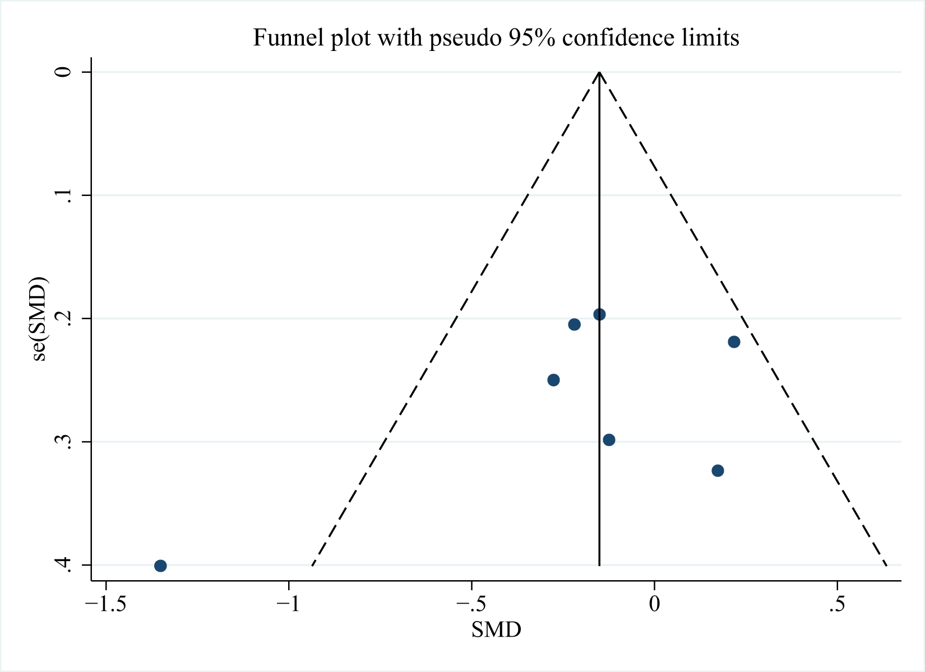 Figure S1. Displaying publication bias in the studies reporting in hepatic fibrosis.
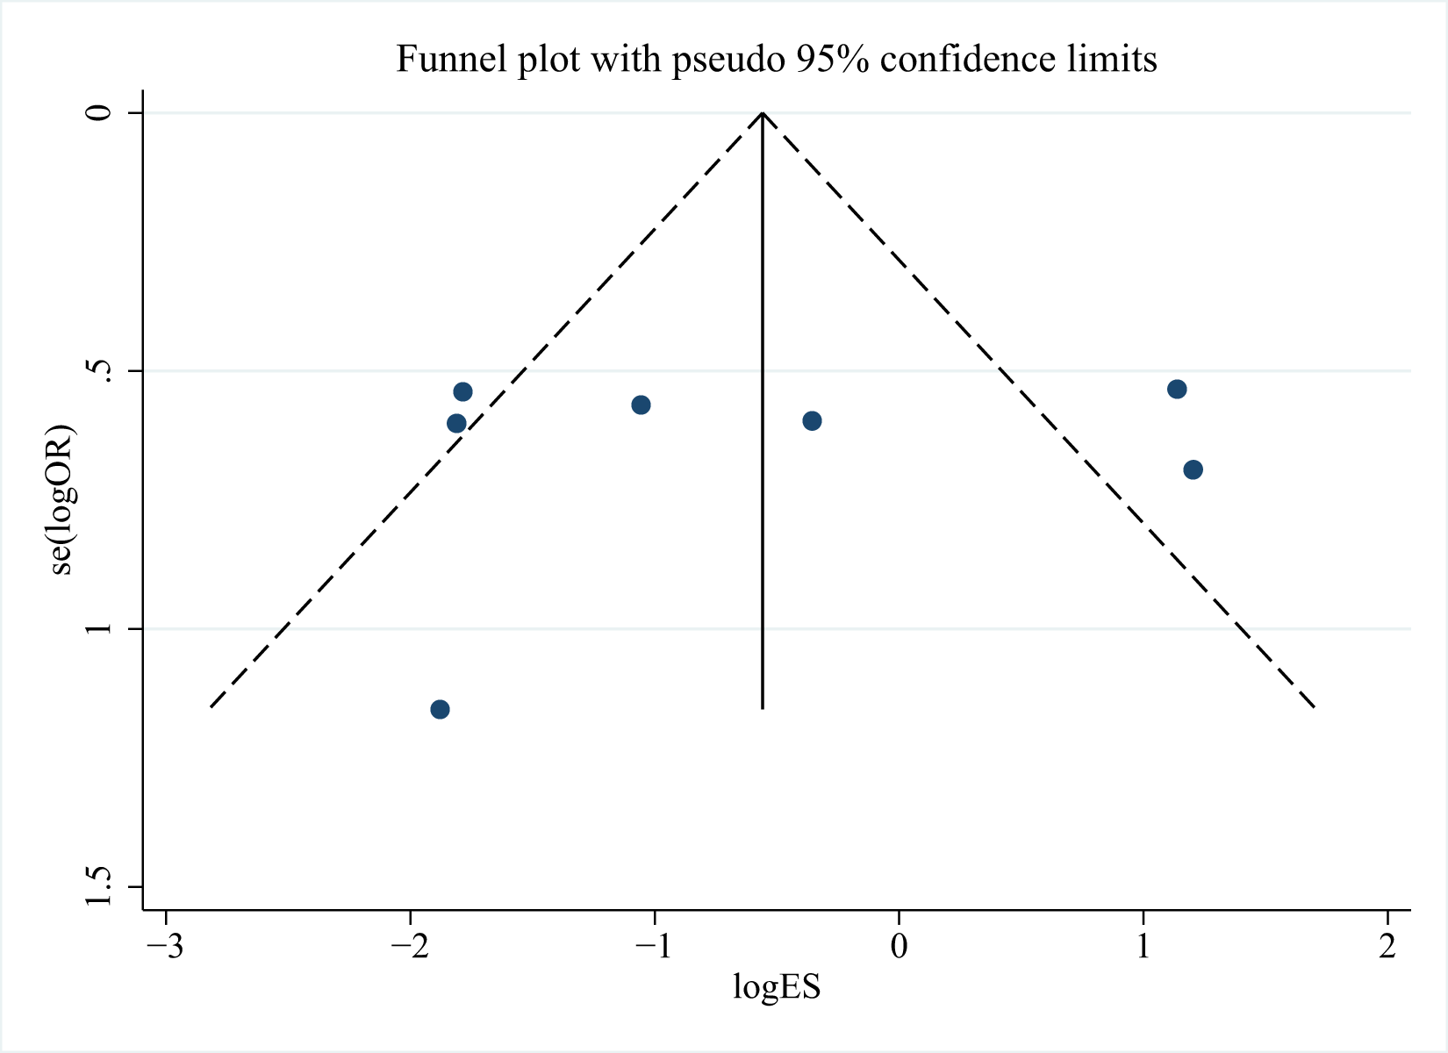
Figure S2. Displaying publication bias in the studies reporting in hepatic steatosis.
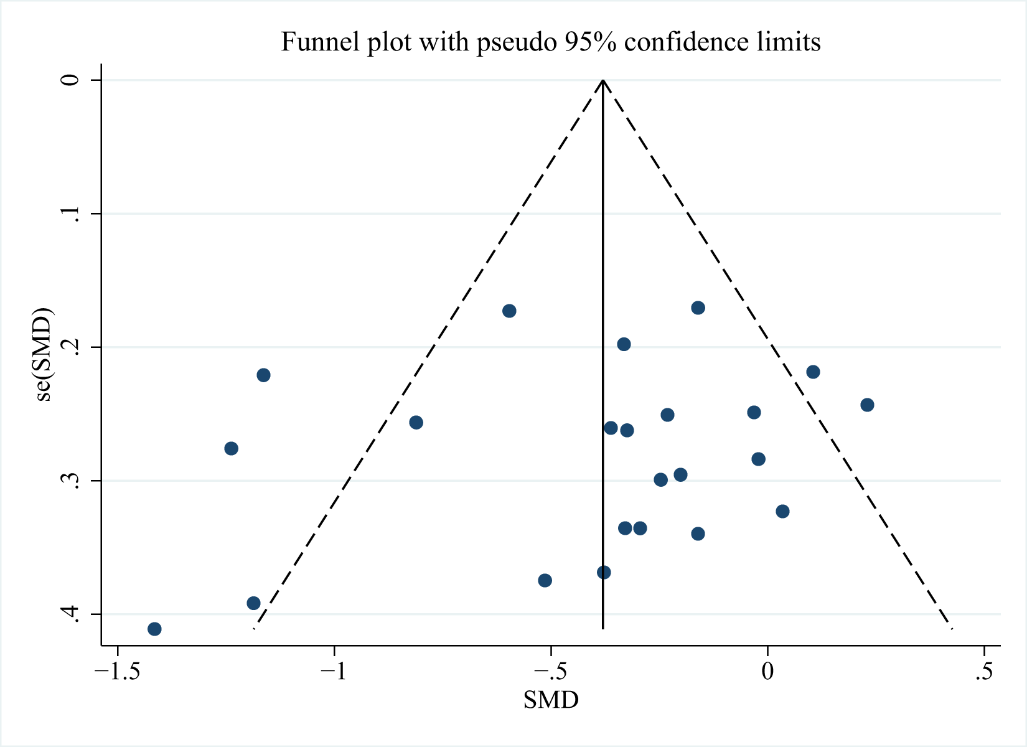
Figure S3. Displaying publication bias in the studies reporting in AST.
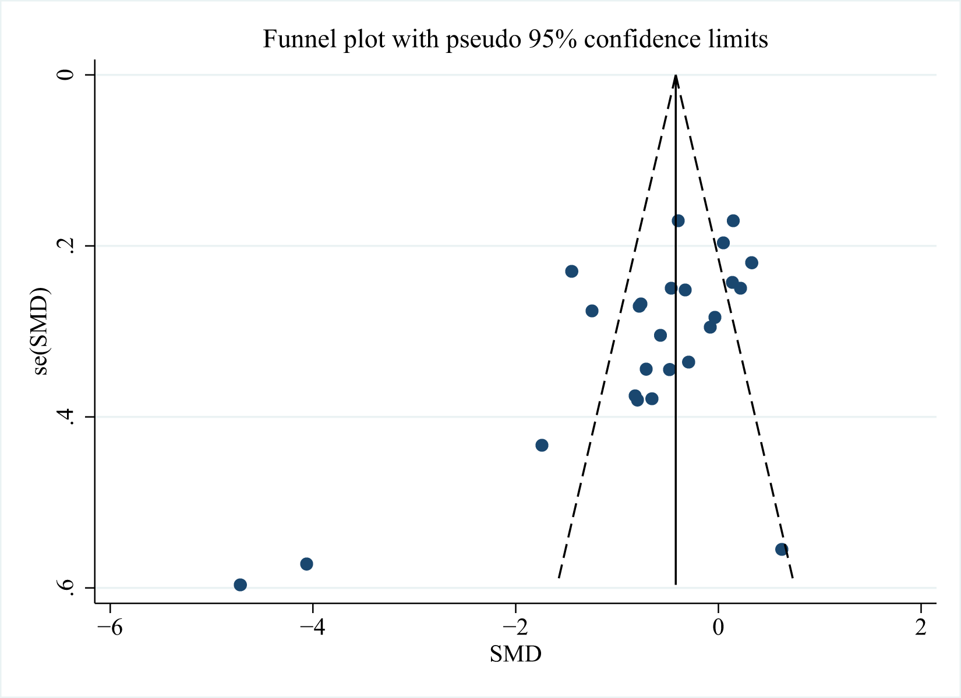
Figure S4. Displaying publication bias in the studies reporting in ALT.
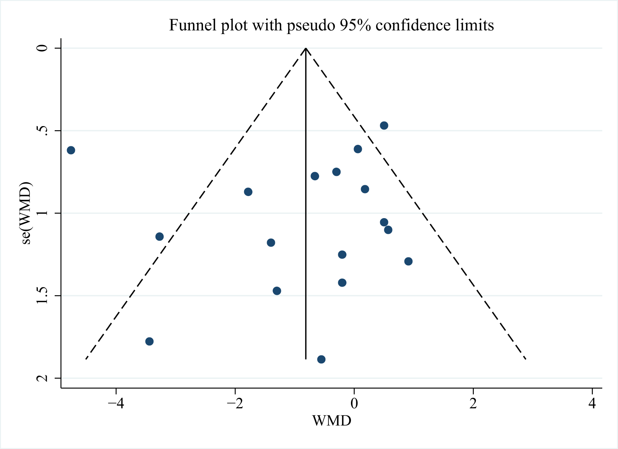
Figure S5. Displaying publication bias in the studies reporting in BMI.
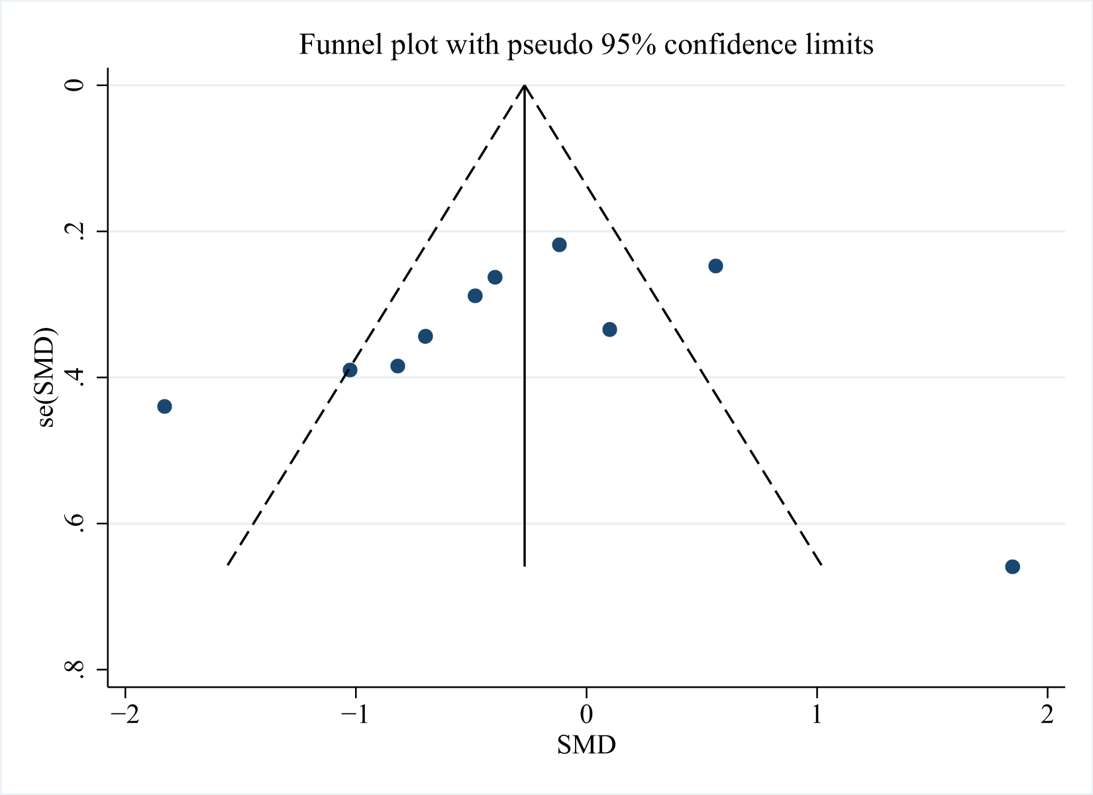
Figure S6. Displaying publication bias in the studies reporting in ALP.
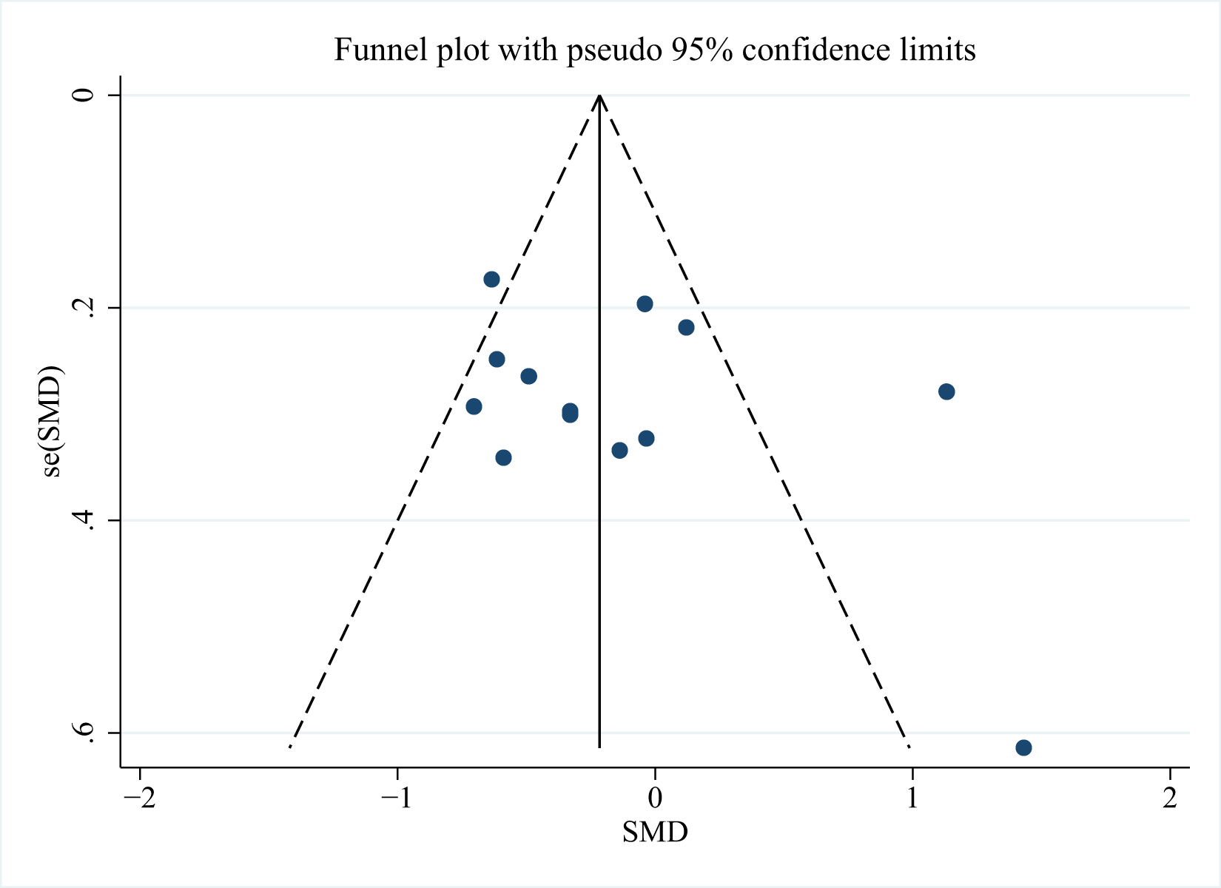
Figure S7. Displaying publication bias in the studies reporting in GGT.
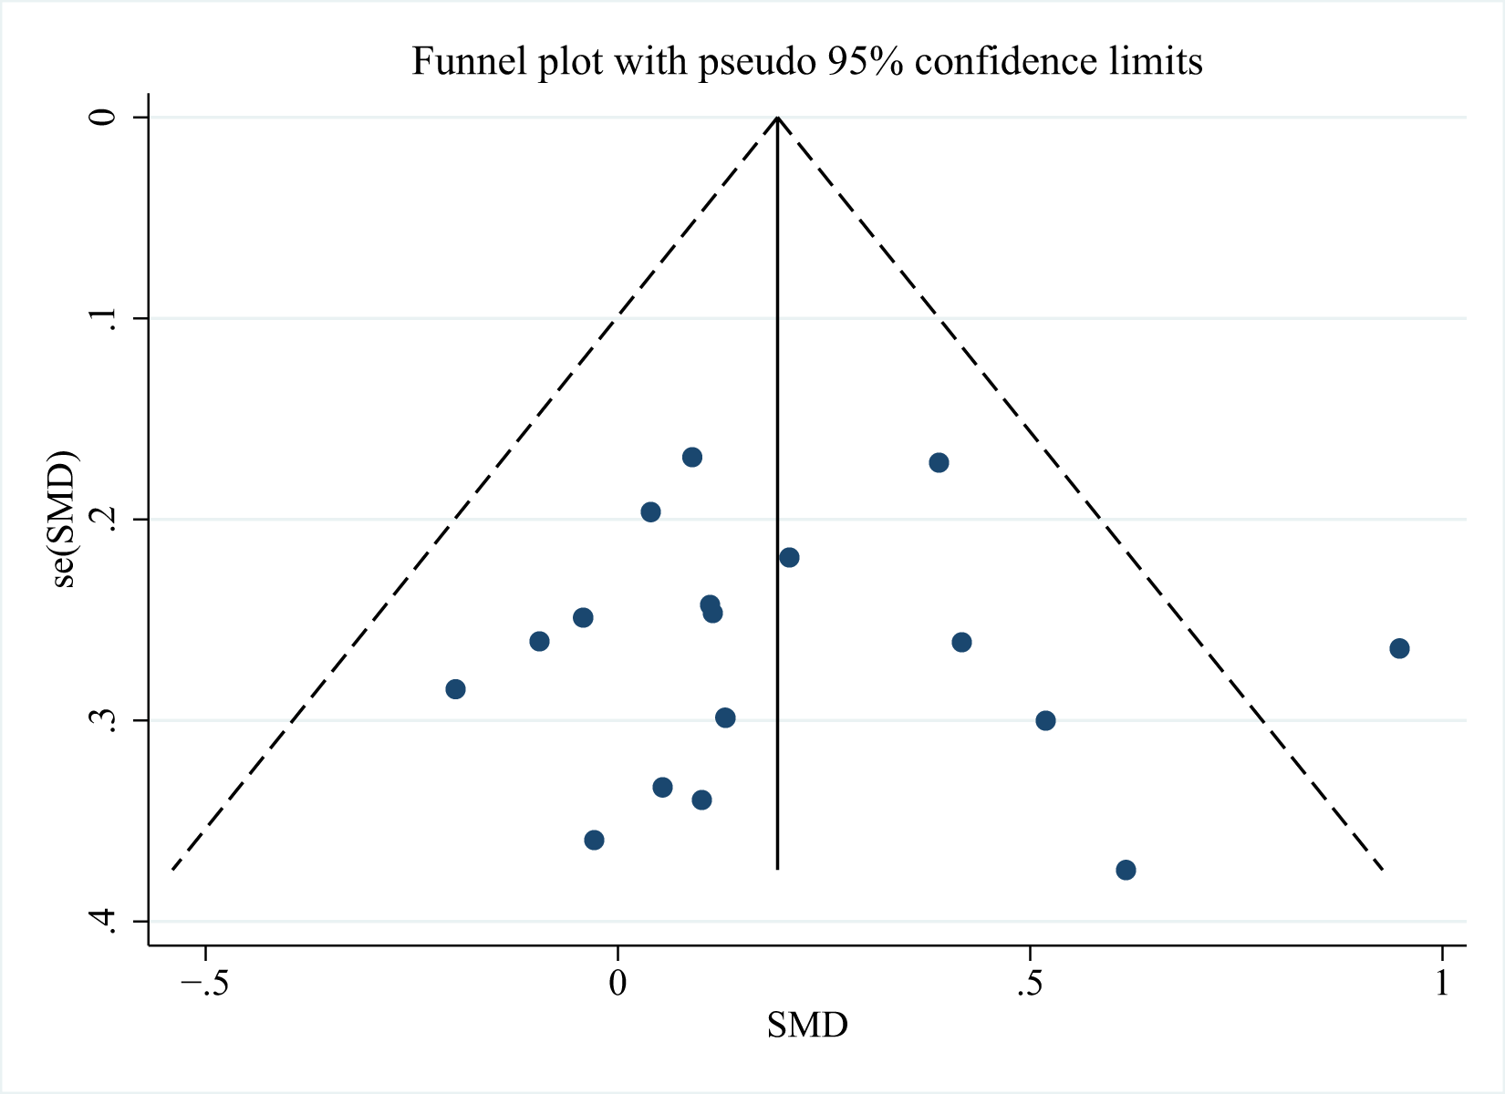
Figure S8. Displaying publication bias in the studies reporting in HDL.
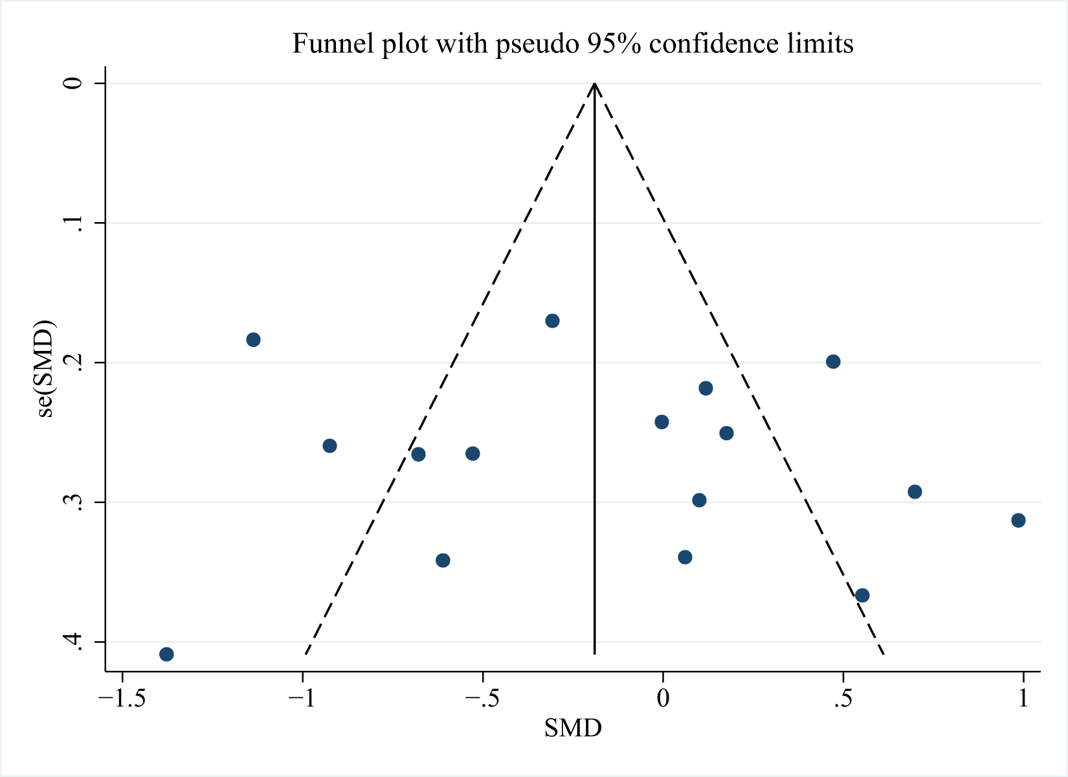
Figure S9. Displaying publication bias in the studies reporting in LDL.
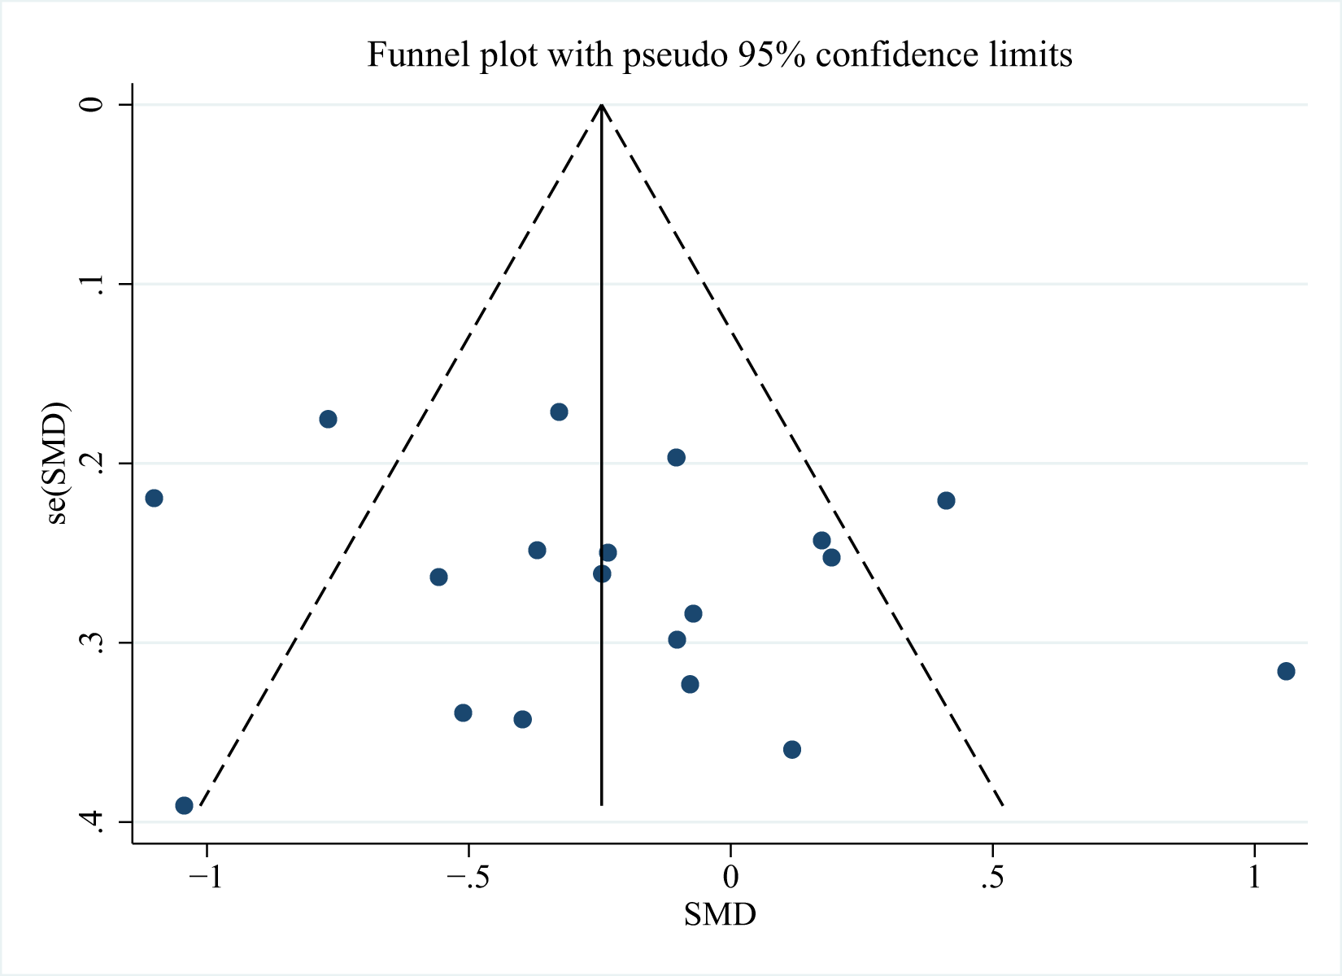
Figure S10. Displaying publication bias in the studies reporting in TG.
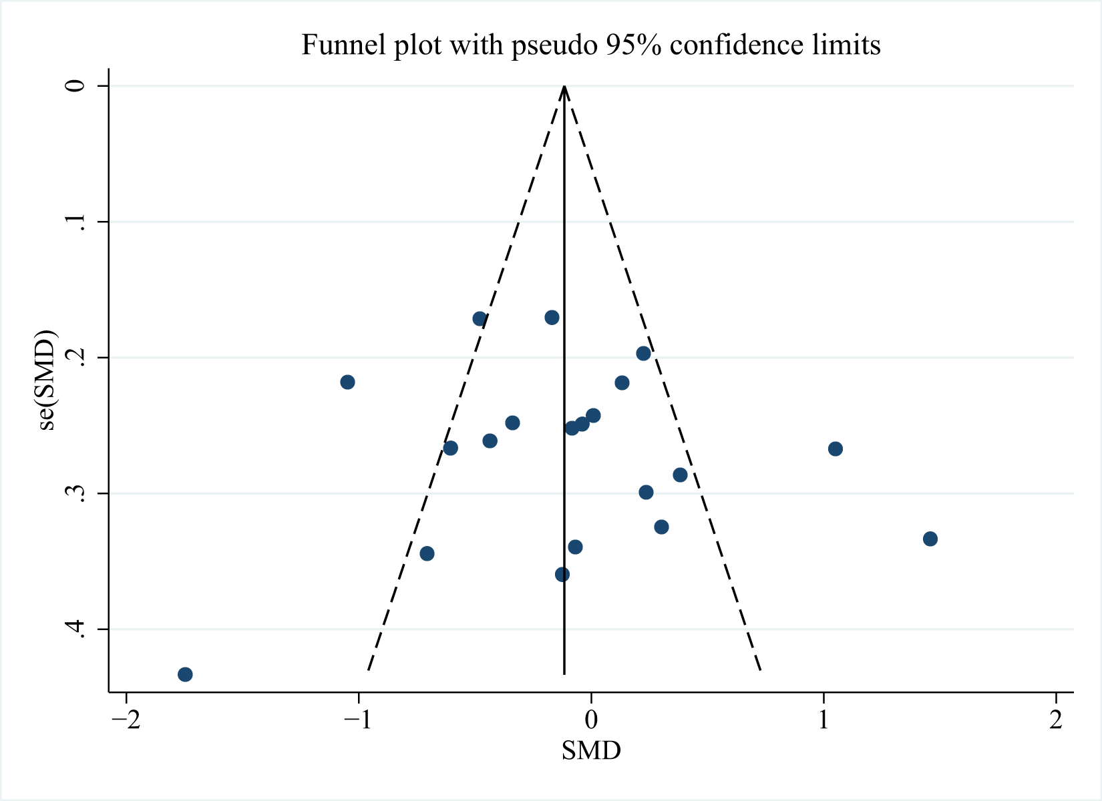
Figure S11. Displaying publication bias in the studies reporting in TC.
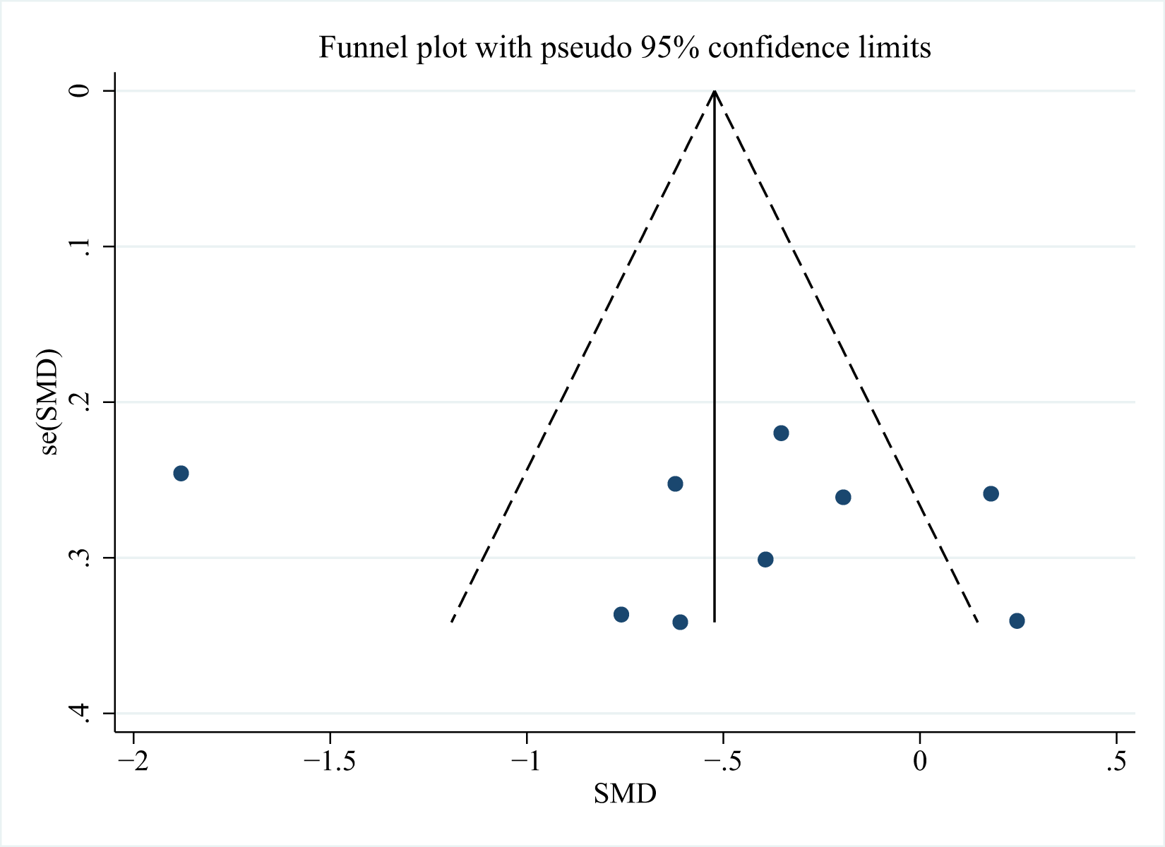
Figure S12. Displaying publication bias in the studies reporting in hs-CRP.
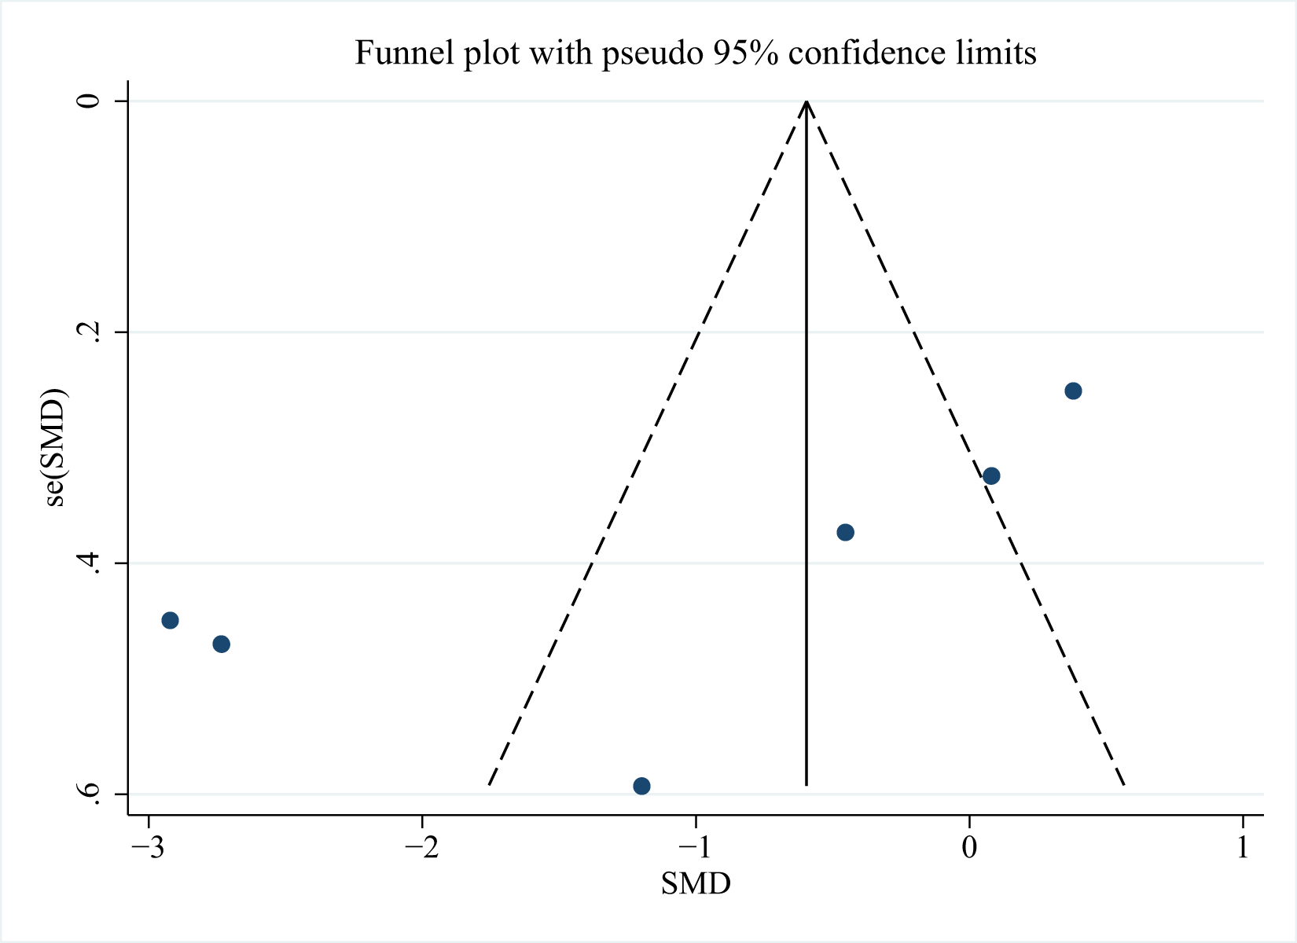
Figure S13. Displaying publication bias in the studies reporting in IL-6.
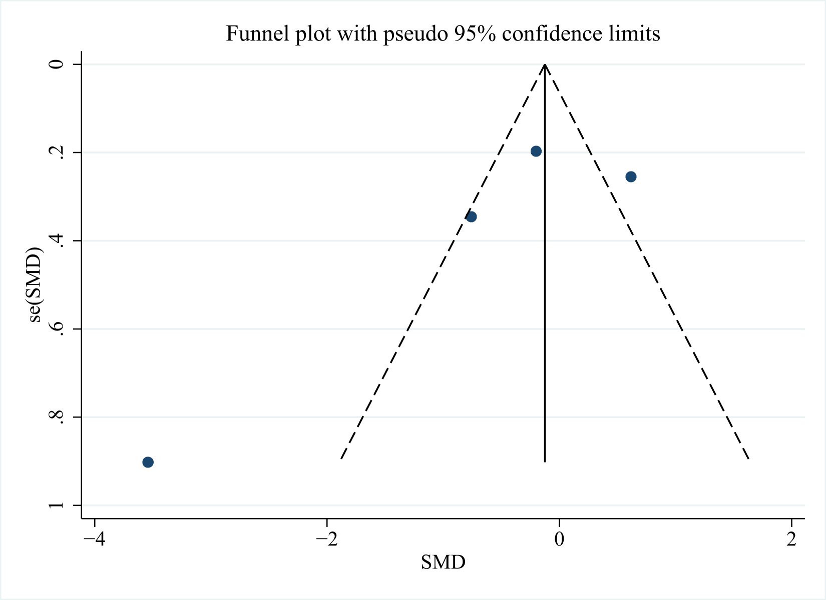
Figure S14. Displaying publication bias in the studies reporting in LPS.
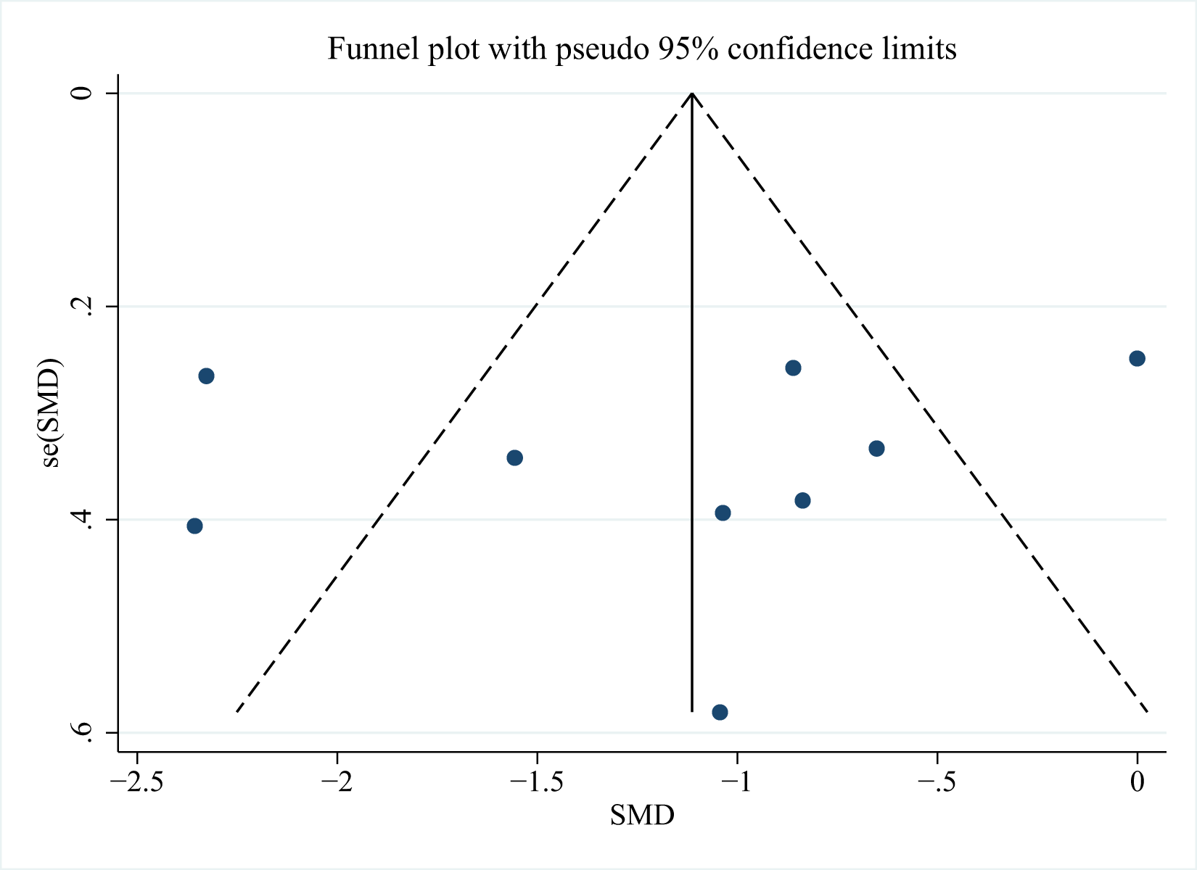
Figure S15. Displaying publication bias in the studies reporting in TNF-α.

