Supplementary Material

OncomiR-181a promotes carcinogenesis by repressing the extracellular matrix proteoglycan decorin in hepatocellular carcinoma
- Reem Amr Assal, Rowan Bahaa El-din Abd El-bary, Rana Ahmed Youness, Mohamed Mamdouh Abdelrahman, Hala Zahran, Karim Adel Hosny, Gamal Esmat, Kai Breuhahn, Nada El-Ekiaby, Injie Omar Fawzy, Ahmed Ihab Abdelaziz*
*Correspondence: Dr Ahmed Ihab Abdelaziz: aihab@ngu.edu.eg
Supplementary Figures
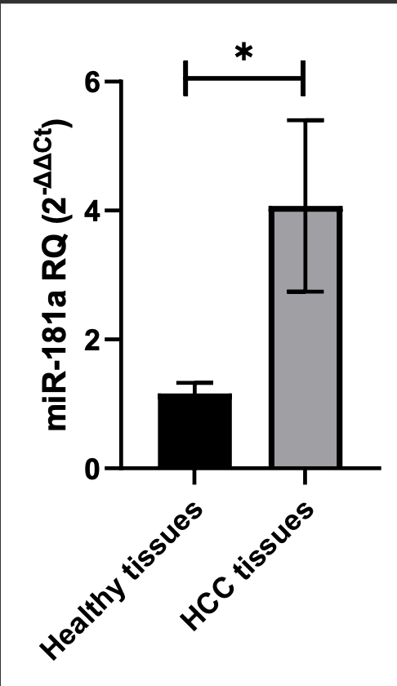
Supplementary Figure S1. Screening of miR-181a in HCC and healthy liver tissues. The expression level of miR-181a was significantly higher in the HCC tissues than that in the healthy liver tissues (P=0.0244).

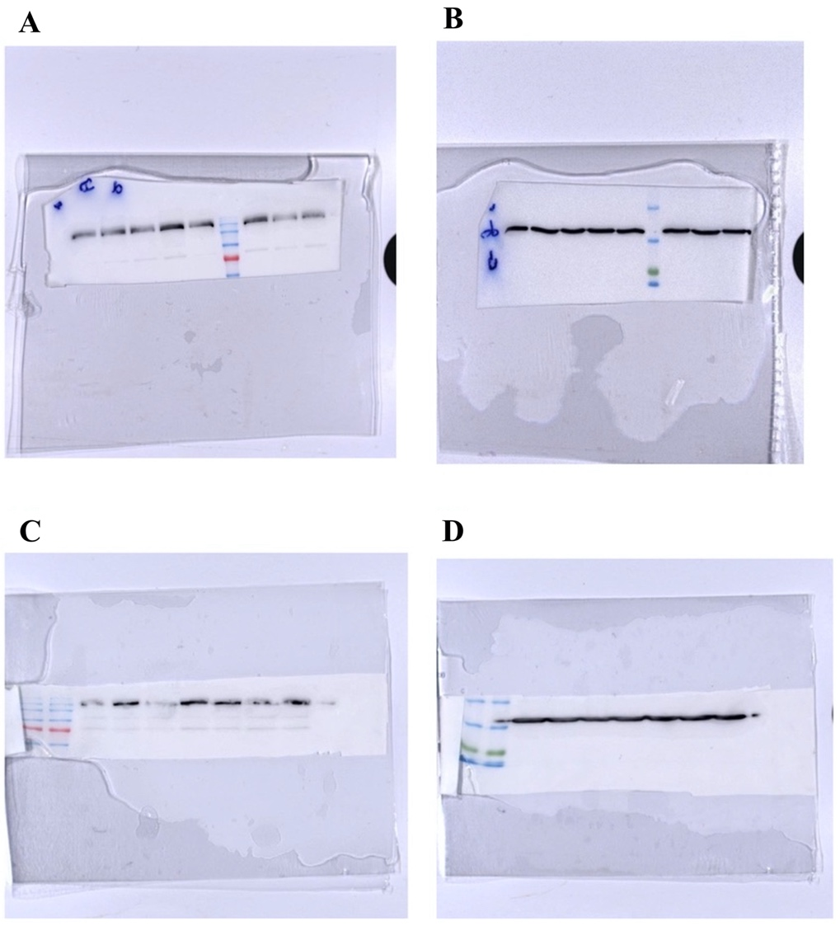
Supplementary Figure S2. Uncropped original blots of DCN and GAPDH proteins.
Panels (A): primary antibody against DCN.
Panel (B): primary antibody against GAPDH.
Panels (A) and (B) represent images from the same blot for the first (lanes 3–5) and second (lanes 7–9) biological repeats. The samples loaded in lanes 7–9 are those shown in the body of the main paper in Figure 2e. Lane 3, siDCN; lane 4, negative control; lane 5, miR-181a; lane 6, ladder; lane 7, negative control; lane 8, siDCN; and lane 9, miR-181a. Lanes 1 and 2 contain samples that were not included in the manuscript.
Panels (C): primary antibody against DCN.
Panel (D): primary antibody against GAPDH.
Panels (C) and (D) represent images from the same blot for the third biological repeat (lanes 5–7). Lane 1, ladder 1; lane 2, ladder 2; lane 5, siDCN; lane 6, negative control; and lane 7, miR-181a. Lanes 3, 4, 8, and 9 contain samples that were not included in the manuscript.
The loading controls were run on the same gel. Then, the blot was cropped during the experiment as a different set of secondary antibodies was used for DCN and GAPDH. Grouped blots from different parts of the same blot are presented in Figure 2e in the manuscript file, where the dashed line delineates the cropping site.

A B C
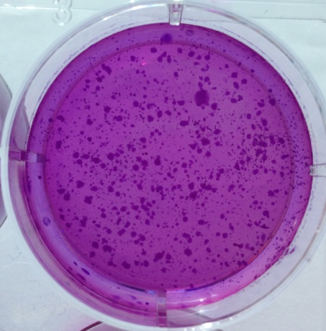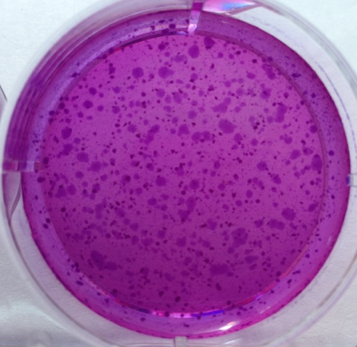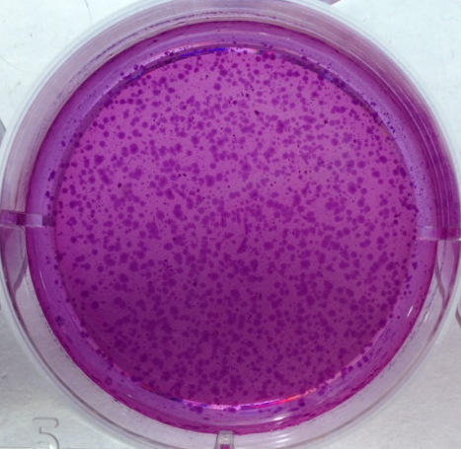
Supplementary Figure S3. Representative images for the colony forming assay. (A) Control un-transfected HuH-7 cells, (B) HuH-7 cells transfected with specific siRNAs against DCN as a positive control, and (C) HuH-7 cells transfected with miR-181a mimics.

(A) (B)
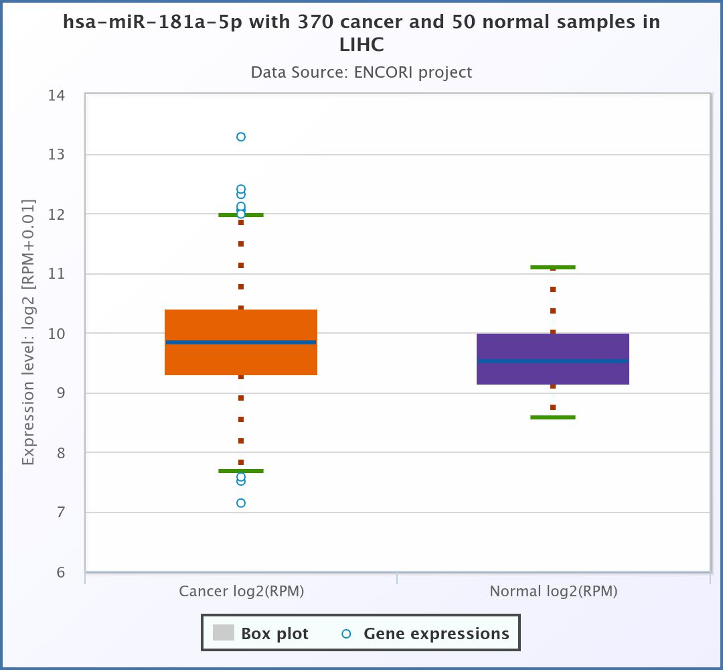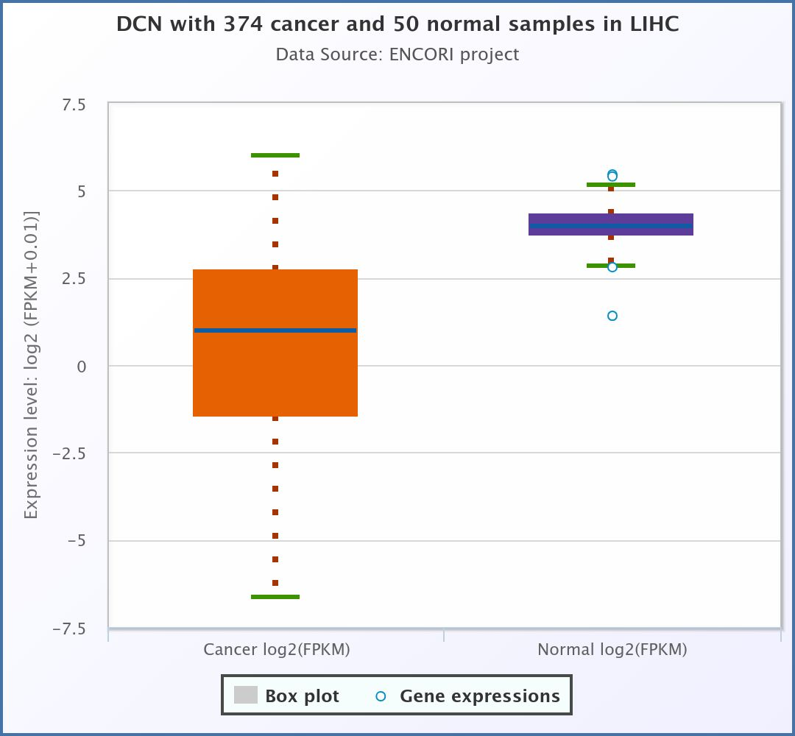

Supplementary Figure S4. TCGA data for the differential expression pattern of miR-181a and DCN in HCC and normal liver tissues. TCGA data revealed the overexpression of miR-181a in 370 HCC tissues compared to that in 50 normal liver tissues. They also revealed the down expression of DCN in 374 HCC tissues compared to that in 50 normal liver tissues.

