The Tri-Color prestained protein marker (WJ103, Epizyme, China) was used to marking protein molecular weight. The distribution of proteins with various molecular weights is illustrated in the figure.
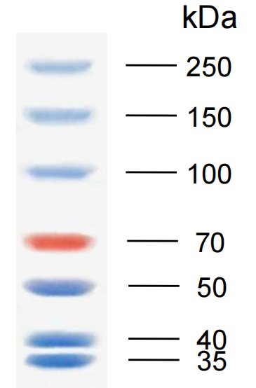
The results from three independent experimental samples were displayed in figures. These images are the original and unprocessed versions, including full-length gels and blots.
Sample 1
β-actin
CD276
100kDa
150kDa
250kDa
70kDa
50kDa
40kDa

Sample 2
100kDa
150kDa
250kDa
70kDa
50kDa
40kDa
CD276
β-actin
Sample 3
100kDa
150kDa
250kDa
70kDa
50kDa
40kDa
CD276
β-actin

