Supplementary Fig. 1. Selection of clinical laboratory features based on the LASSO algorithm
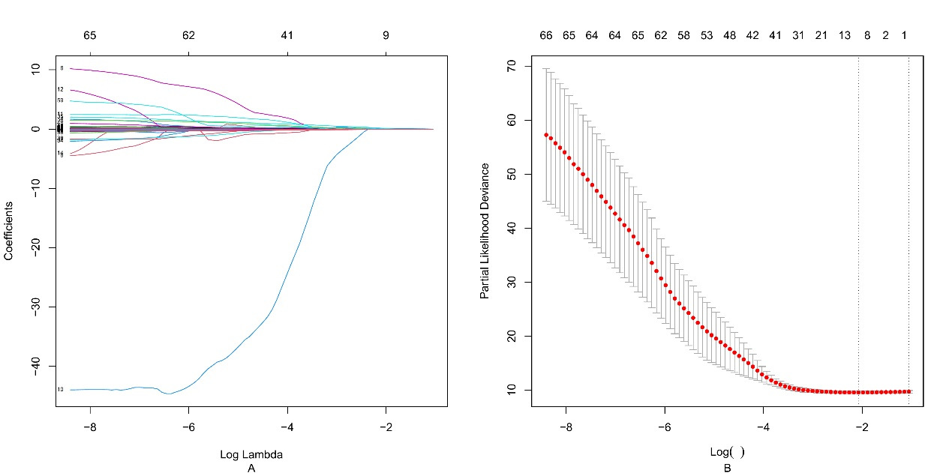
A. Convergence plot of feature coefficients using 10-fold cross-validation, where each curve represents the trajectory of coefficient changes for each independent variable. B. Using the optimal log(λ) value as the truncation point (left vertical dashed line), nine clinical laboratory features were selected.

Supplementary Fig. 2. ROC and AUC of each model at different time points A, B, and C.
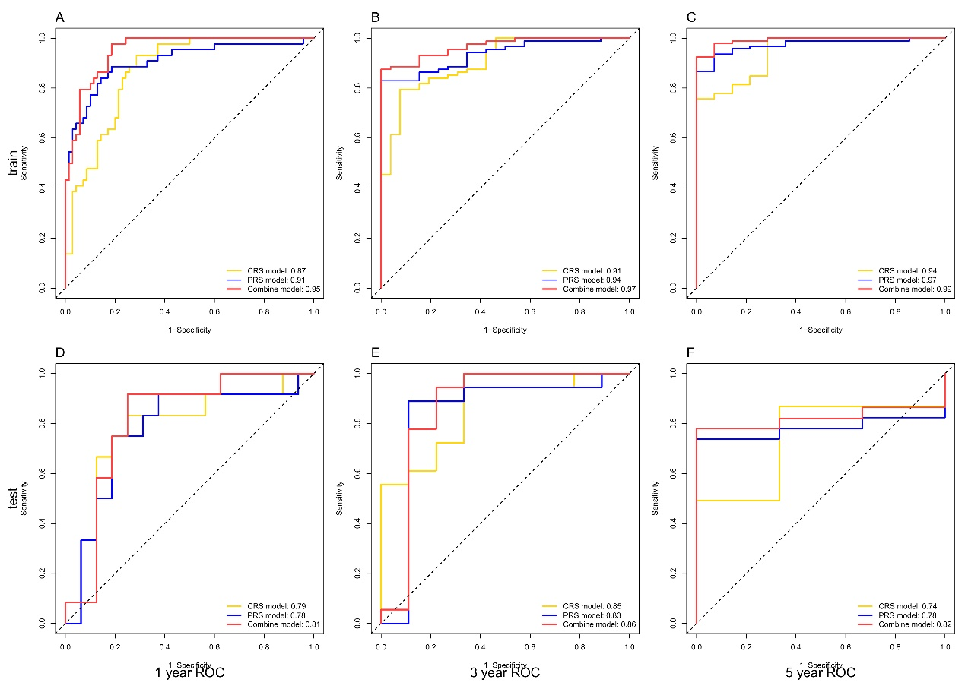
ROC and AUC of each model’s training set at the 1-, 3-, and 5-year time points, respectively. D, E, and F. ROC and AUC of each model’s test set at the 1-, 3-, and 5-year time points, respectively.

Supplementary Fig. 3. Decision curves of each model at different time points
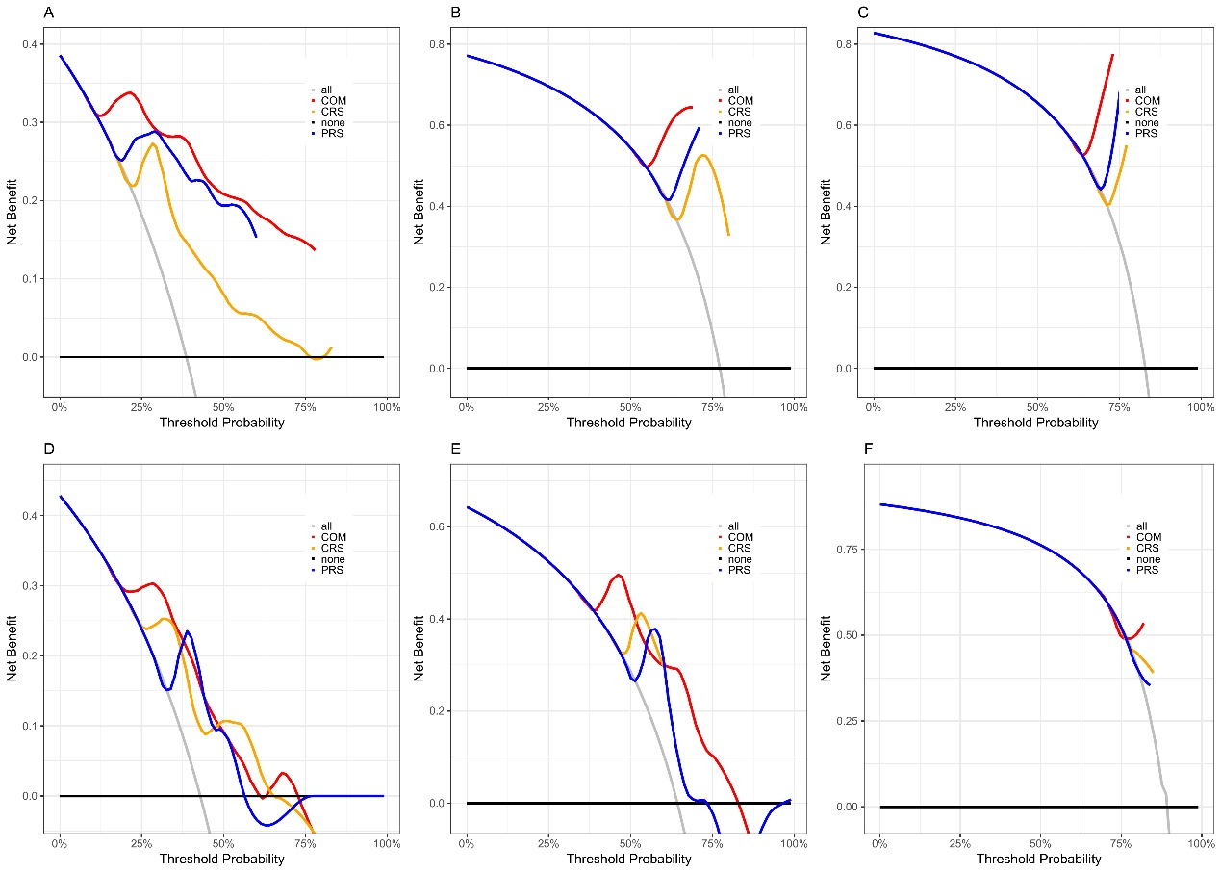
A, B, and C. Decision curves of each model’s training set at the 1-, 3-, and 5-year time points, respectively. D, E, and F. Decision curves of each model’s test set at the 1-, 3-, and 5-year time points, respectively. PRS: Pathological risk signature model, CRS: Clinical risk signature model, COM: Combined model.

Supplementary Fig. 4. ROC and AUC of each model
