Supplementary Material
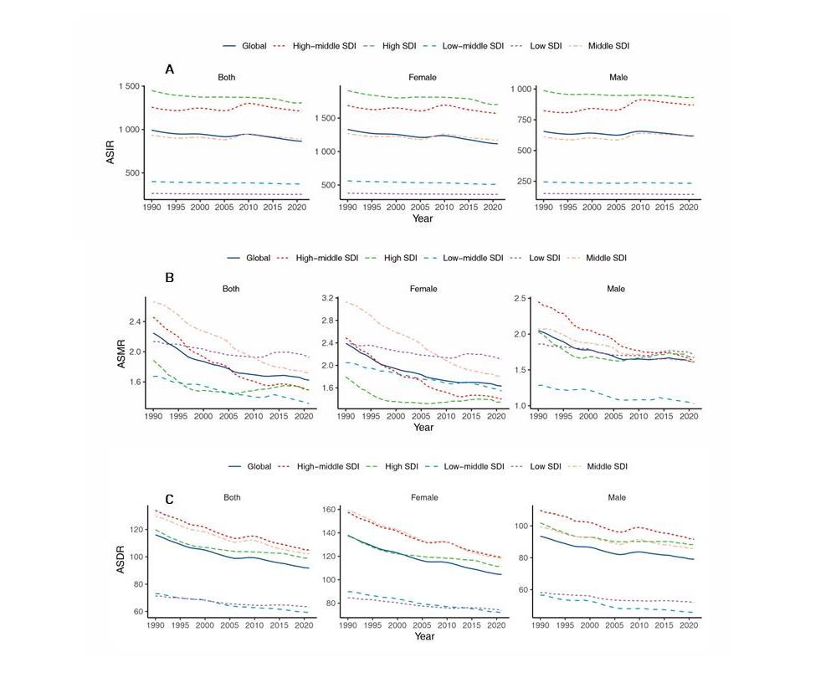
Supplementary Figure 1. Change trends of ASIR, ASMR, and ASDR of gallbladder and biliary diseases among different SDI regions. A, ASIR. B, ASMR. C, ASDR. Abbreviations: ASIR, age-standardized incidence rate; ASMR, age-standardized mortality rate; ASDR, age-standardized DALYs rate, SDI, socio-demographic index.

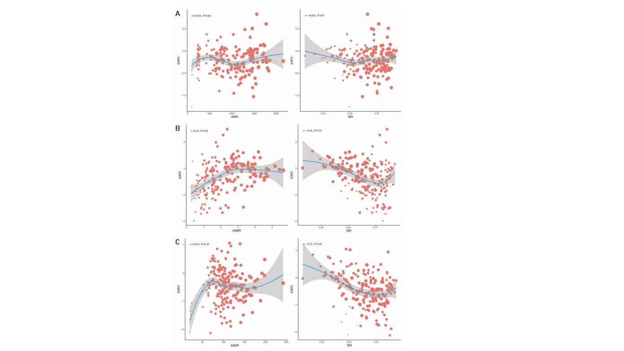
Supplementary Figure 2. The correlation between EAPC and gallbladder and biliary diseases ASR and socio-demographic index. A, ASIR. B, ASMR. C, ASDR. Abbreviations: ASIR, age-standardized incidence rate; ASMR, age-standardized mortality rate; ASDR, age-standardized DALYs rate, SDI, socio-demographic index, EAPC, estimated annual percentage change.

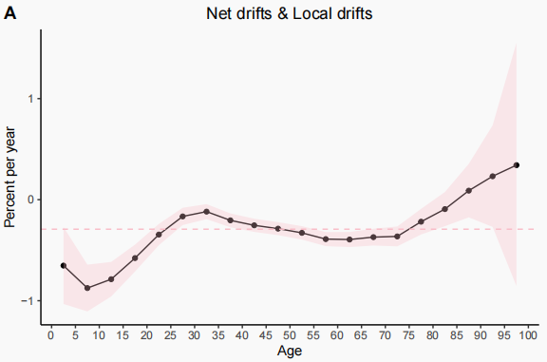
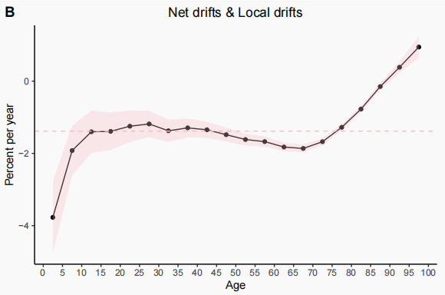
Supplementary Figure 3. The global net and local drifts by age group in gallbladder biliary disease incidence and mortality.

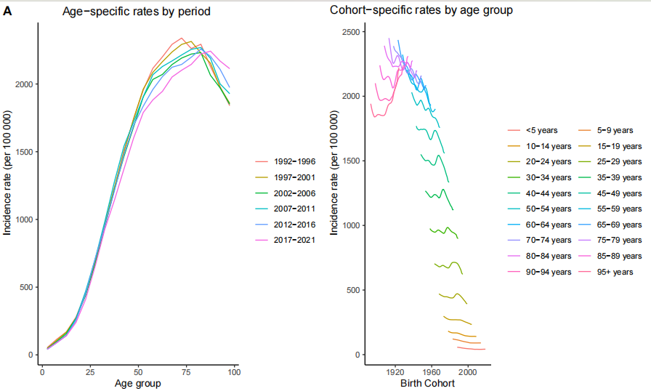
Supplementary Figure 4. Age- and cohort-specific incidence rates of gallbladder and biliary diseases from 1992 to 2021.

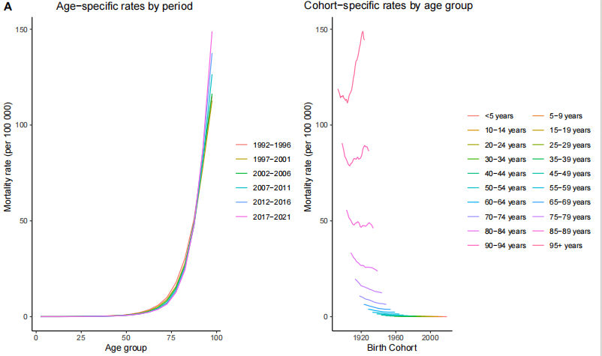
Supplementary Figure 5. Age- and cohort-specific mortality rates of gallbladder and biliary diseases from 1992 to 2021.

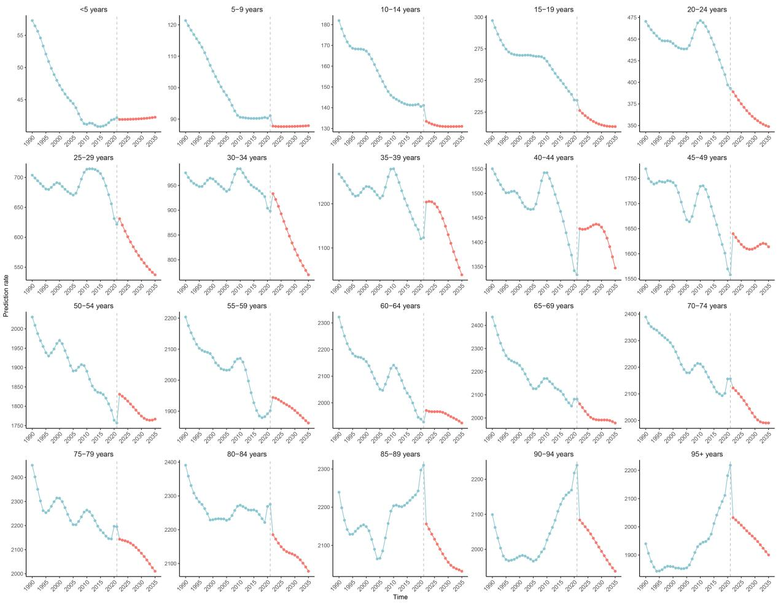
Supplementary Figure 6. Projected incidence rates of gallbladder biliary disease in both sexes of all ages, 1990-2035.

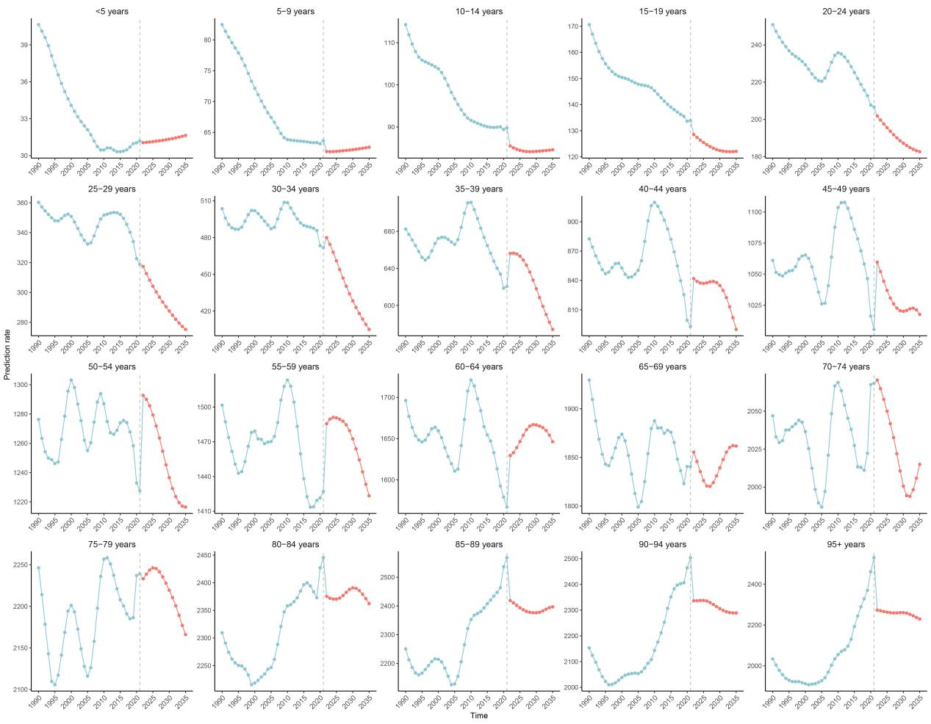
Supplementary Figure 7. Projected incidence rates of gallbladder biliary disease in males of all ages, 1990-2035.

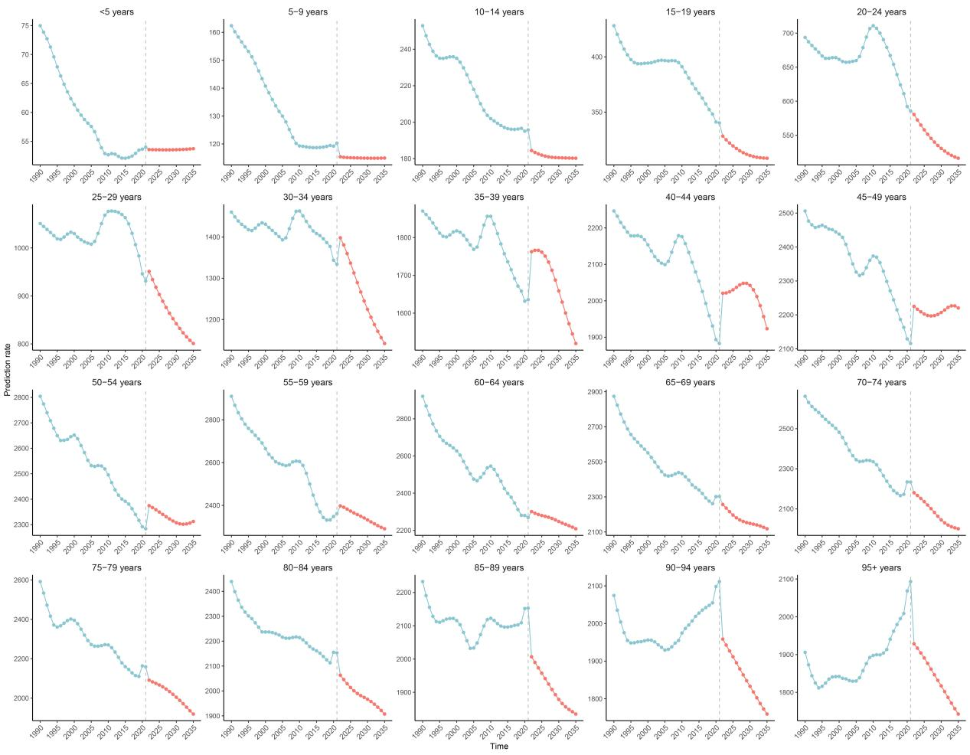
Supplementary Figure 8. Projected incidence rates of gallbladder biliary disease in females of all ages, 1990-2035.

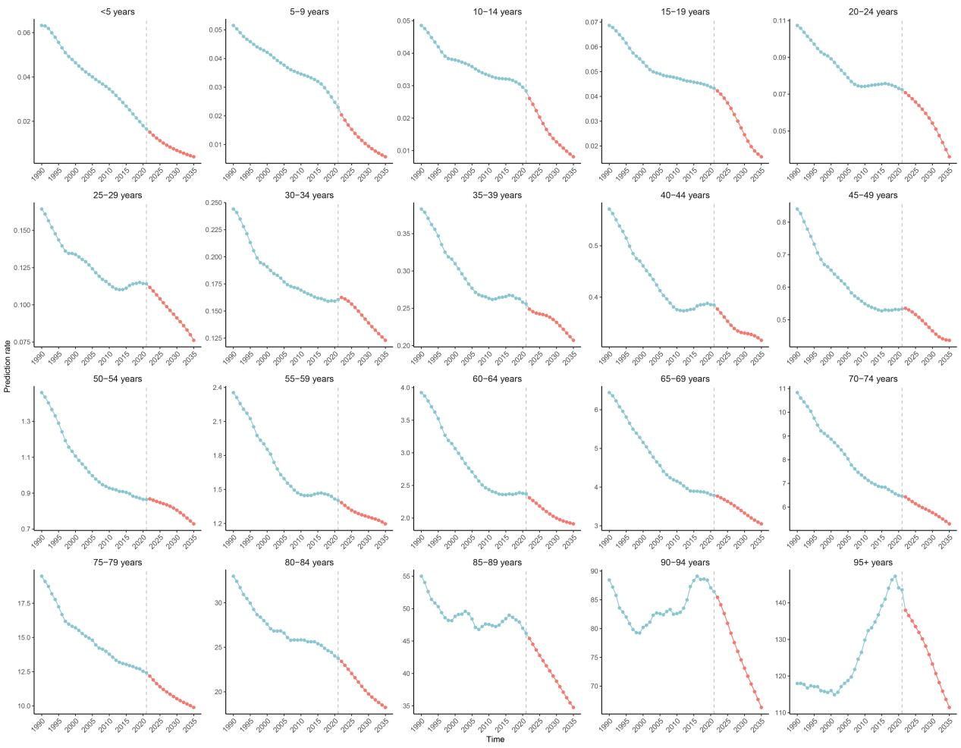
Supplementary Figure 9. Projected mortality rates of gallbladder biliary disease in both sexes of all ages, 1990-2035.

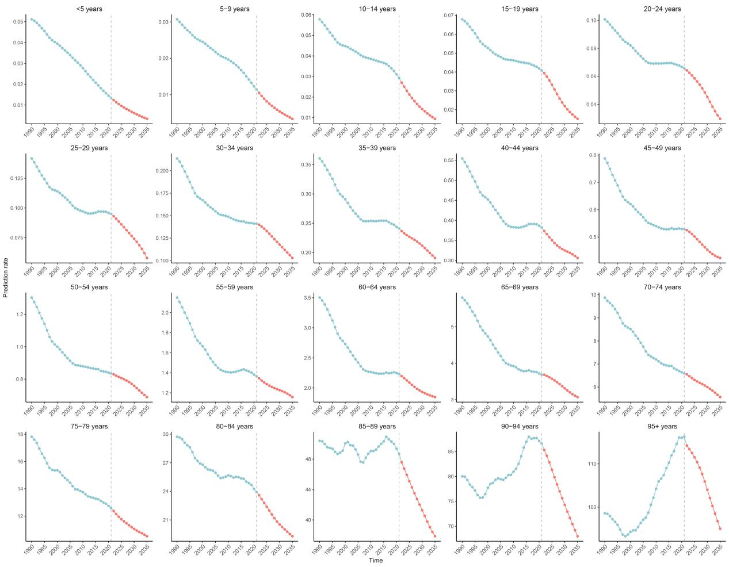
Supplementary Figure 10. Projected mortality rates of gallbladder biliary disease in males of all ages, 1990-2035.

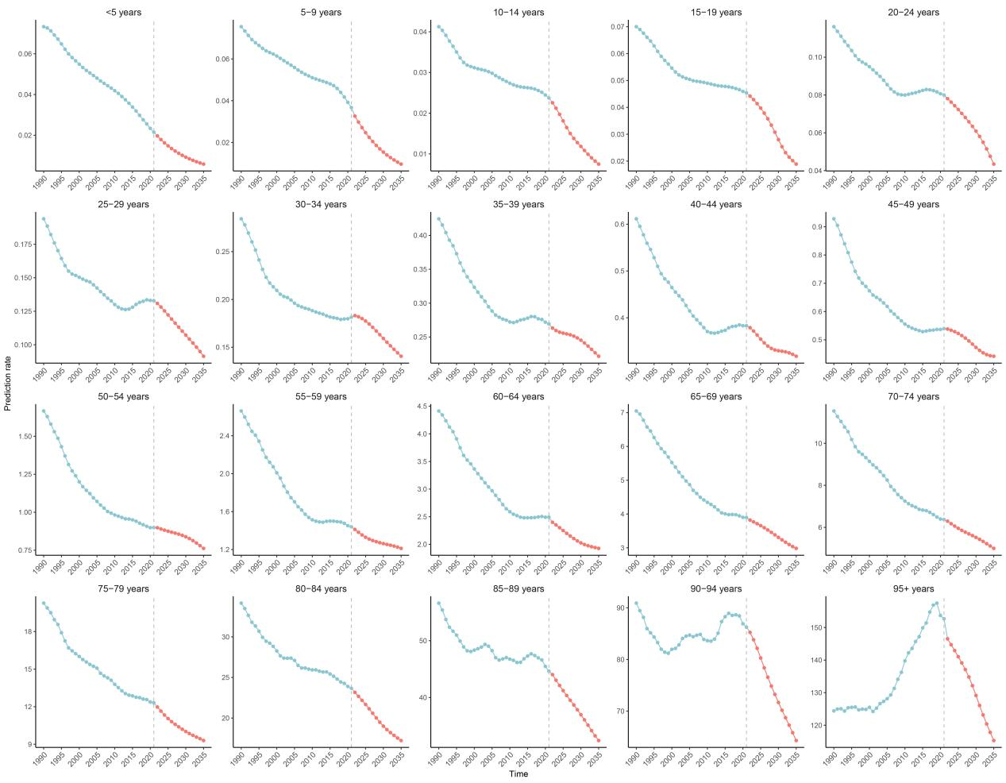
Supplementary Figure 11. Projected mortality rates of gallbladder biliary disease in females of all ages, 1990-2035.

