High serum CA19-9 predicts severe cholecystitis in calculous cholecystitis patients

Table S1. Liver function, blood cell count and operation data of patients with calculous cholecystitis in high serum CA19-9 group and normal group in Center A.
 | Normal group  (n=70) | High group  (n=35) | X²/t | p
ALB (g/L) | 45.34±0.4 | 42.81±0.7 | -3.133 | 0.003
TB (μmol/L) | 14.21±0.56 | 17.17±2.54 | 1.135 | 0.264
DB(μmol/L) | 4.92±0.26 | 5.61±1.09 | 0.620 | 0.539
ALT (U/L) | 25.06±1.85 | 32.71±7.94 | 0.939 | 0.354
AST (U/L) | 21.33±1.37 | 27.31±3.72 | 1.837 | 0.069
ALP (U/L) | 83.21±3.88 | 114.46±26.18 | 1.181 | 0.246
GGT (U/L) | 65.03±15.55 | 101.17±36.16 | 1.074 | 0.286
WBC (×10⁹/L) | 5.66±0.17 | 7.55±0.5 | 3.557 | 0.001
N (×10⁹/L) | 3.27±0.13 | 5.05±0.51 | 3.406 | 0.002
L (×10⁹/L) | 1.82±0.07 | 1.9±0.08 | 0.629 | 0.531
M (×10⁹/L) | 0.33±0.02 | 0.43±0.03 | 2.486 | 0.015
NLR | 2.1±0.18 | 3.14±0.47 | 2.037 | 0.048
LMR | 5.99±0.22 | 4.98±0.42 | -2.140 | 0.037
PLT (×10⁹/L) | 221.69±7.63 | 259.89±17.95 | 1.959 | 0.056
PLR | 158.73±22.15 | 143.49±11.93 | -0.469 | 0.640
HGB (g/L) | 135.71±2.8 | 128.91±2.76 | -1.538 | 0.127
CRP* (g/L) | 1.69±0.41 | 32.28±10.69 | 2.859 | 0.009
Gallbladder thickness (mm） | 2.14±0.2 | 6.27±0.54 | 7.131 | <0.001
Operation method
LC (3 holes) | 69 (99%) | 30 (86%) | - | -
LC (4 holes) | 1 (1%) | 1 (3%) | - | 0.310
Open surgery | 0 (0%) | 4 (11%) | - | 0.010
Operation duration (min) | 76.84±2.65 | 109.14±6.74 | 4.459 | <0.001

Table S2. Basic information of patients with calculous cholecystitis in high serum CA19-9 group and normal group in Center B.
 | Normal group  (n=70) | High group  (n=35) | X²/t | p
Gender |  |  | <0.001 | 1
Male | 30 (43%) | 15 (43%)
Female | 40 (57%) | 20 (57%)
Age | 56.93±1.50 | 56.80±3.04 | -0.038 | 0.970
Symptom |  |  | - | 0.716
Negative | 6 (9%) | 2 (6%)
Positive | 64 (91%) | 33 (94%)
Stone diameter (mm) |  |  | 1.222 | 0.269
≤10 | 36 (51%) | 14 (40%)
>10 | 34 (49%) | 21 (60%)
Number of stone |  |  | 2.188 | 0.139
Single | 13 (19%) | 11 (31%)
Multiple | 57 (81%) | 24 (69%)
Serum CA19-9 levels
<37U/ml | 70(100%) | -
≥37-<111U/ml | - | 19 (54%)
≥111-370U/ml | - | 5 (14%)
≥370U/ml | - | 11 (31%)

 | Normal group  (n=70) | High group  (n=35) | X²/t | p
ALB (g/L) | 39.96±0.39 | 37.76±0.81 | -2.444 | 0.018
TB (μmol/L) | 14.73±2.23 | 22.24±3.32 | 1.912 | 0.059
DB(μmol/L) | 3.72±0.98 | 7.51±1.64 | 1.980 | 0.052
ALT (U/L) | 24.40±1.46 | 26.71±1.96 | 0.929 | 0.355
AST (U/L) | 22.49±1.09 | 25.17±1.40 | 1.464 | 0.146
ALP (U/L) | 81.33±4.49 | 94.77±5.88 | 1.770 | 0.080
GGT (U/L) | 39.69±6.7 | 59.83±11.73 | 1.594 | 0.114
WBC (×10⁹/L) | 5.35±0.16 | 9.46±0.85 | 4.745 | <0.001
N (×10⁹/L) | 3.06±0.13 | 7.26±0.82 | 3.406 | 0.002
L (×10⁹/L) | 1.7±0.07 | 1.38±0.08 | 0.629 | 0.531
M (×10⁹/L) | 0.38±0.02 | 0.71±0.07 | 2.486 | 0.015
NLR | 2.28±0.27 | 6.97±1.21 | 3.776 | 0.001
LMR | 4.76±0.23 | 2.64±0.31 | -5.442 | <0.001
PLT (×10⁹/L) | 207.16±8.25 | 226.11±13.79 | 1.248 | 0.215
PLR | 148.76±15.84 | 184.27±15.49 | 1.422 | 0.158
HGB (g/L) | 124.66±2.18 | 126.6±2.37 | 0.553 | 0.581
CRP* (g/L) | 3.43±1.07 | 67.75±16.13 | 3.979 | 0.001
Gallbladder thickness (mm） | 1.96±0.1 | 5.59±0.48 | 7.431 | <0.001
Operation method
LC (3 holes) | 68 (97%) | 29 (83%) | - | -
LC (4 holes) | 2 (3%) | 6 (17%) | - | 0.016
Open surgery | 0 (0%) | 0 (0%) | - | -
Operation duration (min) | 69.03±2.7 | 88.71±5.97 | 3.003 | 0.004
Table S3. Liver function, blood cell count and operation data of patients with calculous cholecystitis in high serum CA19-9 group and normal group in Center B.

Normal group (n=31) |  |  |  |  |  |  |  | High group(n=23)
Case | CA19-9(U/ml) | CRP(g/L) |  | Case | CA19-9(U/ml) | CRP(g/L) |  | Case | CA19-9(U/ml) | CRP(g/L)
1 | 32.23 | 6.41 |  | 24 | 1.3 | 0.78 |  | 1 | 6742.97 | 49.32
2  3  4  3  4  5  6  7  8  9  10 | 22.91 | 1.40 |  | 25 | 1.2 | 1.41 |  | 2 | 1573 | 113.9
3  4 | 19.87 | 1.07 |  | 26 | 1.2 | 1.36 |  | 3 | 1000 | 16.51
4 | 19.45 | 11.56 |  | 27 | 1.2 | 1.16 |  | 4 | 882.7 | 103.98
5 | 17.17 | 0.50 |  | 28 | 1.2 | 0.53 |  | 5 | 700 | 9.10
6 | 17.01 | 0.58 |  | 29 | 1.2 | 0.50 |  | 6 | 666.06 | 15.86
7 | 15.7 | 0.71 |  | 30 | 1.2 | 0.50 |  | 7 | 443.5 | 115.12
8 | 15.4 | 0.50 |  | 31 | 1.2 | 0.44 |  | 8 | 422.59 | 15.40
9 | 13.14 | 4.38 |  |  |  |  |  | 9 | 415.54 | 5.47
10 | 11.95 | 1.53 |  |  |  |  |  | 10 | 144 | 3.51
11 | 11.76 | 0.82 |  |  |  |  |  | 11 | 138.5 | 65.85
12 | 11.37 | 1.02 |  |  |  |  |  | 12 | 138.46 | 6.37
13 | 10.03 | 5.30 |  |  |  |  |  | 13 | 120 | 192.08
14 | 10.10 | 0.41 |  |  |  |  |  | 14 | 85.71 | 6.48
15 | 8.44 | 0.42 |  |  |  |  |  | 15 | 78.2 | 0.69
16 | 8.18 | 0.92 |  |  |  |  |  | 16 | 70.17 | 6.16
17 | 7.57 | 1.13 |  |  |  |  |  | 17 | 69.47 | 1.74
18 | 6.58 | 1.03 |  |  |  |  |  | 18 | 65.5 | 1.15
19 | 5.93 | 2.51 |  |  |  |  |  | 19 | 63.07 | 0.68
20 | 5.62 | 0.87 |  |  |  |  |  | 20 | 56.52 | 6.27
21 | 5.12 | 0.73 |  |  |  |  |  | 21 | 56.45 | 0.38
22 | 4.27 | 0.56 |  |  |  |  |  | 22 | 54.93 | 5.11
23 | 2.81 | 1.41 |  |  |  |  |  | 23 | 44.23 | 1.31
Table S4.The level of CA19-9 and its corresponding CRP values in center A.

 | Normal group (n=46) |  |  |  |  |  |  |  | High group(n=17)
Case | CA19-9(U/ml) |  | CRP(g/L) |  | Case | CA19-9(U/ml) | CRP(g/L) |  | Case | CA19-9(U/ml) | CRP(g/L)
1 | 30.1 | 0.51 |  |  | 24 | 6.18 | 0.58 |  | 1 | 47114.3 | 199.81
2  3  4  3  4  5  6  7  8  9  10 | 22.37 | 1.13 |  |  | 25 | 5.85 | 0.58 |  | 2 | 44911 | 121.16
3  4 | 18.95 | 5.08 |  |  | 26 | 5.53 | 0.50 |  | 3 | 1245.4 | 79.43
4 | 18.7 | 4.21 |  |  | 27 | 5.32 | 1.59 |  | 4 | 421.11 | 3.67
5 | 14.62 | 16.84 |  |  | 28 | 5.18 | 0.67 |  | 5 | 360.13 | 98.48
6 | 12.61 | 0.56 |  |  | 29 | 5.11 | 3.01 |  | 6 | 162.68 | 3.71
7 | 12.28 | 2.13 |  |  | 30 | 5.08 | 0.50 |  | 7 | 154.36 | 11.13
8 | 11.87 | 0.57 |  |  | 31 | 4.72 | 2.48 |  | 8 | 93.48 | 128.30
9 | 11.3 | 0.53 |  |  | 32 | 4.65 | 2.74 |  | 9 | 91.6 | 2.63
10 | 10.93 | 0.59 |  |  | 33 | 4.4 | 0.58 |  | 10 | 88.29 | 82.21
11 | 9.98 | 35.6 |  |  | 34 | 4.33 | 0.54 |  | 11 | 78.73 | 18.17
12 | 9.97 | 0.53 |  |  | 35 | 3.77 | 0.50 |  | 12 | 65.5 | 4.64
13 | 9.60 | 21.0 |  |  | 36 | 3.39 | 0.97 |  | 13 | 53.68 | 135.31
14 | 9.43 | 1.38 |  |  | 37 | 3.27 | 1.24 |  | 14 | 51.7 | 15.80
15 | 9.27 | 1.01 |  |  | 38 | 3.1 | 2.66 |  | 15 | 46.06 | 1.21
16 | 8.37 | 3.17 |  |  | 39 | 2.06 | 2.74 |  | 16 | 45.9 | 70.81
17 | 8.35 | 0.55 |  |  | 40 | 2.06 | 2.64 |  | 17 | 37.5 | 175.90
18 | 7.42 | 0.96 |  |  | 41 | 2.06 | 2.48
19 | 7.31 | 28.0 |  |  | 42 | 2.06 | 1.35
20 | 7.15 | 0.54 |  |  | 43 | 2.06 | 0.54
21 | 6.72 | 0.57 |  |  | 44 | 2.06 | 0.43
22 | 6.62 | 0.29 |  |  | 45 | 2.0 | 3.52
23 | 6.53 | 0.50 |  |  | 46 | 2.1 | 0.52
Table S5. The level of CA19-9 and its corresponding CRP values in center B.

Group | Serum  CA19-9  (U/ml) | Tissue  CA19-9  mRNA | Age | Gender | Symptom | WBC (×10^9/L) | N  (×10^9/L) | M (×10^9/L) | CRP  (g/L) | Thickness  (mm) | Operation  time(min)
High | 63.07 | 0.14579908 | 33 | Male | + | 7.47 | 4.41 | 0.35 | 0.68 | 4.91 | 110
High | 700 | 0.14833252 | 28 | Female | + | 6.12 | 2.97 | 0.26 | 9.10 | 5.46 | 120
High | 422.59 | 0.15678103 | 62 | Female | + | 6.59 | 4.75 | 0.41 | 15.4 | 14.78 | 150
High | 78.20 | 0.07489000 | 55 | Female | + | 6.03 | 3.32 | 0.36 | 0.69 | 2.36 | 85
Normal | 2.81 | 0.08837133 | 55 | Female | + | 5.77 | 3.66 | 0.19 | 1.41 | 1.19 | 90
Normal | 8.18 | 0.10836174 | 53 | Female | + | 7.02 | 4.38 | 0.29 | 0.92 | 1.21 | 75
Normal | 4.27 | 0.14175292 | 26 | Female | + | 4.52 | 3.05 | 0.29 | 0.56 | 2.92 | 70
Normal | 1.20 | 0.03922299 | 42 | Male | + | 4.21 | 1.85 | 0.34 | 0.53 | 2.79 | 55
Table S6. Sequencing sample information

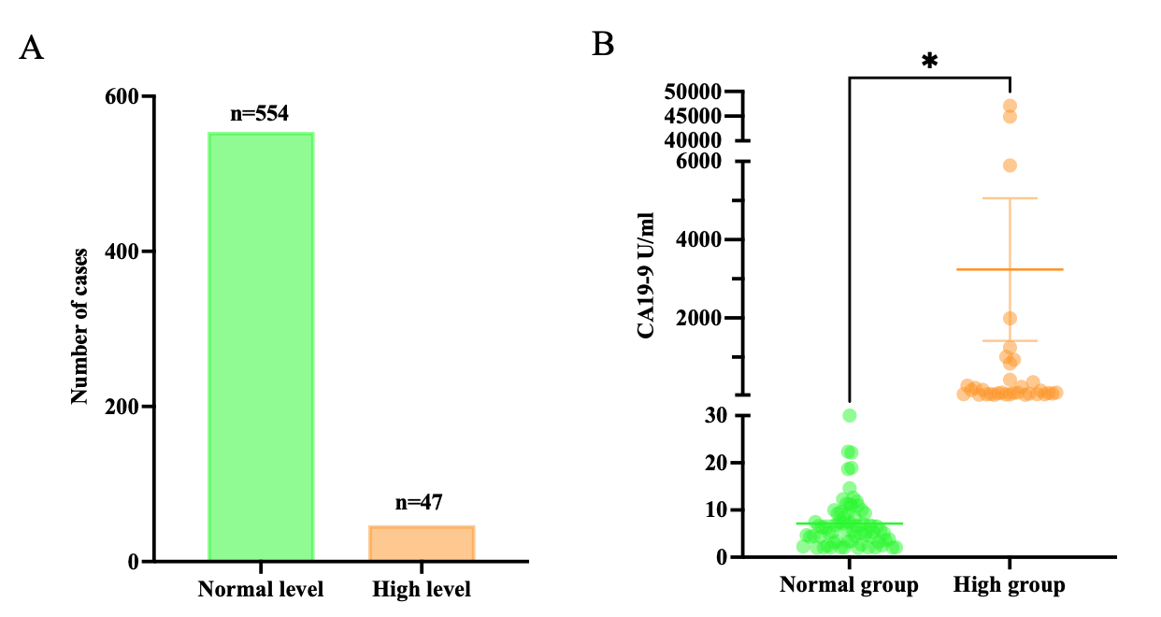
Figure S1. The serum CA19-9 level in center B. A. The number of cases with high and normal level of serum CA19-9 in center B; B. The serum CA19-9 level in normal group and high group . Data was analyzed by unpaired t test and presented as mean ± SEM. *p < 0.05; **p < 0.01; ***p < 0.001 ; ****p < 0.0001.
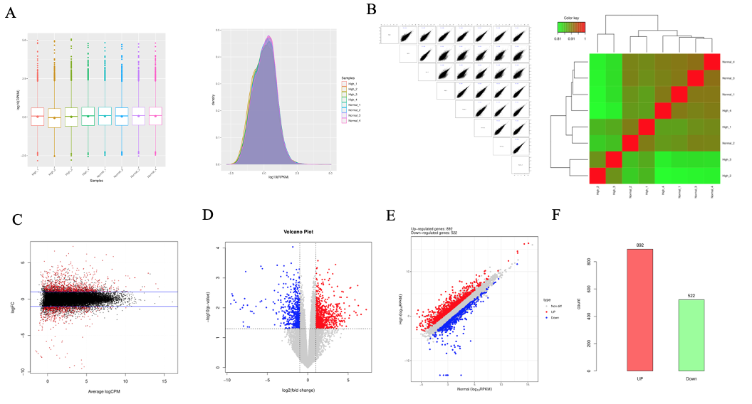
Figure S2.mRNA sequencing data A. mRNA RPKM value box diagram and density distribution curve; B. The scatter plot of gene expression correlation among samples and hierarchical cluster diagram of gene expression level of sample; C. mRNA differential expression gene MA Plot map; D. volcanic map of mRNA gene expression; E. Scatter plot of expression between comparison groups; F. The number of up-and down-regulated genes of mRNA differentially expressed.

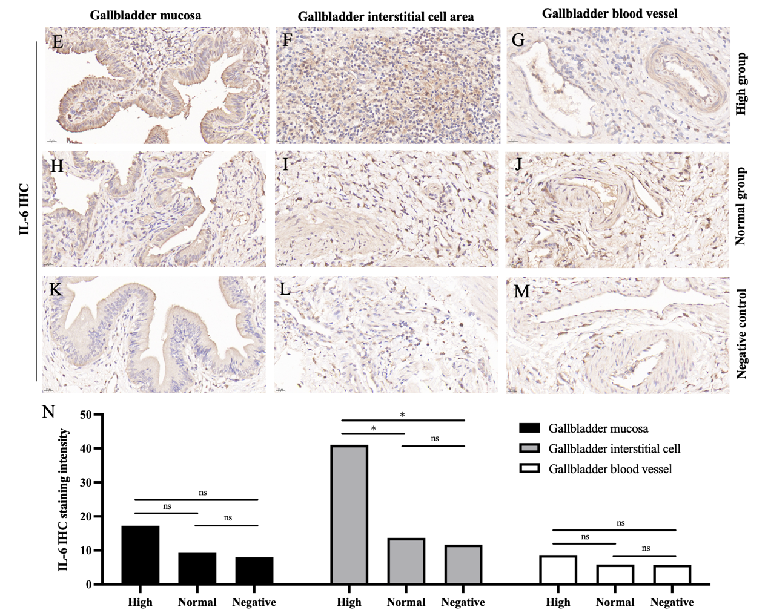
Figure S3. IHC of IL-6 in gallbladder tissue from center A. A IHC of IL-6 in high group. B IHC of IL-6 in normal group. C IHC of IL-6 in negative control in Center A. level of IL-6 IHC staining. *p < 0.05; **p < 0.01; ***p < 0.001 ; ****p < 0.0001.

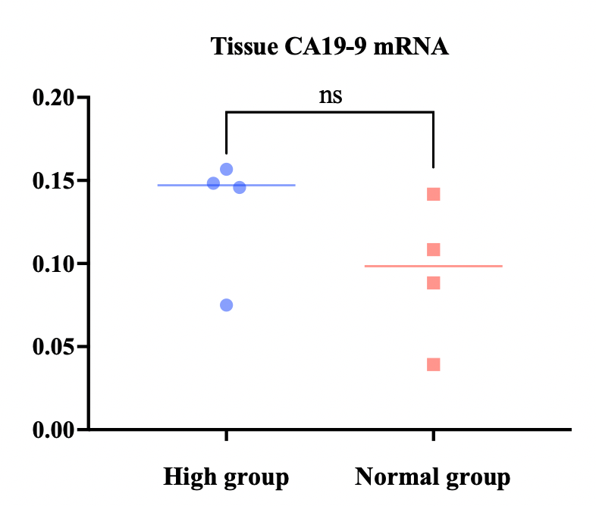
Figure S4. The expression of tissue CA19-9 mRNA in the sequencing samples. *p < 0.05; **p < 0.01; ***p < 0.001 ; ****p < 0.0001.

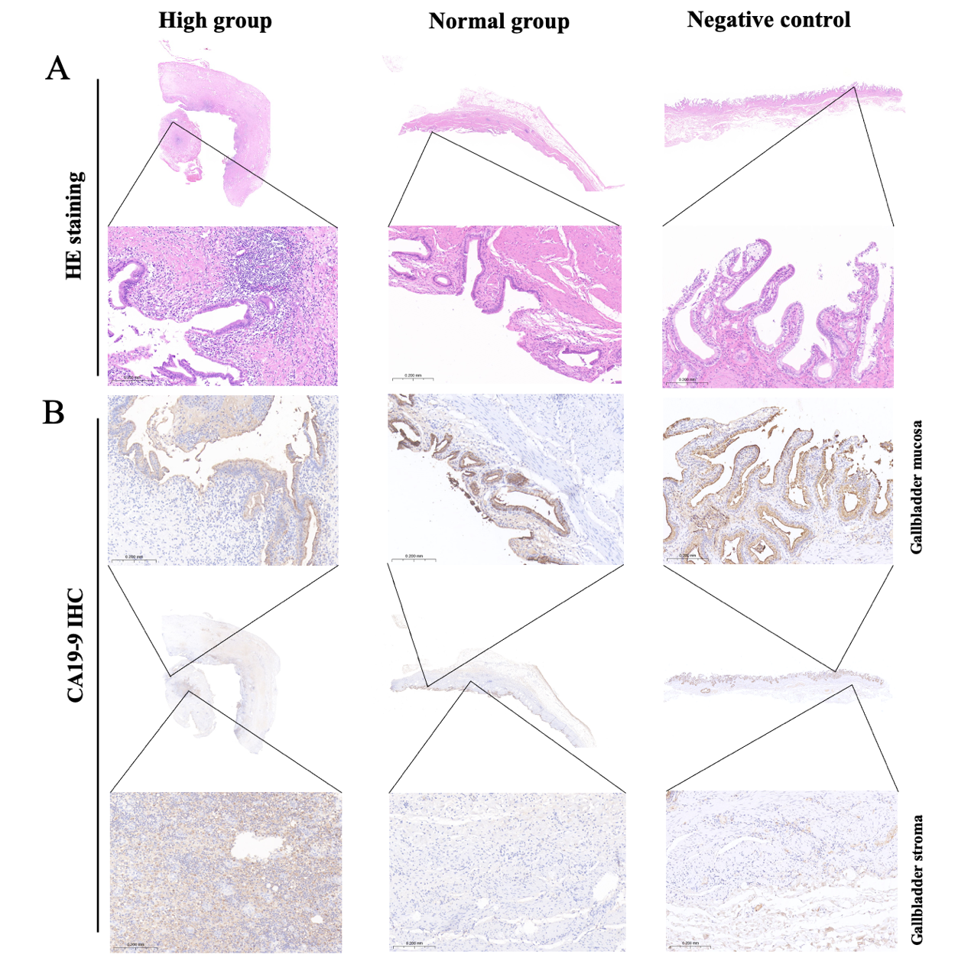
Figure S5. Typical cases in high group, normal group and negative control group. A. Hematoxylin staining (HE); B. CA19-9 immunohistochemistry in gallbladder mucosa and gallbladder stroma.

