The Role of Exercise-based Prehabilitation in Enhancing Surgical Outcomes for Patients with Digestive System Tumors: A Meta-Analysis

Supplement Figure 1. Results of sensitivity analysis of postoperative complications.
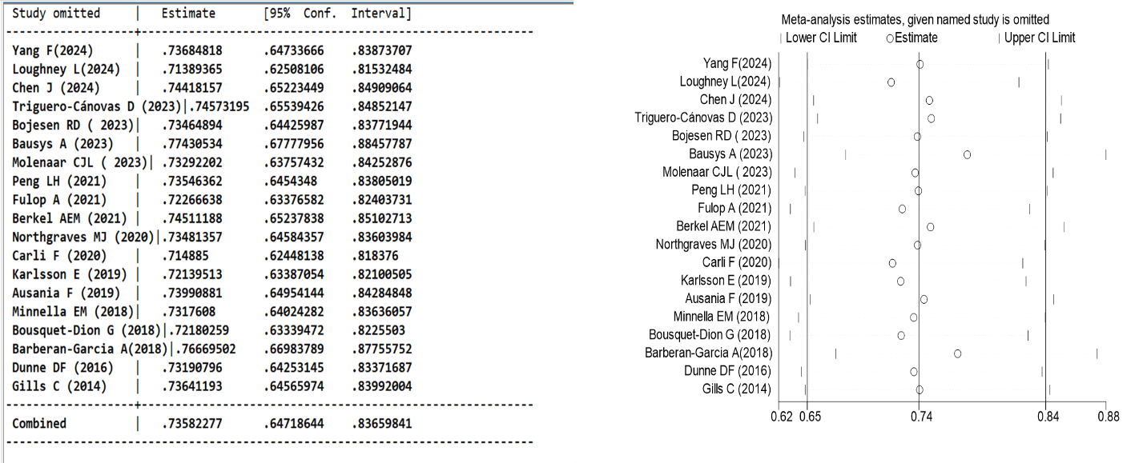
Supplement Figure 2. Results of sensitivity analysis of postoperative severe complications (Clavien-Dindo classification ≥3).
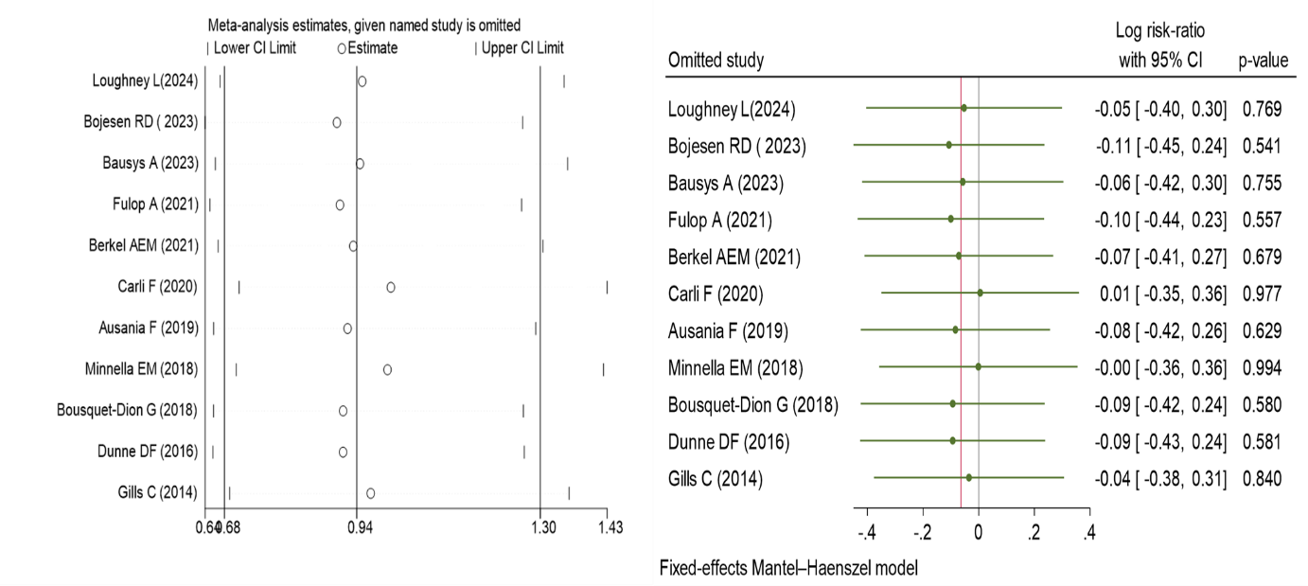

Supplement Figure 3. Results of sensitivity analysis of length of hospital stay.
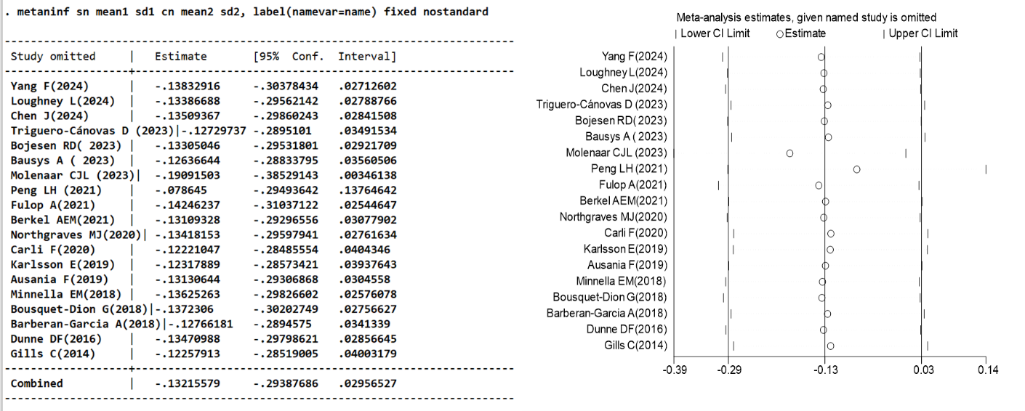

Supplement Figure 4. Funnel plot of 6MWD before surgery and sensitivity analysis of 6MWD before surgery
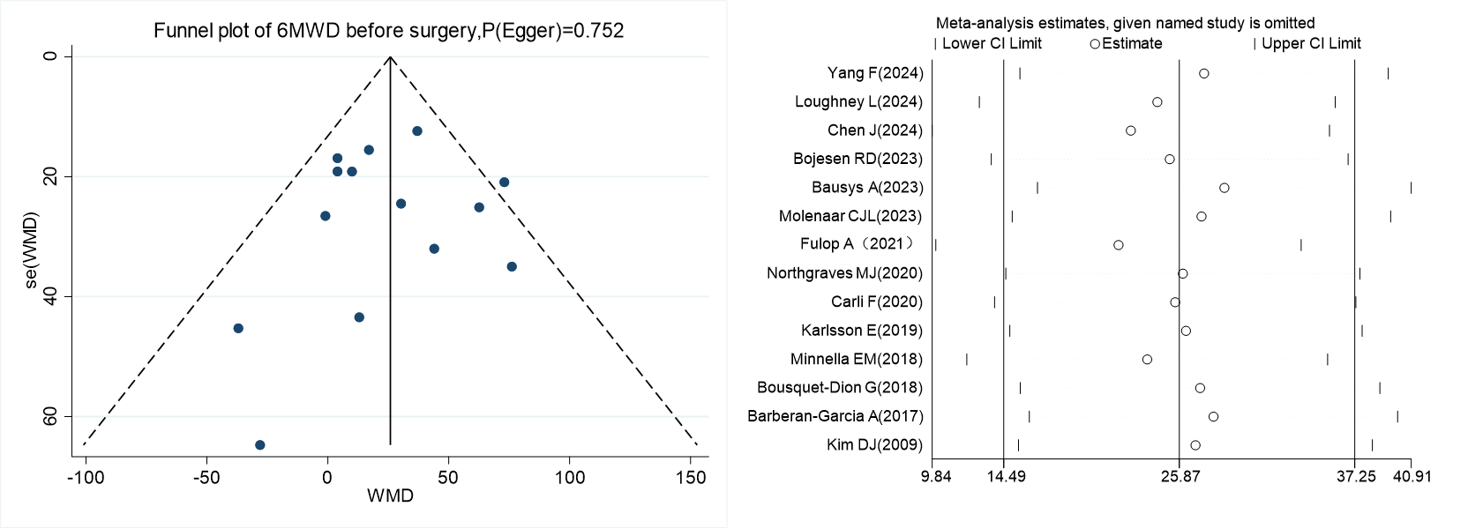
Supplement Figure 5. Egger test of 6MWD four weeks after surgery
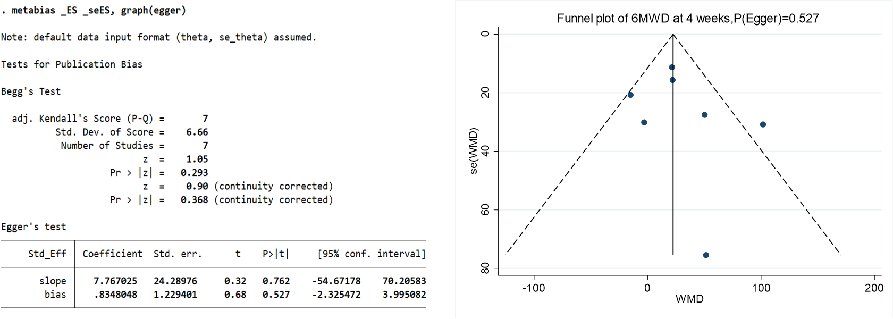

Supplement Figure 6. Egger test and Funnel-plot of changes at baseline vs. preoperative 6MWD, 4 weeks postoperatively, and 8 weeks postoperatively, the results of sensitivity analysis.
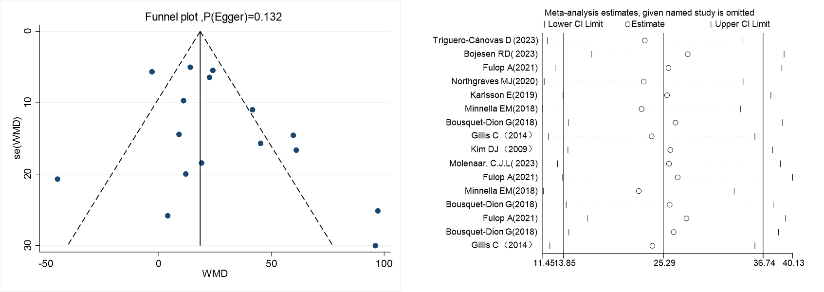

Supplement Table 1. Pubmed Search Strategy
Pubmed Search Strategy
19 | #9 AND #15 AND #18
18 | randomized controlled trial[Publication Type] OR randomized[Title/Abstract] OR placebo[Title/Abstract]
17 | #15 AND #16
16 | ("Preoperative Period"[Mesh] ) OR (Period, Preoperative)
15 | #10 OR #11 OR #12 OR #13 OR #14
14 | ("Psychosocial Intervention"[Mesh]) OR ((((((( (Intervention, Psychosocial[Title/Abstract])) OR (Interventions, Psychosocial[Title/Abstract])) OR (Psychosocial Interventions[Title/Abstract])) OR (Psychological Intervention[Title/Abstract])) OR (Intervention, Psychological[Title/Abstract])) OR (Interventions, Psychological[Title/Abstract])) OR (Psychological Interventions[Title/Abstract]))
13 | ("Resistance Training"[Mesh]) OR ((((((((((((Training, Resistance[Title/Abstract]) OR (Strength Training[Title/Abstract])) OR (Strengthening Program, Weight-Lifting[Title/Abstract])) OR (Weight Lifting Strengthening Program[Title/Abstract])) OR (Weight-Lifting Exercise Program[Title/Abstract])) OR (Weight Lifting Exercise Program[Title/Abstract])) OR (Weight-Bearing Strengthening Program[Title/Abstract])) OR (Strengthening Program, Weight-Bearing[Title/Abstract])) OR (Weight Bearing Strengthening Program[Title/Abstract])) OR (Weight-Bearing Exercise Program[Title/Abstract])) OR (Exercise Program, Weight-Bearing[Title/Abstract])) OR (Weight Bearing Exercise Program[Title/Abstract]))
12 | ("Exercise"[Mesh]) OR ((((((((((((((Physical Activity[Title/Abstract]) OR (Activity, Physical[Title/Abstract])) OR (Physical Activities[Title/Abstract])) OR (Exercise, Physical[Title/Abstract])) OR (Physical Exercise[Title/Abstract])) OR (Acute Exercise[Title/Abstract])) OR (Exercise, Acute[Title/Abstract])) OR (Exercise, Isometric[Title/Abstract])) OR (Isometric Exercise[Title/Abstract])) OR (Exercise, Aerobic[Title/Abstract])) OR (Aerobic Exercise[Title/Abstract])) OR (Exercises, Aerobic[Title/Abstract])) OR (Exercise Training[Title/Abstract])) OR (Training, Exercise[Title/Abstract]))
11 | ("Nutritional Support"[Mesh]) OR (((Support, Nutritional [Title/Abstract]) OR (Artificial Feeding [Title/Abstract])) OR (Feeding, Artificial [Title/Abstract]))
10 | ("Preoperative Exercise"[Mesh]) OR (((((((((((((((Exercise, Preoperative[Title/Abstract]) OR (Pre-operative Conditioning[Title/Abstract])) OR (Conditioning, Pre-operative[Title/Abstract])) OR (Pre operative Conditioning[Title/Abstract])) OR (Pre-operative Rehabilitation[Title/Abstract])) OR (Rehabilitation, Pre-operative[Title/Abstract])) OR (Preoperative Rehabilitation[Title/Abstract])) OR (Rehabilitation, Preoperative[Title/Abstract])) OR (Preoperative Conditioning[Title/Abstract])) OR (Conditioning, Preoperative[Title/Abstract])) OR (Preoperative Conditionings[Title/Abstract])) OR (Pre-operative Exercise[Title/Abstract])) OR (Exercise, Pre-operative[Title/Abstract])) OR (Pre operative Exercise[Title/Abstract])) OR (Prehabilitation[Title/Abstract]))
9 | # 1 OR #2 OR #3 OR #4 OR #5 OR #6 OR #7 OR #8
8 | ("Pancreatic Neoplasms"[Mesh]) OR (((((((((((Neoplasm, Pancreatic[Title/Abstract]) OR (Pancreatic Neoplasm[Title/Abstract])) OR (Neoplasm, Pancreas[Title/Abstract])) OR (Pancreas Neoplasm[Title/Abstract])) OR (Neoplasms, Pancreatic[Title/Abstract])) OR (Cancer of Pancreas[Title/Abstract])) OR (Pancreas Cancer[Title/Abstract])) OR (Cancer, Pancreas[Title/Abstract])) OR (Pancreatic Cancer[Title/Abstract])) OR (Cancer, Pancreatic[Title/Abstract])) OR (Cancer of the Pancreas[Title/Abstract]))
7 | ("Biliary Tract Neoplasms"[Mesh]) OR ((((((Biliary Tract Neoplasm [Title/Abstract]) OR (Neoplasm, Biliary Tract [Title/Abstract])) OR (Biliary Tract Cancer [Title/Abstract])) OR (Cancer, Biliary Tract [Title/Abstract])) OR (Cancer of Biliary Tract [Title/Abstract])) OR (Cancer of the Biliary Tract [Title/Abstract]))
6 | ("Gallbladder Neoplasms"[Mesh]) OR (((((((((Gallbladder Neoplasm[Title/Abstract]) OR (Neoplasm, Gallbladder[Title/Abstract])) OR (Cancer of Gallbladder[Title/Abstract])) OR (Gallbladder Cancer[Title/Abstract])) OR (Cancer, Gallbladder[Title/Abstract])) OR (Gall Bladder Cancer[Title/Abstract])) OR (Bladder Cancer, Gall[Title/Abstract])) OR (Cancer, Gall Bladder[Title/Abstract])) OR (Cancer of the Gallbladder[Title/Abstract]))
5 | ("Liver Neoplasms"[Mesh]) OR (((((((((((((((Neoplasms, Hepatic[Title/Abstract]) OR (Neoplasms, Liver[Title/Abstract])) OR (Liver Neoplasm[Title/Abstract])) OR (Neoplasm, Liver[Title/Abstract])) OR (Hepatic Neoplasm[Title/Abstract])) OR (Neoplasm, Hepatic[Title/Abstract])) OR (Cancer of Liver[Title/Abstract])) OR (Hepatocellular Cancer[Title/Abstract])) OR (Cancers, Hepatocellular[Title/Abstract])) OR (Hepatic Cancer[Title/Abstract])) OR (Cancer, Hepatic[Title/Abstract])) OR (Liver Cancer[Title/Abstract])) OR (Cancer, Liver[Title/Abstract])) OR (Cancer of the Liver[Title/Abstract])) OR (Cancer, Hepatocellular[Title/Abstract]))
4 | ("Colorectal Neoplasms"[Mesh]) OR ((((((((Colorectal Neoplasm[Title/Abstract]) OR (Neoplasm, Colorectal[Title/Abstract])) OR (Colorectal Tumor[Title/Abstract])) OR (Tumor, Colorectal[Title/Abstract])) OR (Colorectal Cancer[Title/Abstract])) OR (Cancer, Colorectal[Title/Abstract])) OR (Colorectal Carcinoma[Title/Abstract])) OR (Carcinoma, Colorectal[Title/Abstract]))
3 | ("Stomach Neoplasms"[Mesh]) OR ((((((((((((Neoplasm, Stomach[Title/Abstract]) OR (Stomach Neoplasm[Title/Abstract])) OR (Neoplasms, Stomach[Title/Abstract])) OR (Gastric Neoplasm[Title/Abstract])) OR (Neoplasm, Gastric[Title/Abstract])) OR (Cancer of Stomach[Title/Abstract])) OR (Gastric Cancer[Title/Abstract])) OR (Cancer, Gastric[Title/Abstract])) OR (Stomach Cancer[Title/Abstract])) OR (Cancer, Stomach[Title/Abstract])) OR (Cancer of the Stomach[Title/Abstract])) OR (Gastric Cancer, Familial Diffuse[Title/Abstract]))
2 | ("Esophageal Neoplasms"[Mesh]) OR (((((((((((((((((Esophageal Neoplasm[Title/Abstract]) OR (Neoplasm, Esophageal[Title/Abstract])) OR (Esophagus Neoplasm[Title/Abstract])) OR (Esophagus Neoplasms[Title/Abstract])) OR (Neoplasm, Esophagus[Title/Abstract])) OR (Neoplasms, Esophagus[Title/Abstract])) OR (Neoplasms, Esophageal[Title/Abstract])) OR (Cancer of Esophagus[Title/Abstract])) OR (Cancer of the Esophagus[Title/Abstract])) OR (Esophagus Cancer[Title/Abstract])) OR (Cancer, Esophagus[Title/Abstract])) OR (Cancers, Esophagus[Title/Abstract])) OR (Esophagus Cancers[Title/Abstract])) OR (Esophageal Cancer[Title/Abstract])) OR (Cancer, Esophageal[Title/Abstract])) OR (Cancers, Esophageal[Title/Abstract])) OR (Esophageal Cancers[Title/Abstract]))
1 | ("Digestive System Neoplasms"[Mesh]) OR (((((((((Digestive System Neoplasm[Title/Abstract]) OR (Neoplasm, Digestive System[Title/Abstract])) OR (Neoplasms, Digestive System[Title/Abstract])) OR (Cancer of Digestive System[Title/Abstract])) OR (Digestive System Cancers[Title/Abstract])) OR (Cancer of the Digestive System[Title/Abstract])) OR (Digestive System Cancer[Title/Abstract])) OR (Cancer, Digestive System[Title/Abstract])) OR (Cancers, Digestive System[Title/Abstract]))

Supplement Table 2. Detailed pre-rehabilitation interventions included in the study
Study | Intervention group
Study | Exercise interventions | Nutritional interventions | Psychological interventions
Yang F,et al 2024 | - Light-intensity: Focused on upper limb, breathing, and lower limb exercises.  - Twice daily: Performed starting from when surgery was scheduled until the day before the operation. | / | /
Loughney L, et al 2024 | Exercise Components:  - Aerobic Exercise: Walking, jogging, cycling, etc.  - Strength Training: Whole-body strength training using resistance bands, dumbbells, etc.  - Flexibility Training: Stretching exercises to improve joint range of motion.  - 3-5 times per week, 30-60 minutes per session. | / | /
Chen J, et al 2024 | a 3-week, individualized, supervised multimodal prehabilitation program.  1. Aerobic and Resistance Exercises:  - Aerobic Exercise: 30 minutes of moderate-intensity exercise (jogging, walking, cycling) at least 3 days per week, aiming for a Borg Scale score of 13-16.  - Resistance Exercise: 25 minutes of resistance training using an elastic band, focusing on major muscle groups, performed 2-3 times per week.  2. Respiratory Training:  - Use of a TRI-BALL® respiratory trainer for 10 minutes, 3 times daily, focusing on deep, slow breathing exercises (Sustained Maximal Inspiration). | - Assessment of nutritional status using the NRS2002 scale and goal setting for daily caloric and protein intake.  - Whey protein supplementation for participants not meeting protein requirements through diet alone. | - Anxiety-coping interventions, including relaxation techniques and deep breathing exercises, provided by a nurse trained in psychological care.  - Referral to a medical psychologist for participants at higher risk for psychological distress.  - Counseling on smoking and alcohol cessation.
Triguero-Cánovas D,et al 2023 | A home-based multimodal prehabilitation  Daily aerobic exercises and 3 weekly sessions of muscle endurance exercises.  - Aerobic Exercise: Engaging in daily activities such as walking, cycling, or swimming to improve cardiovascular fitness and endurance.  - Muscle Endurance Training: Performing three weekly sessions of targeted exercises focusing on strength and muscle endurance. These exercises are functional and can be easily performed at home without specialized equipment. | - Balanced Diet: Encouraging a diet rich in fruits, vegetables, whole grains, and lean proteins to ensure adequate nutrition and support recovery.  - Protein Supplementation: Administering hyperproteic nutritional supplements like Ensure Plus Advance to meet the increased protein needs associated with cancer and surgery.  - Vitamin and Mineral Intake: Ensuring adequate intake of essential vitamins and minerals, particularly vitamin D and calcium, to support bone health and immune function. | - Relaxation Techniques: Teaching relaxation exercises and breathing techniques to reduce anxiety and stress before and after surgery.  - Education and Support: Providing information about the surgery, expected outcomes, and self-care practices to empower patients and alleviate fears and uncertainties.
Bojesen RD,et al 2023 | 4 weeks of individualized physical training: 3 times a week  - High-intensity interval training (HIIT)：4 high-intensity intervals of 2-3 minutes on a stationary exercise bike at 90% of the patient’s maximum oxygen uptake measured at baseline with a cardiopulmonary exercise test. 3 minutes of low-intensity intervals (30% of the maximum oxygen uptake) between each high-intensity interval.  - Resistance training: Three sets of 8-12 repetitions for each of the large muscle groups using machines (Technogym®, Italy) following a predefined progression scheme. | - Consultation with a dietician for approximately 1 hour within the first week after inclusion.  - Protein supplements: TMP-90 Shake® (Friesland Campina, Netherlands) 30 g twice a day.  - Vitamins: Vitamin D with calcium (38 µg + 400 mg Unikalk Mega®, Orkla Health A/S, Denmark) and multivitamin (Apovit Multi®, Apovit, Denmark). | /
Bausys, A, et al 2023 | A personalized, multimodal, semi-supervised, home-based prehabilitation  - Endurance training: 10-30 min of daily exercise, such as walking, stair climbing, dancing, water exercises, or cycling, based on the patient’s preference. Target intensity was 40-65% of heart rate reserve.  - Respiratory muscle training: 5-10 min of daily exercises to strengthen respiratory muscles.  - Resistance training: 10-20 min of exercises three times per week to improve muscular strength.  - Stretching exercises: 5-10 min of exercises three times per week.  - Training duration: Total daily training time did not exceed 60 min. | - Nutritional consultation: Provided by a physician nutrition specialist with personalized recommendations to prevent or correct malnutrition.  - Energy and protein intake: 25-30 kcal per kg of body weight and 1.5 g per kg of ideal body weight.  - Oral nutritional supplements: Prescribed if necessary to increase calorie and protein intake.  - Preoperative supplementation: 250 ml of oral nutritional supplements (Nutridrink Protein®) once daily for 10 days before surgery. | - Anxiety and depression assessment: Using the Hospital Anxiety and Depression Scale (HADS).  - Relaxation techniques: Training provided by an oncopsychologist to help patients reduce and manage anxiety at home.
Molenaar CJL, et al 2023 | 3 times per week, 1 hour each session, including aerobic and strength training.  - Aerobic exercise: High-intensity interval training using baseline CPET-derived variables.  - Strength training: 2 sets of 10 repetitions targeting major muscle groups. | - Personalized program provided by a registered dietitian based on nutritional assessment and dietary habits.  - a daily protein intake of 1.5 g/kg.  - Whey protein supplement provided, with instructions to ingest 30 g within 1 hour after in-hospital training session and 1 hour before sleep daily.  - Vitamin D and multivitamin supplements also provided. | - Relaxation techniques and deep breathing exercises provided by psychology-trained personnel in a 1-to-1 session.  - Participants with high risk of mental distress referred to a medical psychologist.  - Smoking Cessation Program (if indicated):  Individual counseling and nicotine replacement therapy.
Peng LH, et al 2021 | Pre-operative Rehabilitation Exercise Program  - Upper and Lower Limbs: Hand squeeze and relaxation, biceps flexion and extension, shoulder abduction, ankle rotation and dorsiflexion, quadriceps contraction and relaxation.  - Thoracic Breathing: Chest wall expansion, deep inhalation and slow exhalation.  - Abdominal Breathing: Abdominal wall expansion, deep inhalation and slow exhalation.  - Abdominal Muscles: Abdominal curls, pelvic floor contraction, lumbar extension and relaxation.  - Frequency: Twice a day (morning and afternoon), with 10-15 repetitions per set. | / | /
Fulop A, et al 2021 | A multimodal home-based exercise:  - Aerobic(30min，moderate intensity, daily)  - Breathing exercises | - Oral nutritional supplementation | - A 60-min session under the supervision of a psychologist.  - Techniques for reducing anxiety and lifestyle advice.
Berkel AEM, et al 2021 | A personalized supervised exercise program in community  - Moderate-to-high intensity interval training on a cycle ergometer: aerobic （40min）and resistance training (20min) .  - Unsupervised exercises at home (moderate intensity) twice a week for at least 30 minutes. | / | /
Northgraves MJ, et al 2020 | Three 60-min supervised exercise sessions per week delivered by a certified strength and conditioning instructor.  - Resistance exercise  - Aerobic exercise | / | /
Carli F, et al 2020 | A personalized and home-based multimodal program  - Supervised program(once a week for 4 weeks）: moderate aerobic exercise (30 min) and resistance exercises using an elastic band (25 min)  - A personalized home-based program of aerobic activities (walk daily, 30 min, moderate-intensity) and resistance training (elastic band routine 3 times per week) | - Assessed by a registered dietitian.  - The protein supplements within 1 hour of their exercise training. | - Assessment and personalized coping strategies by a psychology-trained nurse.  - A compact disc with relaxing exercises (3 times a week).
Karlsson E, et al 2019 | - The 1-hour supervised sessions in the participants’ home: inspiratory muscle training (IMT); high-intensity functional strength exercises; endurance training;  - On unsupervised days: 150 minutes/week of moderate physical activity, do a core set of functional strength exercises 2–3 times/week, and perform IMT for 30 breaths twice a day. | / | /
Ausania F, et al 2019 | - 5 days training in outpatient clinic (60 min): a high-intensity endurance training performed on a cycle-ergometer stationary bicycle (muscle toning exercise 20 min, aerobic exercise 20 min).  - Daily training at home: Following the supervised program, patients were trained to perform unsupervised home-based functional exercises. | - Nutritional support (oral supplement);  - Total parenteral nutrition if required;  - Follow-up in outpatient clinic. | /
Minnella EM, et al 2018 | An individualized, home-based exercise training program 4 times per week.  - Aerobic exercise: 30 min, moderate continuous training 3 days per week.  - Strengthening activity: 1 day per week, 30 min, using an elastic band as resistance (TheraBand). | - Status evaluation and food-based dietary advices by a dietitian.  - whey protein supplement (1.2 to 1.5 g/kg) | /
Bousquet-Dion G, et al 2018 | A home-based program: moderate intensity aerobic and resistance exercise  - The home-based component: Aerobic exercise (3–4 days per week 30 min); The resistance training (3–4 times per week);  - The supervised exercise: moderate aerobic exercise (30 min) and resistance exercise (25 min), stretching (5 min). | - Assessed and nutritional counseling by a registered dietitian.  - Protein and/or the supplements within one hour of their exercise training (Protein 1.2 g/kg of body weight). | - A 60-minute session under the supervision of a psychology-trained member (relaxation exercises based on visualization, along with breathing exercises).  - A compact disc to help them perform the exercises at home two to three times a week.
Barberan-Garcia A, et al 2018 | A personalized prehabilitation program in the community setting.  - Supervised high-intensity endurance exercise training program；on the cycle-ergometer stationary bicycle (1 to 3 sessions per week).  - The non-supervised program promoting physical activity. | / | /
Dunne DF, et al 2016 | - Prehabilitation consisted of 12 interval exercise sessions over a 4-week period within an exercise laboratory.  - The interval sessions included a warm-up and warm-down, and 30 min of interval training alternating between exercise of moderate and vigorous intensity. | / | /
Gills C, et al 2014 | - Moderate aerobic and resistance exercises: 50 min of home-based, unsupervised exercise for at least 3 days per week, alternating between aerobic and resistance training. | - A registered dietitian assessed and provided individualized care.  - Consume the protein supplement within 1 h of their exercise regimen. | - Reducing anxiety techniques by a psychologist (A 60-min visit).  - A compact disc to perform these exercises at home two to three times per week.
Kim DJ, et al 2009 | - 4 weeks home based exercise program of aerobic exercise: a portable cycle ergometer for home-based training. A physical therapist visited the subjects to make sure they followed the program as prescribed. | / | /

Supplement Table 3. List of complications
Study | Postoperative total complications | Severe complications (Clavien-Dindo classification ≥3)
Yang F, et al 2024 | PR-ERAS (7/50 ,14%)  - Pneumonia (1)  - Surgical complications:anastomotic leak, hemorrhage, lymphorrhea,ileus,gastroparesis, incision infection, and abdominal infection.  S-ERAS (9/45 ,20%)  - Pneumonia (3)  - Surgical complications: anastomotic leak, hemorrhage, lymphorrhea,ileus,gastroparesis, incision infection, and abdominal infection. | /
Loughney L, et al 2024 | Exercise (18/29,62%)  Usual care (12/25,48%) | Exercise (7/29,24%)  Usual care (7/25,28%)
Chen J, et al 2024 | Intervention Group (14/57, 24.6%)  - Medical complication (7): Cardiovascular (2)，Neurological (2), Pulmonary (4), Urological (2), Thromboembolic (0), Others (1);  - Surgical complication (8): Delayed gastric emptying (2), Anastomotic leakage (1), Intra-abdominal abscess (2) , Bleeding (1), Ileus (0), Cholecystitis (1), Abdominal wound complication (1);  Control Group (23/58, 39.7%)  - Medical complication (17): Cardiovascular (4)，Neurological (1), Pulmonary (9), Urological (3), Thromboembolic (1), Others (4);  - Surgical complication (10): Delayed gastric emptying (3), Anastomotic leakage (1), Intra-abdominal abscess (2), Bleeding (1), Ileus (2), Cholecystitis (0), Abdominal wound complication (2); | Charlson Comorbidity Index>20  Intervention Group (6/57, 10.5%)  Control Group (15/58, 25.9%)
Triguero-Cánovas D, et al 2023 | Prehabilitation (3/23,13%)  - Anastomosis leak (2), Surgical site infections (0), Ileus (1);  Standard care (8/21,38.1%)  - Anastomosis leak (2), Surgical site infections (3), Ileus (3); | /
Bojesen RD,et al 2023 | Prehabilitation (8/16,50%)  Standard care (13/20,65%) | Prehabilitation (5/16,30%)  Standard care (4/20,20%)
Bausys A,et al 2023 | No. of patients with 90-day postoperative complications  Prehabilitation (14/59,23.7%)  - Pulmonary (2), Infections of uncertain source (2), Wound infection (1), Anaemia requiring haemotransfusions (4), Anastomotic insufficiency (1), Postoperative bleeding (3), Intra-abdominal abscess (1), Pancreatitis or pancreatic fistula (2), Cardiovascular (1), Neurological (1), Nausea/vomiting (0), Duodenal stump leakage (1), Anastomotic stenosis (0), Urinary tract infections (0), Other (0);  Control (35/59,59.7%)  - Pulmonary (8), Infections of uncertain source (8), Wound infection (6), Anaemia requiring haemotransfusions (3), Anastomotic insufficiency (4), Postoperative bleeding (1), Intra-abdominal abscess (2), Pancreatitis or pancreatic fistula (1), Cardiovascular (2), Neurological (2), Nausea/vomiting (3), Duodenal stump leakage (1), Anastomotic stenosis (1), Urinary tract infections (1), Other (8); | Severity of 90-day complications  Prehabilitation (10/59,16.9%)  Control (11/59,18.6%)
Molenaar, CJL, et al 2023 | Prehabilitation (39/123,31.7%)  - Medical complications(19)：Cardiovascular (5), Respiratory (3), Urogenital (8), Neurological (0), Other (6);  - Surgical complications(26)：Wound or stoma related (8), Blood loss (5), Ileus/ gastroparesis (13), colorectal anastomotic leakage (2), Abscess (1), Other (4);  Standard care (54/128,42.2%)  - Medical complications(35)：Cardiovascular (12), Respiratory (7), Urogenital (11), Neurological (3), Other (11);  - Surgical complications(35)：Wound or stoma related (11), Blood loss (5), Ileus/ gastroparesis (19), colorectal anastomotic leakage (5), Abscess (5), Other (5); | Charlson Comorbidity Index>20  Prehabilitation (21/123,17.1%)  Standard care (38/128,29.7%)
Peng LH, et al 2023 | PR-ERAS (14/109,12.8%)  S-ERAS (18/104,17.3%) | /
Fulop A, et al 2021 | Prehabilitation group (17/77,22.1%)  Control group (16/72,22.2%) | Prehabilitation group (4/77,5.2%)  Control group (2/72,2.8%)
Berkel AEM, et al 2021 | Prehabilitation (12/28,43%)  - Non-surgical (8): Cardiovascular (3)；Neurological (1)；Pulmonary(5)；Renal(4)；Thromboembolic(0)；Other(Delirium, collapse, decubitus) (1)；  - Surgical (10): Anastomotic leakage (1)；Intra-abdominal abscess (1)；Sepsis (3)；Ileus (4)；Abdominal wound complication (3)；Urological (2)；Bleeding (1)；Iatrogenic intestinal injury (0);  Usual Care (21/29,72%)  - Non-surgical (11): Cardiovascular (6)；Neurological (0)；Pulmonary(4)；Renal(1)；Thromboembolic(1)；Other(Delirium, collapse, decubitus) (4)；  - Surgical (16): Anastomotic leakage (1)；Intra-abdominal abscess (1)；Sepsis (0)；Ileus (6)；Abdominal wound complication (6)；Urological (3)；Bleeding (1)；Iatrogenic intestinal injury (1); | Prehabilitation (4/28,14%)  - Pulmonary (1), Renal (1), Sepsis (2), Bleeding (1);  Usual Care (4/29, 14%)  - Cardiovascular (1), Anastomotic leakage (1), Ileus (1), Iatrogenic intestinal injury (1);
Northgraves MJ, et al 2020 | Prehabilitation (3/10,30%)  Standard care (4/11,36%) | /
Carli F, et al 2020 | Prehabilitation (25/55,45.5%)  - Cardiovascular (4): Heart failure (3), Arrhythmias (1), Deep vein thrombosis (1)  - Respiratory (9): Pneumonia (5), Lobar atelectasis (3), Pleural fluid (1), Respiratory failure (3);  - Infectious(6)：Urinary tract infection (1), Wound infection (2), Intra- or retro-peritoneal infection (2), Sepsis (2); Other (0);  - Other medical (12): Acute kidney injury (6), Urinary retention (1), Anemia (1), Other Gastrointestinal (5), Psychiatric complications (3);  - Surgical complications (14): Anastomotic leak (2), Bowel perforation (0), Ileus (12), Wound dehiscence (2), Bleeding (2); Other (0);  Rehabilitation (25/55, 45.5%)  - Cardiovascular (3): Heart failure (0), Arrhythmias (2), Deep vein thrombosis (2)  - Respiratory (9): Pneumonia (5), Lobar atelectasis (1), Pleural fluid (0), Respiratory failure (3);  - Infectious(7)：Urinary tract infection (2), Wound infection (1), Intra- or retro-peritoneal infection (1), Sepsis (0); Other (3);  - Other medical (13): Acute kidney injury (4), Urinary retention (3), Anemia (0), Other Gastrointestinal (6), Psychiatric complications (1);  - Surgical complications (14): Anastomotic leak (3), Bowel perforation (1), Ileus (7), Wound dehiscence (1), Bleeding (5); Other (1); | Prehabilitation (7/55,12.7%)  Rehabilitation (11/55, 20%)
Karlsson E, et al 2019 | Prehabilitation (6/10,60%)  - Wound infections (2), Pneumonia (1), Urinary tract infections (2), Pulmonary (1);  Standard care (2/11, 18.2%)  - Disturbance of fluid balance (1), Wound infection (1); | /
Ausania F, et al 2019 | Prehabilitation (6/18, 33.3%)  - Pancreatic leak (B + C) (2), Delayed gastric emptying (1);  Standard care (12/22,54.5%)  - Pancreatic leak (B + C) (6), Delayed gastric emptying (9); | Prehabilitation (4/18, 22.2%)  Standard care (4/22, 18.2%)
Minnella EM, et al 2018 | Prehabilitation (14/24,58.3%)  Control (18/25,72%) | Prehabilitation (6/24,25%)  Control (10/25,40%)
Bousquet-Dion G, et al 2018 | Prehabilitation (14/37,37.8%)  Rehabilitation (8/26, 30.8%) | Prehabilitation (2/35,5.7%)  Rehabilitation (0/26, 0%)
Barberan-Garcia A, et al 2018 | Intervention (19/62, 19%)  - Medical: Cardiovascular (1), Respiratory (4), Neurological (2), Acute kidney injury (0), Nausea/vomiting (3), Deep venous thrombosis (0), Urinary tract infection (3), Bloodstream infection (lab confirmed) (1), Infection of uncertain source (0), Others (Liver insufficiency, diabetic decompensation, acute urinary retention) (6);  - Surgical: Postoperative hemorrhage (4), Anastomotic breakdown (3), Paralytic ileus (0), Surgical site infection (superficial and deep) (1), Surgical site infection (organ and space) (1), Mechanical ileus (1);  Control (39/63, 62%)  - Medical: Cardiovascular (8), Respiratory (10), Neurological (5), Acute kidney injury (4), Nausea/vomiting (6), Deep venous thrombosis (1), Urinary tract infection (4), Bloodstream infection (lab confirmed) (4), Infection of uncertain source (7), Others (Liver insufficiency, diabetic decompensation, acute urinary retention) (13);  - Surgical: Postoperative hemorrhage (6), Anastomotic breakdown (3), Paralytic ileus (10), Surgical site infection (superficial and deep) (1), Surgical site infection (organ and space) (1), Mechanical ileus (0); | /
Dunne DF, et al 2016 | Prehabilitation (8/19,42.1%)  Standard care (7/15, 46.7%) | Prehabilitation (3/19,15.8%)  Standard care (1/15,6.7%)
Gills C, et al 2014 | Prehabilitation (12/38,32%)  - Ileus (3), Wound infection (3), Anastomotic leak (2), Abscess (1), Pulmonary edema (1), Urinary tract infection (1), gastrointestinal bleeding (1), Intestinal ischemia (0);  Rehabilitation (17/39,44%)  - Ileus (6), Wound infection (3), Anastomotic leak (3), Abscess (3), Pulmonary edema (1), Urinary tract infection (0), gastrointestinal bleeding (0), Intestinal ischemia (1); | Prehabilitation (4/38,11%)  Rehabilitation (6/39,15%)
(n / n , n%) : （Number of complications / Total number of patients in the group, incidence of complications）

