Supplementary Materials

Impact of Steatotic Liver Disease Subtypes, Sarcopenia, and Fibrosis on All-cause and Cause-specific Mortality: A 15.7-year Cohort Study

Yebei Liang, Xiaoqi Ye, Min Pan, Yijun Chen, Yeqing Yuan, Li Luo

Supplemental Figure 1. Flowchart of study population. 2
Supplemental Figure 2. Kaplan-Meier survival curves illustrating the associations of MAFLD (A), SLD subtypes (B), and sarcopenia (C) with all-cause mortality. 3
Supplemental Figure 3. Kaplan-Meier survival curves illustrating the associations of MAFLD (A), SLD subtypes (B), and sarcopenia (C) with cardiac-specific mortality. 4
Supplemental Figure 4. Kaplan-Meier survival curves illustrating the associations of MAFLD (A), SLD subtypes (B), and sarcopenia (C) with cancer-specific mortality. 5
Supplemental Figure 5. Kaplan-Meier survival curves, by MAFLD (A)/MASLD (B) and sarcopenia status, for all-cause mortality. 6
Supplemental Figure 6. Prevalence of sarcopenia defining using ASM/height² (A) or ASM/BMI (B) among subjects without and with MAFLD/MASLD. 7
Supplemental Table 1. Characteristics of subjects with MetALD or other aetiology SLD*. 8
Supplemental Table 2. Hazard ratios (95% CIs), by sarcopenia and advanced fibrosis*, for all-cause mortality among subjects with MAFLD/MASLD. 10
Supplemental Table 3. Hazard ratios (95% CIs) of MAFLD subcategory for all-cause, cardiac-specific, and cancer-specific mortality. 11
Supplemental Table 4. Hazard ratios (95% CIs) of sarcopenia for all-cause, cardiac-specific, and cancer-specific mortality strastified by age. 12

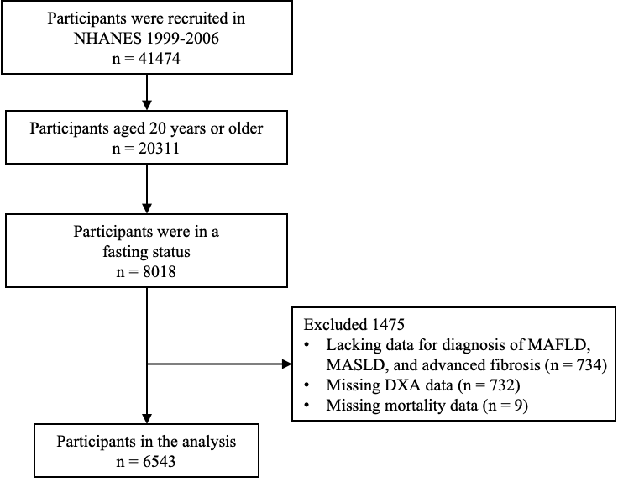

Supplemental Figure 1. Flowchart of study population.

DXA, dual-energy X-ray absorptiometry; MAFLD, metabolic dysfunction-associated fatty liver disease; MASLD, metabolic dysfunction-associated steatotic liver disease; NHANES, National Health and Nutrition Examination Survey.

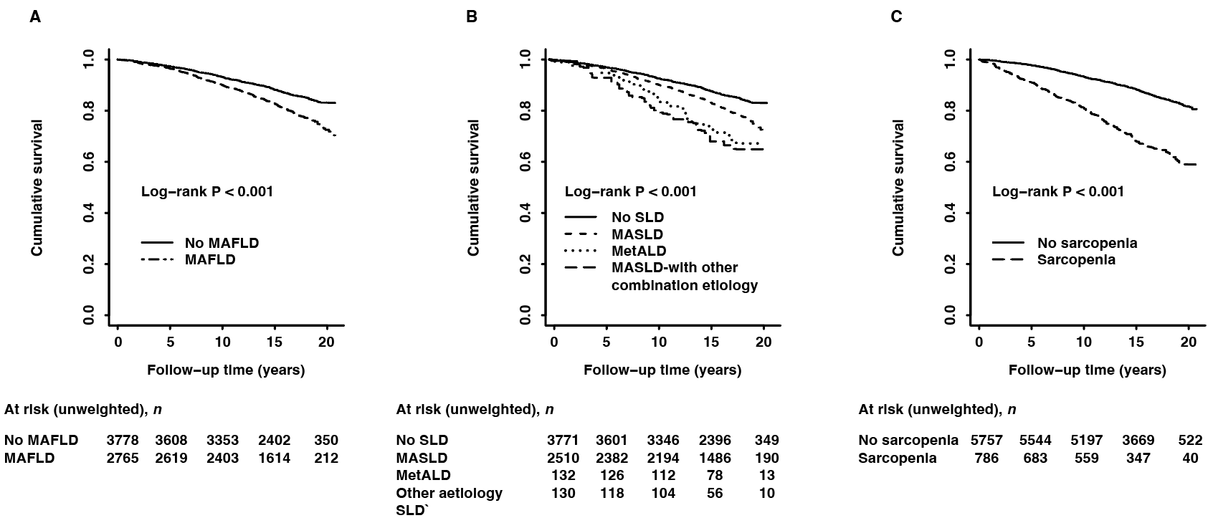

Supplemental Figure 2. Kaplan-Meier survival curves illustrating the associations of MAFLD (A), SLD subtypes (B), and sarcopenia (C) with all-cause mortality.

MAFLD, metabolic dysfunction-associated fatty liver disease; MASLD, metabolic dysfunction-associated steatotic liver disease; MetALD, metabolic dysfunction and alcohol-associated liver disease; SLD steatotic liver disease.

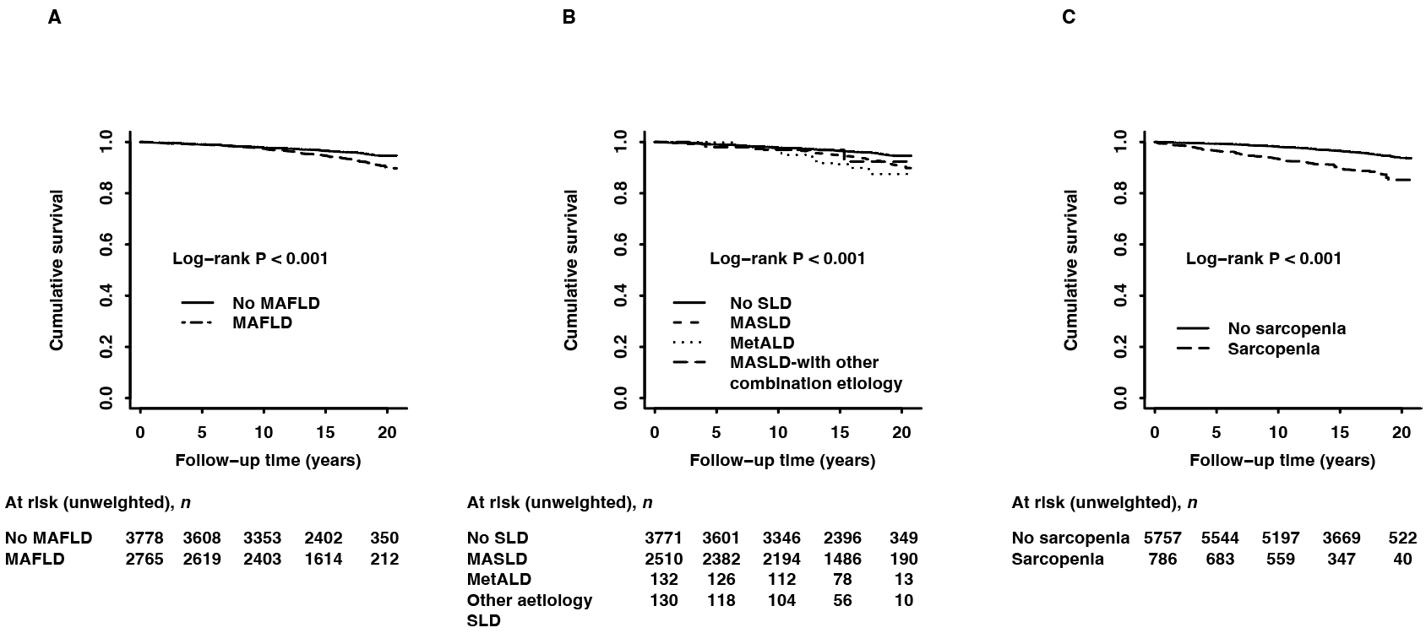

Supplemental Figure 3. Kaplan-Meier survival curves illustrating the associations of MAFLD (A), SLD subtypes (B), and sarcopenia (C) with cardiac-specific mortality.

MAFLD, metabolic dysfunction-associated fatty liver disease; MASLD, metabolic dysfunction-associated steatotic liver disease; MetALD, metabolic dysfunction and alcohol-associated liver disease; SLD steatotic liver disease.
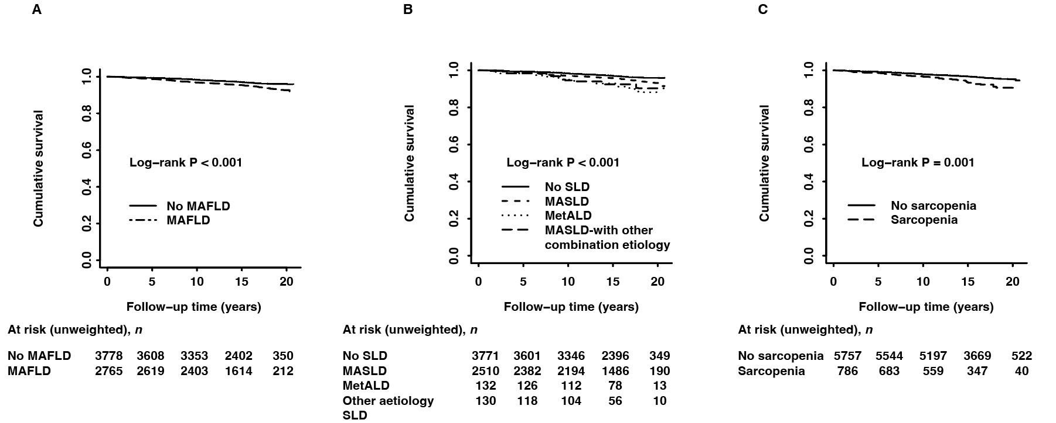

Supplemental Figure 4. Kaplan-Meier survival curves illustrating the associations of MAFLD (A), SLD subtypes (B), and sarcopenia (C) with cancer-specific mortality.

MAFLD, metabolic dysfunction-associated fatty liver disease; MASLD, metabolic dysfunction-associated steatotic liver disease; MetALD, metabolic dysfunction and alcohol-associated liver disease; SLD steatotic liver disease.

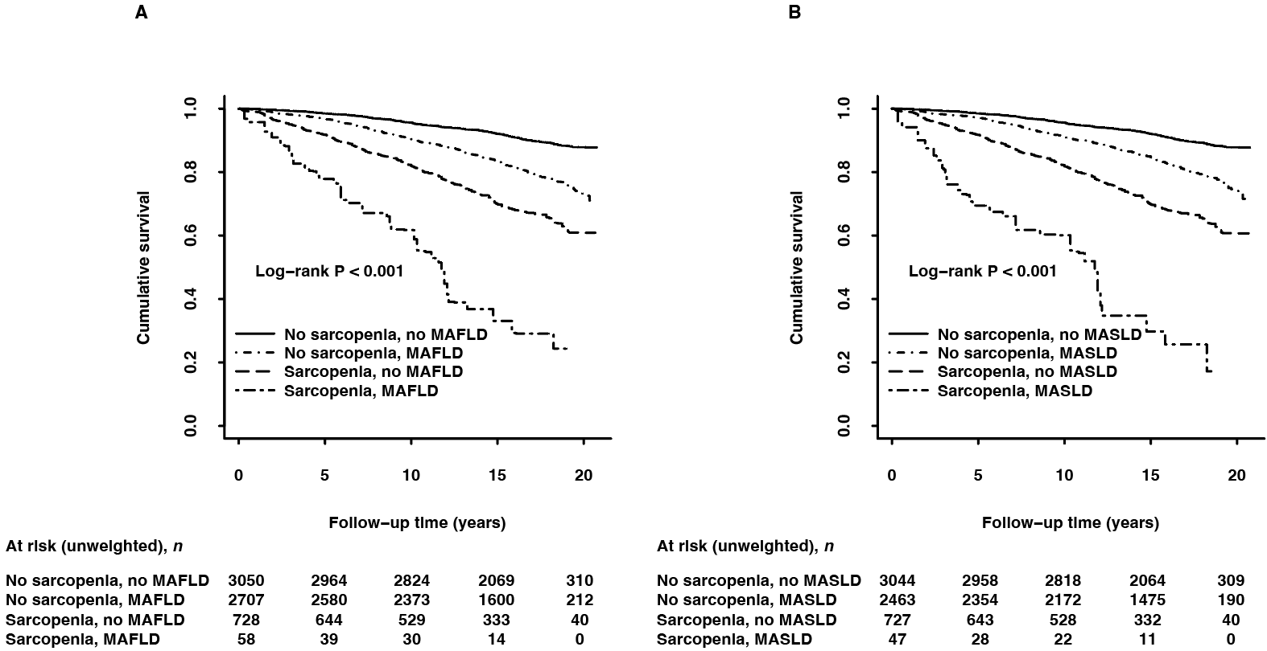

Supplemental Figure 5. Kaplan-Meier survival curves, by MAFLD (A)/MASLD (B) and sarcopenia status, for all-cause mortality.

MAFLD, metabolic dysfunction-associated fatty liver disease; MASLD, metabolic dysfunction-associated steatotic liver disease.

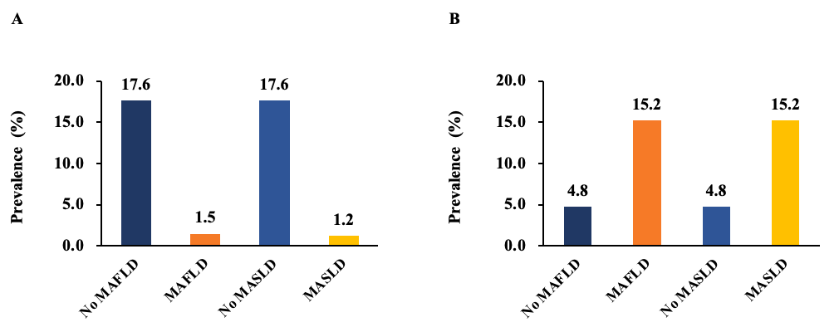

Supplemental Figure 6. Prevalence of sarcopenia defining using ASM/height² (A) or ASM/BMI (B) among subjects without and with MAFLD/MASLD.

ASM, appendicular skeletal muscle mass; BMI, body mass index; MAFLD, metabolic dysfunction-associated fatty liver disease; MASLD, metabolic dysfunction-associated steatotic liver disease.

Supplemental Table 1. Characteristics of subjects with MetALD or other aetiology SLD*.
Characteristic | No SLD  n = 3771, 57.6% | MetALD  n = 132, 2.0% | Other aetiology SLD  n = 130, 2.0% | † P value | ‡ P value
Follow-up time, years | 16.0 (0.1) | 15.2 (0.3) | 13.9 (0.5) | 0.230 | 0.001
Age, years | 43.5 (0.4) | 50.1 (1.1) | 44.0 (1.5) | < 0.001 | 1.000
Women, no. (%) | 2020 (56.5) | 37 (29.8) | 33 (28.9) | < 0.001 | < 0.001
Race/ethnicity, no. (%) |  |  |  | 0.021 | 0.420
Non-Hispanic white | 746 (6.5) | 30 (7.5) | 28 (7.5)
Non-Hispanic black | 1986 (72.5) | 81 (81.9) | 58 (69.8)
Hispanic | 715 (10.2) | 15 (5.8) | 33 (13.9)
Others | 324 (10.7) | 6 (4.9) | 11 (8.8)
Education levels, no. (%) |  |  |  | 0.226 | < 0.001
Less than high school | 475 (5.9) | 16 (5.7) | 17 (8.3)
High school or equivalent | 1409 (36.0) | 59 (44.3) | 68 (55.5)
College or above | 1880 (58.0) | 57 (50.0) | 45 (36.3)
Marital status, no. (%) |  |  |  | 0.070 | < 0.001
Married | 2013 (57.8) | 76 (66.4) | 48 (37.2)
Never married | 671 (18.3) | 12 (8.9) | 23 (19.9)
Others | 983 (23.9) | 34 (24.7) | 56 (42.9)
Income levels, no. (%) |  |  |  | 0.216 | < 0.001
Low | 845 (17.5) | 25 (11.7) | 47 (34.2)
Medium | 1377 (37.2) | 39 (34.6) | 49 (42.0)
High | 1250 (45.3) | 54 (53.8) | 26 (23.8)
SBP, mmHg | 118.9 (0.4) | 125.7 (1.5) | 127.7 (2.5) | < 0.001 | 0.006
DBP, mmHg | 69.9 (0.3) | 73.8 (1.1) | 75.0 (1.3) | 0.002 | 0.002
FPG, mmol/L | 5.3 (0.0) | 6.2 (0.2) | 6.1 (0.2) | 0.002 | 0.001
HbA1c, % | 5.3 (0.0) | 5.6 (0.1) | 5.6 (0.1) | 0.189 | 0.028
FINS, pmol/L | 45.8 (0.6) | 77.8 (4.5) | 96.4 (8.7) | < 0.001 | < 0.001
HOMA-IR | 1.8 (0.0) | 3.6 (0.3) | 4.8 (0.5) | < 0.001 | < 0.001
CRP, mg/L | 0.3 (0.0) | 0.5 (0.0) | 0.5 (0.1) | 0.001 | 0.783
TG, mmol/L | 1.2 (0.0) | 3.2 (0.4) | 2.8 (0.4) | < 0.001 | 0.004
TC, mmol/L | 5.0 (0.0) | 5.8 (0.1) | 5.4 (0.2) | < 0.001 | 0.112
HDL-C, mmol/L | 1.5 (0.0) | 1.3 (0.0) | 1.3 (0.0) | < 0.001 | < 0.001
LDL-C, mmol/L | 3.0 (0.0) | 3.3 (0.1) | 3.1 (0.1) | 0.067 | 1.000
ALT, U/L | 23.5 (0.2) | 35.6 (5.7) | 43.3 (3.8) | 0.219 | < 0.001
AST, U/L | 22.2 (0.2) | 39.9 (4.6) | 50.9 (4.7) | 0.002 | < 0.001
GGT, U/L | 20.5 (0.3) | 64.7 (12.6) | 114.9 (21.9) | < 0.001 | < 0.001
BMI, kg/m² | 24.6 (0.1) | 30.8 (0.4) | 30.7 (0.5) | < 0.001 | < 0.001
Waist circumference, cm | 87.0 (0.2) | 106.9 (1.0) | 106.1 (1.1) | < 0.001 | < 0.001
Smoking status, no. (%) |  |  |  | < 0.001 | < 0.001
Never smoker | 2016 (52.1) | 27 (17.4) | 28 (17.1)
Past smoker | 862 (22.2) | 45 (37.9) | 30 (20.4)
Current smoker | 881 (25.7) | 60 (44.8) | 71 (86.9)
Drinking status, no. (%) |  |  |  | - | < 0.001
Never drinker | 1079 (25.5) | 0 (0.0) | 11 (5.0)
Past drinker | 327 (7.4) | 0 (0.0) | 14 (8.1)
Current drinker | 2214 (67.1) | 132 (100.0) | 101 (86.9)
Leisure-time exercise, no. (%) |  |  |  | 0.493 | 0.001
Inactive | 2229 (53.7) | 77 (53.5) | 93 (72.6)
Intermediate | 486 (13.7) | 22 (17.3) | 16 (13.0)
Ideal | 1056 (32.6) | 33 (29.2) | 21 (14.4)
Sarcopenia, no. (%) | 727 (17.6) | 5 (3.5) | 7 (5.7) | < 0.001 | 0.007
Cumulative mortality, no. (%)
All-cause | 814 (14.0) | 44 (30.2) | 45 (30.9) | < 0.001 | < 0.001
Cardiac-specific | 251 (4.0) | 15 (9.5) | 8 (5.0) | 0.007 | 0.632
Cancer-specific | 183 (3.3) | 13 (9.0) | 13 (6.9) | < 0.001 | 0.057
*Other aetiology SLD included cases with positive hepatitis B surface antigen, hepatitis C virus RNA, and hepatitis C virus antibody, or alcoholic liver disease.
†P value: no SLD vs. MetALD; ‡P value: no SLD vs. other aetiology SLD.
ALT, alanine aminotransferase; AST, aspartate aminotransferase; BMI, body mass index; CRP, C-reactive protein; DBP, diastolic blood pressure; FINS, fasting insulin; FPG, fasting plasma glucose; GGT, gamma-glutamyl transpeptidase; HbA1c, glycated hemoglobin; HDL-C, high-density lipoprotein cholesterol; HOMA-IR, homeostasis model assessment of insulin resistance; LDL-C, low-density lipoprotein cholesterol; MASLD, metabolic dysfunction-associated steatotic liver disease; MetALD, metabolic dysfunction and alcohol-associated liver disease; SBP, systolic blood pressure; SLD steatotic liver disease; TC, total cholesterol; TG, triglyceride.

Supplemental Table 2. Hazard ratios (95% CIs), by sarcopenia and advanced fibrosis*, for all-cause mortality among subjects with MAFLD/MASLD.
Variable | Events/N | Incidence rate  (95% CI) | Model 1†  (HR, 95% CI) | P value | Model 2‡  (HR, 95% CI) | P value | Model 3§  (HR, 95% CI) | P value
MAFLD population (n = 2765)
No sarcopenia, no advanced fibrosis | 334/2031 | 13.9 (12.2-15.7) | Reference |  | Reference |  | Reference
No sarcopenia, advanced fibrosis | 373/676 | 48.8 (44.1-53.5) | 1.47 (1.18-1.84) | 0.001 | 1.64 (1.33-2.02) | < 0.001 | 1.59 (1.28-1.97) | < 0.001
Sarcopenia, no advanced fibrosis | 13/21 | 45.3 (18.9-71.6) | 1.40 (0.67-2.94) | 0.361 | 1.35 (0.65-2.83) | 0.415 | 1.43 (0.64-3.22) | 0.380
Sarcopenia, advanced fibrosis | 33/37 | 85.4 (64.1-100.0) | 3.49 (2.22-5.48) | < 0.001 | 3.32 (2.08-5.29) | < 0.001 | 3.48 (2.12-5.71) | < 0.001
MASLD population (n = 2510)
No sarcopenia, no advanced fibrosis | 290/1858 | 12.8 (10.9-14.7) | Reference |  | Reference |  | Reference
No sarcopenia, advanced fibrosis | 336/605 | 48.8 (43.4-54.1) | 1.39 (1.10-1.77) | 0.007 | 1.55 (1.23-1.94) | < 0.001 | 1.50 (1.20-1.88) | 0.001
Sarcopenia, no advanced fibrosis | 11/17 | 49.4 (15.7-83.1) | 1.62 (0.67-3.94) | 0.282 | 1.34 (0.59-3.08) | 0.478 | 1.45 (0.59-3.56) | 0.411
Sarcopenia, advanced fibrosis | 27/30 | 94.4 (86.1-100.0) | 2.91 (1.72-4.95) | < 0.001 | 3.22 (1.87-5.55) | < 0.001 | 3.41 (1.92-6.05) | < 0.001
HR (95% CI) was calculated using the weighted Cox proportional hazards models.
*Advanced fibrosis was defined as FIB-4 ≥ 1.30.
†Model 1 was adjusted for age, sex, and race/ethnicity.
‡Model 2 was adjusted for variables in Model 1 and also for education levels, marital status, income levels, smoking status, drinking status, and leisure-time exercise.
§Model 3 was adjusted for variables in Model 2 and also for body mass index, hypertension, diabetes, triglyceride, and high-density lipoprotein cholesterol.
CI, confidence interval; FIB-4, fibrosis-4; HR, hazard ratio; MAFLD, metabolic dysfunction-associated fatty liver disease; MASLD, metabolic dysfunction-associated steatotic liver disease.

Supplemental Table 3. Hazard ratios (95% CIs) of MAFLD subcategory for all-cause, cardiac-specific, and cancer-specific mortality.
Variable | Events/N | Incidence rate  (95% CI) | Model 1†  (HR, 95% CI) | P value | Model 2‡  (HR, 95% CI) | P value | Model 3§  (HR, 95% CI) | P value
All-cause mortality
No MAFLD | 814/3778 | 13.9 (12.6-15.3) | Reference |  | Reference |  | Reference
MAFLD without concomitant  other aetiology* | 664/2507 | 19.9 (17.8-22.0) | 1.18 (1.04-1.33) | 0.012 | 1.17 (1.03-1.34) | 0.017 | 1.15 (0.90-1.47) | 0.250
MAFLD concomitant with other  aetiology* | 89/258 | 31.5 (26.0-37.1) | 2.25 (1.71-2.95) | < 0.001 | 2.31 (1.75-3.04) | < 0.001 | 2.22 (1.64-3.00) | < 0.001
Cardiac-specific mortality
No MAFLD | 251/3778 | 3.9 (3.3-4.6) | Reference |  | Reference |  | Reference
MAFLD without concomitant  other aetiology* | 220/2507 | 6.2 (5.1-7.3) | 1.30 (1.06-1.58) | 0.011 | 1.28 (1.04-1.58) | 0.020 | 0.96 (0.64-1.45) | 0.862
MAFLD concomitant with other  aetiology* | 23/258 | 7.6 (3.5-11.7) | 1.98 (1.10-3.58) | 0.024 | 2.18 (1.18-4.04) | 0.014 | 1.67 (0.86-3.24) | 0.127
Cancer-specific mortality
No MAFLD | 183/3778 | 3.2 (2.7-3.8) | Reference |  | Reference |  | Reference
MAFLD without concomitant  other aetiology* | 163/2507 | 5.0 (4.0-5.9) | 1.22 (0.93-1.61) | 0.153 | 1.23 (0.91-1.67) | 0.175 | 1.30 (0.85-2.00) | 0.222
MAFLD concomitant with other  aetiology* | 26/258 | 8.3 (4.8-11.8) | 2.31 (1.36-3.92) | 0.003 | 2.47 (1.43-4.26) | 0.002 | 2.59 (1.52-4.40) | 0.001
HR (95% CI) was calculated using the weighted Cox proportional hazards models.
*Other aetiology included cases with excessive drinking (alcohol intake > 210 g/weekly for men and > 140 g/weekly for women), positive hepatitis B surface antigen, hepatitis C virus RNA, and hepatitis C virus antibody.
†Model 1 was adjusted for age, sex, and race/ethnicity.
‡Model 2 was adjusted for variables in Model 1 and also for education levels, marital status, income levels, smoking status, drinking status, and leisure-time exercise.
§Model 3 was adjusted for variables in Model 2 and also for body mass index, hypertension, diabetes, triglyceride, and high-density lipoprotein cholesterol.
CI, confidence interval; HR, hazard ratio; MAFLD, metabolic dysfunction-associated fatty liver disease.

Supplemental Table 4. Hazard ratios (95% CIs) of sarcopenia for all-cause, cardiac-specific, and cancer-specific mortality strastified by age.
Variable | Events/N | Incidence rate  (95% CI) | Model 1*  (HR, 95% CI) | P value | Model 2†  (HR, 95% CI) | P value | Model 3‡  (HR, 95% CI) | P value
All-cause mortality
Age < 50 years
No sarcopenia | 167/3222 | 5.1 (4.2-5.9) | Reference |  | Reference |  | Reference
Sarcopenia | 16/250 | 6.2 (3.0-9.3) | 1.40 (0.79-2.50) | 0.245 | 0.94 (0.52-1.71) | 0.835 | 1.41 (0.74-2.68) | 0.289
Age ≥ 50 years
No sarcopenia | 1024/2535 | 31.8 (29.3-34.3) | Reference |  | Reference |  | Reference
Sarcopenia | 360/536 | 58.0 (52.6-63.5) | 1.74 (1.50-2.02) | < 0.001 | 1.57 (1.33-1.84) | < 0.001 | 1.74 (1.49-2.03) | < 0.001
Cardiac-specific mortality
Age < 50 years
No sarcopenia | 40/3222 | 1.1 (0.7-1.6) | Reference |  | Reference |  | Reference
Sarcopenia | 4/250 | 1.0 (0.0-2.2) | 1.10 (0.29-4.24) | 0.887 | 0.38 (0.09-1.64) | 0.190 | 0.70 (0.17-2.83) | 0.615
Age ≥ 50 years
No sarcopenia | 339/2535 | 9.9 (8.6-11.2) | 9.9 (8.6-11.2) |  | Reference |  | Reference
Sarcopenia | 111/536 | 17.6 (14.1-21.0) | 1.66 (1.28-2.16) | < 0.001 | 1.42 (1.07-1.90) | 0.017 | 1.73 (1.26-2.37) | 0.001
Cancer-specific mortality
Age < 50 years
No sarcopenia | 43/3222 | 1.1 (0.7-1.6) | Reference |  | Reference |  | Reference
Sarcopenia | 4/250 | 1.9 (0.0-4.0) | 2.01 (0.59-6.87) | 0.263 | 1.28 (0.40-4.08) | 0.666 | 1.45 (0.38-5.50) | 0.579
Age ≥ 50 years
No sarcopenia | 256/2535 | 8.6 (7.4-9.9) | Reference |  | Reference |  | Reference
Sarcopenia | 69/536 | 9.8 (7.1-12.4) | 1.16 (0.83-1.61) | 0.372 | 1.10 (0.76-1.58) | 0.605 | 1.18 (0.80-1.73) | 0.406
HR (95% CI) was calculated using the weighted Cox proportional hazards models.
*Model 1 was adjusted for age, sex, and race/ethnicity.
†Model 2 was adjusted for variables in Model 1 and also for education levels, marital status, income levels, smoking status, drinking status, and leisure-time exercise.
‡Model 3 was adjusted for variables in Model 2 and also for body mass index, hypertension, diabetes, triglyceride, and high-density lipoprotein cholesterol.
CI, confidence interval; HR, hazard ratio.

