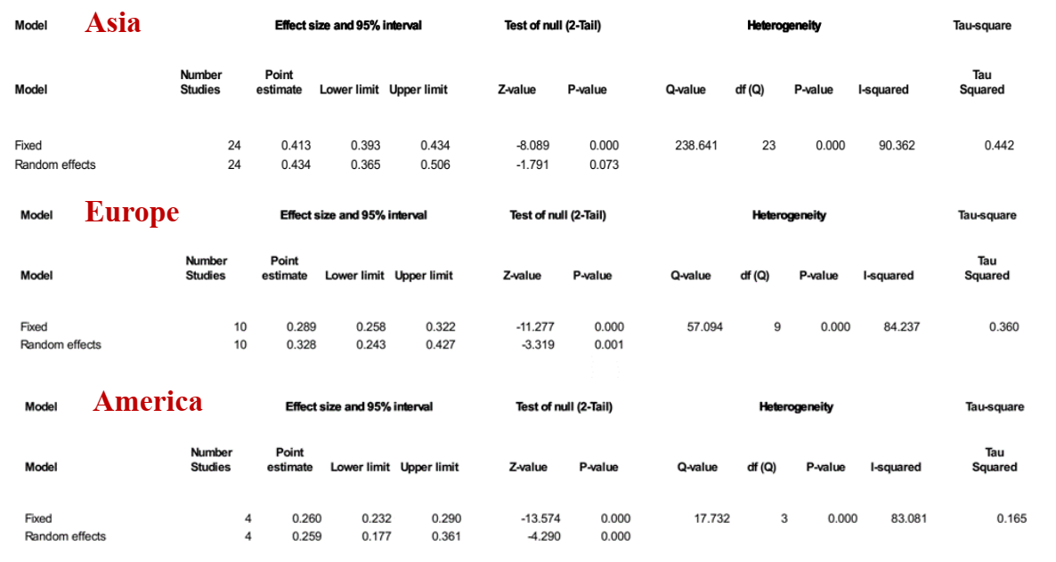
Supplementary Figure S1. Prevalence of F. nucleatum among patients with CRC in Asia, Europe, and America

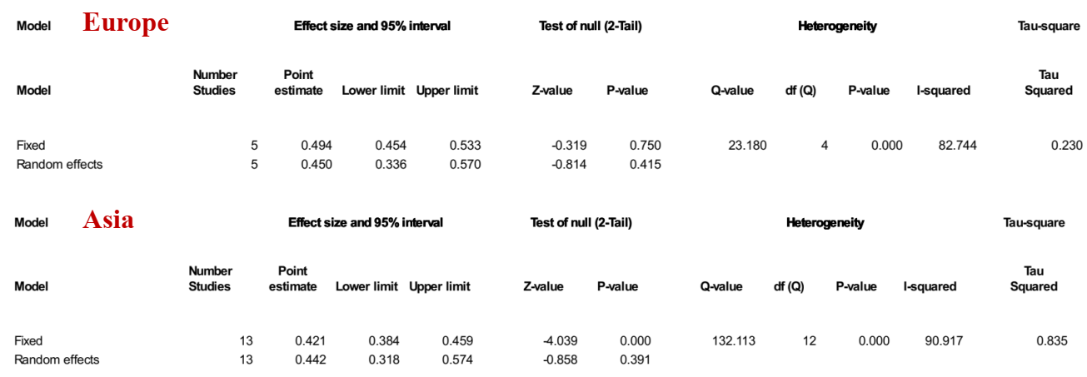
Supplementary Figure S2. Prevalence of B. fragilis among patients with CRC in Europe and Asia

