TableS1. Baseline Characteristics of NAFLD participants aged over 18 years based on inclusion and exclusion Criteria
Characteristics | Excluded Cohort (n=3499) | Included Cohort (n =6759) | P-value
age, year | 49.2 ± 15.0 | 53.8 ± 17.4 | 0.051
Gender, n (%) |  |  | 0.422
Male | 1882 (53.8) | 3579 (53)
Female | 1617 (46.2) | 3180 (47)
PIR | 2.4 ± 1.6 | 2.5 ± 1.6 | 0.082
Waist circumference, cm | 110.9 ± 12.8 | 112.1 ± 12.6 | 0.232
BMI, kg/m2 | 33.8 ± 6.2 | 34.1 ± 6.1 | 0.066
WHtR | 0.7 ± 0.1 | 0.7 ± 0.1 | 0.312
Race, n (%) |  |  | 0.103
Mexican American | 913 (26.1) | 1286 (19)
Other Hispanic | 323 (9.2) | 559 (8.3)
Non-Hispanic white | 1425 (40.7) | 3067 (45.4)
Non-Hispanic Black | 676 (19.3) | 1435 (21.2)
Other Race | 162 (4.6) | 412 (6.1)
Moderate activity, n (%) |  |  | 0.451
Yes | 1263 (36.1) | 2345 (34.7)
No | 2236 (63.9) | 4414 (65.3)
Smoking status, n (%) |  |  | 0.127
Current or ever | 2028 (58.5) | 2930 (44.9)
Never | 1437 (41.5) | 3599 (55.1)
Diabetes, n (%) | 843 (24.4) | 1594 (23.6) | 0.498
Hypertension, n (%) | 1578 (45.1) | 3362 (49.8) | 0.231
CVD, n (%) | 553 (15.8) | 1038 (16.2) | 0.107
CKD, n (%) | 547 (15.6) | 1703 (25.2) | <0.001
CVD death, n (%) | 182 (5.2) | 418 (6.2) | 0.078
All cause death, n (%) | 589 (17.5) | 1254 (18.6) | 0.094
ALT, U/L | 33.7 ± 29.4 | 28.6 ± 32.9 | <0.001
AST, U/L | 29.2 ± 24.8 | 26.1 ± 23.6 | <0.001
Albumin, g/L | 41.1 ± 4.3 | 41.6 ± 3.3 | <0.001
Uric acid, mmol/L | 352.5 ± 88.2 | 357.4 ± 85.5 | 0.142
FPG, mg/dL | 8.44 ± 4.61 | 8.39 ± 4.89 | 0.156
TC, mmol/L | 5.2 (4.5, 6.0) | 5.0 (4.3, 5.8) | < 0.001
TG, mmol/L | 1.7 (1.2, 2.5) | 1.6 (1.2, 2.3) | 0.004
HDL, mmol/L | 1.2 (1.0, 1.4) | 1.2 (1.0, 1.4) | < 0.001
LDL, mmol/L | 3.1 (2.5, 3.8) | 3.0 (2.4, 3.6) | 0.213
eGFR, mL/min/1.73 m² | 95.8 (81.4, 114.8) | 86.1 (70.6, 104.0) | < 0.001
Values are mean ± SD or number (%). p < 0.05 was deemed significant. BMI, body mass index; FPG, fasting blood glucose; TC, total cholesterol; TG, triglyceride; HDL-c, High density lipoprotein cholesterol; LDL-c, Low density lipoprotein cholesterol; GGT, glutamyl transpeptidase; ALT, alanine aminotransferase; AST, aspartate aminotransferase; PIR, poverty-income ratio; eGFR, estimated glomerular filtration rate

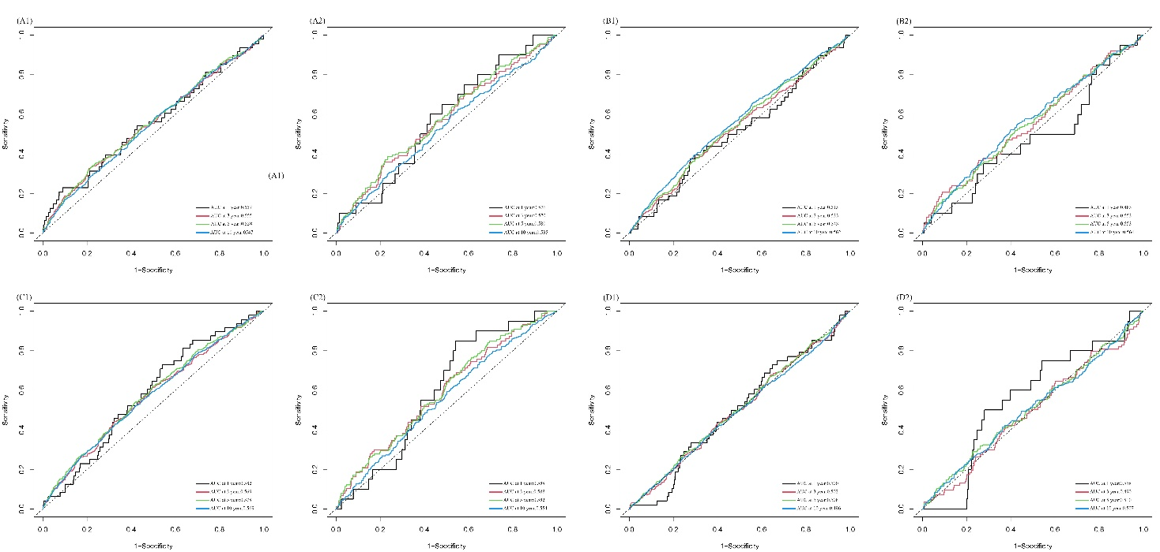
Supplementary Fig.1. The predictive ability of METS-IR, TyG, BMI, and VAI for both all-cause and CVD related mortality in individuals with NAFLD. (A1) METS-IR-all cause mortality (A2) METS-IR-CVD mortality (B1) TyG-all cause mortality (B2) TyG-CVD mortality (C1) BMI-all cause mortality (C2) BMI-CVD mortality (D1) VAI-all cause mortality (D2) VAI-CVD mortality

