Table S1 Association between MCMI with NAFLD and liver fibrosis in training cohort
Liver status | Model 1 [OR  (95%CI)] | Model 2 [OR  (95%CI)] | Model 3 [OR  (95%CI)]
NAFLD | 5.41(3.80, 7.70) | 5.07(3.48, 7.37) | 2.88(1.78, 4.66)
Low (<2.63, n=205) | Ref | Ref | Ref
Moderate (2.63-3.49, n=247) | 5.67(3.33, 9.63) | 5.20(2.92, 9.24) | 2.80(1.10, 7.14)
High (≥3.49, n=240) | 16.07(8.98, 28.73) | 14.26(7.54, 26.99) | 3.22(1.02, 10.11)
p for trend | <0.001 | <0.001 | 0.033
Liver fibrosis | 3.18(1.97, 5.15) | 3.19(1.89, 5.37) | 1.58(0.70, 3.58)
Low (<2.63, n=205) | Ref | Ref | Ref
Moderate (2.63-3.49, n=247) | 0.51(0.07, 3.52) | 0.46(0.06, 3.44) | 0.26(0.03, 2.32)
High (≥3.49, n=240) | 5.10(1.36, 19.12) | 4.50(1.15, 17.65) | 0.95(0.20, 4.54)
p for trend | 0.010 | 0.018 | 0.772
Model 1: Unadjusted; Model 2: Adjusted age, race and education; Model 3: Adjusted age, race, education, BMI, diabetes, dyslipidemia and uric acid.
Abbreviations: MCMI modified cardiometabolic index; NAFLD non-alcoholic fatty liver disease; CI confidence interval; BMI body mass index.
Notes: Weighted percentage for category variables and mean ± standard error for continuous variables.

Table S2 Association between MCMI with NAFLD and liver fibrosis in validation cohort
Liver status | Model 1 [OR  (95%CI)] | Model 2 [OR  (95%CI)] | Model 3 [OR  (95%CI)]
NAFLD | 4.80(2.93, 7.85) | 4.55(2.54, 8.16) | 1.77(0.70, 4.50)
Low (<2.81, n=232) | Ref | Ref | Ref
Moderate (2.81-3.64, n=246) | 5.77(3.67, 9.07) | 5.61(3.30, 9.51) | 2.23(0.95, 5.20)
High (≥3.64, n=215) | 16.12(9.53, 27.26) | 14.42(7.66, 27.13) | 2.04(0.82, 5.10)
p for trend | <0.001 | <0.001 | 0.070
Liver fibrosis | 2.56(1.88, 3.49) | 2.54(1.76, 3.68) | 1.99(0.76, 5.22)
Low (<2.81, n=232) | Ref | Ref | Ref
Moderate (2.81-3.64, n=246) | 1.94(0.51, 7.33) | 1.76(0.38, 8.19) | 0.98(0.19, 5.13)
High (≥3.64, n=215) | 5.91(2.54, 13.79) | 5.16(1.92, 13.90) | 1.53(0.36, 6.43)
p for trend | <0.001 | 0.004 | 0.418
Model 1: Unadjusted; Model 2: Adjusted age, race and education; Model 3: Adjusted age, race, education, BMI, diabetes, dyslipidemia and uric acid.
Abbreviations: MCMI modified cardiometabolic index; NAFLD non-alcoholic fatty liver disease; CI confidence interval; BMI body mass index.
Notes: Weighted percentage for category variables and mean ± standard error for continuous variables.
Fig S1 ROC curves for NAFLD (A) and liver fibrosis (B) in training cohort
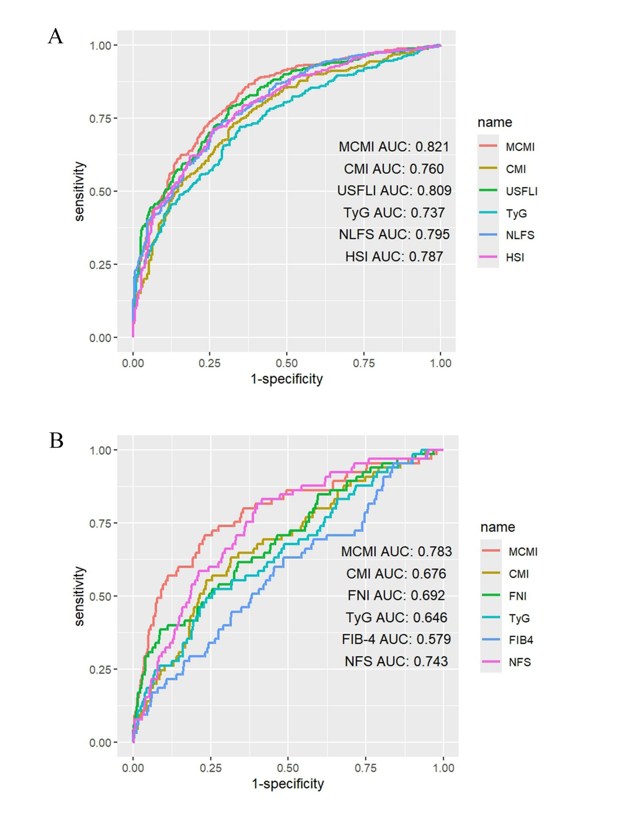

ROC receiver operating characteristic curve; NAFLD non-alcoholic fatty liver disease; AUC area under the curve; MCMI modified cardiometabolic index; CMI cardiometabolic index; USFLI fatty liver index for the U.S. population; TyG Triglyceride glucose index; NLFS NAFLD liver fat score; HSI Hepatic steatosis index; FNI Fibrotic nonalcoholic steatohepatitis index; FIB-4 Fibrosis-4 Index; NFS NAFLD Fibrosis Score.

Fig S2 ROC curves for NAFLD (A) and liver fibrosis (B) in validation cohort
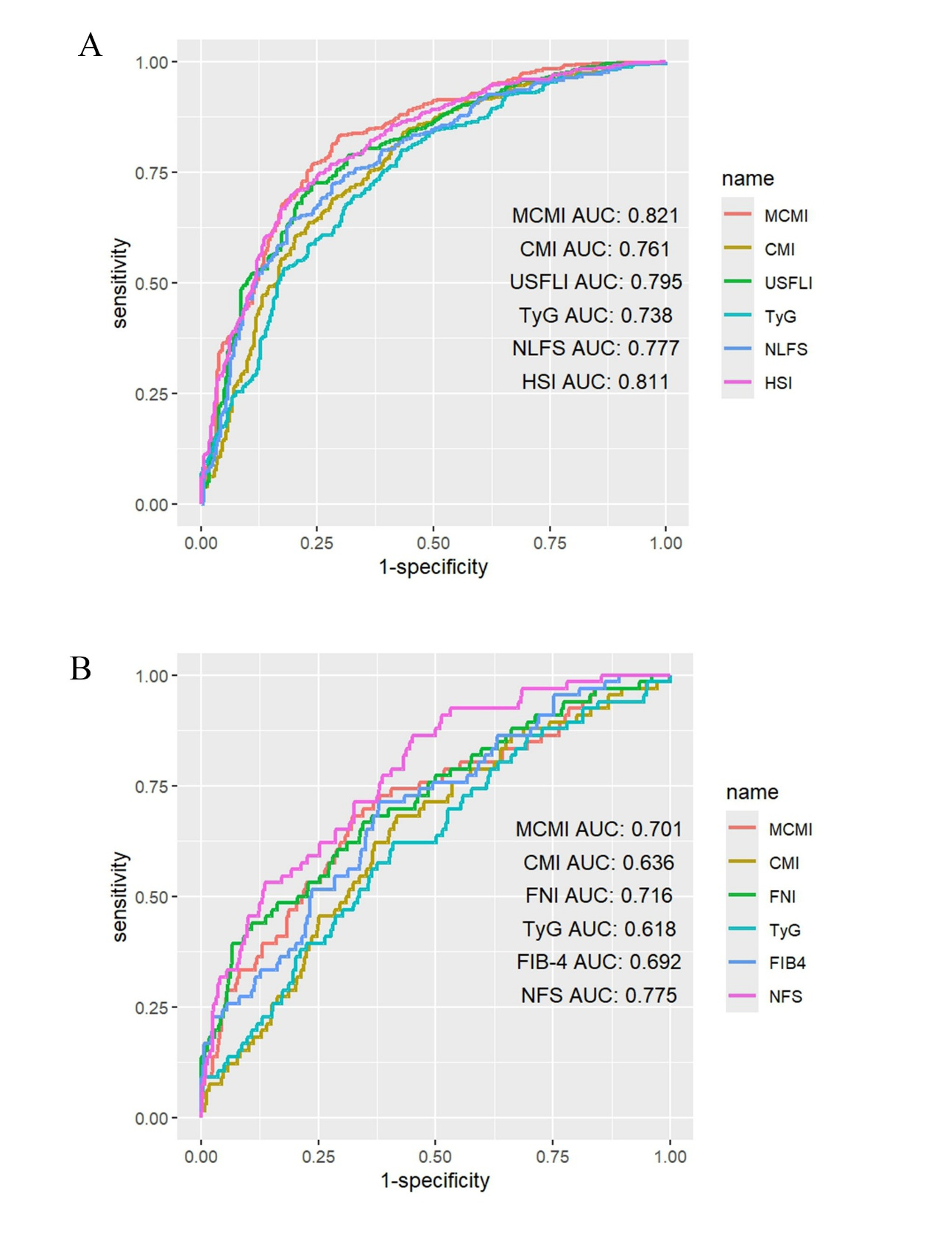

ROC receiver operating characteristic curve; NAFLD non-alcoholic fatty liver disease; AUC area under the curve; MCMI modified cardiometabolic index; CMI cardiometabolic index; USFLI fatty liver index for the U.S. population; TyG Triglyceride glucose index; NLFS NAFLD liver fat score; HSI Hepatic steatosis index; FNI Fibrotic nonalcoholic steatohepatitis index; FIB-4 Fibrosis-4 Index; NFS NAFLD Fibrosis Score.

