Suppl. Table 1 |Patients’ peripheral blood indexes before treatment(0 weeks)
Observation indexes | No. of patients(N = 98) | Percentage(%)
NLR, median(IQR) | 2.72（0.77-7.07）
> 2.72 | 49 | 50
≤2 .72 | 49 | 50
PLR, median(IQR) | 186.15（54.17-450.57）
> 186.15 | 48 | 49
≤186.15 | 50 | 51
CAR, median(IQR) | 0.15（0.004-5.72）
> 0.15 | 47 | 48
≤0.15 | 51 | 52
CEA(ng/ml)
> 5 | 41 | 41.8
≤5 | 57 | 58.2
CA199(ng/ml)
> 37 | 39 | 39.8
≤37 | 59 | 60.2
N=98
Up: elevated compared to pre-treatment Down: decreased compared to pre-treatment
Abbreviations:NLR: neutrophil-to-lymphocyte ratio; PLR: platelet-to-lymphocyte ratio; CAR: C-reactive protein-to-albumin ratio; CEA: carcinoembryonic antigen; CA199: sugar antigen 199

Suppl. Table 2 |Patients’ peripheral blood indexes after treatment(12 weeks)
Observation indexes | No. of patients(N = 98) | Percentage(%)
NLR, median(IQR) | 1.99（0.57-7.92）
UP | 33 | 33.7
DOWN | 65 | 66.3
PLR, median(IQR) | 123.65(27.73-274.63)
UP | 26 | 26.5
DOWN | 72 | 73.5
CAR, median(IQR) | 0.08(0.004-7.05)
UP | 43 | 43.9
DOWN | 55 | 56.1
CEA(ng/ml)
> 5 | 36 | 36.7
≤5 | 62 | 62.3
CA199(IU/ml)
> 37 | 31 | 31.6
≤37 | 67 | 68.4
N=98
Up: elevated compared to pre-treatment Down: decreased compared to pre-treatment
Abbreviations:NLR: neutrophil-to-lymphocyte ratio; PLR: platelet-to-lymphocyte ratio; CAR: C-reactive protein-to-albumin ratio; CEA: carcinoembryonic antigen; CA199: sugar antigen 199

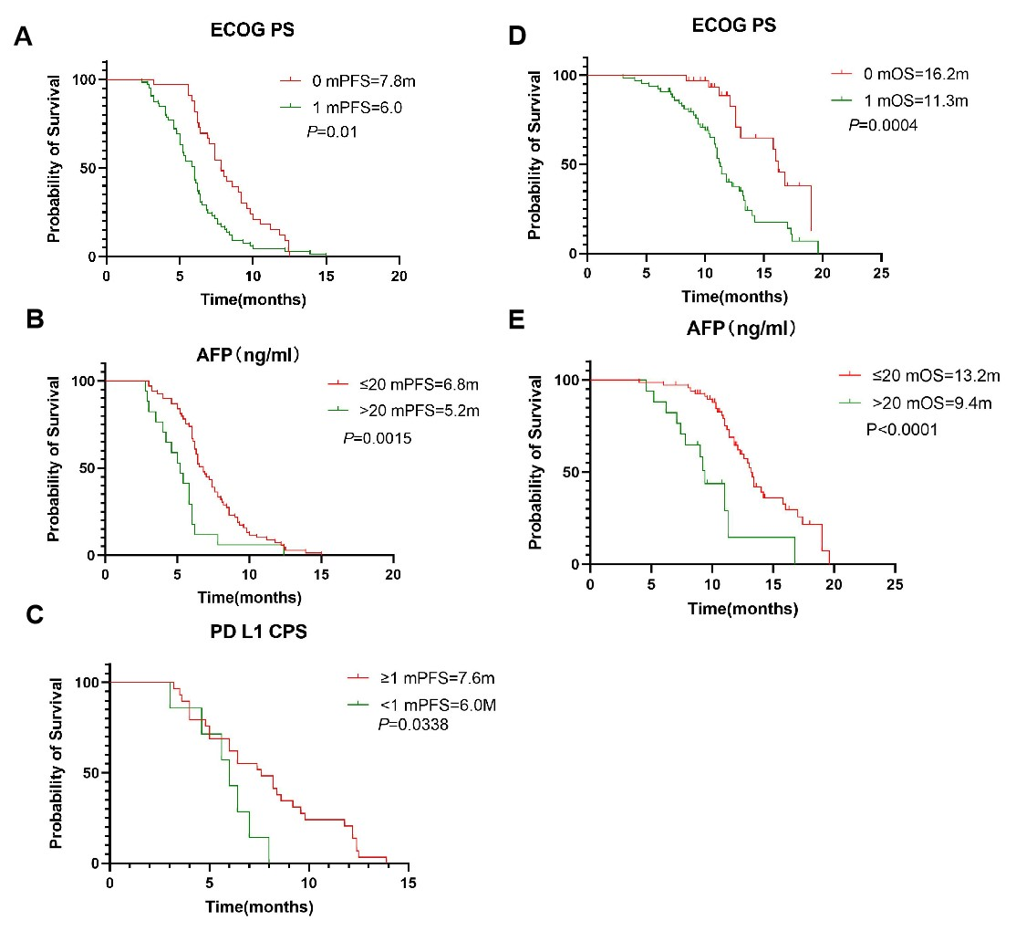
Suppl. Figure 1| Kaplan–Meier curves for PFS according to ECOG PS(A), AFP(B), PD L1 CPS(C). Kaplan–Meier curves for OS according to ECOG PS(D), AFP(C),PD L1 CPS(E).

Suppl. Table 3| Associations of clinical factors and peripheral blood indexes with treatment response using chi-squared test or Fisher exact test
Disease control rate |  |  | Objective response rate
 | n(%) | P | n(%) | P
Age(years)
≥65  ＜65 | 45/49(0.918)  40/49(0.816) | 0.662 | 32/49(0.653)  27/49(0.551) | 0.874
Gender
Female | 19/25(0.760) | 0.009 | 12/25(0.480) | 0.104
Male | 66/73(0.904) | 0.009 | 47/73(0.644) | 0.104
ECOG PS
1 | 53/65(0.815) | 0.048 | 30/65(0.7462) | 0.448
0 | 32/33(0.970) | 0.048 | 29/33(0.879) | 0.448
Liver metastases
Yes | 22/26(0.846) | 0.013 | 19/26(0.731) | 0.177
No | 63/72(0.875) | 0.013 | 40/72(0.556) | 0.177
Omental invasion
Yes | 30/35(0.857) | 0.030 | 18/35(0.514) | 0.208
No | 55/63(0.873) | 0.030 | 41/63(0.651) | 0.208
AFP (ng/ml)
>20 | 13/17(0.765) | 0.006 | 7/17(0.412) | 0.063
≤20 | 62/69(0.899) |  | 47/69(0.681)
PD-L1 CPS
CPS≥1 | 26/29(0.897) | 0.007 | 21/29(0.724) | 0.045
CPS<1 | 5/7(0.714) | 0.007 | 4/7(0.571) | 0.045
NLR0W
> 2.72  ≤2.72 | 40/49(0.816)  45/49(0.918) | 0.662 | 26/49(0.531)  33/49(0.673) | 0.826
PLR0W
＞186.15  ≤186.15 | 38/48(0.792)  47/50(0.940) | 0.403 | 22/48(0.458)  37/50(0.740) | 0.618
CAR0W
＞0.15  ≤0.15 | 36/47(0.766)  47/51(0.922) | 0.329 | 22/47(0.468)  37/51(0.725) | 0.575
CEA0W (ng/ml)
＞5 | 34/41(0.7829) | 0.070 | 21/41(0.512) | 0.354
≤5 | 51/57(0.895) | 0.070 | 38/57(0.667) | 0.354
CA199_{0w} (IU/ml)
＞37 | 30/39(0.769) | 0.045 | 16/39(0.410) | 0.235
≤37 | 55/59(0.932) | 0.045 | 43/59(0.729) | 0.235
NLR_{12w}
Up | 23/33(0.697) | 0.021 | 12/33(0.364) | 0.136
Down | 62/65(0.954) | 0.021 | 47/65(0.723) | 0.136
PLR_{12w}
Up | 23/26(0.885) | 0.015 | 15/26(0.577) | 0.13
Down | 62/72(0.861) | 0.015 | 44/72(0.611) | 0.13
CAR_{12w}
Up | 33/43(0.767) | 0.097 | 17/43(0.395) | 0.331
Down | 52/55(0.945) | 0.097 | 42/55(0.764) | 0.331
CEA_{12w}
＞5 | 27/36(0.750) | 0.028 | 14/36(0.389) | 0.177
≤5 | 58/62(0.935) |  | 45/62(0.726) | 0.177
CA199_{12w}
＞37 | 20/31(0.645) | 0.019 | 6/31(0.194) | 0.101
≤37 | 65/67(0.970) |  | 53/67(0.791) | 0.101

Suppl. Table 4| Univariate Logistic regression models for DCR and ORR
Characteristics | Disease control rate |  | Characteristics | Objective response rate
Characteristics | Odds Ratio (95% CI) | P value | Characteristics | Odds Ratio (95% CI) | P value
NLR12w |  |  | ECOG
up | 1 |  | 0 | 1
down | 0.111 (0.028 – 0.441) | 0.002 | 1 | 8.458 (2.669 – 26.807) | < 0.001
PLR0w |  |  | NLR12w
≤186.15 | 1 |  | up | 1
>186.15 | 4.123 (1.059 – 16.050) | 0.041 | down | 0.219 (0.090– 0.535) | < 0.001
CAR12w |  |  | PLR0w
down | 1 |  | ≤186.15 | 1
up | 5.253 (1.346 – 20.504) | 0.017 | >186.15 | 3.364 (1.438 – 7.866) | 0.005
CA199 0w (IU/ml) |  |  | CAR0w
≤37 | 1 |  | >0.15 | 1
>37 | 4.125 (1.171 – 14.528) | 0.027 | ≤0.15 | 0.333 (0.144 – 0.772) | 0.01
CA199 12w (IU/ml) |  |  | CAR12w
≤37 | 1 |  | down | 1
>37 | 17.875 (3.653 – 87.462) | < 0.001 | up | 4.941 (2.066 – 11.820) | < 0.001
CEA12w (ng/ml) |  |  | CA199 0w (IU/ml)
≤5 | 1 |  | ≤37 | 1
＞5 | 4.833 (1.367 – 17.094) | 0.015 | >37 | 3.863 (1.638 – 9.113) | 0.002
 |  |  | CA199 12w (IU/ml)
 |  |  | ≤37 | 1
 |  |  | >37 | 15.774 (5.421 – 45.898) | < 0.001
 |  |  | AFP (ng/ml)
 |  |  | ≤20 | 1
 |  |  | >20 | 3.052 (1.026 – 9.082) | 0.045

Suppl. Table 5 | Univariable Cox regression analysis for PFS and OS
Characteristics | Progression free survival |  | Characteristics | Overall survival
Characteristics | Hazard ratio (95% CI) | P value | Characteristics | Hazard ratio (95% CI) | P value
ECOG |  |  | ECOG
0 | 1 |  | 0 | 1
1 | 2.013 (1.310 - 3.091) | 0.001 | 1 | 2.903 (1.548 - 5.442) | < 0.001
AFP |  |  | AFP
<=20 | 1 |  | <=20 | 1
>20 | 2.400 (1.391 - 4.141) | 0.002 | >20 | 3.783 (1.905 - 7.511) | < 0.001
NLR0w |  |  | NLR0w
≤2.72 | 1 |  | ≤2.72 | 1
>2.72 | 1.697 (1.132 - 2.544) | 0.010 | >2.72 | 1.940 (1.133 - 3.322) | 0.016
NLR12w |  |  | NLR12w
up | 1 |  | up | 1
down | 0.417 (0.267 - 0.652) | < 0.001 | down | 0.349 (0.201 - 0.606) | < 0.001
PLR0w |  |  | CAR0w
≤186.15 | 1 |  | >0.15 | 1
>186.15 | 1.527 (1.019 - 2.287) | 0.040 | ≤0.15 | 0.411 (0.242 - 0.701) | 0.001
CAR0w |  |  | CAR12w
>0.15 | 1 |  | down | 1
≤0.15 | 0.530 (0.351 - 0.799) | 0.002 | up | 2.164 (1.261 - 3.711) | 0.005
CAR12w |  |  | CA199 0w (IU/ml)
down | 1 |  | ≤37 | 1
up | 1.878 (1.247 - 2.829) | 0.003 | >37 | 3.071 (1.766 - 5.342) | < 0.001
CA199 0w (IU/ml) |  |  | CA199 12w (IU/ml)
≤37 | 1 |  | ≤37 | 1
>37 | 2.181 (1.427 - 3.333) | < 0.001 | >37 | 4.722 (2.636 - 8.458) | < 0.001
CA199 12w (IU/ml) |  |  | CEA12w (ng/ml)
≤37 | 1 |  | ≤5 | 1
>37 | 6.465 (3.779 - 11.062) | < 0.001 | >5 | 3.072 (1.713 - 5.509) | < 0.001
CEA0w (ng/ml)
≤5 | 1
>5 | 1.801 (1.187 - 2.733) | 0.006
CEA12w (ng/ml)
≤5 | 1
>5 | 2.800 (1.786 - 4.391) | < 0.001

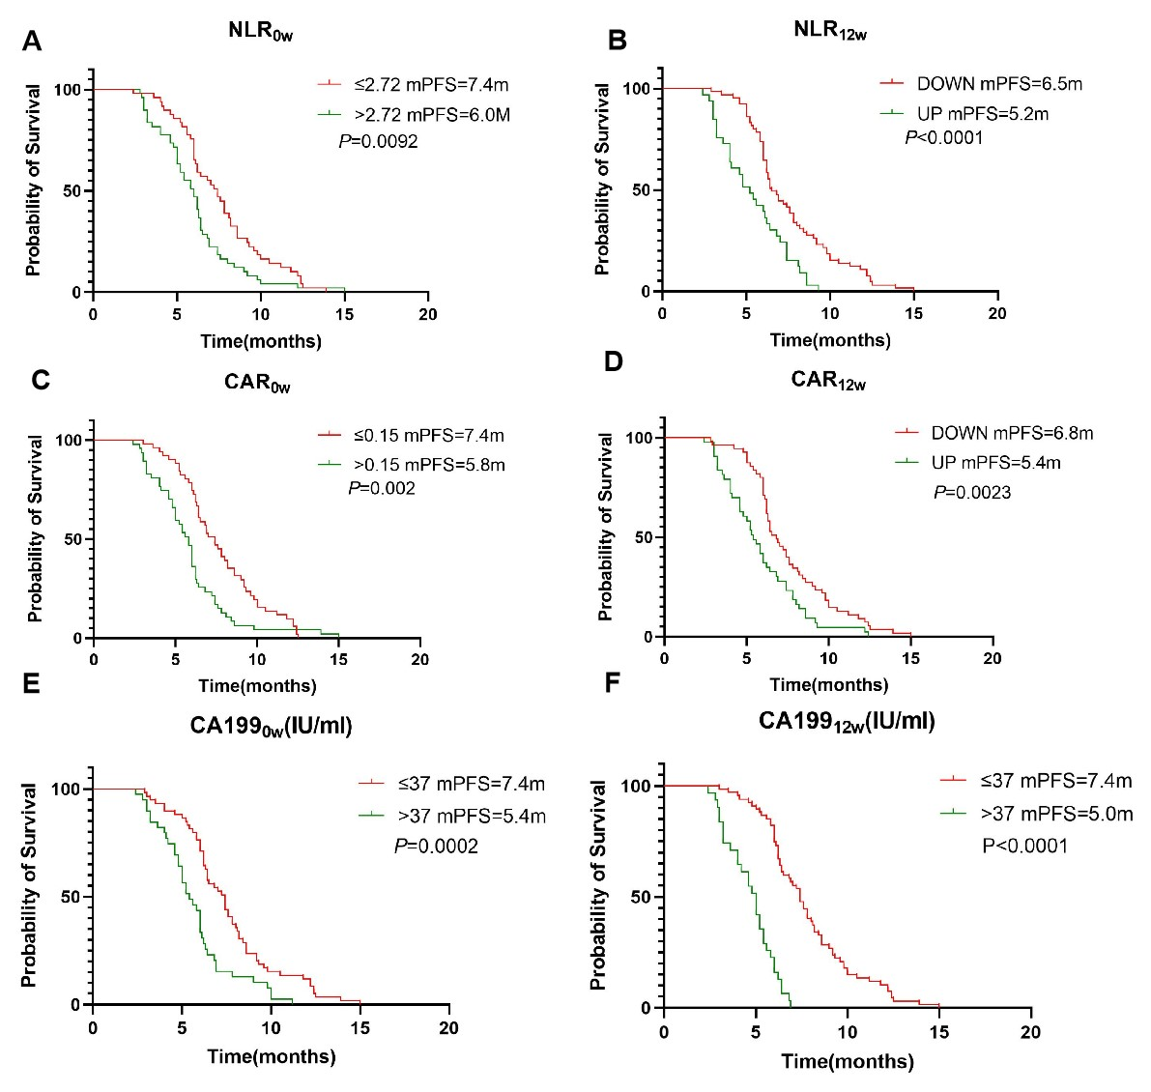
Suppl.Figure 2 | Kaplan–Meier curves for PFS according to NLR0w (A), NLR12w (B), CAR0w (C),CAR12w (D),, CA199 0w(E)and CA199 12w (F).
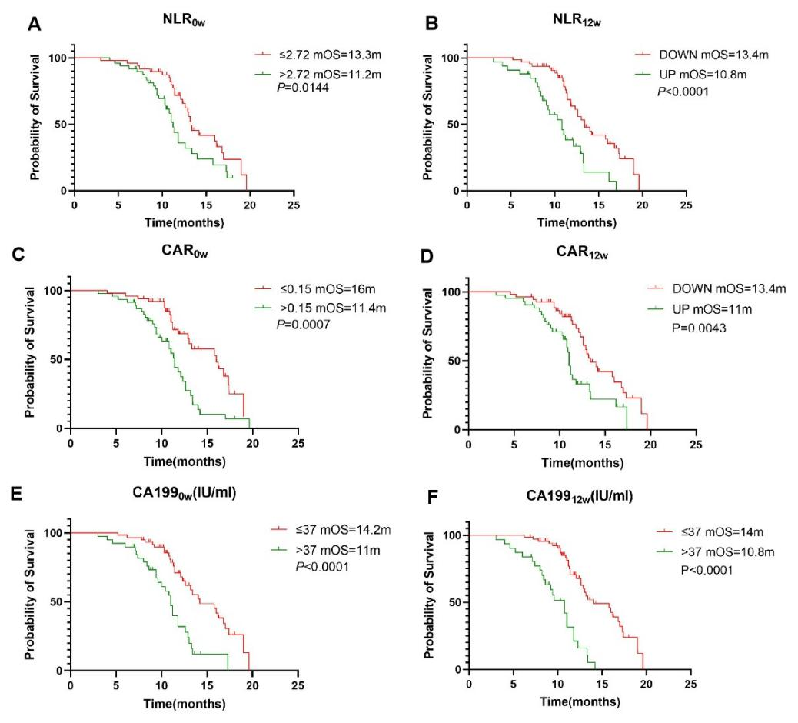
Suppl.Figure 3 | Kaplan–Meier curves for OS according to NLR0w (A), NLR12w (B), CAR0w (C),CAR12w (D), CA199 0w(E)and CA199 12w (F).
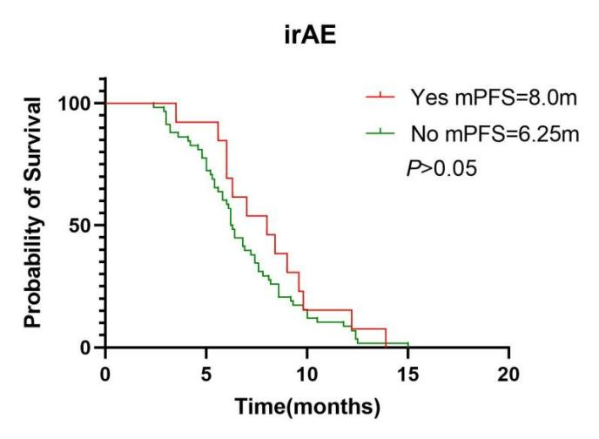
Suppl. Figure 4| Kaplan-Meier survival curves to irAEs.

