Appendix 1:
PubMed
(("Helicobacter pylori"[MeSH Terms] OR ("helicobacter"[All Fields] AND "pylori"[All Fields]) OR "helicobacter pylori"[All Fields]) AND ("stomach neoplasms"[MeSH Terms] OR ("stomach"[All Fields] AND "neoplasms"[All Fields]) OR "stomach neoplasms"[All Fields] OR ("gastric"[All Fields] AND "cancer"[All Fields]) OR "gastric cancer"[All Fields])) AND (("Randomized Controlled Trial" [Publication Type]) OR (RCT)) OR (Randomized Controlled Trial))

Cochrane library
ID Search Hits
#1 MeSH descriptor: [Helicobacter pylori] explode all trees 2617
#2 Helicobacter pylori 6386
#3 #1 OR #2 6386
#4 MeSH descriptor: [Stomach Neoplasms] explode all trees 4136
#5 gastric OR stomach 43042
#6 cancer OR neoplasm 246863
#7 #5 AND #6 12529
#8 #4 OR #7 12853
#9 #3 AND #8 in Trials 725

Web of Science
(("Helicobacter pylori"[MeSH Terms] OR ("helicobacter"[All Fields] AND "pylori"[All Fields]) OR "helicobacter pylori"[All Fields]) AND ("stomach neoplasms"[MeSH Terms] OR ("stomach"[All Fields] AND "neoplasms"[All Fields]) OR "stomach neoplasms"[All Fields] OR ("gastric"[All Fields] AND "cancer"[All Fields]) OR "gastric cancer"[All Fields])) AND (("Randomized Controlled Trial" [Publication Type]) OR (RCT)) OR (Randomized Controlled Trial))

EMBASE
#1 'helicobacter pylori'/exp 64946
#2 helicobacter AND pylori 82219
#3 #1 OR #2 82219
#4 'stomach tumor'/exp 213324
#5 stomach AND tumor 154862
#6 gastric AND cancer 184208
#7 stomach AND neoplasms 16311
#8 #4 OR #5 OR #6 OR #7 289222
#9 'randomized controlled trial'/exp 853456
#10 randomized AND controlled AND trial 1225029
#11 rct 67569
#12 #9 OR #10 OR #11 1248202
#13 #3 AND #8 AND #12 756

Appendix 2:
Gastric cancer incidence
Patient or population: Gastric cancer incidence
Settings:
Intervention: H. pylori eradication
Outcomes | Illustrative comparative risks* (95% CI) |  | Relative effect  (95% CI) | No of Participants  (studies) | Quality of the evidence  (GRADE) | Comments
Outcomes | Assumed risk | Corresponding risk
 | Control | H. pylori eradication
Gastric cancer incidence |  | The mean fbg in the intervention groups was  RR: 0.61, 95% CI: 0.47–0.79, z = 3.67, p < 0.001 |  | 104786  (11 studies) | ⊕⊕⊝⊝  low^{1,2,3} | RR: 0.61; 95% CI: 0.47–0.79
*The basis for the assumed risk (e.g. the median control group risk across studies) is provided in footnotes. The corresponding risk (and its 95% confidence interval) is based on the assumed risk in the comparison group and the relative effect of the intervention (and its 95% CI).
CI: Confidence interval;
GRADE Working Group grades of evidence
High quality: Further research is very unlikely to change our confidence in the estimate of effect.
Moderate quality: Further research is likely to have an important impact on our confidence in the estimate of effect and may change the estimate.
Low quality: Further research is very likely to have an important impact on our confidence in the estimate of effect and is likely to change the estimate.
Very low quality: We are very uncertain about the estimate.
¹ No explanation was provided.
² I² = 53.5%, P = 0.018
³ Egger’s test p = 0.08
Figure 2.1 GRADE Assessment Results for Gastric cancer incidence
All-cause mortality
Patient or population: All-cause mortality
Settings:
Intervention: H. pylori eradication
Outcomes | Illustrative comparative risks* (95% CI) |  | Relative effect  (95% CI) | No of Participants  (studies) | Quality of the evidence  (GRADE) | Comments
Outcomes | Assumed risk | Corresponding risk
 | Control | H. pylori eradication
All-cause mortality |  | The mean fbg in the intervention groups was  RR: 1.00, 95% CI: 0.89–1.12, z = 0.05, p = 0.963 |  | 7310  (6 studies) | ⊕⊕⊝⊝  modeate¹ | RR: 1.00; 95% CI: 0.89–1.12
*The basis for the assumed risk (e.g. the median control group risk across studies) is provided in footnotes. The corresponding risk (and its 95% confidence interval) is based on the assumed risk in the comparison group and the relative effect of the intervention (and its 95% CI).
CI: Confidence interval;
GRADE Working Group grades of evidence
High quality: Further research is very unlikely to change our confidence in the estimate of effect.
Moderate quality: Further research is likely to have an important impact on our confidence in the estimate of effect and may change the estimate.
Low quality: Further research is very likely to have an important impact on our confidence in the estimate of effect and is likely to change the estimate.
Very low quality: We are very uncertain about the estimate.
¹ No explanation was provided.
Figure 2.2 GRADE Assessment Results for All-cause mortality
Gastric cancer mortality
Patient or population: Gastric cancer mortality
Settings:
Intervention: H. pylori eradication
Outcomes | Illustrative comparative risks* (95% CI) |  | Relative effect  (95% CI) | No of Participants  (studies) | Quality of the evidence  (GRADE) | Comments
Outcomes | Assumed risk | Corresponding risk
 | Control | H. pylori eradication
Gastric cancer mortality |  | The mean fbg in the intervention groups was  RR: 0.83, 95% CI: 0.69–1.01, z = 1.90, p = 0.057 |  | 7310  (6 studies) | ⊕⊕⊝⊝  modeate¹ | RR: 0.83, 95% CI: 0.69–1.01
*The basis for the assumed risk (e.g. the median control group risk across studies) is provided in footnotes. The corresponding risk (and its 95% confidence interval) is based on the assumed risk in the comparison group and the relative effect of the intervention (and its 95% CI).
CI: Confidence interval;
GRADE Working Group grades of evidence
High quality: Further research is very unlikely to change our confidence in the estimate of effect.
Moderate quality: Further research is likely to have an important impact on our confidence in the estimate of effect and may change the estimate.
Low quality: Further research is very likely to have an important impact on our confidence in the estimate of effect and is likely to change the estimate.
Very low quality: We are very uncertain about the estimate.
¹ No explanation was provided.
Figure 2.3 GRADE Assessment Results for Gastric cancer mortality

Appendix 3: Risk of Bias
Author | Bias arising from the randomization process | Bias due to deviations from intended intervention | Bias due to missing outcome data | Bias in measurement of the outcome | Bias in selection of the reported result | Overall
Choi et al. (2018a) | Low | Low | Low | Low | Low | Low
Choi et al. (2020) | Low | Low | Low | Low | Low | Low
Choi et al. (2018b) | Some concerns | High | Low | Low | Low | High
Correa et al. (2000) | Some concerns | Low | High | Low | Low | High
Fukase et al. (2008) | Some concerns | High | Low | Low | Low | High
Kim et al. (2016) | Low | Low | Low | Low | Low | Low
Li et al. (2019) | Low | Low | Low | Some concerns | Low | Some concerns
Pan et al. (2024) | Low | Some concerns | Low | Low | Low | Some concerns
Wong et al. (2012) | Low | Low | Low | Low | Low | Low
Yan et al. (2022) | Low | Low | Low | Some concerns | Low | Some concerns
Zhou et al. (2014) | Low | Low | Some concerns | Low | Low | Some concerns

Appendix 4: Sensitivity Analysis
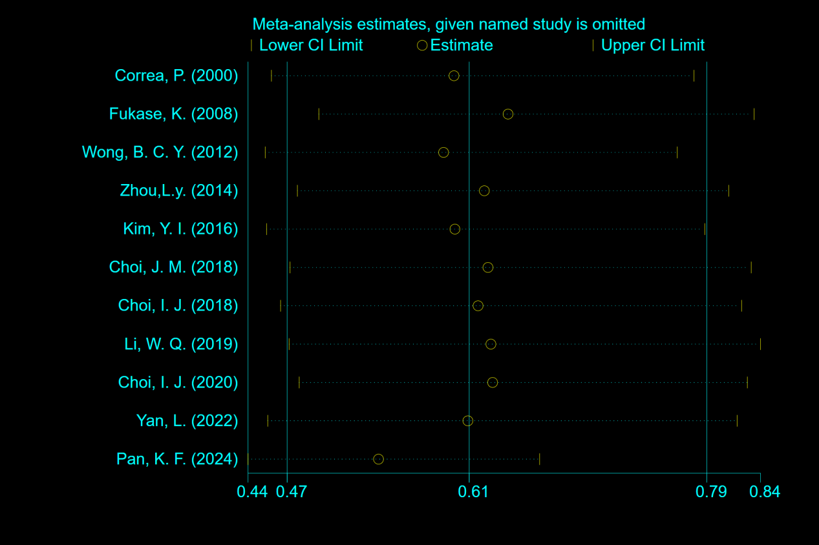

Appendix 5: Meta-Regression Analysis (n=11)
Covariate | Coefficient | Standard Error | t-value | P-value | 95% Confidence Interval
Presence of gastric cancer | -0.4292 | 0.6393 | -0.67 | 0.527 | (-1.9936, 1.1352)
Follow-up > 8 years | -0.0164 | 0.5673 | -0.03 | 0.978 | (-1.4044, 1.3717)
Geographic region | -0.6095 | 1.1562 | -0.53 | 0.617 | (-3.4385, 2.2195)
Mean age > 50 years | 0.1714 | 0.6742 | 0.25 | 0.808 | (-1.4783, 1.8211)
Constant | 0.1960 | 1.1829 | 0.17 | 0.874 | (-2.6985, 3.0905)

Model Parameters
Tau² (REML estimate) = 0.0583
Proportion of residual heterogeneity (I²_res) = 59.80%
Adjusted R² = -3.49% (explanatory variables did not improve model fit)
Joint significance test: F(4, 6) = 0.44, P = 0.7758 (Knapp–Hartung adjustment)

