Table S1. Baseline analysis of MASLD participants according to PIV quartiles.
Variable | Total | Q1 | Q2 | Q3 | Q4 | P-value
Range |  | <176.52 | 176.52-269.67 | 269.67-409.87 | ≥409.87
L | 2.27  ±0.01 | 2.39  ±0.04 | 2.27  ±0.02 | 2.28  ±0.02 | 2.17  ±0.02 | < 0.0001
M | 0.59  ±0.00 | 0.45  ±0.01 | 0.53  ±0.00 | 0.61  ±0.00 | 0.74  ±0.00 | < 0.0001
N | 4.61  ±0.02 | 3.15  ±0.02 | 4.02  ±0.02 | 4.81  ±0.02 | 6.12  ±0.03 | < 0.0001
P | 260.04  ±0.93 | 217.47  ±1.20 | 244.40  ±1.17 | 266.63  ±1.27 | 301.78  ±1.81 | < 0.0001
PIV | 345.69  ±2.85 | 128.44  ±0.67 | 221.93  ±0.59 | 332.25  ±0.77 | 644.51  ±5.74 | < 0.0001
Age, year | 49.82  ±0.22 | 50.25  ±0.37 | 49.25  ±0.30 | 49.58  ±0.35 | 50.23  ±0.38 | 0.047
PIR | 2.92  ±0.03 | 2.86  ±0.04 | 2.96  ±0.05 | 2.97  ±0.04 | 2.89  ±0.04 | 0.021
Energy intake, kcal/day | 2161.24  ±10.51 | 2147.15  ±22.15 | 2195.20  ±20.63 | 2179.13  ±21.58 | 2123.71  ±20.33 | 0.055
BMI, Kg/m2 | 34.12  ±0.09 | 33.57  ±0.15 | 33.57  ±0.12 | 34.28  ±0.14 | 34.92  ±0.15 | < 0.0001
Sex |  |  |  |  |  | 0.056
male | 7964  (52.78) | 1943  (52.49) | 2033  (55.16) | 1970  (52.19) | 2018  (51.36)
female | 7507  (47.22) | 1925  (47.51) | 1835  (44.84) | 1897  (47.81) | 1850  (48.64)
Race |  |  |  |  |  | < 0.0001
Mexican American | 3178  ( 9.49) | 812  (11.22) | 883  (10.33) | 807  ( 9.02) | 676  ( 7.79)
Non-Hispanic Black | 3070  (10.33) | 1298  (20.02) | 726  ( 9.58) | 582  ( 7.74) | 464  ( 5.87)
Non-Hispanic White | 7002  (69.53) | 1190  (57.30) | 1698  (69.33) | 1916  (72.79) | 2198  (76.23)
Other Hispanic | 1319  ( 5.56) | 318  (5.47) | 349  (5.68) | 344  (6.06) | 308  (5.03)
Other Race | 902  ( 5.09) | 250  (5.99) | 212  (5.07) | 218  (4.40) | 222  (5.08)
Marital status |  |  |  |  |  | < 0.001
No-single | 9789  (67.41) | 2445  (68.40) | 2501  (69.31) | 2488  (68.02) | 2355  (64.30)
Single | 5682  (32.59) | 1423  (31.60) | 1367  (30.69) | 1379  (31.98) | 1513  (35.70)
Educational level |  |  |  |  |  | < 0.001
<high school | 2010  ( 6.23) | 552  (7.30) | 533  (6.47) | 489  (5.80) | 436  (5.59)
high school | 6165  (38.40) | 1482  (37.29) | 1493  (35.77) | 1555  (38.96) | 1635  (41.17)
>high school | 7296  (55.37) | 1834  (55.41) | 1842  (57.76) | 1823  (55.25) | 1797  (53.24)
Smoke |  |  |  |  |  | < 0.0001
never | 8194  (52.89) | 2240  (57.27) | 2137  (55.22) | 1990  (51.88) | 1827  (48.27)
former | 4494  (28.94) | 1047  (27.02) | 1076  (27.77) | 1173  (30.39) | 1198  (30.14)
now | 2783  (18.17) | 581  (15.71) | 655  (17.02) | 704  (17.73) | 843  (21.59)
Physical activity |  |  |  |  |  | 0.106
no | 8285  (48.00) | 2142  (48.89) | 2089  (48.43) | 1998  (46.27) | 2056  (48.56)
moderate | 3811  (27.40) | 910  (26.31) | 924  (26.26) | 987  (28.19) | 990  (28.56)
vigorous | 3375  (24.60) | 816  (24.80) | 855  (25.32) | 882  (25.54) | 822  (22.88)
CVD |  |  |  |  |  | < 0.001
No | 13238  (88.03) | 3390  (89.12) | 3371  (88.86) | 3322  (88.98) | 3155  (85.48)
Yes | 2233  (11.97) | 478  (10.88) | 497  (11.14) | 545  (11.02) | 713  (14.52)
DM |  |  |  |  |  | 0.001
No | 11189  (77.88) | 2778  (77.81) | 2861  (80.21) | 2809  (78.00) | 2741  (75.65)
Yes | 4282  (22.12) | 1090  (22.19) | 1007  (19.79) | 1058  (22.00) | 1127  (24.35)
Hypertension |  |  |  |  |  | < 0.0001
No | 6364  (44.87) | 1621  (47.18) | 1658  (47.01) | 1608  (45.47) | 1477  (40.49)
Yes | 9107  (55.13) | 2247  (52.82) | 2210  (52.99) | 2259  (54.53) | 2391  (59.51)
All-cause death |  |  |  |  |  | < 0.0001
No | 13033  (88.11) | 3390  (90.05) | 3332  (90.18) | 3266  (88.45) | 3045  (84.34)
Yes | 2438  (11.89) | 478  ( 9.95) | 536  ( 9.82) | 601  (11.55) | 823  (15.66)
CVD-cause death |  |  |  |  |  | < 0.0001
No | 14657  (96.22) | 3707  (96.68) | 3690  (96.97) | 3672  (96.51) | 3588  (94.89)
Yes | 814  ( 3.78) | 161  (3.32) | 178  (3.03) | 195  (3.49) | 280  (5.11)
Continuous variables were expressed as mean ± standard error and tested using analysis of variance (ANOVA), while categorical variables displayed number (weighted percentage) and tested using chi-square analysis.

Table S2. Association of PIV with all-cause mortality in the MASLD population.
ALL-cause | Crude Model  HR (95%CI) | P-value | Model 1  HR (95%CI) | P-value | Model 2  HR (95%CI) | P-value
Ln (PIV) | 1.39 (1.25,1.55) | <0.0001 | 1.32 (1.20,1.45) | <0.0001 | 1.26(1.14,1.38) | <0.0001
PIV quartile
Q1 | ref | ref | ref | ref | ref | ref
Q2 | 0.89(0.75,1.05) | 0.168 | 0.96 (0.81,1.14) | 0.641 | 0.94 (0.80,1.11) | 0.486
Q3 | 1.05(0.89,1.24) | 0.591 | 1.04(0.88,1.24) | 0.639 | 1.01 (0.85,1.19) | 0.924
Q4 | 1.45(1.22,1.72) | <0.0001 | 1.39(1.18,1.63) | <0.0001 | 1.27(1.09,1.49) | 0.003
P for trend | <0.0001 |  | <0.0001 |  | <0.001
The crude model was unadjusted. Model 1 incorporated adjustments for demographic variables including age, sex, race, education level, PIR, and marital status. Model 2 further adjusted for behavioral and clinical covariates such as smoking status, physical activity, dietary energy intake, BMI, diabetes, hypertension, and CVD history, building upon Model 1.

Table S3. Association of PIV with CVD mortality in the MASLD population.
CVD-cause | Crude Model  HR (95%CI) | P-value | Model 1  HR (95%CI) | P-value | Model 2  HR (95%CI) | P-value
Ln (PIV) | 1.43(1.20,1.72) | <0.001 | 1.34(1.13,1.60) | 0.001 | 1.31(1.10,1.56) | 0.003
PIV quartile
Q1 | ref | ref | ref | ref | ref | ref
Q2 | 0.82(0.63,1.08) | 0.160 | 0.91(0.69,1.19) | 0.485 | 0.92(0.69,1.21) | 0.528
Q3 | 0.95(0.70,1.30) | 0.746 | 0.95(0.69,1.30) | 0.727 | 0.95(0.70,1.30) | 0.755
Q4 | 1.42(1.11,1.82) | 0.007 | 1.34(1.03,1.74) | 0.027 | 1.30(1.01,1.69) | 0.046
P for trend | <0.001 |  | 0.013 |  | 0.025
The crude model was unadjusted. Model 1 incorporated adjustments for demographic variables including age, sex, race, education level, PIR, and marital status. Model 2 further adjusted for behavioral and clinical covariates such as smoking status, physical activity, dietary energy intake, BMI, diabetes, hypertension, and CVD history, building upon Model 1.

Table S4. The threshold effects analysis of the association between lnPIV and mortality in the MASLD population.
 | HR (95% CI) | p | p for interaction
All-cause
Ln PIV |  |  | < 0.0001
<5.43 | 0.78(0.62,0.99) | 0.039
≥5.43 | 1.74(1.49,2.03) | <0.0001
CVD-cause
Ln PIV |  |  | 0.014
<5.65 | 0.95(0.64,1.41) | 0.796
≥5.65 | 1.92(1.50,2.45) | <0.0001
Adjusted for age, sex, race, education level, PIR, marital status, smoking status, physical activity, dietary energy intake, BMI, diabetes, hypertension, and CVD history.

Table S5. Association of PIV with all-cause mortality in USFLI-MASLD.
ALL-cause | Crude Model  HR (95%CI) | P-value | Model 1  HR (95%CI) | P-value | Model 2  HR (95%CI) | P-value
Ln (PIV) | 1.48(1.23,1.78) | <0.0001 | 1.37(1.16,1.62) | <0.001 | 1.28(1.08,1.52) | 0.004
PIV quartile
Q1 | ref | ref | ref | ref | ref | ref
Q2 | 0.86(0.62,1.18) | 0.339 | 0.93(0.69,1.26) | 0.654 | 0.94(0.69,1.27) | 0.670
Q3 | 1.08(0.82,1.44) | 0.573 | 1.15(0.87,1.52) | 0.338 | 1.12(0.83,1.50) | 0.453
Q4 | 1.48(1.11,1.96) | 0.007 | 1.37(1.06,1.77) | 0.017 | 1.26(1.07,1.63) | 0.025
P for trend | 0.001 |  | 0.003 |  | 0.026
The crude model was unadjusted. Model 1 incorporated adjustments for demographic variables including age, sex, race, education level, PIR, and marital status. Model 2 further adjusted for behavioral and clinical covariates such as smoking status, physical activity, dietary energy intake, BMI, diabetes, hypertension, and CVD history, building upon Model 1.

Table S6. Association of PIV with CVD mortality in USFLI-MASLD.
CVD-cause | Crude Model  HR (95%CI) | P-value | Model 1  HR (95%CI) | P-value | Model 2  HR (95%CI) | P-value
Ln (PIV) | 1.71(1.27,2.29) | <0.001 | 1.55(1.17,2.06) | 0.002 | 1.55(1.16,2.08) | 0.003
PIV quartile
Q1 | ref | ref | ref | ref | ref | ref
Q2 | 0.88(0.54,1.44) | 0.616 | 0.97(0.61,1.54) | 0.902 | 0.89(0.54,1.47) | 0.657
Q3 | 1.38(0.85,2.22) | 0.190 | 1.46(0.91,2.35) | 0.120 | 1.46(0.91,2.36) | 0.117
Q4 | 1.71(1.06,2.76) | 0.027 | 1.58(1.08,2.53) | 0.032 | 1.49(1.09,2.39) | 0.041
P for trend | 0.005 |  | 0.020 |  | 0.022
The crude model was unadjusted. Model 1 incorporated adjustments for demographic variables including age, sex, race, education level, PIR, and marital status. Model 2 further adjusted for behavioral and clinical covariates such as smoking status, physical activity, dietary energy intake, BMI, diabetes, hypertension, and CVD history, building upon Model 1.
Figure S1. Simplified schematic of PIV’s mechanistic role in MASLD progression.
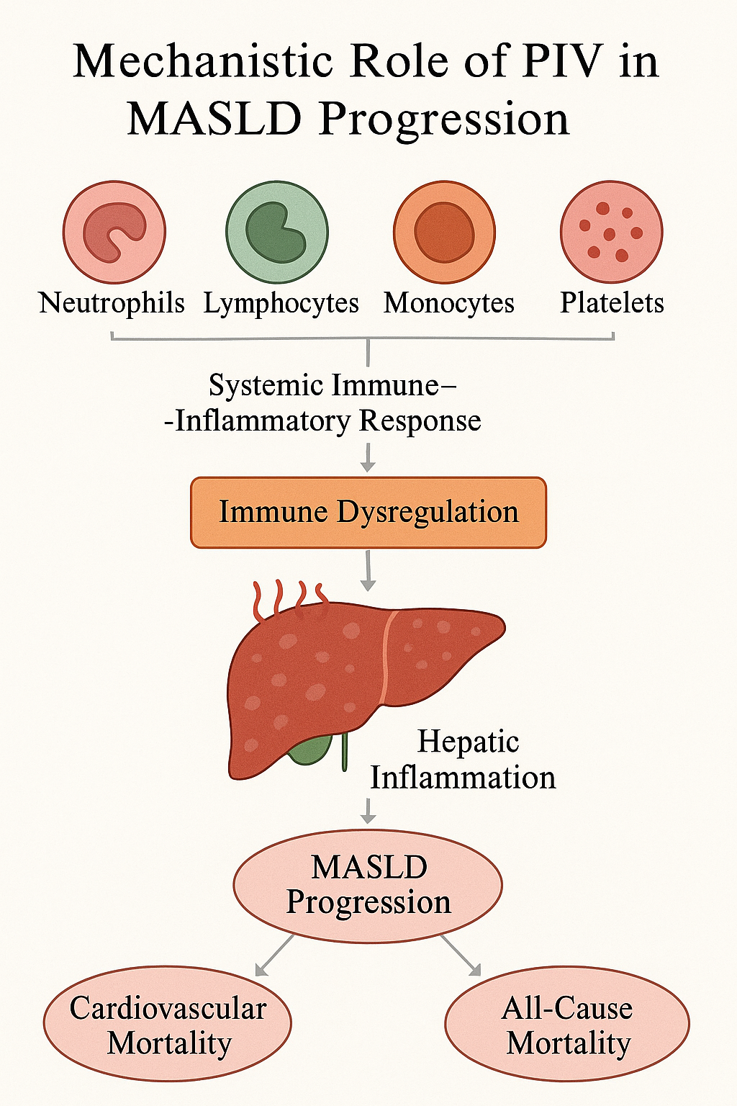

Figure S2. ROC curve for inflammatory markers. A: All-cause; B: CVD-cause.

