Supplementary Figure 1 (A) The ASPR of EOGBTC for both sexes in 2021. (B) The ASIR of EOGBTC for both sexes in 2021. (C) The ASMR of EOGBTC for both sexes in 2021; (D) The ASDR of EOGBTC for both sexes in 2021. EOGBTC, early-onset gallbladder and biliary tract cancer; ASPR, age‐standardized prevalence rate; ASIR, age‐standardized incidence rate; ASMR, age‐standardized mortality rate; ASDR, age-standardized DALYs rate. DALYs, disability-adjusted life years.

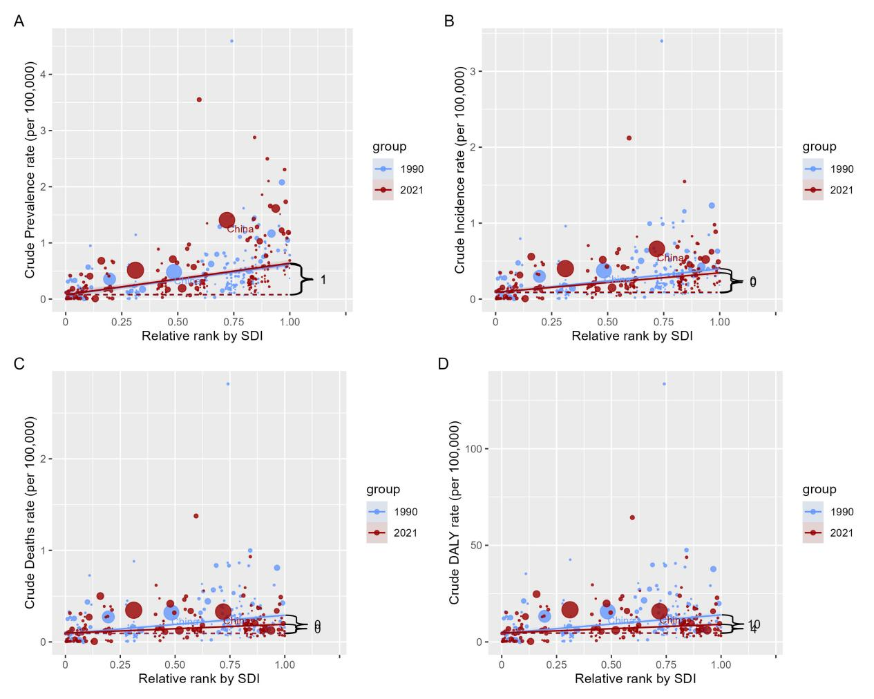

Supplementary Figure 2 Slope indexes for EOGBTC budern from 1990 to 2021 worldwide. (A) EOGBTC prevelence；(B) EOGBTC incidence；(C) EOGBTC morality；（D）EOGBTC DALYs, EOGBTC, early-onset gallbladder and biliary tract cancer; DALYs, disability-adjusted life years.

Supplementary Figure 3 Concentration indexes for EOGBTC DALYs from 1990 to 2021 worldwide EOGBTC, early-onset gallbladder and biliary tract cancer; DALYs, disability-adjusted life years.

