Table S1. Search strategy for Pubmed, Embase and Cochrane Library
 | Pubmed | Embase | Cochrane library
 | Disease terms
1 | Varices | Varices | Varices
2 | Esophageal and gastric varices [Mesh] | Esophagus varices [Emtree] | Esophageal and gastric varices [Mesh]
 | Entry Terms: | Synonyms: | Synonyms:
3 | Esophageal Varices | Esophageal and gastric varices | Varix, Gastric
4 | Esophageal Varix | Esophageal varices | Varices, Gastric
5 | Varices, Esophageal | Esophageal varicosis | Gastric Varix
6 | Varix, Esophageal | Esophageal varix | Gastric Varices
7 | Gastric Varix | Esophagogastric varix | Esophageal Varices
8 | Varices, Gastric | Esophagus varicosis | Varix, Esophageal
9 | Varix, Gastric | Esophagus varix | Esophageal Varix
10 | Gastric Varices | Oesophageal and gastric varices | Varices, Esophageal
11 |  | Oesophageal varices
12 |  | Oesophageal varicosis
13 |  | Oesophageal varix
14 |  | Oesophagogastric varix
15 |  | Oesophagus varicosis
16 |  | Varicosis, esophagus
17 |  | Esophagus varices
18 | 1 or 2 or 3 or 4 or 5 or 6 or 7 or 8 or 9 or 10 | 1 or 2 or 3 or 4 or 5 or 6 or 7 or 8 or 9 or 10 or 11 or 12 or 13 or 14 or 15 or 16 or 17 | 1:ti,ab,kw or 2:ti,ab,kw or 3:ti,ab,kw or 4:ti,ab,kw or 5:ti,ab,kw or 6:ti,ab,kw or 7:ti,ab,kw or 8:ti,ab,kw or 9:ti,ab,kw or 10:ti,ab,kw
 | Bleeding terms
19 | Bleeding | Bleeding | Bleeding
20 | Haematemesis | Haematemesis | Haematemesis
21 | Gastrointestinal Hemorrhage [Mesh] | Upper gastrointestinal bleeding [Emtree] | Gastrointestinal Hemorrhage [Mesh]
 | Entry Terms: | Synonyms: | Synonyms:
22 | Hemorrhage, Gastrointestinal | Bleeding, upper gastrointestinal | Hematochezias
23 | Gastrointestinal Hemorrhages | UGIB (upper gastrointestinal bleeding) | Hematochezia
24 | Hematochezia | Upper digestive bleeding | Hemorrhage, Gastrointestinal
25 | Hematochezias | Upper digestive haemorrhage | Gastrointestinal Hemorrhages
26 |  | Upper digestive hemorrhage
27 |  | Upper digestive tract bleeding
28 |  | Upper digestive tract haemorrhage
29 |  | Upper digestive tract hemorrhage
30 |  | Upper gastrointestinal haemorrhage
31 |  | Upper gastrointestinal hemorrhage
32 |  | Upper gastrointestinal tract bleeding
33 |  | Upper gastrointestinal tract haemorrhage
34 |  | Upper gastrointestinal tract hemorrhage
35 |  | Upper GI bleeding
36 |  | Upper GI haemorrhage
37 |  | Upper GI hemorrhage
38 |  | Upper GI tract bleeding
39 |  | Upper GI tract haemorrhage
40 |  | Upper GI tract hemorrhage
41 |  | Upper gastrointestinal bleeding
42 | 19 or 20 or 21 or 22 or 23 or 24 or 25 | 19 or 20 or 21 or 22 or 23 or 24 or 25 or 26 or 27 or 28 or 29 or 30 or 31 or 32 or 33 or 34 or 35 or 36 or 37 or 38 or 39 or 40 or 41 | 19:ti,ab,kw or 20:ti,ab,kw or 21:ti,ab,kw or 22:ti,ab,kw or 23:ti,ab,kw or 24:ti,ab,kw or 25:ti,ab,kw
 | Time terms
43 | Curative time | Curative time | Curative time
44 | Treatment time | Treatment time | Treatment time
45 | Endoscopy timing | Endoscopy timing | Time to Treatment
46 | Time-to-Treatment[Mesh] | Time to treatment [Emtree] | Endoscopy timing
 | Entry Terms: | Synonyms:
47 | Time-to-Treatments | Door to treatment time
48 | Time to Treatment | Onset to treatment time
49 | Time to Treatments | Symptom to treatment time
50 | Door-to-Treatment Time | Time to therapy
51 | Door to Treatment Time | Time-to-treatment
52 | 43 or 44 or 45 or 46 or 47 or 48 or 49 or 50 or 51 | 43 or 44 or 45 or 46 or 47 or 48 or 49 or 50 or 51 | 43:ti,ab,kw or 44:ti,ab,kw or 45:ti,ab,kw or 46:ti,ab,kw
53 | 18 and 42 and 52 | 18 and 42 and 52 | 18 and 42 and 52
54 | Remove duplicates from 53
55 | Exclude articles with the following criteria: (1) Case reports, editorials, commentaries, letters, review articles, meta analysis, guidelines, clinical conference, clinical trial; (2) non-cirrhotic populations; (3) upper gastrointestinal bleeding unrelated to cirrhosis; (4) studies not focused on the timing of endoscopy; (5) studies that did not report data on mortality or rebleeding in AVB patients.

Table S2. Definitions and primary outcomes of each groups according to the included studies
First author (year) | Decisions of the timing of endoscopy | Definition of time to endoscopy | Group and number of patients in early/ delayed endoscopy | Rebleeding in each group | Death in each group
Cheung(2009) | NA | Interval from initial assessment at the hospital to the time of initiation of sedation at endoscopy. | ≤4 h/>4 h: 57/153  ≤8 h/>8 h: 102/108  ≤12 h/>12 h: 134/76 | In-hospital rebleeding:  ≤4 h/>4 h: 9/31 ≤8 h/>8 h: 21/19 ≤12 h/>12 h: 28/12 | In-hospital death:  ≤4 h/>4 h: 6/14  ≤8 h/>8 h: 11/9  ≤12 h/>12 h: 15/5
Hsu(2009) | Performance of emergent endoscopy and its timing was individualized principally at the discretions of the duty gastroenterologist, and there was no strict regulation during the study period. Endoscopy was performed after initial stabilization. | The time interval(precise to min) between patients’ arrival at hospital (documented at triage in the emergency department) and insertion of UGI endoscopy (documented in the computerized report database). | ≤15 h/>15 h: 176/135 | NA | In-hospital death:  ≤15 h/>15 h: 7/18
Chen(2012) | Endoscopy was performed as soon as possible and the timing depended on the patient’s or family’s will, informed consent, availability of endoscopist, and first aid for resuscitation if there was unstable hemodynamic status. | Door-to-endoscopy time was defined as the time interval between the patient’s arrival at the emergency department and the endoscopic diagnosis and ligation. | ≤12 h/>12 h: 54/47 | 6-week rebleeding: ≤12 h/>12 h: 10/16 | 6-week death:  ≤12 h/>12 h: 12/20
Tapper(2018) | NA | NA | ≤12 h/>12 h: 158/40 | NA | 6-week death:  ≤12 h/>12 h: 10/3
Yoo(2018) | the GI specialist determined the timing of the endoscopy , considering each patient’s age, presence of comorbidities such as renal failure or cardiopulmonary disease, presence of hepatic encephalopathy ,hemodynamic instability , and laboratory abnormalities including anemia, lactic acidosis and coagulopathy . If patients did not exhibit poor clinical factors or they had signs of hepatic encephalopathy more than grade Ⅲ, delayed endoscopic examination was considered. | The time interval from the hospital arrival to the initial endoscopic examination. | ≤12 h/>12 h: 173/101 | 6-week rebleeding:  ≤12 h/>12 h: 35/25 | In-hospital death: ≤12 h/>12 h: 14/8  6-week death:  ≤12 h/>12 h: 39/30
Wang(2018) | NA | NA | 12-24 h/>24 h: 61/63 | 2-week rebleeding:  12-24 h/>24 h: 5/0  6-month rebleeding:  12-24 h/>24 h: 19/21 | 6-week death:  12-24 h/>24 h: 1/6
Huh(2019) | The timing of endoscopy depended on the discretion of the endoscopists on duty, the patient’s will, and hemodynamic status. | For emergency department: the interval between the  patient’s arrival at the emergency department and the endoscopic examination procedure start time.  For in-hospital bleeding: the time interval from the development of symptoms to the endoscopic examination procedure start time. | ≤12 h/>12 h: 317/94 | 6-week rebleeding:  ≤12 h/>12 h: 98/17 | In-hospital death: ≤12 h/>12 h: 40/7
Mousa(2021) | NA | NA | ≤12 h/12-24 h: 180/117 | Rebleeding:  ≤12 h/12-24 h: 0/4 | Death:  ≤12 h/12-24 h: 0/2
Wu(2022) | The timing of endoscopy is determined by the gastrointestinal endoscopist, taking into account the patient’s age, the presence of comorbidities such as renal failure or cardiopulmonary disease, the presence of hepatic encephalopathy, hemodynamic status, and laboratory abnormalities including severe anemia and coagulopathy. | The interval between admission and the start of the endoscopy. | ≤12 h/>12 h: 191/265 | 30 days rebleeding:  ≤12 h/>12 h: 25/23 | 30 days death:  ≤12 h/>12 h: 9/9
Yan(2022) | The timing of endoscopy depended on hemodynamic status, the discretion of the endoscopists on duty, and the patient’s will. | The interval between the hospital arrival and the initial endoscopic  procedure. | < 6 h/6-24 h: 170/142 | 6-week rebleeding:  ≤6 h/6-24 h: 19/23 | 6-week death:  ≤6 h/6-24 h: 28/15
Peng(2023) | The discretion of attending physicians according to the patients’ age, consciousness, comorbidities, and  hemodynamics. | The interval from the  admission to endoscopy. | <12 h/≥12 h: 75/453  <24 h/≥24 h: 175/349  <48 h/>48 h: 289/236 | 5-day rebleeding:  <12 h/≥12 h: 5/21  <24 h/≥24 h: 10/17  <48 h/≥48 h: 13/13 | In-hospital death:  <12 h/≥12 h: 4/8  <24 h/≥24 h: 7/6  <48 h/≥48 h: 8/5
Zhang(2023) | Endoscopy timing was at the discretion of the gastroenterologist on call. | The interval between the patient’s arrival at the emergency department and the endoscopic examination procedure start, within 24 hours after consultation. | < 6 h/6-24 h: 2383/936 | 5-day rebleeding:  < 6 h/6-24 h: 89/27 | In-hospital death:  < 6 h/6-24 h: 66/11
NA, not available in the original studies.

Table S3. Secondary outcomes of each groups according to the included studies
First author (year) | Length of hospital stay | Need for salvage treatment | Units of transfusion
Cheung(2009) | ≤12 h/>12 h: 9.1 ± 8.5/8.4 ± 6.6 | NA | ≤12 h/>12 h: 3.7 ± 3.0/3.6 ± 2.6
Hsu(2009) | NA | NA | NA
Chen(2012) | NA | NA | NA
Tapper(2018) | NA | NA | NA
Yoo(2018) | ≤12 h/>12 h: 5.1 ± 5.2/6.1 ± 6.0 | NA | NA
Wang(2018) | 12-24 h/>24 h: 10 ± 3.3/12.5 ± 3.8 | NA | NA
Huh(2019) | ≤12 h/>12 h: 11.9 ± 10.6/11.8 ± 6.4 | ≤12 h/>12 h: 47/8 | ≤12 h/>12 h: 4.4 ± 4.0/3.1 ± 2.7
Mousa(2021) | ≤12 h/12-24 h: 2 ± 0.79/4.9 ± 1.05 | NA | NA
Wu(2022) | ≤12 h/>12 h: 9.3 ± 3.0/9.0 ± 3.3 | ≤12 h/>12 h: 24/22 | ≤12 h/>12 h: 2.4 ± 3.0/1.6 ± 2.9
Yan(2022) | ≤6 h/6-24 h: 15.10 ± 8.09/16.40 ± 7.88 | ≤6 h/6-24 h: 10/5 | ≤6 h/6-24 h: 1.40 ± 1.83/2.13 ± 3.17
Peng(2023) | NA | NA | NA
Zhang(2023) | < 6 h/6-24 h: 16.28 ± 10.84/12.89 ± 9.68 | <6 h/6-24 h: 531/201 | NA
NA, not available in the original studies.

Table S4. Outcomes and management of included studies
First author (year) | Statistical differences in the primary outcomes | PSM or IPW |  | Primary outcomes after PSM or IPW | Prophylactic antibiotic (%) | Vasoactive drugs (%) | Independent risk factor for the primary outcome
Cheung (2009) | No significant difference in mortality and rebleeding | NA | / |  | 22% | 70% | Mortality: infection, albumin, MELD score
Hsu(2009) | Mortality: The urgent group was lower than the early group (P < 0.05). | NA | / |  | NA | 97.43% | Mortality: door-to-endoscopy, MELD score, first EGD failure, hematemesis
Chen(2012) | Mortality and rebleeding in the hematemesis group: The urgent group was lower than the early group (P < 0.05). Mortality and rebleeding in the non-hematemesis group: no significant differences were observed. | NA | / |  | 100% | 100% | Rebleeding: door-to-endoscopy, MELD score, portal vein thrombosis  Mortality: Hematemesis at arrival, MELD score, HCC
Tapper(2018) | No significant difference in mortality | NA | / |  | 84.9% | 90.8% | NA
Yoo(2018) | No significant difference in mortality and rebleeding | IPW | No statistically significant changes. |  | 100% | 100% | Mortality: age, MELD score, HCC, diabetes mellitus, moderate to severe initial ascites
Wang(2018) | Mortality: The urgent group was lower than the early group (P < 0.05). Rebleeding: The 2-week was higher in the urgent group than early group (P < 0.05), no significant difference in the 6-month. | NA | / |  | 100% | 100% | NA
Huh(2019) | Mortality: No significant difference. Rebleeding: The urgent group was higher than the early group (P < 0.05). | PSM | NA |  | 100% | 100% | Rebleeding and mortality: time to endoscopy, age, MELD score, observation without therapy, systolic blood pressure, infection
Mousa(2021) | Mortality and rebleeding in the urgent group were lower than the early group. | NA | / |  | 100% | 100% | NA
Wu(2022) | No significant difference in mortality and rebleeding | PSM | Rebleeding: The urgent group was higher than the early group (P < 0.05). Mortality: No statistically significant changes. |  | 100% | 100% | Rebleeding and mortality: age and shock on admission
Yan(2022) | No significant difference in mortality and rebleeding | NA | / |  | 100% | 100% | Mortality: HCC, Glasgow-Blatchford score, MELD score, bleeding time, encephalopathy
Peng(2023) | No significant difference in mortality and rebleeding | PSM | No statistically significant changes. |  | NA | 100% | NA
Zhang(2023) | Mortality: The urgent group was higher than the early group (P < 0.05). Rebleeding: No significant difference. | PSM | Mortality: No significant difference. Rebleeding: No statistically significant changes. |  | 100% | 100% | Rebleeding: Child-Pugh class
NA, not available in the original studies; PSM, propensity score matching; IPW, Inverse Probability Weighting; MELD, model for end-stage liver disease; HCC, hepatocellular carcinoma; EGD, esophagogastroduodenoscopy

Table S5. Quality of studies assessment using Newcastle-Ottawa Quality Assessment Scale.
First author (year) | Selection |  |  |  |  | Comparability |  | Outcome |  |  | Total
First author (year) | NOS1 | NOS2 | NOS3 | NOS4 |  | NOS5 |  | NOS6 | NOS7 | NOS8 | Total
Cheung (2009) | * | * | * | * |  | * |  | * | / | / | 6
Hsu(2009) | * | * | * | * |  | / |  | * | / | / | 5
Chen(2012) | * | * | * | * |  | / |  | * | * | * | 7
Tapper(2018) | * | * | * | * |  | / |  | * | * | * | 7
Yoo(2018) | * | * | * | * |  | * |  | * | * | * | 8
Wang(2018) | * | * | * | * |  | * |  | * | * | * | 8
Huh(2019) | * | * | * | * |  | * |  | * | * | * | 8
Mousa(2021) | * | * | * | / |  | * |  | * | / | / | 5
Wu(2022) | * | * | * | * |  | * |  | * | * | * | 8
Yan(2022) | * | * | * | * |  | * |  | * | * | * | 8
Peng(2023) | * | * | * | * |  | * |  | * | / | * | 7
Zhang(2023) | * | * | * | * |  | * |  | * | / | * | 7
NOS1: Representativeness of the exposed cohort; NOS2: Selection of the non exposed cohort; NOS3: Ascertainment of exposure; NOS4: Demonstration that outcome of interest was not present at start of study; NOS5: Comparability of cohorts on the basis of the design or analysis; NOS6: Assessment of outcome; NOS7: Was follow up long enough for outcomes to occur; NOS8: Adequacy of follow up of cohorts;

Table S6. Hemodynamics of each groups according to the included studies
First author (year) | SBP (mmHg) |  |  | Heart rate (beat/min) |  |  | Hemoglobin (g/L) |  |  | GBS score
First author (year) | urgent | early | P value | urgent | early | P value | urgent | early | P value | urgent | early | P value
Cheung(2009) | NA | NA | NA | NA | NA | NA | NA | NA | NA | NA | NA | NA
Hsu(2009) | NA | NA | NA | NA | NA | NA | NA | NA | NA | NA | NA | NA
Chen(2012) | NA | NA | NA | NA | NA | NA | NA | NA | NA | NA | NA | NA
Tapper(2018) | NA | NA | NA | NA | NA | NA | NA | NA | NA | NA | NA | NA
Yoo(2018) | 116 ± 26 | 120 ± 26 | 0.221 | 96 ± 19 | 94 ± 17 | 0.551 | 90 ± 25 | 96 ± 25 | 0.044 | 9.2 ± 3.3 | 9.1 ± 3.9 | 0.818
Wang(2018) | NA | NA | NA | NA | NA | NA | NA | NA | NA | NA | NA | NA
Huh(2019) | 107.3 ± 25.6 | 106.2 ± 22.1 | 0.712 | 98.4 ± 21 | 88.7 ± 18.5 | <0.001 | NA | NA | NA | NA | NA | NA
Mousa(2021) | NA | NA | NA | NA | NA | NA | 79 ± 26 | 78 ± 23 | 0.61 | NA | NA | NA
Wu(2022) | 113.1 ± 19.9 | 114.4 ± 17.7 | 0.18 | 88.1 ± 15.6 | 81.7 ± 15.2 | <0.001 | 82 ± 22.5 | 84 ± 22.4 | 0.503 | 12.4 ± 3.2 | 11.5 ± 3.5 | 0.004
Yan(2022) | 112.1± 18.31 | 113.89 ± 16.63 | 0.37 | 96.71 ± 16.73 | 93.67 ± 15.88 | 0.099 | 76.16 ± 22.14 | 76.75 ± 19.85 | 0.807 | 11.2 ± 3.02 | 11.24 ± 3.13 | 0.91
Peng(2023) | NA | NA | NA | NA | NA | NA | NA | NA | NA | NA | NA | NA
Zhang(2023) | 114.35 ± 17.53 | 114.24 ± 17.81 | NA | 86.35 ± 23.64 | 86.82 ± 17.15 | NA | 75 ± 30 | 77.75 ± 30.3 | NA | NA | NA | NA
NA, not available in the original studies. SBP, systolic blood pressure;

Table S7. Severity of liver disease of each groups according to the included studies
First author (year) | Child-Pugh score |  |  | MELD score
First author (year) | urgent | early | P value | urgent | early | P value
Cheung(2009) | NA | NA | NA | NA | NA | NA
Hsu(2009) | NA | NA | NA | NA | NA | NA
Chen(2012)* | 9.35 ± 2.28 | 9.35 ± 2.29 | 0.793 | 13.53 ± 6.47 | 16.35 ± 8.41 | 0.109
Tapper(2018) | NA | NA | NA | NA | NA | NA
Yoo(2018) | NA | NA | NA | 15.4 ± 6.9 | 16.9 ± 9.2 | 0.112
Wang(2018) | NA | NA | NA | NA | NA | NA
Huh(2019) | 8.2 ± 2.4 | 8.5 ± 2.4 | 0.222 | 12.3 ± 7.1 | 11.5 ± 6.4 | 0.326
Mousa(2021) | NA | NA | NA | NA | NA | NA
Wu(2022) | 7.8 ± 1.8 | 7.2 ± 1.6 | 0.001 | 10.6 ± 4 | 9.3 ± 4.1 | 0.003
Yan(2022) | 8.19 ± 1.83 | 7.89 ± 1.48 | 0.11 | 14.04 ± 4.92 | 14.42 ± 5.09 | 0.502
Peng(2023) | NA | NA | NA | NA | NA | NA
Zhang(2023) | NA | NA | NA | NA | NA | NA
NA, not available in the original studies. MELD, model for end-stage liver disease; *Provided the median and interquartile range, we used the Median to Mean Converterit tool to convert it into the form of mean ± standard deviation. For detailed information, please refer to https://www.math.hkbu.edu.hk/~tongt/papers/median2mean.html.

Table S8. Child-Pugh score and MELD score associated with the rebleeding and mortality in meta-regression
Variable | outcomes | OR | 95% CI | P value
Child-Pugh score | mortality | 0.36 | 0.17 to 0.76 | 0.007
Child-Pugh score | rebleeding | 0.44 | 0.15 to 1.29 | 0.134
MELD score | mortality | 0.85 | 0.59 to 1.23 | 0.394
MELD score | rebleeding | 0.8 | 0.62 to 1.04 | 0.096
MELD, model for end-stage liver disease;
Table S9. Publication bias
Outcomes | Egger’s test. (P value) | Begg’s test. (P value)
Primary outcomes
Overall mortality
Bias | 0.41 | 0.34
Overall rebleeding
Bias | 0.4 | 0.1
Secondary outcomes
Length of hospital stay
Bias | 0.06 | 0.05
Need for salvage treatment
Bias | 0.04 | 0.5
Units of transfusion
Bias | 0.7 | 1
Subgroup analysis
Mortality under different definitions of endoscopy timing
6 h versus 6-24 h
Bias | NA | NA
12 h versus 12-24 h
Bias | 0.8 | 0.8
Rebleeding under different definitions of endoscopy timing
6 h versus 6-24 h
Bias | NA | NA
12 h versus 12-24 h
Bias | 0.48 | 0.12
Reporting time of mortality
6-week
Bias | 0.52 | 0.57
In-hospital
Bias | 0.78 | 0.85
Reporting time of rebleeding
6-week
Bias | 0.8 | 0.35
In-hospital
Bias | 0.07 | 0.12

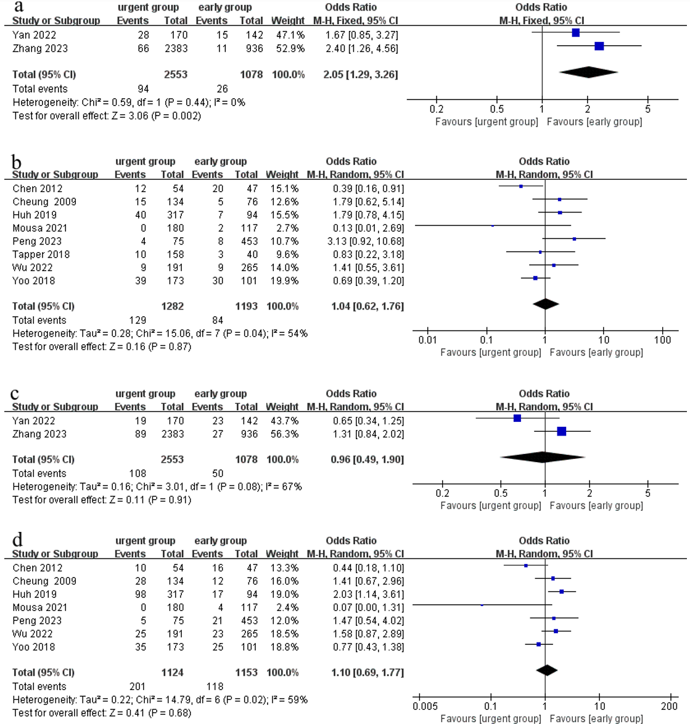
Figure S1. Forrest plot of the different definitions of endoscopy timing in subgroup analysis. (a) Mortality under endoscopy timing was defined as <6 h and 6-24 h; (b) Mortality under endoscopy timing was defined as ≤12 h and >12 h; (c) Rebleeding under endoscopy timing was defined as <6 h and 6-24 h; (d) Rebleeding under endoscopy timing was defined as ≤12 h and >12 h;

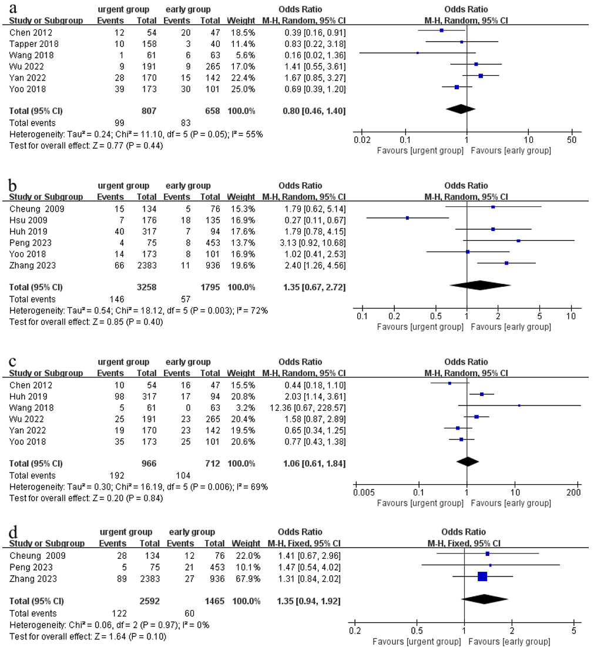
Figure S2. Forrest plot of the reporting time in subgroup analysis. (a) 6-week mortality; (b) in-hospital mortality; (c) 6-week rebleeding; (d) in-hospital rebleeding;
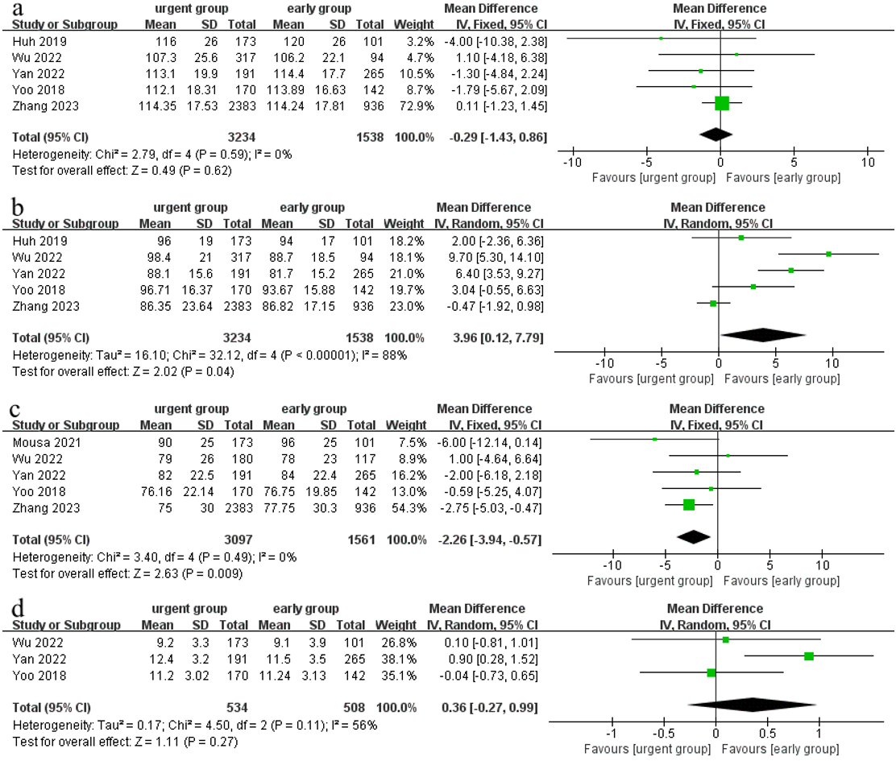
Figure S3. Forrest plot of the hemodynamics in subgroup analysis. (a) SBP; (b) heart rate; (c) hemoglobin; (d) Glasgow-Blatchford score;

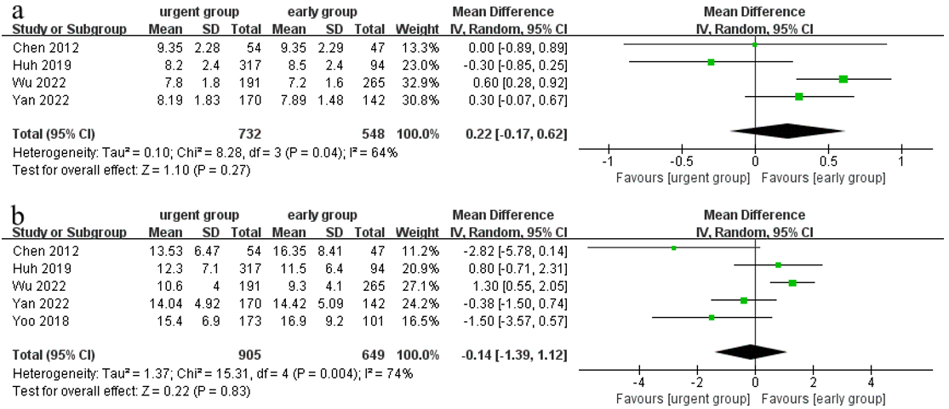
Figure S4. Forrest plot of the severity of liver disease in subgroup analysis. (a) Child-Pugh score; (b) MELD score;

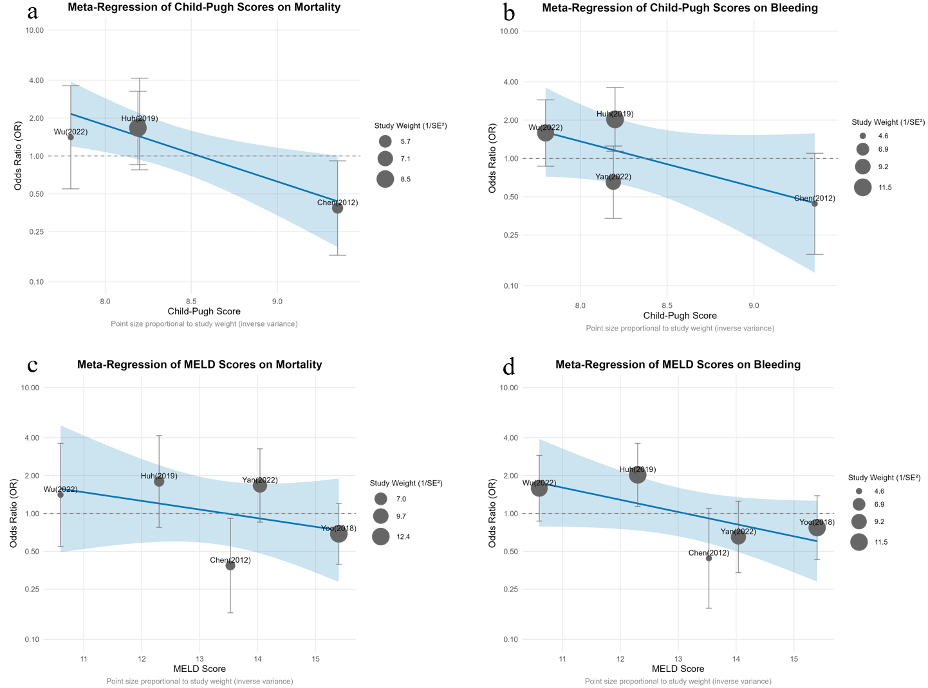
Figure S5. Forrest plot of the severity of liver disease in subgroup analysis. (a) Meta-Regression of Child-Pugh Scores on Mortality; (b) Meta-Regression of Child-Pugh Scores on Bleeding; (c) Meta-Regression of MELD Scores on Mortality; (d) Meta-Regression of MELD Scores on Bleeding; The figure shows the results of the meta-regression analysis based on the Child and MELD score, exploring their impact on the risk of mortality and rebleeding in patients with AVB. Each bubble in the figure represents a study. The size of the bubble is directly proportional to the research accuracy; that is, the higher the accuracy, the larger the bubble. The blue straight line represents the trend of linear regression, and the shaded area is the 95% confidence interval.

PRISMA 2020 Checklist
Section and Topic | Item # | Checklist item | Location where item is reported
TITLE
Title | 1 | Identify the report as a systematic review. | P1
ABSTRACT
Abstract | 2 | See the PRISMA 2020 for Abstracts checklist. | P1
INTRODUCTION
Rationale | 3 | Describe the rationale for the review in the context of existing knowledge. | P2
Objectives | 4 | Provide an explicit statement of the objective(s) or question(s) the review addresses. | P2
METHODS
Eligibility criteria | 5 | Specify the inclusion and exclusion criteria for the review and how studies were grouped for the syntheses. | P3
Information sources | 6 | Specify all databases, registers, websites, organisations, reference lists and other sources searched or consulted to identify studies. Specify the date when each source was last searched or consulted. | P2
Search strategy | 7 | Present the full search strategies for all databases, registers and websites, including any filters and limits used. | P2-P3
Selection process | 8 | Specify the methods used to decide whether a study met the inclusion criteria of the review, including how many reviewers screened each record and each report retrieved, whether they worked independently, and if applicable, details of automation tools used in the process. | P3
Data collection process | 9 | Specify the methods used to collect data from reports, including how many reviewers collected data from each report, whether they worked independently, any processes for obtaining or confirming data from study investigators, and if applicable, details of automation tools used in the process. | P3
Data items | 10a | List and define all outcomes for which data were sought. Specify whether all results that were compatible with each outcome domain in each study were sought (e.g. for all measures, time points, analyses), and if not, the methods used to decide which results to collect. | P3
Data items | 10b | List and define all other variables for which data were sought (e.g. participant and intervention characteristics, funding sources). Describe any assumptions made about any missing or unclear information. | P3
Study risk of bias assessment | 11 | Specify the methods used to assess risk of bias in the included studies, including details of the tool(s) used, how many reviewers assessed each study and whether they worked independently, and if applicable, details of automation tools used in the process. | P3
Effect measures | 12 | Specify for each outcome the effect measure(s) (e.g. risk ratio, mean difference) used in the synthesis or presentation of results. | P4
Synthesis methods | 13a | Describe the processes used to decide which studies were eligible for each synthesis (e.g. tabulating the study intervention characteristics and comparing against the planned groups for each synthesis (item #5)). | P4
Synthesis methods | 13b | Describe any methods required to prepare the data for presentation or synthesis, such as handling of missing summary statistics, or data conversions. | P4
Synthesis methods | 13c | Describe any methods used to tabulate or visually display results of individual studies and syntheses. | P4
Synthesis methods | 13d | Describe any methods used to synthesize results and provide a rationale for the choice(s). If meta-analysis was performed, describe the model(s), method(s) to identify the presence and extent of statistical heterogeneity, and software package(s) used. | P4
Synthesis methods | 13e | Describe any methods used to explore possible causes of heterogeneity among study results (e.g. subgroup analysis, meta-regression). | P4
Synthesis methods | 13f | Describe any sensitivity analyses conducted to assess robustness of the synthesized results. | P4
Reporting bias assessment | 14 | Describe any methods used to assess risk of bias due to missing results in a synthesis (arising from reporting biases). | P4
Certainty assessment | 15 | Describe any methods used to assess certainty (or confidence) in the body of evidence for an outcome. | P4
RESULTS
Study selection | 16a | Describe the results of the search and selection process, from the number of records identified in the search to the number of studies included in the review, ideally using a flow diagram. | P4
Study selection | 16b | Cite studies that might appear to meet the inclusion criteria, but which were excluded, and explain why they were excluded. | P4
Study characteristics | 17 | Cite each included study and present its characteristics. | P4-P5
Risk of bias in studies | 18 | Present assessments of risk of bias for each included study. | P4
Results of individual studies | 19 | For all outcomes, present, for each study: (a) summary statistics for each group (where appropriate) and (b) an effect estimate and its precision (e.g. confidence/credible interval), ideally using structured tables or plots. | P5-P7
Results of syntheses | 20a | For each synthesis, briefly summarise the characteristics and risk of bias among contributing studies. | P5-P7
Results of syntheses | 20b | Present results of all statistical syntheses conducted. If meta-analysis was done, present for each the summary estimate and its precision (e.g. confidence/credible interval) and measures of statistical heterogeneity. If comparing groups, describe the direction of the effect. | P5-P7
Results of syntheses | 20c | Present results of all investigations of possible causes of heterogeneity among study results. | P5-P7
Results of syntheses | 20d | Present results of all sensitivity analyses conducted to assess the robustness of the synthesized results. | P7
Reporting biases | 21 | Present assessments of risk of bias due to missing results (arising from reporting biases) for each synthesis assessed. | P5-P7
Certainty of evidence | 22 | Present assessments of certainty (or confidence) in the body of evidence for each outcome assessed. | P5-P7
DISCUSSION
Discussion | 23a | Provide a general interpretation of the results in the context of other evidence. | P7-P8
Discussion | 23b | Discuss any limitations of the evidence included in the review. | P8-P10
Discussion | 23c | Discuss any limitations of the review processes used. | P8-P10
Discussion | 23d | Discuss implications of the results for practice, policy, and future research. | P10
OTHER INFORMATION
Registration and protocol | 24a | Provide registration information for the review, including register name and registration number, or state that the review was not registered. | P2
Registration and protocol | 24b | Indicate where the review protocol can be accessed, or state that a protocol was not prepared. | P2
Registration and protocol | 24c | Describe and explain any amendments to information provided at registration or in the protocol. | P2
Support | 25 | Describe sources of financial or non-financial support for the review, and the role of the funders or sponsors in the review. | P12
Competing interests | 26 | Declare any competing interests of review authors. | P12
Availability of data, code and other materials | 27 | Report which of the following are publicly available and where they can be found: template data collection forms; data extracted from included studies; data used for all analyses; analytic code; any other materials used in the review. | P12
From: Page MJ, McKenzie JE, Bossuyt PM, Boutron I, Hoffmann TC, Mulrow CD, et al. The PRISMA 2020 statement: an updated guideline for reporting systematic reviews. BMJ 2021;372:n71. doi: 10.1136/bmj.n71. This work is licensed under CC BY 4.0. To view a copy of this license, visit https://creativecommons.org/licenses/by/4.0/

