Supplementary Table 1
Item | GERD (50) | SCG (53) | χ²/t | p
DeMeester scores | 17.80(14.83, 19.65) | 10.48(7.86, 10.48) | 12.138 | <0.001

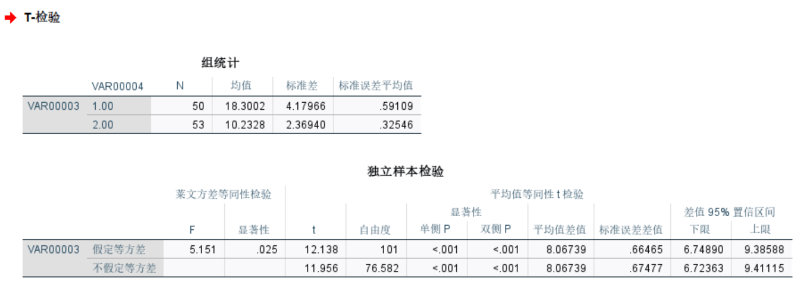

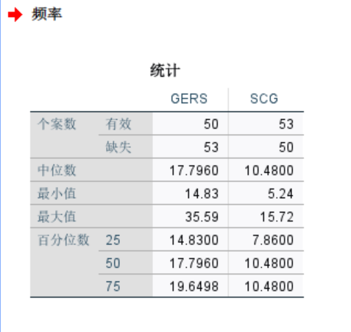

Supplementary Table 2
GERD |  |  | SCG
 | SIBO |  |  | SIBO
 | r | p |  | r | p
PPI | -0.247 | 0.084 | PPI | 0.039 | 0.780
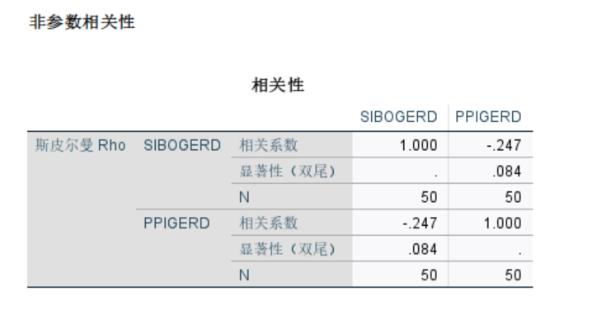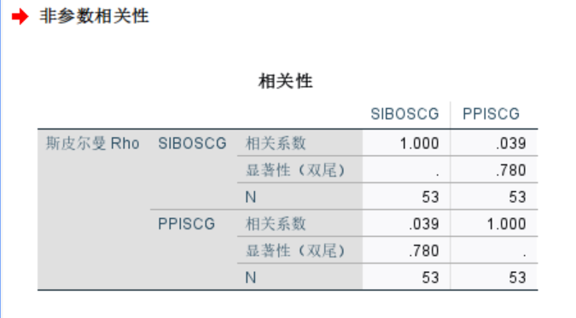

Supplementary Table 3
 | GSRS | GAD-7 | PSQI
cronbach α | 0.949 | 0.898 | 0.859
