Supplementary figure 1 Images taken by gastroscopy in RE and non-RE groups.
RE group:
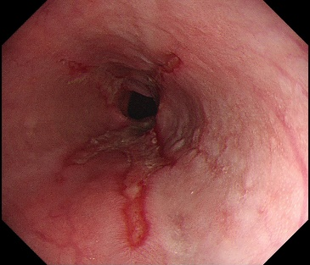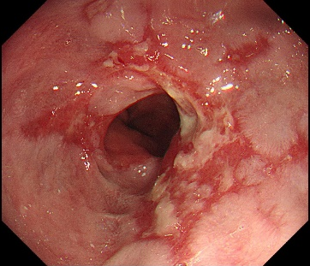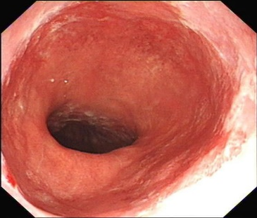
No. 1 | No.2 | No.3
Male | Male | Male
Age, 63 | Age, 60 | Age, 67
LA-C | LA-D | LA-B

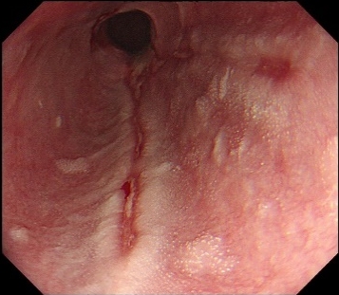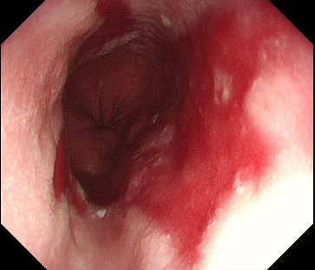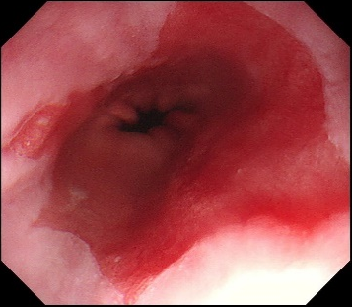
No. 4 | No.5 | No.6
Male | Female | Female
Age, 71 | Age, 59 | Age, 48
LA-C | LA-C | LA-C

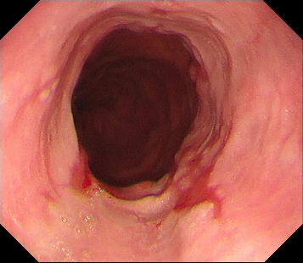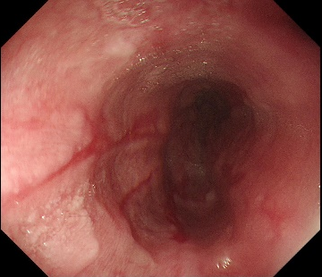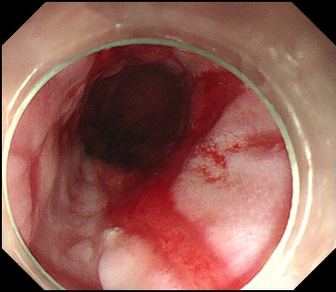
No. 7 | No.8 | No.9
Male | Male | Male
Age, 64 | Age, 52 | Age, 68
LA-B | LA-C | LA-D

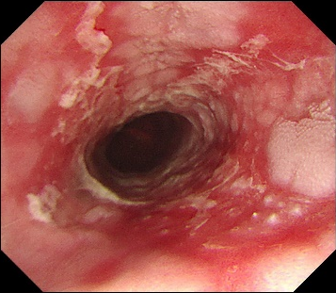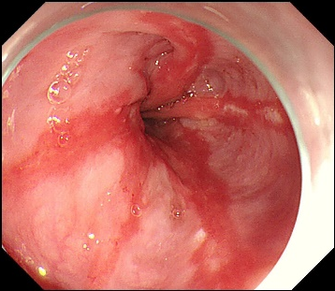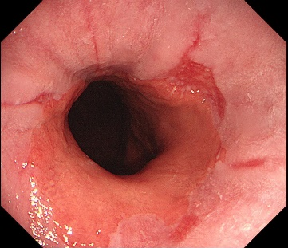
No. 10 | No.11 | No.12
Male | Female | Male
Age, 69 | Age, 67 | Age, 30
LA-D | LA-C | LA-B

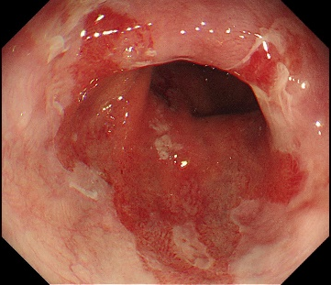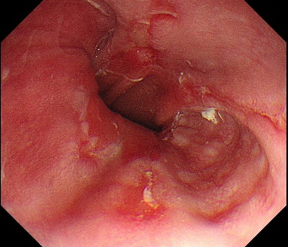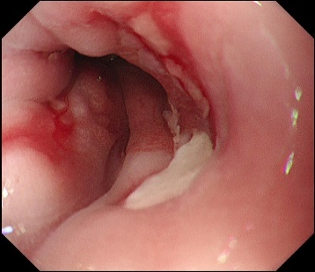
No. 13 | No.14 | No.15
Female | Male | Male
Age, 61 | Age, 50 | Age, 48
LA-D | LA-D | LA-D

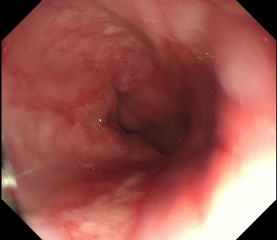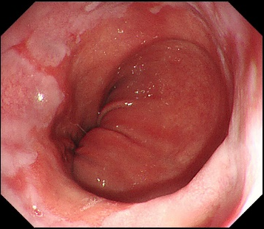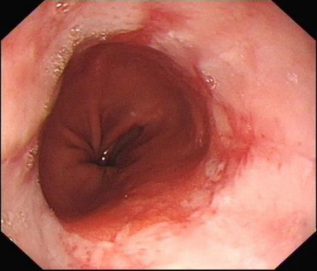
No. 16 | No.17 | No.18
Female | Male | Female
Age, 74 | Age, 42 | Age, 63
LA-B | LA-C | LA-C

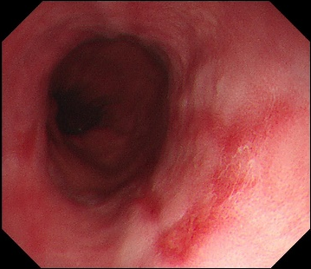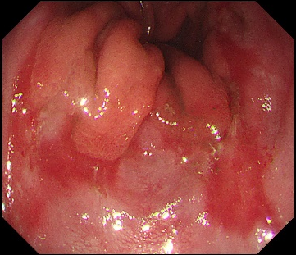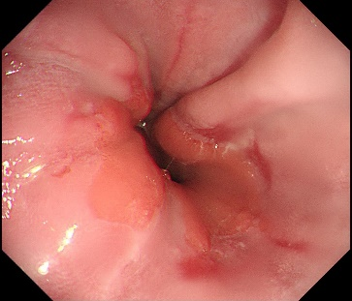
No. 19 | No.20 | No.21
Male | Female | Male
Age, 55 | Age, 61 | Age, 37
LA-B | LA-C | LA-C

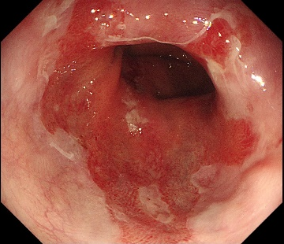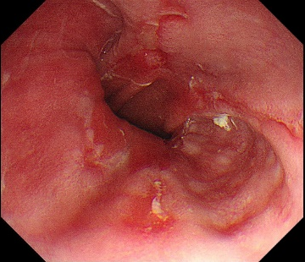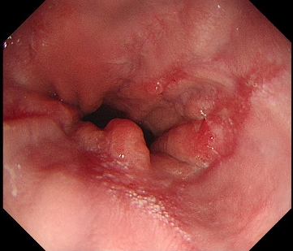
No. 22 | No.23 | No.24
Male | Male | Male
Age, 71 | Age, 58 | Age, 33
LA-C | LA-C | LA-C

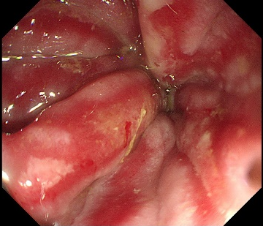
No. 25
Male
Age, 59
LA-C

Non-RE group:
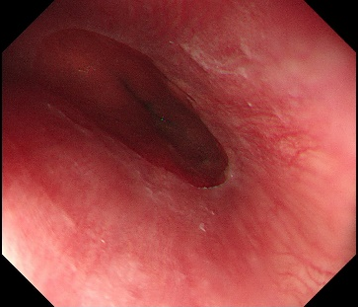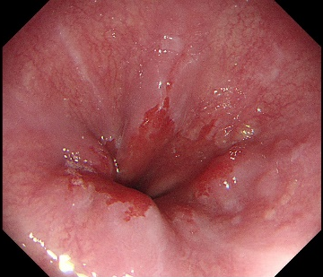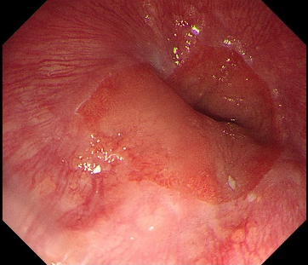
No. 1 | No.2 | No.3
Male | Male | Female
Age, 82 | Age, 62 | Age, 73

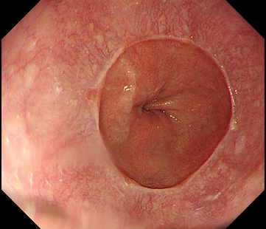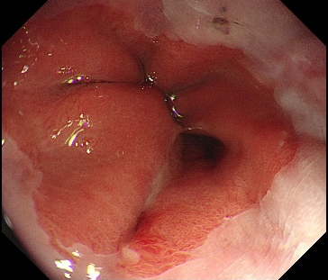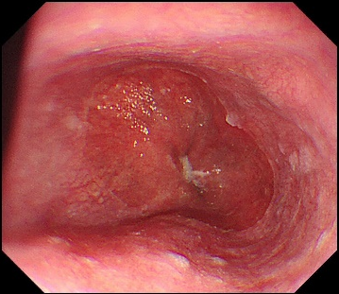
No. 4 | No.5 | No.6
Female | Male | Female
Age, 60 | Age, 57 | Age, 70

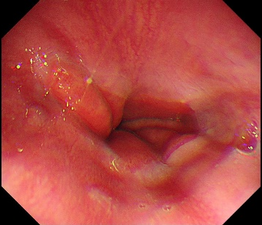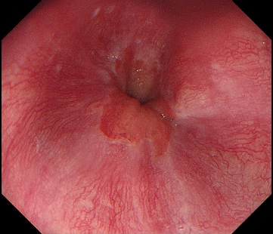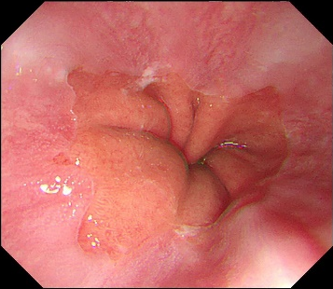
No. 7 | No.8 | No.9
Male | Male | Female
Age, 30 | Age, 67 | Age, 54

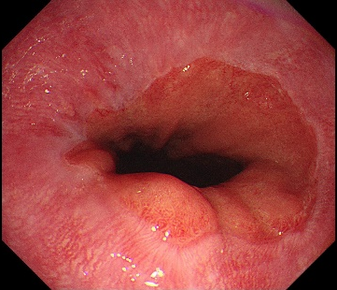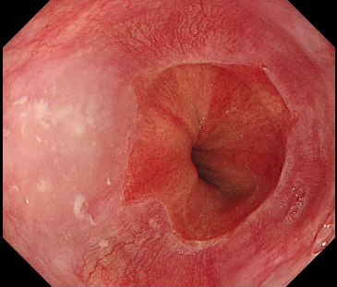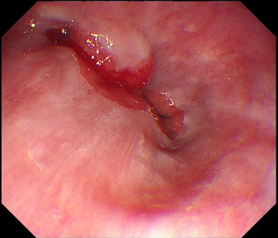
No. 10 | No.11 | No.12
Male | Female | Male
Age, 40 | Age, 75 | Age, 78

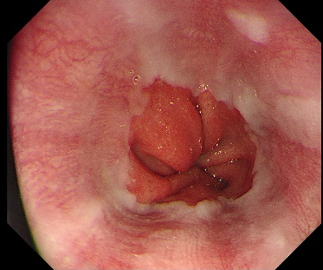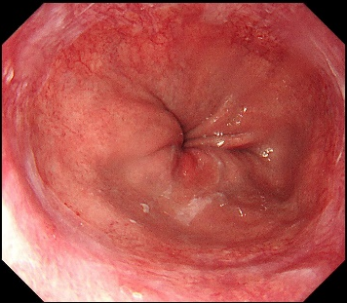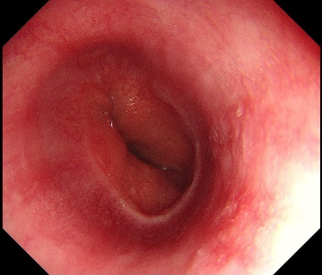
No. 13 | No.14 | No.15
Male | Male | Female
Age, 43 | Age, 59 | Age, 41

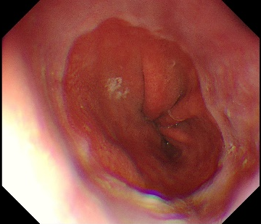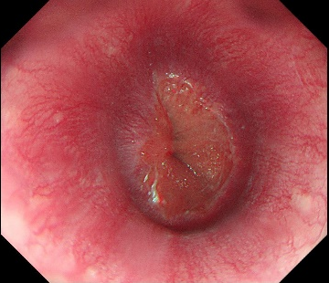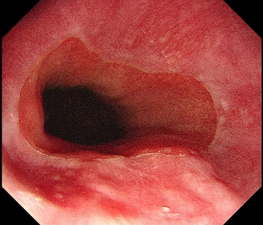
No. 16 | No.17 | No.18
Female | Female | Female
Age, 47 | Age, 46 | Age, 46

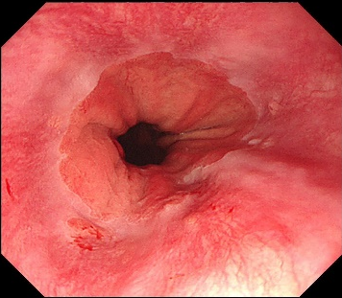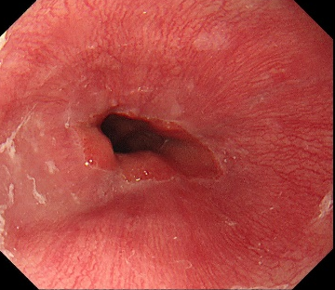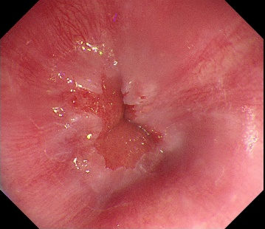
No. 19 | No.20 | No.21
Male | Female | Female
Age, 55 | Age, 56 | Age, 62

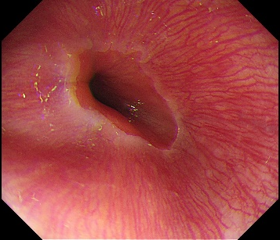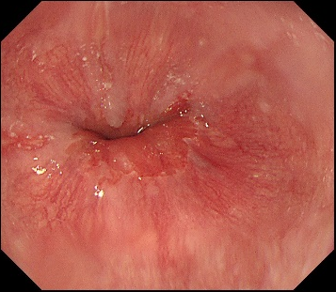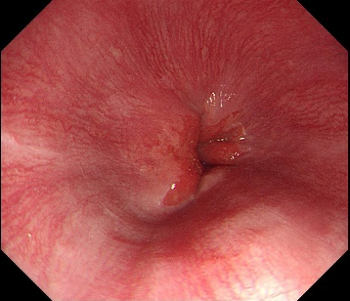
No. 22 | No.23 | No.24
Female | Male | Male
Age, 56 | Age, 61 | Age, 66

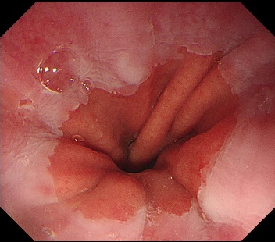
No. 25
Female
Age, 58

