Supplementary Figure S1
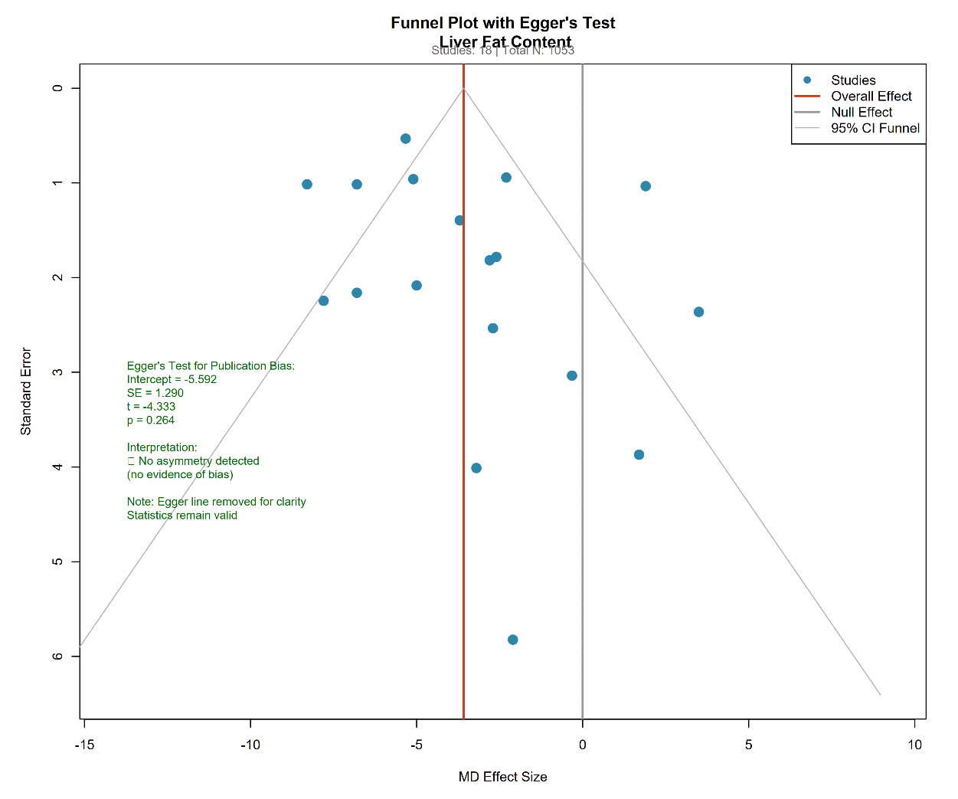
Supplementary Figure S1A : Funnel Plot of Liver Fat Content

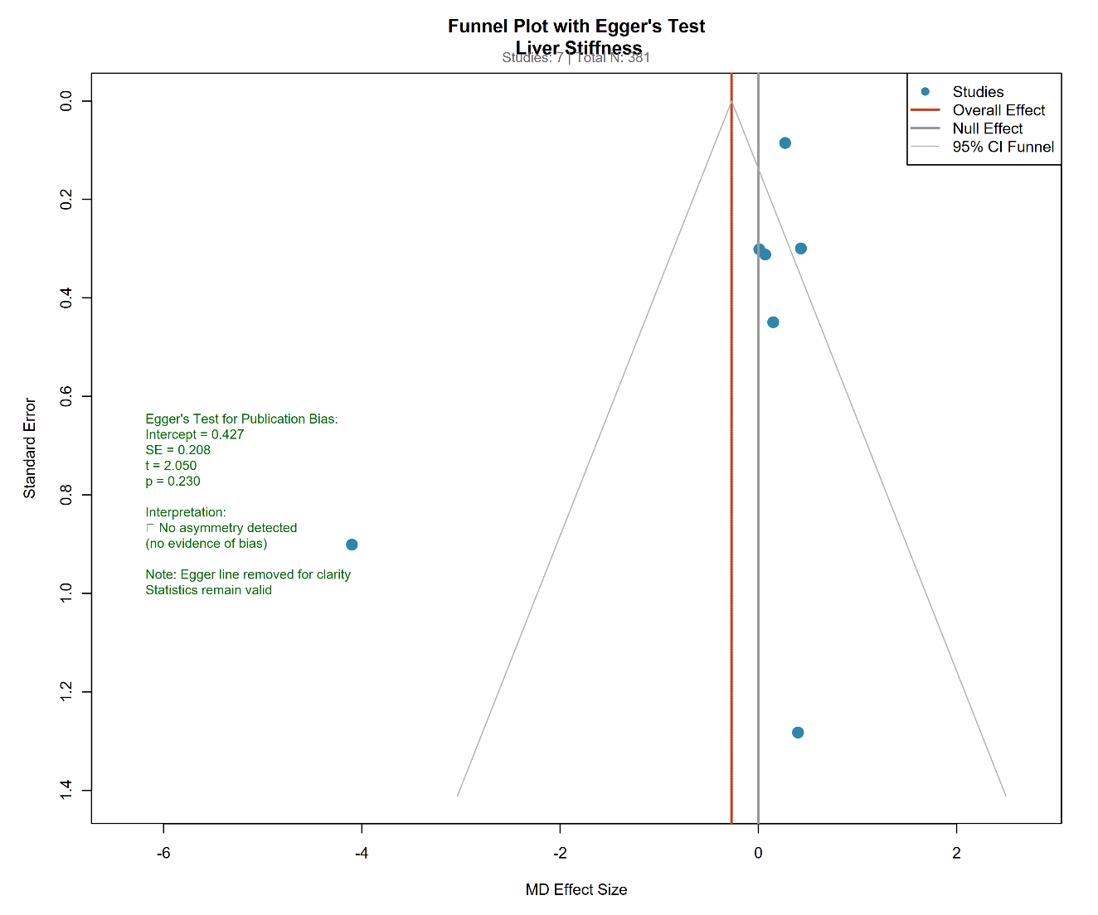
Supplementary Figure S1B : Funnel Plot of Liver Stiffness

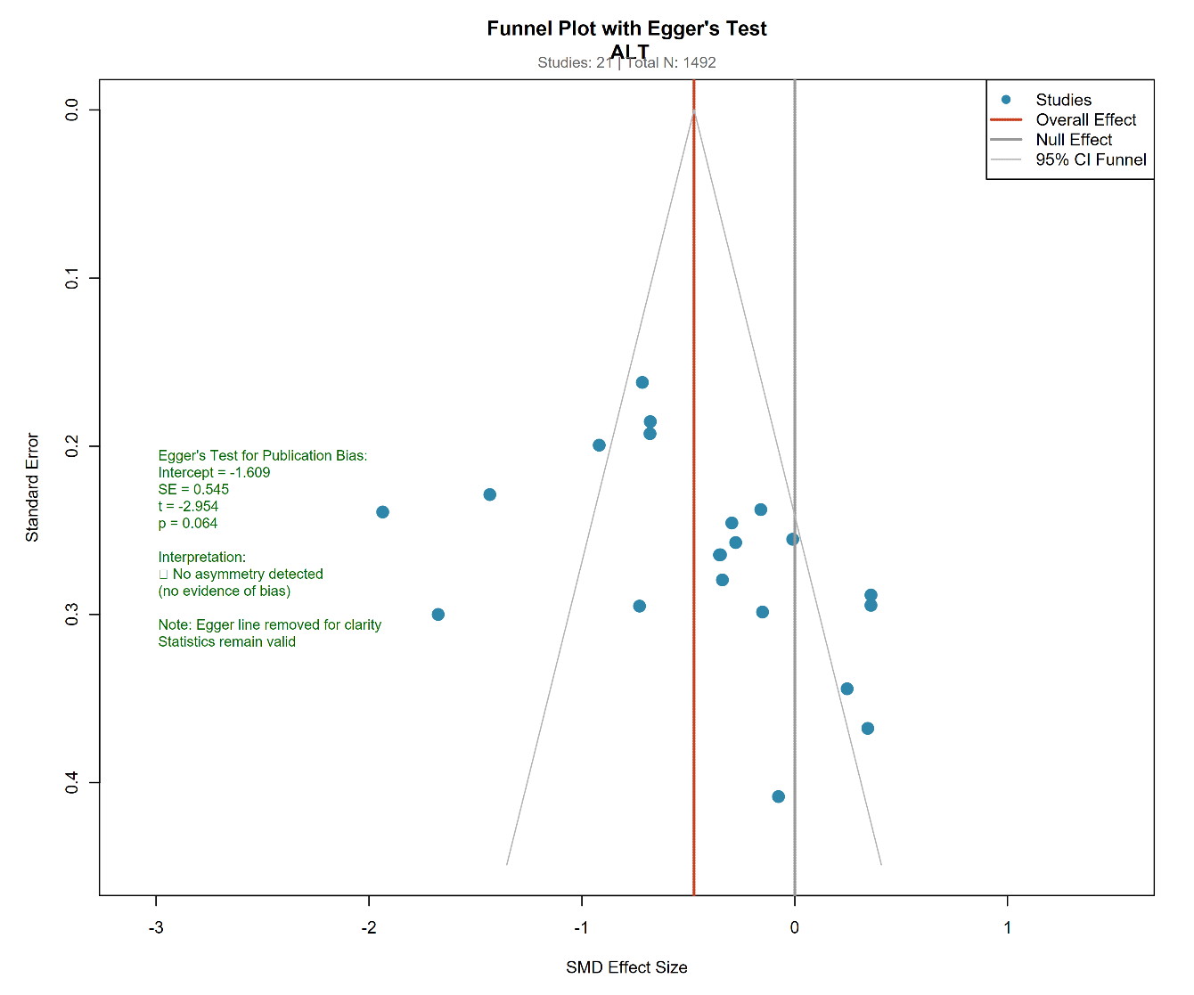
Supplementary Figure S1C : Funnel Plot of ALT
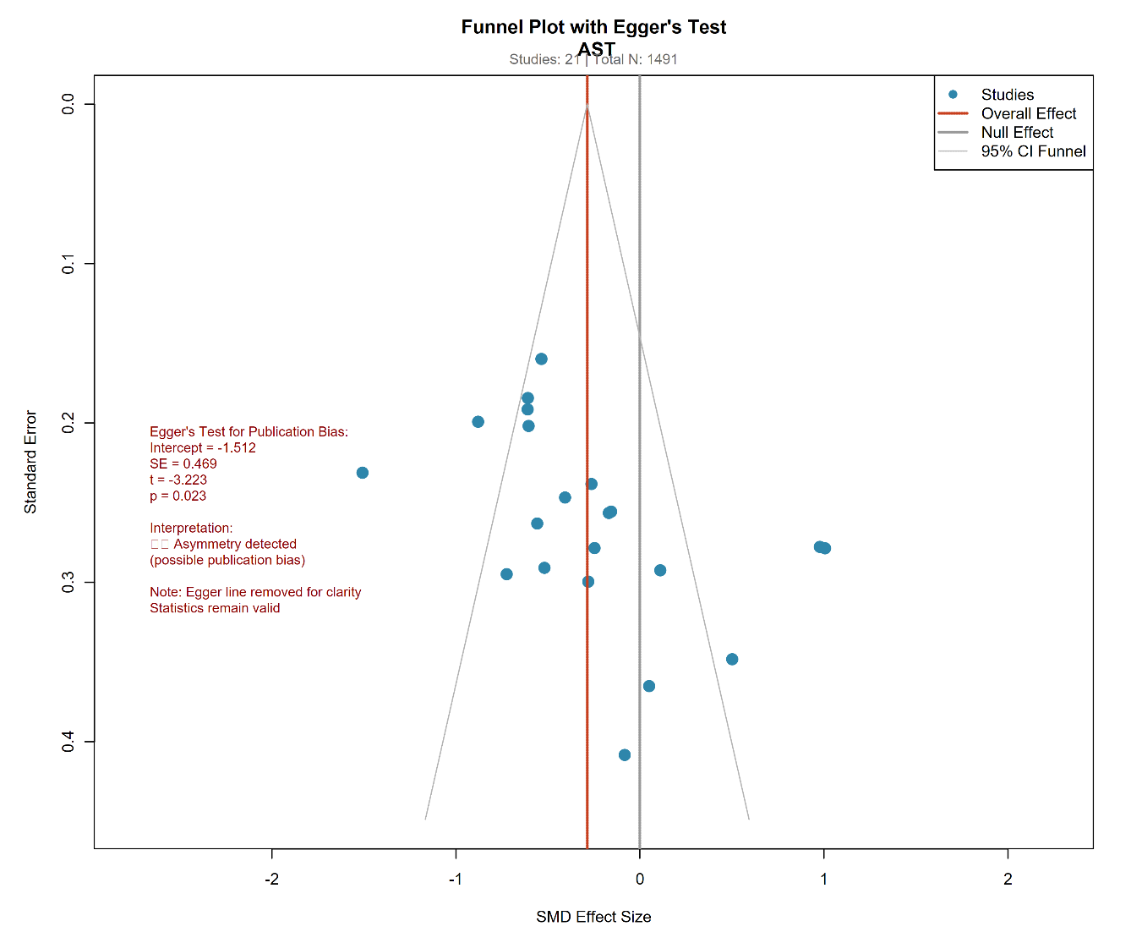
Supplementary Figure S1D : Funnel Plot of AST
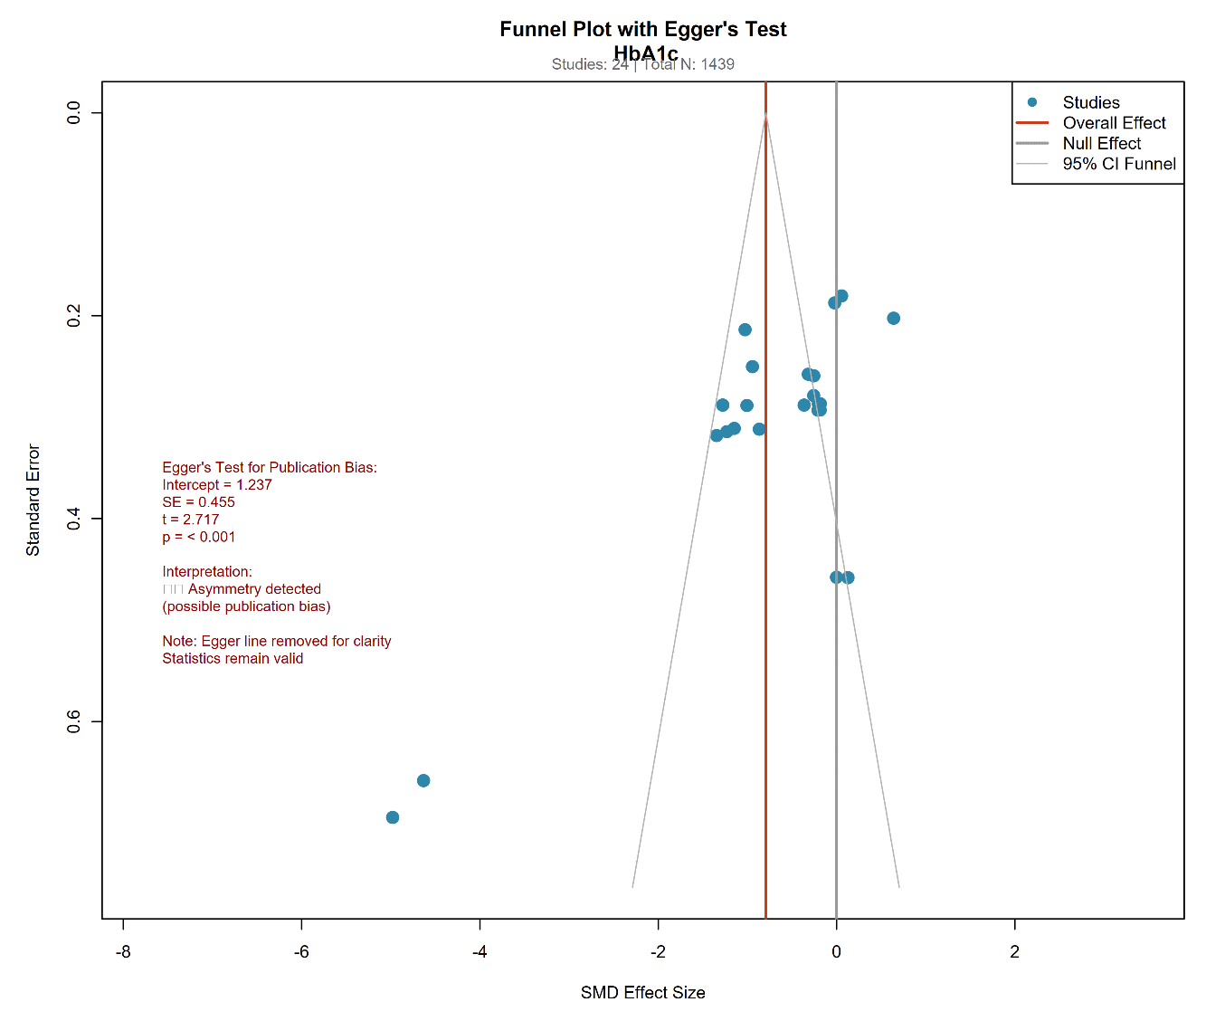
Supplementary Figure S1E : Funnel Plot of HbA1C
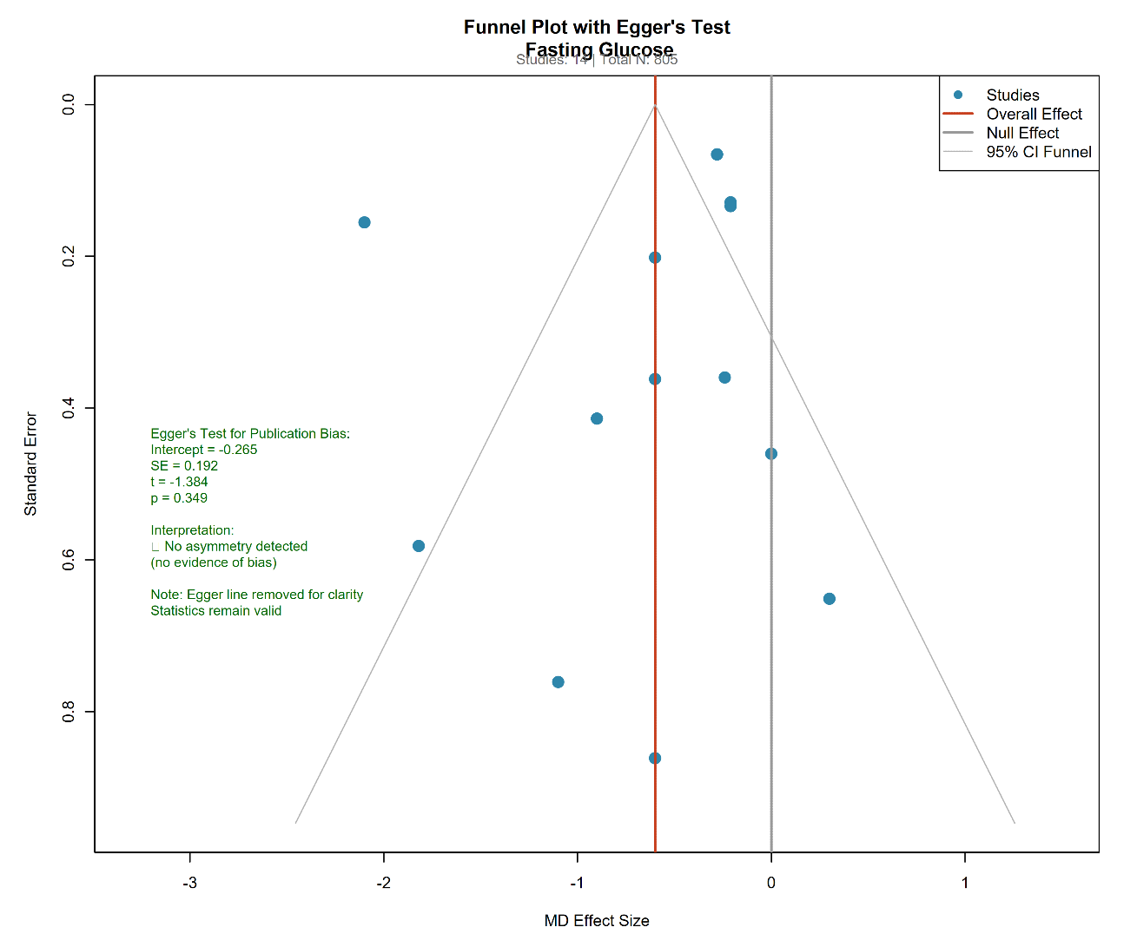
Supplementary Figure S1F : Funnel Plot of Fasting Glucose
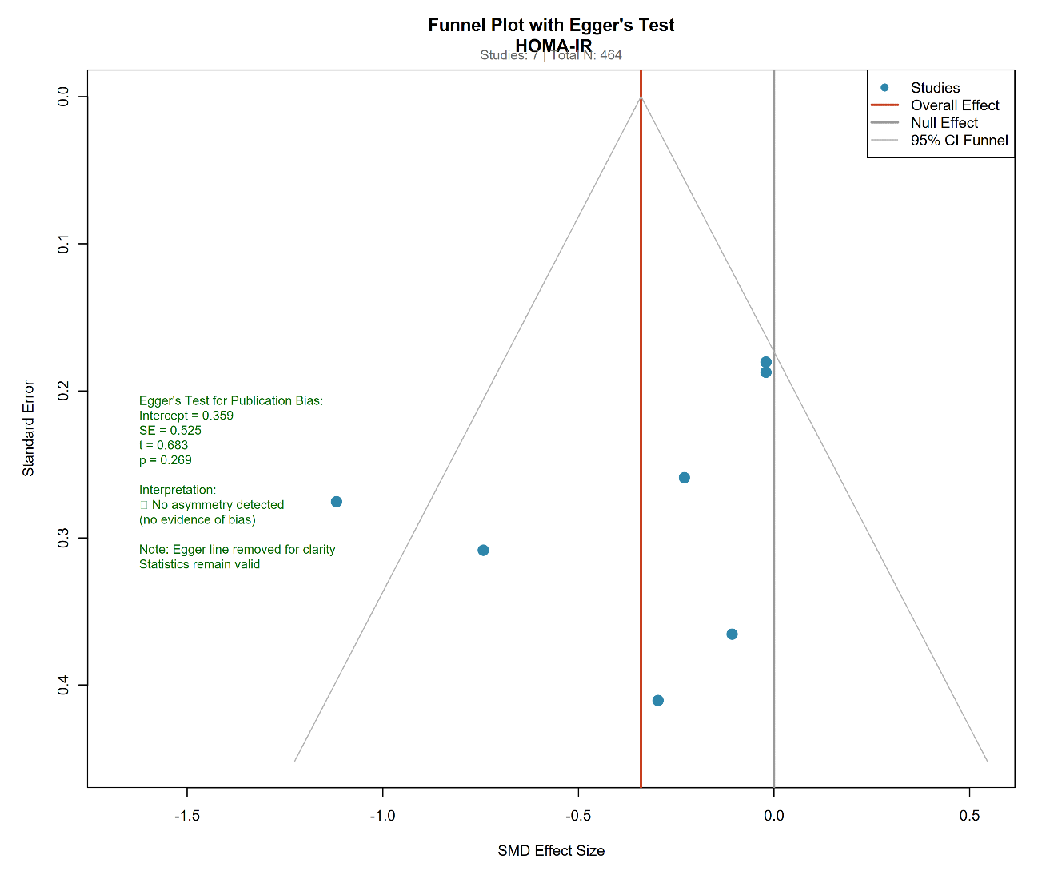
Supplementary Figure S1G : Funnel Plot of HOMA-IR
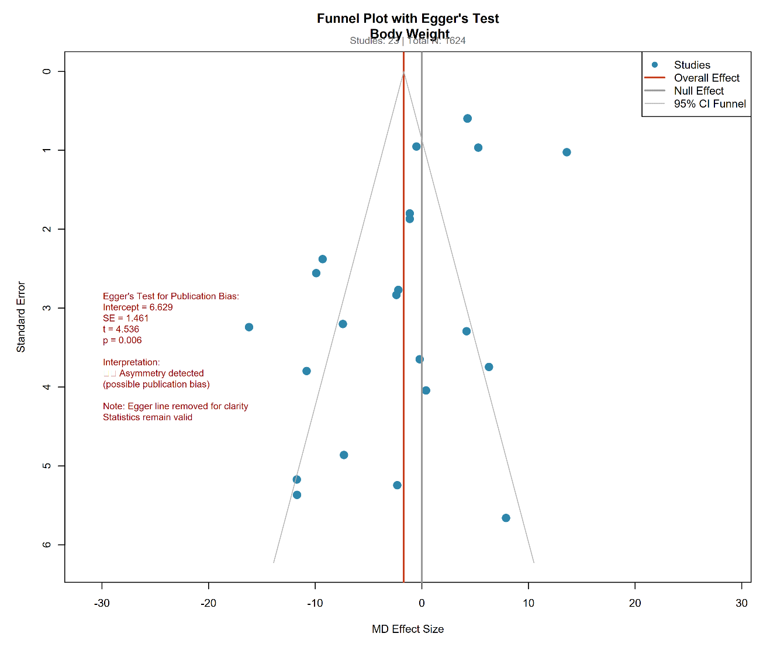
Supplementary Figure S1H : Funnel Plot of Body Weight
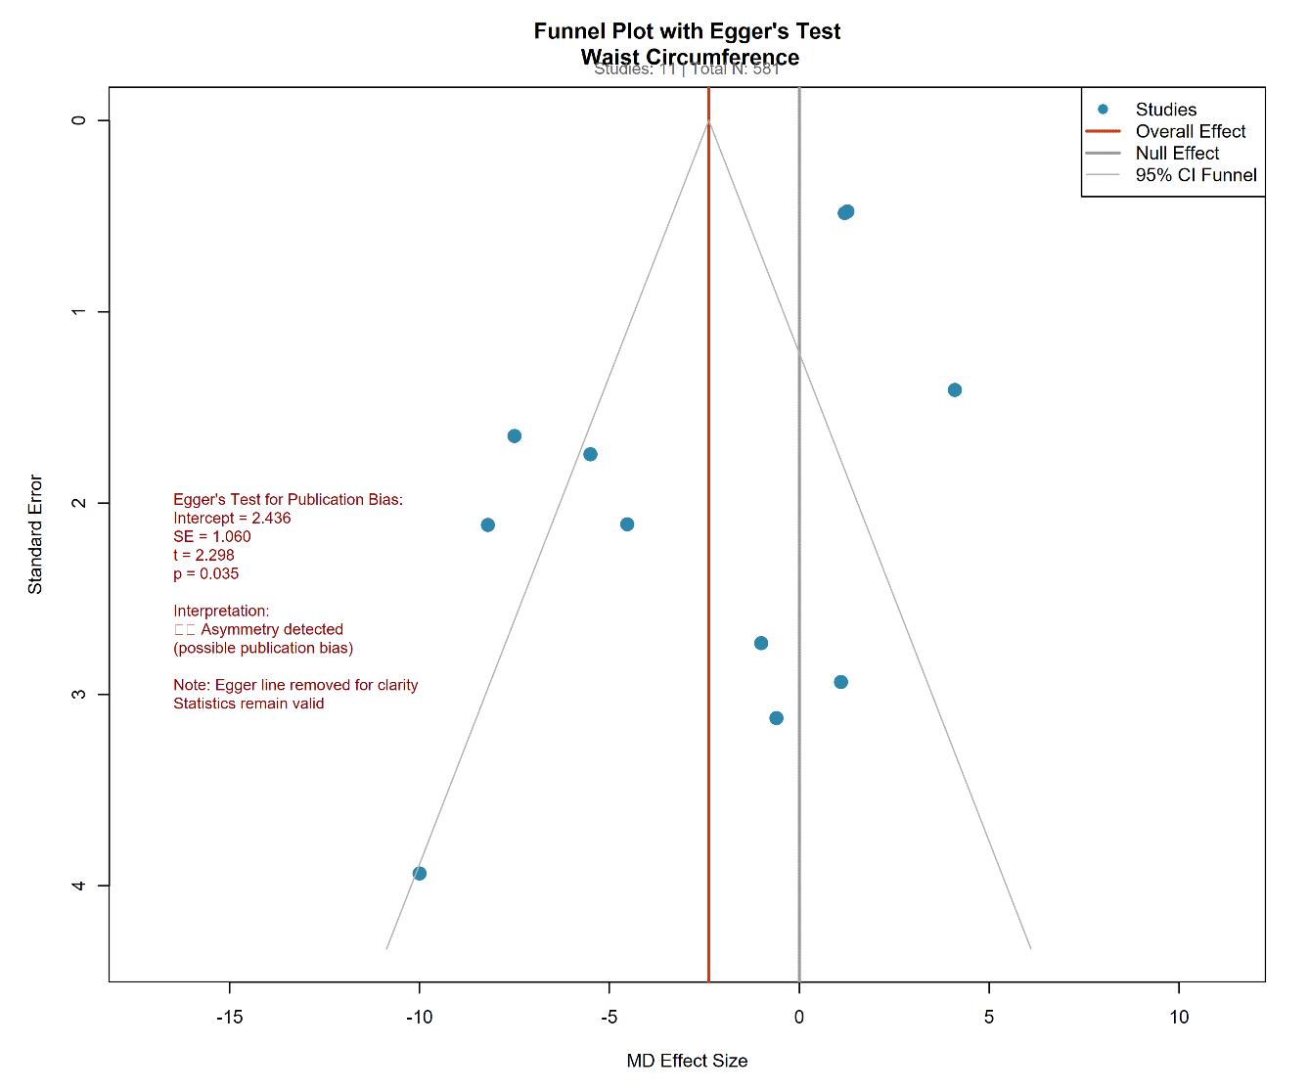
Supplementary Figure S1I : Funnel Plot of Waist Circumference
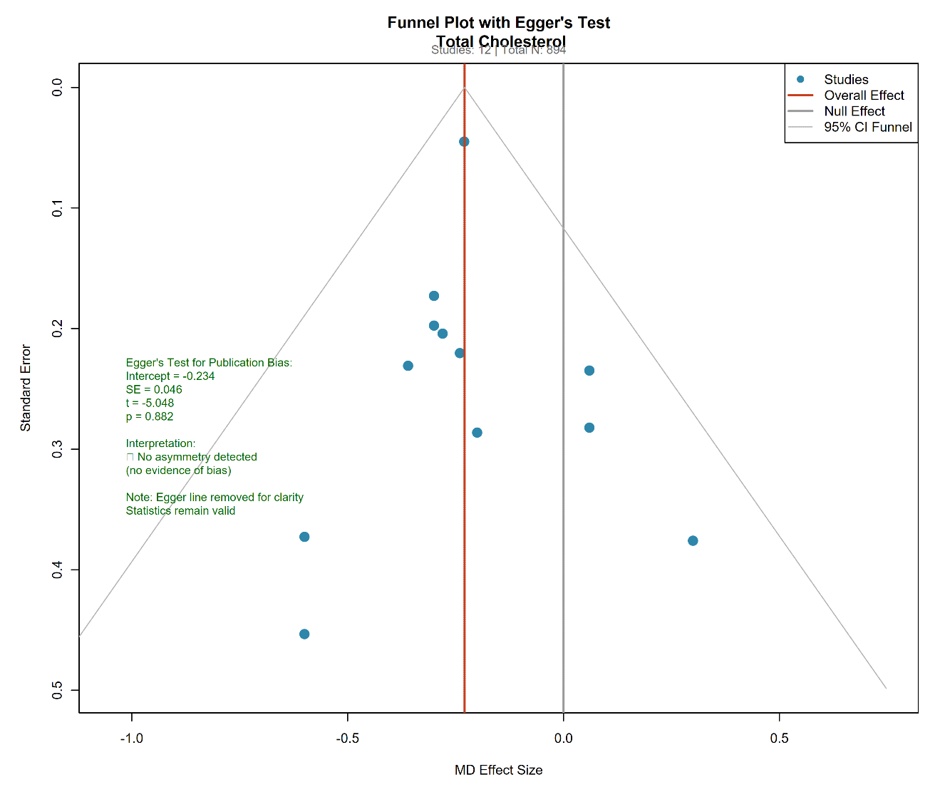
Supplementary Figure S1J : Funnel Plot of Total Cholesterol
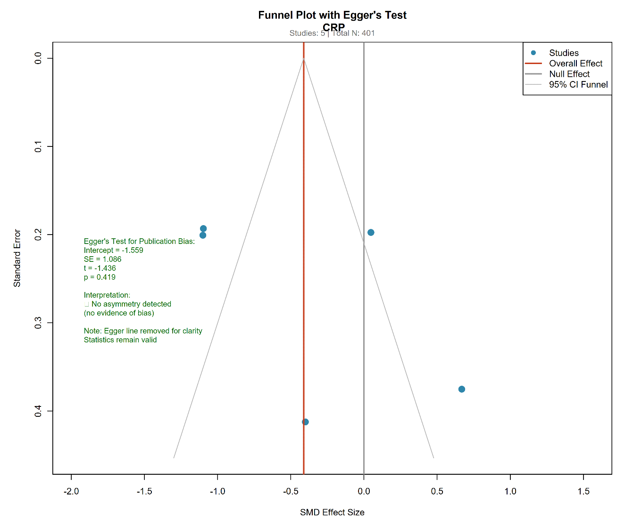
Supplementary Figure S1K : Funnel Plot of CRP

