Supplementary Figure S3
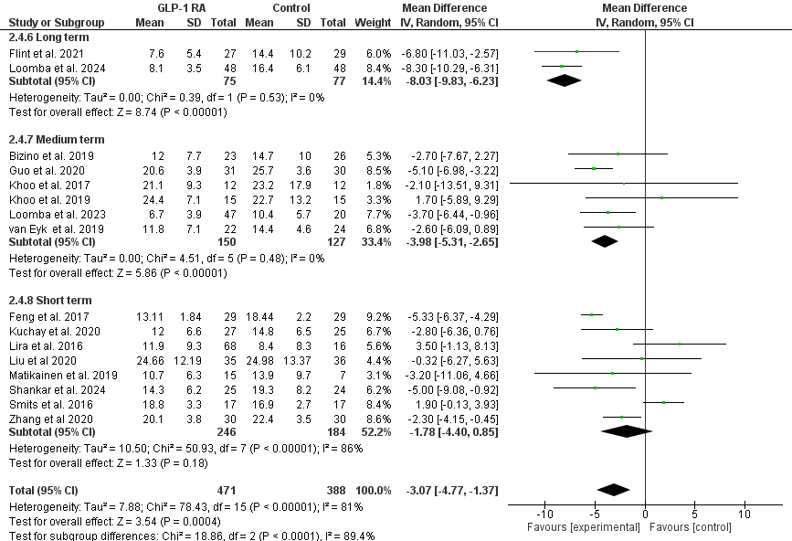

Supplementary Figure S3A : Forest Plot of Liver Fat Content affected by Duration

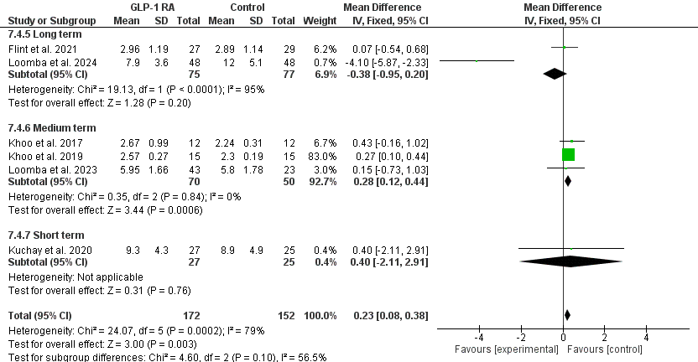

Supplementary Figure S3B : Forest Plot of Liver Stiffness affected by Duration

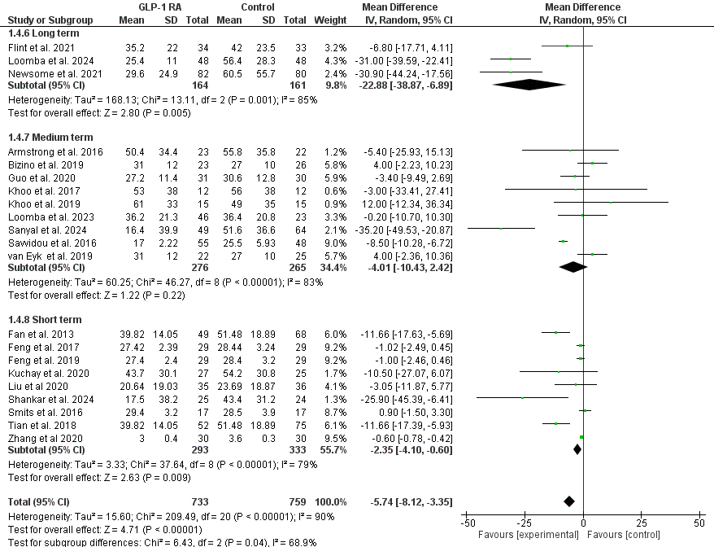

Supplementary Figure S3C : Forest Plot of ALT affected by Duration

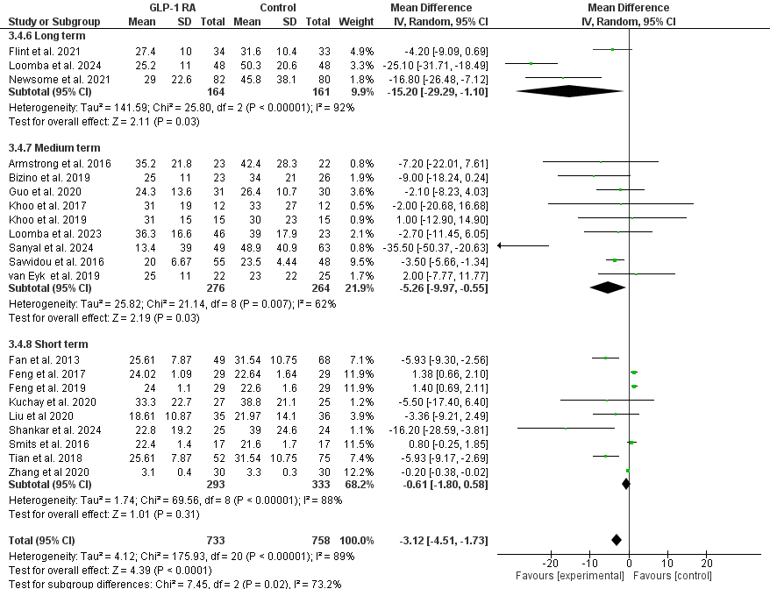

Supplementary Figure S3D : Forest Plot of AST affected by Duration

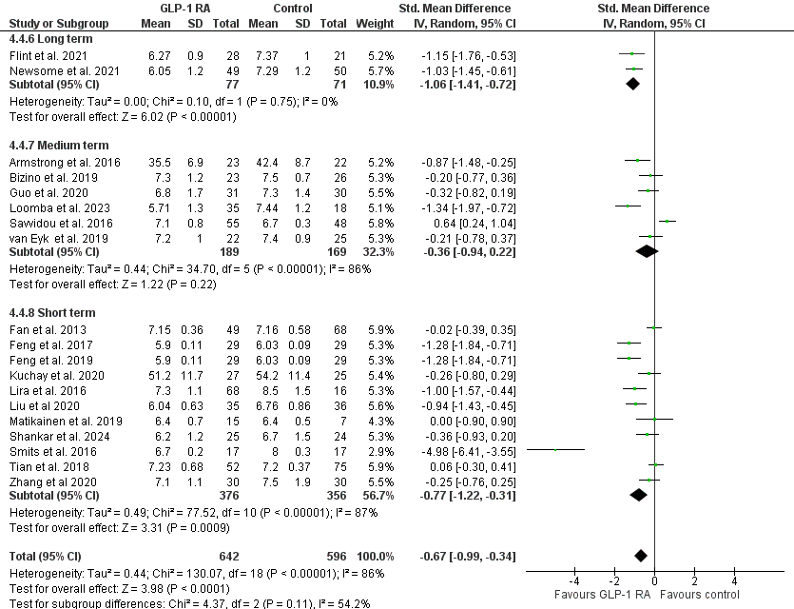

Supplementary Figure S3E : Forest Plot of HbA1C affected by Duration

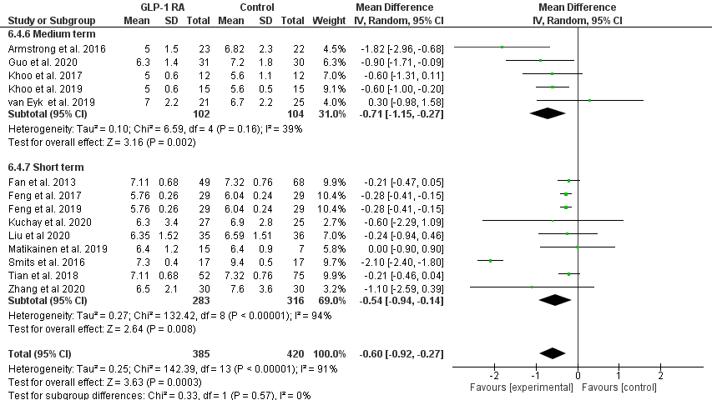

Supplementary Figure S3F : Forest Plot of fasting glucose affected by Duration
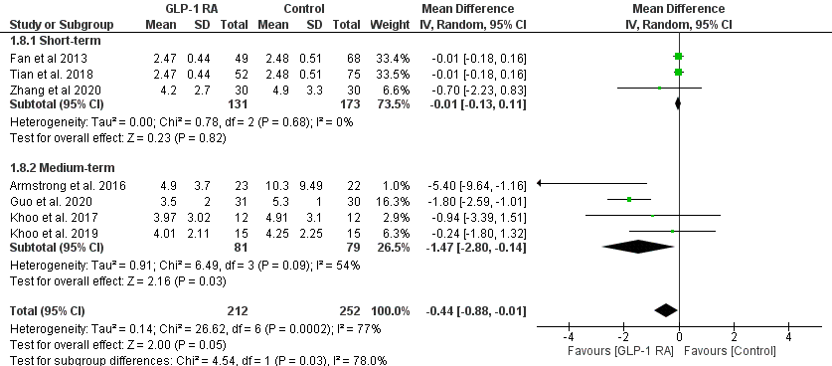

Supplementary Figure S3G : Forest Plot of HOMA-IR affected by Duration

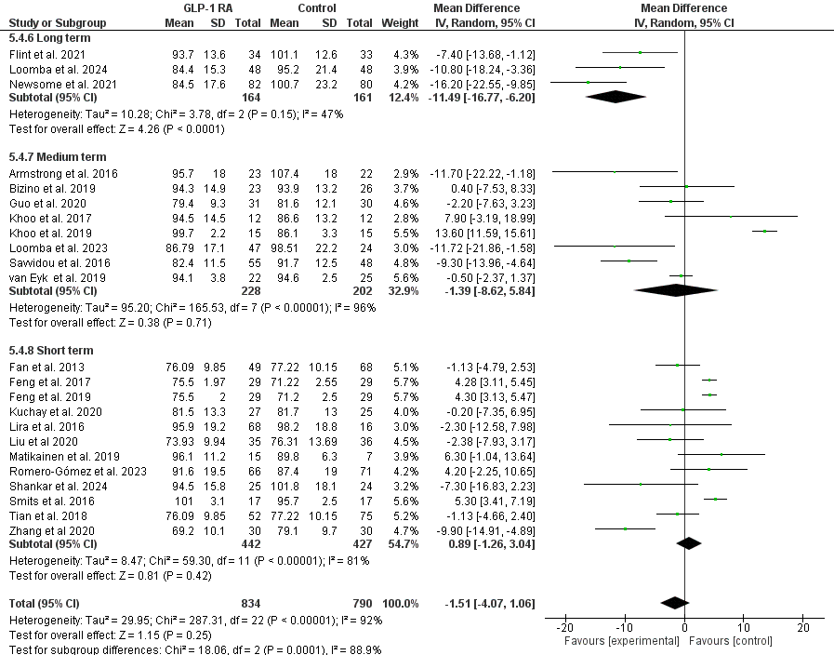

Supplementary Figure S3H : Forest Plot of Body Weight affected by Duration

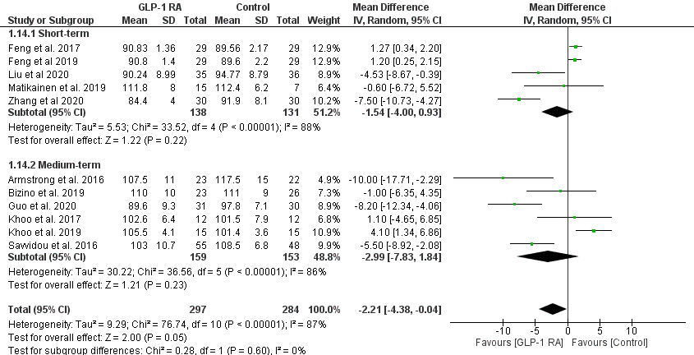

Supplementary Figure S3I : Forest Plot of Waist Circumference affected by Duration

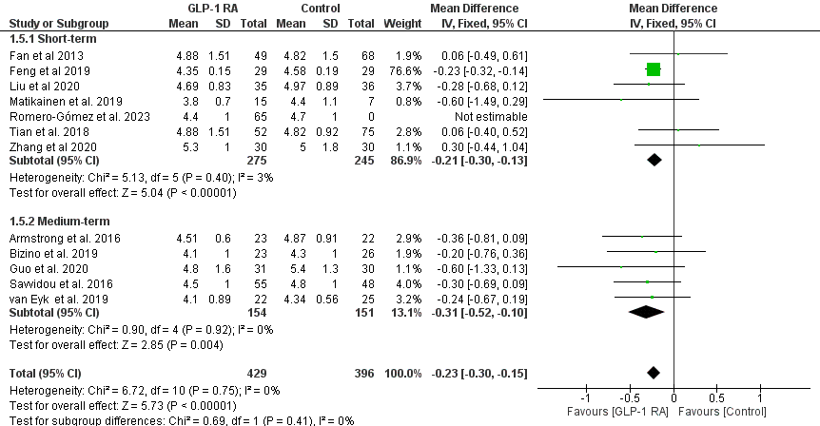

Supplementary Figure S3J : Forest Plot of Total Cholesterol affected by Duration

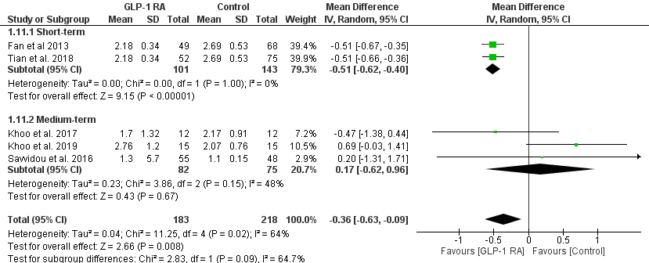

Supplementary Figure S3K : Forest Plot of CRP affected by Duration

