Supplementary Figures
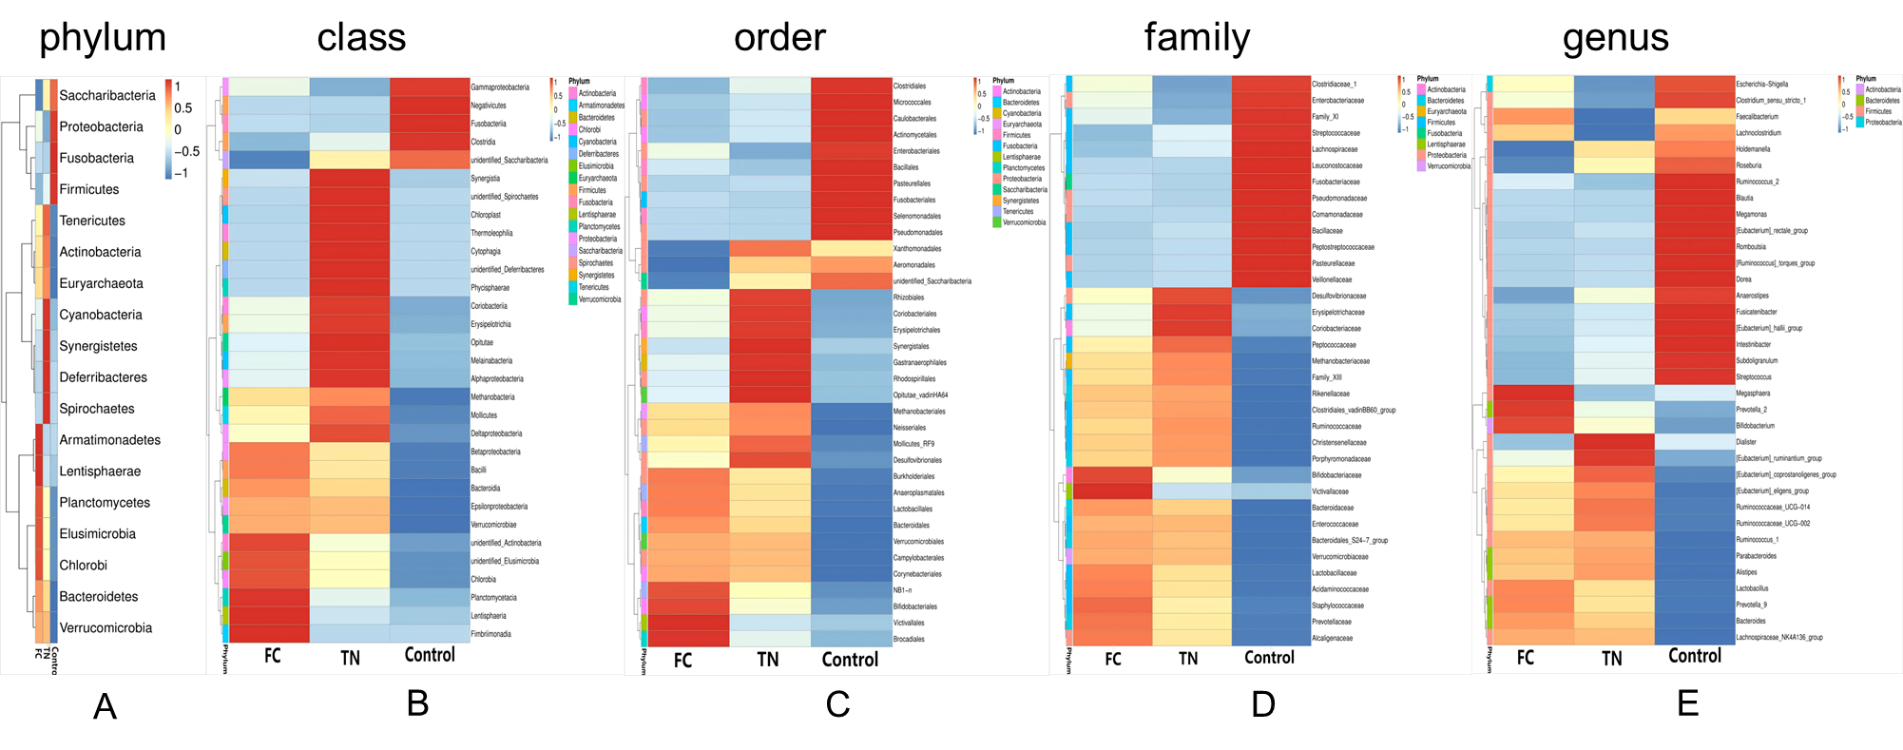
Figure S1. The OTUs clustering heatmaps (A-E) show the degree of clustering of multiple-level bacterial communities in the three groups. It revealed that the FC group exhibited typical disorders characterized by a decrease in Bacteroidetes (phylum), enrichment of Gammaproteobacteria (class), and proliferation of Enterobacteriales (order). TN significantly increased Bacteroidia (class) and Clostridia (class), partially restoring SCFA-producing bacteria (such as Blautia and Roseburia).

