Inulin-induced improvements on bowel habit and fecal microbiota in adults with functional constipation: Findings of a randomized, double-blind, placebo-controlled study
Supplementary Material
Abbreviations
BSFS = Bristol Stool Form Scale
IBS-C = constipation-predominant irritable bowel syndrome
IPAQ = International Physical Activity Questionnaire
FDR = false-discovery rate
PAC-QOL = Patient Assessment of Constipation - Quality of Life
PAC-SYM = Patient Assessment of Constipation – Symptoms

Supplementary Table 1. Estimated model fixed effects obtained from the linear mixed model analysis of the cross-over trial to assess the intervention difference (inulin versus placebo), meaning the difference in the change between post- and pre-intake levels, modeled by the interaction term intervention*time. The subject is included as random effects, and the carry-over effect is modeled in the interaction term intervention*period.
Effect |  | Estimate | Std. Error | df | t-value | p-value
Stool frequency (x/week)
Intercept |  | 3.60 | 0.18 | 108.45 | 19.56 | <0.001
Intervention | placebo | -0.77 | 0.26 | 107.01 | -2.94 | 0.004
 | inulin | reference
Time | pre-intake | -1.43 | 0.19 | 107.00 | -7.69 | <0.001
 | post-intake | reference
Period | period 2 | -0.32 | 0.23 | 75.44 | -1.40 | 0.165
 | period 1 | reference
Intervention*Time |  | 0.53 | 0.26 | 106.77 | 2.02 | 0.046
Intervention*Period |  | 0.96 | 0.37 | 36.57 | 2.57 | 0.014
Stool consistency (BSFS)
Intercept |  | 2.64 | 0.16 | 69.65 | 16.51 | <0.001
Intervention | placebo | -0.35 | 0.23 | 68.20 | -1.54 | 0.127
 | inulin | reference
Time | pre-intake | -0.62 | 0.12 | 105.98 | -4.98 | <0.001
 | post-intake | reference
Period | period 2 | -0.13 | 0.21 | 53.65 | -0.63 | 0.533
 | period 1 | reference
Intervention*Time |  | 0.09 | 0.17 | 105.53 | 0.53 | 0.600
Intervention*Period |  | 0.66 | 0.38 | 37.32 | 1.72 | 0.093
PAQ-QOL - total score
Intercept |  | 1.35 | 0.15 | 62.49 | 9.07 | <0.001
Intervention | placebo | 0.35 | 0.21 | 62.04 | 1.65 | 0.104
 | inulin | reference
Time | pre-intake | 0.61 | 0.10 | 112.12 | 5.86 | <0.001
 | post-intake | reference
Period | period 2 | 0.10 | 0.20 | 49.50 | 0.50 | 0.622
 | period 1 | reference
Intervention*Time |  | -0.41 | 0.15 | 112.03 | -2.74 | 0.007
Intervention*Period |  | -0.28 | 0.37 | 36.93 | -0.76 | 0.454
PAQ-QOL – physical discomfort subscore
Intercept |  | 1.47 | 0.18 | 65.23 | 8.12 | <0.001
Intervention | placebo | 0.35 | 0.26 | 64.74 | 1.37 | 0.175
 | inulin | reference
Time | pre-intake | 0.80 | 0.13 | 111.88 | 6.01 | <0.001
 | post-intake | reference
Period | period 2 | 0.05 | 0.24 | 50.71 | 0.21 | 0.832
 | period 1 | reference
Intervention*Time |  | -0.43 | 0.19 | 111.78 | -2.31 | 0.023
Intervention*Period |  | -0.37 | 0.44 | 36.68 | -0.83 | 0.411
PAQ-QOL – psychosocial discomfort subscore
Intercept |  | 1.01 | 0.18 | 59.82 | 5.60 | <0.001
Intervention | placebo | 0.15 | 0.26 | 59.42 | 0.60 | 0.551
 | inulin | reference
Time | pre-intake | 0.50 | 0.12 | 112.11 | 4.07 | <0.001
 | post-intake | reference
Period | period 2 | -0.13 | 0.24 | 48.20 | -0.55 | 0.586
 | period 1 | reference
Intervention*Time |  | -0.48 | 0.17 | 112.03 | -2.77 | 0.007
Intervention*Period |  | 0.23 | 0.45 | 36.95 | 0.51 | 0.616
PAQ-QOL – worries & concerns subscore
Intercept |  | 1.21 | 0.17 | 54.34 | 7.03 | <0.001
Intervention | placebo | 0.34 | 0.25 | 54.04 | 1.37 | 0.177
 | inulin | reference
Time | pre-intake | 0.56 | 0.11 | 112.12 | 5.32 | <0.001
 | post-intake | reference
Period | period 2 | 0.14 | 0.24 | 45.55 | 0.59 | 0.559
 | period 1 | reference
Intervention*Time |  | -0.40 | 0.15 | 112.05 | -2.68 | 0.009
Intervention*Period |  | -0.23 | 0.45 | 36.99 | -0.52 | 0.609
PAQ-QOL – satisfaction subscore
Intercept |  | 2.13 | 0.16 | 107.82 | 13.27 | <0.001
Intervention | placebo | 0.70 | 0.23 | 106.25 | 3.09 | 0.003
 | inulin | reference
Time | pre-intake | 0.89 | 0.16 | 108.58 | 5.61 | <0.001
 | post-intake | reference
Period | period 2 | 0.29 | 0.20 | 74.41 | 1.45 | 0.152
 | period 1 | reference
Intervention*Time |  | -0.28 | 0.22 | 108.73 | -1.24 | 0.218
Intervention*Period |  | -1.08 | 0.33 | 36.82 | -3.33 | 0.002
PAQ-SYM - total score
Intercept |  | 1.31 | 0.15 | 64.29 | 8.92 | <0.001
Intervention | placebo | 0.29 | 0.21 | 63.81 | 1.37 | 0.174
 | inulin | reference
Time | pre-intake | 0.61 | 0.11 | 112.15 | 5.78 | <0.001
 | post-intake | reference
Period | period 2 | 0.07 | 0.20 | 50.40 | 0.36 | 0.722
 | period 1 | reference
Intervention*Time |  | -0.35 | 0.15 | 112.05 | -2.32 | 0.022
Intervention*Period |  | -0.35 | 0.36 | 36.96 | -0.97 | 0.338
PAQ-SYM – abdominal symptoms subscore
Intercept |  | 1.42 | 0.18 | 69.33 | 8.04 | <0.001
Intervention | placebo | 0.29 | 0.25 | 68.78 | 1.16 | 0.250
 | inulin | reference
Time | pre-intake | 0.62 | 0.14 | 112.12 | 4.54 | <0.001
 | post-intake | reference
Period | period 2 | 0.07 | 0.23 | 52.88 | 0.31 | 0.758
 | period 1 | reference
Intervention*Time |  | -0.47 | 0.19 | 112.01 | -2.43 | 0.017
Intervention*Period |  | -0.34 | 0.43 | 36.89 | -0.81 | 0.425
PAQ-SYM – rectal symptoms subscore
Intercept |  | 0.66 | 0.16 | 68.56 | 4.21 | <0.001
Intervention | placebo | 0.53 | 0.22 | 68.02 | 2.40 | 0.019
 | inulin | reference
Time | pre-intake | 0.52 | 0.12 | 112.32 | 4.43 | <0.001
 | post-intake | reference
Period | period 2 | 0.15 | 0.21 | 52.60 | 0.71 | 0.481
 | period 1 | reference
Intervention*Time |  | -0.27 | 0.17 | 112.21 | -1.64 | 0.104
Intervention*Period |  | -0.58 | 0.38 | 37.10 | -1.54 | 0.131
PAQ-SYM – stool symptoms subscore
Intercept |  | 1.47 | 0.16 | 76.31 | 9.10 | <0.001
Intervention | placebo | 0.15 | 0.23 | 75.66 | 0.64 | 0.525
 | inulin | reference
Time | pre-intake | 0.94 | 0.13 | 112.20 | 7.06 | <0.001
 | post-intake | reference
Period | period 2 | -0.28 | 0.21 | 56.44 | -1.33 | 0.189
 | period 1 | reference
Intervention*Time |  | -0.30 | 0.19 | 112.07 | -1.61 | 0.110
Intervention*Period |  | -0.14 | 0.38 | 36.93 | -0.36 | 0.720
BSFS = Bristol Stool Form Scale, PAC-QOL = patient assessment of constipation – quality of life, PAC-SYM = patient assessment of constipation -symptoms; IPAQ = international physical activity questionnaire

Supplementary Table 2. Relative abundance (%) of common taxa (1.0% relative abundance in at least 50% of all samples) based on the analysis of the cross-over trial pre- and post-intake of the intervention (inulin or placebo) and the fold-difference between post-intake levels along with corresponding p-values and FDR-corrected q-values. Note that values marked with an asterisk (*) are based on analysis that only includes samples containing the particular taxon.
taxon | Inulin  mean relative abundance |  | Placebo  mean relative abundance |  | Difference post-intake Inulin versus Placebo
taxon | Pre-intake | Post-intake | Pre-intake | Post-intake | Fold-difference | p-value | q-value
Adlercreutzia | 0.37% | 0.20% | 0.21% | 0.27% | 0.75 | 0.527 | 0.987
Akkermansia | 4.12% | 3.64% | 4.06% | 8.06% | 0.45 | 0.505 | 0.987
Anaerostipes | 1.22% | 2.08% | 1.29% | 1.31% | 1.59 | 0.270 | 0.987
Anaerostipes |  | 2.56%* |  | 1.46%* | 1.75* | 0.016* | 0.253*
Bacteroides | 2.22% | 1.58% | 2.24% | 1.11% | 1.42 | 0.995 | 0.995
Bifidobacterium | 16.42% | 18.36% | 14.42% | 15.09% | 1.22 | 0.565 | 0.987
Blautia | 12.68% | 13.50% | 13.15% | 14.28% | 0.95 | 0.726 | 0.987
Christensenellaceae R7 group | 1.96% | 1.26% | 1.72% | 1.61% | 0.78 | 0.733 | 0.987
Clostridium sensu stricto 1 | 2.24% | 2.03% | 1.73% | 1.17% | 1.74 | 0.336 | 0.987
Collinsella | 0.47% | 1.62% | 1.26% | 2.04% | 0.80 | 0.772 | 0.987
Coprococcus 1 | 0.50% | 0.41% | 0.42% | 0.28% | 1.45 | 0.129 | 0.987
Coprococcus 1 |  | 0.57%* |  | 0.36%* | 1.59* | 0.002* | 0.063*
Coprococcus 2 | 0.65% | 0.54% | 0.48% | 0.41% | 1.33 | 0.484 | 0.987
Coprococcus 3 | 0.58% | 0.46% | 0.44% | 0.41% | 1.13 | 0.629 | 0.987
Dorea | 2.30% | 2.08% | 2.22% | 1.92% | 1.08 | 0.726 | 0.987
Erysipelotrichaceae UCG 003 | 1.66% | 1.22% | 1.38% | 1.62% | 0.75 | 0.534 | 0.987
Eubacterium coprostanoligenes group | 1.38% | 1.05% | 1.13% | 1.01% | 1.05 | 0.841 | 0.987
Eubacterium hallii group | 1.99% | 2.16% | 2.04% | 1.81% | 1.19 | 0.302 | 0.987
Faecalibacterium | 1.70% | 1.70% | 2.07% | 1.52% | 1.12 | 0.350 | 0.987
Family XIII AD3011 group | 0.38% | 0.30% | 0.23% | 0.29% | 1.04 | 0.883 | 0.987
Fusicatenibacter | 1.86% | 1.35% | 2.08% | 1.41% | 0.96 | 0.196 | 0.987
Intestinibacter | 1.05% | 0.76% | 0.99% | 0.71% | 1.08 | 0.724 | 0.987
Lachnospiraceae unidentified Genus | 5.02% | 4.69% | 4.59% | 3.56% | 1.32 | 0.273 | 0.987
Methanobrevibacter | 2.08% | 2.33% | 2.52% | 2.29% | 1.01 | 0.940 | 0.995
Romboutsia | 3.06% | 3.06% | 2.87% | 2.58% | 1.19 | 0.607 | 0.987
Roseburia | 0.40% | 0.30% | 0.41% | 0.28% | 1.06 | 0.164 | 0.987
Ruminiclostridium 5 | 0.34% | 0.29% | 0.28% | 0.50% | 0.58 | 0.410 | 0.987
Ruminococcaceae NK4A214 group | 0.56% | 0.44% | 0.39% | 0.55% | 0.81 | 0.338 | 0.987
Ruminococcaceae UCG 002 | 1.31% | 0.87% | 1.11% | 1.18% | 0.74 | 0.995 | 0.995
Ruminococcaceae UCG 005 | 0.49% | 0.29% | 0.25% | 0.32% | 0.90 | 0.565 | 0.987
Ruminococcaceae UCG 014 | 1.04% | 0.83% | 0.87% | 0.73% | 1.13 | 0.779 | 0.987
Ruminococcaceae unidentified Genus | 0.40% | 0.35% | 0.38% | 0.42% | 0.83 | 0.866 | 0.987
Ruminococcus 1 | 0.59% | 0.45% | 0.73% | 0.52% | 0.87 | 0.857 | 0.987
Ruminococcus 2 | 8.01% | 6.77% | 7.66% | 7.46% | 0.91 | 0.656 | 0.987
Ruminococcus gauvreauii group | 0.33% | 0.34% | 0.33% | 0.31% | 1.09 | 0.407 | 0.987
Ruminococcus torques group | 1.31% | 1.36% | 1.42% | 1.33% | 1.02 | 0.946 | 0.995
Streptococcus | 0.94% | 0.88% | 1.48% | 1.08% | 0.82 | 0.715 | 0.987
Subdoligranulum | 3.52% | 5.02% | 4.72% | 4.06% | 1.24 | 0.528 | 0.987
Terrisporobacter | 0.26% | 0.37% | 0.35% | 0.25% | 1.49 | 0.585 | 0.987
Turicibacter | 0.38% | 0.22% | 0.44% | 0.23% | 0.97 | 0.172 | 0.987

A
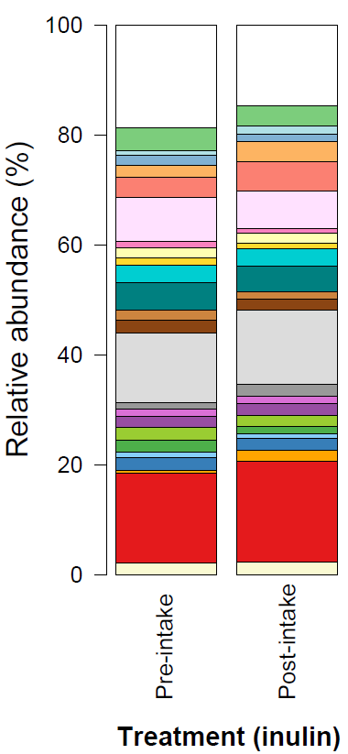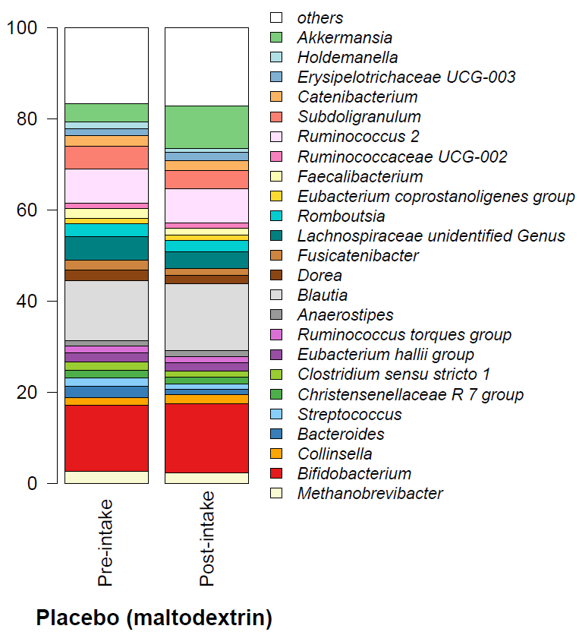
B
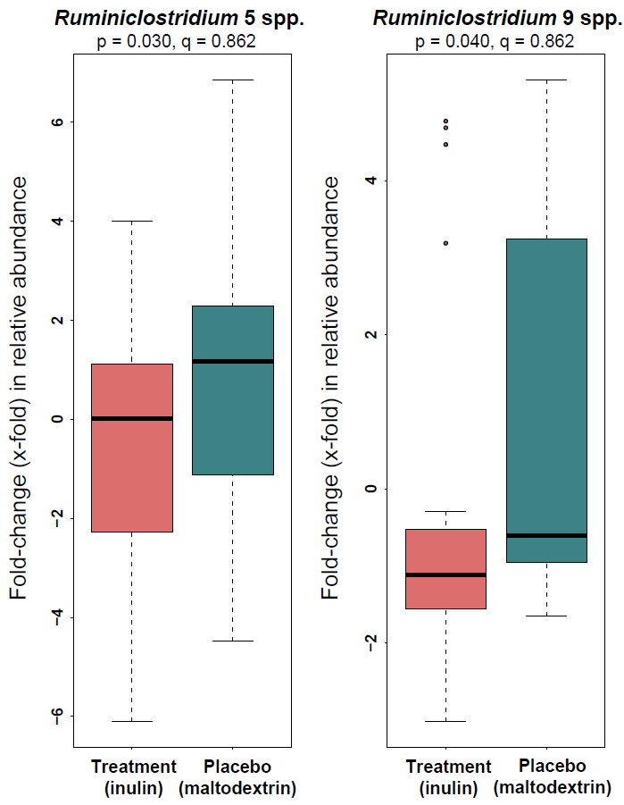
Supplementary Figure 1. Fecal microbiota composition and changes in individual taxa. (A) Common genera (>1.0% abundance in at least 50% of the samples) pre-intake and post-intake (inulin or placebo) relative levels.(B) Genera identified to significantly differ in their pre-post-intake changes between inulin and placebo intake.

Supplementary Table 3. First period analysis of changes in stool frequency, stool consistency, PAC-QOL, PAC-SYM and physical activity. Pre, post-intake levels and changes are reported as mean (SEM) if not indicated otherwise, and differences in changes are reported as estimated differences (95% CI) between treatments with the number of observations included (n) and p-values.
 | Inulin |  |  | Placebo |  |  | Difference change Inulin vs. Placebo
 | Run-in | Period 1 | Change | Run-in | Period 1 | Change | Difference | 95%CI | p-value
Stool frequency (x/week)¹ | 2.10 (0.18) | 3.66 (0.18) | 1.56 (0.26) | 2.03 (0.18) | 2.74 (0.18) | 0.71 (0.26) | 0.85 (0.36) | [0.15, 1.55] | 0.022
Stool consistency (BSFS) | 1.92 (0.14) | 2.75 (0.14) | 0.83 (0.16) | 1.82 (0.14) | 2.23 (0.14) | 0.40 (0.16) | 0.43 (0.22) | [-0.01, 0.86] | 0.062
PAC-QOL
Total score | 2.05 (0.14) | 1.26 (0.14) | -0.79 (0.13) | 1.89 (0.16) | 1.71 (0.16) | -0.18 (0.13) | -0.61 (0.16) | [-0.97, -0.24] | 0.003
Physical discomfort | 2.37 (0.17) | 1.37 (0.17) | -1.00 (0.17) | 2.24 (0.17) | 1.76 (0.17) | -0.48 (0.18) | -0.52 (0.25) | [-1.01, -0.04] | 0.042
Psychosocial discomfort | 1.58 (0.17) | 0.93 (0.17) | -0.65 (0.15) | 1.21 (0.17) | 1.14 (0.17) | -0.07 (0.16) | -0.58 (0.22) | [-1.01, -0.15] | 0.011
Worries and concerns | 1.84 (0.17) | 1.16 (0.17) | -0.68 (0.14) | 1.72 (0.17) | 1.55 (0.17) | -0.16 (0.15) | -0.52 (0.20) | [-0.92, -0.12] | 0.016
Satisfaction | 3.18 (0.16) | 1.95 (0.16) | -1.23 (0.22) | 3.34 (0.17) | 2.94 (0.16) | -0.40 (0.23) | -0.82 (0.32) | [-1.44, -0.21] | 0.013
PAC-SYM
Total score | 1.98 (0.14) | 1.25 (0.14) | -0.73 (0.15) | 1.90 (0.14) | 1.56 (0.14) | -0.34 (0.15) | -0.39 (0.21) | [-0.80, 0.02] | 0.072
Abdominal symptoms | 2.13 (0.16) | 1.34 (0.16) | -0.79 (0.19) | 1.94 (0.17) | 1.64 (0.17) | -0.30 (0.19) | -0.50 (0.27) | [-1.03, 0.03] | 0.075
Rectal symptoms | 1.25 (0.15) | 0.59 (0.15) | -0.66 (0.18) | 1.52 (0.15) | 1.11 (0.15) | -0.41 (0.18) | -0.25 (0.26) | [-0.75, 0.25] | 0.338
Stool related symptoms | 2.29 (0.18) | 1.58 (0.18) | -0.71 (0.17) | 2.12 (0.18) | 1.75 (0.18) | -0.37 (0.17) | -0.34 (0.24) | [-0.81, 0.12] | 0.158
IPAQ²
“low” | 5 (25%) | 7 (36.8%) | - | 4 (21.1%) | 2 (11.1%) | - | - |  | 0.189*
“moderate” | 12 (60%) | 7 (36.8%) | - | 12 (63.2%) | 9 (50%) | - | - |  | 0.189*
“high” | 3 (15%) | 5 (26.3%) | - | 3 (15.8%) | 7 (38.9%) | - | - |  | 0.189*
BSFS, Bristol Stool Form Scale; IPAQ, international physical activity questionnaire; PAC-QOL, patient assessment of constipation – quality of life; PAC-SYM, patient assessment of constipation – symptoms. ¹Stool frequency values expressed as median (IQR) were for inulin: pre-intake = 2.00 (2.00, 2.12), post-intake = 4.00 (2.75, 4.50), and change = 1.50 (0.75, 3.00), and for placebo: pre-intake = 2.00 (2.00, 2.25), post-intake = 2.50 (2.25, 3.25) and change = 0.50 (0.25, 1.25). The median [95%CI] difference between changes after inulin versus placebo intake was 1.00 [>0.00, 1.50] and p = 0.030. ² Values are expressed as count (%). * represents the p-value for the difference in post-intake counts

A | B
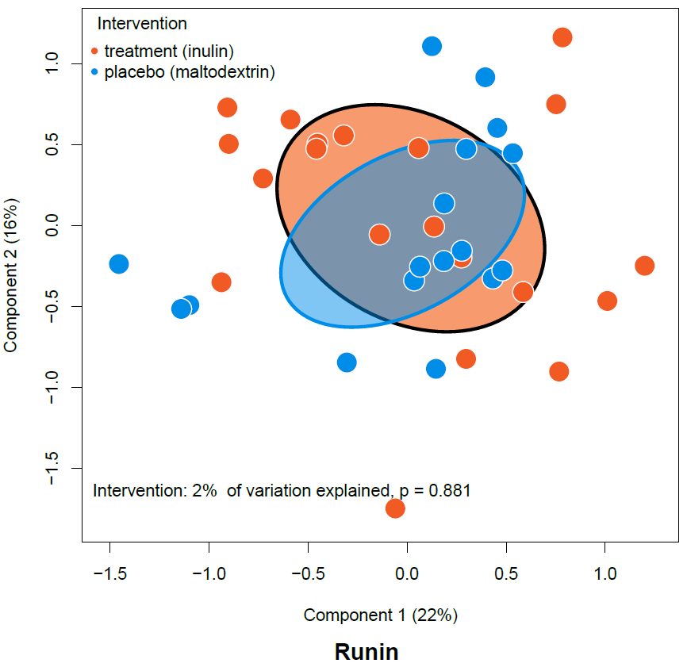 | 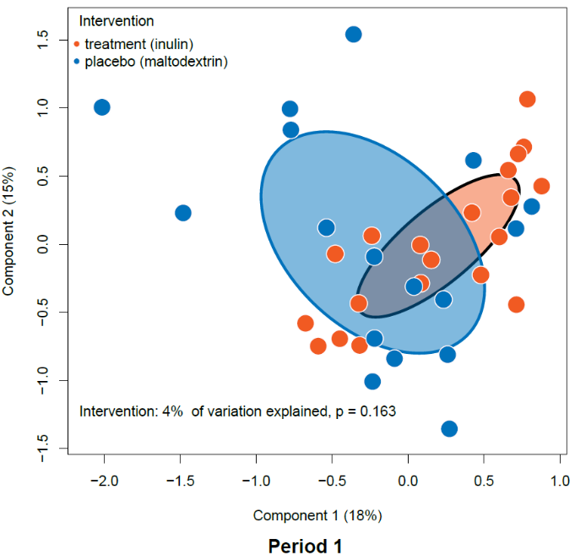
C
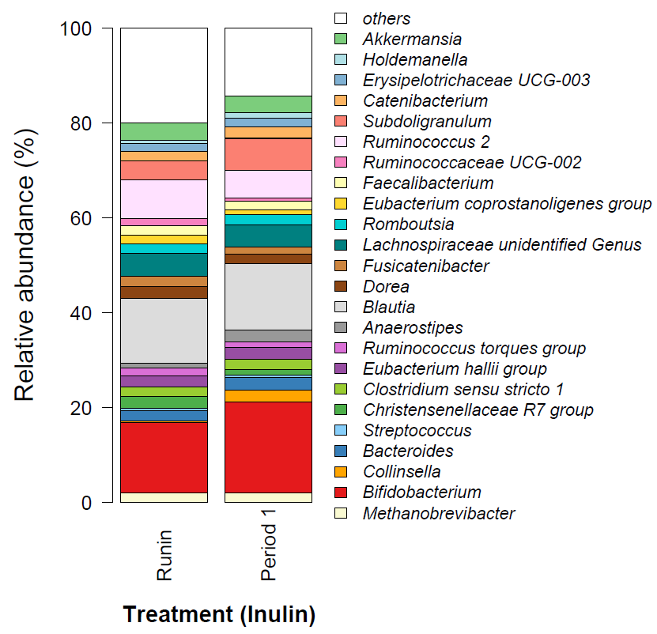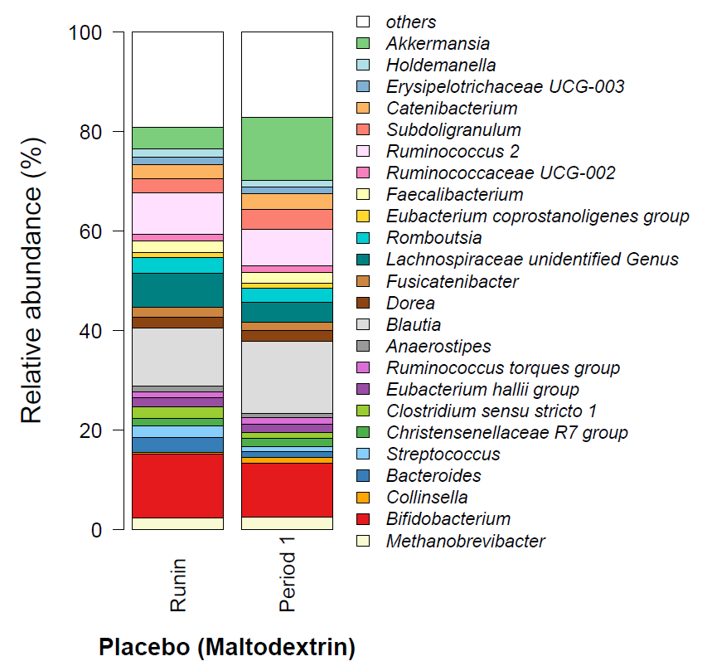
Supplementary Figure 2. First period analysis of fecal microbiota composition. (A-B) Fecal microbiota composition at genus level was visualized and assessed by principal coordinate analysis using β-diversity based on Bray-Curtis dissimilarity at (A) run-in and (B) after period 1 of the intervention (either inulin or placebo intake). (C) Common genera (>1% abundance in 50% of the samples) at run-in and after period 1 in participants consuming either the treatment (inulin) or the placebo (maltodextrin).

A | B
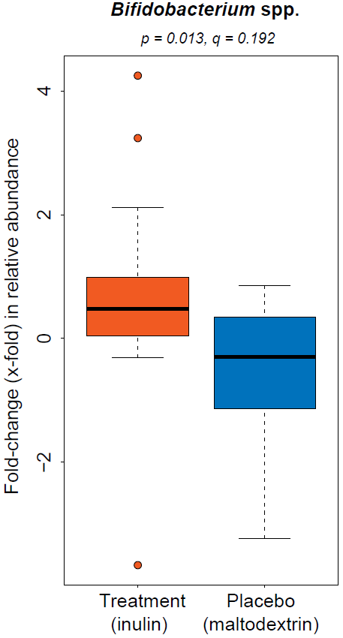 | 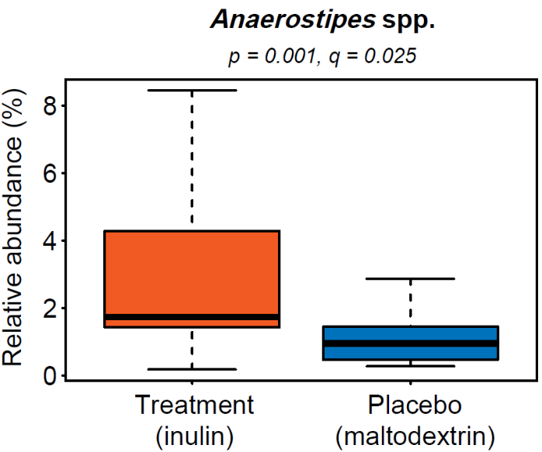
 | 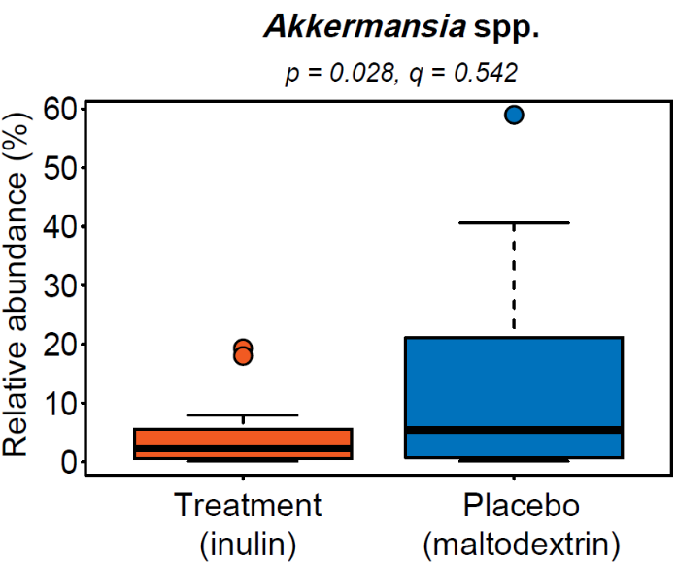
Supplementary Figure 3. First period analysis of differences in individual genera. (A) Differences in fold-changes after period 1 between interventions (inulin versus placebo) in Bifidobacterium spp. relative abundances. (B) Differences in period 1 relative abundances of Anaerostipes spp. and Akkermansia spp. between interventions (inulin versus placebo). Note that the difference in Akkermansia spp. relative abundances were mainly caused by one individual consuming the placebo, where Akkermansia spp. comprised 80% of the fecal microbiota.

A | 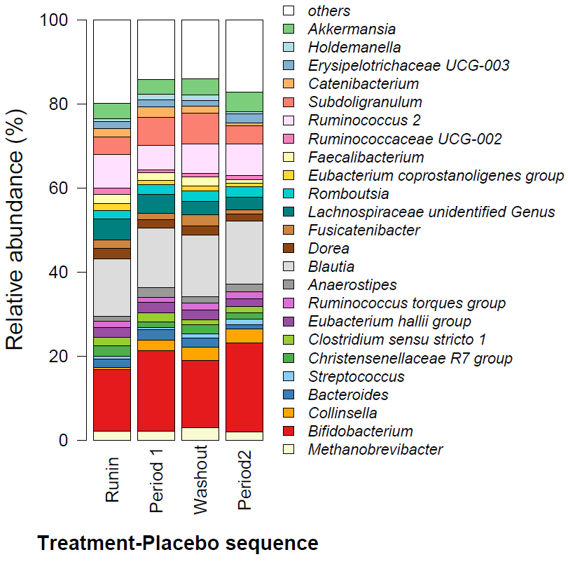 | B | 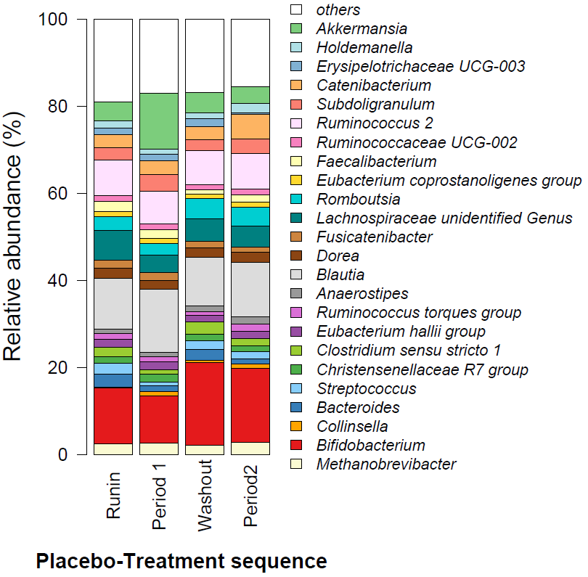
C | 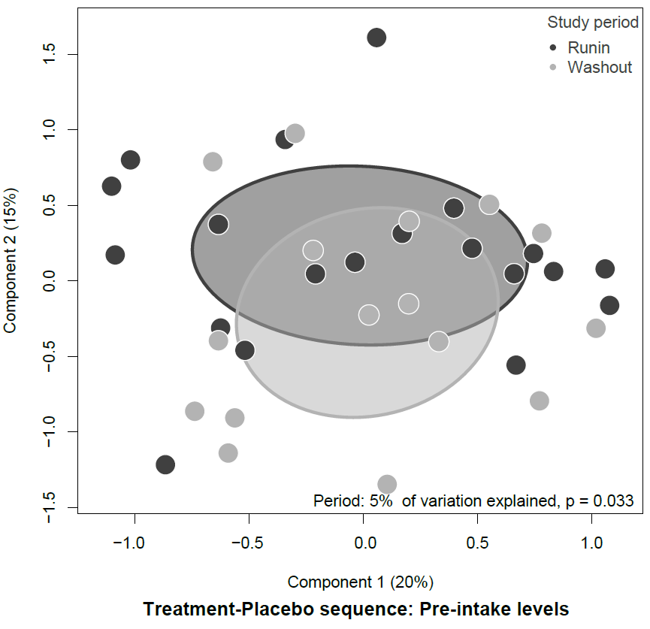 | D | 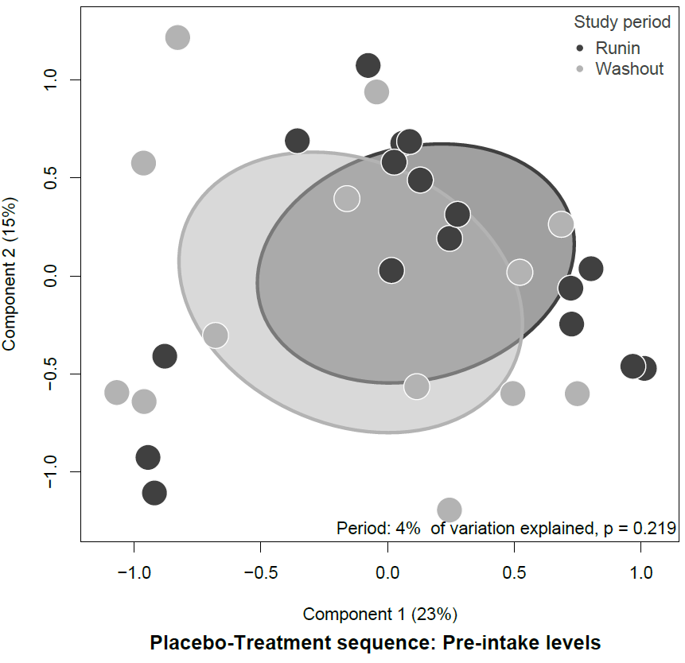
E | 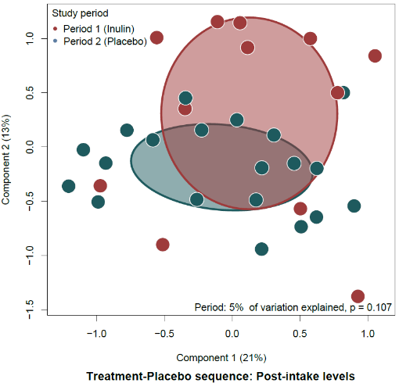 | F | 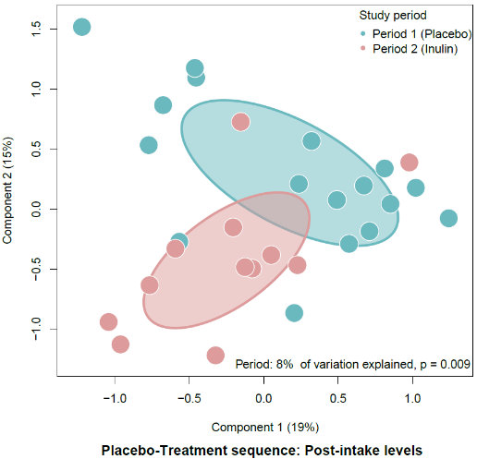
Supplementary Figure 4. Per-Sequence fecal microbiota composition. (A-B) Common genera (>1% abundance in 50% of the samples) at each study period in (A) the treatment-placebo sequence and (B) the placebo-treatment sequence. (C-F) fecal microbiota composition at genus level visualized and assessed by principal coordinate analysis using β-diversity based on Bray-Curtis dissimilarity for pre-intake levels in (C) the treatment-placebo sequence and (D) the placebo-treatment sequence and for post-intake levels in (E) the placebo-treatment sequence and (F) the treatment-placebo sequence. The difference between each group was tested using PERMANOVA and corresponding p-values are depicted in the lower right of the figures.

Supplementary Table 4. Differences between subjects apparently more affected by carry-over versus those less affected (treatment-placebo sequence). Descriptive statistics reported for the treatment-placebo sequence at run-in, period 1 (inulin), washout and period 2 (placebo) split into subjects with more affected by carry-over (stool frequency > 3x/week, period 2) and those less affected (stool frequency <= 3x/week, period 2) for stool frequency (defecations per week), stool consistency (Bristol Stool Form Scale), patient-assessment of constipation - Quality of life (PAC-QOL) total and subscores, patient-assessment of constipation - Symptoms (PAC-SYM) total and subscores, as well as physical activity (IPAQ). Outcome levels are reported as mean (SEM) if not indicated otherwise.
 | Subjects more affected by carry-over (n=9) |  |  |  | Subjects less affected by carry-over (n=9)
 | Run-in | Period 1 | Washout | Period 2 | Run-in | Period 1 | Washout | Period 2
Stool frequency (x/week)¹ | 2.00 [2.00, 2.00] | 4.50 [3.50, 4.50] | 3.00 [2.50, 3.50] | 4.50 [4.50, 5.00] | 2.00 [2.00, 2.00] | 3.50 [2.50, 4.00] | 2.00 [1.75,2.13] | 2.50 [2.00, 3.00]
Stool consistency (BSFS) | 1.81 (0.15) | 2.71 (0.28) | 2.46 (0.36) | 3.25 (0.43) | 2.07 (0.21) | 2.78 (0.28) | 1.83 (0.23) | 2.51 (0.30)
PAC-QOL
Total score | 2.03 (0.22) | 1.13 (0.2) | 1.48 (0.31) | 1.28 (0.3) | 2.17 (0.19) | 1.44 (0.23) | 2.06 (0.15) | 1.87 (0.34)
Physical discomfort | 2.21 (0.20) | 1.24 (0.24) | 1.39 (0.31) | 1.27 (0.32) | 2.62 (0.12) | 1.56 (0.25) | 2.37 (0.10) | 1.99 (0.32)
Psychosocial discomfort | 1.48 (0.27) | 0.87 (0.18) | 0.96 (0.36) | 1.08 (0.36) | 1.77 (0.28) | 1.03 (0.24) | 1.58 (0.24) | 1.63 (0.39)
Worries and concerns | 1.87 (0.30) | 1.13 (0.29) | 1.47 (0.38) | 1.37 (0.37) | 1.98 (0.19) | 1.24 (0.26) | 1.84 (0.21) | 1.74 (0.37)
Satisfaction | 3.22 (0.18) | 1.49 (0.27) | 2.47 (0.22) | 1.42 (0.27) | 3.15 (0.26) | 2.55 (0.32) | 3.13 (0.25) | 2.51 (0.38)
PAC-SYM
Total score | 1.77 (0.21) | 1.1 (0.14) | 1.23 (0.26) | 1.09 (0.22) | 2.23 (0.11) | 1.46 (0.23) | 1.99 (0.20) | 1.72 (0.34)
Abdominal symptoms | 1.91 (0.22) | 1.2 (0.16) | 1.24 (0.33) | 1.34 (0.22) | 2.3 (0.12) | 1.54 (0.27) | 1.83 (0.27) | 1.83 (0.40)
Rectal symptoms | 0.88 (0.26) | 0.46 (0.13) | 0.70 (0.30) | 0.43 (0.22) | 1.63 (0.20) | 0.74 (0.24) | 1.30 (0.28) | 1.29 (0.31)
Stool related symptoms | 2.18 (0.30) | 1.4 (0.19) | 1.56 (0.24) | 0.87 (0.16) | 2.51 (0.25) | 1.82 (0.30) | 2.58 (0.25) | 1.27 (0.24)
IPAQ²
“low” | 2 (22.2%) | 4 (50.0%) | 2 (22.2%) | 3 (33.3%) | 1 (11.1%) | 2 (22.2%) | 1 (11.1%) | 1 (11.1%)
“moderate” | 5 (55.6%) | 3 (37.5%) | 5 (55.6%) | 4 (44.4%) | 7 (77.8%) | 3 (33.3%) | 4 (44.4%) | 3 (33.3%)
“high” | 2 (22.2%) | 1 (12.5%) | 2 (22.2%) | 2 (22.2%) | 1 (11.1%) | 4 (44.4%) | 4 (44.4%) | 5 (55.6%)
1 Values are expressed as median [IQR]; ² Values are expressed as count (%)
BSFS = Bristol Stool Form Scale, PAC-QOL = patient assessment of constipation – quality of life, PAC-SYM = patient assessment of constipation -symptoms; IPAQ = international physical activity questionnaire

A | 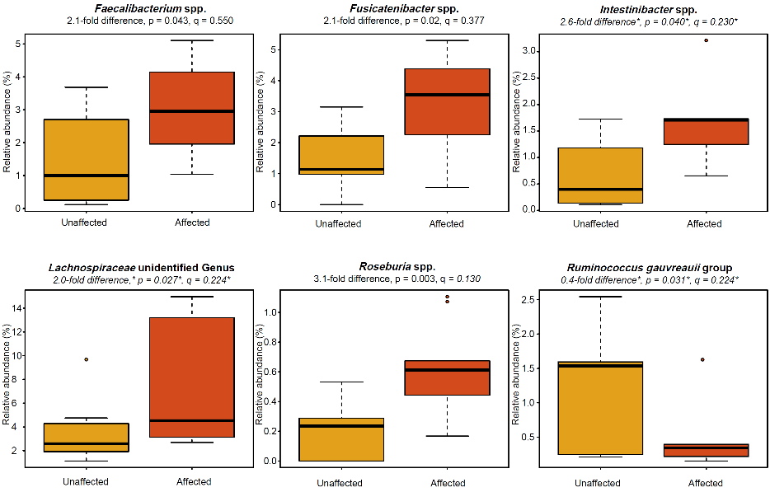
B | 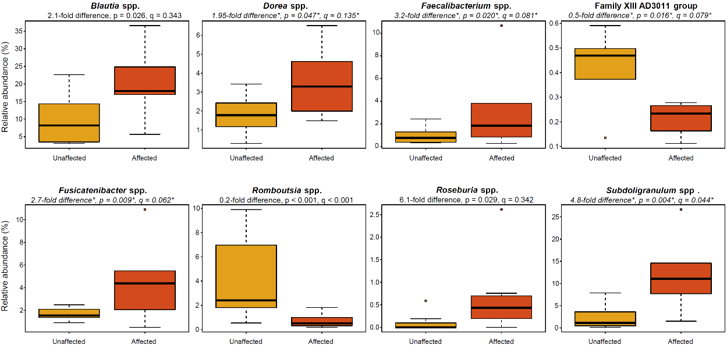
Supplementary Figure 5. Differences in fecal microbiota between subjects apparently more affected by carry-over versus those less affected (treatment-placebo sequence). (A) Run-in differences in genera identified to statistically significantly differ in relative abundances between subjects apparently affected versus those unaffected by carry-over . (B) Wash-out differences in genera identified to statistically significantly differ in relative abundances between subjects apparently affected versus those unaffected by carry-over. Fold differences, p-values, and FDR-corrected q-values denoted with an asterisk * are based only on samples with the taxon present

