Supplemental Figure legend
Supplemental Figure 1 Predicted class distributions across different few-shot settings for MAFLD-GPT.
Supplemental Figure 2 Performance comparison of MAFLD-GPT across gender subgroups
Supplemental Figure 3 Performance comparison of MAFLD-GPT across age subgroups.

Supplemental Figure 1 Predicted class distributions across different few-shot settings for MAFLD-GPT
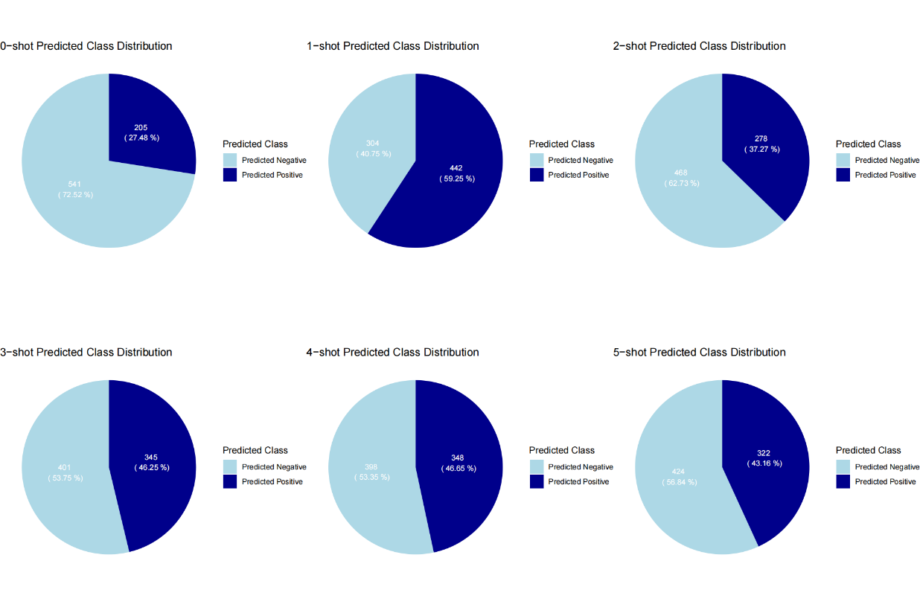
The numbers and percentages within each sector indicate sample counts for each predicted class.
Supplemental Figure 2 Performance comparison of MAFLD-GPT (3shot) across gender subgroups
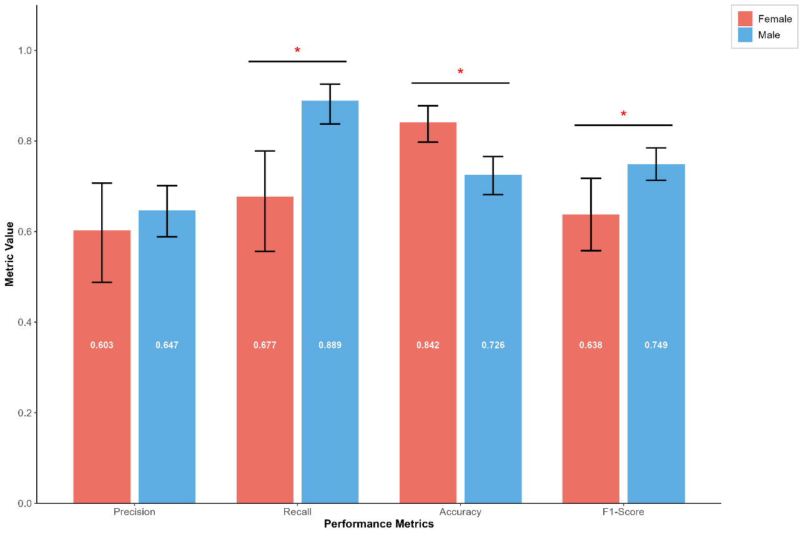
Statistical significance between groups was determined using two-tailed tests (* P < 0.05, ** P < 0.01, *** P < 0.001).

Supplemental Figure 3 Performance comparison of MAFLD-GPT across age subgroups
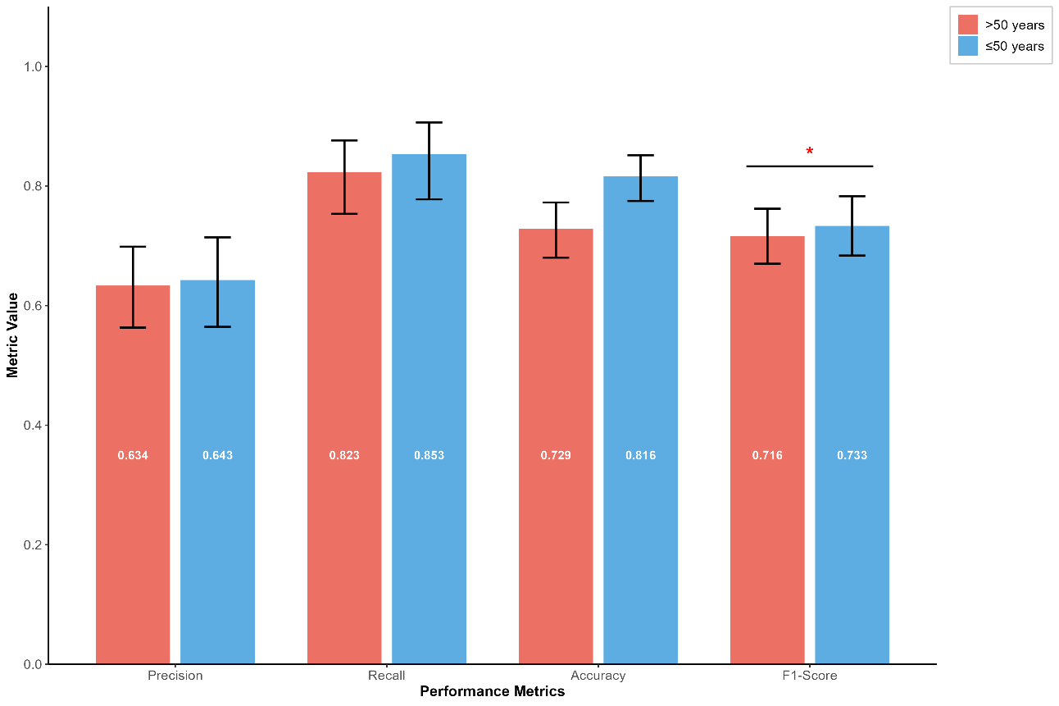.
Statistical significance between groups was determined using two-tailed tests (* P < 0.05, ** P < 0.01, *** P < 0.001).

