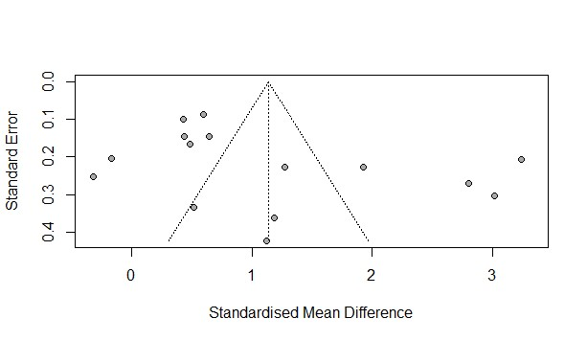

Figure S1. Funnel plot for the pooled SMD of PLR between patients with SAP vs. non-SAP
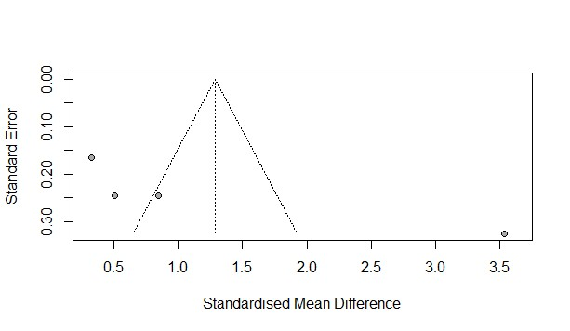
Figure S2. Funnel plot for the pooled SMD of PLR between patients with SAP vs. MSAP

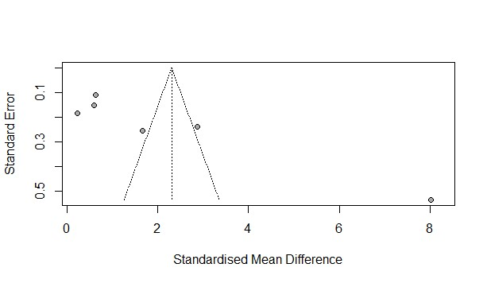
Figure S3. Funnel plot for the pooled SMD of PLR between patients with SAP vs. MAP

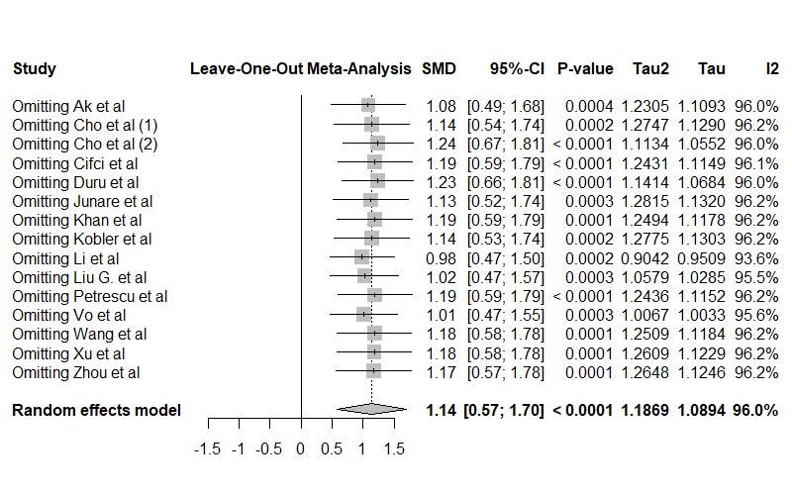
Figure S4. sensitivity analysis for the pooled SMD of PLR between patients with SAP vs. non-SAP

