Supplementary materials
Risk Assessment of Digestive Cancers with the Modified EAT-Lancet Diet Pattern: A Prospective Cohort Study Based on UK Biobank
Supplementary Table S1 International Classification of Disease Codes used to identify cancer in the UK Biobank cohort
Supplementary Table S2 Data fields and date of cancer diagnosis in the UK Biobank cohort
Supplementary Table S3 Definition of portion size and food items used in this study
Supplementary Table S4 Summary results of 8 independent SNPs used for PRS construction of rectal cancer
Supplementary Table S5 Summary results of 22 independent SNPs used for PRS construction of pancreatic cancer
Supplementary Table S6 Summary results of 14 independent SNPs used for PRS construction of esophagus cancer
Supplementary Table S7 Summary results of 5 independent SNPs used for PRS construction of liver cancer
Supplementary Table S8 Cut-offs for each component of the EAT-Lancet diet score（Score2）
Supplementary Table S9 Baseline characteristics of participants in the UK Biobank (N=111785)
Supplementary Table S10 components of cancer-specific Score3 and coefficients in LASSO-Cox regression
Supplementary Table S11 C-index (95% CI) and ΔC-index (Score3 vs Score1) for predictive discrimination of dietary scores (Score1–Score3) across digestive cancer types
Supplementary Table S12 Internal validation of the cancer-specific Score3: bootstrap correction, train-test split, and cross-validation performance
Supplementary Table S13 Net reclassification improvement (NRI) for dietary scores (Score2 and Score3) versus Score1 across seven digestive cancer types.
Supplementary Table S14 Multiplicative and additive interactions between dietary scores and genetic risk on four digestive cancers incidence, including RERI (Relative Excess Risk due to Interaction) and AP (Attributable Proportion due to Interaction).
Figure S1 Associations between Score1–Score3 (cancer-specific) and risks of digestive cancers
Figure S2 Flexible 10-year calibration curves of Score3 (cancer-specific) for predicting survival probability of seven digestive cancers
Figure S3 Cumulative risk of other three digestive cancers during follow-up according to Score3 (cancer-specific)
Figure S4 Dose-response association of the risks of other three digestive cancers with Score3 (cancer-specific)
Figure S5 Associations between Score3 (cancer-specific) and risks of seven digestive cancers
Figure S6 Associations of risks of other three digestive cancers with Score3 (cancer-specific), stratified by PRS subgroups
Figure S7 Associations of Score3 (cancer-specific) with risks of four digestive cancers, stratified by sex subgroups
Figure S8 Associations of Score3 (cancer-specific) with risks of four digestive cancers, stratified by smoking subgroups

Supplementary Table S1 International Classification of Disease Codes used to identify cancer in the UK Biobank cohort

Cancer | ICD10 codesª | ICD9 codes^{b}
All | C00-C97 | 1401-2279
Digest | C15-C26 | 1505-1599
Esophagus | C15 | 1505-1509
Stomach | C16 | 1510-1519
Colon | C18-C19 | 1530-1539
Rectum | C20 | 1541
Liver | C22 | 1550-1551
Biliary tract | C23-C24 | 1561-1562
Pancreas | C25 | 1570-1579
Abbreviations: ICD, International Classification of Diseases.
ªICD9 codes for: 40006 National cancer registry，41270 Hospital inpatient
^{b}ICD10 codes for: 40006 National cancer registry，41270 Hospital inpatient

Supplementary Table S2 Data fields and date of cancer diagnosis in the UK Biobank cohort
Category | Data field | Description
Basic information
Age | 21022 | Age at recruitment
Age | 53 | Date of attending assessment center
Date of death | 40000 | Date of death
Sex | 31 | Sex
Townsend | 189 | Townsend deprivation index at recruitment
Ethnic | 21000 | Ethnic background
Date of cancer diagnosis | 40005 | national cancer registry
Date of first in-patient diagnosis - ICD10 | 41280 | hospital inpatient
Date of first in-patient diagnosis - ICD9 (hospital inpatient) | 41281 | hospital inpatient
Covariates
BMI | 21001 | Body mass index (BMI)
Waist circumference (cm) | 48 | Waist circumference
Alcohol intake frequency | 1558 | Alcohol intake frequency
Smoking | 20116 | Smoking status

Supplementary Table S3 Definition of portion size and food items used in this study

Component | ³Definition of 1 portion | Food items based on the Oxford WebQ questionnaire
Whole grains
1 Rice, wheat, corn, and other | 1 portion: 130 g | porridge, muesli, oat crunch, sweetened cereal, plain cereal, bran cereal, whole-wheat cereal, other cereal, wholemeal pasta, brown rice, couscous, other grain
Tubers and starchy vegetables
2 Potatoes | 1 portion: 58 g | fried, boiled, baked or mashed potatoes, sweet potato
Vegetables
3 All vegetables | 1 portion: 100 g | quorn, mixed vegetable, vegetable pieces, coleslaw, side salad, avocado, broad bean, green bean, beetroot, broccoli, butternut squash, cabbage, carrot, cauliflower, celery, courgette, cucumber, garlic, leek, lettuce, mushroom, onion, parsnip, pea, sweet pepper, spinach, fresh tomato, tinned tomato, turnip, watercress, other vegetable, sweetcorn
Fruits
4 All fruits | 1 portion: 150 g | stewed fruit, prune (1 portion: 48g), dried fruit (1 portion: 48g), mixed fruit, apple, banana, berry (1 portion: 48g), cherry (1  portion: 48g), grapefruit, grape (1 portion: 48g), mango, melon, orange, satsuma, peach, pear, pineapple, plum (1 portion: 48g), other fruit
Dairy foods
5 Whole milk or derivative equivalents | 1 portion: 258 g | milk, favoured milk, yogurt (1 portion: 180g), low fat hard cheese, hard cheese, soft cheese, blue cheese, low fat cheese spread, cheese spread, cottage cheese, feta, mozzarella, goat’s cheese, other cheese (1 portion: 28g)
Protein sources
6 ¹Beef, lamb, pork |  | bacon, ham (1 portion: 40g), liver, sausage, beef, pork, lamb (1 portion: 80g)
7 Chicken, other poultry | 1 portion: 80 g | crumbed or deep-fried poultry, poultry
8 Eggs | 1 portion: 60 g | whole egg, omelette, eggs in the sandwich, scotch egg, other egg
9 Fish | 1 portion: 100 g | shellfish, tinned tuna, oily fish, breaded fish, battered fish, white fish, other fish
Legumes
10 Dry beans, lentils, peas | 1 portion: 100 g | dried lentils, peas and baked beans
11 Soy foods | 1 portion: 100 g | tofu
12 Peanuts or tree nuts | 1 portion: 28 g | unsalted peanuts, salted nuts, unsalted nuts, seed
Added fats
13 Palm oil, unsaturated oils, dairy fats (incl. in milk), lard or tallow |  | ²ratio of 0.8 for unsaturated: saturated fat intake
Added sugars
14 All sweeteners | 1 portion: 4 g | derived from sweet foods and beverages, and sugar added to food or beverages recorded in the 24-hour diet recall
¹Beef, lamb and pork were aggregated into red meat intake.
²Too little information about the types of oils was recorded in the 24-hour diet recall so fat intake was approximated as a ratio of total unsaturated and saturated fat in line with the EAT-Lancet reference diet
³Definition of 1 portion was not explicitly described in the UK Biobank 24-hour dietary recall data; however, previous studies have summarized the portion sizes used to calculate food consumption in this dataset(1).

Supplementary Table S4 Summary results of 8 independent SNPs used for PRS construction of rectal cancer

SNP | Position | Chromosome | Risk allele | Beta | P value
rs2027077 | 183073453 | 1 | G | 0.16636 | 1.74E-07
rs17604996 | 126763087 | 5 | A | -0.37222 | 1.24E-07
rs6983267 | 128413305 | 8 | G | 0.19483 | 4.81E-10
rs148162237 | 142347996 | 8 | G | -1.48148 | 1.99E-07
rs3087967 | 111156836 | 11 | T | 0.18182 | 3.37E-08
rs58658771 | 33001734 | 15 | T | -0.21691 | 1.18E-08
rs4939827 | 46453463 | 18 | T | 0.17092 | 4.87E-08
rs146801533 | 19166671 | 20 | T | -0.60002 | 3.52E-07

Supplementary Table S5 Summary results of 22 independent SNPs used for PRS construction of pancreatic cancer

SNP | Position | Chromosome | Risk allele | Beta | P value
rs13303010 | 894573 | 1 | G | 0.231 | 8.36E-14
rs2816938 | 199985368 | 1 | A | 0.191 | 3.36E-15
rs3790844 | 200007432 | 1 | A | 0.211 | 7.62E-16
rs1486134 | 67639769 | 2 | G | 0.122 | 4.61E-09
rs9854771 | 189508471 | 3 | G | 0.105 | 4.54E-08
rs2736098 | 1294086 | 5 | C | 0.174 | 6.86E-15
rs35226131 | 1295373 | 5 | C | 0.400 | 2.19E-08
rs401681 | 1322087 | 5 | T | 0.174 | 9.32E-17
rs73328514 | 47488569 | 7 | A | 0.163 | 0.000000135
rs17688601 | 40866663 | 7 | C | 0.128 | 1.11E-08
rs6971499 | 130680521 | 7 | T | 0.211 | 7.41E-14
rs2941471 | 76470404 | 8 | A | 0.117 | 6.6E-10
rs10094872 | 128719884 | 8 | T | 0.131 | 1.19E-09
rs1561927 | 129568078 | 8 | T | 0.117 | 7.09E-08
rs505922 | 136149229 | 9 | C | 0.239 | 7.35E-27
rs9581943 | 28493997 | 13 | A | 0.140 | 5.12E-14
rs9543325 | 73916628 | 13 | C | 0.215 | 1.22E-22
rs7190458 | 75263661 | 16 | A | 0.307 | 1.29E-11
rs4795218 | 36078510 | 17 | G | 0.128 | 1.32E-08
rs7214041 | 70401476 | 17 | T | 0.223 | 9.49E-15
rs1517037 | 56878274 | 18 | C | 0.151 | 3.28E-08
rs16986825 | 29300306 | 22 | T | 0.140 | 1.21E-08

Supplementary Table S6 Summary results of 14 independent SNPs used for PRS construction of esophagus cancer

SNP | Chromosome | Risk allele | Beta | P value
rs7255 | 2 | T | 0.15 | 4.27E-08
rs13397172 | 2 | C | 0.12 | 4.27E-08
rs2687202 | 3 | T | 0.13 | 1.79E-05
rs9823696 | 3 | A | 0.16 | 1.64E-08
rs9257809 | 6 | A | 0.13 | 1.60E-02
rs62423175 | 6 | A | 0.21 | 3.19E-08
rs2188554 | 7 | A | 0.21 | 5.81E-09
rs17749155 | 8 | A | 0.13 | 1.26E-03
rs10108511 | 8 | T | 0.08 | 3.97E-03
rs7852462 | 9 | C | 0.07 | 1.45E-02
rs1247942 | 12 | G | 0.11 | 9.83E-05
rs2464469 | 15 | G | 0.11 | 1.25E-04
rs1979654 | 16 | G | 0.10 | 3.24E-04
rs10419226 | 19 | T | 0.11 | 1.19E-04

Supplementary Table S7 Summary results of 5 independent SNPs used for PRS construction of liver cancer

SNP | Chromosome | Risk allele | OR
rs9842969 | 3 | T | 1.75
rs2242652 | 5 | G | 1.43
rs58542926 | 19 | T | 1.53
rs58489806 | 19 | T | 1.50
rs738409 | 22 | G | 1.65

Supplementary Table S8 Cut-offs for each component of the EAT-Lancet diet score（Score2）

Component | Target intake，grams  (reference interval) | 3 points | 2 points | 1 point | 0 point
Emphasized intake
Vegetables | 300 (200–600) | >300 | 200–300 | 100–200 | <100
Fruits | 200 (100–300) | >200 | 100–200 | 50–100 | <50
¹Unsaturated: Saturated fat intake |  |  | ≥0.8 |  | <0.8
Legumes | 75 (0–150) | >75 | 37.5–75 | 18.75–37.5 | <18.75
Nuts | 50 (0–100) | >50 | 25–50 | 12.5–25 | <12.5
²Whole grains | 232 | >232 | 116–232 | 58–116 | <58
Fish | 28 (0–100) | >28 | 14–28 | 7–14 | <7
Limited intake
³Red meat | 7 (0–14) | <7 | 7–14 | 14–28 | >28
Processed meat | 7 (0–14) | <7 | 7–14 | 14–28 | >28
Poultry | 29 (0–58) | <29 | 29–58 | 58–116 | >116
Eggs | 13 (0–25) | <13 | 13–25 | 25–50 | >50
⁴Dairy food | 250 (0–500) | <250 | 250–500 | 500–1000 | >1000
Potatoes | 50 (0–100) | <50 | 50–100 | 100–200 | >200
Added sugar | 31 (0–31) | <31 | 31–62 | 62–124 | >124
¹Too little information about the types of oils were recorded in the 24-hour diet recall so fat intake was approximated as a ratio of total unsaturated and saturated fat. Participants who met the recommendation of ratio of 0.8 for unsaturated: saturated fat intake were assigned with 2 points and those did not meet the recommendation were assigned with 0 point(2)
²Whole grains excludes refined products.
³red meat include beef, pork and lamb.
⁴Dairy food were weighted differently according to Stubbendorff : Dairy intake was standardized to milk equivalents using conversion factors based on total solids, following the approach by the Stockholm Resilience Centre.(3)

Supplementary Table S9 Baseline characteristics of participants in the UK Biobank (N=111785)

Characteristics | Overall | Esophagus cancer | liver Cancer | Stomach Cancer | Rectal Cancer | Biliary Tract Cancer | Colon Cancer | Pancreatic Cancer
n | 111785 | 224 | 146 | 163 | 399 | 75 | 914 | 325
Sex (%)
Female | 62313 (55.7) | 76 (33.9) | 51 (34.9) | 46 (28.2) | 142 (35.6) | 31 (41.3) | 428 (46.8) | 148 (45.5)
Male | 49472 (44.3) | 148 (66.1) | 95 (65.1) | 117 (71.8) | 257 (64.4) | 44 (58.7) | 486 (53.2) | 177 (54.5)
Age (mean (SD)) | 55.72 (7.83) | 60.15 (6.51) | 60.37 (5.85) | 59.57 (6.72) | 59.57 (6.87) | 60.09 (5.40) | 59.38 (7.00) | 60.21 (6.11)
Ethnic (%)
White | 102227 (91.4) | 215 (96.0) | 140 (95.9) | 156 (95.7) | 371 (93.0) | 72 (96.0) | 831 (90.9) | 302 (92.9)
Other | 9558  (8.6) | 9 (4.0) | 6 (4.1) | 7 (4.3) | 28 (7.0) | 3 (4.0) | 83 (9.1) | 23 (7.1)
Body Mass Index (%), kg/m2
<25 | 44401 (39.7) | 51 (22.8) | 37 (25.3) | 35 (21.5) | 128 (32.1) | 18 (24.0) | 282 (30.9) | 89 (27.4)
25-30 | 45578 (40.8) | 107 (47.8) | 54 (37.0) | 83 (50.9) | 183 (45.9) | 33 (44.0) | 414 (45.3) | 159 (48.9)
>30 | 21806 (19.5) | 66 (29.5) | 55 (37.7) | 45 (27.6) | 88 (22.1) | 24 (32.0) | 218 (23.9) | 77 (23.7)
Alcohol Frequency (%)
Never | 26355 (23.6) | 54 (24.1) | 41 (28.1) | 41 (25.2) | 117 (29.3) | 15 (20.0) | 270 (29.5) | 82 (25.2)
Special occasions only | 28947 (25.9) | 67 (29.9) | 37 (25.3) | 43 (26.4) | 106 (26.6) | 19 (25.3) | 248 (27.1) | 85 (26.2)
One to three times a month | 27628 (24.7) | 45 (20.1) | 30 (20.5) | 39 (23.9) | 84 (21.1) | 23 (30.7) | 179 (19.6) | 80 (24.6)
Once or twice a week | 12165 (10.9) | 20 (8.9) | 14 (9.6) | 17 (10.4) | 28 (7.0) | 7 (9.3) | 90 (9.8) | 25 (7.7)
Three or four times a week | 10302 (9.2) | 27 (12.1) | 15 (10.3) | 16 (9.8) | 31 (7.8) | 4 (5.3) | 74 (8.1) | 29 (8.9)
Daily or almost daily | 6388 (5.7) | 11 (4.9) | 9 (6.2) | 7 (4.3) | 33 (8.3) | 7 (9.3) | 53 (5.8) | 24 (7.4)
Smoking Status (%)
Never | 64457 (57.7) | 87 (38.8) | 63 (43.2) | 74 (45.4) | 179 (44.9) | 31 (41.3) | 455 (49.8) | 166 (51.1)
Previous | 39504 (35.3) | 105 (46.9) | 64 (43.8) | 77 (47.2) | 193 (48.4) | 39 (52.0) | 395 (43.2) | 125 (38.5)
Current | 7824 (7.0) | 32 (14.3) | 19 (13.0) | 12 (7.4) | 27 (6.8) | 5 (6.7) | 64 (7.0) | 34 (10.5)
Townsend Deprivation Index (%)
Low | 36809 (32.9) | 80 (35.7) | 50 (34.2) | 59 (36.2) | 139 (34.8) | 25 (33.3) | 324 (35.4) | 99 (30.5)
Intermediate | 38115 (34.1) | 78 (34.8) | 51 (34.9) | 52 (31.9) | 141 (35.3) | 32 (42.7) | 300 (32.8) | 122 (37.5)
High | 36861 (33.0) | 66 (29.5) | 45 (30.8) | 52 (31.9) | 119 (29.8) | 18 (24.0) | 290 (31.7) | 104 (32.0)
Energy (mean (SD)) | 2056.38 (494.72) | 2140.42 (532.79) | 2131.00 (482.98) | 2182.27 (480.01) | 2173.01 (480.45) | 2068.28 (488.16) | 2101.21 (480.18) | 2048.43 (471.20)

Supplementary Table S10 components of cancer-specific Score3 and coefficients in LASSO-Cox regression

Components of score3 | Coefficient
Esophagus cancer
Whole grains | -0.2015
Potatoes | 0.1079
Vegetables | 0.0197
Dairy food | -0.1476
Poultry | -0.0477
Fish | 0.0765
Nuts | 0.0667
Unsaturated: Saturated fat intake | 0.0030
liver Cancer
Potatoes | 0.1786
Dairy food | -0.1470
Red meat | 0.0668
Poultry | -0.0638
Fish | 0.0062
Stomach Cancer
Whole grains | -0.1132
Potatoes | 0.0390
Dairy food | -0.0109
Legumes | -0.0331
Rectal Cancer
Whole grains | -0.0177
Potatoes | 0.1390
Fruits | 0.1200
Dairy food | -0.0042
Poultry | 0.0082
Legumes | -0.0361
Added sugar | 0.0373
Processed meat | 0.1186
Biliary Tract Cancer
Potatoes | 0.0159
Red meat | 0.1244
Colon Cancer
Potatoes | 0.0561
Red meat | 0.0288
Processed meat | 0.0202
Pancreatic Cancer
Whole grains | 0.0518
Potatoes | 0.1355
Vegetables | 0.0883
Fruits | -0.0231
Dairy food | 0.0716
Red meat | 0.0663
eggs | 0.0625
Nuts | 0.0289
Legumes | 0.0872
Unsaturated: Saturated fat intake | -0.0004
Processed meat | 0.0105

Supplementary Table S11 C-index (95% CI) and ΔC-index (Score3 vs Score1) for predictive discrimination of dietary scores (Score1–Score3) across digestive cancer types.

Group | Score1 |  |  | Score2 |  |  | Score3 (cancer-specific) |  | ΔC-index
Group | C-index | C-index (95%CI) |  | C-index | C-index (95%CI) |  | C-index | C-index (95%CI) | ΔC-index
Esophagus cancer | 0.579 | 0.579 (0.525-0.634) |  | 0.541 | 0.541 (0.485-0.598) |  | 0.623 | 0.623 (0.571-0.675) | 0.044
liver Cancer | 0.551 | 0.551 (0.477-0.625) |  | 0.560 | 0.560 (0.490-0.630) |  | 0.630 | 0.630 (0.566-0.695) | 0.079
Stomach Cancer | 0.513 | 0.513 (0.443-0.584) |  | 0.509 | 0.509 (0.441-0.577) |  | 0.591 | 0.591 (0.531-0.651) | 0.078
Rectal Cancer | 0.537 | 0.537 (0.492-0.582) |  | 0.555 | 0.555 (0.512-0.599) |  | 0.611 | 0.611 (0.573-0.650) | 0.074
Biliary Tract Cancer | 0.566 | 0.566 (0.465-0.668) |  | 0.578 | 0.578 (0.484-0.671) |  | 0.647 | 0.647 (0.551-0.743) | 0.081
Colon Cancer | 0.522 | 0.522 (0.492-0.552) |  | 0.529 | 0.529 (0.500-0.558) |  | 0.541 | 0.541 (0.515-0.567) | 0.019
Pancreatic Cancer | 0.571 | 0.571 (0.521-0.621) |  | 0.583 | 0.583 (0.535-0.631) |  | 0.604 | 0.604 (0.560-0.649) | 0.033

Supplementary Table S12 Internal validation of the cancer-specific Score3: bootstrap correction, train-test split, and cross-validation performance

Group | ªOptimism value (bootstrap) | ^{b}Optimism-corrected C-index (bootstrap) | ^{c}Calibration slope (bootstrap) | ^{d}C-index (train-test split) | ^{e}C-index (CV, mean ± SD)
Esophagus cancer | 0.002 | 0.581 | 0.999 | 0.571 | 0.583 ± 0.044
liver Cancer | 0.008 | 0.583 | 0.987 | 0.668 | 0.576 ± 0.070
Stomach Cancer | 0.016 | 0.553 | 0.976 | 0.584 | 0.563 ± 0.037
Rectal Cancer | 0.001 | 0.574 | 1.000 | 0.565 | 0.574 ± 0.022
Biliary Tract Cancer | 0.021 | 0.582 | 0.975 | 0.676 | 0.559 ± 0.084
Colon Cancer | 0.007 | 0.524 | 0.979 | 0.554 | 0.527 ± 0.026
Pancreatic Cancer | 0.007 | 0.566 | 1.007 | 0.571 | 0.570 ± 0.023
Score3 was individually derived for each cancer using LASSO-Cox regression. Internal validation was performed as follows:
(a) Bootstrap validation (500 repetitions) to assess model optimism (overfitting), calculate ªoptimism value, ^{b}optimism-corrected C-index, and estimate ^{c}calibration slope;
(b) Random 70/30 train–test split to examine discriminative performance (^{d}C-index);
(c) Five-fold cross-validation to further evaluate discrimination stability (^{e}C-index).
Supplementary Table S13 Net reclassification improvement (NRI) for dietary scores (Score2 and Score3) versus Score1 across seven digestive cancer types.

Group | Score2 vs Score1 |  |  |  | Score3 vs Score1
Group | NRI | 95%CI Lower | 95%CI Upper |  | NRI | 95%CI Lower | 95%CI Upper
Esophagus cancer | -0.046 | -0.098 | 0.008 |  | 0.041 | -0.06 | 0.139
liver Cancer | 0.022 | -0.016 | 0.06 |  | 0.113 | 0.019 | 0.203
Stomach Cancer | -0.006 | -0.127 | 0.112 |  | 0.089 | 0.001 | 0.176
Rectal Cancer | 0.019 | -0.033 | 0.065 |  | 0.085 | 0.036 | 0.133
Biliary Tract Cancer | 0.035 | -0.016 | 0.082 |  | 0.134 | 0.024 | 0.258
Colon Cancer | 0.009 | -0.005 | 0.025 |  | 0.025 | -0.01 | 0.057
Pancreatic Cancer | 0.011 | -0.024 | 0.049 |  | 0.058 | 0.004 | 0.118

Supplementary Table S14 Multiplicative and additive interactions between dietary scores and genetic risk on four digestive cancers incidence, including RERI (Relative Excess Risk due to Interaction) and AP (Attributable Proportion due to Interaction).

Group | Multiplicative Interaction | RERI | AP
Rectal Cancer | 1.323 (0.871–2.010) | 0.687 (0.045–1.260) | 0.286 (0.028–0.491)
Pancreatic Cancer | 0.796 (0.487–1.300) | 0.395 (-0.848–1.408) | 0.106 (-0.191–0.333)
liver Cancer | 0.910 (0.439–1.885) | 0.748 (-1.259–2.572) | 0.193 (-0.256–0.491)
Esophagus cancer | 1.007 (0.575–1.762) | 0.118 (-0.954–0.893) | 0.053 (-0.391–0.373)
RERI: Relative Excess Risk due to Interaction
AP: Attributable Proportion due to Interaction

Figure S1 Associations between Score1–Score3 (cancer-specific) and risks of digestive cancers

Figure S2 Flexible 10-year calibration curves of Score3 (cancer-specific) for predicting survival probability of seven digestive cancers.

Figure S3 Cumulative risk of other three digestive cancers during follow-up according to Score3 (cancer-specific)
（a）Stomach cancer（b）Biliary tract cancer（c）Colon cancer

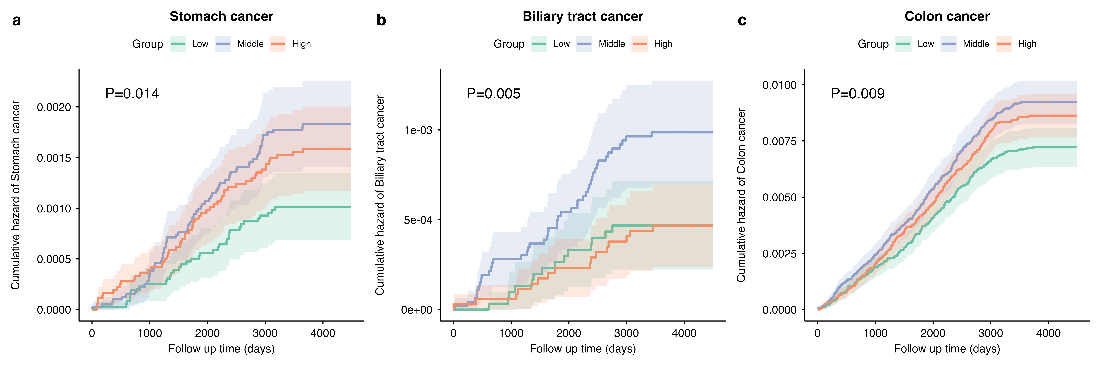

Figure S4 Dose-response association of the risks of other three digestive cancers with Score3 (cancer-specific)
（a）Stomach cancer（b）Biliary tract cancer（c）Colon cancer
Models were adjusted for sex, age, ethnicity, BMI, smoking status, alcohol frequency, Townsend Deprivation Index.
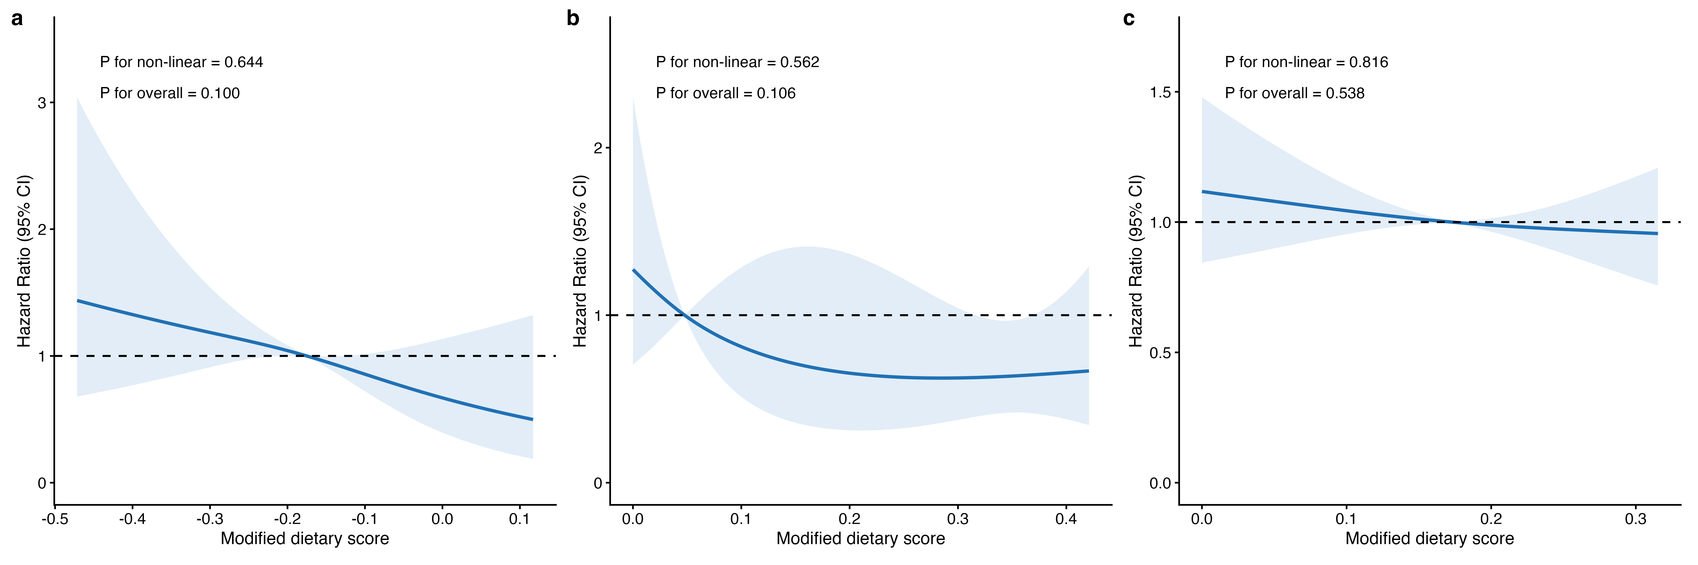

Figure S5 Associations between Score3 (cancer-specific) and risks of seven digestive cancers
Model 1: Adjusted for sex, age, ethnicity, BMI, smoking status, alcohol frequency, Townsend Deprivation Index, energy with further exclusion of participants diagnosed or deceased within 2 years after the 3-year landmark (5 years for pancreatic cancer). The numbers of excluded cases are shown. The excluded cases were shown.
Model 2: Adjusted for sex, age, ethnicity, smoking status, alcohol frequency, Townsend Deprivation Index and energy.

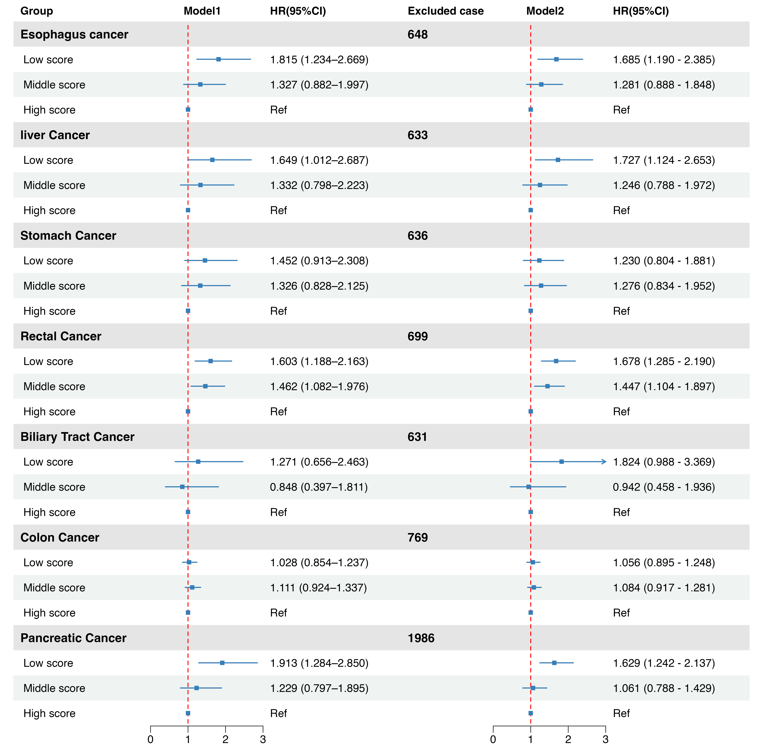

Figure S6 Associations of risks of other three digestive cancers with Score3 (cancer-specific), stratified by PRS subgroups

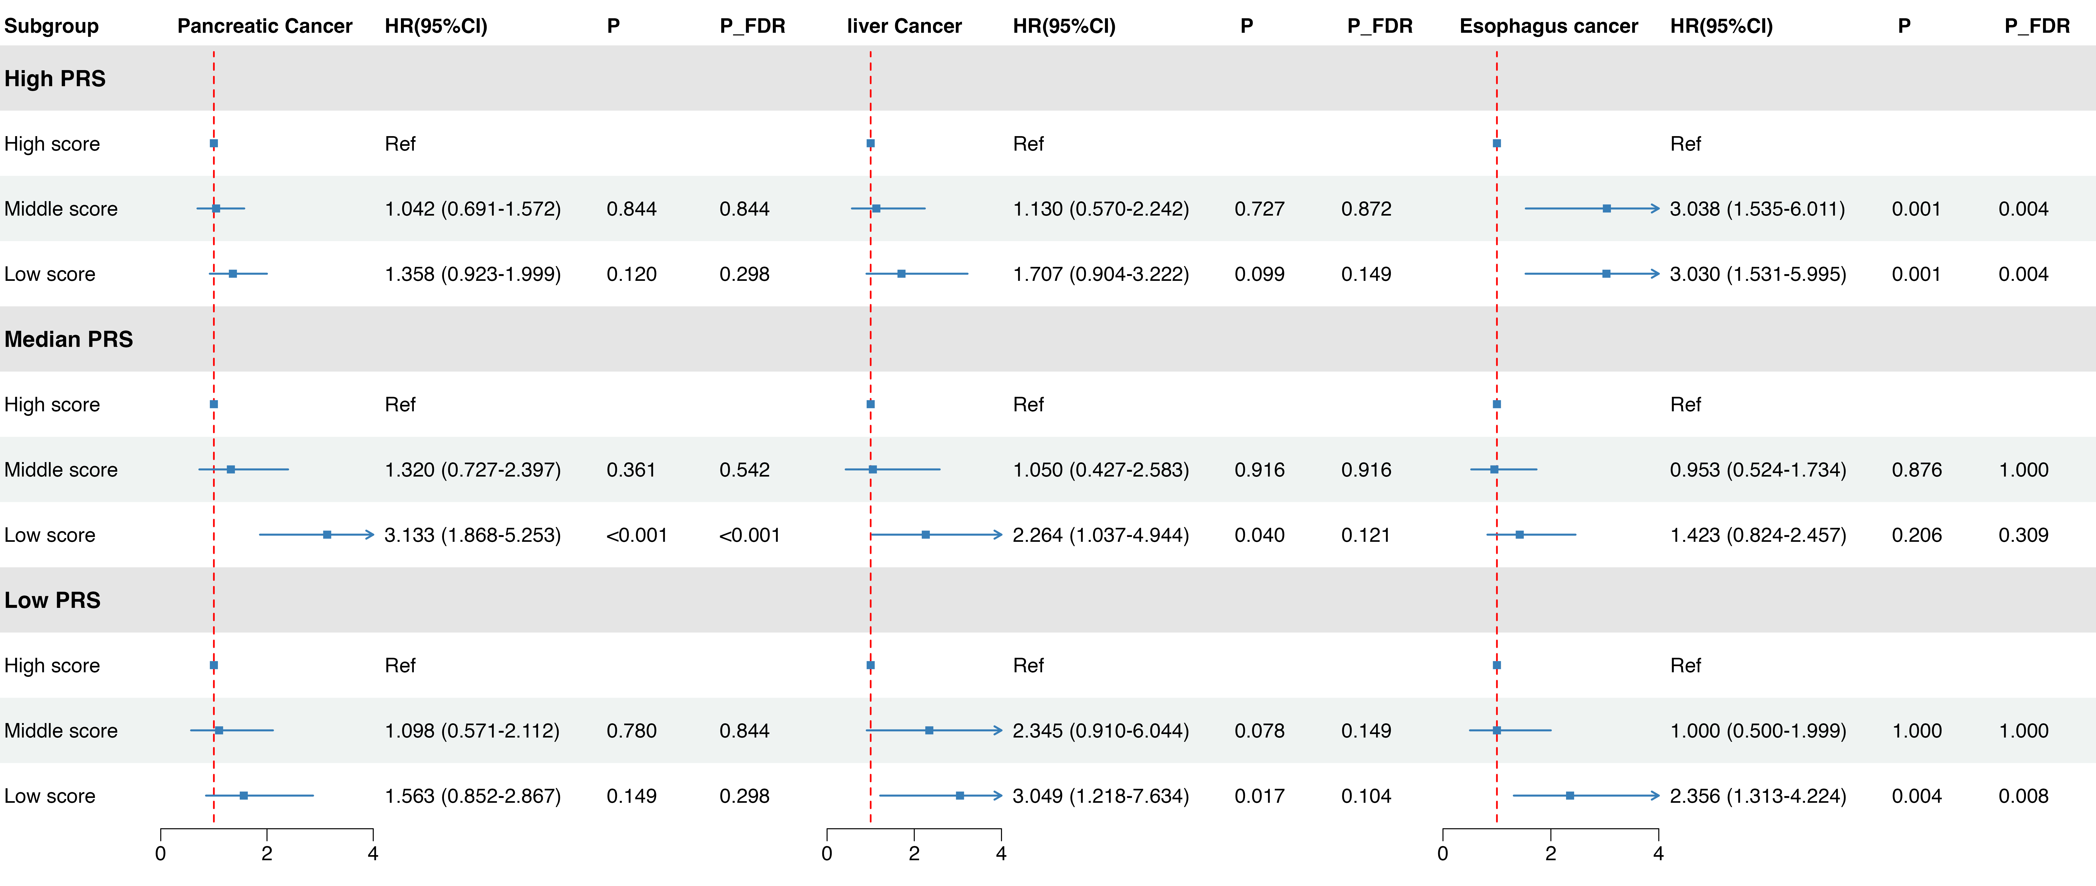

Figure S7 Associations of Score3 (cancer-specific) with risks of four digestive cancers, stratified by sex subgroups

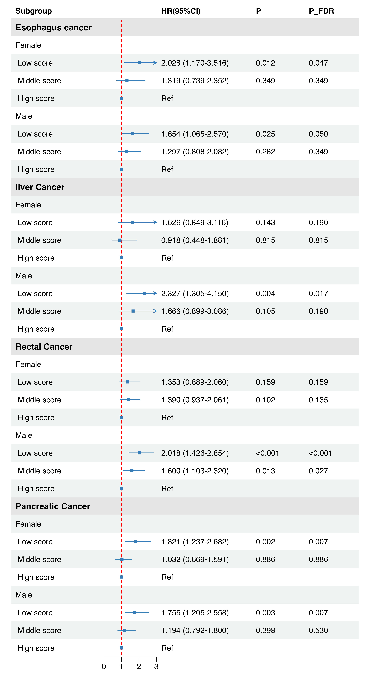

Figure S8 Associations of Score3 (cancer-specific) with risks of four digestive cancers, stratified by smoking subgroups

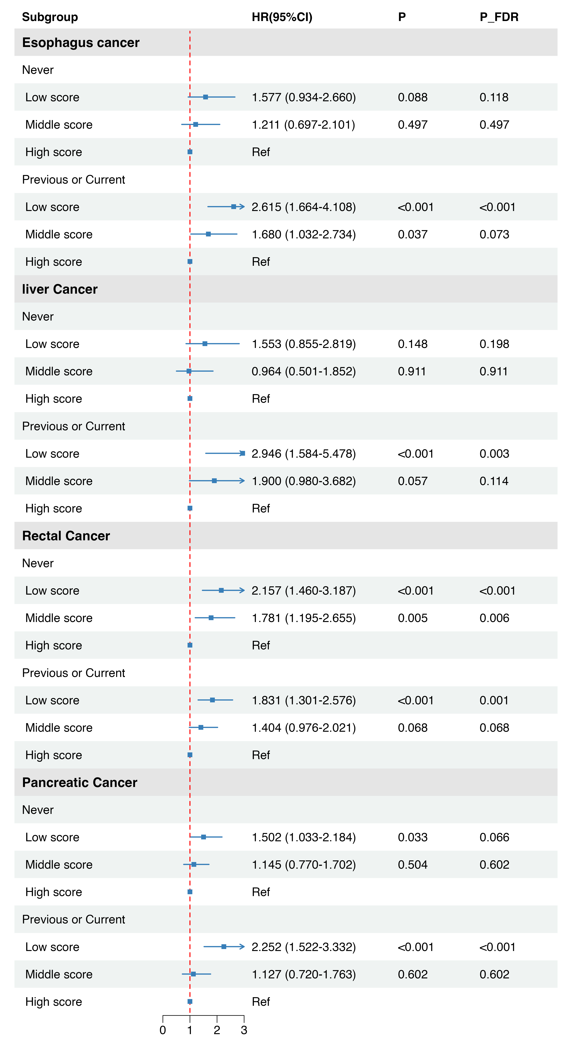

References for Supplemental material:

1. Xu C, Cao Z, Yang H, Hou Y, Wang X, Wang Y. Association Between the EAT-Lancet Diet Pattern and Risk of Type 2 Diabetes: A Prospective Cohort Study. Front Nutr. 2021;8:784018. Epub 20220114. doi: 10.3389/fnut.2021.784018. PubMed PMID: 35096931; PubMed Central PMCID: PMC8795697.
2. Lu X, Wu L, Shao L, Fan Y, Pei Y, Lu X, et al. Adherence to the EAT-Lancet diet and incident depression and anxiety. Nat Commun. 2024;15(1):5599. Epub 20240703. doi: 10.1038/s41467-024-49653-8. PubMed PMID: 38961069; PubMed Central PMCID: PMC11222463.
3. Stubbendorff A, Sonestedt E, Ramne S, Drake I, Hallstrom E, Ericson U. Development of an EAT-Lancet index and its relation to mortality in a Swedish population. Am J Clin Nutr. 2022;115(3):705-16. doi: 10.1093/ajcn/nqab369. PubMed PMID: 34791011; PubMed Central PMCID: PMC8895215.

