Database | Search Terms | Search Field | Search Results
PubMed | (Sweeping OR swab OR sweep OR swabbing) AND ("Helicobacter pylori" OR "H. pylori" OR "Campylobacter pylori" OR "Campylobacter pyloridis" OR "Helicobacter nemestrinae") | All Field | 58
WOS | (Sweeping OR swab OR sweep OR swabbing) AND ("Helicobacter pylori" OR "H. pylori" OR "Campylobacter pylori" OR "Campylobacter pyloridis" OR "Helicobacter nemestrinae") | All Field | 85
SCOPUS | (Sweeping OR swab OR sweep OR swabbing) AND ("Helicobacter pylori" OR "H. pylori" OR "Campylobacter pylori" OR "Campylobacter pyloridis" OR "Helicobacter nemestrinae") | Title, Abstract, Keywords | 92
Cochrane | (Sweeping OR swab OR sweep OR swabbing) AND ("Helicobacter pylori" OR "H. pylori" OR "Campylobacter pylori" OR "Campylobacter pyloridis" OR "Helicobacter nemestrinae") | Title, Abstract, Keywords | 6
Table S I: Search terms and results in different databases.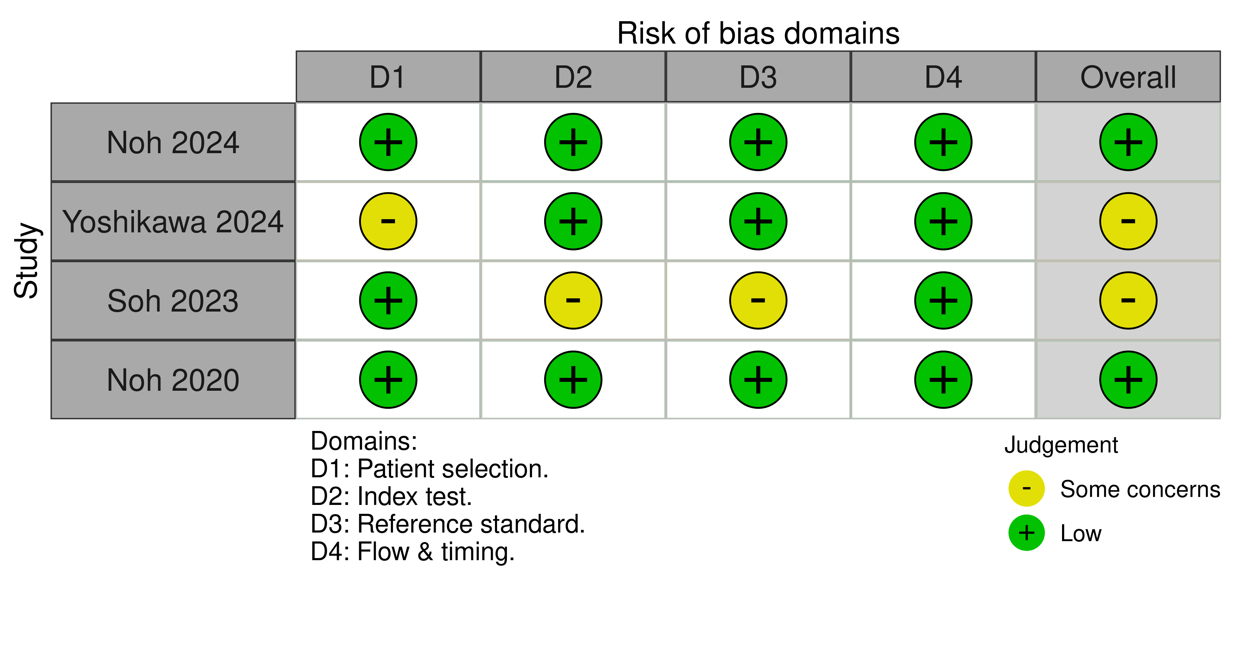
Figure S1: QUADAS-2 for the included studies.

