Table S1: List pf trans-heterozygous mutations known in genes linked with pancreatitis (PRSSI SPINK, CFTR and CPA1).
Author | Population | No. of subjects | TRPV6 | Variants in other CP related genes
Masamune et al | Japan | 1 | p.R345C | SPINK1 p.N34S
 | French | 1 | p.R174X | SPINK1 p.N34S
 |  | 1 | p.G311V | SPINK1 p.N34S
 |  | 1 | p.R345C | CFTR p.F508del
 | German | 9 | p.R342C | SPINK1 p.N34S
 |  |  | p.R483W | SPINK1 p.N34S
 |  |  | p.C659X | SPINK1 p.N34S
 | Japan | 1 | p.H205Y | SPINK1 p.N34S
 | French | 1 | p.A18S | SPINK1 p.N34S
 |  | 4 | p.L299Q | SPINK1 p.N34S
 | German | 3 | p.L299Q | SPINK1 p.N34S
Orcaz et al | Polish | 1 | p.V239SfsX53 | SPINK1 p.N34S
 |  | 1 | p.R745X | CFTR p.F508del
 | German | 7 | p.H162P | SPINK1 p.N34S  CFTR p.V859M
 |  |  | p.P312Q | SPINK p.L14R
 |  |  | p.V540I | SPINK p.N34S
 |  | 1 | p.V239SfsX53 | SPINK1 p.N34S  CFTR p.R117H
 | Non German | 1 | p.G119R | SPINK1 p.N34S  CFTR p.V235I
 |  | 1 | p.R342W | SPINK1 p.N34S  CFTR p.F508del
Hamada et al | French |  | p.R25S | CTRC p.R254W
 |  |  | p.R345H | CFTR p.F508del
 |  |  | p.M506T | CFTR c.1210-34_1210-6TG[12]T[5]
 |  |  | p.K82R | CFTR c.1210-34_1210-6TG[11]T[5]
 |  |  | p.R345C | CFTR p.L997F
 |  |  | p.R483Q | SPINK1 p.N34S
 |  |  | p.A344V | SPINK1 p.N34S
 |  |  | p.R403W | CFTR c.1210-34_1210-6TG[11]T[5]
 |  |  | p.R66W | CFTR p.L997F
 |  |  | p.R646Q | CFTR c.1210-34_1210-6TG[11]T[5]
Hirai et al | Japan | 3 | p.A18S | SPINK1 p.N34S,  CFTR p.M470V  PRSS1 p.R122H
 |  | 3 | p.C197R+M418V+M721T | PRSS1 p.R122H  CFTR p.M740V  SPINK1 p.N34S  CPA1 p.A137G
 |  | 3 | p.I223T | SPINK p.N34S  CFTR p.V470M  SPINK1 c.194+2T>C  PRSS1 p.G208A
 |  | 4 | p.D324N | PRSS1 p.G208A  SPINK1 p.N34S
 |  | 1 | p.V540F | CFTR p.M470V
 |  | 1 | p.A606T | CPA1 p.A137G  CFTR p.M470V+p.R1453W
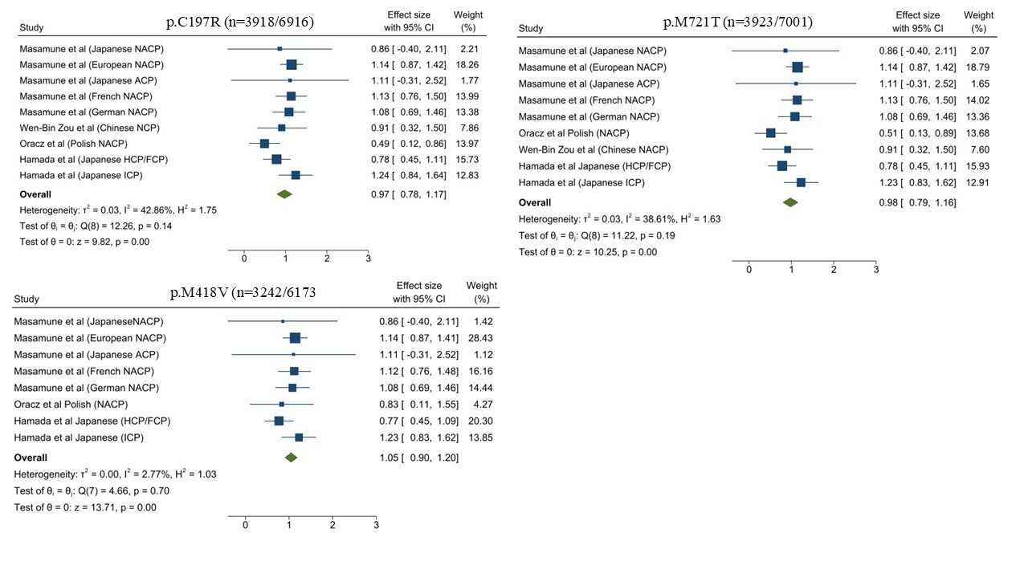
Figure S1: Forest plot for the association between genetic variants of TRPV6 and the risk of pancreatitis. NACP: Non-Acholic chronic pancreatitis, ACP: Alcoholic pancreatitis ICP: Idiopathic pancreatitis, HP: hereditary pancreatitis, FCP: familial chronic pancreatitis.

