Supplementary figures

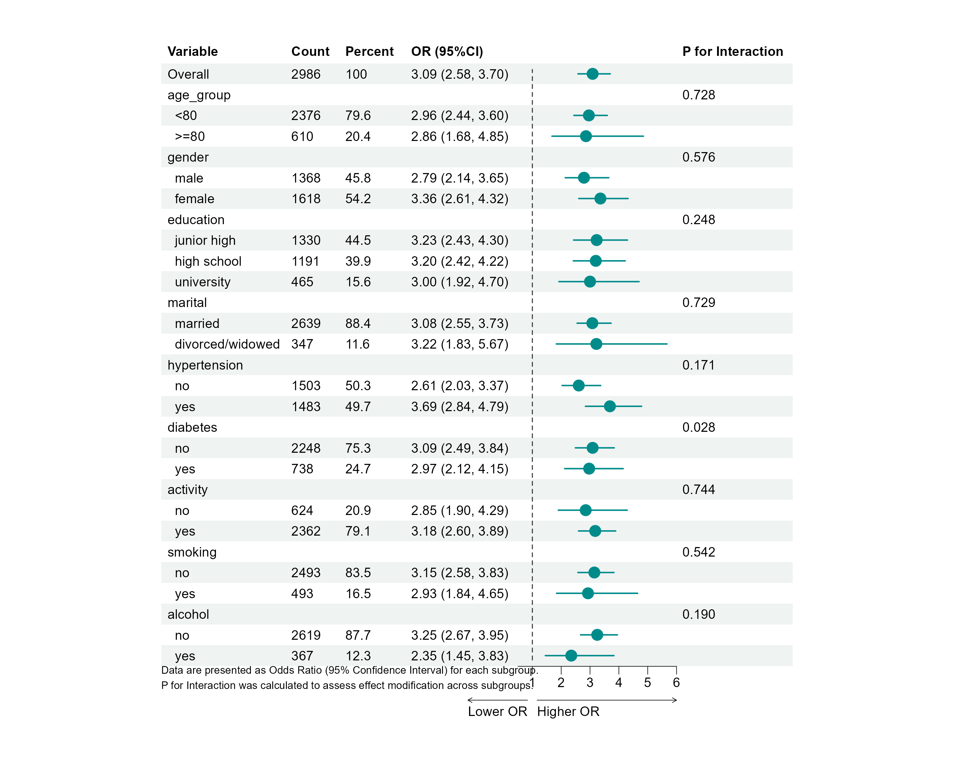
Supplementary Figure 5 Subgroup analysis of the association between TyG and MAFLD.

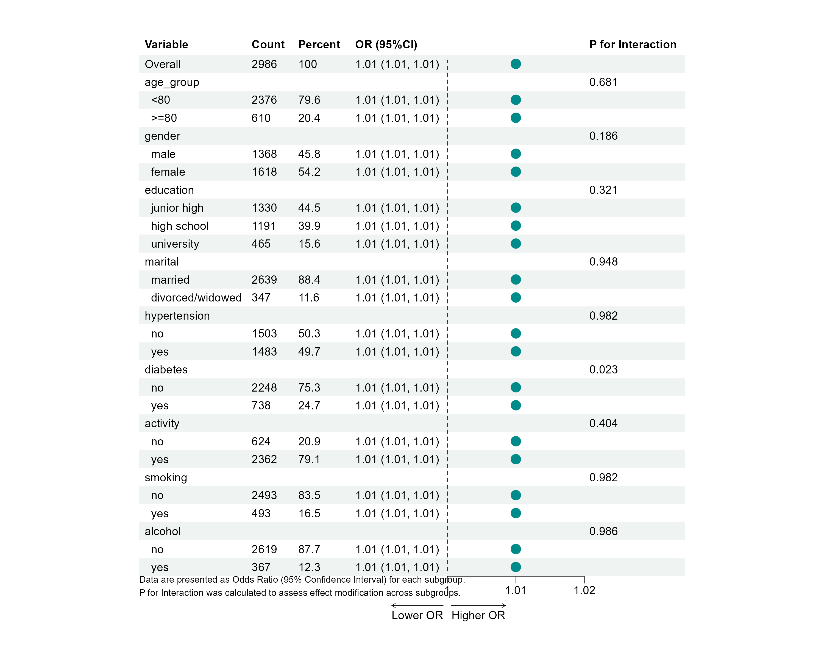
Supplementary Figure 6 Subgroup analysis of the association between TyG-WC and MAFLD.

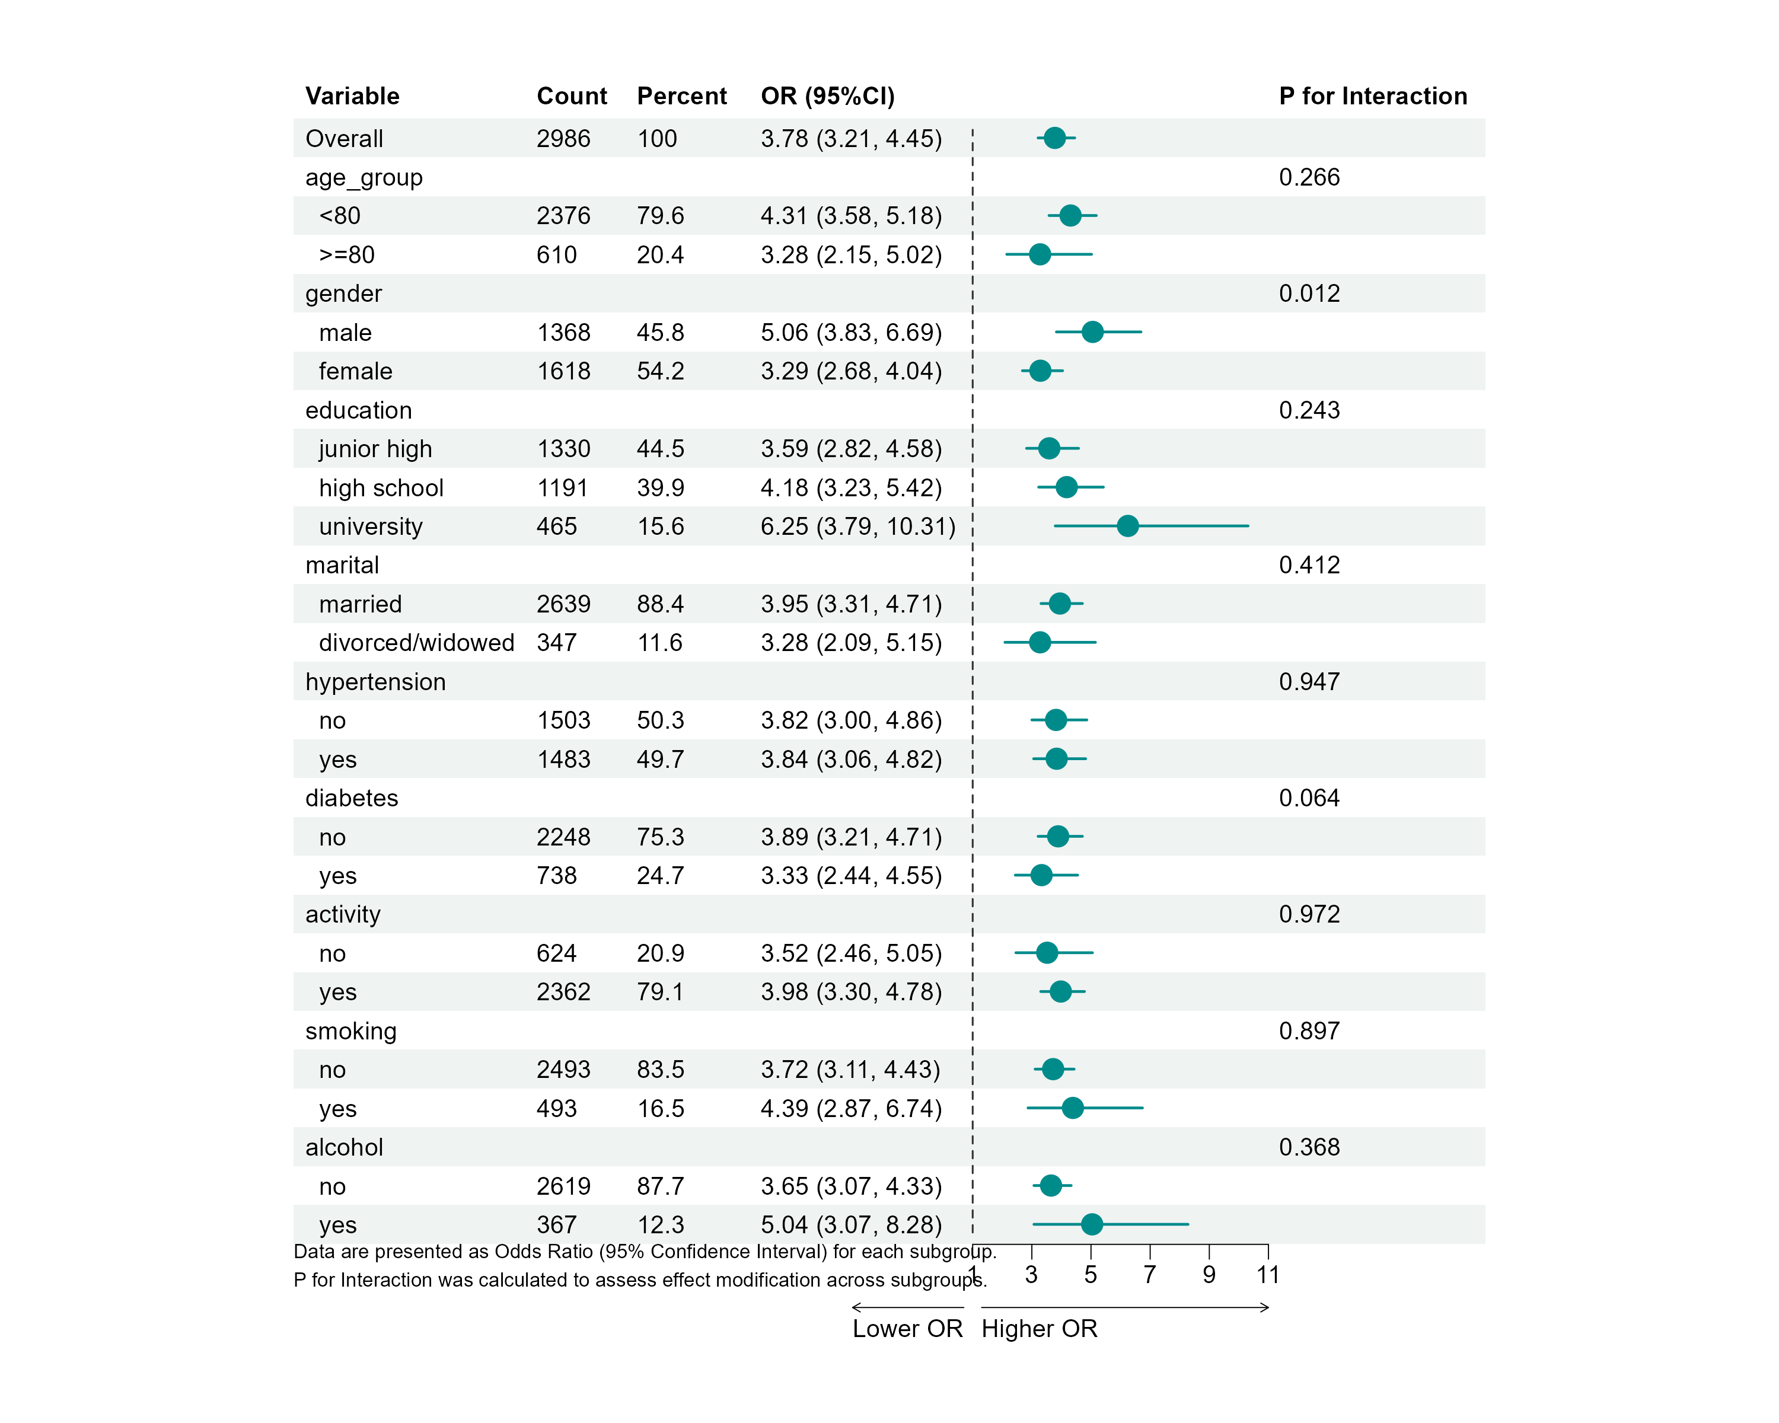
Supplementary Figure 7 Subgroup analysis of the association between TyG-WHtR and MAFLD.

