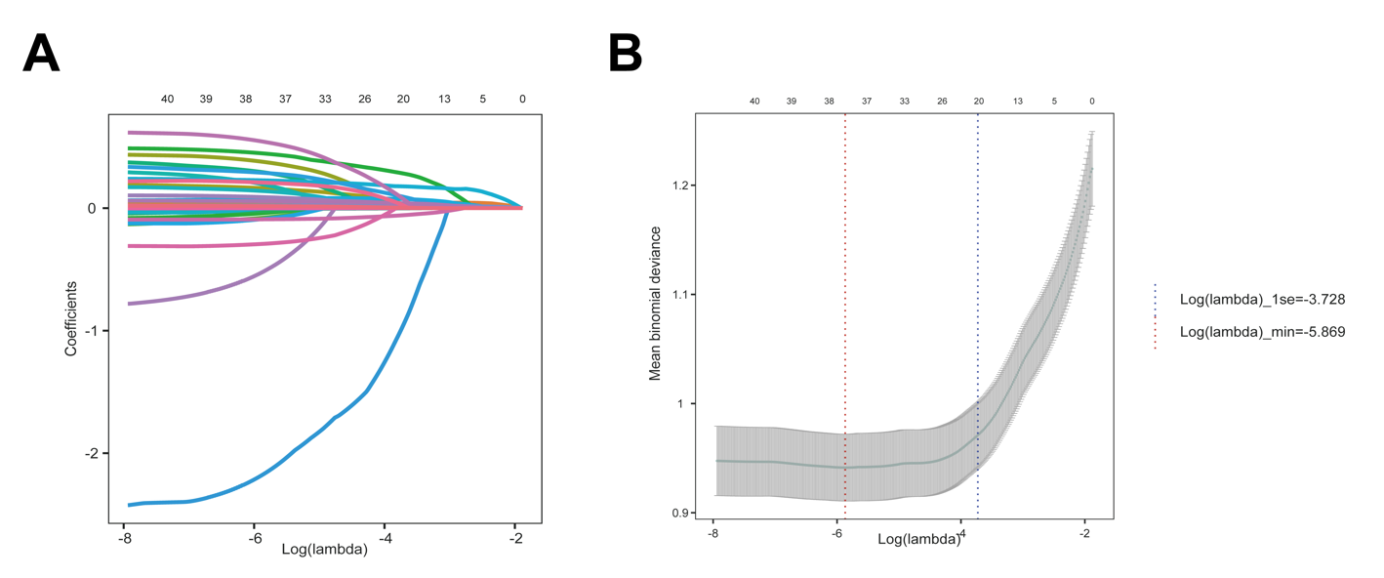

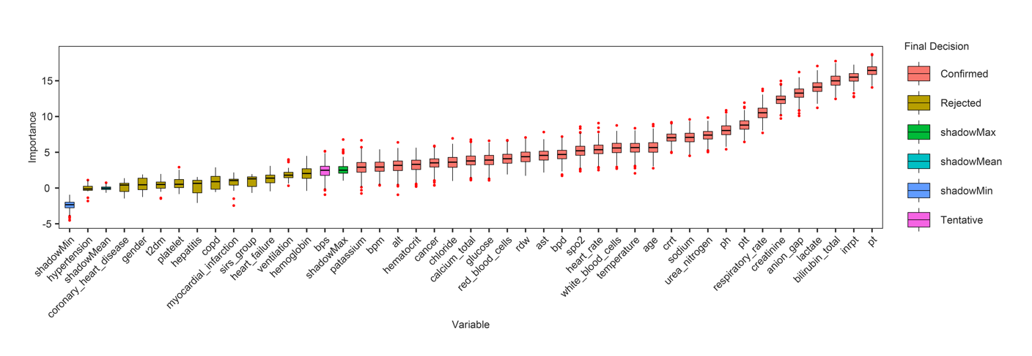

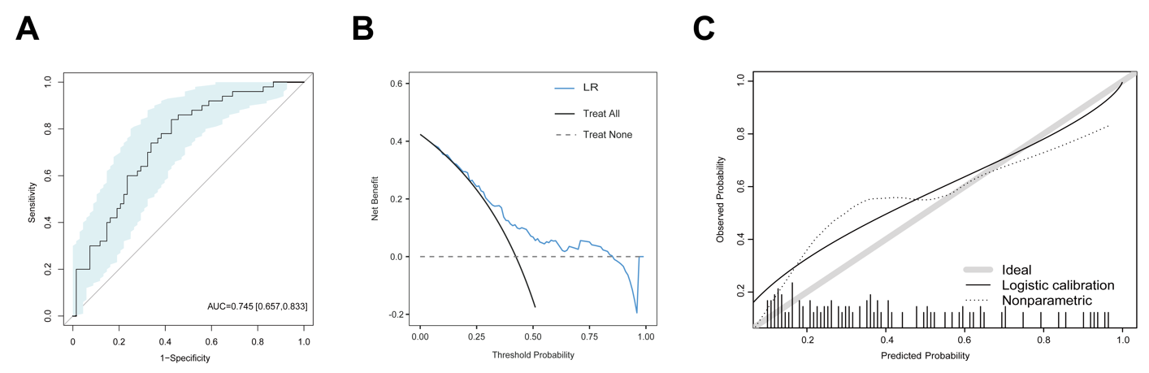

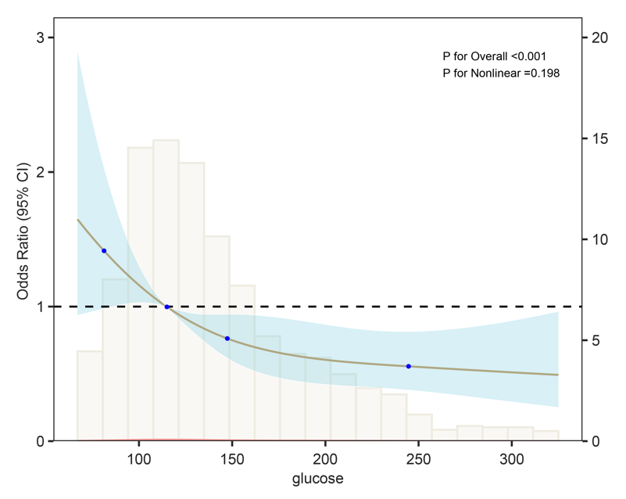

Supplementary Table S1. International Classification of Diseases (ICD) codes used to identify patients with cirrhosis.
ICD Version | Code | Diagnosis | Source
9 | 5712 | Alcoholic cirrhosis of liver | Primary diagnosis
9 | 5715 | Cirrhosis of liver without mention of alcohol | Primary diagnosis
9 | 5716 | Biliary cirrhosis | Primary diagnosis
10 | K7030 | Alcoholic cirrhosis of liver without ascites | Primary diagnosis
10 | K7031 | Alcoholic cirrhosis of liver with ascites | Primary diagnosis
10 | K743 | Primary biliary cirrhosis | Primary diagnosis
10 | K744 | Secondary biliary cirrhosis | Primary diagnosis
10 | K745 | Biliary cirrhosis, unspecified | Primary diagnosis
10 | K7460 | Unspecified cirrhosis of liver | Primary diagnosis
10 | K7469 | Other cirrhosis of liver | Primary diagnosis
10 | K7682 | Hepatic encephalopathy | Secondary diagnosis
9 | 4560 | Esophageal varices with bleeding | Secondary diagnosis
9 | 4561 | Esophageal varices without mention of bleeding | Secondary diagnosis
9 | 45620 | Esophageal varices in diseases classified elsewhere, with bleeding | Secondary diagnosis
9 | 45621 | Esophageal varices in diseases classified elsewhere, without mention of bleeding | Secondary diagnosis
9 | 56723 | Spontaneous bacterial peritonitis | Secondary diagnosis
9 | 5722 | Hepatic encephalopathy | Secondary diagnosis
9 | 5723 | Portal hypertension | Secondary diagnosis
9 | 5724 | Hepatorenal syndrome | Secondary diagnosis
9 | 78959 | Other ascites | Secondary diagnosis
10 | I8500 | Esophageal varices without bleeding | Secondary diagnosis
10 | I8501 | Esophageal varices with bleeding | Secondary diagnosis
10 | I8510 | Secondary esophageal varices without bleeding | Secondary diagnosis
10 | I8511 | Secondary esophageal varices with bleeding | Secondary diagnosis
10 | K652 | Spontaneous bacterial peritonitis | Secondary diagnosis
10 | K7290 | Hepatic failure, unspecified without coma | Secondary diagnosis
10 | K7291 | Hepatic failure, unspecified with coma | Secondary diagnosis
10 | K766 | Portal hypertension | Secondary diagnosis
10 | K767 | Hepatorenal syndrome | Secondary diagnosis
10 | R188 | Other ascites | Secondary diagnosis

Supplementary Table S2. Missing data across study variables
Variable Names | Missing(%)
D-dimer | 99.1
Globulin | 98.3
Uric acid | 98.2
Hemoglobin A1c | 96.7
Total protein | 96.5
LDL cholesterol | 94.7
HDL cholesterol | 94.2
Total cholesterol | 93.5
Triglycerides | 87.1
Indirect bilirubin | 76.2
Direct bilirubin | 72.9
Absolute neutrophil count | 48.9
Absolute lymphocyte count | 48.9
Fibrinogen | 48.8
Ionized calcium | 41.1
Albumin | 27.8
Total carbon dioxide | 21.5
Partial pressure of carbon dioxide | 21.5
Partial pressure of oxygen | 21.5
PH | 18.8
Lactate | 15.1
Systolic blood pressure | 10.7
Diastolic blood pressure | 10.7
Mean arterial pressure | 10.7
Alanine aminotransferase | 7.0
Aspartate aminotransferase | 6.6
Total bilirubin | 6.6
Temperature | 3.5
Partial thromboplastin time | 2.7
International normalized ratio | 1.7
Prothrombin time | 1.7
Total calcium | 0.9
Red cell distribution width | 0.7
Hemoglobin | 0.4
Platelet count | 0.4
Red blood cell count | 0.4
White blood cell count | 0.4
Hematocrit | 0.3
Creatinine | 0.2
Blood urea nitrogen | 0.2
Anion gap | 0.2
Chloride | 0.2
Glucose | 0.2
Potassium | 0.2
Sodium | 0.2
Heart rate | 0.1
Respiratory rate | 0
Age | 0
SpO2 | 0
SOFA | 0
APS III | 0
SAPS II | 0
OASIS | 0
MELD | 0

Supplementary Table S3. Collinearity diagnostics for candidate predictors included in the multivariable logistic regression model.
Variable Name | VIF
Age | 1.204
White blood cells | 1.064
Total bilirubin | 1.331
Glucose | 1.058
INR | 1.162
Lactate | 1.067

Supplementary Table S4. List of Abbreviations
Abbreviation | Full term
ACLF | Acute-on-Chronic Liver Failure
AUROC | Area Under the Receiver Operating Characteristic Curve
CatBoost | Categorical Boosting
CI | Confidence Interval
CITI | Collaborative Institutional Training Initiative
CLIF-C ACLF | Chronic Liver Failure Consortium Acute-on-Chronic Liver Failure score
CLIF-SOFA | Chronic Liver Failure–Sequential Organ Failure Assessment score
CRRT | Continuous renal replacement therapy
DCA | Decision Curve Analysis
DT | Decision Tree
eICU | eICU Collaborative Research Database
ICD | International Classification of Diseases
ICU | Intensive Care Unit
INR | International Normalized Ratio
IQR | Interquartile range
KNN | k-Nearest Neighbors
LASSO | Least Absolute Shrinkage and Selection Operator
LightGBM | Light Gradient Boosting Machine
LR-ML | Logistic Regression within Machine Learning
MELD | Model for End-Stage Liver Disease
MIMIC | Medical Information Mart for Intensive Care
MLP | Multilayer Perceptron
NAFLD | Non-Alcoholic Fatty Liver Disease
NASH | Non-Alcoholic Steatohepatitis
NB | Naive Bayes
OR | Odds Ratio
RCT | Randomized Controlled Trial
RF | Random Forest
ROC | Receiver Operating Characteristic
Sepsis-3 | Third International Consensus Definitions for Sepsis and Septic Shock
SMOTE | Synthetic Minority Oversampling Technique
SOFA | Sequential Organ Failure Assessment
SQL | Structured Query Language
SVM | Support Vector Machine
VIFs | Variance inflation factors
XGBoost | Extreme Gradient Boosting

