Supplement materials
Database Search Strategy

1. PubMed Search Strategy
# Step 1: Search for Colorectal Neoplasms [MeSH Terms]
("Colorectal Neoplasms"[Mesh] OR
"Colorectal Cancer"[tiab] OR
"Colon Cancer"[tiab] OR
"Rectal Cancer"[tiab] OR
"Colorectal Carcinoma"[tiab] OR
"CRC"[tiab])
AND
# Step 2: Search for Prognostic Nutritional Index [Free terms]
("Prognostic Nutritional Index"[tiab] OR
"PNI"[tiab] OR
"Nutritional Index"[tiab] OR
"Nutritional Status"[Mesh] OR
"Nutrition Assessment"[Mesh])
AND
# Step 3: Search for Prognosis/Outcomes [MeSH Terms]
("Prognosis"[Mesh] OR
"Survival Analysis"[Mesh] OR
"Survival Rate"[Mesh] OR
"Mortality"[Mesh] OR
"Recurrence"[tiab] OR
"Survival"[tiab] OR
"Prognostic"[tiab] OR
"Outcome"[tiab])

2. CNKI Search Strategy
# Step 1: Search for Colorectal Cancer
(主题 = '结直肠癌' OR 主题 = '结肠癌' OR 主题 = '直肠癌' OR 主题 = '大肠癌' OR 主题 = '结直肠肿瘤')
AND
# Step 2: Search for Prognostic Nutritional Index
(主题 = '预后营养指数' OR 主题 = 'PNI' OR 主题 = '营养状况' OR 主题 = '营养评估')
AND
# Step 3: Search for Prognosis/Outcomes
(主题 = '预后' OR 主题 = '生存' OR 主题 = '复发' OR 主题 = '转移' OR 主题 = '生存分析')

Table S1 Quality score of included study assessed by NOS score
study | year | Representativeness of the exposed cohort | Selection of the nonexposed cohort | Ascertainment of exposure | Demonstration that outcome of interest was not present at the start of study | Study controls for age, sex, marital status | Study controls for any additional factor | Assessment of outcome | Was follow up long enough for outcomes to occur | Adequacy of follow-up of cohorts | overall score
Silva | 2024 | 1 | 1 | 1 | 1 | 1 | 1 | 1 | 1 | 1 | 9
Chen | 2016 | 1 | 1 | 1 | 1 | 1 | 1 | 1 | 1 | 1 | 9
Peng | 2017 | 1 | 1 | 1 | 1 | 1 | 1 | 1 | 1 | 1 | 9
Cao | 2017 | 1 | 1 | 1 | 1 | 1 | 1 | 1 | 1 | 1 | 9
Wang | 2020 | 1 | 1 | 1 | 1 | 1 | 1 | 1 | 1 | 1 | 9
Zhu | 2021 | 1 | 1 | 1 | 1 | 1 | 1 | 1 | 1 | 1 | 9
Xu | 2021 | 1 | 1 | 1 | 1 | 1 | 1 | 1 | 1 | 1 | 9
Lin | 2021 | 1 | 1 | 1 | 1 | 1 | 1 | 1 | 1 | 1 | 9
Wang1 | 2021 | 1 | 1 | 1 | 1 | 1 | 1 | 1 | 1 | 1 | 9
Xie | 2022 | 1 | 1 | 1 | 1 | 1 | 1 | 1 | 1 | 1 | 9
Qiu | 2022 | 1 | 1 | 1 | 1 | 1 | 1 | 1 | 1 | 0 | 8
Xu1 | 2022 | 1 | 1 | 1 | 1 | 0 | 1 | 1 | 1 | 1 | 8
Li | 2023 | 1 | 1 | 1 | 1 | 1 | 1 | 1 | 1 | 1 | 9
Ni | 2023 | 1 | 1 | 1 | 1 | 1 | 1 | 1 | 1 | 1 | 9
Qiao | 2023 | 1 | 1 | 1 | 1 | 1 | 1 | 1 | 1 | 1 | 9
Zhang | 2024 | 1 | 1 | 1 | 1 | 1 | 1 | 1 | 1 | 1 | 9
Wang | 2024 | 1 | 1 | 1 | 1 | 1 | 1 | 1 | 1 | 1 | 9
Zhang1 | 2024 | 1 | 1 | 1 | 1 | 1 | 1 | 1 | 1 | 1 | 9
Yang | 2024 | 1 | 1 | 1 | 1 | 1 | 1 | 1 | 1 | 1 | 9
Niu | 2024 | 1 | 1 | 1 | 1 | 1 | 1 | 1 | 1 | 1 | 9
Zhu | 2025 | 1 | 1 | 1 | 1 | 1 | 1 | 1 | 1 | 0 | 8
Nozoe | 2012 | 1 | 1 | 1 | 1 | 1 | 1 | 1 | 1 | 1 | 9
Mohri | 2013 | 1 | 1 | 1 | 1 | 1 | 1 | 1 | 1 | 1 | 9
Shibutani | 2015 | 1 | 1 | 1 | 1 | 1 | 1 | 1 | 1 | 0 | 8
Tokunaga | 2015 | 1 | 1 | 1 | 1 | 1 | 1 | 1 | 1 | 1 | 9
Sasaki | 2018 | 1 | 1 | 1 | 1 | 1 | 1 | 1 | 1 | 1 | 9
Maruyama | 2020 | 1 | 1 | 1 | 1 | 1 | 1 | 1 | 1 | 1 | 9
Sato | 2020 | 1 | 1 | 1 | 1 | 1 | 1 | 1 | 1 | 1 | 9
Tominaga | 2020 | 1 | 1 | 1 | 1 | 1 | 1 | 1 | 1 | 1 | 9
Tamai | 2021 | 1 | 1 | 1 | 1 | 1 | 1 | 1 | 1 | 1 | 9
Mizutani | 2022 | 1 | 1 | 1 | 1 | 1 | 1 | 1 | 1 | 0 | 8
Nagashima | 2022 | 1 | 1 | 1 | 1 | 1 | 1 | 1 | 1 | 1 | 9
Taniai | 2023 | 1 | 1 | 1 | 1 | 1 | 1 | 1 | 1 | 1 | 9
Noh | 2017 | 1 | 1 | 1 | 1 | 1 | 1 | 1 | 1 | 1 | 9
Kim | 2023 | 1 | 1 | 1 | 1 | 1 | 1 | 1 | 1 | 1 | 9
Lee | 2025 | 1 | 1 | 1 | 1 | 1 | 1 | 1 | 1 | 1 | 9
Luvián‐Morales | 2019 | 1 | 1 | 1 | 1 | 1 | 1 | 1 | 1 | 1 | 9
Ucar | 2020 | 1 | 1 | 1 | 1 | 1 | 1 | 1 | 1 | 1 | 9
Bardakci | 2021 | 1 | 1 | 1 | 1 | 1 | 1 | 1 | 1 | 1 | 9
Erdogan | 2023 | 1 | 1 | 1 | 1 | 1 | 1 | 1 | 1 | 1 | 9
Kocak | 2023 | 1 | 1 | 1 | 1 | 1 | 1 | 1 | 1 | 1 | 9
Tuncel | 2023 | 1 | 1 | 1 | 1 | 1 | 1 | 1 | 1 | 1 | 9
Nguyen | 2024 | 1 | 1 | 1 | 1 | 0 | 1 | 1 | 1 | 0 | 7

Table S2 Certainty of evidence
Outcomes | Quality assessment |  |  |  |  | Samples | HR (95%CI) | Certainty of the evidence
Outcomes | Risk of bias | Inconsistency | Indirectness | Imprecision | Publication bias | Samples | HR (95%CI) | Certainty of the evidence
OS | Limitations | Serious | Not serious | Not Serious | Not serious | 18,231 | 1.88 (1.69-2.09) | Low○○
DFS | Limitations | Serious | Not serious | Serious | Not serious | 5,181 | 1.31 (0.84-2.03) | Very low○○○
PFS | Limitations | Serious | Not serious | Serious | Not serious | 2,856 | 1.15 (0.78–1.72) | Very low○○○

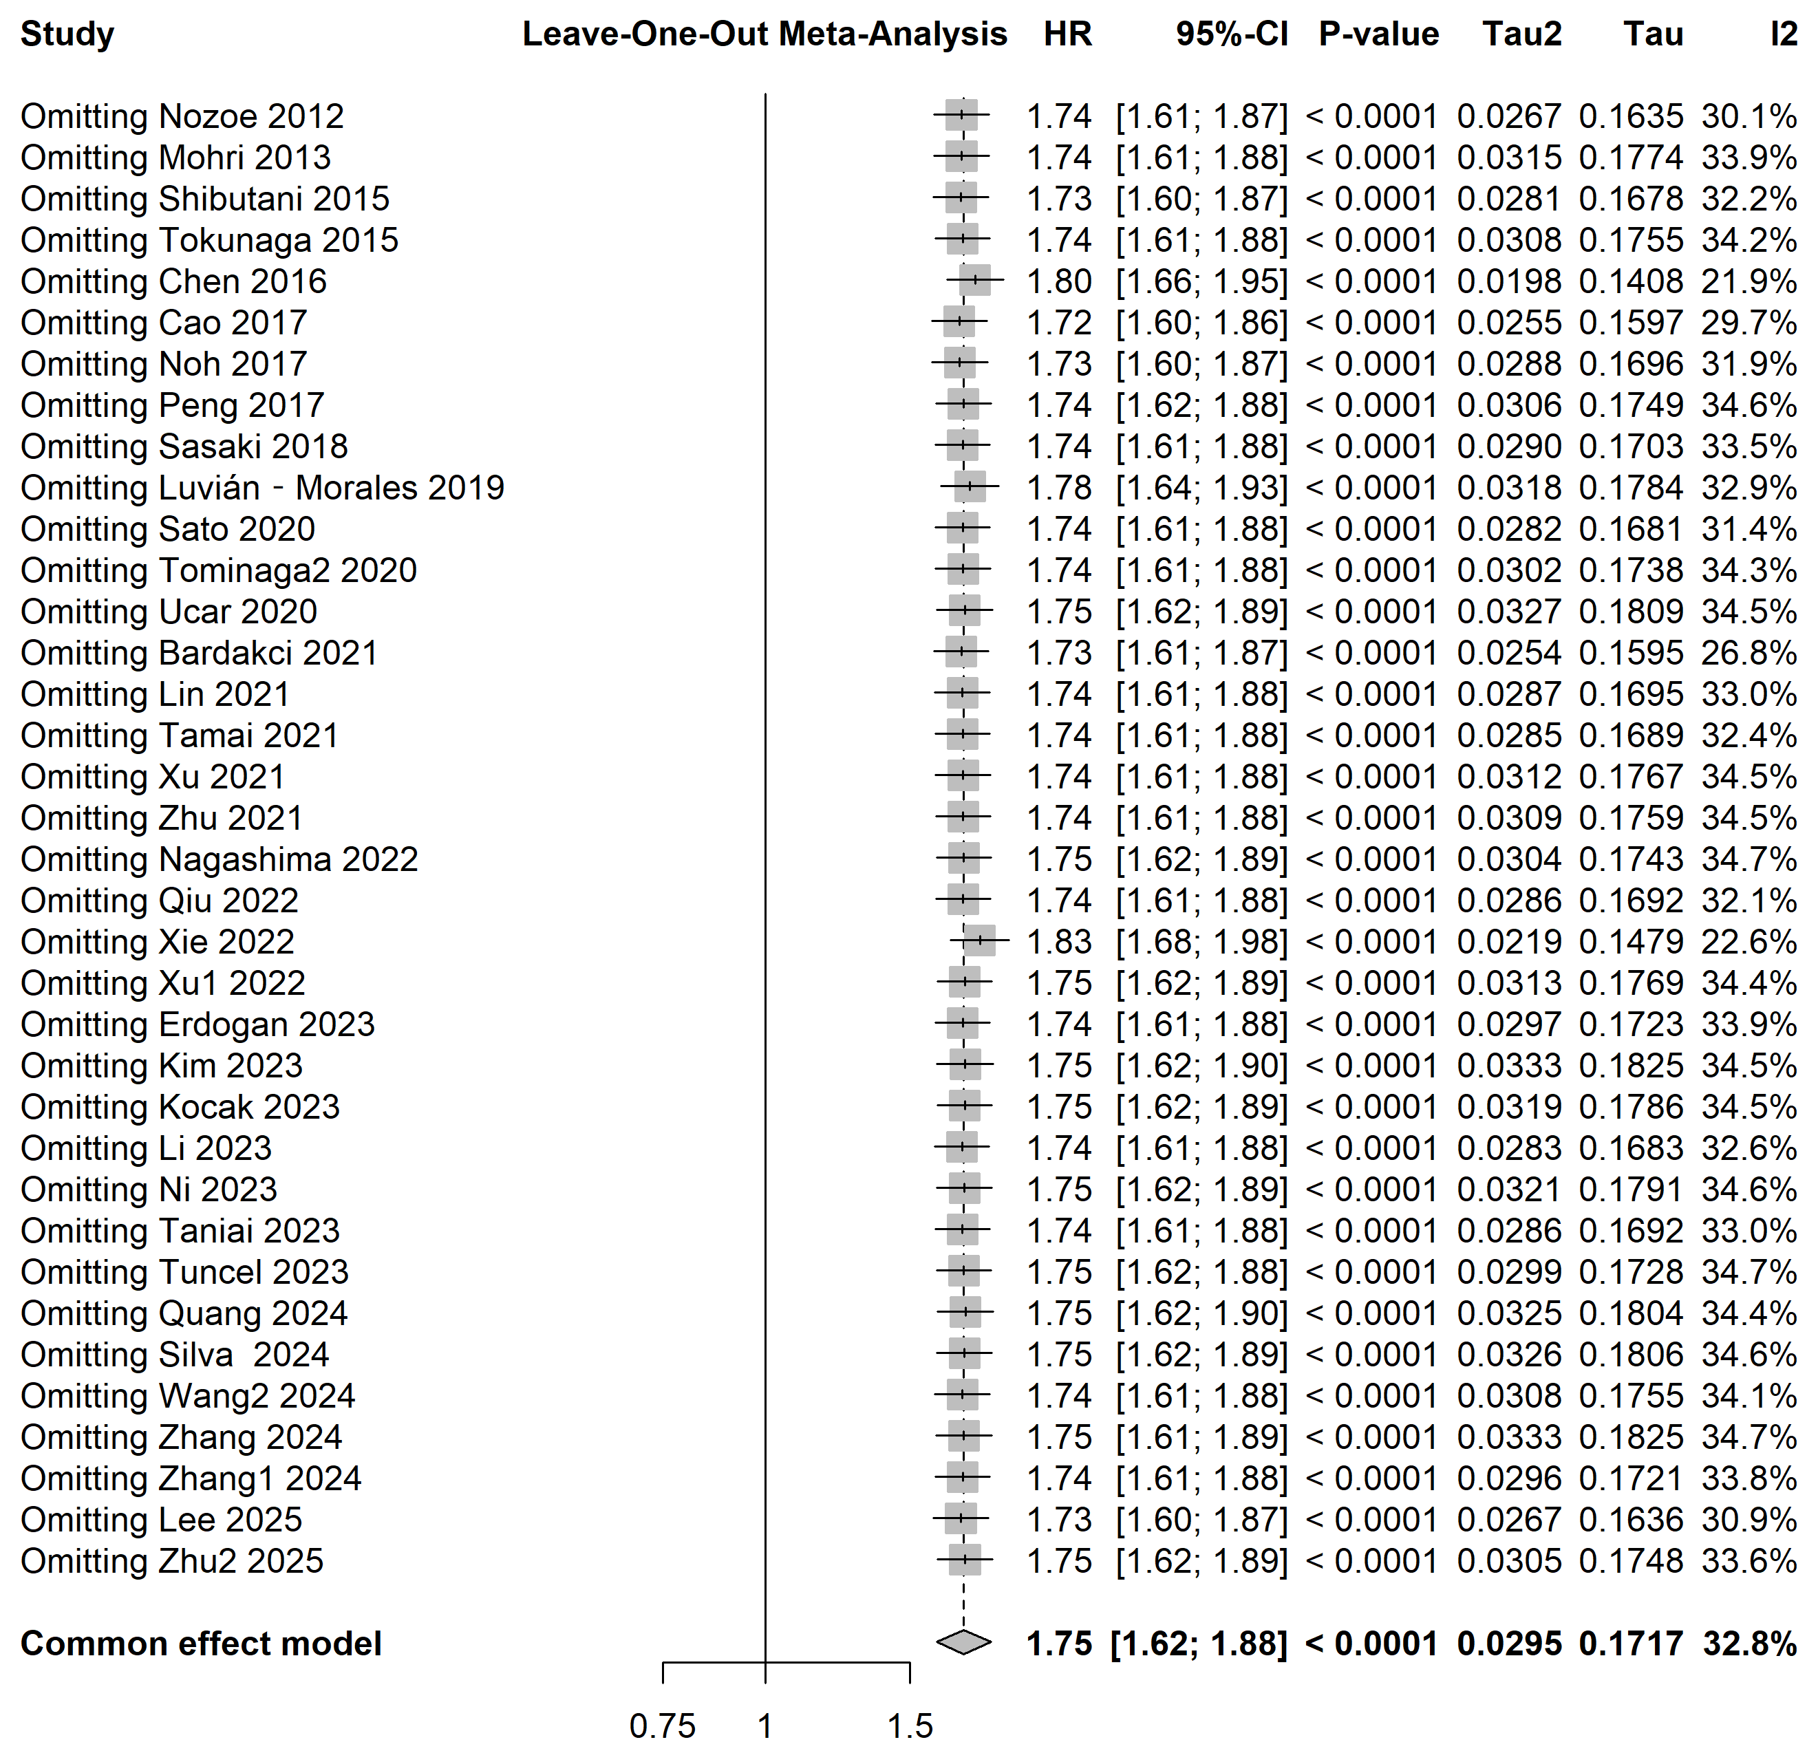

Figure S1 Sensitivity analysis for the prognostic value of PNI on the OS of CRC patients

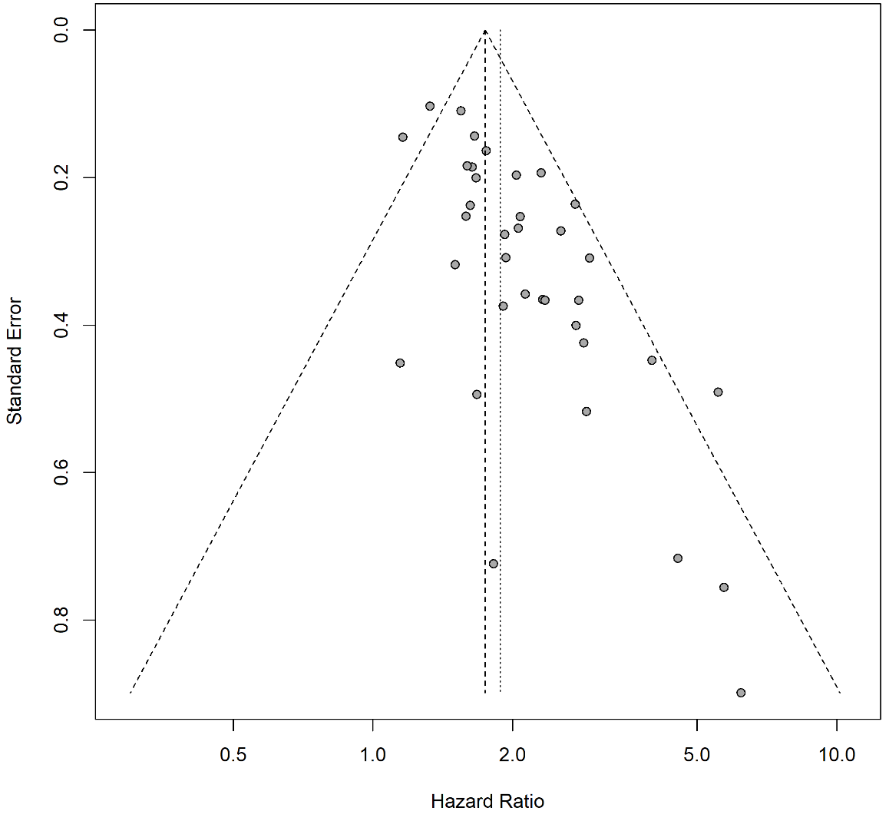
Figure S2 Funnel plot of publication bias for the prognostic value of PNI on the OS of CRC patients

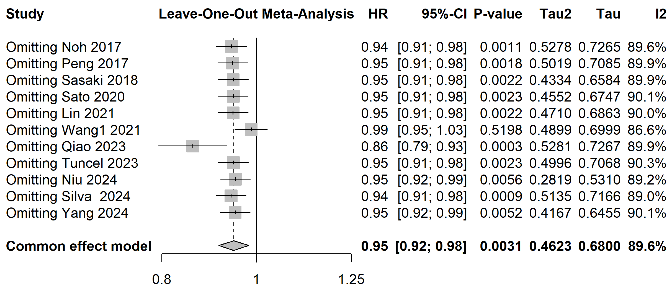
Figure S3 Sensitivity analysis for the prognostic value of PNI on the OS of CRC patients

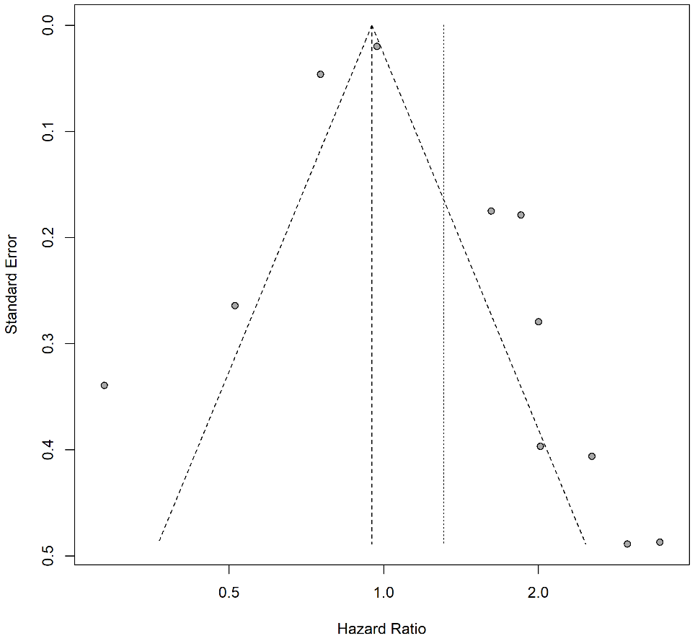
Figure S4 Funnel plot of publication bias for the prognostic value of PNI on the OS of CRC patients

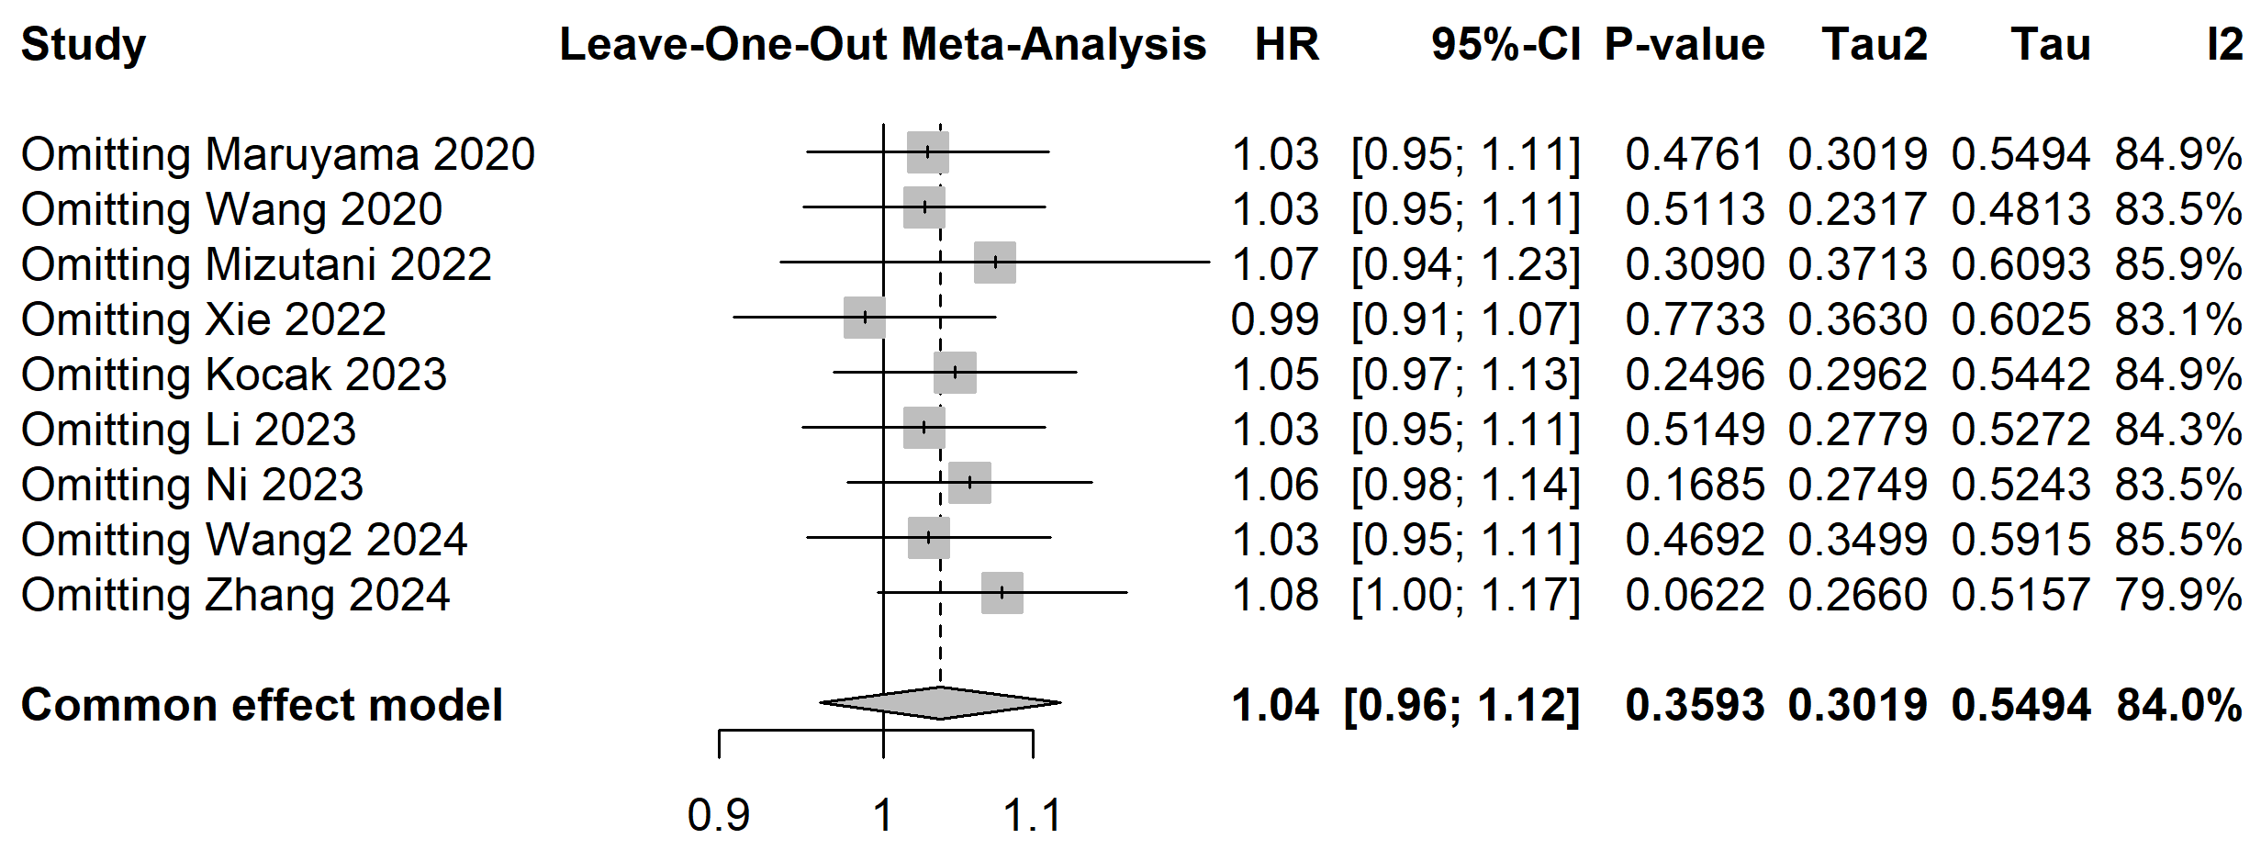
Figure S5 Sensitivity analysis for the prognostic value of PNI on the OS of CRC patients

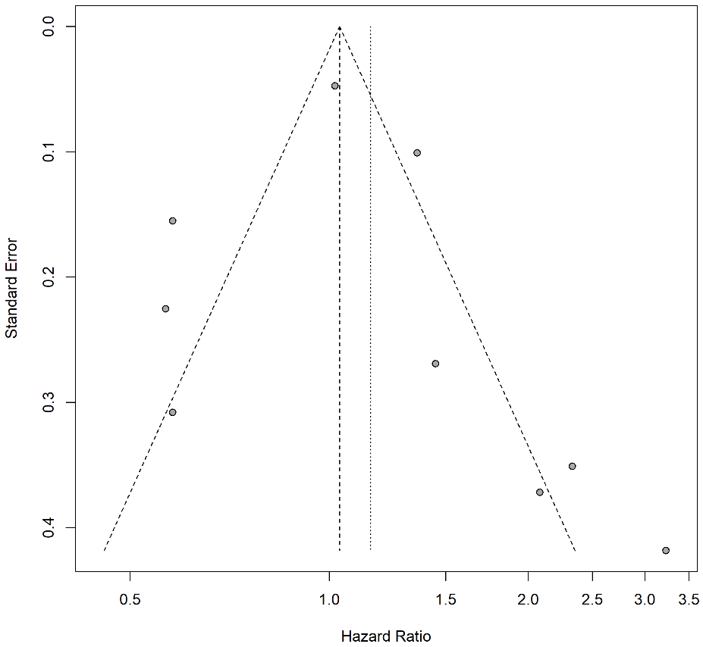
Figure S6 Funnel plot of publication bias for the prognostic value of PNI on the OS of CRC patients

