Appendix A. Searching strategies
Database | Searching strategies | Results
PubMed | ((((((((((((((((Colorectal Neoplasms[MeSH Terms]) OR (Colorectal Neoplasm*[Title/Abstract])) OR (Colorectal Tumor[Title/Abstract])) OR (Colorectal Cancer[Title/Abstract])) OR (Colorectal Carcinoma[Title/Abstract])) OR (Rectal Neoplasms[MeSH Terms])) OR (Rect* Neoplasm[Title/Abstract])) OR (Rect* Tumor[Title/Abstract])) OR (Rect* Cancer[Title/Abstract])) OR (Rect* Carcinoma[Title/Abstract])) OR (Colonic Neoplasms[MeSH Terms])) OR (Colon* Neoplasm[Title/Abstract])) OR (Colon* Tumor[Title/Abstract])) OR (Colon* Cancer[Title/Abstract])) OR (Colon* Carcinoma[Title/Abstract]))) AND ("CIPN"[Title/Abstract] OR "peripheral neuropathy"[Title/Abstract] OR "chemotherapy induced peripheral neuropathy"[Title/Abstract]) | 543
Web of science | (((((TS=(CIPN)) OR TS=(peripheral neuropathy)) OR TS=(chemotherapy induced peripheral neuropathy)) OR TI=(chemotherapy induced peripheral neuropathy)) OR TI=(peripheral neuropathy)) OR TI=(CIPN) AND (((((((((((TI=(Colorectal Neoplasm*)) OR TI=(Colorectal Tumor)) OR TI=(Colorectal Cancer)) OR TI=(Colorectal Carcinoma)) OR TI=(Rect* Neoplasm*)) OR TI=(Rect* Tumor)) OR TI=(Rect* Cancer)) OR TI=(Rect* Carcinoma)) OR TI=(Colon* Neoplasm*)) OR TI=(Colon* Tumor)) OR TI=(Colon* Cancer)) OR TI=(Colon* Carcinoma) | 557
Embase | ('cipn'):ti,ab,kw OR ('peripheral neuropathy'):ti,ab,kw OR ('chemotherapy induced peripheral neuropathy'):ti,ab,kw)AND ('colorectal tumor')/exp OR (('colorectal cancer')/exp) OR (('colorectal neoplasm*'):ti,ab,kw) OR (('colorectal tumor*'):ti,ab,kw) OR (('colorectal cancer'):ti,ab,kw) OR (('colorectal carcinoma*'):ti,ab,kw) OR (('rectum cancer')/exp) OR (('rectum tumor')/exp) OR (('Rect* Neoplasm*'):ti,ab,kw) OR (('Rect* Tumor*'):ti,ab,kw) OR (('Rect* Cancer'):ti,ab,kw) OR (('Rect* Carcinoma*'):ti,ab,kw) OR (('colon tumor')/exp) OR (('colon cancer')/exp) OR (('Colon* Neoplasm*'):ti,ab,kw) OR (('Colon* Tumor*'):ti,ab,kw) OR (('Colon* Cancer'):ti,ab,kw) OR (('Colon* Carcinoma*'):ti,ab,kw)) | 1311
CINAHL | (SU CIPN OR SU peripheral neuropathy OR SU chemotherapy induced peripheral neuropathy )AND (SU colorectal cancer OR SU colorectal neoplasm* OR SU colorectal tumor* OR SU colorectal carcinoma* OR SU rect* cancer OR SU rect* neoplasm* OR SU rect* tumor* OR SU rect* carcinoma* OR SU colon* cancer OR SU colon* neoplasm* OR SU colon* tumor* OR SU colon* carcinoma*) | 101
Cochrane library | (CIPN):ti,ab,kw OR (peripheral neuropathy):ti,ab,kw OR (chemotherapy induced peripheral neuropathy):ti,ab,kw AND (Colorectal Neoplasms):MeSH OR (Colorectal Neoplasm*):ti,ab,kw OR (Colorectal Tumor):ti,ab,kw OR (Colorectal Cancer):ti,ab,kw OR (Colorectal Carcinoma):ti,ab,kw OR (Rectal Neoplasms):MeSH OR (Rect* Neoplasm*):ti,ab,kw OR (Rect* Tumor):ti,ab,kw OR (Rect* Cancer):ti,ab,kw OR (Rect* Carcinoma):ti,ab,kw OR (Colonic Neoplasms):MeSH OR (Colon* Neoplasm*):ti,ab,kw OR (Colon* Tumor):ti,ab,kw OR (Colon* Cancer):ti,ab,kw OR (Colon* Carcinoma*):ti,ab,kw) | 540

Appendix A. Searching strategies (continued)
Database | Searching strategies | Results
SinoMed | "周围神经"[核心字段:智能] OR "周围神经炎"[核心字段:智能] OR "周围神经毒性"[核心字段:智能]AND ("结直肠肿瘤"[加权:扩展] OR "结肠肿瘤"[加权:扩展] OR "直肠肿瘤"[加权:扩展] OR "结直肠癌"[中文标题:智能] OR "结肠癌"[中文标题:智能] OR "直肠癌"[中文标题:智能] OR "肠癌"[中文标题:智能]) | 481
Notes: CINAHL = Cumulated Index to Nursing and Allied Health Literature. CNKI = China National Knowledge Infrastructure. VIP = China Science and Technology Journal Database.

Table 1 The characteristics of included studies
Author-Year | Country | Study design | Assessment tool | Sample Size  (E/C) | Prevalence (%)  CIPN | Factors | Literature  Quality evaluation
Alejandro et al. 2012 | America | Cohort study | NCI-CTCAE v.4 | 422(107/295) | 25.4 | Gender,Age,BMI,  Accumulated dose of Oxaliplatin  Targeted therapy,Cold exposure,Diabetes | Moderate
Bian et al. 2024 | China | Case-control study | NCI-CTCAE v.4 | 219(144/75) | 65.8 | Gender,Tumor metastasis,NRS 2002 | Moderate
Ottaiano et al. 2015 | Italy | Case-control study | NCI-CTCAE v.4 | 102(14/88) | 13.7 | Age,Gender ,Diabetes  Hypertension ,Smoking of History,BMI | Moderate
Shahriari-Ahmadi et al. 2015 | Iran | Case-control study | NCI-CTCAE v.3 | 130(105/25) | 80.1 | Age,Gender,BMI,  Diabetes,Hemoglobin,Calcium,Magnesium,  History of Drinking | High
Sheng et al. 2019 | China | Cohort study | NCI-CTCAE v.4 | 268(61/207) | 22.8 | Diabetes,Gender,Age  Smoking history,History of Drinking  Accumulated dose of Oxaliplatin | Moderate
Tanishima et al. 2016 | Japan | Case-control study | NCI-CTCAE v.4 | 47(22/25) | 46.81 | Gender, Chemotherapy regimen | Moderate
Vincenzi et al. 2013 | Italy | Case-control study | NCI-CTCAE v.3 | 169(88/81) | 52.1 | Age,Gender,Hemoglobin,Albumin,  Calcium,Magnesium,Biabetes,  History of Drinking,Chemotherapy frequency | High
Velasco et al. 2014 | Spain | Cohort study | NCI-CTCAE v.3 | 200(36/164) | 18 | Gender ,Age, Chemotherapy regimen | Moderate
Wei et al. 2022 | China | Case-control study | WHO | 265（181/84） | 68.3 | Gender,Age,Hypertension  Diabetes,History of Smoking,  History of Drinking history,Targeted therapy  Accumulated dose of Oxaliplatin | Moderate
Yildirim et al. 2020 | Türkiye | Cohort study | NCI-CTCAE v.3 | 186(78/108) | 41.9 | Gender, Cold exposure,Chemotherapy regimen;Targeted therapy | Moderate
E exposed group,CIPN; C control group,No CIPN;CIPN chemotherapy induced CIPN；BMI body mass index；NRS2002 Nutrition Risk Screening 2002；WHO World Health Organization Scale;NCI-CTCAE National Cancer Institute-Common Toxicity Criteria
Table 2 Subgroup analyses by gender, Study design and Countries.
Subgroups | Number of included studies | CRC-related CIPN
Subgroups | Number of included studies | Prevalence(%) | 95%CI | I2(%) | P
Gender
Male | 10 | 46 | 0.28-0.63 | 97.97 | 0.000
Female | 10 | 42 | 0.27-0.57 | 95.85 | 0.000
Study design
Cohort study | 4 | 39 | 0.21-0.57 | 96.77 | 0.000
Case-control study | 6 | 55 | 0.35-0.75 | 97.87 | 0.000
Countries
Developed countries | 5 | 36 | 0.24-0.49 | 94.56 | 0.000
Developing countries | 5 | 50 | 0.25-0.76 | 98.89 | 0.000

Table 3 Factors influencing of CIPN in Colorectal Cancer
Factors |  | No. of studies | Sample | Heterogeneity |  | Pooled effects |  | Effect model
 |  | No. of studies | Sample | I²(%) | P | OR/MD(95%CI) | P
Demographic factors
Gender |  | 10 | 1940 | 74 | ＜0.001 | 0.86(0.56,1.33) | 0.50 | Random
Gender | Sensitivity analysis | 6 | 1298 | 1 | 0.41 | 1.39(1.09,1.78) | 0.008 | Fixed
Age |  | 2 | 622 | 49 | 0.16 | 0.68(0.47,0.98) | 0.04 | Fixed
Age |  | 2 | 465 | 88 | 0.004 | 1.10(-5.04,7.24)* | 0.72 | Random
BMI |  | 3 | 554 | 94 | ＜0.001 | 0.43(0.05,3.91) | 0.64 | Random
BMI | Sensitivity analysis | 2 | 232 | 9 | ＜0.001 | 0.15(0.07,0.34) | 0.30 | Fixed
Smoking history |  | 3 | 605 | 17 | 0.03 | 1.55(1.06,2.27) | 0.02 | Fixed
Drinking history |  | 4 | 830 | 50 | 0.11 | 1.30(0.67,2.53) | 0.43 | Random
Drinking history | Sensitivity analysis | 3 | 661 | 0 | 0.43 | 1.78(1.15,2.74) | 0.009 | Fixed
Disease-related factors
Diabetes |  | 5 | 934 | 75 | 0.003 | 2.18(1.01,4.70) | 0.05 | Random
Hypertension |  | 2 | 367 | 0 | 0.76 | 1.39(0.80.1.41) | 0.24 | Fixed
Magnesium |  | 2 | 299 | 0 | 0.91 | 0.24(0.12,0.50) | ＜0.001 | Fixed
Hypocalcemia |  | 2 | 299 | 0 | 0.53 | 0.61(0.32,1.14) | 0.12 | Fixed
Hypomagnesemia |  | 2 | 299 | 59 | 0.002 | 1.61(0.30,8.59) | 0.58 | Random
Therapeutic factors
Cumulative Oxaliplatin |  | 2 | 622 | 68 | 0.08 | 0.56(0.38,0.83) | 0.004 | Fixed
Target therapy |  | 3 | 803 | 52 | 0.13 | 1.22(0.75,1.98) | 0.43 | Fixed
Target therapy | Sensitivity analysis | 2 | 449 | 0 | 0.68 | 1.58(1.01,2.49) | 0.04 | Fixed
Chemotherapy regimen |  | 3 | 432 | 14 | 0.31 | 0.80(0.49,1.32) | 0.38 | Fixed
Other factors
Cold exposure |  | 2 | 398 | 0 | 0.70 | 1.54(1.03,2.30) | 0.03 | Fixed
BMI Body Mass Index ;*MD Mean Differences ± Standard Devia

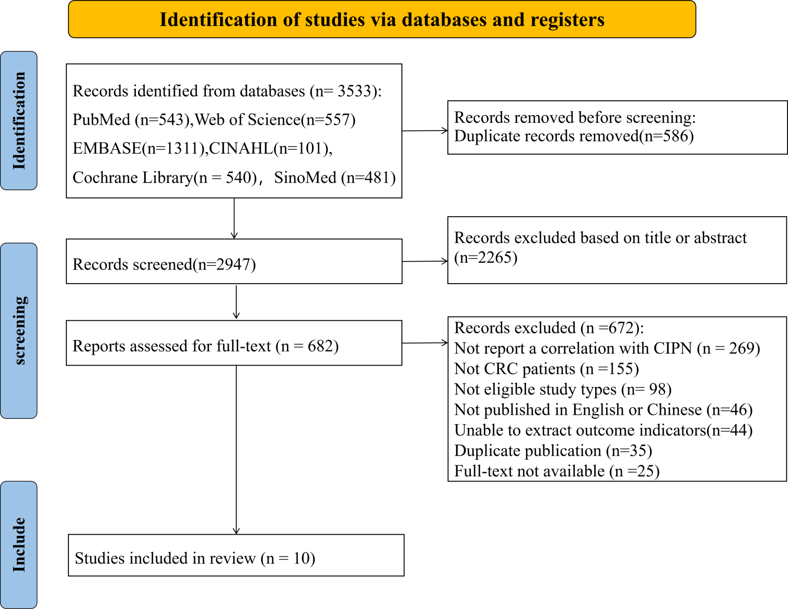
Figure 1. Flow diagram of the literature selection.

CIPN=chemotherapy induced CIPN. CRC=colorectal cancer
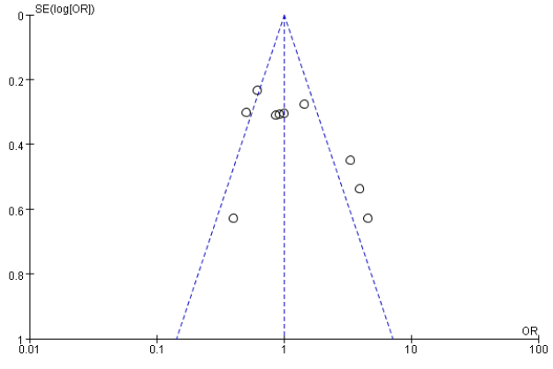

Figure 2. Funnel diagram

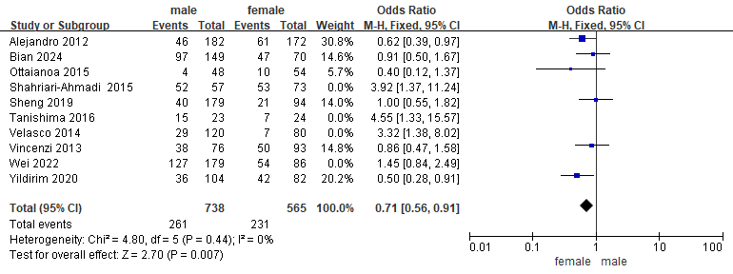Figure 3. Forest plot of the correlation between Gender and CIPN
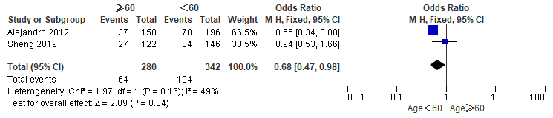

Figure 4. Forest plot of the correlation between Age and CIPN by odds ratio
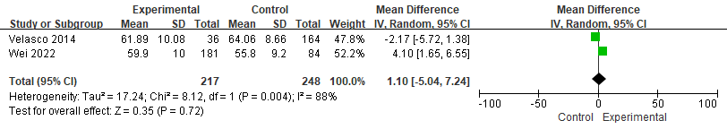 Figure 5. Forest plot of the correlation between Age and CIPN by mean diffierence

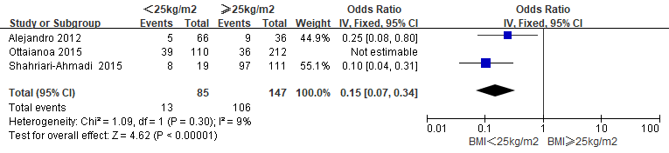 Figure 6. Forest plot of the correlation between BMI and CIPN
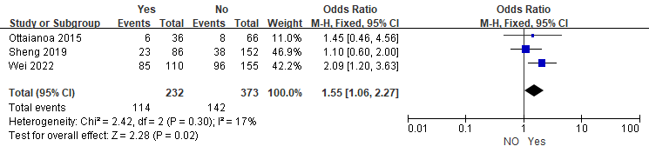Figure 7. Forest plot of the correlation between Smoking history and CIPN
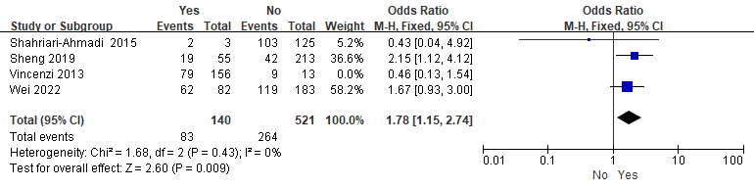
Figure 8. Forest plot of the correlation between Drinking history and CIPN
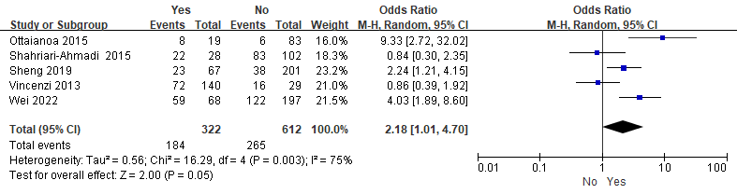 Figure 9. Forest plot of the correlation between Diabetes and CIPN

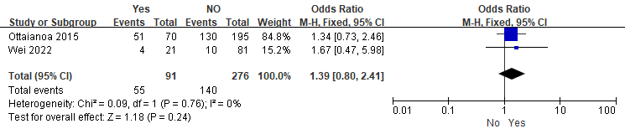Figure 10. Forest plot of the correlation between Hypertension and CIPN
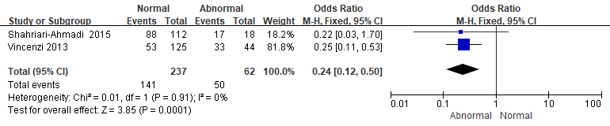Figure 11. Forest plot of the correlation between Magnesium and CIPN
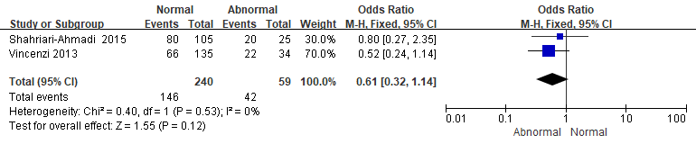Figure 12. Forest plot of the correlation between Calcium and CIPN
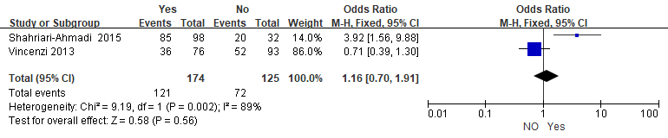Figure 13. Forest plot of the correlation between Hemoglobin and CIPN
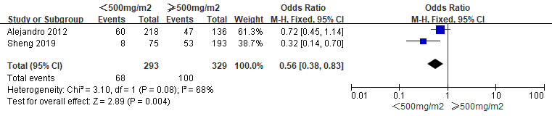Figure 14. Forest plot of the correlation between Cumulative Oxaliplatin and CIPN
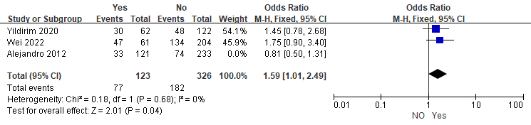 Figure 15. Forest plot of the correlation between Target therapy and CIPN
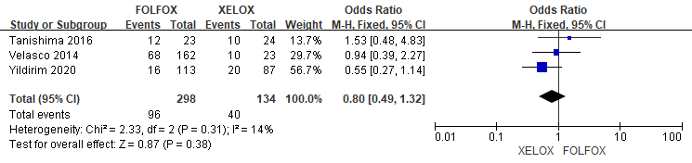Figure 16. Forest plot of the correlation between Chemotherapy regimen and CIPN
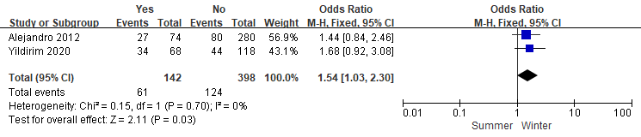Figure 17. Forest plot of the correlation between Cold exposure and CIPN

