Table S1. Baseline characteristics of patients after PSM
Characteristics | HA group (n=14) | Control group (n=14) | P value
Age, year | 63.51±12.48  65.00 (39.00, 77.00) | 59.07±8.50  58.58 (47.00, 75.00) | 0.250
Male, No. (%) | 7 (50.00%) | 4 (28.57%) | 0.440
Etiology, No. (%)
Viral hepatitis | 1 (7.14%) | 6 (42.85%) | 0.077
Alcohol | 6 (42.85%) | 2 (16.67%) | 0.209
Autoimmune diseases | 4 (28.57%) | 3 (21.43%) | 1.000
Unknown | 3 (21.43%) | 3 (21.43%) | 1.000
Decompensation at inclusion, No. (%)
HE | 3 (21.43%) | 3 (21.43%) | 1.000
Ascites | 10 (71.43%) | 9 (64.29%) | 1.000
GIB | 1 (7.14%) | 5 (35.71%) | 0.165
Hypertension, No.(%) | 1 (7.14%) | 3 (21.43%) | 0.596
Diabetes, No.(%) | 4 (28.57%) | 3 (21.43%) | 1.000
Laboratory parameters at inclusion
WBC (109/L) | 2.96±1.15  3.10 (0.60, 5.20) | 4.48±2.78  3.80 (0.90, 9.00) | 0.280
PLT (109/L) | 81.79±47.62  74.00 (24.00, 180.00) | 89.00±70.66  68.00 (21.00, 249.00) | 0.818
ALB (g/L) | 31.69±5.53  33.45 (22.30, 39.70) | 28.22±6.56  26.30 (19.90, 44.70) | 0.103
TBIL (umol/L) | 36.61±37.53  20.60 (8.80, 125.60) | 47.29±44.46  26.15 (9.70, 159.10) | 0.408
ALT (U/L) | 22.15±16.02  17.97 (7.80, 60.11) | 31.12±35.03  21.65 (7.70, 146.01) | 0.435
AST (U/L) | 46.88±47.86  25.46 (13.46, 190.18) | 53.19±51.87  35.60 (16.35, 219.09) | 0.312
SCr (umol/L) | 59.32±20.66  58.41 (33.41, 121.69) | 62.09±23.24  54.59 (38.80, 108.47) | 0.783
INR | 1.31±0.24  1.26 (1.03, 1.98) | 1.37±0.33  1.26 (0.99, 2.15) | 0.730
Child-Pugh score | 7.64±1.65  7.00 (6.00, 11.00) | 8.57±1.74  8.50 (6.00, 12.00) | 0.119
MELD score | 11.60±3.94  10.95 (7.00, 22.00) | 12.60±4.54  11.03 (6.00, 22.00) | 0.581
Abbreviations: PSM: propensity score matching; HA: Human albumin; HE: Hepatic encephalopathy; GIB: Gastrointestinal bleeding; WBC, White blood cells; PLT: Platelet; ALB: Albumin; TBIL: Total bilirubin; ALT: Alanine aminotransferase; AST: Aspartate aminotransferase; SCr: Serum creatinine; INR: International normalized ratio; MELD: Model for end-stage liver disease.

Table S2. The intervals for detecting inflammatory and oxidative stress factors
Group | HA | Control | P value
Overall patients | 4.22±1.73  4.00 (2.00, 8.00) | 3.75±1.55  3.00 (2.00, 9.00) | 0.296
Ascites subgroup | 4.11±1.63  4.00 (2.00, 7.00) | 3.62±1.81  3.00 (2.00, 9.00) | 0.287
HE subgroup | 4.43±2.07  4.00 (2.00, 8.00) | 3.60±1.34  3.00 (2.00, 5.00) | 0.505
Abbreviations: HA: Human albumin; HE: Hepatic encephalopathy; GIB: Gastrointestinal bleeding.

Table S3. Change of levels of inflammation and oxidative stress factors in the HA and control groups after PSM
Factors | HA group (n=14) | Control group (n=14) | P value
MDA
Baseline | 13.89±5.85  12.68 (7.00, 25.00) | 9.93±3.51  10.38 (5.00, 17.00) | 0.073
Absolute change | -3.84±5.90  -5.99 (-9.00, 13.00) | -0.86±3.95  0.34 (-10.00, 5.00) | 0.035
SOD
Baseline | 8.12±0.55  8.10 (7.00, 9.00) | 8.07±1.07  7.80 (7.00, 10.00) | 0.550
Absolute change | 0.29±0.44  0.42 (-0.56, 0.61) | 0.02±0.67  0.05 (-1.00, 0.97) | 0.270
GSH
Baseline | 142.81±9.60  146.00 (128.00, 158.00) | 140.63±9.68  139.74 (128.00, 163.00) | 0.312
Absolute change | 9.85±13.63  10.75 (-18.00, 32.33) | 6.53±15.99  4.44 (-15.00, 27.00) | 0.818
IL-6
Baseline | 126.69±0.52  19.23 (7.00, 575.00) | 30.57±30.24  17.61 (11.00, 116.00) | 0.312
Absolute change | -36.36±108.55  -1.95 (-286.00, 19.97) | -2.99±29.68  1.75 (-92.00, 38.00) | 0.129
IL-10
Baseline | 137.65±80.90  121.04 (101.00, 265.00) | 121.98±31.73  121.04 (87.00, 210.00) | 0.335
Absolute change | -2.94±41.06  -3.16 (-16.00, 11.00) | 1.18±3.47  1.31 (-5.00, 6.00) | 0.019
TNF-α
Baseline | 119.40±6.04  35.27 (26.00, 253.00) | 46.42±26.18  42.12 (26.00, 121.24) | 0.818
Absolute change | -53.59±70.74  -24.30 (-79.46, 15.00) | -2.98±27.89  5.17 (-27.10, 20.00) | 0.039
Abbreviations: HA: Human albumin; PSM: propensity score matching; MDA: Malondialdehyde; SOD: Superoxide dismutase; GSH: Glutathione; IL-6: Interleukin-6; IL-10: Interleukin-10; TNF-α: Tumor necrosis factor-alpha.

Table S4. Levels of inflammation and oxidative stress factors before and after treatment in the HA and control groups after PSM
Factors | HA group (n=14) |  | P value | Control group (n=14) |  | P value
Factors | Baseline | After treatment | P value | Baseline | After treatment
MDA | 13.89±5.85  12.68 (7.00, 25.00) | 10.05±5.78  8.36 (4.06, 25.00) | 0.026 | 9.93±3.51  10.38 (5.00, 17.00) | 9.07±3.32  7.93 (6.54, 12.28) | 0.507
SOD | 8.12±0.55  8.10 (7.00, 9.00) | 8.40±0.63  8.58 (7.39, 9.32) | 0.041 | 8.07±1.07  7.80 (7.00, 10.00) | 8.09±1.13  8.08 (5.95, 10.00) | 0.778
GSH | 142.81±9.60  146.00 (128.00, 158.00) | 152.66±11.40  153.05 (137.00, 171.00) | 0.022 | 140.63±9.68  139.74 (128.00, 163.00) | 147.15±18.06  149.10 (114.00, 170.26) | 0.245
IL-6 | 126.69±0.52  19.23 (7.00, 575.00) | 90.33±177.40  17.22 (11.00, 289.32) | 0.221 | 30.57±30.24  17.61 (11.00, 116.00) | 27.59±13.44  26.58 (12.00, 61.00) | 0.470
IL-10 | 137.65±80.90  121.04 (101.00, 265.00) | 134.71±42.88  122.19 (98.13, 228.50) | 0.030 | 121.98±31.73  121.04 (87.00, 210.00) | 123.16±29.50  119.75 (92.58, 205.11) | 0.198
TNF-α | 119.40±6.04  35.27 (26.00, 253.00) | 65.81±143.77  29.63 (15.71, 181.08) | 0.022 | 46.42±26.18  42.12 (26.00, 121.24) | 43.44±11.51  44.24 (24.57, 61.23) | 0.470
Abbreviations: HA: Human albumin; PSM: propensity score matching; MDA: Malondialdehyde; SOD: Superoxide dismutase; GSH: Glutathione; IL-6: Interleukin-6; IL-10: Interleukin-10; TNF-α: Tumor necrosis factor-alpha.

Table S5. Univariable and multivariable analyses of factors affecting further decompensation in cirrhosis patients
Variables | Univariable |  |  |  | Multivariable
Variables | sHR | 95%CI | P value |  | sHR | 95%CI | P value
HA infusion | 0.342 | 0.13-0.90 | 0.03 |  | 0.312 | 0.12-0.84 | 0.02
Age | 1.01 | 0.97-1.05 | 0.67
Sex: male vs. female | 0.49 | 0.12-1.72 | 0.29
HE: yes vs. no | 1.21 | 0.31-4.43 | 0.78
Ascites: yes vs. no | 0.50 | 0.16-1.49 | 0.21
MELD: >9 vs ≤9 | 0.86 | 0.72-0.99 | 0.06 |  | 1.338 | 0.55-3.26 | 0.52
Child Pugh | 0.79 | 0.59-1.04 | 0.10
WBC | 0.79 | 0.56-1.02 | 0.13
TBIL | 0.99 | 0.97-1.00 | 0.17
PLT | 0.99 | 0.98-1.00 | 0.19
ALB | 1.04 | 0.96-1.14 | 0.36
AST | 1.00 | 0.98-1.01 | 0.51
SCr | 1.01 | 0.98-1.03 | 0.52
ALT | 1.00 | 0.98-1.02 | 0.98
INR | 0.05 | 0.00-0.70 | 0.06
Abbreviations: HA: Human albumin; sHR: Subdistribution hazard ratio; CI: Confidence interval; HE: Hepatic encephalopathy; MELD: Model for end-stage liver disease; Child Pugh: Child-pugh score; WBC: White blood cell count; TBIL: Total bilirubin; PLT: Platelet count; ALB: Albumin; AST: Aspartate aminotransferase; SCr: Serum creatinine; ALT: Alanine aminotransferase; INR: International normalized ratio.
Note: Variables with P<0.10 in the univariable analysis were considered candidate variables for the multivariable model. Because INR is included in the MELD score, it was not included in the multivariable Fine-Gray model together with MELD to avoid multicollinearity. Therefore, the final multivariable Fine-Gray model included HA infusion and MELD score.

Table S6. Baseline characteristics of patients in ascites subgroup
Characteristics | HA group (n=19) | Control group (n=13) | P value
Age, year | 57.10±12.83  55.00 (34.81, 89.00) | 61.02±13.81  65.00 (39.00, 77.00) | 0.431
Male, No. (%) | 13 (68.42%) | 10 (76.92%) | 0.704
Etiology, No. (%)
Viral hepatitis | 5 (26.32%) | 6 (46.15%) | 0.283
Alcohol | 6 (31.58%) | 2 (15.38%) | 0.420
Autoimmune diseases | 5 (26.32%) | 2 (15.38%) | 0.671
Unknown | 3 (15.79%) | 3 (23.08%) | 0.666
Decompensation at inclusion, No. (%)
HE | 6 (31.58%) | 0 | 0.059
GIB | 0 | 6 (46.15%) | 0.002
Hypertension, No.(%) | 1 (5.26%) | 2 (15.38%) | 0.552
Diabetes, No.(%) | 3 (15.79%) | 5 (38.46%) | 0.219
Laboratory parameters at inclusion
WBC (109/L) | 4.90±2.21  4.50 (1.90, 9.00) | 4.22±4.05  3.30 (0.60, 17.20) | 0.084
PLT (109/L) | 95.89±67.42  75.00 (31.00, 249.00) | 93.08±55.55  94.00 (24.00, 208.00) | 0.969
ALB (g/L) | 27.11±6.13  24.80 (22.50, 30.00) | 33.45±5.09  34.20 (22.30, 40.30) | 0.003
TBIL (umol/L) | 63.06±80.40  44.90 (9.70, 371.40) | 28.86±28.18  19.90 (8.80, 113.90) | 0.057
ALT (U/L) | 42.33±47.19  23.19 (7.70, 188.09) | 24.97±16.18  18.46 (8.79, 60.11) | 0.388
AST (U/L) | 87.50±95.75  59.16 (16.35, 409.49) | 48.43±49.30  29.53 (13.46, 190.18) | 0.088
SCr (umol/L) | 72.26±25.93  61.99 (39.40, 119.02) | 63.28±24.50  59.12 (37.01, 137.72) | 0.409
INR | 1.41±0.29  1.36 (0.99, 2.15) | 1.25±0.18  1.20 (1.03, 1.59) | 0.125
Child-Pugh score | 9.53±1.81  10.00 (6.00, 12.00) | 7.23±1.42  7.00 (6.00, 11.00) | 0.001
MELD score | 14.07±4.87  13.44 (6.43, 26.64) | 10.69±2.65  10.70 (7.33, 17.21) | 0.048
Abbreviations: HA: Human albumin; HE: Hepatic encephalopathy; GIB: Gastrointestinal bleeding; WBC, White blood cells; PLT: Platelet; ALB: Albumin; TBIL: Total bilirubin; ALT: Alanine aminotransferase; AST: Aspartate aminotransferase; SCr: Serum creatinine; INR: International normalized ratio; MELD: Model for end-stage liver disease.

Table S7. Change of levels of inflammation and oxidative stress factors in the HA and control groups in ascites subgroup
Factors | HA group (n=19) | Control group (n=13) | P value
MDA
Baseline | 16.13±8.96  12.69 (5.10, 36.25) | 10.71±4.07  11.28 (0.64, 16.70) | 0.161
Absolute change | -4.33±7.37  -2.38 (-19.84, 12.94) | -0.36±7.14  -1.63 (-9.64, 19.29) | 0.212
SOD
Baseline | 8.02±0.52  7.93 (7.02, 8.88) | 7.91±0.75  7.76 (7.00, 9.83) | 0.347
Absolute change | 0.11±0.32  0.13 (-0.56, 0.61) | 0.12±0.43  0.03 (-0.50, 0.97) | 0.454
GSH
Baseline | 132.76±14.22  134.04 (105.30, 158.26) | 142.57±14.28  144.40 (115.57, 163.14) | 0.074
Absolute change | 7.62±13.28  9.17 (-22.61, 32.33) | 0.59±13.26  2.42 (-19.45, 22.33) | 0.186
IL-6
Baseline | 109.05±154.20  23.56 (12.79, 575.41) | 29.48±31.56  14.55 (10.58, 116.27) | 0.018
Absolute change | -31.02±69.87  -1.98 (-43.18, 1.36) | -6.43±27.90  1.68 (-91.79, 17.00) | 0.088
IL-10
Baseline | 133.65±38.47  118.75 (93.42, 264.50) | 114.80±21.68  111.17 (87.25, 152.50) | 0.199
Absolute change | 0.64±23.41  -0.58 (-36.00, 54.58) | 10.25±16.75  14.92 (-22.58, 38.00) | 0.074
TNF-α
Baseline | 99.12±61.15  80.29 (26.00, 253.00) | 74.48±43.51  65.06 (26.00, 192.00) | 0.227
Absolute change | -16.97±27.50  -15.28 (-79.46, 23.96) | 0.23±13.40  4.27 (-27.10, 13.08) | 0.063
Abbreviations: HA: Human albumin; MDA: Malondialdehyde; SOD: Superoxide dismutase; GSH: Glutathione; IL-6: Interleukin-6; IL-10: Interleukin-10; TNF-α: Tumor necrosis factor-alpha.

Table S8. Levels of inflammation and oxidative stress factors before and after treatment in the HA and control groups in ascites subgroup
Factors | HA group (n=19) |  | P value | Control group (n=13) |  | P value
Factors | Baseline | After treatment | P value | Baseline | After treatment
MDA | 16.13±8.96  12.69 (5.10, 36.25) | 11.80±7.18  9.83 (4.06, 28.28) | 0.009 | 10.71±4.07  11.28 (0.64, 16.70) | 10.35±4.38  10.71 (4.67, 19.93) | 0.347
SOD | 8.02±0.52  7.93 (7.02, 8.88) | 8.12±0.55  8.03 (7.39, 9.17) | 0.126 | 7.91±0.75  7.76 (7.00, 9.83) | 8.03±0.79  7.83 (6.99, 10.04) | 0.345
GSH | 132.76±14.22  134.04 (105.30, 158.26) | 140.39±19.83  139.08 (103.85, 172.09) | 0.027 | 142.57±14.28  144.40 (115.57, 163.14) | 143.15±13.28  143.19 (124.97, 166.98) | 0.972
IL-6 | 109.05±154.20  23.56 (12.79, 575.41) | 78.04±95.25  21.64 (13.82, 289.32) | 0.030 | 29.48±31.56  14.55 (10.58, 116.27) | 23.04±9.49  21.95 (11.89, 42.35) | 0.650
IL-10 | 133.65±38.47  118.75 (93.42, 264.50) | 134.29±36.18  121.17 (91.00, 228.50) | 0.778 | 114.80±21.68  111.17 (87.25, 152.50) | 125.05±14.86  126.58 (104.75, 153.33) | 0.055
TNF-α | 99.12±61.15  80.29 (26.00, 253.00) | 82.14±48.98  69.99 (16.13, 217.19) | 0.024 | 74.48±43.51  65.06 (26.00, 192.00) | 74.71±38.97  72.87 (31.12, 174.10) | 0.753
Abbreviations: HA: Human albumin; MDA: Malondialdehyde; SOD: Superoxide dismutase; GSH: Glutathione; IL-6: Interleukin-6; IL-10: Interleukin-10; TNF-α: Tumor necrosis factor-alpha.

Table S9. Baseline characteristics of patients in HE subgroup
Characteristics | HA group (n=7) | Control group (n=5) | P value
Age, year | 61.42±13.35  59.00 (51.00, 89.00) | 63.40±7.83  60.00 (58.00, 77.00) | 0.514
Male, No. (%) | 6 (85.71%) | 4 (80.00%) | 1.000
Etiology, No. (%)
Viral hepatitis | 2 (28.57%) | 2 (40.00%) | 1.000
Alcohol | 3 (42.86%) | 2 (40.00%) | 1.000
Autoimmune diseases | 0 | 0 | -
Unknown | 2 (28.57%) | 1 (20.00%) | 1.000
Decompensation at inclusion, No. (%)
GIB | 0 | 0 | -
Ascites | 6 (85.71%) | 0 | 0.015
Hypertension, No.(%) | 3 (42.86%) | 1 (20.00%) | 1.000
Diabetes, No.(%) | 1 (14.29%) | 0 | 1.000
Laboratory parameters at inclusion
WBC (109/L) | 5.07±2.27  3.90 (3.00, 8.60) | 3.94±2.04  4.20 (1.70, 6.50) | 0.465
PLT (109/L) | 84.43±60.49  75.00 (34.00, 210.00) | 114.40±90.36  80.00 (25.00, 237.00) | 0.685
ALB (g/L) | 26.39±8.18  23.40 (22.00, 44.70) | 34.72±6.62  35.50 (24.30, 40.40) | 0.088
TBIL (umol/L) | 45.01±24.14  44.90 (17.50, 77.50) | 41.80±48.78  15.00 (11.30, 125.60) | 0.223
ALT (U/L) | 27.40±14.97  23.19 (15.08, 57.19) | 23.64±12.75  20.59 (7.80, 42.71) | 0.808
AST (U/L) | 73.74±51.70  63.99 (22.52, 174.72) | 32.93±11.10  32.82 (20.47, 47.04) | 0.808
SCr (umol/L) | 80.19±26.92  80.10 (45.61, 119.02) | 55.05±14.45  57.18 (33.41, 69.80) | 0.123
INR | 1.43±0.31  1.36 (1.14, 2.05) | 1.33±0.38  1.21 (1.03, 1.98) | 0.222
Child-Pugh score | 10.14±1.57  11.00 (8.00, 12.00) | 7.40±2.30  7.00 (5.00, 11.00) | 0.046
MELD score | 14.10±3.72  15.51 (9.73, 18.43) | 11.56±5.98  9.45 (6.76, 21.62) | 0.223
Abbreviations: HA: Human albumin; HE: Hepatic encephalopathy; GIB: Gastrointestinal bleeding; WBC, White blood cells; PLT: Platelet; ALB: Albumin; TBIL: Total bilirubin; ALT: Alanine aminotransferase; AST: Aspartate aminotransferase; SCr: Serum creatinine; INR: International normalized ratio; MELD: Model for end-stage liver disease.

Table S10. Change of levels of inflammation and oxidative stress factors in the HA and control groups in HE subgroup
Factors | HA group (n=7) | Control group (n=5) | P value
MDA
Baseline | 12.58±7.70  11.27 (5.10, 28.60) | 10.75±6.50  8.82 (4.83, 19.69) | 0.685
Absolute change | 0.21±5.91  -0.73 (-5.60, 12.94) | -1.96±3.83  -2.36 (-7.67, 2.31) | 0.684
SOD
Baseline | 8.03±0.37  8.15 (7.55, 8.45) | 8.13±1.21  8.45 (6.56, 9.42) | 0.570
Absolute change | 0.03±0.32  0.09 (-0.56, 0.43) | 0.01±0.61  -0.05 (-0.61, 0.97) | 0.685
GSH
Baseline | 136.29±14.59  138.32 (114.55, 158.26) | 143.65±11.73  140.67 (128.24, 157.56) | 0.372
Absolute change | 1.77±13.34  8.45 (-22.61, 14.90) | 4.68±12.72  10.00 (-13.76, 17.28) | 0.570
IL-6
Baseline | 114.99±204.93  23.41 (12.92, 575.41) | 28.16±12.12  22.48 (16.42, 41.92) | 0.570
Absolute change | -45.12±106.68  -2.20 (-286.09, 3.79) | 4.92±20.83  4.47 (-14.18, 38.29) | 0.223
IL-10
Baseline | 124.89±28.41  114.33 (93.42, 175.50) | 126.73±48.17  108.33 (91.17, 210.42) | 0.570
Absolute change | -3.27±21.94  -3.67 (-30.92, 37.67) | 3.90±9.02  4.08 (-7.08, 13.17) | 0.291
TNF-α
Baseline | 122.36±83.78  111.67 (39.96, 252.64) | 44.61±14.00  40.95 (34.86, 69.03) | 0.042
Absolute change | -32.44±30.99  -35.60 (-79.46, 13.60) | 5.87±11.33  8.18 (-9.71, 20.28) | 0.042
Abbreviations: HA: Human albumin; MDA: Malondialdehyde; SOD: Superoxide dismutase; GSH: Glutathione; IL-6: Interleukin-6; IL-10: Interleukin-10; TNF-α: Tumor necrosis factor-alpha.

Table S11. Levels of inflammation and oxidative stress factors before and after treatment in the HA and control groups in HE subgroup
Factors | HA group (n=7) |  | P value | Control group (n=5) |  | P value
Factors | Baseline | After treatment | P value | Baseline | After treatment
MDA | 12.58±7.70  11.27 (5.10, 28.60) | 12.79±9.60  8.90 (4.77, 28.28) | 0.236 | 10.75±6.50  8.82 (4.83, 19.69) | 8.78±4.58  7.15 (5.89, 16.90) | 0.225
SOD | 8.03±0.37  8.15 (7.55, 8.45) | 8.06±0.33  8.03 (7.67, 8.54) | 0.612 | 8.13±1.21  8.45 (6.56, 9.42) | 8.14±1.60  8.02 (5.95, 9.97) | 0.893
GSH | 136.29±14.59  138.32 (114.55, 158.26) | 138.07±18.80  137.23 (111.43, 166.71) | 0.612 | 143.65±11.73  140.67 (128.24, 157.56) | 148.33±23.31  153.36 (114.48, 170.26) | 0.500
IL-6 | 114.99±204.93  23.41 (12.92, 575.41) | 69.87±99.82  22.86 (16.53, 289.32) | 0.128 | 28.16±12.12  22.48 (16.42, 41.92) | 33.08±15.88  26.48 (20.89, 60.77) | 0.893
IL-10 | 124.89±28.41  114.33 (93.42, 175.50) | 121.62±21.69  116.83 (94.33, 163.83) | 0.499 | 126.73±48.17  108.33 (91.17, 210.42) | 130.63±43.99  115.58 (95.25, 207.42) | 0.345
TNF-α | 122.36±83.78  111.67 (39.96, 252.64) | 89.93±77.23  72.18 (15.71, 217.19) | 0.043 | 44.61±14.00  40.95 (34.86, 69.03) | 50.48±19.41  45.50 (26.37, 77.21) | 0.345
Abbreviations: HA: Human albumin; MDA: Malondialdehyde; SOD: Superoxide dismutase; GSH: Glutathione; IL-6: Interleukin-6; IL-10: Interleukin-10; TNF-α: Tumor necrosis factor-alpha.

Table S12. Baseline characteristics of patients stratified by HA infusion course in the HA group
Characteristics | HA infusion >7 days (n=11) | HA infusion ≤7 days (n=12) | P value
Age, year | 61.42±10.99  58.58 (51.00, 89.00) | 53.18±11.66  51.00 (34.81, 74.00) | 0.096
Male, No. (%) | 4 (36.36%) | 4 (33.33%) | 1.000
Etiology, No. (%)
Viral hepatitis | 3 (27.27%) | 3 (25.00%) | 1.000
Alcohol | 3 (27.27%) | 4 (33.33%) | 1.000
Autoimmune diseases | 4 (36.36%) | 3 (25.00%) | 1.000
Unknown | 3 (27.27%) | 2 (16.67%) | 0.064
Decompensation at inclusion, No. (%)
HE | 3 (27.27%) | 4 (33.33%) | 1.000
GIB | 0 | 1 (8.33%) | 1.000
Ascites | 10 (90.91%) | 9 (75.00) | 0.590
Hypertension, No.(%) | 0 | 1 (8.33%) | 1.000
Diabetes, No.(%) | 3 (27.27%) | 2 (16.67%) | 0.640
Laboratory parameters at inclusion
WBC (109/L) | 4.03±2.33  3.80 (0.90, 8.60) | 4.93±2.22  4.50 (2.10, 9.00) | 0.339
PLT (109/L) | 110.00±82.83  91.00 (21.00, 249.00) | 70.36±37.47  72.00 (31.00, 162.00) | 0.295
ALB (g/L) | 27.37±6.61  25.50 (22.00, 44.70) | 26.51±4.43  25.40 (19.90, 36.00) | 0.902
TBIL (umol/L) | 60.10±45.75  60.40 (9.70, 159.10) | 71.74±103.83  33.80 (14.90, 371.40) | 0.806
ALT (U/L) | 36.63±37.32  22.73 (13.97, 146.01) | 42.07±50.87  29.73 (7.70, 188.09) | 0.712
AST (U/L) | 74.86±62.73  53.31 (21.01, 219.09) | 88.70±112.55  49.60 (16.35, 409.49) | 0.806
SCr (umol/L) | 64.87±23.77  55.23 (38.80, 119.02) | 74.11±28.35  61.99 (42.87, 114.76) | 0.538
INR | 1.41±0.35  1.36 (0.99, 2.15) | 1.45±0.28  1.35 (1.22, 2.15) | 0.622
Child-Pugh score | 9.25±1.91  9.50 (6.00, 12.00) | 9.55±1.64  10.00 (7.00, 11.00) | 0.704
MELD score | 14.05±4.85  14.47 (6.43, 22.13) | 14.47±5.36  12.37 (8.93, 26.64) | 0.296
Abbreviations: HA: Human albumin; HE: Hepatic encephalopathy; GIB: Gastrointestinal bleeding; WBC, White blood cells; PLT: Platelet; ALB: Albumin; TBIL: Total bilirubin; ALT: Alanine aminotransferase; AST: Aspartate aminotransferase; SCr: Serum creatinine; INR: International normalized ratio; MELD: Model for end-stage liver disease.

Table S13. Change of levels of inflammation and oxidative stress factors between HA infusion course subgroups in the HA group
Factors | HA infusion ≤7 days (n=12) | HA infusion >7 days (n=11) | P value
MDA
Baseline | 12.24±4.33  12.08 (7.82, 23.90) | 15.50±7.13  15.69 (5.10, 36.25) | 0.389
Absolute change | -2.61±5.72  -2.99 (-8.20, 12.94) | -3.63±3.78  -2.10 (-12.61, 0.93) | 0.854
SOD
Baseline | 8.17±0.49  8.10 (7.55, 9.02) | 7.93±0.56  7.81 (7.02, 8.88) | 0.295
Absolute change | 0.27±0.47  0.45 (-0.56, 0.61) | 0.37±0.27  0.30 (0.04, 0.60) | 0.951
GSH
Baseline | 144.29±8.82  146.00 (128.26, 158.26) | 139.81±5.55  140.11 (105.30, 148.56) | 0.196
Absolute change | 6.10±10.94  9.81 (-22.61, 21.12) | 11.95±11.57  7.86 (-3.69, 32.33) | 0.971
IL-6
Baseline | 102.15±181.31  19.23 (6.83, 575.41) | 82.58±96.58  23.56 (15.35, 276.05) | 0.268
Absolute change | -35.02±85.32  -1.84 (-286.09, 5.33) | -15.75±29.49  -2.20 (-77.09, 19.97) | 0.223
IL-10
Baseline | 136.62±45.48  118.33 (101.25, 264.50) | 121.45±21.58  116.00 (93.42, 170.58) | 0.622
Absolute change | 0.49±23.65  -0.38 (-36.00, 54.58) | 0.89±21.69  -3.67 (-27.75, 37.67) | 0.902
TNF-α
Baseline | 99.05±146.28  34.03 (26.00, 182.42) | 87.28±78.47  39.50 (28.82, 253.00) | 0.242
Absolute change | -49.46±100.88  -18.72 (-70.25, 38.73) | -30.36±37.60  -19.86 (-79.46, 11.96) | 0.667
Abbreviations: HA: Human albumin; MDA: Malondialdehyde; SOD: Superoxide dismutase; GSH: Glutathione; IL-6: Interleukin-6; IL-10: Interleukin-10; TNF-α: Tumor necrosis factor-alpha.

Table S14. Levels of inflammatory and oxidative stress factors before and after treatment according to HA infusion course in the HA group
Factors | HA infusion >7 days (n=11) |  | P value | HA infusion ≤7 days (n=12) |  | P value
Factors | Baseline | After treatment | P value | Baseline | After treatment
MDA | 15.50±7.13  15.69 (5.10, 36.25) | 11.87±6.67  10.13 (4.06, 28.28) | 0.010 | 12.24±4.33  12.08 (7.82, 23.90) | 9.64±5.90  7.30 (4.22, 24.92) | 0.084
SOD | 7.93±0.56  7.81 (7.02, 8.88) | 8.29±0.47  8.38 (7.39, 8.97) | 0.003 | 8.17±0.49  8.10 (7.55, 9.02) | 8.44±0.74  8.33 (7.57, 9.32) | 0.071
GSH | 139.81±5.55  140.11 (105.30, 148.56) | 151.76±10.21  149.69 (103.85, 172.09) | 0.010 | 144.29±8.82  146.00 (128.26, 158.26) | 150.39±11.02  146.92 (137.34, 169.19) | 0.071
IL-6 | 82.58±96.58  23.56 (15.35, 276.05) | 66.83±80.85  21.64 (14.86, 220.65) | 0.075 | 102.15±181.31  19.23 (6.83, 575.41) | 67.13±100.59  17.22 (10.88, 289.32) | 0.239
IL-10 | 121.45±21.58  116.00 (93.42, 170.58) | 118.53±21.82  114.24 (91.00, 168.16) | 0.075 | 136.62±45.48  118.33 (101.25, 264.50) | 137.26±42.79  122.19 (102.25, 228.50) | 0.937
TNF-α | 87.28±78.47  39.50 (28.82, 253.00) | 56.92±61.88  34.26 (18.19, 217.19) | 0.013 | 99.05±146.28  34.03 (26.00, 182.42) | 49.59±36.66  29.63 (15.71, 142.35) | 0.084
Abbreviations: HA: Human albumin; MDA: Malondialdehyde; SOD: Superoxide dismutase; GSH: Glutathione; IL-6: Interleukin-6; IL-10: Interleukin-10; TNF-α: Tumor necrosis factor-alpha.

Table S15. Quality of observational studies.
First author (year) | Selection | Comparability | Exposure/Outcome | Total
First author (year) | (☆☆☆☆) | (☆☆) | (☆☆☆) | Total
Jalan (2004) | ☆☆☆ | ☆ | ☆☆☆ | 7

Table S16. Sensitivity analysis of inflammation and oxidative stress factors in the HA group.
Factors | Study Removed | SMD | Lower CI | Upper CI | I² | P
IL-6 | Chen (2009) | -0.73 | -1.8 | 0.37 | 95% | 0.19
IL-6 | Fagan (2023) | -0.96 | -2.05 | 0.13 | 94% | 0.08
IL-6 | Fernández (2019b) | -0.83 | -2.12 | 0.47 | 95% | 0.21
IL-6 | Sharma (2015) | -0.29 | -0.62 | 0.04 | 31% | 0.08
IL-6 | Simón-Talero (2013) | -0.91 | -2.03 | 0.22 | 95% | 0.11
TNF-α | Chen (2009) | -1.00 | -2.68 | 0.69 | 97% | 0.25
TNF-α | Fagan (2023) | -1.30 | -2.96 | 0.37 | 95% | 0.13
TNF-α | Sharma (2015) | -0.35 | -0.81 | 0.11 | 34% | 0.14
TNF-α | Simón-Talero (2013) | -1.29 | -2.97 | 0.39 | 95% | 0.13
Abbreviations: IL-6: Interleukin-6; TNF-α: Tumor necrosis factor-α; SMD: Standardized mean difference; CI: Confidence interval; I²: I-squared statistic.

Table S17. Sensitivity analysis of inflammation and oxidative stress factors in the control group.
Factors | Study Removed | SMD | Lower CI | Upper CI | I² | P
IL-6 | Chen (2009) | -0.39 | -1.09 | 0.30 | 89% | 0.27
IL-6 | Simón-Talero (2013) | -0.55 | -1.23 | 0.12 | 86% | 0.11
IL-6 | Sharma (2015) | -0.15 | -0.42 | 0.12 | 9% | 0.27
IL-6 | Fernández (2019b) | -0.44 | -1.27 | 0.39 | 89% | 0.30
IL-6 | Fagan (2023) | -0.54 | -1.23 | 0.15 | 87% | 0.12
TNF-α | Chen (2009) | -0.54 | -1.47 | 0.38 | 91% | 0.25
TNF-α | Simón-Talero (2013) | -0.48 | -1.53 | 0.57 | 90% | 0.37
TNF-α | Sharma (2015) | -0.06 | -0.40 | 0.29 | 0% | 0.75
TNF-α | Fagan (2023) | -0.51 | -1.52 | 0.51 | 90% | 0.33
Abbreviations: IL-6: Interleukin-6; TNF-α: Tumor necrosis factor-α; SMD: Standardized mean difference; CI: Confidence interval; I²: I-squared statistic.

Table S18. Sensitivity analysis of changes in inflammation and oxidative stress factors between HA group and control group.
Factors | Study Removed | SMD | Lower CI | Upper CI | I² | P
IL-6 | Chen (2009) | -0.56 | -1.20 | 0.07 | 90% | 0.08
IL-6 | Fagan (2023) | -0.59 | -1.24 | 0.05 | 89% | 0.07
IL-6 | Fernández (2019b) | -0.54 | -1.26 | 0.18 | 89% | 0.14
IL-6 | Fernández (2019a) | -0.51 | -1.22 | 0.20 | 90% | 0.16
IL-6 | Sharma (2015) | -0.26 | -0.48 | -0.03 | 0% | 0.02
IL-6 | Simón-Talero (2013) | -0.52 | -1.20 | 0.16 | 90% | 0.13
TNF-α | Chen (2009) | -0.55 | -1.43 | 0.33 | 92% | 0.22
TNF-α | Fagan (2023) | -0.63 | -1.54 | 0.29 | 92% | 0.18
TNF-α | Fernández (2019b) | -0.65 | -1.56 | 0.25 | 90% | 0.16
TNF-α | Sharma (2015) | -0.16 | -0.44 | 0.12 | 0% | 0.26
TNF-α | Simón-Talero (2013) | -0.62 | -1.54 | 0.29 | 92% | 0.18
Abbreviations: IL-6: Interleukin-6; TNF-α: Tumor necrosis factor-α; SMD: Standardized mean difference; CI: Confidence interval; I²: I-squared statistic.

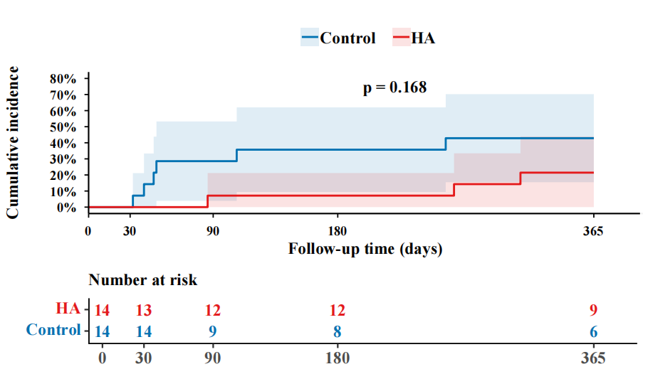
Figure S1. One-year cumulative incidence of further decompensation between HA group and control group after PSM.

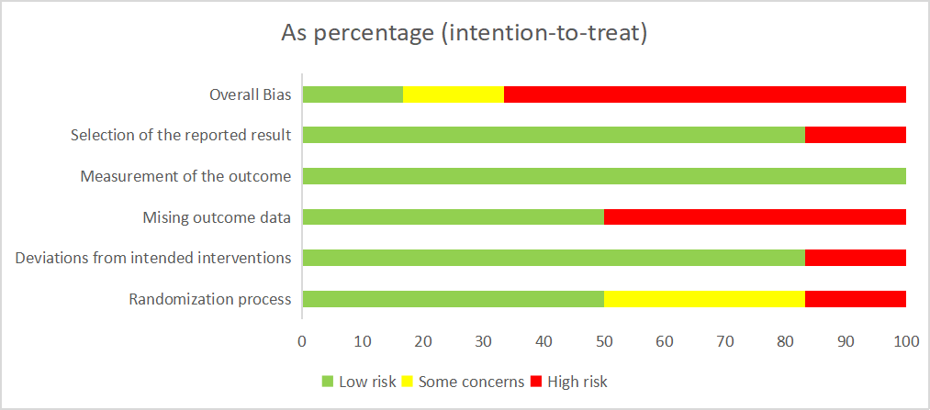
Figure S2. Risk of bias of the included randomized controlled trials.

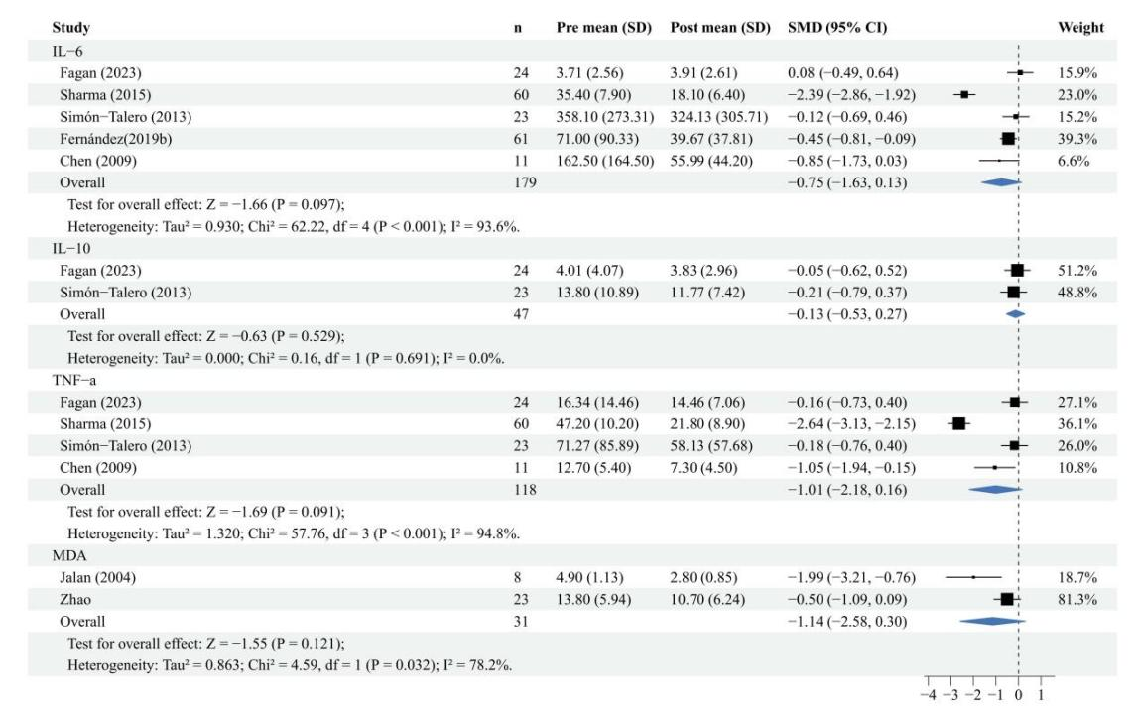
Figure S3. Changes in inflammatory and oxidative stress factors in the HA group before and after treatment. Detailed patient characteristics and HA infusion regimens were provided in Table 4.

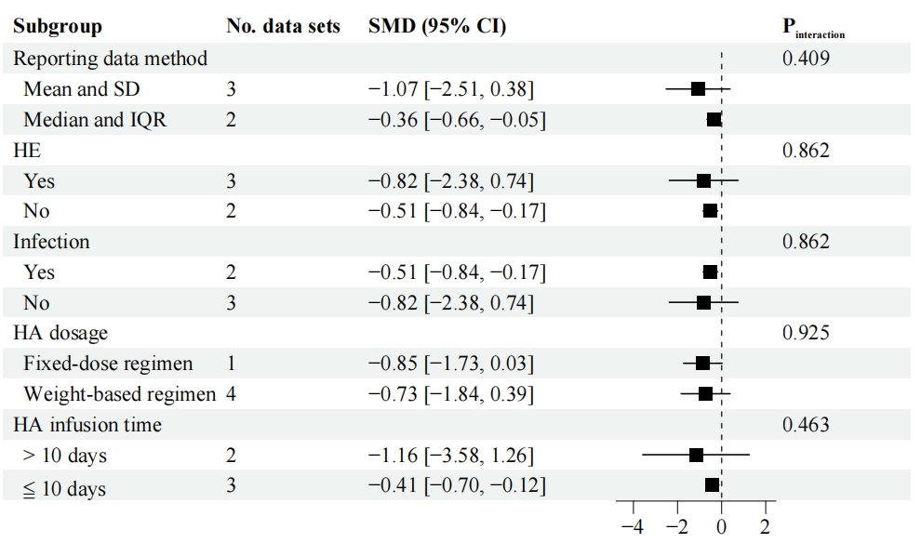
Figure S4. Subgroup analysis of the change in IL-6 in the HA group before and after treatment. Detailed patient characteristics and HA infusion regimens were provided in Table 4.

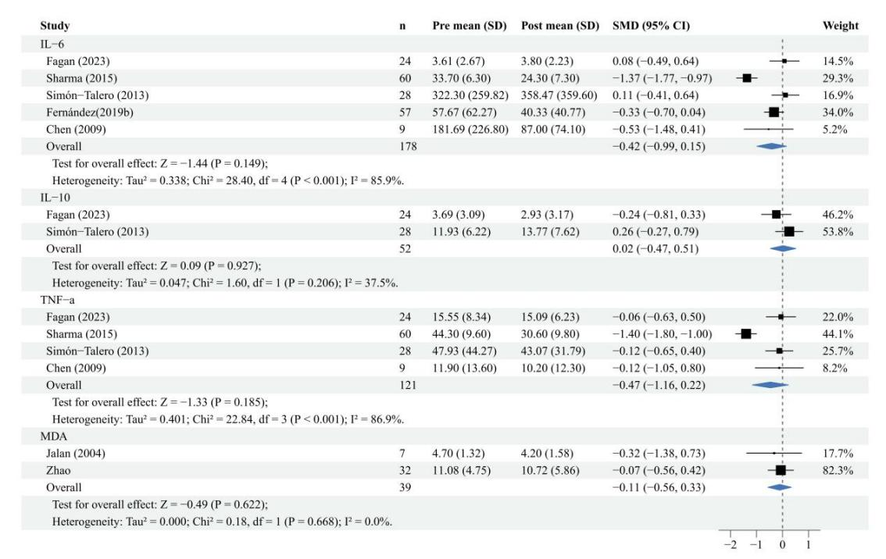
Figure S5. Changes in inflammatory and oxidative stress markers in the control group before and after treatment. Detailed patient characteristics were provided in Table 4.

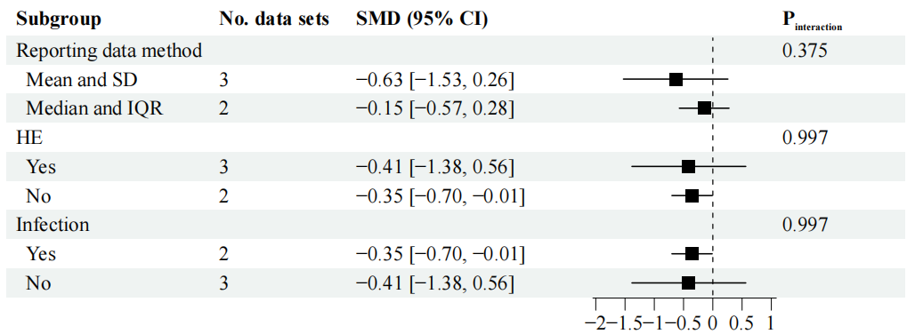
Figure S6. Subgroup analysis of the change in IL-6 in the control group before and after treatment. Detailed patient characteristics were provided in Table 4.

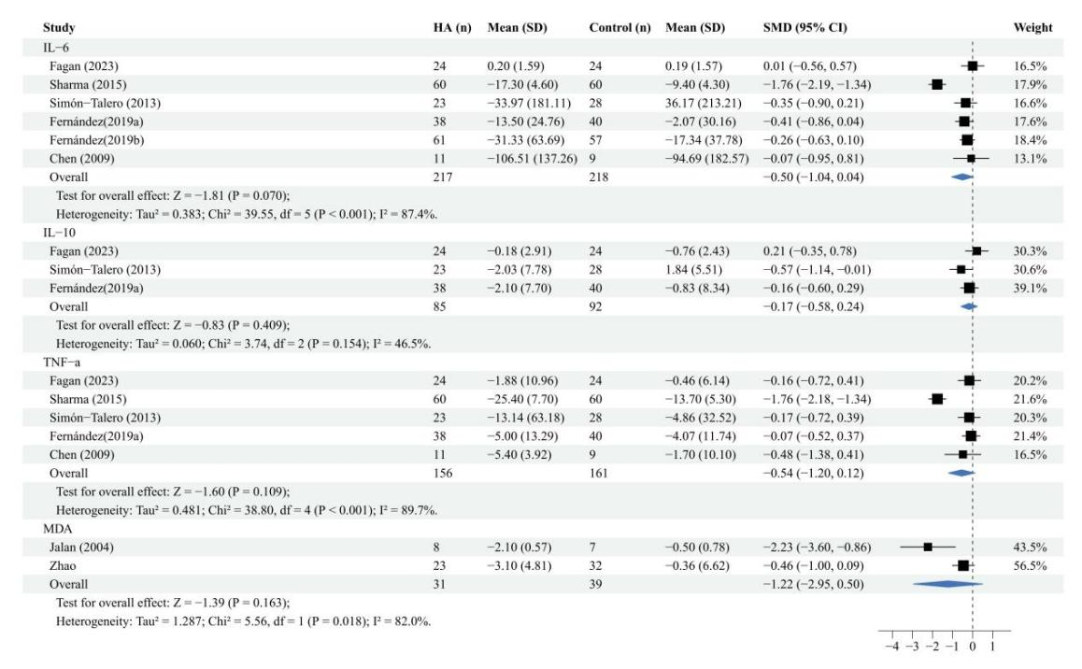
Figure S7. Changes in inflammatory and oxidative stress markers between the HA group and control group. Detailed patient characteristics were provided in Table 4.

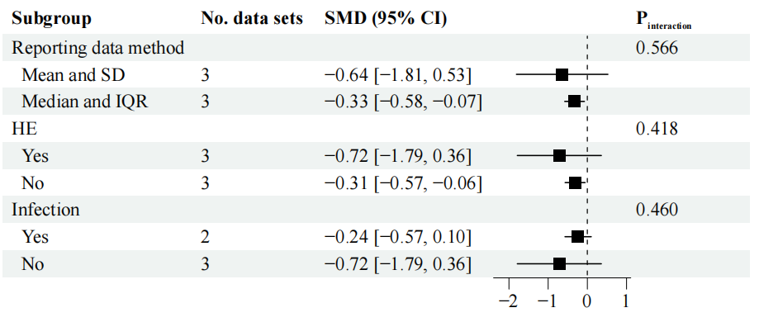
Figure S8. Subgroup analysis of ΔIL-6 between the HA group and control group. Detailed patient characteristics were provided in Table 4.

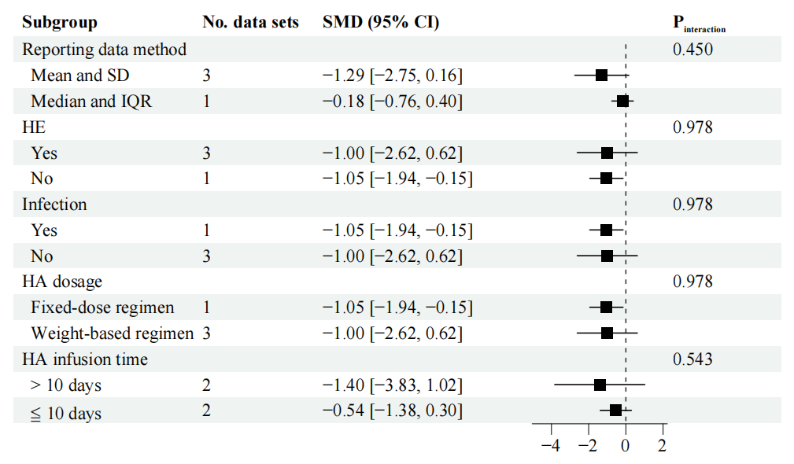
Figure S9. Subgroup analysis of the change in TNF-α in the HA group before and after treatment. Detailed patient characteristics and HA infusion regimens were provided in Table 4.

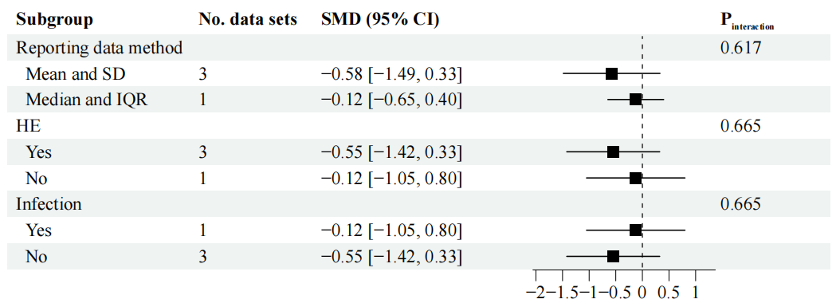
Figure S10. Subgroup analysis of the change in TNF-α in the control group before and after treatment. Detailed patient characteristics were provided in Table 4.

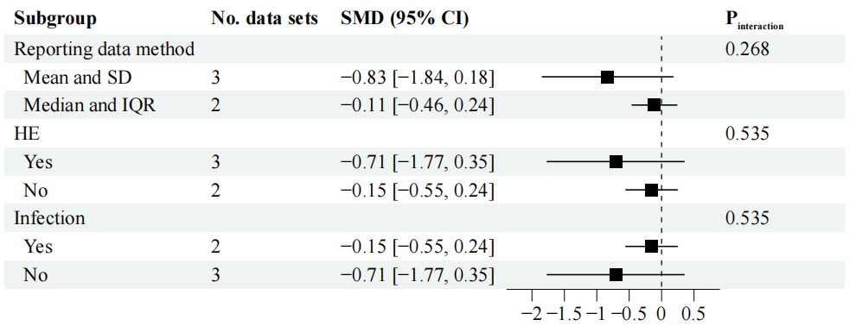
Figure S11. Subgroup analysis of ΔTNF-α between the HA group and control group. Detailed patient characteristics were provided in Table 4.

