Supplementary figure 1A. Subgroup analysis based on the tumor type about the association of preoperative psoas muscle index with overall survival among surgical esophageal cancer patients.
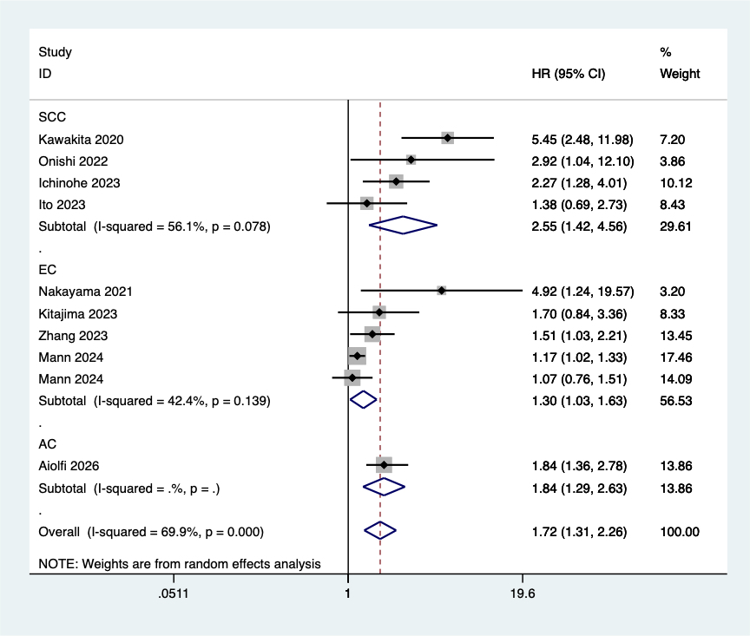

Supplementary figure 1B. Subgroup analysis based on the history of neoadjuvant therapy about the association of preoperative psoas muscle index with overall survival among surgical esophageal cancer patients.
