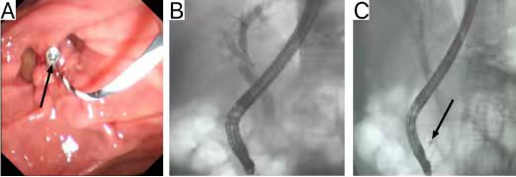
Figure 1. Overview of Hemoclip Placement During ERCP：A. Successful placement of the hemoclip (black arrow)；B. Fluoroscopic view of the ERCP procedure；C. Fluoroscopic view showing successful placement of the hemoclip (black arrow).
Note: Endoscopic technique for hemoclip application at the sphincterotomy site. This figure illustrates the mechanical placement of a clip; in the present study, clips were applied prophylactically following sphincterotomy in the absence of active bleeding.

