Supplemental materials

Development and Validation of a Nomogram to Predict Recurrence After Hepatectomy in Overweight Patients with Hepatocellular Carcinoma: A Retrospective Cohort Study
Jiajing Zhao¹, Yunjian Meng², Zhongyi Jiang¹, Zhike Li¹, Youyao Li¹, Yuanjun Liu², Jiangang Bi^{1,2 *}, Liping Liu^{1,2*}
¹ Department of Hepatobiliary and Pancreas Surgery, Shenzhen People's Hospital, The Second Clinical Medical College, Jinan University, Shenzhen, 518020.China.
² Department of Hepatobiliary and Pancreas Surgery, The First Affiliated Hospital, School of Medicine, Southern University of Science and Technology, Shenzhen, 518020, China.
* Correspondence:
Corresponding Author: Jiangang Bi
E-mail: 23501983@qq.com
Shenzhen People's Hospital, 1017 Dongmen North Road, Luohu District, Shenzhen City, Guangdong Province, China

Corresponding Author: Liping Liu
- mail: liuliping@mail.sustech.edu.cn
Shenzhen People's Hospital, 1017 Dongmen North Road, Luohu District, Shenzhen City, Guangdong Province, China

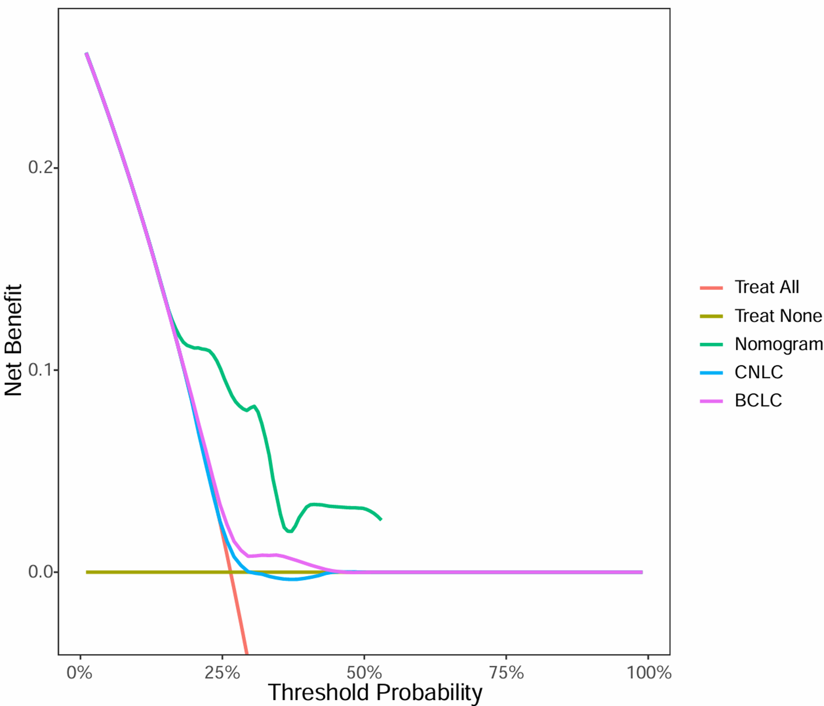
Figure S1 The DCA curve of the one-year DFS of the nomogram model in the training set
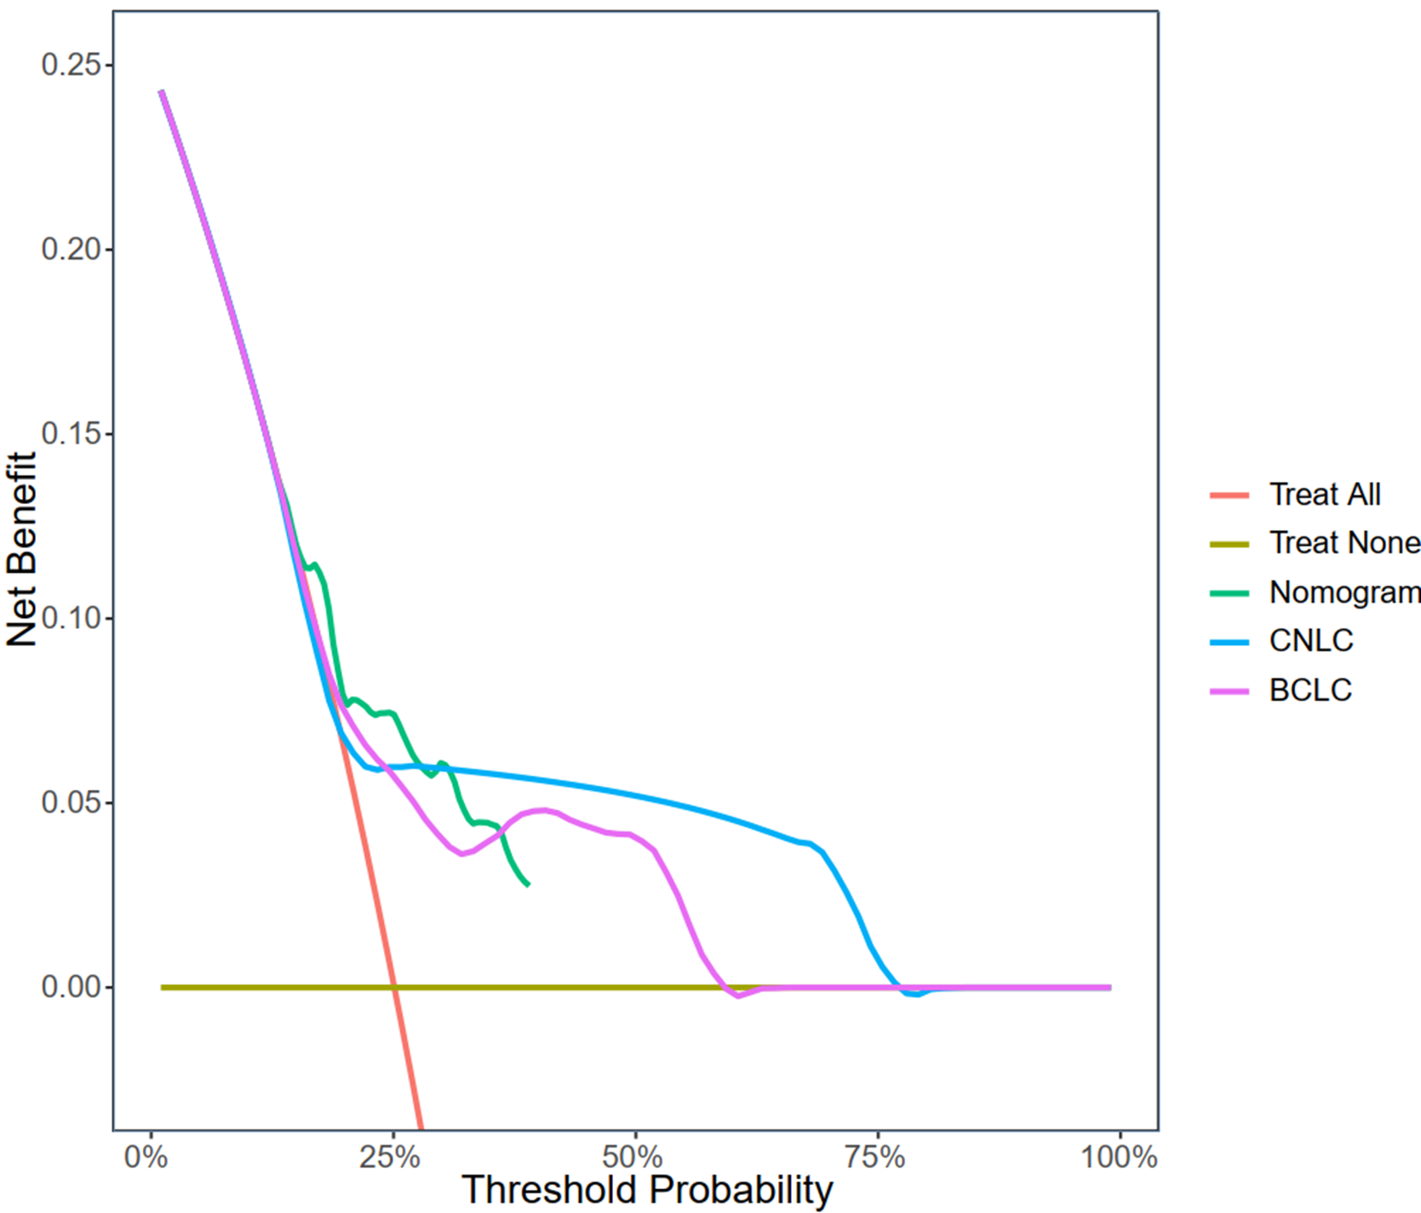

Figure S2 The DCA curve of the one-year DFS of the nomogram model in the validation set

