Supplemental Material
Retrieval :
Database | Search Time Frame | Complete Search Strategy (Keywords, Boolean Operators, Subject Headings, Filters)
PubMed | Inception to March 2023 | Search Strategy:  1. (Transjugular Intrahepatic Portosystemic Shunt[MeSH Terms] OR TIPS OR transjugular intrahepatic portosystemic shunt OR portosystemic shunt, transjugular intrahepatic) AND  2. (Liver Cirrhosis[MeSH Terms] OR cirrhosis OR hepatic cirrhosis OR liver fibrosis) AND  3. (Hepatocellular Carcinoma[MeSH Terms] OR HCC OR hepatocellular carcinoma OR liver cancer OR hepatic carcinoma) AND  4. (Cohort Studies[MeSH Terms] OR retrospective study OR prospective study OR observational study)
Embase | Inception to March 2023 | Search Strategy:  1. (transjugular intrahepatic portosystemic shunt/exp OR TIPS OR transjugular intrahepatic portosystemic shunt OR portosystemic shunt) AND  2. (liver cirrhosis/exp OR cirrhosis OR hepatic cirrhosis OR liver fibrosis) AND  3. (hepatocellular carcinoma/exp OR HCC OR hepatocellular carcinoma OR liver cancer OR hepatic carcinoma) AND  4. (cohort study/exp OR retrospective study OR prospective study OR observational study)
Web of Science Core Collection | Inception to March 2023 | Search Strategy:  1. TS=(transjugular intrahepatic portosystemic shunt OR TIPS OR portosystemic shunt) AND  2. TS=(liver cirrhosis OR cirrhosis OR hepatic cirrhosis OR liver fibrosis) AND  3. TS=(hepatocellular carcinoma OR HCC OR liver cancer OR hepatic carcinoma) AND  4. TS=(cohort study OR retrospective study OR prospective study OR observational study)
Cochrane Library | Inception to March 2023 | Search Strategy:  1. (transjugular intrahepatic portosystemic shunt OR TIPS OR portosystemic shunt):ti,ab,kw AND  2. (liver cirrhosis OR cirrhosis OR hepatic cirrhosis OR liver fibrosis):ti,ab,kw AND  3. (hepatocellular carcinoma OR HCC OR liver cancer OR hepatic carcinoma):ti,ab,kw AND  4. (cohort study OR retrospective study OR prospective study OR observational study):ti,ab,kw

Supplementary Table 1. Basic information of included study
Year | Author | Country | Study type | Age |  | Sex  (Male/%) |  |  | HCC detection | Child-Pugh score/class  MELD score
 |  |  |  | TIPS | Control | TIPS | Control |  | HCC detection | TIPS | Control
1985 | Bjørneboe M [7] | Denmark | Retrospective | NA |  | 124  (62) | 224  (59) |  | Autopsy | NA
2002 | Escorsell A [11] | Spain | Prospective  (RCT) | 57±9 | 56±11 | 33  (70.2) | 35  (79.5) |  | NA | B/C:30/17 | B/C:28/16
2005 | Bañares R [12] | Spain | Retrospective | 56.17±11.7 | 56.04±11.5 | 100  (72.5) | 100  (72.5) |  | US,  Histological， AFP | 7.51 ±1.8  A:48  B:68  C:22 | 7.63 ±1.6  A:48  B:68  C:22
2005 | Libbrecht L [13] | Belgium | Prospective  (Comment) | 54±8 | 55±10 | 7  (63.6） | 41  (63.1） |  | Clinical, radiological, histopathology | NA
2010 | Iegri C [14] | Italy | Case-control (Conference Abstract) | 58.6±9.4 | 58.6±9.9 | 64  (64) | 64  (64) |  | NA | NA
2014 | De Santis A [8] | Italy | Retrospective | 58.6 ± 9.4 | 58.6 ± 9.9 | 65(64) | 65(64) |  | US and AFP | 7.5±1.6  A:33  B:61  C:7 | 7.1±1.7  A:40  B:54  C:7
2015 | Borentain P [15] | France | Retrospective | 51.1 ± 6.8 | 49.6 ± 8.2 | 52  (76.5) | 114  (78.1) |  | US and AFP | 10.0 ± 1.9  18.5 ± 5.6 | 9.8 ± 2.3  19.6 ± 8.3
2018 | Husing-Kabar A [9] | Germany | Retrospective | 56 (48–65) |  | 819 (61.2) |  |  | US,  CT, MRI, biopsy， AFP 11 (8–15) | 11 (8–15)
2018 | Husing-Kabar A [9] | Germany | Case-control matching | 58(51-65) | 58 (50–65) | 141  (65.3) |  | 141  (65.3) | US,  CT, MRI, biopsy， AFP | 12  (10–14.8) | 11.7  (9.2–14.4)
2019 | Yong Lv [16] | China | Prospective  (RCT) | 50·7 ±11·6 | 50·9 ±10·4 | 53 (63) |  | 34 (76) | NA | 8·0 (7·0–9·0)  B:65  C:19  14·3 (12·0–16·8) | 8·0 (7·0–9·0)  B:35  C:10  14·6 (12·2–17·5)
2020 | Minciuna I [17] | Romania | Retrospective (Conference Abstract) | 53.65 | 57.13 | NA |  |  | NA | NA

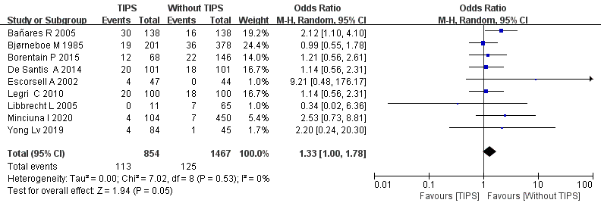
Supplementary Figure 1. Incidence of liver cancer

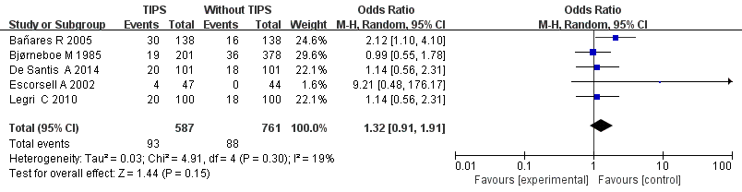
Supplementary Figure 2. Incidence of liver cancer in most patients with alcoholic liver disease

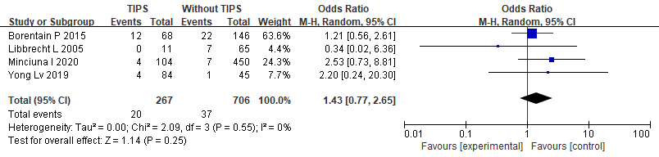

Supplementary Figure 3. Incidence of liver cancer in most patients with non-alcoholic liver disease

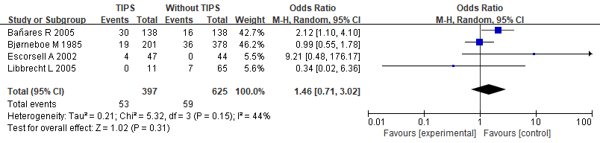
Figure 4. Incidence of HCC in studies published before 2005

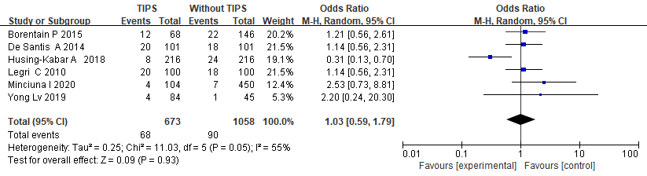
Figure 5. Incidence of HCC in studies published after 2005

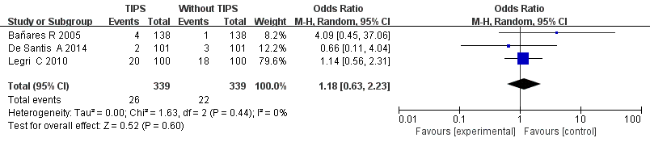
Supplementary Figure 6. Incidence of liver cancer in 1 year

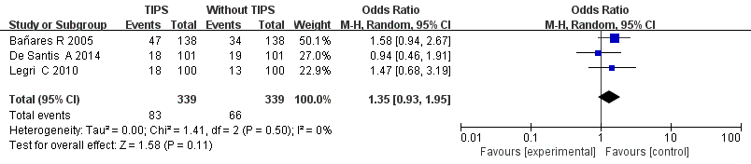
Supplementary Figure 7. Incidence of liver cancer in 5 years

