Title: Meta-analysis: Safety and Efficacy of Ustekinumab in Pediatric Inflammatory Bowel Disease Patients with Anti-TNF Failure
Journal: Digestive Disease and Science
Authors: Zhaoyang Heng¹, Li Zhan², Yuhan Zhang³, Keyou Zhou¹, Meng Song⁴, Kelei Zhao⁴, Md. Shoykot Jahan⁴, Most. Fatema Akter⁴, Ping Lu⁴, Yinghua Ji⁴, Yanting Liu⁴
Affiliations:
1 First Clinical College, Henan Medical University, Xinxiang, Henan, China
2 Clinical Medical College, Southwest Medical University, Luzhou, Sichuan, China
3 The Second Xiangya Hospital, Central South University, Changsha, Hunan, China
4 Department of Oncology, The First Affiliated Hospital of Henan Medical University, Xinxiang, Henan, China
Table S1: Search Strategy per Database

Database | Search Strategy
Pubmed/Medline  (249) | ("ustekinumab"[MeSH Terms] OR "ustekinumab"[All Fields] OR "stelara"[All Fields] OR "CNTO 1275"[All Fields] OR "CNTO-1275"[All Fields]) AND ("inflammatory bowel diseases"[MeSH Terms] OR ("inflammatory"[All Fields] AND "bowel"[All Fields] AND "diseases"[All Fields]) OR "inflammatory bowel disease"[All Fields] OR "IBD"[All Fields] OR "Crohn Disease"[MeSH Terms] OR "Crohn's disease"[All Fields] OR "Crohn's"[All Fields] OR "Colitis, Ulcerative"[MeSH Terms] OR "ulcerative colitis"[All Fields] OR "UC"[All Fields]) AND ("pediatrics"[MeSH Terms] OR "pediatrics"[All Fields] OR "pediatric"[All Fields] OR "paediatric"[All Fields] OR "child"[MeSH Terms] OR "child"[All Fields] OR "children"[All Fields] OR "childhood"[All Fields] OR "adolescent"[MeSH Terms] OR "adolescent"[All Fields] OR "adolescents"[All Fields] OR "teenager"[All Fields] OR "youth"[All Fields] OR "infant"[MeSH Terms] OR "infant"[All Fields])
Embase  (374) | ('ustekinumab':ti,ab,kw OR 'stelara':ti,ab,kw OR 'cnto 1275':ti,ab,kw OR 'cnto-1275':ti,ab,kw) AND ('inflammatory bowel disease':ti,ab,kw OR 'ibd':ti,ab,kw OR 'crohn disease':ti,ab,kw OR 'ulcerative colitis':ti,ab,kw OR 'colitis':ti,ab,kw OR 'ileitis':ti,ab,kw) AND ('child':ti,ab,kw OR 'children':ti,ab,kw OR 'pediatric':ti,ab,kw OR 'paediatric':ti,ab,kw OR 'adolescent':ti,ab,kw OR 'adolescence':ti,ab,kw OR 'teenager':ti,ab,kw OR 'youth':ti,ab,kw OR 'infant':ti,ab,kw)
Web of Science  (212) | TS=(("ustekinumab" OR "Stelara" OR "CNTO 1275" OR "CNTO-1275") AND ("inflammatory bowel disease" OR "IBD" OR "Crohn's disease" OR "ulcerative colitis" OR "UC") AND ("pediatric" OR "paediatric" OR "child" OR "children" OR "adolescent" OR "youth" OR "teenager" OR "infant"))
Cochrane Library  (33) | ("ustekinumab" OR "Stelara" OR "CNTO 1275") AND ("inflammatory bowel disease" OR "Crohn's disease" OR "ulcerative colitis" OR "IBD") AND ("pediatric" OR "paediatric" OR "child" OR "children" OR "adolescent")

Table S2: The 2020 Preferred Reporting Items for Systematic Reviews and Meta-Analyses (PRISMA) Checklist
Section and Topic | Item # | Checklist item | Location where item is reported
TITLE
Title | 1 | Identify the report as a systematic review. | 1
ABSTRACT
Abstract | 2 | See the PRISMA 2020 for Abstracts checklist. | 1
INTRODUCTION
Rationale | 3 | Describe the rationale for the review in the context of existing knowledge. | 1-2
Objectives | 4 | Provide an explicit statement of the objective(s) or question(s) the review addresses. | 2
METHODS
Eligibility criteria | 5 | Specify the inclusion and exclusion criteria for the review and how studies were grouped for the syntheses. | 2-3
Information sources | 6 | Specify all databases, registers, websites, organisations, reference lists and other sources searched or consulted to identify studies. Specify the date when each source was last searched or consulted. | 3
Search strategy | 7 | Present the full search strategies for all databases, registers and websites, including any filters and limits used. | 3,appendix
Selection process | 8 | Specify the methods used to decide whether a study met the inclusion criteria of the review, including how many reviewers screened each record and each report retrieved, whether they worked independently, and if applicable, details of automation tools used in the process. | 3
Data collection process | 9 | Specify the methods used to collect data from reports, including how many reviewers collected data from each report, whether they worked independently, any processes for obtaining or confirming data from study investigators, and if applicable, details of automation tools used in the process. | 3
Data items | 10a | List and define all outcomes for which data were sought. Specify whether all results that were compatible with each outcome domain in each study were sought (e.g. for all measures, time points, analyses), and if not, the methods used to decide which results to collect. | 3
Data items | 10b | List and define all other variables for which data were sought (e.g. participant and intervention characteristics, funding sources). Describe any assumptions made about any missing or unclear information. | 3
Study risk of bias assessment | 11 | Specify the methods used to assess risk of bias in the included studies, including details of the tool(s) used, how many reviewers assessed each study and whether they worked independently, and if applicable, details of automation tools used in the process. | 3
Effect measures | 12 | Specify for each outcome the effect measure(s) (e.g. risk ratio, mean difference) used in the synthesis or presentation of results. | 3-4
Synthesis methods | 13a | Describe the processes used to decide which studies were eligible for each synthesis (e.g. tabulating the study intervention characteristics and comparing against the planned groups for each synthesis (item #5)). | 3-4
Synthesis methods | 13b | Describe any methods required to prepare the data for presentation or synthesis, such as handling of missing summary statistics, or data conversions. | 3-4
Synthesis methods | 13c | Describe any methods used to tabulate or visually display results of individual studies and syntheses. | 3-4
Synthesis methods | 13d | Describe any methods used to synthesize results and provide a rationale for the choice(s). If meta-analysis was performed, describe the model(s), method(s) to identify the presence and extent of statistical heterogeneity, and software package(s) used. | 3-4
Synthesis methods | 13e | Describe any methods used to explore possible causes of heterogeneity among study results (e.g. subgroup analysis, meta-regression). | 3-4
Synthesis methods | 13f | Describe any sensitivity analyses conducted to assess robustness of the synthesized results. | 3-4
Reporting bias assessment | 14 | Describe any methods used to assess risk of bias due to missing results in a synthesis (arising from reporting biases). | 3-4
Certainty assessment | 15 | Describe any methods used to assess certainty (or confidence) in the body of evidence for an outcome. | NA
RESULTS
Study selection | 16a | Describe the results of the search and selection process, from the number of records identified in the search to the number of studies included in the review, ideally using a flow diagram. | 4-5
Study selection | 16b | Cite studies that might appear to meet the inclusion criteria, but which were excluded, and explain why they were excluded. | 4
Study characteristics | 17 | Cite each included study and present its characteristics. | 4-6
Risk of bias in studies | 18 | Present assessments of risk of bias for each included study. | 5-6
Results of individual studies | 19 | For all outcomes, present, for each study: (a) summary statistics for each group (where appropriate) and (b) an effect estimate and its precision (e.g. confidence/credible interval), ideally using structured tables or plots. | 8-11
Results of syntheses | 20a | For each synthesis, briefly summarise the characteristics and risk of bias among contributing studies. | 4-6
Results of syntheses | 20b | Present results of all statistical syntheses conducted. If meta-analysis was done, present for each the summary estimate and its precision (e.g. confidence/credible interval) and measures of statistical heterogeneity. If comparing groups, describe the direction of the effect. | 7-10
Results of syntheses | 20c | Present results of all investigations of possible causes of heterogeneity among study results. | 10-11
Results of syntheses | 20d | Present results of all sensitivity analyses conducted to assess the robustness of the synthesized results. | 11
Reporting biases | 21 | Present assessments of risk of bias due to missing results (arising from reporting biases) for each synthesis assessed. | 11-12
Certainty of evidence | 22 | Present assessments of certainty (or confidence) in the body of evidence for each outcome assessed. | NA
DISCUSSION
Discussion | 23a | Provide a general interpretation of the results in the context of other evidence. | 12-14
Discussion | 23b | Discuss any limitations of the evidence included in the review. | 14
Discussion | 23c | Discuss any limitations of the review processes used. | 14
Discussion | 23d | Discuss implications of the results for practice, policy, and future research. | 14-15
OTHER INFORMATION
Registration and protocol | 24a | Provide registration information for the review, including register name and registration number, or state that the review was not registered. | 2
Registration and protocol | 24b | Indicate where the review protocol can be accessed, or state that a protocol was not prepared. | 2
Registration and protocol | 24c | Describe and explain any amendments to information provided at registration or in the protocol. | NA
Support | 25 | Describe sources of financial or non-financial support for the review, and the role of the funders or sponsors in the review. | NA
Competing interests | 26 | Declare any competing interests of review authors. | 15
Availability of data, code and other materials | 27 | Report which of the following are publicly available and where they can be found: template data collection forms; data extracted from included studies; data used for all analyses; analytic code; any other materials used in the review. | 15
From: Page MJ, McKenzie JE, Bossuyt PM, Boutron I, Hoffmann TC, Mulrow CD, et al. The PRISMA 2020 statement: an updated guideline for reporting systematic reviews. BMJ 2021;372:n71. doi: 10.1136/bmj.n71. This work is licensed under CC BY 4.0. To view a copy of this license, visit https://creativecommons.org/licenses/by/4.0/
Table S3: Quality Assessment of Included Studies Using the MINORS Scale
Study | Item 1 | Item 2 | Item 3 | Item 4 | Item 5 | Item 6 | Item 7 | Item 8 | Total Score
Mitchel 2025 | 2 | 2 | 2 | 2 | 1 | 2 | 2 | 0 | 13
Alhadab 2025 | 2 | 2 | 0 | 2 | 1 | 2 | 2 | 0 | 11
Yamamoto 2025 | 2 | 2 | 0 | 2 | 1 | 2 | 2 | 0 | 11
Pujol-Muncunill 2024 | 2 | 2 | 0 | 2 | 1 | 2 | 2 | 0 | 11
Cohen A 2021 | 2 | 2 | 0 | 2 | 0 | 2 | 2 | 0 | 10
Kim 2021 | 2 | 2 | 0 | 2 | 1 | 2 | 2 | 0 | 11
Takeuchi 2020 | 2 | 2 | 0 | 2 | 1 | 2 | 1 | 0 | 10
Dayan 2019 | 2 | 2 | 0 | 2 | 1 | 2 | 2 | 0 | 11
Koudsi 2023 | 2 | 2 | 0 | 2 | 1 | 2 | 2 | 0 | 11
Cohen S 2024 | 2 | 2 | 0 | 2 | 1 | 2 | 2 | 0 | 11
Do 2020 | 2 | 2 | 0 | 2 | 1 | 2 | 2 | 0 | 11
Rehman 2024 | 2 | 2 | 0 | 2 | 1 | 2 | 2 | 0 | 11
Chavannes 2018 | 2 | 2 | 0 | 2 | 1 | 2 | 2 | 0 | 11
Yerushalmy-Feler 2022 | 2 | 2 | 0 | 2 | 1 | 2 | 2 | 0 | 11
Rébus 2024 | 2 | 2 | 0 | 2 | 1 | 2 | 2 | 0 | 11
The items are scored 0 (not reported), 1 (reported but inadequate), or 2 (reported and adequate). The maximum possible score for non-comparative studies is 16. Item 1: A clearly stated aim; Item 2: Inclusion of consecutive patients; Item 3: Prospective collection of data; Item 4: Endpoints appropriate to the aim of the study; Item 5: Unbiased assessment of the study endpoint; Item 6: Follow-up period appropriate to the aim of the study; Item 7: Loss to follow-up less than 5%; Item 8: Prospective calculation of the study size
Supplementary Table S4. Treatment durability, concomitant therapies, and timing of response or remission in included studies
Study | Follow-up / assessment windows | Treatment durability | Concomitant or bridging therapies | Timing of response/remission | Dose escalation / optimization and notes
Mitchel et al., 2025 | Median follow-up: 16.6 months; outcomes assessed at 6, 12, 24, and 36 months. | Drug failure occurred in 28% at 1 year and 38% by last follow-up. Among patients after escalation, 89% remained on UST within 6 months, and 65% remained on UST by last follow-up. | At UST initiation, 23 patients used methotrexate, 5 used azathioprine, and 22 were on corticosteroids. Steroid exposure within 3 months before UST was reported in 30 patients. | Time to steroid-free clinical remission for 50% of patients was 2.7 months. At 1 year, 59 patients were in steroid-free clinical remission. | Drug escalation occurred in 70%, mainly interval shortening from q8w to q4w or q6w; some received IV reinduction. After escalation, 70% achieved clinical remission and 69% achieved steroid-free remission at last follow-up.
Alhadab et al., 2024 | Minimum follow-up >=1 year; clinical and laboratory outcomes at baseline, week 26, and week 52. | At 1 year, 84% remained on UST. No severe adverse reactions were reported. | Five patients received corticosteroids at induction; three patients used azathioprine. Antibiotics were used early in treatment in one perianal disease case. | Clinical remission was assessed at week 52. Steroid-free remission increased from 0% to 38.4% at week 26 and 69.2% at week 52. One patient's headache/vomiting improved 3 months after UST initiation. | Dose interval or dose escalation was determined by clinician assessment; specific pooled escalation numbers were not clearly reported.
Yamamoto et al., 2024 | Median follow-up: 136 weeks; outcomes at weeks 8, 52, and 106. | Continuation rates were 100% at week 8, approximately 91%-92% at week 52, and 80% at week 106. Discontinuation incidence was 6.2% per patient-year; all discontinuations were due to non-response. | At baseline, 34/43 were on partial enteral nutrition, 26 used azathioprine, 1 mercaptopurine, and 3 tacrolimus. Steroid exposure included prednisolone, budesonide, and hydrocortisone. | Clinical remission rates were 84%, 82%, and 80% at weeks 8, 52, and 106. Steroid-free remission rates were 44%, 71%, and 80% at weeks 8, 52, and 106. | Interval shortening to q4-7w was required in seven patients with VEO-IBD. One patient underwent IV reinduction after self-interruption; others did not undergo reinduction despite loss of response.
Pujol-Muncunill et al., 2024 | Median follow-up: 7.4 months; week 12 and week 52 outcomes. | At week 52, 51/74 patients remained on UST. Twenty-three of 74 discontinued within 1 year, mostly due to lack of response. Six required surgery during 12 months but continued UST after surgery. | Baseline: 28 patients on corticosteroids, 15 on exclusive enteral nutrition, and 48 on immunosuppressants. Immunosuppressant use decreased from 45.7% at week 12 to 35.3% at week 52. | Clinical response at week 6 was a predictor of remission at week 12. Corticosteroid- and EEN-free remission was 40.5% at week 12 and 40.5% at week 52. | Twenty-five patients underwent treatment optimization within 12 months: 15 within the first 12 weeks, 3 within 6 months, and 7 within 12 months. Among optimized patients, 18/25 responded. IV reinduction was performed in two patients.
Cohen et al., 2021 | Follow-up varied; responders were followed for 6-22 months and nonresponders for 2-24 months. | Five of 11 showed initial response; 2/5 maintained response through all available follow-up. Three developed secondary loss of response between 11 and 19 months. One patient clearly maintained remission beyond 1 year, stable at 22 months. | At induction, 4/11 used methotrexate or azathioprine and 4/11 used corticosteroids. | Responders had abbrPCDAI decrease within 3-6 months. Three patients with secondary loss of response achieved clinical remission within 1-4 months after interval shortening. CRP normalized within 1 month of clinical improvement in responders with elevated baseline CRP. | Maintenance intervals were shortened from q8w to q4w in 9/11 due to ongoing symptoms. Among eight patients with interval shortening, three showed clinical response.
Kim et al., 2021 | Median duration on UST: 62.1 weeks / 14.3 months. | At last follow-up, 32/38 (84.2%) remained on UST. Five of 38 discontinued due to secondary loss of response; other discontinuations included insurance-related and patient-initiated discontinuation. | At UST induction, 7/38 were on oral corticosteroids. Previous immunomodulator exposure was common, including methotrexate and thiopurines. | Exact median time to response/remission was not reported; outcomes were mainly reported at last follow-up. | Eighteen of 38 required dose escalation, IV reinduction, or both. Among the dose-adjustment group, 61.1% achieved clinical remission.
Takeuchi et al., 2020 | Minimum follow-up >=26 weeks; median observed UST duration 58 weeks. | All patients remained on UST at week 26. Among 10 patients followed for more than 52 weeks, 9/10 continued beyond week 52. One VEO-IBD patient discontinued at week 39 due to poor response. | Baseline steroid exposure was 8/17. Concomitant therapies included azathioprine (n=8), mercaptopurine (n=1), and tacrolimus (n=1). Some patients initiated UST after remission induced by EEN or other biologic interventions. | Steroid-free remission was 59% at week 26, 50% at week 52, and 70% beyond week 52. Two patients achieved steroid-free remission at weeks 65 and 79. | Two VEO-IBD patients required dose escalation to 2.5 mg/kg; one required interval shortening to q5w. No patient underwent reinduction.
Dayan et al., 2019 | Minimum follow-up 52 weeks; median follow-up 18 months. | At week 52, 39/52 (75%) remained on UST. Thirteen discontinued by week 52, with reasons including therapy switch, surgery, side effects, and insurance denial. | At baseline, 23% received concomitant immunomodulators and 54% were receiving corticosteroids. | Main outcomes were reported at week 52. Steroid-free remission was 50% in bio-exposed patients and 90% in bio-naive patients. Exact median time to remission was not reported. | Among the 39 patients still on UST at week 52, 62% had interval shortening. Three patients received IV reinduction due to persistent symptoms.
Koudsi et al., 2023 | Mean follow-up 13 months; median 10.5 months. Assessments at induction, 3 months, and last follow-up. | UST was discontinued in 15/53 (28%) due to lack of efficacy, loss of response, or adverse events. Seven discontinued within the first 3 months and eight after 3 months. | Prior or baseline treatment burden was high: corticosteroids 42/53, azathioprine 50/53, methotrexate 21/53, and 5-ASA 22/52. Only nine patients were steroid-free at inclusion. | In CD, mean PCDAI decreased from 28.7 at induction to 18.7 at 3 months and 10 at last follow-up. In UC, mean PUCAI decreased from 47 to 25 at 3 months and 18.3 at last follow-up. | Twenty-four patients underwent optimized therapy with q4w injections at 3 months.
Cohen et al., 2024 | Median follow-up 12.8 months; outcomes at weeks 16, 26, and 52. | Twenty-four of 58 discontinued UST after a median of 5 months; reasons were non-response in 21 and adverse events in three. Ten patients underwent colectomy after discontinuation. | Combination therapy was used in 47/58 (81%): corticosteroids in 31, 5-ASA in 26, thiopurines in 16, methotrexate in three, and other agents in selected cases. | Corticosteroid-free clinical remission was 46.6%, 56.9%, and 63.8% at weeks 16, 26, and 52. Among 31 children treated with corticosteroids at baseline, 26 weaned within a median of 3 months. Clinical response at week 16 was 67.2%. | Dose escalation occurred in 23/58 (39.7%); 13 patients had clinical or biomarker response to escalation.
Do et al., 2021 | Assessment at baseline, 2-3 months, and last assessment. Individual UST therapy duration ranged from approximately 16 to 143 weeks. | No unified cohort-level continuation rate was reported. Seven of 10 patients received augmented maintenance dosing and all seven showed clinical response; all but one achieved sustained clinical remission. | Bridging therapy was not systematically reported. One patient received specific carbohydrate diet plus UST; in the standard-dose group, high-dose corticosteroid use confounded the assessment of response. | Most responders showed improvement within the first 2-3 months of therapy. Formal median time to response or remission was not reported. | Seven of 10 required q4-6w augmented maintenance dosing to achieve response/remission. Several patients had low trough levels on q8w/q6w dosing and achieved therapeutic concentrations after interval shortening.
Rehman et al., 2024 | Median follow-up 56 weeks; longitudinal tracking at weeks 8, 16, 24, 32, 40, 48, and 56. | Nine of 10 achieved steroid-free clinical remission and biochemical remission. One patient did not achieve remission and underwent colectomy. | The study mainly reported prior therapies: systemic steroids 10/10, mesalamine 8/10, methotrexate 4/10, 6-MP 1/10, and IBD-specific diet therapy 4/10. It did not clearly define therapies used specifically as UST induction bridging therapy. | No median time to response was reported. Week-based follow-up showed overall downtrends in PUCAI, CRP, and fecal calprotectin after UST initiation. | Seven of 10 patients required dose escalation by weeks 16-20 to achieve clinical remission.
Chavannes et al., 2018 | Baseline, 3 months, and 12 months; median observed UST treatment duration 13 months. | The probability of remaining on UST at 12 months was 76.9%. Approximately 30% discontinued therapy, mainly due to poor clinical response. | Twenty-one of 44 patients were on corticosteroids at UST initiation. Concomitant immunomodulator use was evaluated as a potential predictor. | Clinical remission was achieved by 36.4% at 3 months and 38.6% at 12 months. Clinical response was 47.8% at both 3 and 12 months. Median time-to-response/remission was not reported. | Six different subcutaneous induction regimens were used. Thirteen of 44 (29.5%) were dose-escalated to q4w maintenance due to persistent symptoms.
Yerushalmy-Feler et al., 2022 | Follow-up after UST dose escalation at 3, 6, and 12 months. | Thirteen of 69 (18.8%) discontinued UST after a median of 3 months; all discontinuations were due to active disease. | At dose escalation, 46/69 (66.7%) received combination therapy, mainly immunomodulators, partial enteral nutrition, and corticosteroids; selected children received concomitant biologic therapy. | After escalation, clinical response/remission was 67%/42% at 3 months, 57%/38% at 6 months, and 42.4%/30.3% at 12 months by ITT analysis. | Escalation was mainly interval shortening (91.3%), usually to q4-6w; a minority underwent reinduction or combined reinduction plus interval shortening.
Rebus et al., 2024 | W0, W14, and W52; UST group n=33. | At W52, 27/33 (82%) were still treated with UST. Six discontinued prematurely: two due to primary failure and four due to loss of response. Two were lost to follow-up. | At W0, current treatments included corticosteroids 10/33, immunosuppressants 9/33, enteral nutrition 1/33, and parenteral nutrition 2/33. Some patients still used corticosteroids or immunosuppressants at W14/W52. | Corticosteroid-free clinical remission was 49% at W14 and 55% at W52. Among patients in CFR at W14, some maintained remission at W52. Median time to remission was not reported. | Treatment optimization was required in 21% at W14 and 61% at W52, mainly by increasing administration frequency.
Abbreviations: UST, ustekinumab; CD, Crohn disease; UC, ulcerative colitis; IBDU, inflammatory bowel disease unclassified; CFR, corticosteroid-free clinical remission; CS, corticosteroid; EEN, exclusive enteral nutrition; PEN, partial enteral nutrition; q4w/q6w/q8w, every 4/6/8 weeks; CRP, C-reactive protein; FC/FCP, fecal calprotectin; ITT, intention-to-treat; VEO-IBD, very early-onset inflammatory bowel disease; NR, not reported.

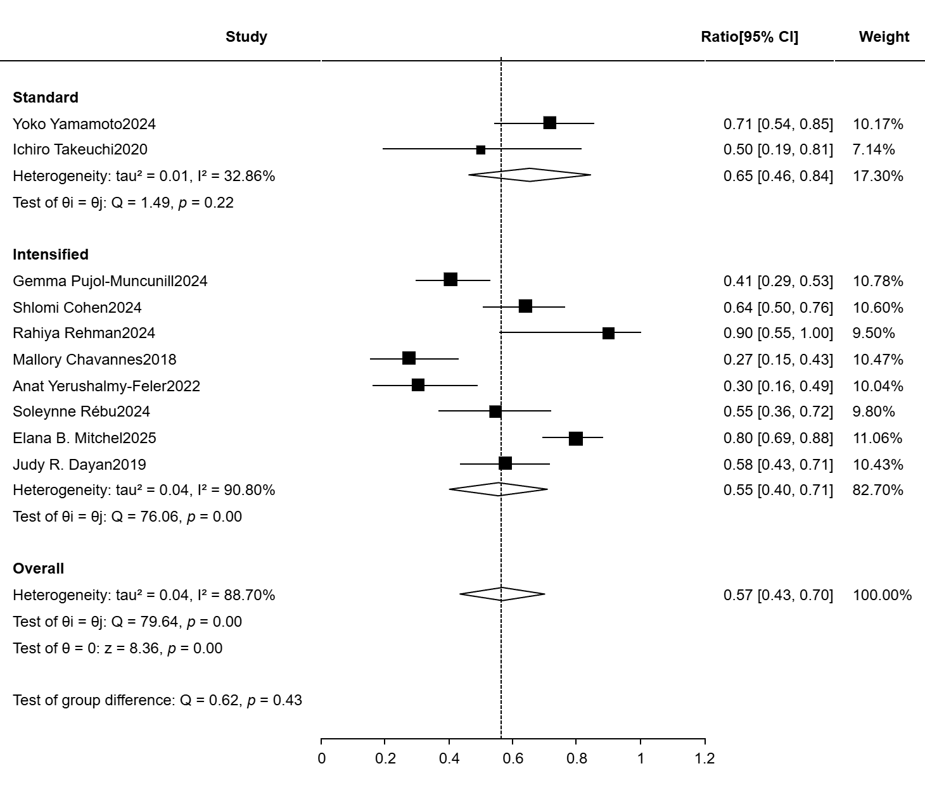
Figure S1 Pooled steroid-free clinical remission rate at week 52 for Standard and Intensified subgroups

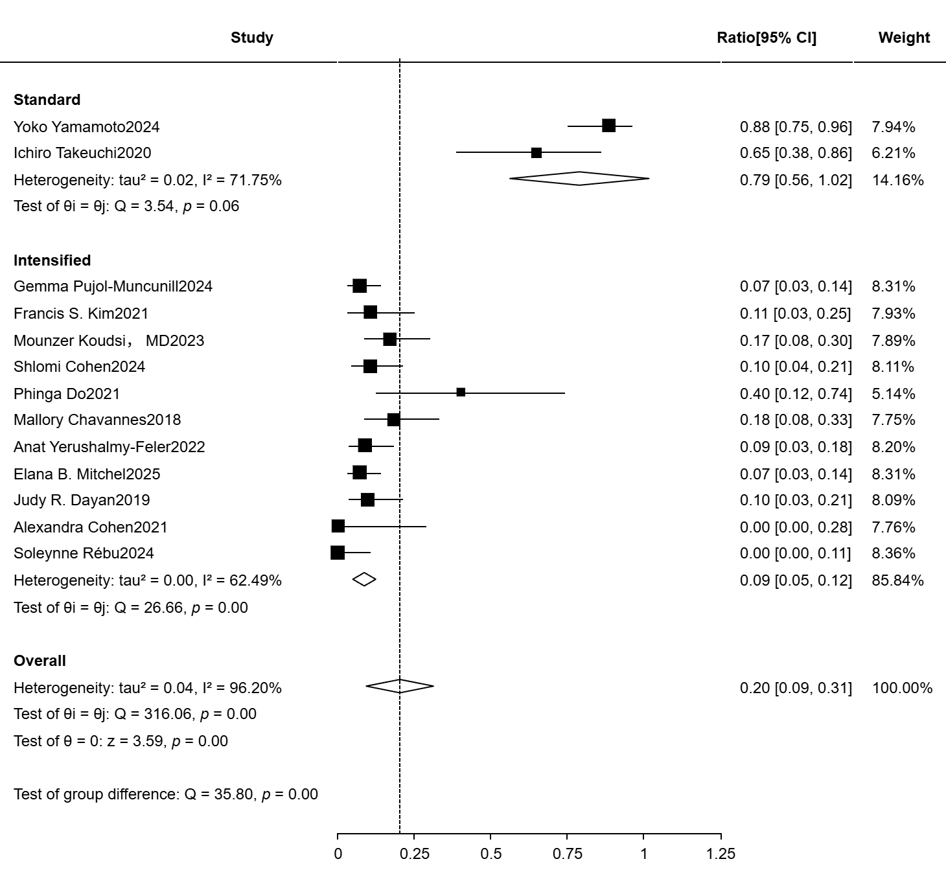
Figure S2 Pooled incidence rate of adverse events for Standard and Intensified subgroups
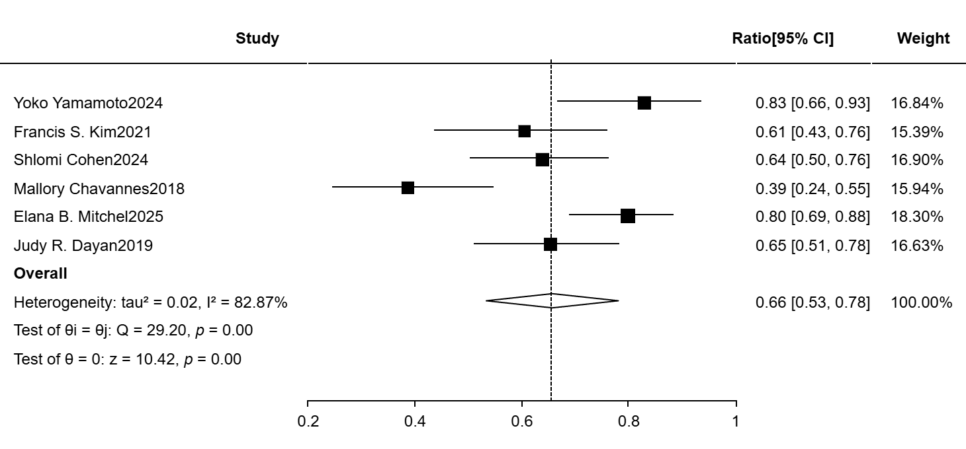
Figure S3 Sensitivity analysis of the 52-week clinical response rate

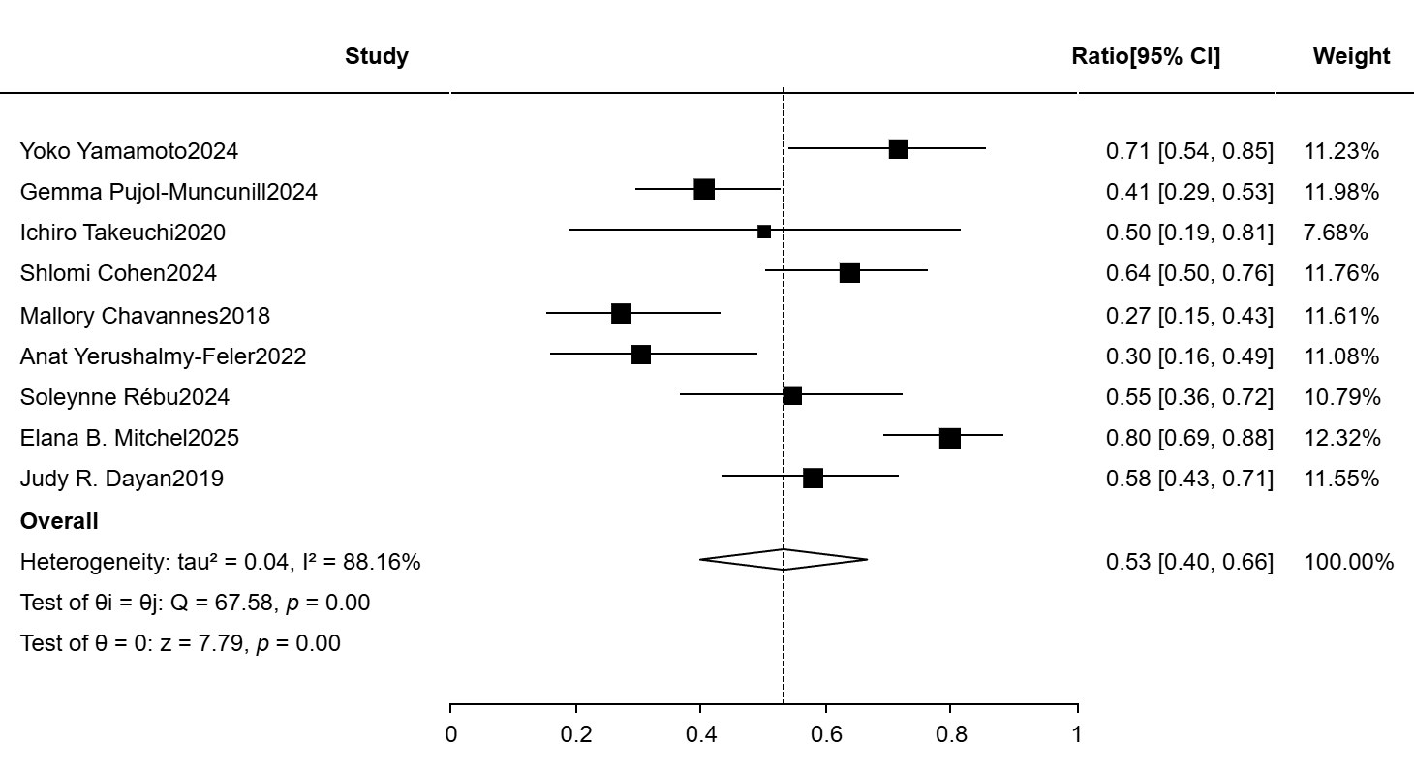
Figure S4 Sensitivity analysis of steroid-free clinical remission rate at week 52
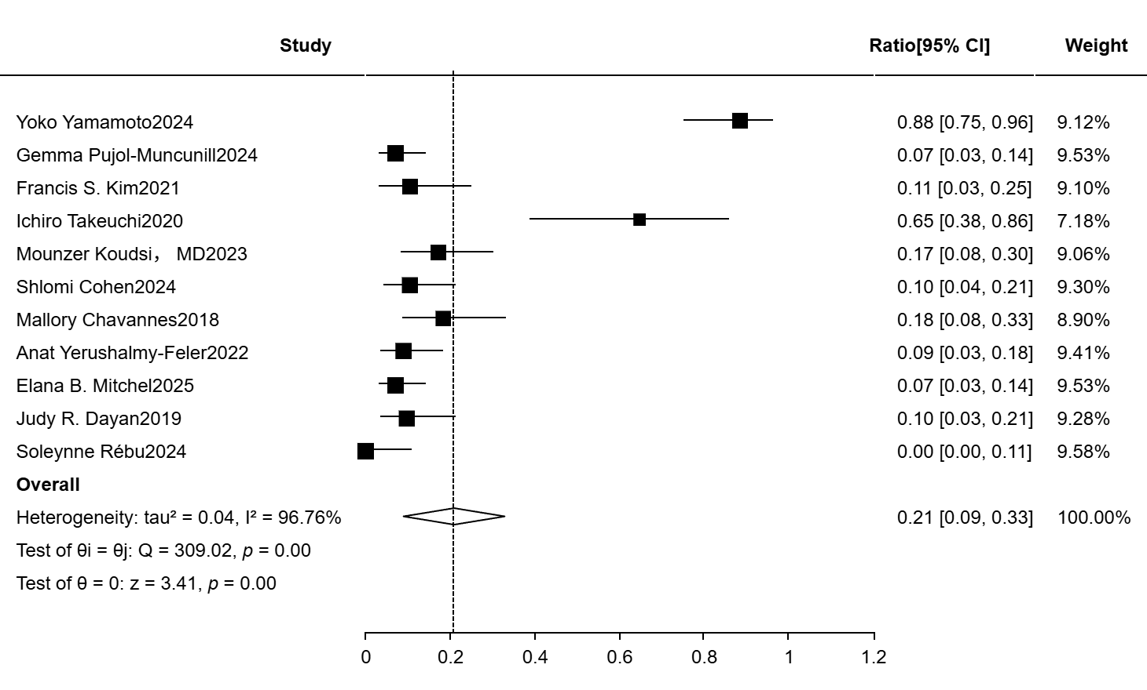
Figure S5 Sensitivity analysis of Pooled incidence rate of adverse events

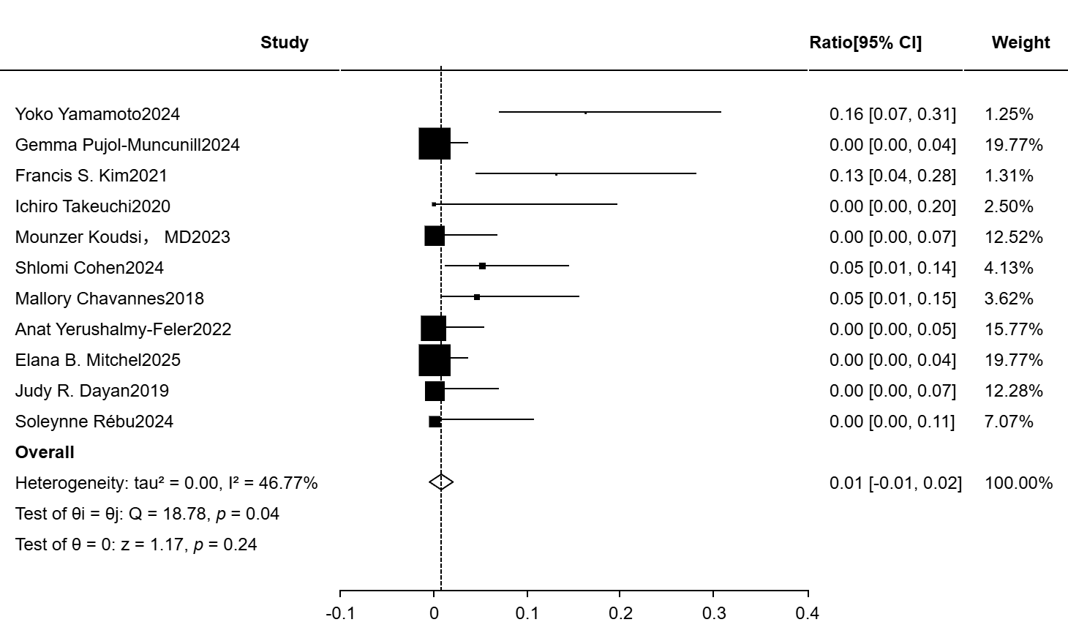
Figure S6 Sensitivity analysis of Pooled serious incidence rate of adverse events

