Supplementary figures.
Figure S1.High expression of FBXW8 was associated with poor prognosis. Kaplan–Meier survival curves of FBXW8 in (A) Age≤60, (B) Age>60, (C) BMI<=25, (D) BMI>25, (E) stage N0, (F) stage M0, (G) stage II and III (H) Asian, (I) Vascular invasion, (J) Weiht<=70, (K) Tumor free. OS, Overall Survival.
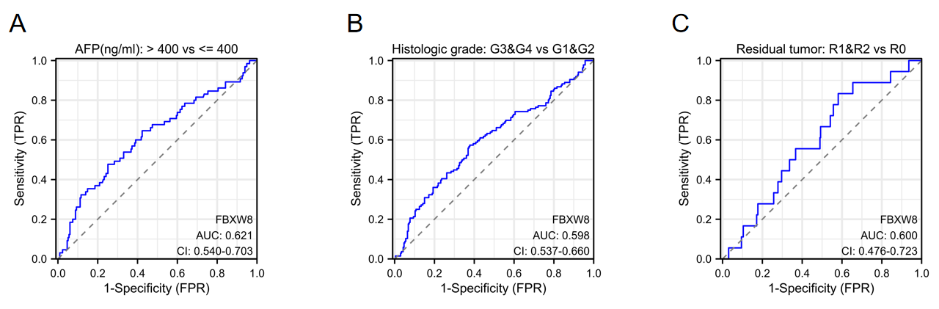

Figure S2. ROC validation of FBXW8 in clinicopathological features. Diagnostic ROC curves in (A) AFP, (B) Histologic grade, (C) Residual tumor.

Figure S3. Prognosis of FBXW8-related genes in hepatocellular carcinoma from the TCGA database. (A) CUL7, (B) RBX1, (C) SKP1, (D) CUL1,(E) GLMN, (F) OBSL1, (G) SKP2, (H) UBA3, (I) FBXO4, (J)IRS1, (K) DDB1, (L) BTRC, (M) TP53, (N) CCDC8, (O) CCND1. ns:p ≥ 0.05; *p < 0.05; **p < 0.01; ***p < 0.001.

Figure S4. FBXW8 promoted MHCC-97H cells proliferation, migration and invasion. (A). MHCC-97H cells were stably transfected with pBABE-3XFlag-FBXW8 or empty vector (pBABE-3XFlag) as control. The endogenous and exogenous expression levels of FBXW8 were detected by western blotting in MHCC-97H-FBXW8 by the indicated antibodies.. The Flag-tagged FBXW8 protein is indicated by an asterisk (*). (B). MHCC-97H-FBXW8 and control cells were seeded into 96-well plates. Cell proliferation was assessed using the CCK-8 assay at 24-hour intervals, starting from 24 hours after seeding. (C). MHCC-97H-FBXW8 and control cells were seeded into the upper chambers of 24-well Transwell plates. After 48 hours, cells that had migrated through the membrane were stained with crystal violet. Bar indicates 50μm.

