Supplementary material

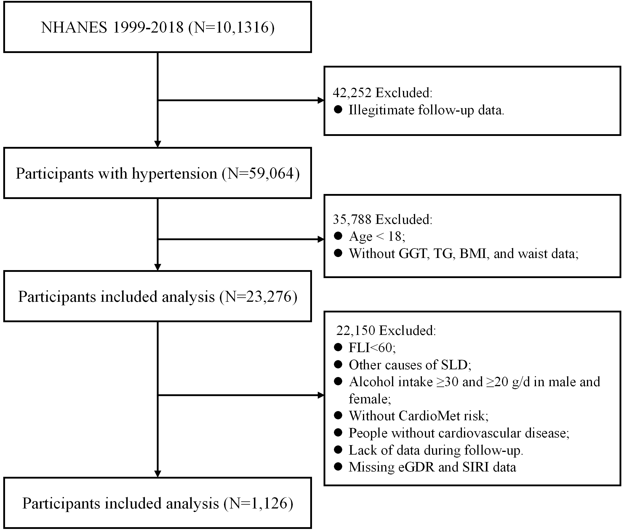
Figure S1. The flow chart of participants in the current study

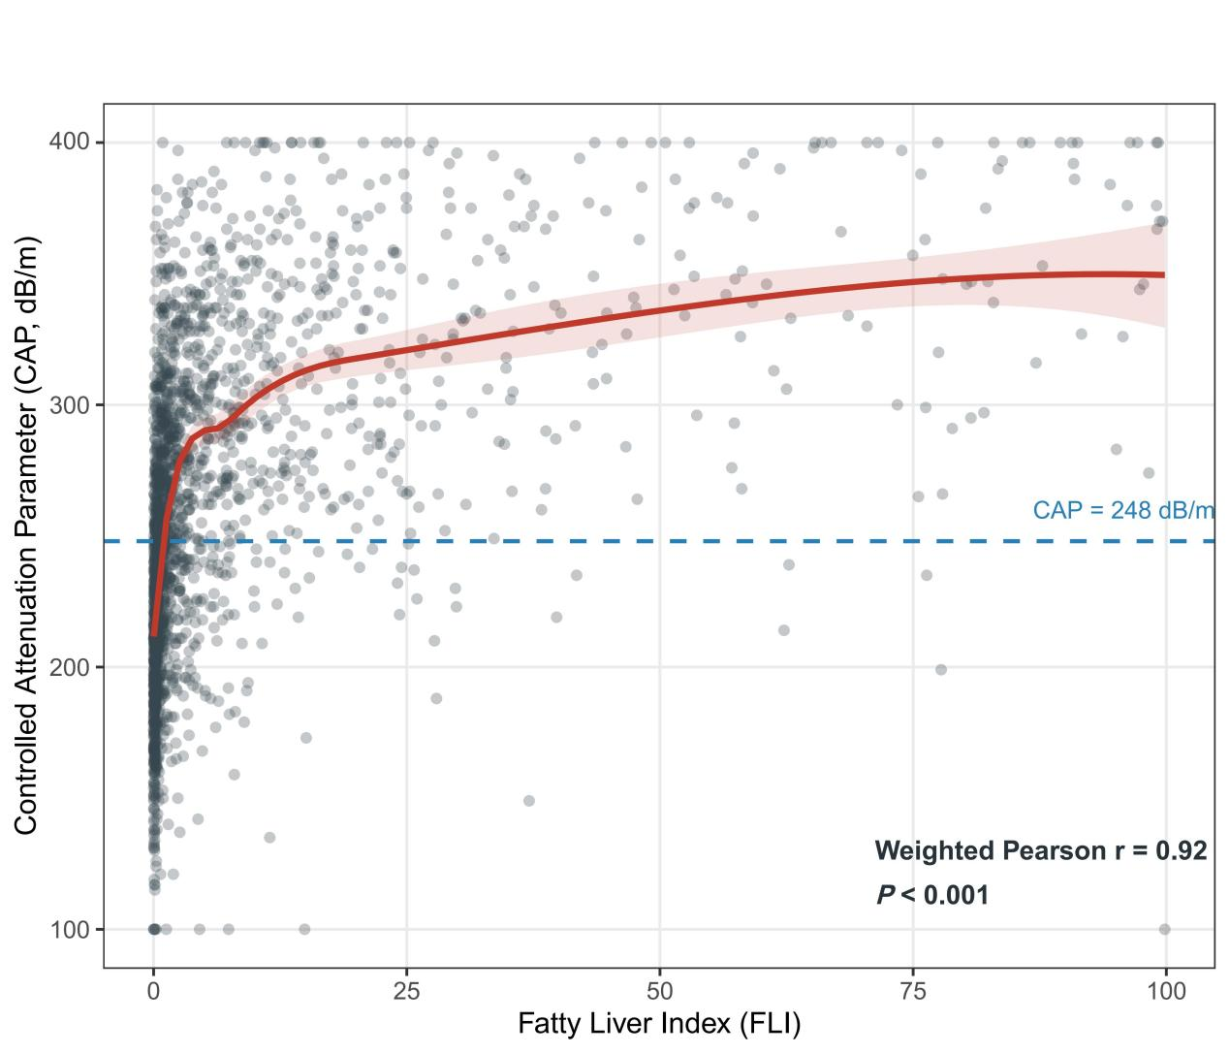
Figure S2. Correlation between FLI and CAP
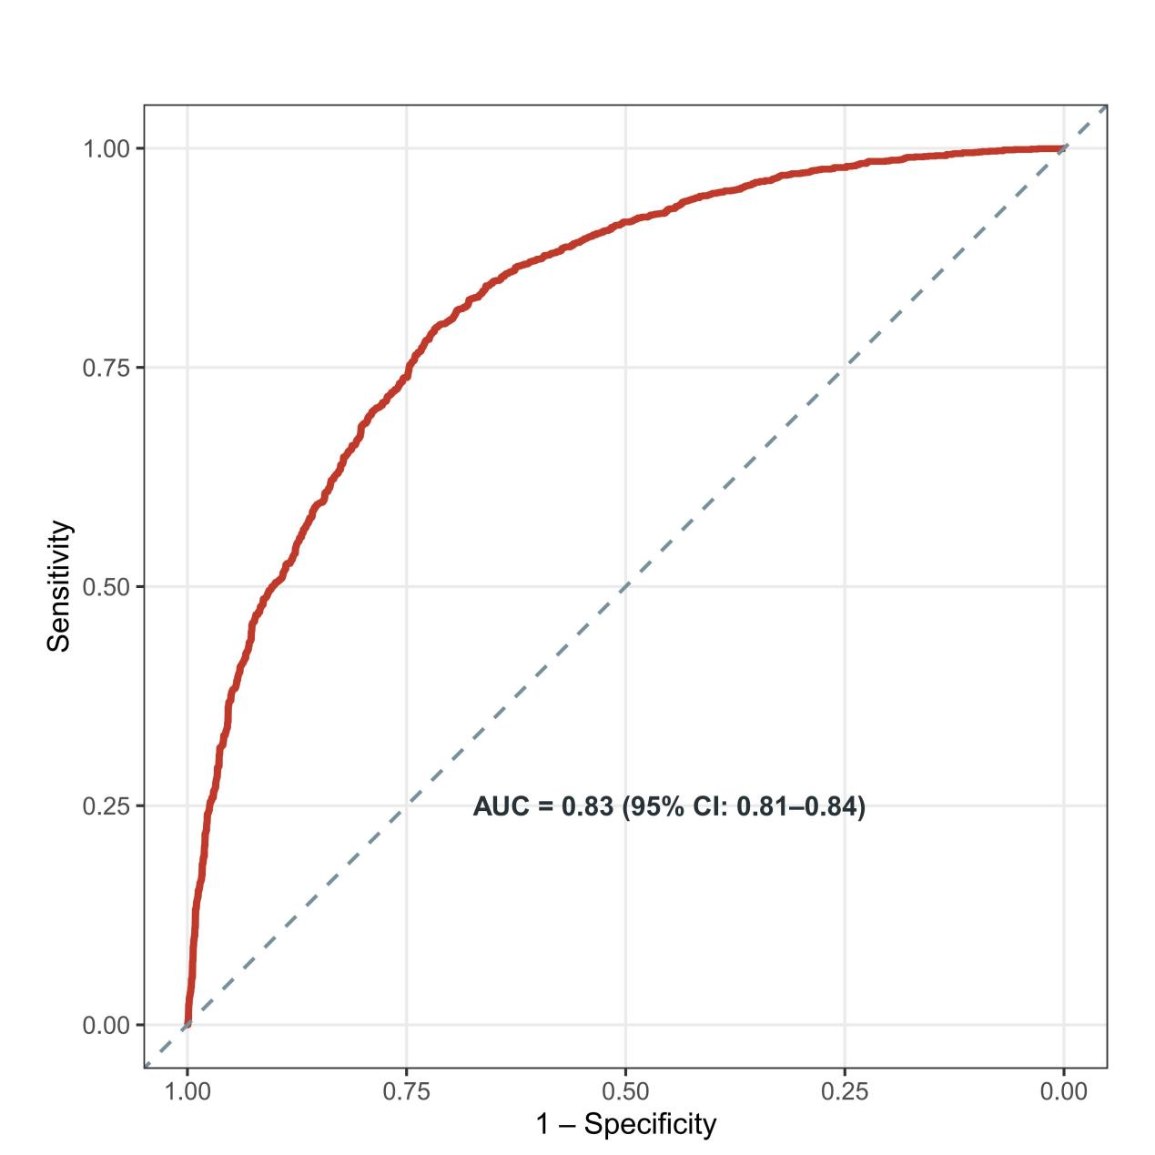
Figure S3. ROC Curve: FLI Predicting CAP−defined Steatosis

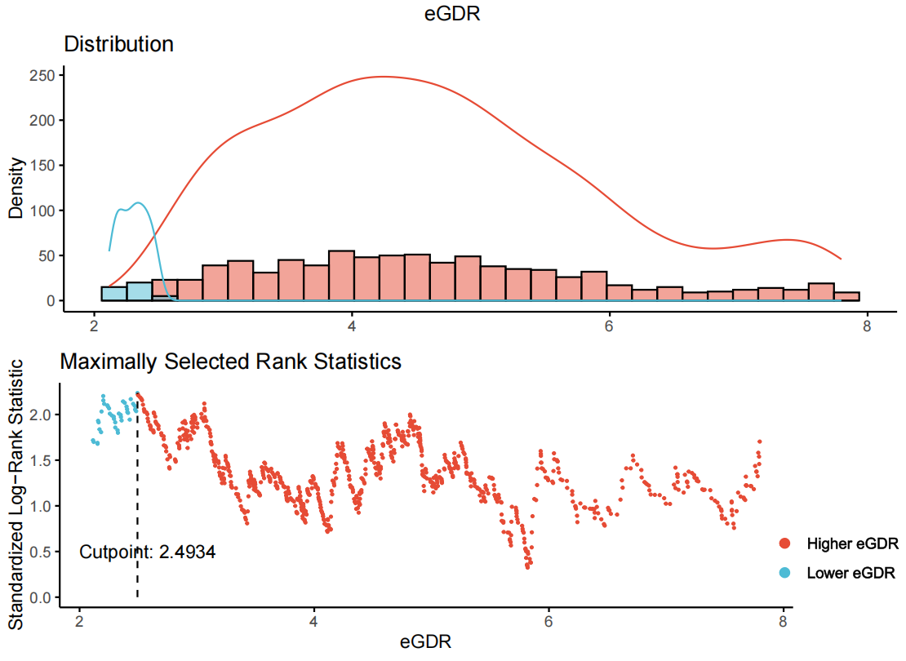
Figure S4. The eGDR cutoff value for cardiovascular mortality was determined using the maximally selected rank statistics method implemented in the maxstat package.

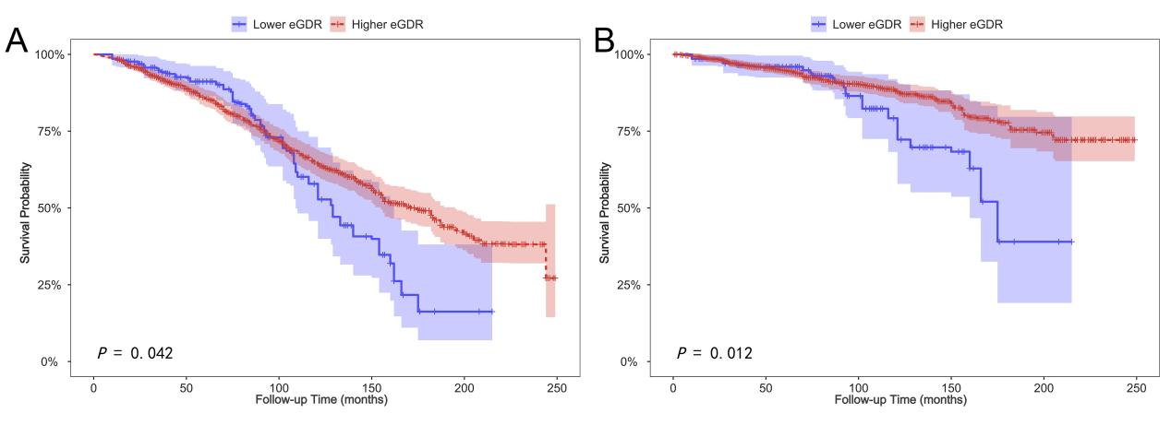
Figure S5. Kaplan-Meier survival curves. A: All-cause mortality; B: Cardiovascular mortality.

Table S1. Description of missing data
Variables | Deficiencies
Variables | N | %
Age | 0 | 0
BMI | 0 | 0
UA | 0 | 0
Sex | 0 | 0
Race | 0 | 0
Smoke | 0 | 0
eGDR | 0 | 0
SIRI | 0 | 0
Education | 1 | 0.1
Marital status | 6 | 0.5
eGFR | 93 | 8.3
PIR | 99 | 8.8
Drink | 140 | 12.4

Table S2. Bootstrap validation of the eGDR categorical analysis for cardiovascular mortality
Bootstrap Validation Metric | Value
Outcome used for cutoff optimization | Cardiovascular mortality
Bootstrap iterations | 1,000
Successful iterations | 968 (96.8%)
HR (Higher vs Lower eGDR)
Original estimate (Model 3) | 0.49 (95% CI: 0.23–1.03)
Bootstrap median | 0.455
Bootstrap 2.5th percentile | 0.349
Bootstrap 97.5th percentile | 0.854
Optimal Cutoff (mg/kg/min)
Original estimate | 2.49
Bootstrap median | 2.493
Bootstrap IQR | 2.436–4.816

Table S3. Effect of eGDR levels on all-cause mortality: adjusted hazard ratios from segmented Cox regression analysis
Inflection point | Adjusted HR (95% CI) | P-value
<5.5901 | 0.78 (0.66, 0.91) | 0.002
>5.5901 | 1.16 (0.99, 1.36) | 0.068
Log-likelihood ratio | <0.001

Table S4. Model 3 for assessing all-cause mortality risk: variance inflation factor and tolerance
Term | VIF | VIF_CI_low | VIF_CI_high | SE_factor | Tolerance | Tolerance_CI_low | Tolerance_CI_high
Gender | 1.378304 | 1.28093 | 1.509428 | 1.174012 | 0.7255296 | 0.6625026 | 0.7806829
Age | 1.413931 | 1.311902 | 1.549335 | 1.189088 | 0.7072483 | 0.6454382 | 0.7622523
Race | 1.41386 | 1.31184 | 1.549256 | 1.189058 | 0.7072836 | 0.6454711 | 0.762288
Education levels | 1.386107 | 1.287708 | 1.518159 | 1.177331 | 0.7214449 | 0.6586923 | 0.7765733
Marital status | 1.203595 | 1.130734 | 1.317064 | 1.097085 | 0.830844 | 0.7592648 | 0.884381
PIR | 1.319686 | 1.230139 | 1.444075 | 1.148776 | 0.757756 | 0.6924846 | 0.8129162
Smoke | 1.195305 | 1.123746 | 1.308244 | 1.0933 | 0.8366066 | 0.7643834 | 0.8898807
Drink | 1.24749 | 1.168046 | 1.364493 | 1.116911 | 0.8016094 | 0.7328728 | 0.856131
BMI | 1.167062 | 1.100139 | 1.27871 | 1.080306 | 0.8568525 | 0.7820383 | 0.908976
UA | 1.327903 | 1.237244 | 1.453208 | 1.152347 | 0.7530668 | 0.6881329 | 0.8082482
eGFR | 1.659352 | 1.526303 | 1.826035 | 1.288158 | 0.6026449 | 0.5476346 | 0.6551777

Table S5. Model 3 for assessing cardiovascular mortality risk: variance inflation factor and tolerance
Term | VIF | VIF_CI_low | VIF_CI_high | SE_factor | Tolerance | Tolerance_CI_low | Tolerance_CI_high
Gender | 1.388264 | 1.289582 | 1.520573 | 1.178246 | 0.7203242 | 0.6576467 | 0.775445
Age | 1.410049 | 1.308525 | 1.544982 | 1.187455 | 0.709195 | 0.6472566 | 0.7642195
Race | 1.399425 | 1.299284 | 1.533074 | 1.182973 | 0.714579 | 0.6522842 | 0.7696545
Education levels | 1.432215 | 1.327819 | 1.569856 | 1.196752 | 0.6982193 | 0.6370012 | 0.7531146
Marital status | 1.204604 | 1.131586 | 1.31814 | 1.097545 | 0.8301483 | 0.7586447 | 0.8837154
PIR | 1.347293 | 1.254029 | 1.474797 | 1.160729 | 0.7422291 | 0.6780593 | 0.7974295
Smoke | 1.17369 | 1.105647 | 1.285556 | 1.08337 | 0.8520137 | 0.7778734 | 0.9044476
Drink | 1.280773 | 1.196588 | 1.40101 | 1.131713 | 0.7807782 | 0.7137705 | 0.8357097
BMI | 1.149586 | 1.085733 | 1.260993 | 1.072187 | 0.8698787 | 0.7930257 | 0.9210364
UA | 1.347497 | 1.254206 | 1.475025 | 1.160817 | 0.7421166 | 0.6779547 | 0.7973171
eGFR | 1.669209 | 1.534937 | 1.837184 | 1.291979 | 0.5990861 | 0.5443112 | 0.6514926

Table S6. Association of eGDR with mortality risk after excluding the diabetic population
 | Crude |  | Model 1 |  | Model 2 |  | Model 3
 | HR (95% CI) | P-value | HR (95% CI) | P-value | HR (95% CI) | P-value | HR (95% CI) | P-value
All-cause mortality
eGDR
Continuous | 0.95 (0.86, 1.05) | 0.317 | 1.04 (0.92, 1.18) | 0.524 | 1.06 (0.93, 1.21) | 0.396 | 1.07 (0.92, 1.24) | 0.416
eGDR category
Lower eGDR | Ref |  | Ref |  | Ref |  | Ref
Higher eGDR | 0.97 (0.44, 2.16) | 0.942 | 0.65 (0.25, 1.72) | 0.386 | 0.70 (0.30, 1.64) | 0.409 | 0.55 (0.21, 1.42) | 0.215
Cardiovascular mortality
eGDR
Continuous | 0.81 (0.70, 0.94) | 0.007 | 0.82 (0.67, 1.01) | 0.065 | 0.83 (0.69, 1.00) | 0.046 | 0.78 (0.57, 1.06) | 0.111
eGDR category
Lower eGDR | Ref |  | Ref |  | Ref |  | Ref
Higher eGDR | 0.65 (0.16, 2.61) | 0.541 | 0.39 (0.08, 1.96) | 0.254 | 0.47 (0.12, 1.85) | 0.279 | 0.56 (0.11, 2.76) | 0.475
Crude, unadjusted; Model 1, adjusted for age and gender; Model 2, further adjusted for race, education level, marital status, and PIR based on Model 1; Model 3, additionally adjusted for smoking, drinking, BMI, UA, and eGFR based on Model 2.

Table S7. DM‑stratified association between eGDR and risk of death
Subgroup | HR (95% CI) | P-value |  | P for interaction
All-cause mortality
DM |  |  |  | 0.435
Yes | 0.94 (0.81, 1.10) | 0.431
No | 1.07 (0.91, 1.25) | 0.428
Cardiovascular mortality
DM |  |  |  | 0.060
Yes | 0.95 (0.72, 1.25) | 0.701
No | 0.78 (0.57, 1.06) | 0.115

Table S8. Association between eGDR and risk of death after excluding BMI
 | Crude |  | Model 1 |  | Model 2 |  | Model 3
 | HR (95% CI) | P-value | HR (95% CI) | P-value | HR (95% CI) | P-value | HR (95% CI) | P-value
All-cause mortality
eGDR
Continuous | 0.96 (0.90, 1.01) | 0.128 | 0.97 (0.91, 1.04) | 0.405 | 0.97 (0.91, 1.04) | 0.428 | 0.97 (0.90, 1.05) | 0.461
eGDR category
Lower eGDR | Ref |  | Ref |  | Ref |  | Ref
Higher eGDR | 0.77 (0.58, 1.01) | 0.062 | 0.57 (0.42, 0.78) | <0.001 | 0.59 (0.44, 0.80) | 0.001 | 0.69 (0.49, 0.95) | 0.025
Cardiovascular mortality
eGDR
Continuous | 0.91 (0.84, 0.98) | 0.017 | 0.91 (0.83, 1.00) | 0.054 | 0.90 (0.82, 0.99) | 0.029 | 0.91 (0.82, 1.00) | 0.054
eGDR category
Lower eGDR | Ref |  | Ref |  | Ref |  | Ref
Higher eGDR | 0.57 (0.36, 0.89) | 0.014 | 0.57 (0.42, 0.78) | <0.001 | 0.49 (0.28, 0.85) | 0.011 | 0.63 (0.33, 1.17) | 0.141
Crude, unadjusted; Model 1, adjusted for age and gender; Model 2, further adjusted for race, education level, marital status, and PIR based on Model 1; Model 3, additionally adjusted for smoking, drinking, UA, and eGFR based on Model 2.

Table S9. Incremental predictive value
 | C statistic | P value | NRI | P value | IDI | P value
All-cause mortality
Base model | 0.766 (0.733, 0.799) | < 0.001 | Ref |  | Ref
Base model+eGDR | 0.771 (0.738, 0.803) | < 0.001 | 0.162 (0.007, 0.225) | 0.040 | 0.003 (-0.003, 0.014) | 0.445
Base model+TyG | 0.768 (0.735, 0.800) | < 0.001 | 0.026 (-0.058, 0.108) | 0.439 | 0.001 (-0.005, 0.012) | 0.664
Cardiovascular mortality
Base model | 0.723 (0.671, 0.776) | < 0.001 | Ref |  | Ref
Base model+eGDR | 0.728 (0.676, 0.779) | < 0.001 | 0.100 (-0.098, 0.236) | 0.346 | 0.002 (-0.008, 0.021) | 0.771
Base model+TyG | 0.724 (0.672, 0.776) | < 0.001 | 0.061 (-0.092, 0.193) | 0.339 | 0.002 (-0.005, 0.024) | 0.631

Table S10. Association between TyG and mortality risk
 | Crude |  | Model 1 |  | Model 2 |  | Model 3
 | HR (95% CI) | P-value | HR (95% CI) | P-value | HR (95% CI) | P-value | HR (95% CI) | P-value
All-cause mortality
TyG
Continuous | 1.15 (0.93, 1.42) | 0.199 | 1.30 (1.05, 1.62) | 0.017 | 1.30 (1.03, 1.64) | 0.026 | 1.24 (0.96, 1.60) | 0.099
TyG maxstat category
Lower TyG | Ref |  | Ref |  | Ref |  | Ref
Higher TyG | 1.28 (0.94, 1.74) | 0.122 | 1.53 (1.17, 1.99) | 0.002 | 1.60 (1.20, 2.12) | 0.001 | 1.51 (1.12, 2.04) | 0.008
Cardiovascular mortality
TyG
Continuous | 1.38 (0.97, 1.97) | 0.070 | 1.58 (1.10, 2.28) | 0.013 | 1.54 (1.03, 2.29) | 0.035 | 1.51 (0.98, 2.31) | 0.060
TyG maxstat category
Lower TyG | Ref |  | Ref |  | Ref |  | Ref
Higher TyG | 1.51 (0.92, 2.48) | 0.100 | 1.77 (1.13, 2.76) | 0.012 | 1.74 (1.06, 2.88) | 0.030 | 1.83 (1.09, 3.09) | 0.023
Crude, unadjusted; Model 1, adjusted for age and gender; Model 2, further adjusted for race, education level, marital status, and PIR based on Model 1; Model 3, additionally adjusted for smoking, drinking, BMI, UA, and eGFR based on Model 2.

Table S11. Association of eGDR with mortality in the MASLD cohort defined by HSI
 | Crude |  | Model 1 |  | Model 2 |  | Model 3
 | HR (95% CI) | P-value | HR (95% CI) | P-value | HR (95% CI) | P-value | HR (95% CI) | P-value
All-cause mortality
eGDR
Continuous | 0.92 (0.88, 0.95) | <0.001 | 0.93 (0.89, 0.97) | 0.002 | 0.93 (0.88, 0.97) | 0.003 | 0.91 (0.84, 0.99) | 0.018
eGDR category
Q1 | Ref |  | Ref |  | Ref |  | Ref
Q2 | 0.96 (0.78, 1.18) | 0.697 | 0.73 (0.59, 0.91) | 0.005 | 0.73 (0.57, 0.93) | 0.01 | 0.58 (0.45, 0.74) | <0.001
Q3 | 0.75 (0.59, 0.96) | 0.024 | 0.58 (0.46, 0.73) | <0.001 | 0.56 (0.44, 0.72) | <0.001 | 0.43 (0.31, 0.59) | <0.001
Q4 | 0.60 (0.47, 0.76) | <0.001 | 0.64 (0.51, 0.81) | <0.001 | 0.65 (0.50, 0.84) | 0.001 | 0.53 (0.37, 0.77) | 0.001
eGDR maxstat category
Lower eGDR | Ref |  | Ref |  | Ref |  | Ref
Higher eGDR | 0.73 (0.48, 1.12) | 0.148 | 0.72 (0.60, 0.85) | <0.001 | 0.73 (0.60, 0.88) | 0.001 | 0.78 (0.61, 0.99) | 0.043
Cardiovascular mortality
eGDR
Continuous | 0.90 (0.85, 0.95) | <0.001 | 0.90 (0.84, 0.98) | 0.013 | 0.91 (0.84, 0.99) | 0.021 | 0.89 (0.77, 1.03) | 0.114
eGDR category
Q1 | Ref |  | Ref |  | Ref |  | Ref
Q2 | 1.10 (0.75, 1.61) | 0.625 | 0.83 (0.55, 1.27) | 0.394 | 0.82 (0.52, 1.28) | 0.379 | 0.68 (0.42, 1.11) | 0.119
Q3 | 0.82 (0.57, 1.17) | 0.273 | 0.64 (0.44, 0.91) | 0.014 | 0.61 (0.41, 0.90) | 0.013 | 0.48 (0.27, 0.85) | 0.012
Q4 | 0.57 (0.40, 0.83) | 0.003 | 0.63 (0.43, 0.92) | 0.018 | 0.66 (0.44, 0.97) | 0.035 | 0.53 (0.28, 0.99) | 0.047
eGDR maxstat category
Lower eGDR | Ref |  | Ref |  | Ref |  | Ref
Higher eGDR | 0.62 (0.48, 0.80) | <0.001 | 0.72 (0.56, 0.94) | 0.014 | 0.75 (0.56, 1.01) | 0.056 | 0.73 (0.48, 1.12) | 0.148
Crude, unadjusted; Model 1, adjusted for age and gender; Model 2, further adjusted for race, education level, marital status, and PIR based on Model 1; Model 3, additionally adjusted for smoking, drinking, BMI, UA, and eGFR based on Model 2.

