Revised Supplementary Appendix
Adjunctive Flupentixol–Melitracen for Patients Labelled as Having Refractory GERD in China
FINAL SUPPLEMENTARY APPENDIX. Complete search strategies, dates, hit counts, and screening results are reported for all eight databases.

Supplementary Table S1. Database search strategies, dates, hit counts, and screening results
Database | Full search strategy | Date | Hit count | Screening/audit status
PubMed | #1 "Gastroesophageal Reflux"[Mesh] OR gastroesophageal reflux disease[tiab] OR gastro-oesophageal reflux disease[tiab] OR GERD[tiab] OR GORD[tiab] OR reflux esophagitis[tiab] OR non-erosive reflux disease[tiab] OR NERD[tiab] OR refractory GERD[tiab] OR rGERD[tiab]; #2 flupentixol[tiab] OR flupenthixol[tiab] OR melitracen[tiab] OR melitracene[tiab] OR Deanxit[tiab] OR flupentixol-melitracen[tiab] OR flupenthixol-melitracen[tiab]; #3 randomized controlled trial[pt] OR controlled clinical trial[pt] OR randomized[tiab] OR randomly[tiab] OR trial[tiab] OR groups[tiab]; #4 animals[mh] NOT humans[mh]; #5 #1 AND #2 AND #3 NOT #4 | 28 Jul 2026 | 4 | No additional eligible study identified; included set unchanged.
Embase | ('gastroesophageal reflux disease'/exp OR 'gastroesophageal reflux disease':ti,ab OR 'gastro-oesophageal reflux disease':ti,ab OR GERD:ti,ab OR GORD:ti,ab OR 'reflux esophagitis':ti,ab OR 'non-erosive reflux disease':ti,ab OR NERD:ti,ab OR 'refractory GERD':ti,ab OR rGERD:ti,ab) AND (flupentixol:ti,ab OR flupenthixol:ti,ab OR melitracen:ti,ab OR melitracene:ti,ab OR Deanxit:ti,ab OR 'flupentixol-melitracen':ti,ab OR 'flupenthixol-melitracen':ti,ab) AND ('randomized controlled trial'/exp OR random*:ti,ab OR trial*:ti,ab OR group*:ti,ab) | 28 Jul 2026 | 5 | No additional eligible study identified; included set unchanged.
Cochrane Library | MeSH descriptor: [Gastroesophageal Reflux] explode all trees OR "gastroesophageal reflux disease" OR GERD OR GORD OR "reflux esophagitis" OR "non-erosive reflux disease" OR NERD OR "refractory GERD" OR rGERD; combined with flupentixol OR flupenthixol OR melitracen OR melitracene OR Deanxit OR flupentixol-melitracen; no additional trial filter beyond CENTRAL indexing | 28 Jul 2026 | 0 | No eligible record identified; included set unchanged.
Web of Science | TS=("gastroesophageal reflux disease" OR "gastro-oesophageal reflux disease" OR GERD OR GORD OR "reflux esophagitis" OR "non-erosive reflux disease" OR NERD OR "refractory GERD" OR rGERD) AND TS=(flupentixol OR flupenthixol OR melitracen OR melitracene OR Deanxit OR "flupentixol-melitracen" OR "flupenthixol-melitracen") AND TS=(random* OR trial* OR group*) | 28 Jul 2026 | 10 | No additional eligible study identified; included set unchanged.
CNKI | SU=(胃食管反流+胃食管返流+胃食管反流病+胃食管返流病+反流性食管炎+返流性食管炎+非糜烂性反流病+难治性胃食管反流+难治性胃食管反流病+GERD+rGERD) AND SU=(氟哌噻吨+美利曲辛+氟哌噻吨美利曲辛+氟哌噻吨美利曲辛片+氟哌噻吨美利曲辛胶囊+黛力新+Deanxit) | 28 Jul 2026 | 347 | Subject-field population-plus-intervention search without a trial-design filter. No additional eligible study identified.
Wanfang Data | (胃食管反流 OR 胃食管返流 OR 胃食管反流病 OR 胃食管返流病 OR 反流性食管炎 OR 返流性食管炎 OR 非糜烂性反流病 OR 难治性胃食管反流 OR 难治性胃食管反流病 OR GERD OR rGERD) AND (氟哌噻吨 OR 美利曲辛 OR 氟哌噻吨美利曲辛 OR 氟哌噻吨美利曲辛片 OR 氟哌噻吨美利曲辛胶囊 OR 黛力新 OR Deanxit) | 28 Jul 2026 | 448 | Theme-field population-plus-intervention search with fuzzy matching and no trial-design filter. No additional eligible study identified.
VIP Database | (胃食管反流 OR 胃食管返流 OR 胃食管反流病 OR 胃食管返流病 OR 反流性食管炎 OR 返流性食管炎 OR 非糜烂性反流病 OR 难治性胃食管反流 OR 难治性胃食管反流病 OR GERD OR rGERD) AND (氟哌噻吨 OR 美利曲辛 OR 氟哌噻吨美利曲辛 OR 氟哌噻吨美利曲辛片 OR 氟哌噻吨美利曲辛胶囊 OR 黛力新 OR Deanxit) | 28 Jul 2026 | 126 | Any-field population-plus-intervention search without a trial-design filter. No additional eligible study identified.
SinoMed | ((("胃食管反流"[全部字段] OR "Gastroesophageal Reflux"[全部字段] OR "胃酸反流"[全部字段] OR "胃酸反流病"[全部字段] OR "胃食管反流病"[全部字段] OR "GERD"[全部字段] OR "食管返流"[全部字段] OR "胃食管反流"[主题词]) OR "胃食管返流"[全部字段] OR "胃食管返流病"[全部字段] OR ("反流性食管炎"[全部字段] OR "消化性食管炎"[全部字段] OR "Peptic Esophagitis"[全部字段] OR "食管炎, 消化性"[主题词]) OR "返流性食管炎"[全部字段] OR "非糜烂性反流病"[全部字段] OR "难治性胃食管反流"[全部字段] OR "难治性胃食管反流病"[全部字段] OR "GERD"[全部字段] OR "rGERD"[全部字段]) AND (("氟哌噻吨"[全部字段] OR "Flupenthixol"[全部字段] OR "α-三氟噻吨"[全部字段] OR "顺-氟哌噻吨"[全部字段] OR "三氟噻吨"[全部字段] OR "复康素"[全部字段] OR "氟哌噻吨"[主题词]) OR "美利曲辛"[全部字段] OR "氟哌噻吨美利曲辛"[全部字段] OR "氟哌噻吨美利曲辛片"[全部字段] OR "氟哌噻吨美利曲辛胶囊"[全部字段] OR "黛力新"[全部字段] OR "Deanxit"[全部字段])) | 28 Jul 2026 | 363 | All-field search with subject/synonym expansion and no trial-design filter. No additional eligible study identified.
The PRISMA flow diagram reports the original search and study-selection process (478 records identified). All eight databases were updated through 28 July 2026, yielding 1,303 raw hits in total. The four Chinese database searches used a sensitive population-plus-intervention strategy without a trial-design filter. Chinese characters are retained only within the literal database search strings to preserve reproducibility. No additional study met the prespecified eligibility criteria, so the included study set and quantitative synthesis were unchanged.

Supplementary Table S2. Characteristics of the 29 retained trials
Study | FM/C | Diagnostic basis | Phenotype | Objective reflux confirmation | Psychological eligibility | Outcome instrument(s) | Intervention | Control | Duration | Background
Zong YY 2025 | 46/46 | Failure of at least 8 weeks of standard-dose PPI therapy. | Not specified. | No/unclear | No (anxiety/depression scales were used, but psychiatric comorbidity was not explicitly defined). | HAMA, HAMD | Flupentixol/melitracen, 1 tablet (flupentixol 0.5 mg plus melitracen 10 mg) bid (morning and noon) + mosapride 5 mg tid + PPI (esomeprazole 20 mg bid). | Mosapride 5 mg tid + PPI (esomeprazole 20 mg bid). | 4 weeks | PPI+prokinetic
Sun ZL 2024 | 50/50 | Symptoms did not improve after more than 8 weeks of conventional-dose PPI therapy. | NERD | No/unclear | Yes (anxiety and depression assessed using SAS and SDS). | SAS, SDS | Flupentixol/melitracen 20 mg/day, once in the morning and once in the evening + mosapride citrate 5 mg/day + rabeprazole sodium 20 mg/day. | Mosapride citrate 5 mg/day + rabeprazole sodium 20 mg/day. | 4 weeks | PPI+prokinetic
Lin HY 2023 | 48/48 | Reflux symptoms and esophageal mucosal injury did not improve substantially after 8-12 weeks of standard-dose PPI therapy. | unspecified | No/unclear | Yes (anxiety and depression assessed using HAMA and HAMD). | HAMA, HAMD | Esomeprazole enteric-coated tablet 40 mg qd + flupentixol/melitracen, 1 capsule bid (morning and noon). | Esomeprazole enteric-coated tablet 40 mg qd. | 4 weeks | PPI_only
Qiu F 2022 | 39/39 | Symptoms persisted after 4-8 weeks of standard-dose PPI therapy. | unspecified | No/unclear | No (severe psychiatric disease was explicitly excluded). | HAMD | Flupentixol/melitracen 10.5 mg bid after breakfast and lunch + esomeprazole 20 mg bid before breakfast and dinner. | Esomeprazole 20 mg bid before breakfast and dinner. | 2 months | PPI_only
Liu ML 2022 | 43/43 | Failure of conventional PPI therapy with SDS >=50 or SAS >=50. | unspecified | No/unclear | Yes (based on SAS and SDS). | HAMA, HAMD | Flupentixol/melitracen, 1 tablet bid (morning and noon) + domperidone 10 mg tid (15 min before meals) + rabeprazole 10 mg bid. | Domperidone 10 mg tid + rabeprazole 10 mg bid. | 4-8 weeks | PPI+prokinetic
Ma L 2021 | 29/29 | Met the Chinese Primary Care Guideline for GERD (2019); reflux esophagitis was diagnosed, gastroduodenal disease was excluded, and abnormal 24-h pH monitoring (DeMeester >14.72) or impedance monitoring was reported. | unspecified | Yes | No (severe cognitive impairment and other psychiatric disorders were excluded, but no scale-based assessment was used). | HAMD, RDQ | Flupentixol/melitracen, 1 tablet bid after breakfast and lunch + lansoprazole 30 mg bid before breakfast and at bedtime + itopride 100 mg bid before breakfast and at bedtime. | Lansoprazole 30 mg bid + itopride 100 mg bid. | 8 weeks | PPI+prokinetic
Jin YS 2021 | 55/55 | No substantial symptom relief after 8 weeks of regular PPI therapy; all participants had anxiety or depressive symptoms. | unspecified | No/unclear | Yes (based on SAS and SDS). | RDQ, SAS, SDS | Flupentixol/melitracen 0.5 mg bid + esomeprazole 20 mg bid (30 min before meals) + mosapride 5 mg tid (30 min before meals). | Esomeprazole 20 mg bid + mosapride 5 mg tid. | 4 weeks | PPI+prokinetic
Ya BY 2020 | 45/45 | Symptoms did not improve substantially after 8-12 weeks of PPI plus prokinetic therapy; defined as refractory NERD. | NERD | No/unclear | No (no scale-based or diagnostic criterion reported). | HAMA, RDQ | Omeprazole 20 mg bid + mosapride 5 mg tid + flupentixol/melitracen, 1 tablet bid. | Omeprazole 20 mg bid + mosapride 5 mg tid. | 8 weeks | PPI+prokinetic
Cai JY 2019 | 35/35 | Endoscopy-confirmed GERD with persistent symptoms despite at least 6 months of standard-dose PPI (esomeprazole 20 mg bid) plus prokinetic therapy (mosapride 5 mg tid); defined as refractory GERD. | unspecified | Yes | No (no psychiatric scale or diagnosis was used for eligibility; SAS/SDS were outcomes only). | RDQ, SAS, SDS | Esomeprazole 20 mg bid + mosapride 5 mg tid + flupentixol/melitracen 10.5 mg bid. | Esomeprazole 20 mg bid + mosapride 5 mg tid. | 8 weeks | PPI+prokinetic
Li S 2019 | 60/60 | Failure of 8-12 weeks of double-dose PPI therapy other than esomeprazole, followed by a switch to another regimen. | unspecified | No/unclear | Yes (anxiety assessed using HAMA). | HAMA | Esomeprazole 20 mg qd (30 min before breakfast) + flupentixol/melitracen, 1 tablet (0.5/10 mg) qd at 10:00 AM. | Esomeprazole 20 mg bid (30 min before breakfast and dinner). | 8 weeks | PPI_only
Song QW 2019 | 56/56 | No substantial improvement after at least 8 weeks of standard-dose PPI therapy, with RDQ >12, or extra-esophageal manifestations plus GERD confirmed by 24-h pH monitoring. | unspecified | No/unclear | Yes (all participants had mild-to-moderate anxiety and depression based on HAMA/HAMD). | HAMA, HAMD | Esomeprazole 20 mg bid + flupentixol/melitracen, 1 tablet bid after breakfast and lunch (up to 4 tablets/day if needed). | Esomeprazole 20 mg bid. | 8 weeks | PPI_only
Hou LL 2019 | 38/38 | GerdQ >=8 with inadequate response after 8 weeks of PPI therapy. | RE (erosive reflux esophagitis, endoscopic grade A-D). | No/unclear | No (patients with psychiatric abnormalities were excluded). | Not reported | Esomeprazole 20 mg bid + flupentixol/melitracen, 1 tablet (flupentixol 0.5 mg plus melitracen 10 mg) bid. | Esomeprazole 20 mg bid. | 8 weeks | PPI_only
Lin DL 2018 | 75/75 | Persistent symptoms after standard-dose PPI therapy (ilaprazole 10 mg/day); defined as refractory GERD. | unspecified | No/unclear | Yes (based on SAS and SDS). | SAS, SDS | Ilaprazole 10 mg/day + flupentixol/melitracen, 1 tablet (0.5 mg plus 10 mg) bid. | Ilaprazole 10 mg/day. | 4 weeks | PPI_only
Shi TF 2018 | 80/80 | Refractory GERD with RDQ >=16 and persistent symptoms after conventional PPI therapy. | unspecified | No/unclear | Yes (anxiety and depression assessed using SAS and SDS). | SAS, SDS | Esomeprazole 20 mg bid + mosapride citrate 5 mg tid + flupentixol/melitracen, 1 tablet bid (0.5 mg plus 10 mg per tablet). | Esomeprazole 20 mg bid + mosapride citrate 5 mg tid. | 8 weeks | PPI+prokinetic
Shi QS 2018 | 41/41 | Diagnosis based on history, clinical signs, endoscopy, and 24-h pH monitoring, with inadequate response to conventional treatment. | unspecified | Yes | No (organic psychiatric disease was excluded; no scale-based diagnosis was used). | SAS, SDS | Esomeprazole 20 mg bid + mosapride 5 mg tid + flupentixol/melitracen capsule, source-reported total capsule mass 0.1 g bid (active ingredients 0.5/10 mg per capsule). | Esomeprazole 20 mg bid + mosapride 5 mg tid. | 4 weeks | PPI+prokinetic
Gao HS 2018 | 37/37 | RDQ >=12 with persistent reflux symptoms after 4-8 weeks of standardized PPI therapy. | NERD + RE | No/unclear | No (severe psychiatric disease was excluded; no scale-based screening was used). | HAMD | Flupentixol/melitracen 20 mg qd + esomeprazole 20 mg qd. | Esomeprazole 20 mg qd. | 8 weeks | PPI_only
Liu DM 2018 | 36/36 | Symptoms did not resolve after conventional PPI (esomeprazole) plus prokinetic (mosapride) therapy. | unspecified | No/unclear | No. | HAMA, HAMD, RDQ | Esomeprazole 20 mg bid + mosapride 5 mg tid + flupentixol/melitracen (Deanxit) 10.5 mg bid. | Esomeprazole 20 mg bid + mosapride 5 mg tid. | 4 weeks | PPI+prokinetic
Guo LL 2018 | 47/47 | Met criteria for refractory GERD, RDQ >12, and disease duration >=6 months, with symptoms such as acid regurgitation, heartburn, and retrosternal burning. | NERD+RE | No/unclear | No (psychiatric disorders or psychiatric history were explicitly excluded). | HAMA, HAMD | Flupentixol/melitracen, source-reported 10 mg, 1 tablet bid + the same regimen as the control group. | Rabeprazole sodium enteric-coated tablet 20 mg bid + mosapride 5 mg bid (source text included an unclear “75 mg x 24 tablets” notation) + hydrotalcite 0.5 g tid. | 4 weeks | PPI+prokinetic+mucosal_protectant（≥1_add_on）
Wang GX 2018 | 180/180 | No substantial improvement after 8 weeks of double-dose PPI therapy; disease duration >6 months. | NERD | No/unclear | No (anxiety/depression scores were recorded, but patients with psychiatric or psychological disorders were excluded). | HAMA, HAMD, RDQ | Rabeprazole 20 mg qd + mosapride 5 mg tid + flupentixol/melitracen, 1 tablet bid. | Rabeprazole 20 mg qd + mosapride 5 mg tid. | 4 weeks | PPI+prokinetic
Zou YN 2018 | 55/55 | Unsatisfactory symptom improvement after 8 weeks of double-dose PPI therapy, with no pathological esophageal mucosal changes on endoscopy. | NERD | No/unclear | No (patients with a history of psychiatric disease were excluded). | RDQ | Conventional therapy (rabeprazole 10 mg bid + hydrotalcite 1 g tid + mosapride 5 mg tid) + flupentixol/melitracen, 1 tablet bid. | Rabeprazole 10 mg bid + hydrotalcite 1 g tid + mosapride 5 mg tid. | 8 weeks | PPI+prokinetic+mucosal_protectant
Zhao H 2017 | 65/65 | Symptoms were not relieved after at least 4 weeks of continuous medication; the report did not specify 8 weeks of double- or standard-dose PPI therapy but labelled participants as having refractory GERD. | unspecified | No/unclear | Yes (based on SAS and SDS). | SAS, SDS | Domperidone 10 mg bid + rabeprazole sodium enteric-coated tablet 10 mg bid + flupentixol/melitracen, 1 tablet bid. | Domperidone 10 mg bid + rabeprazole sodium enteric-coated tablet 10 mg bid. | 4 weeks | PPI+prokinetic
Zhang XL 2017 | 72/70 | No substantial improvement after 8-12 weeks of double-dose PPI therapy, GerdQ >=10, and HAMA >=7 and/or HAMD >=8. | unspecified | No/unclear | Yes (HAMA >=7 and/or HAMD >=8 was an explicit eligibility criterion). | HAMA, HAMD | Esomeprazole 20 mg bid + mosapride 5 mg tid + flupentixol/melitracen 10.5 mg bid. | Esomeprazole 20 mg bid + mosapride 5 mg tid. | 8 weeks | PPI+prokinetic
Liu F 2017 | 40/40 | Diagnosis based on clinical manifestations, imaging, and esophageal/gastric pH testing, with persistent symptoms after PPI therapy. | NERD (non-erosive reflux disease). | Yes | Yes (Hamilton anxiety and depression scores were both >7 at enrolment). | Not reported | Rabeprazole 10 mg bid + hydrotalcite 1 g tid + mosapride 5 mg tid + flupentixol/melitracen (flupentixol 0.5 mg plus melitracen 10 mg), 1 tablet bid. | Rabeprazole 10 mg bid + hydrotalcite 1 g tid + mosapride 5 mg tid. | 8 weeks | PPI+prokinetic+mucosal_protectant（≥1 add-on）
Xu Y 2016 | 48/48 | Unsatisfactory symptom improvement after 8 weeks of double-dose PPI therapy, with persistent reflux. | NERD | No/unclear | No (patients with a history of psychiatric disease were excluded). | HAMA, HAMD, RDQ | Esomeprazole 20 mg bid + mosapride 5 mg tid + Deanxit, 1 tablet bid. | Esomeprazole 20 mg bid + mosapride 5 mg tid. | 4 weeks | PPI+prokinetic
Zeng J 2016 | 45/45 | Unsatisfactory improvement with persistent reflux after at least 8 weeks of standard-dose PPI therapy. | unspecified | No/unclear | No (patients with a history of psychiatric disease were excluded). | HAMA, HAMD | Flupentixol/melitracen (Deanxit), 1 tablet orally bid + rabeprazole sodium enteric-coated tablet 10 mg qd in the morning. | Rabeprazole sodium enteric-coated tablet 10 mg qd in the morning. | 8 weeks | PPI_only
Wan CR 2016 | 58/57 | Poor symptom improvement after 8 weeks of conventional-dose PPI twice daily, with RDQ >12. | RE | No/unclear | No (psychiatric disease was excluded). | HAMA, HAMD | Flupentixol/melitracen (flupentixol 0.5 mg plus melitracen 10 mg per tablet), source-reported 20 mg qd after breakfast + esomeprazole 20 mg qd before breakfast. | Esomeprazole 20 mg qd before breakfast. | 4 weeks | PPI_only
Chen XF 2016 | 30/30 | GerdQ >=8 with persistent reflux symptoms after an inadequate response to 4-8 weeks of standard-dose PPI therapy. | EE, 18 participants; NERD, 42 participants. | No/unclear | Yes (psychiatric disease excluded; anxiety/depression assessed using HAMA/HAMD). | HAMA, HAMD | Flupentixol/melitracen 10.5 mg bid + esomeprazole magnesium 20 mg bid. | Esomeprazole magnesium 20 mg bid. | 8 weeks | PPI_only
Yang XY 2017 | 25/25 | No substantial clinical improvement after 8 weeks of lansoprazole therapy (symptom-score reduction <50%). | Not specified (all endoscopic examinations were negative). | No/unclear | Yes (HAMA >=7 and/or HAMD >=8 was required for eligibility). | HAMA, HAMD | Deanxit added to the control regimen, 1 tablet bid in the morning and at noon. | Lansoprazole 30 mg bid before meals + mosapride citrate 5 mg tid before meals. | 8 weeks | PPI+prokinetic
Yu YY 2014 | 146/143 | GerdQ >=8, endoscopic reflux esophagitis/Barrett's esophagus, or abnormal 24-h pH monitoring (pH <4 for >4% of the recording or DeMeester score >14.72). | Mixed (RE plus NERD; some participants not phenotyped). | No/unclear | Yes (anxiety/depression diagnosed using HADS >=8). | HADS-A, HADS-D | Esomeprazole 40 mg qd + flupentixol/melitracen 0.5/10 mg bid (1 tablet in the morning and evening). | Esomeprazole 40 mg qd | 2 weeks | PPI_only

Notes: “Objective reflux confirmation” was classified conservatively and required source-reported endoscopic/pathological GERD or abnormal reflux monitoring for the full population; endoscopy-negative status alone was not counted as confirmation. Zeng J 2016 was corrected to 45/45.

Supplementary Table S3. Risk-of-bias reconciliation
Study | Sequence | Concealment | Participants/personnel | Outcome assessor | Incomplete data | Selective reporting | Other
Zong YY 2025 | Low | Unclear | Unclear | Unclear | Low | Unclear | Unclear
Sun ZL 2024 | Low | Unclear | Unclear | Unclear | Low | Unclear | Unclear
Lin HY 2023 | Unclear | Unclear | Unclear | Unclear | Low | Unclear | Unclear
Qiu F 2022 | Unclear | Unclear | Unclear | Unclear | Low | Unclear | Unclear
Liu ML 2022 | Low | Unclear | Unclear | Unclear | Low | Unclear | Unclear
Ma L 2021 | Low | Unclear | Unclear | Unclear | Low | Unclear | Unclear
Jin YS 2021 | Low | Unclear | Unclear | Unclear | Low | Unclear | Unclear
Ya BY 2020 | Unclear | Unclear | Unclear | Unclear | Low | Unclear | Unclear
Cai JY 2019 | Low | Unclear | Unclear | Unclear | Low | Unclear | Unclear
Li S 2019 | Low | Unclear | Unclear | Unclear | Low | Unclear | Unclear
Song QW 2019 | Unclear | Unclear | Unclear | Unclear | Low | Unclear | Unclear
Hou LL 2019 | Low | Unclear | Unclear | Unclear | Low | Unclear | Unclear
Lin DL 2018 | Low | Unclear | Unclear | Unclear | Low | Unclear | Unclear
Shi TF 2018 | Unclear | Unclear | Unclear | Unclear | Low | Unclear | Unclear
Shi QS 2018 | Unclear | Unclear | Unclear | Unclear | Low | Unclear | Unclear
Gao HS 2018 | Unclear | Unclear | Unclear | Unclear | Low | Unclear | Unclear
Liu DM 2018 | Unclear | Unclear | Unclear | Unclear | Low | Unclear | Unclear
Guo LL 2018 | Low | Unclear | Unclear | Unclear | Low | Unclear | Unclear
Wang GX 2018 | Low | Unclear | Unclear | Unclear | Low | Unclear | Unclear
Zou YN 2018 | Unclear | Unclear | Unclear | Unclear | Low | Unclear | Unclear
Zhao H 2017 | Unclear | Unclear | Unclear | Unclear | Low | Unclear | Unclear
Zhang XL 2017 | Low | Unclear | Unclear | Unclear | Low | Unclear | Unclear
Liu F 2017 | Low | Unclear | Unclear | Unclear | Low | Unclear | Unclear
Xu Y 2016 | Unclear | Unclear | Low | Unclear | Low | Unclear | Unclear
Zeng J 2016 | Unclear | Unclear | Unclear | Unclear | Low | Unclear | Unclear
Wan CR 2016 | Low | Unclear | Unclear | Unclear | Low | Unclear | Unclear
Chen XF 2016 | Unclear | Unclear | Unclear | Unclear | Low | Unclear | Unclear
Yang XY 2017 | Low | Unclear | Low | Unclear | Unclear | Unclear | Unclear
Yu YY 2014 | Low | Unclear | Unclear | Low | Low | Unclear | Low

Sequence judgments were downgraded to unclear when the report only stated “randomly divided” without an adequate method. Xu 2016 and Yang 2017 reported double-blind methods; Yu 2014 reported blinded outcome assessment.

Supplementary Table S4. Trial-level total-effectiveness definitions
Study | Source-reported definition/threshold | Adjudication/blinding
Zong YY 2025 | Marked response: score reduction >80%; response: 50–80%; no response: <50%. | Generally unclear/unblinded
Sun ZL 2024 | Source categories: markedly effective/effective/ineffective; exact numeric threshold not reported. | Generally unclear/unblinded
Lin HY 2023 | Marked response: RDQ reduction >80%; response: 50–80%; no response: <50%. | Generally unclear/unblinded
Qiu F 2022 | Source categories: markedly effective/effective/ineffective; exact numeric threshold not extractable. | Generally unclear/unblinded
Liu ML 2022 | Composite clinical response reported; exact threshold not extractable from available text. | Generally unclear/unblinded
Ma L 2021 | Marked response: RDQ reduction >80%; response: 50–80%; no response: <50%. | Generally unclear/unblinded
Ya BY 2020 | Marked response: RDQ reduction 70% to <90%; response: 50% to <70%; no response: <50%. | Generally unclear/unblinded
Cai JY 2019 | Marked response: symptoms resolved or score reduction ≥80%; response: 50–80%; no response: <50%. | Generally unclear/unblinded
Li S 2019 | Marked response: mucosal inflammation resolved and symptom score reduction ≥80%; response: mucosal improvement and 50–80%; no response: <50% or worse. | Generally unclear/unblinded
Song QW 2019 | Marked response: clinical symptom score reduction >80%; response: 50–80%; no response: <50%. | Generally unclear/unblinded
Hou LL 2019 | Marked response: symptoms largely resolved and GerdQ reduction >80%; response: 50–80%; no response: <50%. | Generally unclear/unblinded
Lin DL 2018 | Composite improvement in clinical symptoms and sleep; no numeric threshold reported. | Generally unclear/unblinded
Shi TF 2018 | Marked response: symptoms resolved and RDQ reduction >80%; response: 50–80%; no response: <50%. | Generally unclear/unblinded
Shi QS 2018 | Marked response: reflux symptoms essentially resolved; response: clearly improved; no response: not improved. | Generally unclear/unblinded
Gao HS 2018 | Composite clinical response reported; exact threshold not extractable. | Generally unclear/unblinded
Liu DM 2018 | Marked response: symptoms resolved; response: symptoms improved; no response: unchanged/worse. | Generally unclear/unblinded
Guo LL 2018 | Marked/effective/ineffective categories reported; exact numeric threshold not extractable. | Generally unclear/unblinded
Wang GX 2018 | Marked response: efficacy index 70% to <90%; response: 50% to <70%; no response: <50%. | Generally unclear/unblinded
Zhao H 2017 | Marked response: symptoms largely resolved and RDQ reduction ≥80%; response: improvement and RDQ reduction >50%; no response: ≤50%. | Generally unclear/unblinded
Zhang XL 2017 | Marked response: GerdQ reduction ≥80%; response: ≥50%; no response: <50% or worse. | Generally unclear/unblinded
Xu Y 2016 | Marked response: symptoms resolved and RDQ reduction >80%; response: 50–80%; no response: <50%. | Generally unclear/unblinded
Zeng J 2016 | Composite clinical response reported; exact threshold not extractable from the available scan. | Generally unclear/unblinded
Wan CR 2016 | Marked/effective/ineffective categories reported; exact numeric threshold not extractable. | Generally unclear/unblinded
Chen XF 2016 | Marked response: symptoms resolved and GerdQ reduction >80%; response: 50–80%; no response: <50%. | Generally unclear/unblinded
Yang XY 2017 | Eligible A-versus-control comparison; study-reported total response; exact threshold not extractable from the available font-encoded report. | Generally unclear/unblinded
Yu YY 2014 | Complete remission: all symptoms absent and GerdQ=6; satisfactory control: symptoms ≤1/week using prespecified item thresholds. | Generally unclear/unblinded

Supplementary Table S5. Continuous arm-level inputs
Study | Domain | Scale | Measure | n FM | Mean FM | SD FM | n C | Mean C | SD C
Zong YY 2025 | Anxiety | HAMA | SMD | 46 | 7.54 | 0.21 | 46 | 14.27 | 1.31
Zong YY 2025 | Depression | HAMD | SMD | 46 | 7.16 | 0.63 | 46 | 15.43 | 1.33
Sun ZL 2024 | Anxiety | SAS | SMD | 50 | 30.28 | 4.15 | 50 | 45.25 | 5.14
Sun ZL 2024 | Depression | SDS | SMD | 50 | 31.15 | 4.71 | 50 | 43.29 | 4.55
Lin HY 2023 | Anxiety | HAMA | SMD | 48 | 6.15 | 0.64 | 48 | 14.28 | 1.57
Lin HY 2023 | Depression | HAMD | SMD | 48 | 7.13 | 0.76 | 48 | 15.73 | 1.74
Qiu F 2022 | Depression | HAMD | SMD | 39 | 8.45 | 1.21 | 39 | 12.42 | 2.56
Liu ML 2022 | Anxiety | HAMA | SMD | 43 | 4.17 | 1.26 | 43 | 7.36 | 2.15
Liu ML 2022 | Depression | HAMD | SMD | 43 | 6.38 | 1.74 | 43 | 10.03 | 2.65
Ma L 2021 | Depression | HAMD | SMD | 29 | 8.03 | 2.79 | 29 | 16.12 | 3.41
Ma L 2021 | RDQ | RDQ | MD | 29 | 6.72 | 2.11 | 29 | 10.25 | 2.19
Jin YS 2021 | Anxiety | SAS | SMD | 55 | 30.17 | 5.22 | 55 | 48.25 | 5.12
Jin YS 2021 | Depression | SDS | SMD | 55 | 31.10 | 5.75 | 55 | 49.82 | 5.38
Jin YS 2021 | RDQ | RDQ | MD | 55 | 5.32 | 1.25 | 55 | 11.10 | 1.33
Ya BY 2020 | Anxiety | HAMA | SMD | 45 | 8.73 | 0.95 | 45 | 13.12 | 1.18
Ya BY 2020 | RDQ | RDQ | MD | 45 | 1.71 | 0.42 | 45 | 3.03 | 0.57
Cai JY 2019 | Anxiety | SAS | SMD | 35 | 41.10 | 0.30 | 35 | 49.20 | 5.70
Cai JY 2019 | Depression | SDS | SMD | 35 | 43.80 | 5.80 | 35 | 50.20 | 5.70
Cai JY 2019 | RDQ | RDQ | MD | 35 | 5.10 | 0.40 | 35 | 7.10 | 1.00
Li S 2019 | Anxiety | HAMA | SMD | 60 | 6.41 | 1.17 | 60 | 8.55 | 1.32
Song QW 2019 | Anxiety | HAMA | SMD | 56 | 7.10 | 2.00 | 56 | 17.30 | 3.90
Song QW 2019 | Depression | HAMD | SMD | 56 | 8.40 | 2.80 | 56 | 23.40 | 3.70
Lin DL 2018 | Anxiety | SAS | SMD | 75 | 41.36 | 4.58 | 75 | 46.49 | 4.93
Lin DL 2018 | Depression | SDS | SMD | 75 | 42.72 | 5.11 | 75 | 48.62 | 5.48
Shi TF 2018 | Anxiety | SAS | SMD | 80 | 41.02 | 0.51 | 80 | 49.20 | 5.31
Shi TF 2018 | Depression | SDS | SMD | 80 | 43.62 | 5.64 | 80 | 50.27 | 5.99
Shi QS 2018 | Anxiety | SAS | SMD | 41 | 31.40 | 11.70 | 41 | 45.70 | 12.80
Shi QS 2018 | Depression | SDS | SMD | 41 | 32.80 | 8.90 | 41 | 50.30 | 12.40
Gao HS 2018 | Depression | HAMD | SMD | 37 | 7.02 | 2.31 | 37 | 10.67 | 3.51
Liu DM 2018 | Anxiety | HAMA | SMD | 36 | 10.13 | 5.37 | 36 | 18.64 | 10.58
Liu DM 2018 | Depression | HAMD | SMD | 36 | 10.63 | 6.78 | 36 | 24.26 | 10.51
Liu DM 2018 | RDQ | RDQ | MD | 36 | 5.20 | 2.01 | 36 | 11.69 | 3.78
Guo LL 2018 | Anxiety | HAMA | SMD | 47 | 5.55 | 2.30 | 47 | 16.73 | 2.61
Guo LL 2018 | Depression | HAMD | SMD | 47 | 8.63 | 2.53 | 47 | 20.55 | 3.86
Wang GX 2018 | Anxiety | HAMA | SMD | 180 | 8.16 | 1.12 | 180 | 14.25 | 2.01
Wang GX 2018 | Depression | HAMD | SMD | 180 | 10.01 | 1.38 | 180 | 16.37 | 2.08
Wang GX 2018 | RDQ | RDQ | MD | 180 | 6.28 | 0.83 | 180 | 9.17 | 1.27
Zou YN 2018 | RDQ | RDQ | MD | 55 | 6.27 | 1.76 | 55 | 12.53 | 1.38
Zhao H 2017 | Anxiety | SAS | SMD | 65 | 41.60 | 4.20 | 65 | 48.90 | 4.30
Zhao H 2017 | Depression | SDS | SMD | 65 | 42.50 | 4.50 | 65 | 49.50 | 5.00
Zhang XL 2017 | Anxiety | HAMA | SMD | 72 | 13.82 | 4.57 | 70 | 16.71 | 5.38
Zhang XL 2017 | Depression | HAMD | SMD | 72 | 10.41 | 4.37 | 70 | 14.93 | 4.71
Xu Y 2016 | Anxiety | HAMA | SMD | 48 | 8.56 | 3.34 | 48 | 17.42 | 6.13
Xu Y 2016 | Depression | HAMD | SMD | 48 | 11.63 | 3.73 | 48 | 20.10 | 6.28
Xu Y 2016 | RDQ | RDQ | MD | 48 | 6.10 | 4.74 | 48 | 10.35 | 6.65
Zeng J 2016 | Anxiety | HAMA | SMD | 45 | 9.22 | 6.37 | 45 | 17.36 | 9.78
Zeng J 2016 | Depression | HAMD | SMD | 45 | 10.11 | 7.21 | 45 | 23.66 | 12.38
Wan CR 2016 | Anxiety | HAMA | SMD | 58 | 5.00 | 6.00 | 57 | 8.00 | 6.00
Wan CR 2016 | Depression | HAMD | SMD | 58 | 4.00 | 5.00 | 57 | 6.00 | 5.00
Chen XF 2016 | Anxiety | HAMA | SMD | 30 | 7.70 | 2.30 | 30 | 16.20 | 3.70
Chen XF 2016 | Depression | HAMD | SMD | 30 | 8.60 | 2.40 | 30 | 24.30 | 3.10
Yang XY 2017 | Anxiety | HAMA | SMD | 25 | 13.80 | 6.29 | 25 | 15.87 | 6.52
Yang XY 2017 | Depression | HAMD | SMD | 25 | 11.48 | 6.54 | 25 | 15.85 | 6.62
Yu YY 2014 | Anxiety | HADS-A | SMD | 146 | 5.21 | 2.54 | 143 | 7.16 | 2.92
Yu YY 2014 | Depression | HADS-D | SMD | 146 | 4.53 | 1.84 | 143 | 6.56 | 2.92

All continuous models used post-treatment values. No change-score SMD was mixed with a post-treatment SMD.

Supplementary Table S6. Dichotomous arm-level inputs
Study | Outcome | Events FM | N FM | Events C | N C
Zong YY 2025 | Total effective rate | 41 | 46 | 33 | 46
Zong YY 2025 | Any adverse event | 4 | 46 | 8 | 46
Sun ZL 2024 | Total effective rate | 47 | 50 | 38 | 50
Sun ZL 2024 | Any adverse event | 3 | 50 | 4 | 50
Lin HY 2023 | Total effective rate | 45 | 48 | 30 | 48
Lin HY 2023 | Any adverse event | 4 | 48 | 8 | 48
Qiu F 2022 | Total effective rate | 39 | 39 | 31 | 39
Qiu F 2022 | Any adverse event | 1 | 39 | 1 | 39
Liu ML 2022 | Total effective rate | 38 | 43 | 29 | 43
Ma L 2021 | Total effective rate | 28 | 29 | 23 | 29
Ya BY 2020 | Total effective rate | 42 | 45 | 34 | 45
Cai JY 2019 | Total effective rate | 33 | 35 | 25 | 35
Li S 2019 | Total effective rate | 54 | 60 | 37 | 60
Li S 2019 | Any adverse event | 6 | 60 | 19 | 60
Song QW 2019 | Total effective rate | 53 | 56 | 45 | 56
Hou LL 2019 | Total effective rate | 35 | 38 | 29 | 38
Lin DL 2018 | Total effective rate | 73 | 75 | 64 | 75
Shi TF 2018 | Total effective rate | 75 | 80 | 65 | 80
Shi QS 2018 | Total effective rate | 39 | 41 | 31 | 41
Gao HS 2018 | Total effective rate | 35 | 37 | 27 | 37
Liu DM 2018 | Total effective rate | 33 | 36 | 26 | 36
Guo LL 2018 | Total effective rate | 45 | 47 | 37 | 47
Wang GX 2018 | Total effective rate | 159 | 180 | 122 | 180
Wang GX 2018 | Any adverse event | 8 | 180 | 14 | 180
Zou YN 2018 | Any adverse event | 5 | 55 | 4 | 55
Zhao H 2017 | Total effective rate | 63 | 65 | 55 | 65
Zhang XL 2017 | Total effective rate | 49 | 72 | 31 | 70
Xu Y 2016 | Total effective rate | 43 | 48 | 32 | 48
Zeng J 2016 | Total effective rate | 40 | 45 | 27 | 45
Zeng J 2016 | Any adverse event | 2 | 45 | 2 | 45
Wan CR 2016 | Total effective rate | 52 | 58 | 42 | 57
Chen XF 2016 | Total effective rate | 28 | 30 | 19 | 30
Yang XY 2017 | Total effective rate | 20 | 25 | 10 | 25
Yu YY 2014 | Total effective rate | 46 | 146 | 28 | 143

Supplementary Table S7. Trial-level adverse-event evidence
Study | FM events/N | Control events/N | What was counted | Ascertainment | Interval | Attribution
Zong YY 2025 | 4/46 | 8/46 | Somnolence, headache, decreased appetite, diarrhea | Incidence reported; active method not described | 4 weeks | Causality attribution NR
Sun ZL 2024 | 3/50 | 4/50 | Dry mouth, somnolence, nausea, headache | Incidence reported; active method not described | 4 weeks | Causality attribution NR
Lin HY 2023 | 4/48 | 8/48 | Somnolence, headache, abdominal discomfort | Treatment-period events counted; active method not described | 4 weeks | Causality attribution NR
Qiu F 2022 | 1/39 | 1/39 | One event per arm; source text incompletely identifies type | Method not described | 8 weeks | Causality attribution NR
Li S 2019 | 6/60 | 19/60 | Fatigue, dizziness, diarrhea | Recorded and analyzed during treatment | 8 weeks | Causality attribution NR
Wang GX 2018 | 8/180 | 14/180 | Types not separately extractable | Method not described | 4 weeks | Causality attribution NR
Zou YN 2018 | 5/55 | 4/55 | Types not reported | Method not described | 8 weeks | Causality attribution NR
Zeng J 2016 | 2/45 | 2/45 | Dry mouth and insomnia in adjunctive arm; dry mouth in control | Method not described | 8 weeks | Causality attribution NR

Event methods and attribution were mostly not reported. These data do not support a protective or definitive comparative safety inference.

Supplementary Table S8. Detailed exploratory subgroup analyses
Outcome | Variable | Level | k | N | Measure | Effect (95% CI) | I² (%) | Within-level P | Interaction P
Anxiety symptoms (all scales) | Scale | HAMA | 15 | 1675 | SMD | -2.66 (-3.48 to -1.84) | 97.5 | <0.001 | 0.322
Anxiety symptoms (all scales) | Scale | SAS | 7 | 802 | SMD | -2.08 (-2.71 to -1.45) | 92.5 | <0.001
Anxiety symptoms (all scales) | Scale | HADS-A | 1 | 289 | SMD | -0.71 (-0.95 to -0.47) | NR | NR
Anxiety symptoms (all scales) | duration_group | <=4 weeks | 13 | 1786 | SMD | -2.75 (-3.59 to -1.91) | 97.9 | <0.001 | 0.175
Anxiety symptoms (all scales) | duration_group | >4 weeks | 10 | 980 | SMD | -1.93 (-2.59 to -1.28) | 94.4 | <0.001
Anxiety symptoms (all scales) | background | PPI_plus_addon | 15 | 1734 | SMD | -2.52 (-3.23 to -1.82) | 96.7 | <0.001 | 0.499
Anxiety symptoms (all scales) | background | PPI_only | 8 | 1032 | SMD | -2.11 (-2.94 to -1.29) | 96.8 | <0.001
Anxiety symptoms (all scales) | psych_defined | no/NR | 10 | 1161 | SMD | -2.63 (-3.64 to -1.62) | 97.5 | <0.001 | 0.489
Anxiety symptoms (all scales) | psych_defined | yes | 13 | 1605 | SMD | -2.20 (-2.84 to -1.56) | 96.4 | <0.001
Anxiety symptoms (all scales) | rigorous_def | yes | 16 | 2052 | SMD | -2.60 (-3.34 to -1.85) | 97.7 | <0.001 | 0.296
Anxiety symptoms (all scales) | rigorous_def | no/unclear | 7 | 714 | SMD | -1.91 (-2.58 to -1.24) | 92.9 | <0.001
Anxiety symptoms (all scales) | objective_confirmed | no/unclear | 21 | 2614 | SMD | -2.47 (-3.06 to -1.87) | 97.2 | <0.001 | 0.373
Anxiety symptoms (all scales) | objective_confirmed | yes | 2 | 152 | SMD | -1.55 (-2.37 to -0.74) | 79.3 | <0.001
Depressive symptoms (all scales) | Scale | HAMD | 16 | 1675 | SMD | -2.77 (-3.54 to -2.00) | 97.1 | <0.001 | 0.127
Depressive symptoms (all scales) | Scale | SDS | 7 | 802 | SMD | -1.74 (-2.29 to -1.19) | 91.1 | <0.001
Depressive symptoms (all scales) | Scale | HADS-D | 1 | 289 | SMD | -0.83 (-1.07 to -0.59) | NR | NR
Depressive symptoms (all scales) | duration_group | <=4 weeks | 13 | 1786 | SMD | -2.68 (-3.46 to -1.89) | 97.6 | <0.001 | 0.220
Depressive symptoms (all scales) | duration_group | >4 weeks | 11 | 980 | SMD | -1.98 (-2.59 to -1.37) | 93.8 | <0.001
Depressive symptoms (all scales) | background | PPI_plus_addon | 15 | 1702 | SMD | -2.28 (-2.89 to -1.67) | 95.9 | <0.001 | 0.727
Depressive symptoms (all scales) | background | PPI_only | 9 | 1064 | SMD | -2.49 (-3.40 to -1.58) | 97.2 | <0.001
Depressive symptoms (all scales) | psych_defined | no/NR | 12 | 1281 | SMD | -2.30 (-3.07 to -1.53) | 96.5 | <0.001 | 0.788
Depressive symptoms (all scales) | psych_defined | yes | 12 | 1485 | SMD | -2.42 (-3.12 to -1.73) | 96.7 | <0.001
Depressive symptoms (all scales) | rigorous_def | yes | 16 | 1994 | SMD | -2.69 (-3.42 to -1.95) | 97.5 | <0.001 | 0.113
Depressive symptoms (all scales) | rigorous_def | no/unclear | 8 | 772 | SMD | -1.74 (-2.24 to -1.25) | 88.6 | <0.001
Depressive symptoms (all scales) | objective_confirmed | no/unclear | 21 | 2556 | SMD | -2.45 (-3.02 to -1.89) | 96.9 | <0.001 | 0.379
Depressive symptoms (all scales) | objective_confirmed | yes | 3 | 210 | SMD | -1.72 (-2.48 to -0.96) | 82.1 | <0.001
RDQ | duration_group | >4 weeks | 4 | 328 | MD | -3.26 (-5.17 to -1.35) | 98.8 | <0.001 | 0.269
RDQ | duration_group | <=4 weeks | 4 | 638 | MD | -4.84 (-6.93 to -2.76) | 97.7 | <0.001
RDQ | psych_defined | no/NR | 7 | 856 | MD | -3.71 (-4.89 to -2.54) | 98.2 | <0.001 | 0.206
RDQ | psych_defined | yes | 1 | 110 | MD | -5.78 (-6.26 to -5.30) | NR | NR
RDQ | rigorous_def | no/unclear | 3 | 200 | MD | -3.93 (-6.37 to -1.49) | 95.2 | 0.002 | 0.916
RDQ | rigorous_def | yes | 5 | 766 | MD | -4.08 (-5.85 to -2.31) | 99.1 | <0.001
RDQ | objective_confirmed | yes | 2 | 128 | MD | -2.67 (-4.16 to -1.18) | 85.0 | <0.001 | 0.294
RDQ | objective_confirmed | no/unclear | 6 | 838 | MD | -4.46 (-6.11 to -2.81) | 99.0 | <0.001
Total effective rate | duration_group | <=4 weeks | 12 | 1676 | RR | 1.23 (1.17 to 1.29) | 0.0 | <0.001 | 0.416
Total effective rate | duration_group | >4 weeks | 14 | 1266 | RR | 1.26 (1.20 to 1.33) | 0.0 | <0.001
Total effective rate | background | PPI_plus_addon | 15 | 1682 | RR | 1.24 (1.19 to 1.30) | 0.0 | <0.001 | 0.816
Total effective rate | background | PPI_only | 11 | 1260 | RR | 1.27 (1.19 to 1.36) | 22.2 | <0.001
Total effective rate | psych_defined | no/NR | 14 | 1447 | RR | 1.27 (1.21 to 1.33) | 0.0 | <0.001 | 0.295
Total effective rate | psych_defined | yes | 12 | 1495 | RR | 1.27 (1.18 to 1.36) | 42.5 | <0.001
Total effective rate | rigorous_def | yes | 18 | 2170 | RR | 1.27 (1.22 to 1.33) | 0.8 | <0.001 | 0.084
Total effective rate | rigorous_def | no/unclear | 8 | 772 | RR | 1.20 (1.13 to 1.27) | 0.0 | <0.001
Total effective rate | objective_confirmed | no/unclear | 23 | 2732 | RR | 1.25 (1.20 to 1.29) | 4.0 | <0.001 | 0.822
Total effective rate | objective_confirmed | yes | 3 | 210 | RR | 1.26 (1.12 to 1.42) | 0.0 | <0.001
Any adverse event | duration_group | <=4 weeks | 4 | 648 | RR | 0.56 (0.33 to 0.96) | 0.0 | 0.034 | 0.958
Any adverse event | duration_group | >4 weeks | 4 | 398 | RR | 0.61 (0.28 to 1.35) | 21.9 | 0.223
Any adverse event | background | PPI_plus_addon | 4 | 662 | RR | 0.67 (0.39 to 1.16) | 0.0 | 0.152 | 0.310
Any adverse event | background | PPI_only | 4 | 384 | RR | 0.43 (0.23 to 0.81) | 0.0 | 0.009
Any adverse event | psych_defined | no/NR | 5 | 730 | RR | 0.69 (0.40 to 1.21) | 0.0 | 0.194 | 0.243
Any adverse event | psych_defined | yes | 3 | 316 | RR | 0.42 (0.23 to 0.78) | 0.0 | 0.006

Twenty-four outcome–moderator interaction tests were performed. All are exploratory and unadjusted for multiplicity.

Supplementary Table S9. Sensitivity analyses
Outcome | Scenario | k | N | Measure | Effect (95% CI) | I² (%) | 95% PI | Excluded studies
Anxiety symptoms (all scales) | Main analysis | 23 | 2766 | SMD | -2.38 (-2.93 to -1.84) | 97.0 | -5.01 to 0.24 | None
Anxiety symptoms (all scales) | Strict rGERD definition only | 16 | 2052 | SMD | -2.60 (-3.34 to -1.85) | 97.7 | -5.61 to 0.41 | Liu ML 2022; Cai JY 2019; Lin DL 2018; Shi TF 2018; Shi QS 2018; Liu DM 2018; Guo LL 2018
Anxiety symptoms (all scales) | Objective testing required/reported for all participants | 2 | 152 | SMD | -1.55 (-2.37 to -0.74) | 79.3 | -2.86 to -0.25 | Zong YY 2025; Sun ZL 2024; Lin HY 2023; Liu ML 2022; Jin YS 2021; Ya BY 2020; Li S 2019; Song QW 2019; Lin DL 2018; Shi TF 2018; Liu DM 2018; Guo LL 2018; Wang GX 2018; Zhao H 2017; Zhang XL 2017; Xu Y 2016; Zeng J 2016; Wan CR 2016; Chen XF 2016; Yang XY 2017; Yu YY 2014
Anxiety symptoms (all scales) | Exclude studies with total sample <80 | 19 | 2514 | SMD | -2.57 (-3.20 to -1.95) | 97.4 | -5.31 to 0.16 | Cai JY 2019; Liu DM 2018; Chen XF 2016; Yang XY 2017
Anxiety symptoms (all scales) | Exclude standardized residual >2 | 21 | 2578 | SMD | -2.00 (-2.49 to -1.50) | 96.3 | -4.28 to 0.28 | Zong YY 2025; Lin HY 2023
HAMA | Main analysis | 15 | 1675 | SMD | -2.66 (-3.48 to -1.84) | 97.5 | -5.89 to 0.57 | None
HAMA | Strict rGERD definition only | 12 | 1423 | SMD | -2.73 (-3.69 to -1.77) | 97.8 | -6.14 to 0.68 | Liu ML 2022; Liu DM 2018; Guo LL 2018
HAMA | Exclude studies with total sample <80 | 12 | 1493 | SMD | -3.00 (-3.96 to -2.04) | 97.8 | -6.41 to 0.41 | Liu DM 2018; Chen XF 2016; Yang XY 2017
HAMA | Exclude standardized residual >2 | 13 | 1487 | SMD | -2.05 (-2.80 to -1.31) | 96.9 | -4.80 to 0.69 | Zong YY 2025; Lin HY 2023
SAS | Main analysis | 7 | 802 | SMD | -2.08 (-2.71 to -1.45) | 92.5 | -3.80 to -0.36 | None
SAS | Strict rGERD definition only | 3 | 340 | SMD | -2.77 (-3.95 to -1.59) | 93.4 | -5.06 to -0.48 | Cai JY 2019; Lin DL 2018; Shi TF 2018; Shi QS 2018
SAS | Objective testing required/reported for all participants | 2 | 152 | SMD | -1.55 (-2.37 to -0.74) | 79.3 | -2.86 to -0.25 | Sun ZL 2024; Jin YS 2021; Lin DL 2018; Shi TF 2018; Zhao H 2017
SAS | Exclude studies with total sample <80 | 6 | 732 | SMD | -2.10 (-2.82 to -1.38) | 93.7 | -3.96 to -0.25 | Cai JY 2019
SAS | Exclude standardized residual >2 | 7 | 802 | SMD | -2.08 (-2.71 to -1.45) | 92.5 | -3.80 to -0.36 | None
Depressive symptoms (all scales) | Main analysis | 24 | 2766 | SMD | -2.36 (-2.86 to -1.85) | 96.5 | -4.82 to 0.11 | None
Depressive symptoms (all scales) | Strict rGERD definition only | 16 | 1994 | SMD | -2.69 (-3.42 to -1.95) | 97.5 | -5.63 to 0.26 | Liu ML 2022; Ma L 2021; Cai JY 2019; Lin DL 2018; Shi TF 2018; Shi QS 2018; Liu DM 2018; Guo LL 2018
Depressive symptoms (all scales) | Objective testing required/reported for all participants | 3 | 210 | SMD | -1.72 (-2.48 to -0.96) | 82.1 | -3.13 to -0.31 | Zong YY 2025; Sun ZL 2024; Lin HY 2023; Qiu F 2022; Liu ML 2022; Jin YS 2021; Song QW 2019; Lin DL 2018; Shi TF 2018; Gao HS 2018; Liu DM 2018; Guo LL 2018; Wang GX 2018; Zhao H 2017; Zhang XL 2017; Xu Y 2016; Zeng J 2016; Wan CR 2016; Chen XF 2016; Yang XY 2017; Yu YY 2014
Depressive symptoms (all scales) | Exclude studies with total sample <80 | 17 | 2304 | SMD | -2.50 (-3.14 to -1.87) | 97.3 | -5.13 to 0.13 | Qiu F 2022; Ma L 2021; Cai JY 2019; Gao HS 2018; Liu DM 2018; Chen XF 2016; Yang XY 2017
Depressive symptoms (all scales) | Exclude standardized residual >2 | 21 | 2518 | SMD | -1.83 (-2.27 to -1.39) | 95.3 | -3.82 to 0.16 | Zong YY 2025; Lin HY 2023; Chen XF 2016
HAMD | Main analysis | 16 | 1675 | SMD | -2.77 (-3.54 to -2.00) | 97.1 | -5.87 to 0.34 | None
HAMD | Strict rGERD definition only | 12 | 1365 | SMD | -2.93 (-3.91 to -1.95) | 97.8 | -6.40 to 0.54 | Liu ML 2022; Ma L 2021; Liu DM 2018; Guo LL 2018
HAMD | Exclude studies with total sample <80 | 10 | 1283 | SMD | -3.12 (-4.21 to -2.03) | 98.0 | -6.67 to 0.43 | Qiu F 2022; Ma L 2021; Gao HS 2018; Liu DM 2018; Chen XF 2016; Yang XY 2017
HAMD | Exclude standardized residual >2 | 14 | 1487 | SMD | -2.19 (-2.87 to -1.50) | 96.3 | -4.78 to 0.40 | Zong YY 2025; Lin HY 2023
SDS | Main analysis | 7 | 802 | SMD | -1.74 (-2.29 to -1.19) | 91.1 | -3.23 to -0.26 | None
SDS | Strict rGERD definition only | 3 | 340 | SMD | -2.45 (-3.58 to -1.33) | 93.5 | -4.64 to -0.26 | Cai JY 2019; Lin DL 2018; Shi TF 2018; Shi QS 2018
SDS | Objective testing required/reported for all participants | 2 | 152 | SMD | -1.35 (-1.85 to -0.86) | 49.0 | -2.05 to -0.66 | Sun ZL 2024; Jin YS 2021; Lin DL 2018; Shi TF 2018; Zhao H 2017
SDS | Exclude studies with total sample <80 | 6 | 732 | SMD | -1.85 (-2.47 to -1.23) | 92.2 | -3.43 to -0.27 | Cai JY 2019
SDS | Exclude standardized residual >2 | 6 | 692 | SMD | -1.48 (-1.87 to -1.08) | 81.3 | -2.43 to -0.52 | Jin YS 2021
RDQ | Main analysis | 8 | 966 | MD | -4.01 (-5.27 to -2.74) | 98.6 | -7.67 to -0.35 | None
RDQ | Strict rGERD definition only | 5 | 766 | MD | -4.08 (-5.85 to -2.31) | 99.1 | -8.30 to 0.14 | Ma L 2021; Cai JY 2019; Liu DM 2018
RDQ | Objective testing required/reported for all participants | 2 | 128 | MD | -2.67 (-4.16 to -1.18) | 85.0 | -5.13 to -0.22 | Jin YS 2021; Ya BY 2020; Liu DM 2018; Wang GX 2018; Zou YN 2018; Xu Y 2016
RDQ | Exclude studies with total sample <80 | 5 | 766 | MD | -4.08 (-5.85 to -2.31) | 99.1 | -8.30 to 0.14 | Ma L 2021; Cai JY 2019; Liu DM 2018
RDQ | Exclude standardized residual >2 | 8 | 966 | MD | -4.01 (-5.27 to -2.74) | 98.6 | -7.67 to -0.35 | None
Total effective rate | Main analysis | 26 | 2942 | RR | 1.24 (1.20 to 1.29) | 0.0 | 1.20 to 1.29 | None
Total effective rate | Strict rGERD definition only | 18 | 2170 | RR | 1.27 (1.22 to 1.33) | 0.8 | 1.22 to 1.34 | Liu ML 2022; Ma L 2021; Cai JY 2019; Lin DL 2018; Shi TF 2018; Shi QS 2018; Liu DM 2018; Guo LL 2018
Total effective rate | Objective testing required/reported for all participants | 3 | 210 | RR | 1.26 (1.12 to 1.42) | 0.0 | 1.12 to 1.42 | Zong YY 2025; Sun ZL 2024; Lin HY 2023; Qiu F 2022; Liu ML 2022; Ya BY 2020; Li S 2019; Song QW 2019; Hou LL 2019; Lin DL 2018; Shi TF 2018; Gao HS 2018; Liu DM 2018; Guo LL 2018; Wang GX 2018; Zhao H 2017; Zhang XL 2017; Xu Y 2016; Zeng J 2016; Wan CR 2016; Chen XF 2016; Yang XY 2017; Yu YY 2014
Total effective rate | Exclude studies with total sample <80 | 18 | 2404 | RR | 1.24 (1.19 to 1.29) | 5.4 | 1.17 to 1.31 | Qiu F 2022; Ma L 2021; Cai JY 2019; Hou LL 2019; Gao HS 2018; Liu DM 2018; Chen XF 2016; Yang XY 2017
Total effective rate | Exclude standardized residual >2 | 26 | 2942 | RR | 1.24 (1.20 to 1.29) | 0.0 | 1.20 to 1.29 | None
Any adverse event | Main analysis | 8 | 1046 | RR | 0.55 (0.37 to 0.84) | 0.0 | 0.37 to 0.84 | None
Any adverse event | Strict rGERD definition only | 8 | 1046 | RR | 0.55 (0.37 to 0.84) | 0.0 | 0.37 to 0.84 | None
Any adverse event | Exclude studies with total sample <80 | 7 | 968 | RR | 0.55 (0.36 to 0.83) | 0.0 | 0.36 to 0.83 | Qiu F 2022
Any adverse event | Exclude standardized residual >2 | 8 | 1046 | RR | 0.55 (0.37 to 0.84) | 0.0 | 0.37 to 0.84 | None

Supplementary Table S10. Univariable meta-regression (exploratory)
Outcome | Moderator | k | Coefficient | 95% CI | P | Residual I² (%)
Anxiety symptoms (all scales) | duration_weeks | 23 | 0.137 | -0.142 to 0.417 | 0.335 | 97.1
Anxiety symptoms (all scales) | sample_total | 23 | 0.001 | -0.008 to 0.009 | 0.899 | 97.1
Depressive symptoms (all scales) | duration_weeks | 24 | 0.107 | -0.150 to 0.364 | 0.414 | 96.7
Depressive symptoms (all scales) | sample_total | 24 | 0.001 | -0.006 to 0.009 | 0.742 | 96.7
Total effective rate | duration_weeks | 26 | 0.006 | -0.012 to 0.023 | 0.518 | 0.0
Total effective rate | sample_total | 26 | 0.000 | -0.000 to 0.000 | 0.903 | 0.0

Only outcomes with at least 10 studies were modeled; six models were run. Non-significance does not demonstrate absence of a moderator.

Supplementary Table S11. Small-study-effect tests
Outcome | k | Egger z | P | Interpretation
Anxiety symptoms (all scales) | 23 | -6.777 | <0.001 | Interpret with heterogeneity; not a stand-alone publication-bias diagnosis
HAMA | 15 | -4.990 | <0.001 | Interpret with heterogeneity; not a stand-alone publication-bias diagnosis
Depressive symptoms (all scales) | 24 | -7.703 | <0.001 | Interpret with heterogeneity; not a stand-alone publication-bias diagnosis
HAMD | 16 | -5.521 | <0.001 | Interpret with heterogeneity; not a stand-alone publication-bias diagnosis
Total effective rate | 26 | 3.951 | <0.001 | Interpret with heterogeneity; not a stand-alone publication-bias diagnosis

Supplementary Table S12. GRADE summary
Outcome | k | N | Effect | RoB | Inconsistency | Indirectness | Imprecision | Small-study/reporting bias | Certainty
Total clinical effectiveness | 26 | 2942 | RR 1.24 (1.20 to 1.29) | Serious | Not serious | Serious | Not serious | Serious | Very low
Anxiety symptoms | 23 | 2766 | SMD −2.38 (−2.93 to −1.84) | Serious | Very serious | Serious | Not serious | Serious | Very low
Depressive symptoms | 24 | 2766 | SMD −2.36 (−2.86 to −1.85) | Serious | Very serious | Serious | Not serious | Serious | Very low
RDQ | 8 | 966 | MD −4.01 (−5.27 to −2.74) | Serious | Very serious | Serious | Not serious | Not assessable | Very low
Any adverse event | 8 | 1046 | RR 0.55 (0.37 to 0.84) | Serious | Not serious | Very serious | Serious | Not assessable | Very low

For anxiety and depression, the distinct contributing trial sets coincidentally total 2766 participants each.

Supplementary Table S13. Source-reconciliation audit
Study | Action | Source-level finding
Wang XF 2017 | Excluded | Source states allocation according to treatment plan (44 vs 42); not randomized.
Wang YZ 2013 | Excluded | The target article did not report random allocation; an unrelated adjacent article contained randomization wording.
Zeng J 2016 | Corrected | 90 participants (45/45), HAMA 9.22±6.37 vs 17.36±9.78; HAMD 10.11±7.21 vs 23.66±12.38; response 40/45 vs 27/45; adverse events 2/45 vs 2/45.
Shi QS 2018 | Dose clarified | One capsule bid; source-reported total capsule mass 0.1 g, containing flupentixol 0.5 mg + melitracen 10 mg per capsule.
Liu ML 2022 | Scale clarified | SAS/SDS were eligibility thresholds; HAMA/HAMD were outcome instruments.
Yang XY 2017 | Arm selection clarified | Eligible Deanxit-plus-background arm versus identical background control; other active co-intervention arms excluded.

Supplementary Table S14. Full-text reports excluded, with one primary reason for each exclusion
One primary exclusion reason is reported for each of the 37 full-text reports.

Report | Primary exclusion reason
1. Liu S, Dang X, Zhang K. Clinical study of a two-drug combination in patients with GERD. Bingtuan Medicine. 2025;23(2):24-28. | Not randomized: retrospective treatment-group analysis.
2. Yao W. Clinical effects of flupentixol-melitracen for gastroesophageal reflux with sleep disorder and somatic symptoms. Conference proceedings. 2024. | Conference-only report; full journal report and complete data were not available.
3. Chen Z. Banxia Xiexin decoction combined with flupentixol-melitracen for non-erosive gastroesophageal reflux disease. Chinese Medicine Modern Distance Education of China. 2024. | Ineligible intervention/comparison: the contrast evaluated an added traditional Chinese medicine regimen rather than the isolated adjunctive effect of flupentixol-melitracen.
4. Li L. Flupentixol-melitracen combined with mosapride for chronic gastritis with reflux esophagitis. Chinese Health Care. 2024. | Ineligible population: chronic gastritis with reflux esophagitis, not refractory GERD.
5. Sun Y, Zhong P. Flupentixol-melitracen combined with acupuncture of the dorsal Governor Vessel for GERD with sleep disorder. Chinese and Foreign Medical Research. 2024. | Ineligible intervention/comparison: acupuncture was the incremental treatment contrast.
6. Li D. Efficacy and safety of adjunctive flupentixol-melitracen for refractory GERD: a meta-analysis. Master's thesis, Chongqing Medical University. 2024. | Secondary research: systematic review/meta-analysis, not a primary randomized trial.
7. Ji J, Chang Y, Xu M, et al. Flupentixol-melitracen combined with vonoprazan for gastroesophageal reflux with obstructive sleep apnea. Guizhou Medical Journal. 2024;48(4). | Ineligible population: GERD with obstructive sleep apnea, not the prespecified refractory-GERD population.
8. Zeng Q. Flupentixol-melitracen for gastroesophageal reflux disease with sleep disorder. World Journal of Sleep Medicine. 2023. | Ineligible population: GERD with sleep disorder without a refractory-GERD definition.
9. Ji J, Xu M, Chang Y, et al. Proton-pump inhibitor plus flupentixol-melitracen for gastroesophageal reflux overlapping sleep disorder. Institutional research-result record. 2023. | Duplicate/overlapping report of the later Ji et al. clinical publication; the record was not treated as an independent trial.
10. Li H. Association between recurrence of gastroesophageal reflux disease and anxiety/depression. Master's thesis, Central South University. 2023. | Not randomized: observational association study.
11. Wang J, Li D. Flupentixol-melitracen combined with alprazolam for non-erosive GERD with anxiety. Systems Medicine. 2022. | Ineligible comparison: active psychotropic regimens differed between groups, so the isolated adjunctive effect of flupentixol-melitracen could not be estimated.
12. Li K, Lv Y, Yan M. Adjunctive flupentixol-melitracen for erosive reflux esophagitis with psychological disorder. Psychology Monthly. 2022;17(21):78-80. | Ineligible population: erosive reflux esophagitis with psychological disorder without a refractory-GERD definition.
13. Liu X. Flupentixol-melitracen plus a proton-pump inhibitor for chronic gastritis with reflux esophagitis. Journal of Chronic Diseases. 2022. | Ineligible population: chronic gastritis with reflux esophagitis, not refractory GERD.
14. Yi Y, Peng X, Zeng Y. Flupentixol-melitracen combined with esomeprazole for chronic gastritis with GERD. Journal of Medical Theory and Practice. 2022. | Ineligible population: chronic gastritis with GERD, not refractory GERD.
15. Feng X, Zhang Q, Gao H. Effects of flupentixol-melitracen on sleep quality and somatic symptoms in patients with gastroesophageal reflux. World Journal of Sleep Medicine. 2022. | Ineligible population: GERD with sleep/somatic symptoms without a refractory-GERD definition.
16. Xie Y, et al. Flupentixol-melitracen tablets combined with Shuganjieyu capsules for refractory GERD. 2021. | Ineligible comparison: flupentixol-melitracen was administered in both groups; the contrast evaluated the incremental effect of Shuganjieyu.
17. Lou B, Cui Y. Flupentixol-melitracen combined with mosapride for depressed non-erosive GERD. Modern Diagnosis and Treatment. 2020;31(12):1913-1915. | Ineligible comparison: the control received tandospirone, so the psychotropic treatment contrast was not adjunctive flupentixol-melitracen versus an identical background regimen.
18. Wang P, Liu Z. Flupentixol-melitracen combined with pantoprazole for non-erosive GERD. Modern Diagnosis and Treatment. 2020;31(12):1895-1896. | Ineligible population: non-erosive GERD without a refractory-treatment definition.
19. Qi J, Liu J, Zhou X, et al. Sheng Yang Yi Wei needling for gastroesophageal reflux disease. Shanghai Journal of Acupuncture and Moxibustion. 2020;39(4):396-400. | Ineligible comparison: acupuncture was compared with rabeprazole plus flupentixol-melitracen; the study did not isolate the adjunctive drug effect.
20. Liao W, Xu L. Conventional therapy plus Kangfuxin solution and flupentixol-melitracen for elderly reflux esophagitis. World Chinese Journal of Digestology. 2019;27(9):598-604. | Ineligible intervention/comparison: two additional active components differed between groups, so the isolated adjunctive drug effect could not be estimated.
21. Zhao Q, Bai X. Acupuncture of the dorsal Governor Vessel for reflux and psychological symptoms in GERD. Journal of Nanjing University of Traditional Chinese Medicine. 2017. | Ineligible comparison: acupuncture was compared with omeprazole plus flupentixol-melitracen.
22. Chen X, Chen X, Liang H. Adjunctive Deanxit for gastroesophageal reflux disease with sleep disorder. Sichuan Medical Journal. 2016;37(4):422-425. | Ineligible population: GERD with sleep disorder without a refractory-GERD definition.
23. Ma C, Li C, Qian S, et al. Acupuncture combined with Deanxit for refractory GERD. Journal of Sichuan of Traditional Chinese Medicine. 2016;(3):179-181. | Ineligible intervention/comparison: acupuncture was part of the treatment contrast.
24. Ma C, Li C, Qian S, et al. Heat-clearing and warming acupuncture combined with Deanxit for gastroesophageal reflux. Shaanxi Journal of Traditional Chinese Medicine. 2016;(3):355-356. | Ineligible intervention/comparison: acupuncture was part of the treatment contrast.
25. Huang H. Rabeprazole combined with Deanxit for non-erosive GERD. China Foreign Medical Treatment. 2016;35(35):124-126. | Ineligible population: non-erosive GERD without a refractory-treatment definition.
26. Wang Y, Wang D, Shen R, Lu H, Zhang X. Flupentixol-melitracen combined with mosapride and rabeprazole for reflux esophagitis. World Chinese Journal of Digestology. 2016;24(18):2881-2885. | Ineligible population: reflux esophagitis without a refractory-treatment definition.
27. Li X, Shi D, Zhang C, Liang J. Psychological status and adjunctive Deanxit treatment in elderly patients with reflux esophagitis. Journal of International Psychiatry. 2016;43(5):879-881. | Ineligible population: elderly reflux esophagitis with anxiety/depression without a refractory-GERD definition.
28. Zhang J, Jin H, Liu D, Huang T, Wu X. Flupentixol-melitracen combined with rabeprazole for reflux esophagitis. China Pharmacy. 2015;26(6):734-736. | Ineligible population: reflux esophagitis without a refractory-treatment definition.
29. Zhang X, Liu H, Wang W. Epidemiological characteristics of proton-pump-inhibitor-refractory GERD. Medical Journal of the Chinese People's Armed Police Forces. 2015;26(4):376-378. | Not randomized: epidemiological/observational study.
30. Meta-analysis of flupentixol-melitracen combined with other drugs for non-erosive GERD. Herald of Medicine. 2015;34(5). doi:10.3870/yydb.2015.05.025. | Secondary research: meta-analysis, not a primary randomized trial.
31. Sun Q, Yao H. Rabeprazole combined with flupentixol-melitracen for non-erosive GERD. Journal of Shanghai Jiao Tong University (Medical Science). 2014. doi:10.3969/j.issn.1674-8115.2014.03.019. | Ineligible population: non-erosive GERD without a refractory-treatment definition.
32. Jiang Q, Chen Y, Wang A, Luo Z. Aluminum magnesium carbonate, esomeprazole and Deanxit for GERD: an analysis of 60 cases. World Chinese Journal of Digestology. 2013;21(23):2331-2334. | Ineligible comparison: Deanxit was present in all treatment groups, so the isolated adjunctive effect of Deanxit could not be estimated.
33. Ji X, Huang W, Cheng L, Pan C. Flupentixol-melitracen combined with esomeprazole for non-erosive GERD. China Pharmacy. 2013;24(8):711-713. | Ineligible population: non-erosive GERD without a refractory-treatment definition.
34. Wang S, Zhang L, Liu Y, et al. Deanxit combined with a proton-pump inhibitor for GERD with laryngopharyngeal symptoms. Journal of Gastroenterology and Hepatology. 2013;22(12):1192-1194. | Ineligible population: GERD with laryngopharyngeal symptoms without a refractory-GERD definition.
35. Wang G, Cheng Y, Cao H, et al. Psychological disorders in 88 patients with refractory GERD. Conference proceedings of the Chinese Society of Traditional Chinese Medicine. 2011. | Not randomized: cross-sectional psychological assessment.
36. Tang Y, Zhu Y, Wu W. Anxiety, depression and quality of life in refractory GERD and associated factors. Jilin Medical Journal. 2022;43(12):3349-3352. | Not randomized: cross-sectional survey.
37. Zhang X, Liang Y, et al. Modified Xiaoyao Zhizhu powder for liver-depression/spleen-deficiency refractory GERD. Xinjiang Journal of Traditional Chinese Medicine. 2026;44(1):17-20. | Ineligible intervention/comparison: the trial evaluated a traditional Chinese medicine intervention and did not isolate adjunctive flupentixol-melitracen.

Supplementary Figures S1–S9. Revised forest plots
Supplementary Figure S1. Anxiety symptoms.
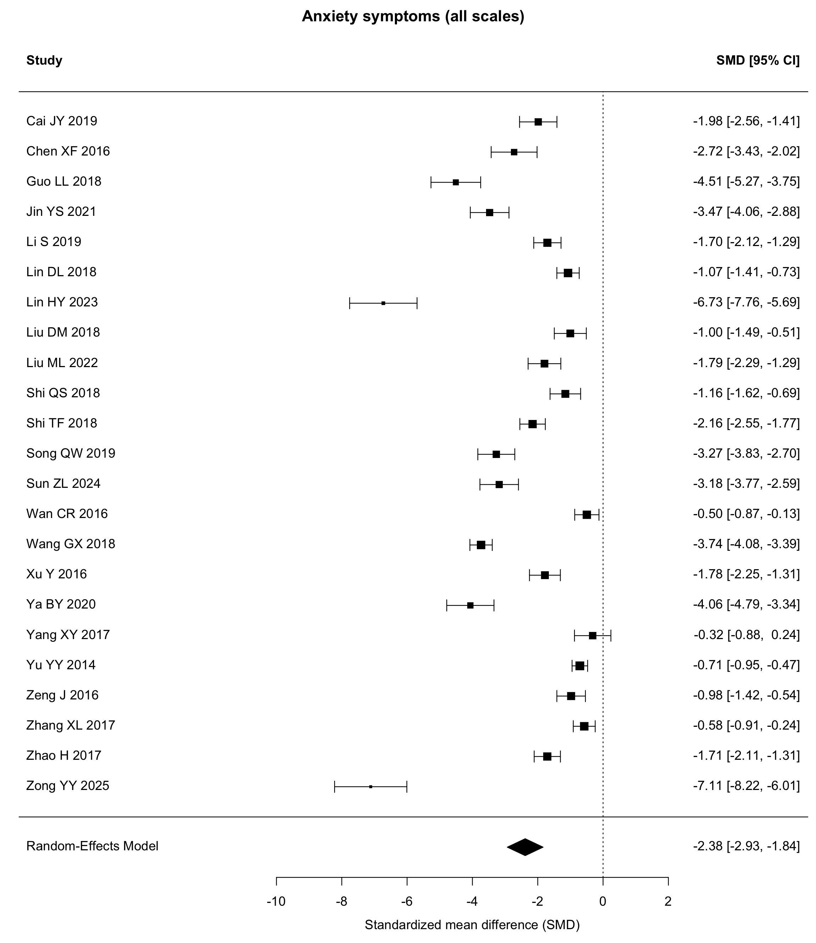
Supplementary Figure S2. Depressive symptoms.
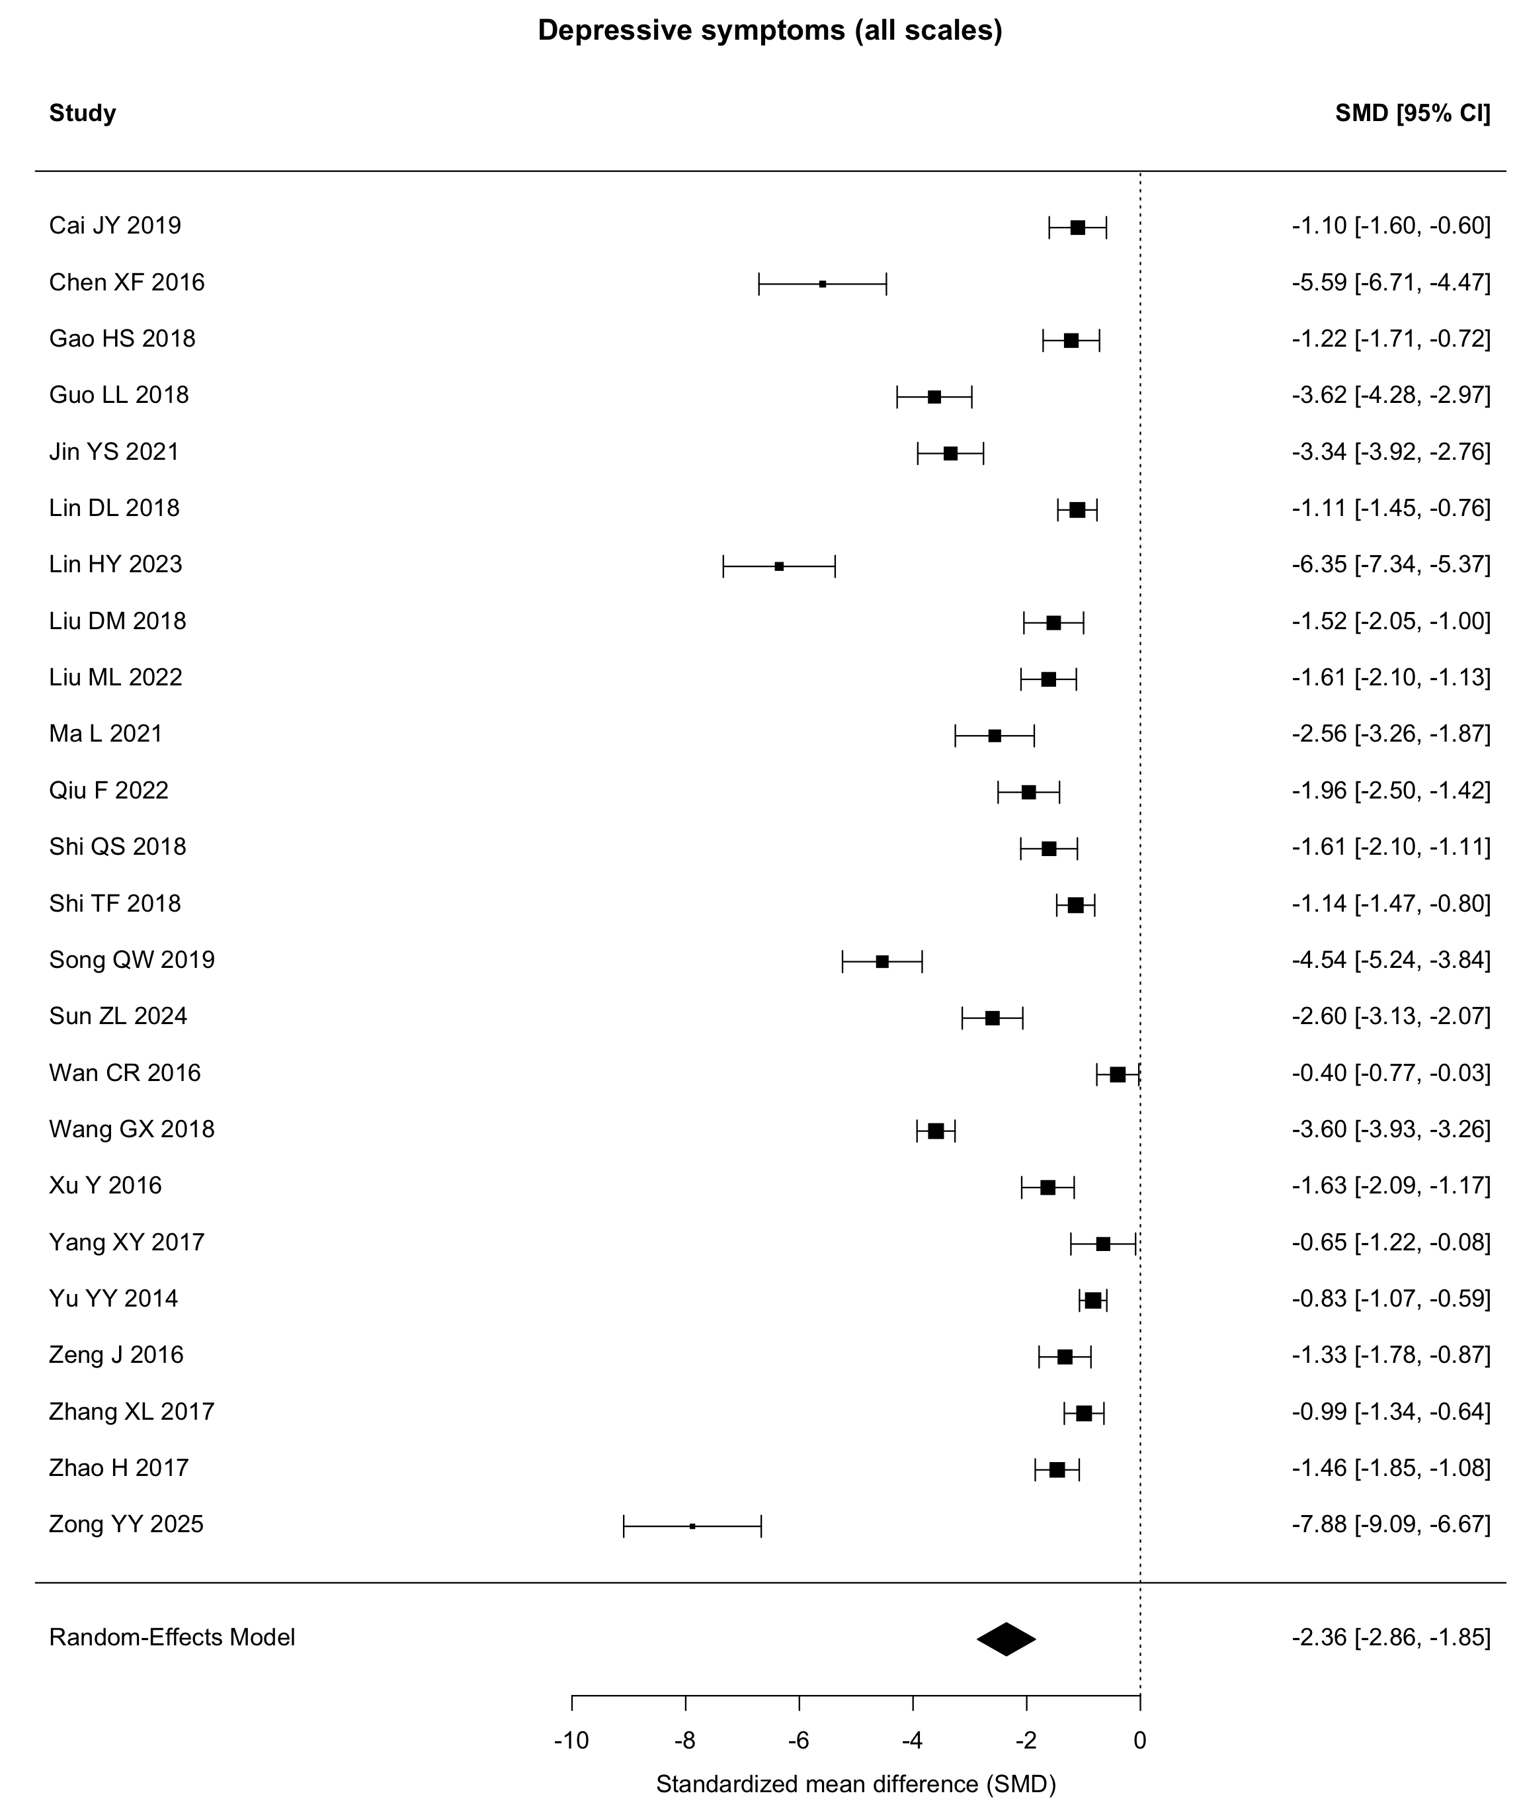
Supplementary Figure S3. HAMA.
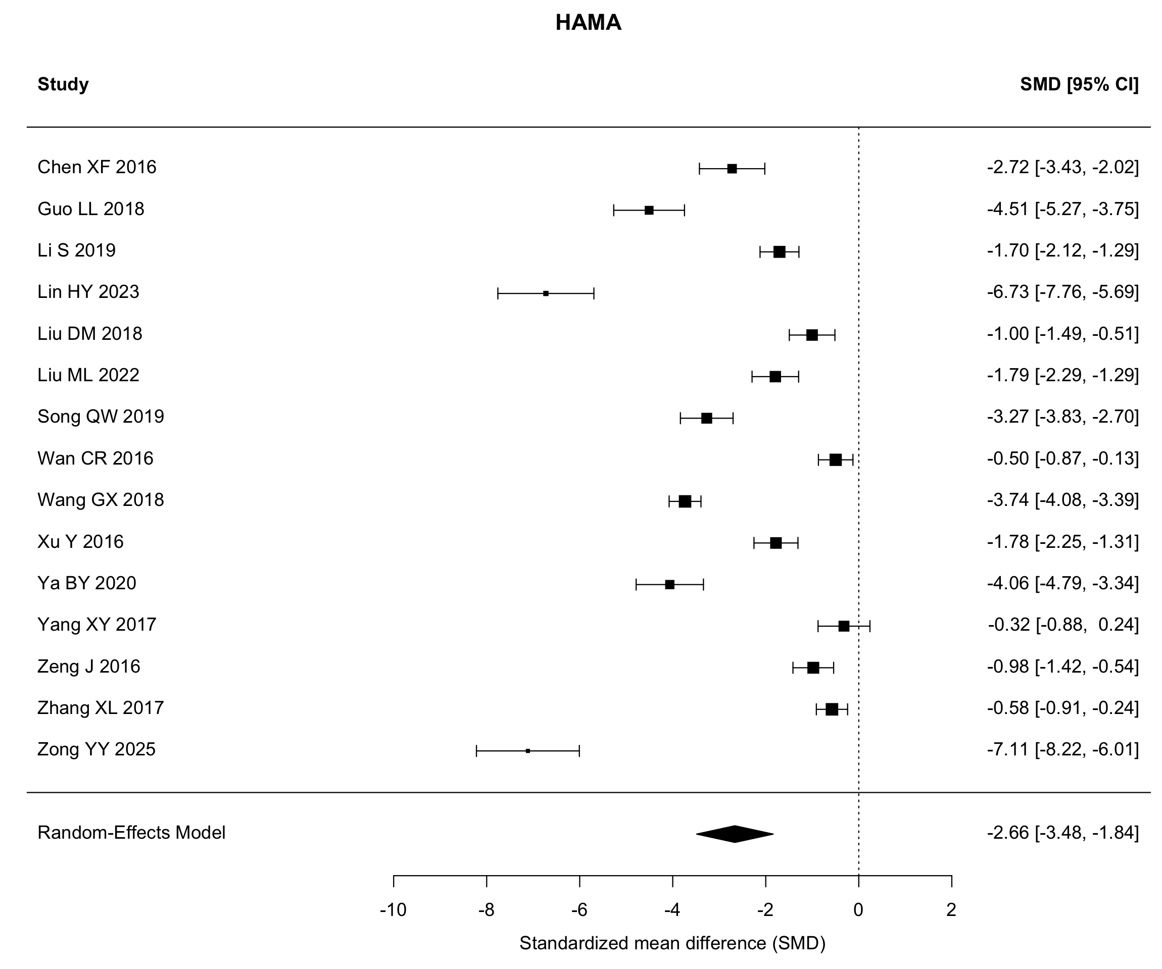
Supplementary Figure S4. SAS.
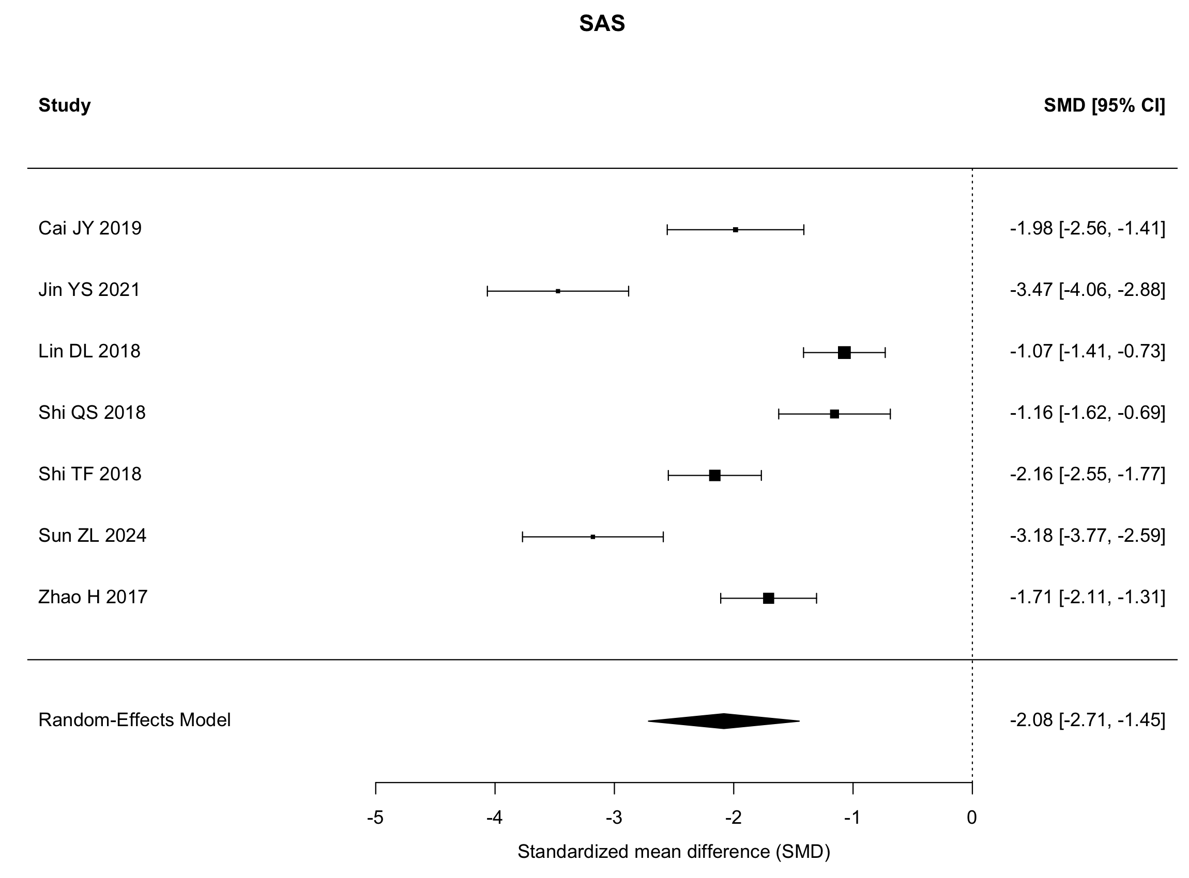
Supplementary Figure S5. HAMD.
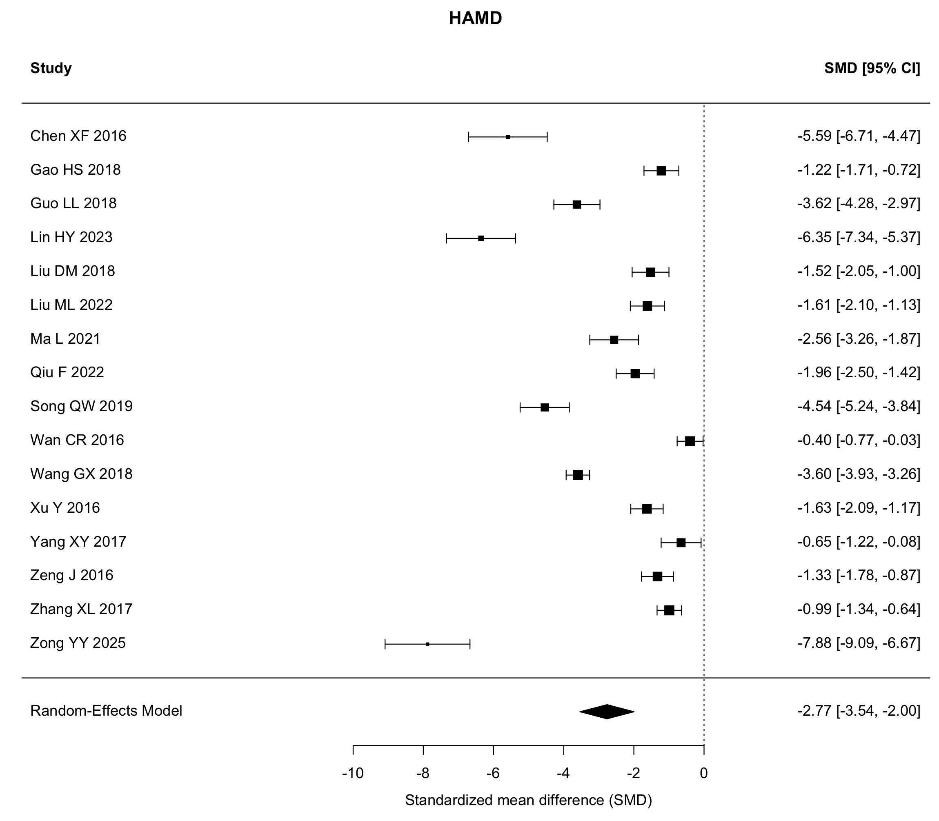
Supplementary Figure S6. SDS.
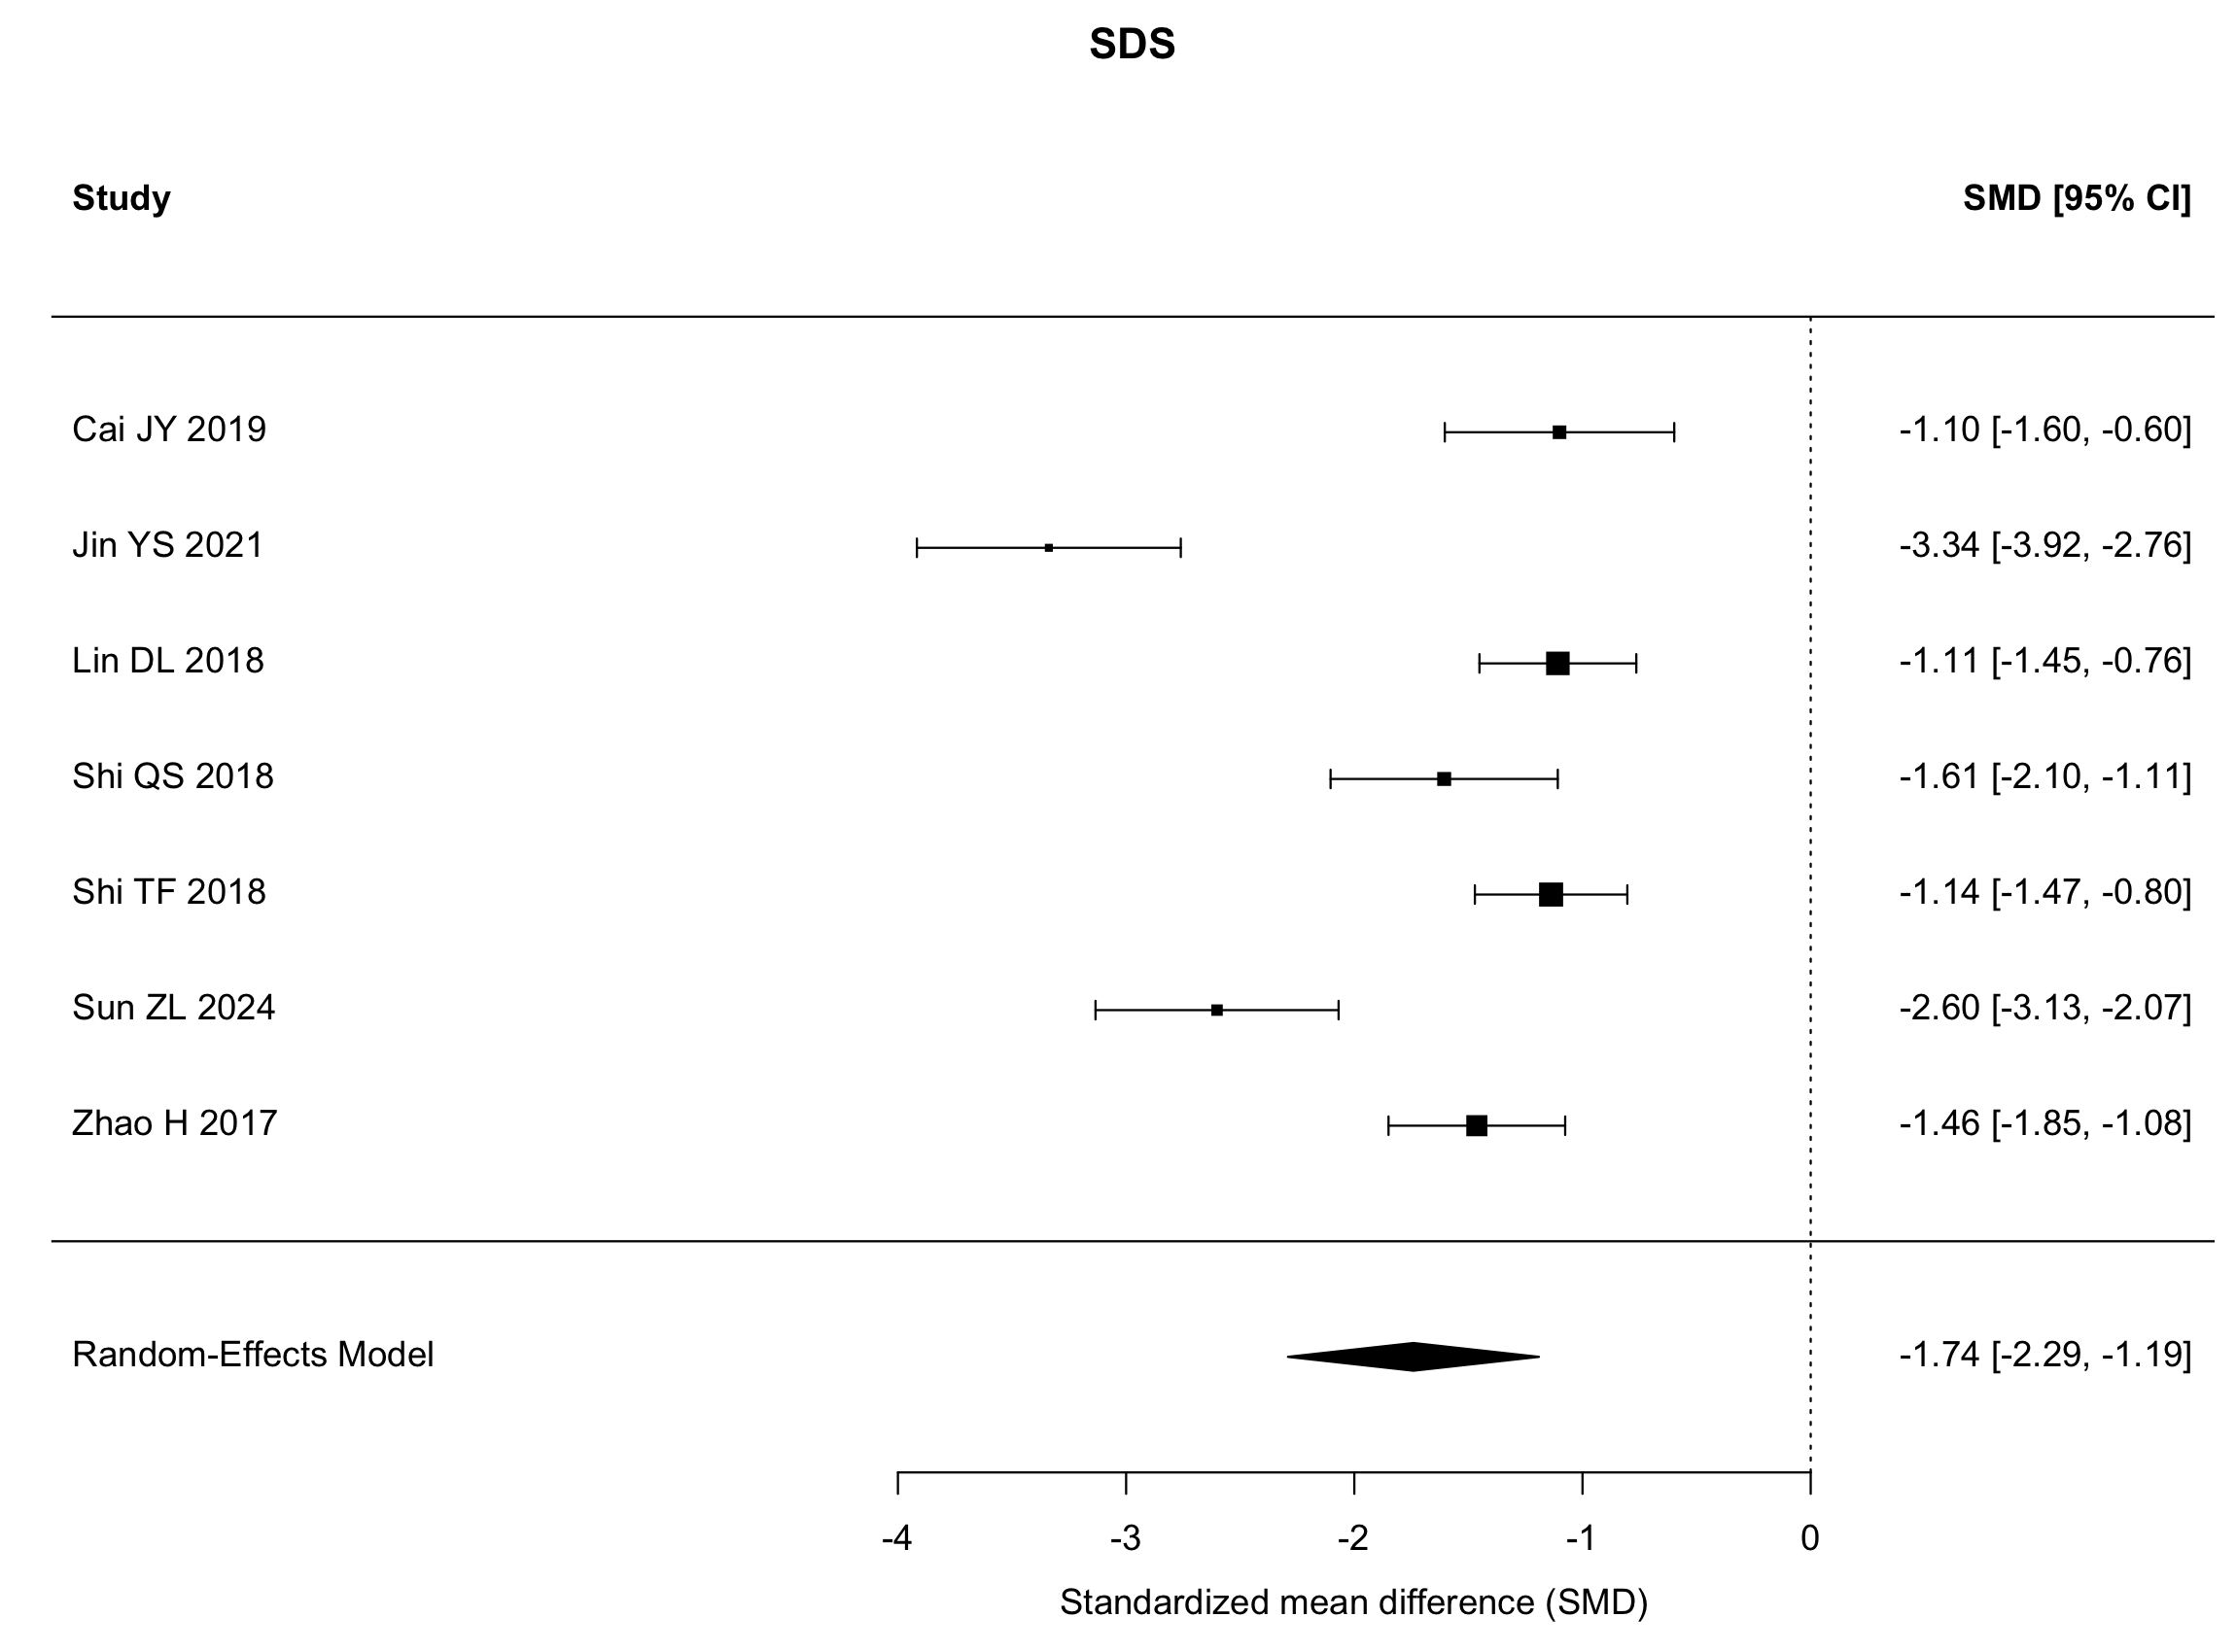
Supplementary Figure S7. RDQ.
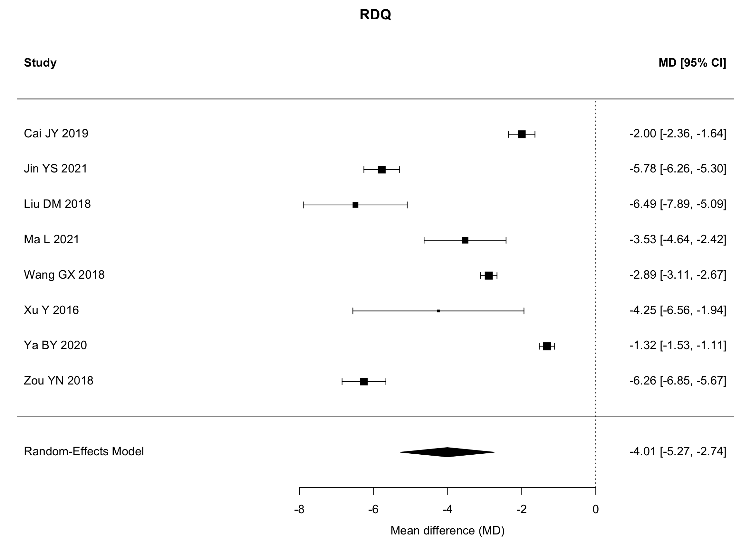
Supplementary Figure S8. Total clinical effectiveness.
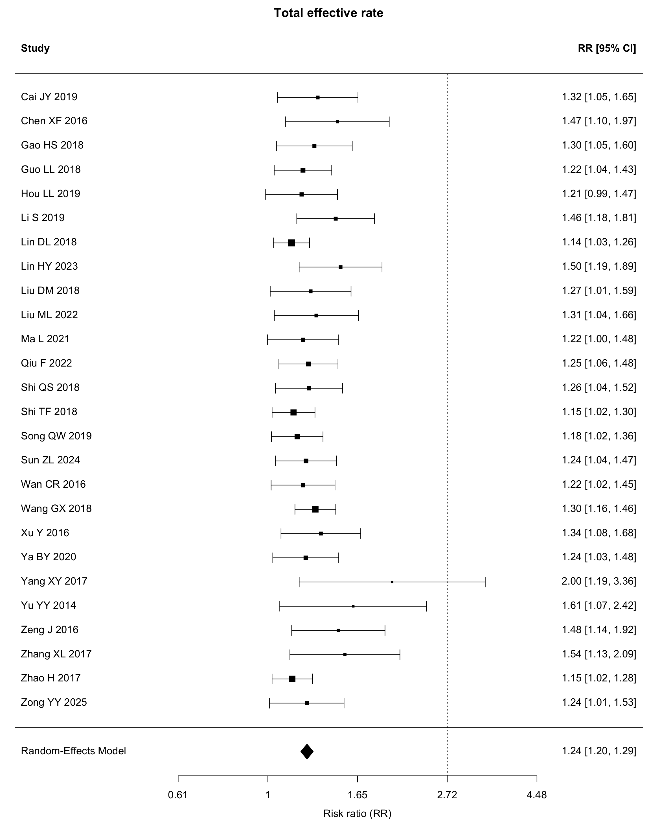
Supplementary Figure S9. Any adverse event.
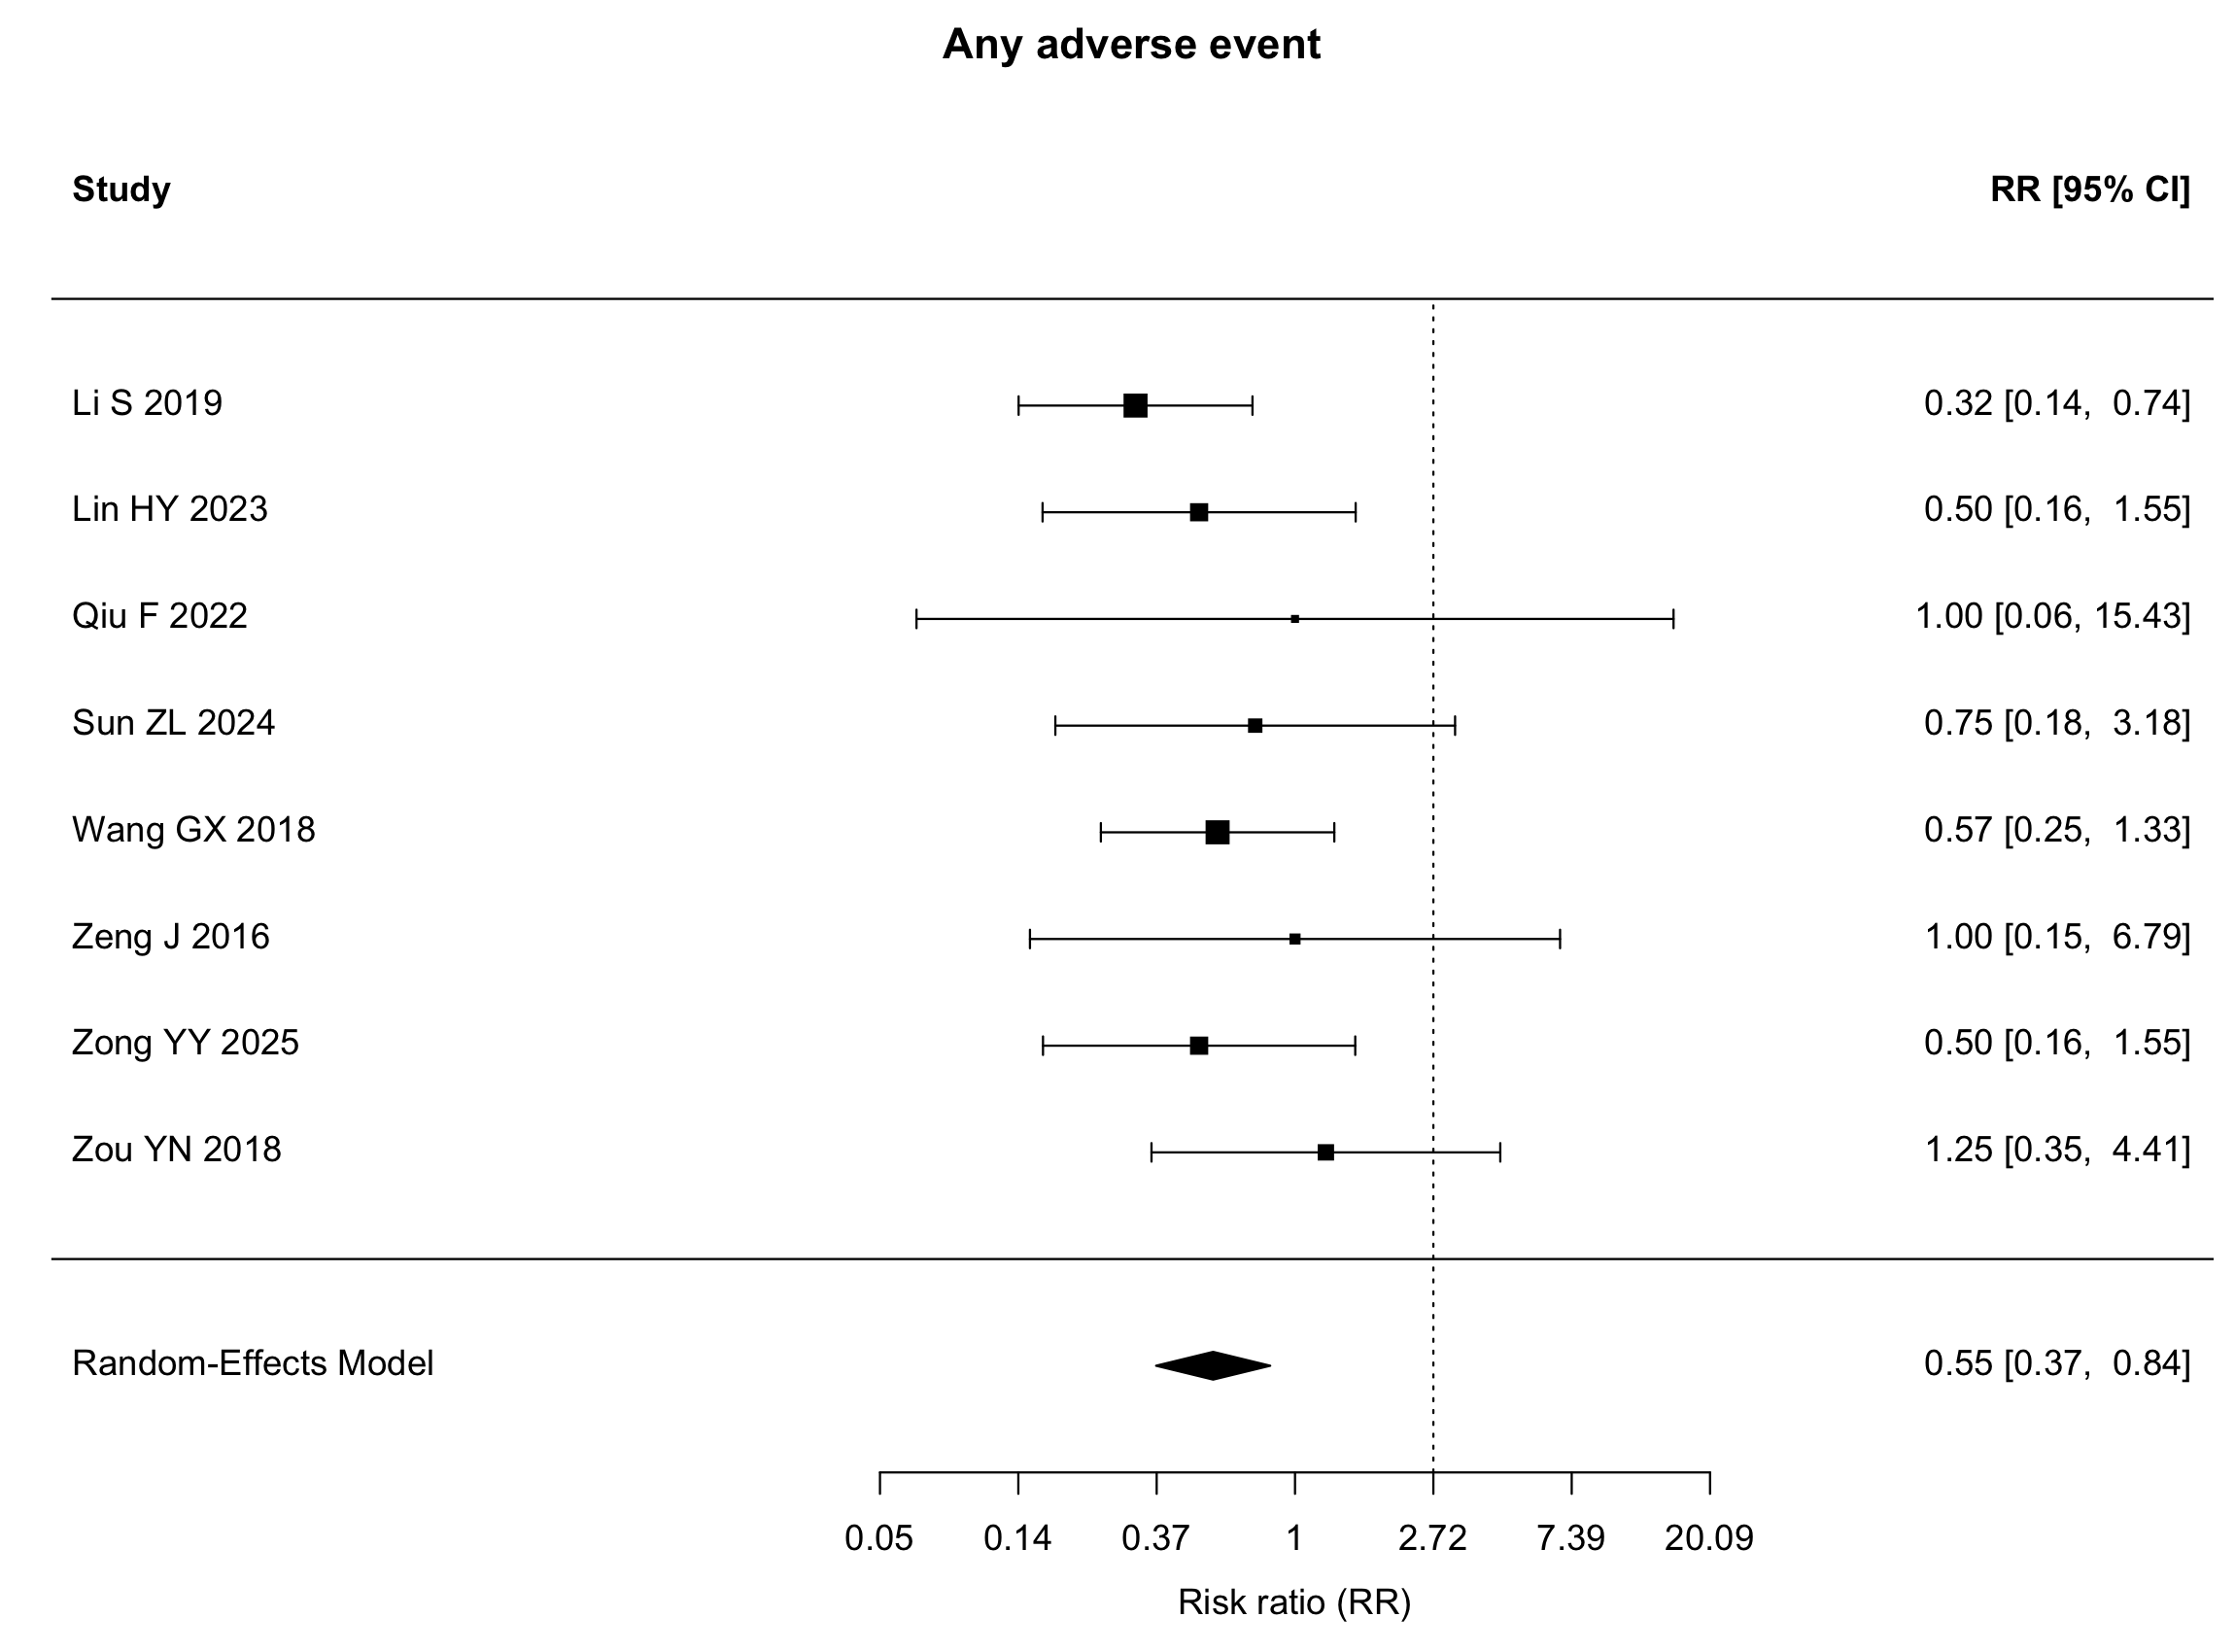

Supplementary Figures S10–S14. Funnel plots
Supplementary Figure S10. Anxiety symptoms.
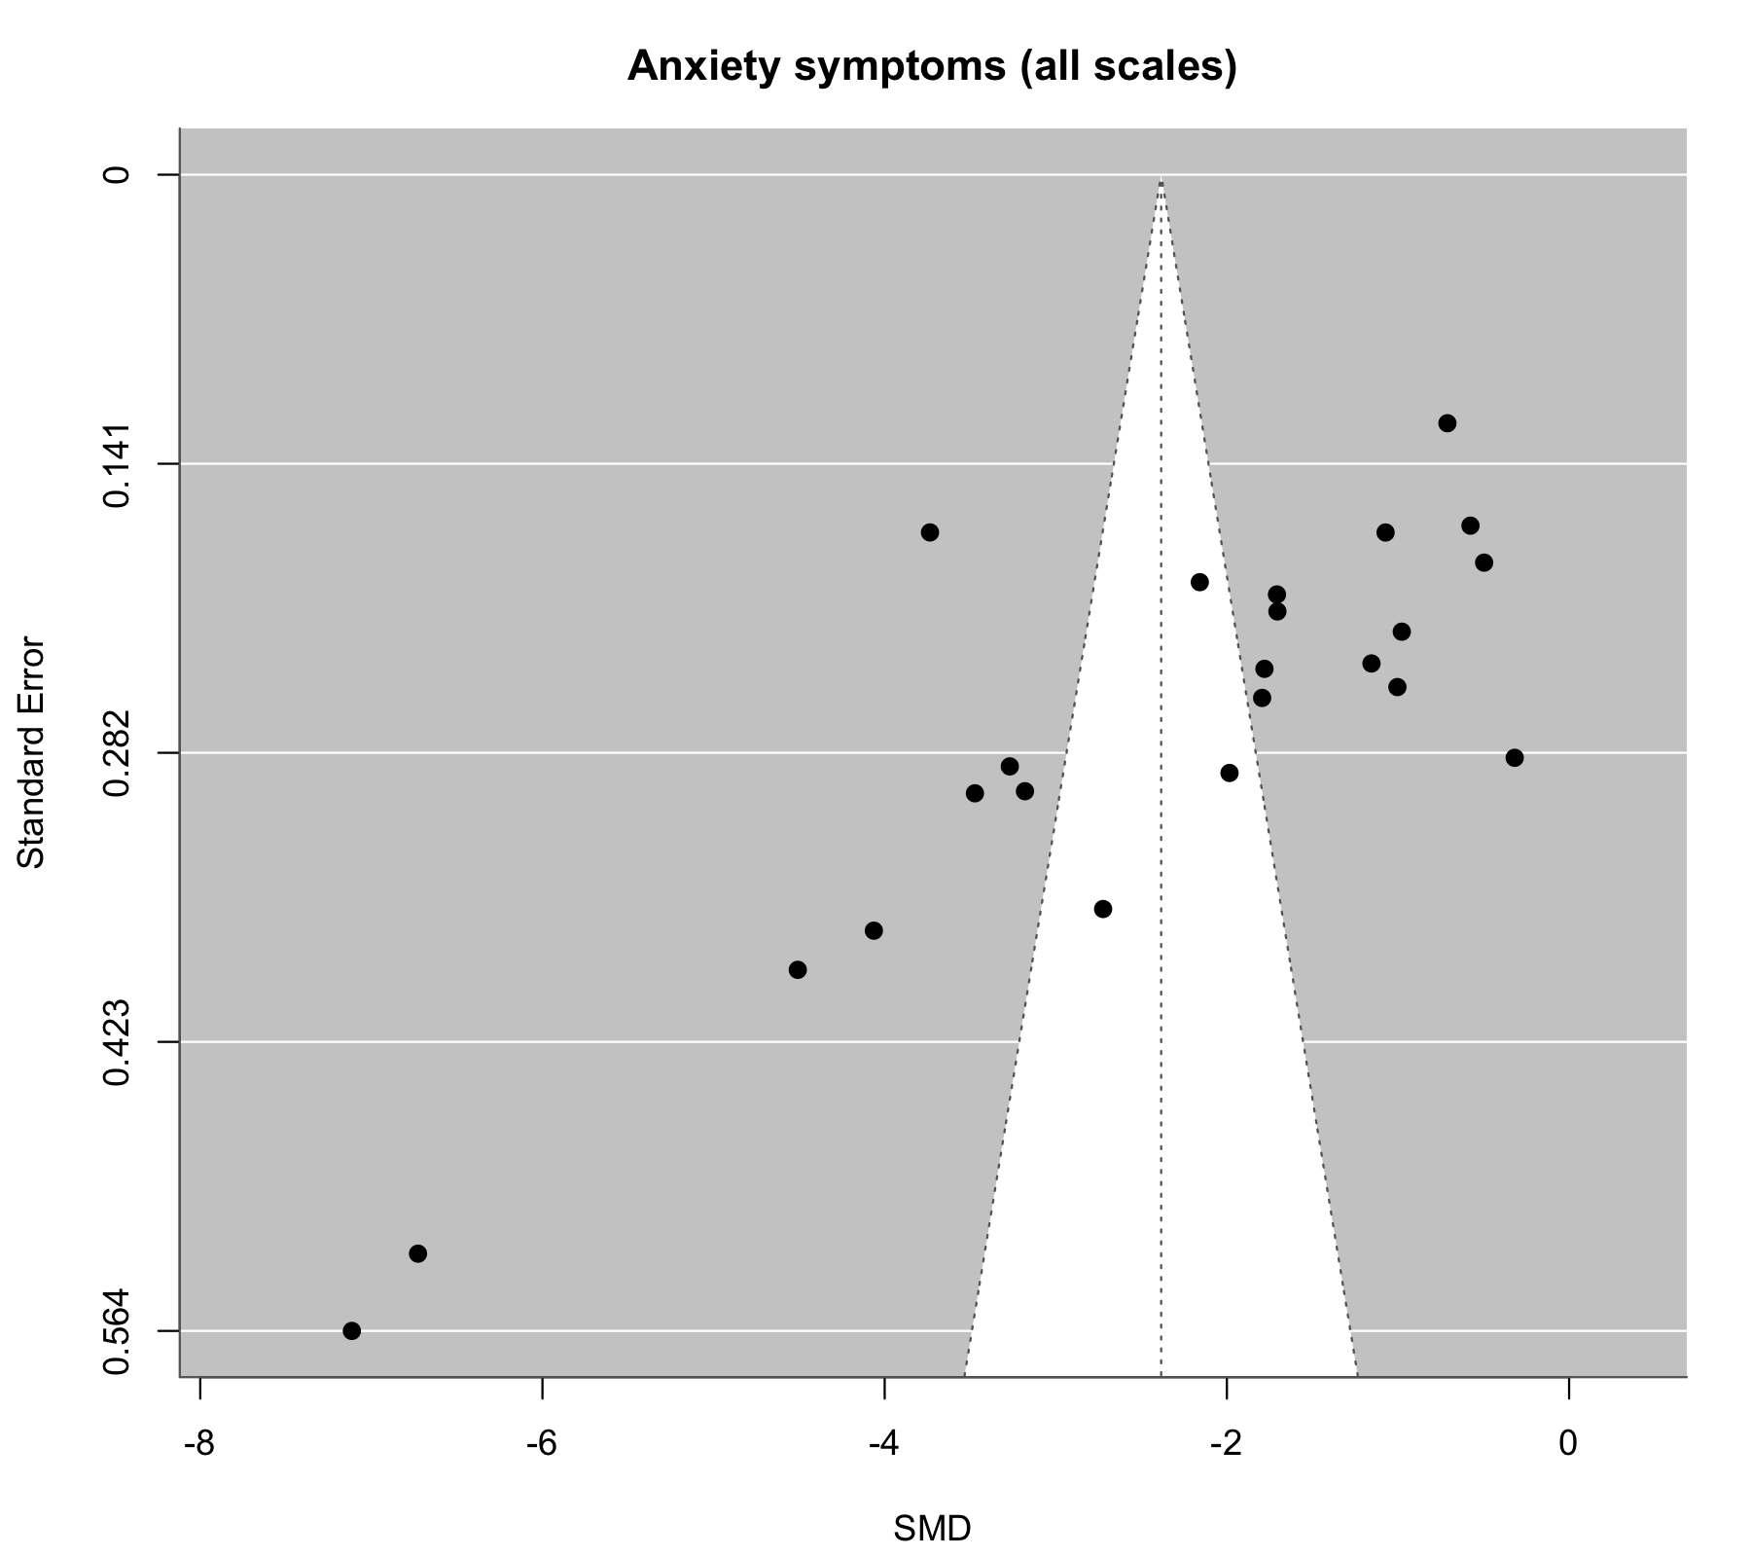
Supplementary Figure S11. HAMA.
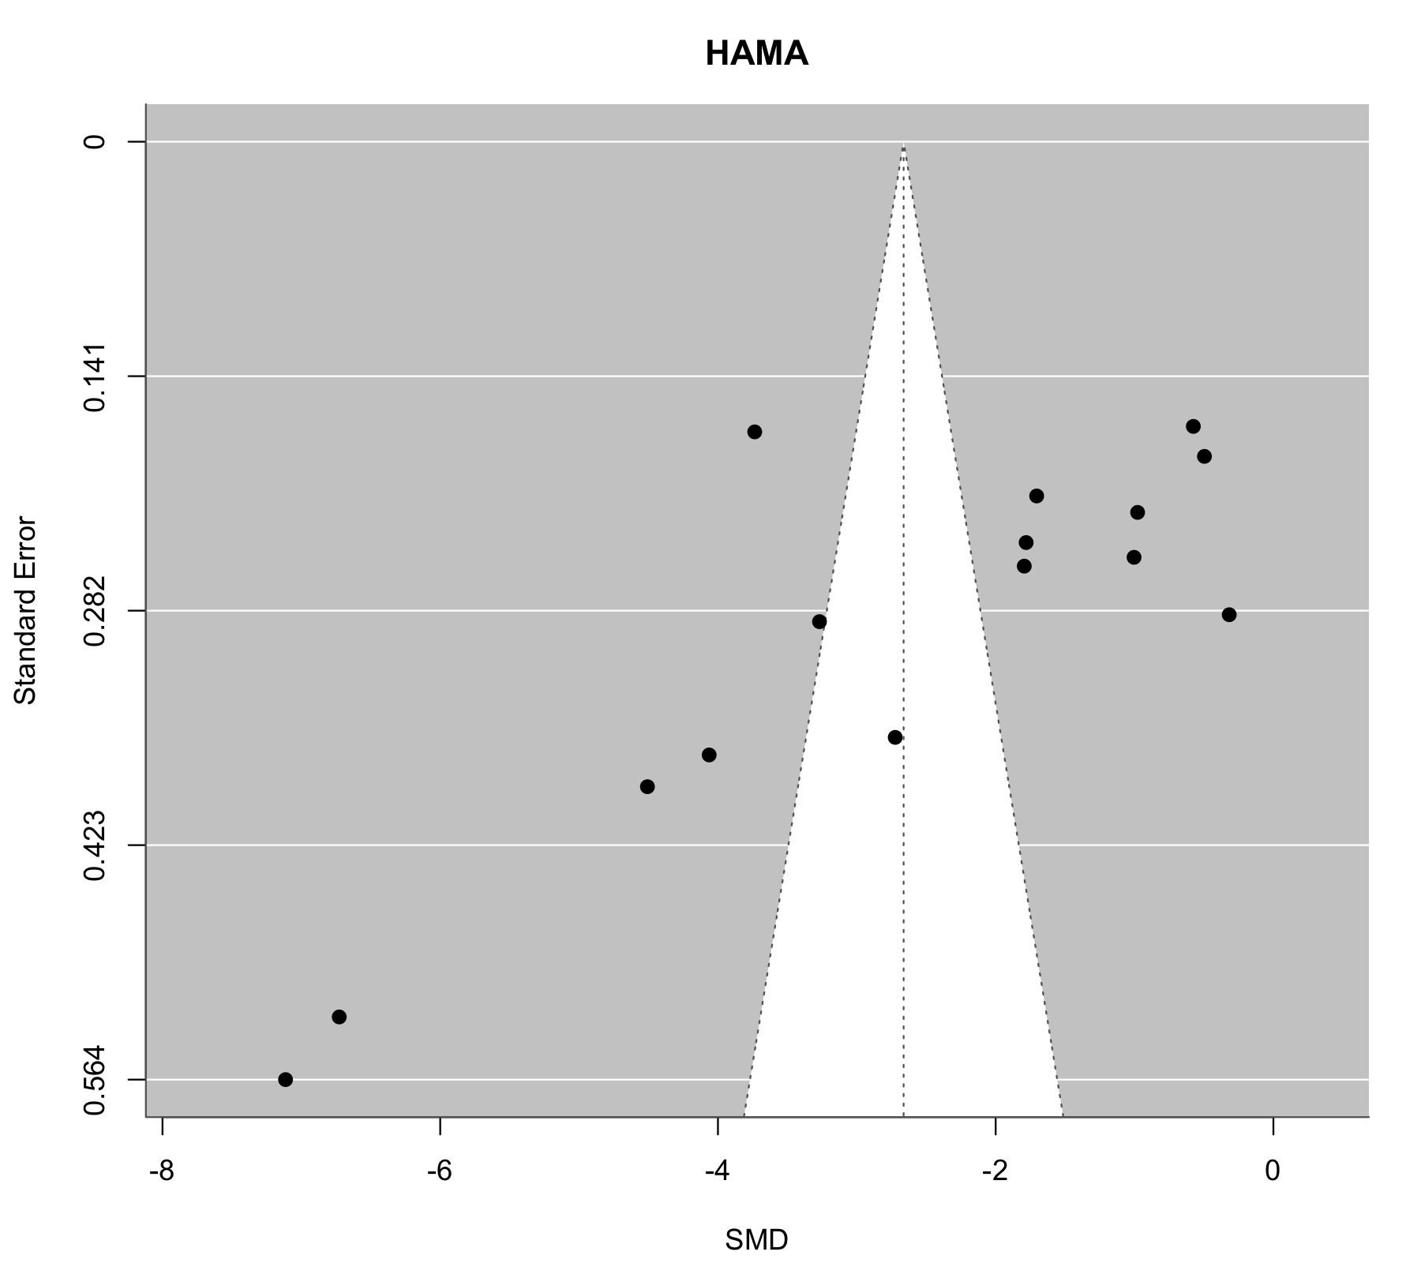
Supplementary Figure S12. Depressive symptoms.
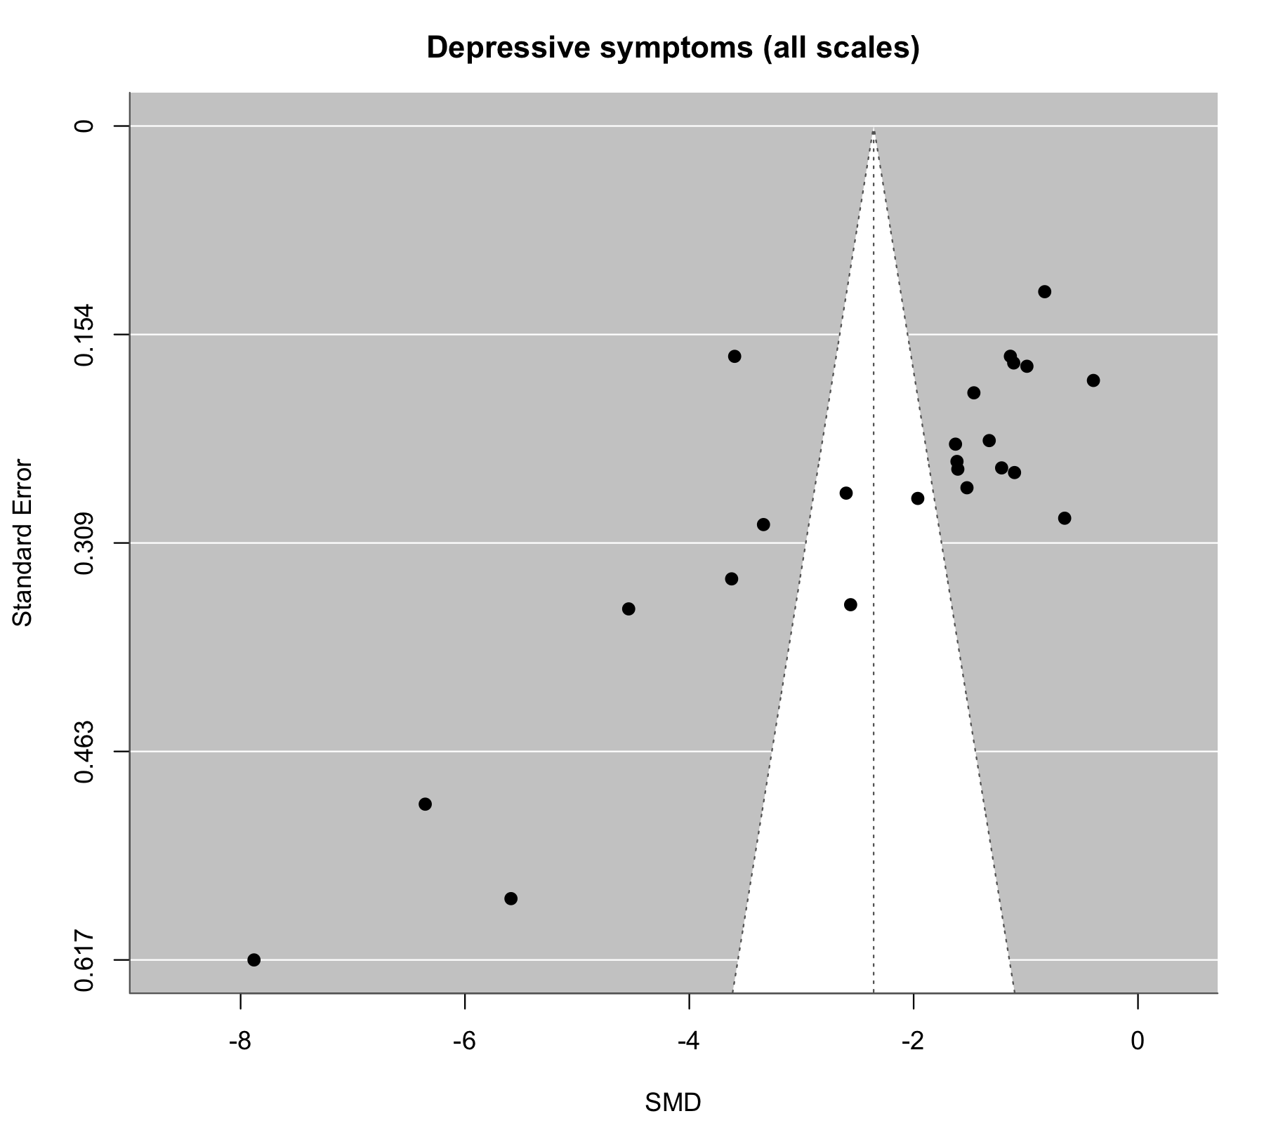
Supplementary Figure S13. HAMD.
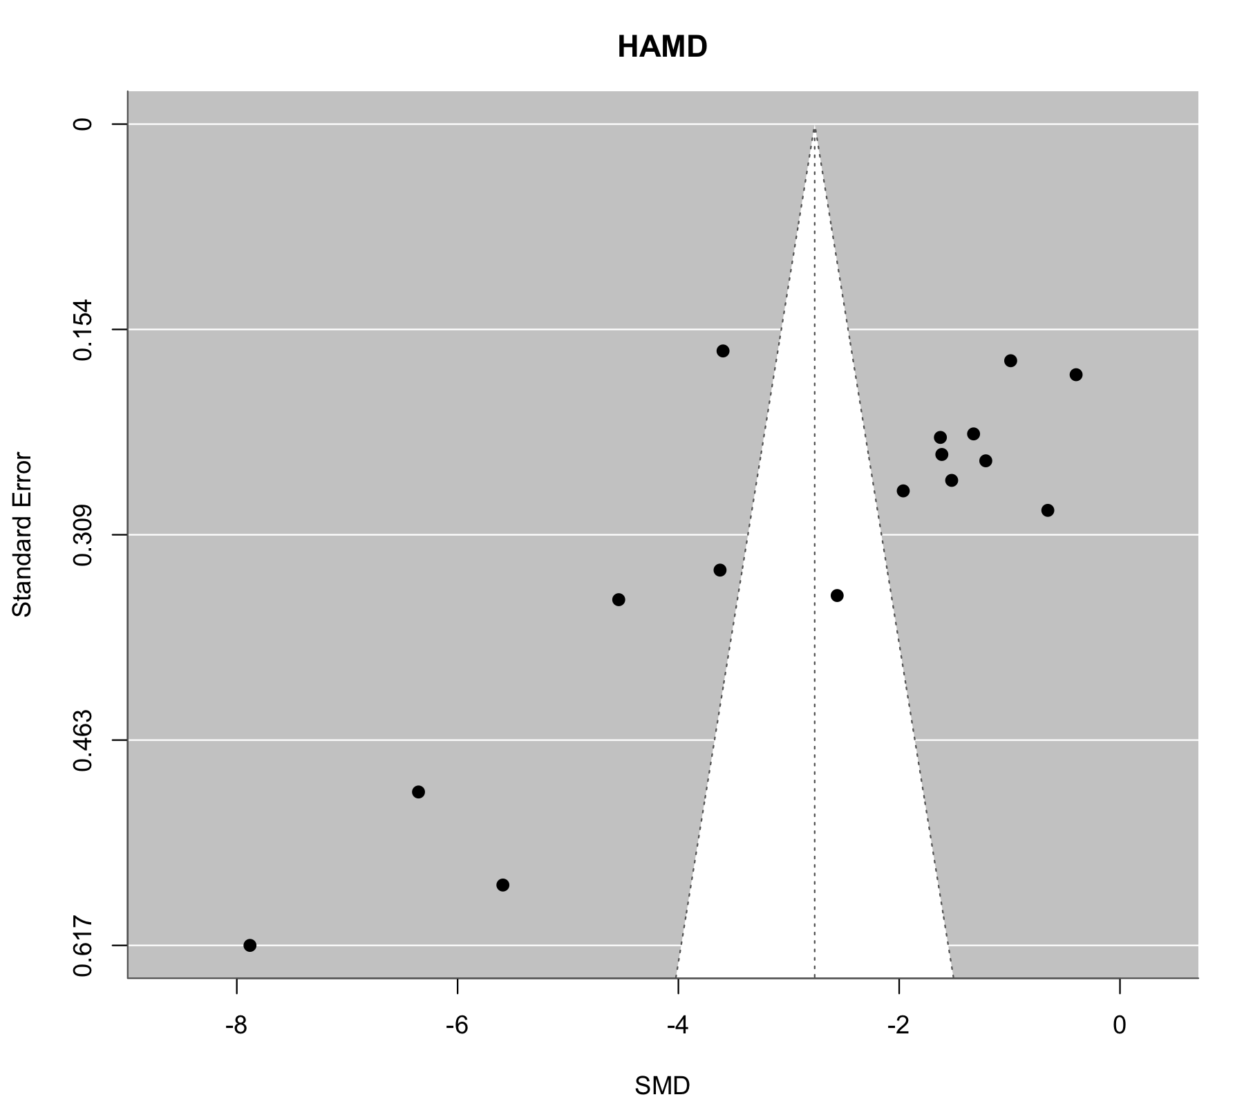
Supplementary Figure S14. Total clinical effectiveness.
