Original Article
Precision Liver Surgery-Guided Anatomical Yttrium-90 Radiation Segmentectomy with Resin Microspheres for Hepatocellular Carcinoma
Supplementary Material

Table S1 Detailed characteristics of patients in Cohort 2
 | BCLC stage | High-risk factors | Progression | PFS (Days)
P1 | C | tumor size > 5cm, invasion of RPPV | No | 962
P2 | B | tumor size > 5cm, multiple lesions | No | 585
P3 | C | HLN metastasis, multiple lesions | No | 285
P4 | A | tumor size = 5.5cm > 5cm | Yes | 982
P5 | A | tumor size > 5cm | No | 796
P6 | A | tumor size = 8.3cm > 5cm | Yes | 648
P7 | A | invasion of LHD | Yes | 552
P8 | C | invasion of LPV | Yes | 375
P9 | A | recurrent HCC | No | 600
P10 | A | recurrent HCC | No | 376
P11 | 0 | recurrent HCC | No | 236
P12 | 0 | Not appliable | No | 565
Description: Information on patients receiving combined systemic therapy.
Note: Patient 12 had no predefined clinical high-risk factors but received systemic therapy at the patient’s request and was therefore included in Cohort 2.
BCLC: Barcelona Clinic Liver Cancer; PFS: progression-free survival; RPPV: right posterior portal vein; HLN: hepatic hilar lymph node; LHD: left hepatic duct; LPV: left portal vein; HCC, hepatocellular carcinoma.

Table S2 Comparison of liver function before and after prophylactic embolization
 | Pre-embolization | Post-embolization | P
ALT, U/L | 22.6 ± 9.6 | 18.8 ± 5.5 | 0.428
AST, U/L | 24.0 ± 8.0 | 19.3 ± 3.8 | 0.217
TB, μmol/L | 13.2 ± 6.3 | 13.6 ± 5.1 | 0.906
ALB, g/L | 40.4 ± 3.5 | 38.4 ± 3.3 | 0.330
ALP, U/L | 93.7 ± 35.9 | 83.3 ± 30.9 | 0.605
Description: Paired liver function tests showed no significant changes after prophylactic embolization.
Note: All prophylactic embolizations were performed during the mapping angiography session. Paired liver function tests before and after embolization were available in 6 of 12 patients who underwent intrahepatic embolization.
ALT: alanine aminotransferase; AST: aspartate aminotransferase; TB: total bilirubin; ALB: albumin; ALP: alkaline phosphatase.
Table S3 Detailed information of patients receiving radiation subsegmentectomy
 | Tumor size (cm) | Hepatic subsegment | Procedure time (min)
P1 | 4.7 | subS7 | 92
P2 | 4.5 | subS7 | 141
P3 | 3.8 | subS7 | 106
P4 | 3.8 | subS8 | 198
P5 | 3.2 | subS6 | 101
P6 | 3.0 | subS8 | 76
P7 | 2.6 | subS8 | 118
P8 | 2.1 | subS8 | 93
P9 | 1.9 | subS6 | 61
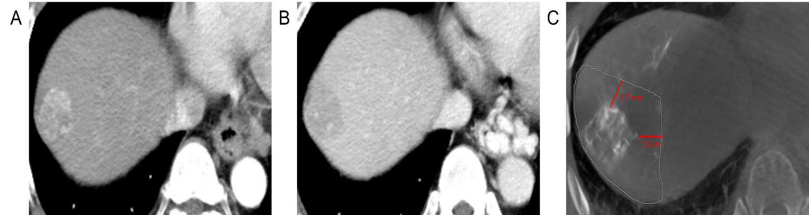
Description: At our institution, radiation subsegmentectomy (sub-RS) is routinely feasible in appropriately selected patients.

Fig. S1 Assessment of the treatment margin during radiation subsegmentectomy. (A-B) Arterial- and portal venous-phase CECT images demonstrate a lesion in hepatic segment VIII (S8). (C) Intraprocedural CBCT delineates the perfused area and its spatial relationship to the tumor boundary. CECT: contrast-enhanced computed tomography; CBCT: cone-beam computed tomography.

