Additional file 1: Conventional self-regulated exercise programs (handouts)
Conventional self-regulated exercises Level 1
BBS<45, Exercises in sitting position

Name: Surname: Birthdate:
Exercise 1:
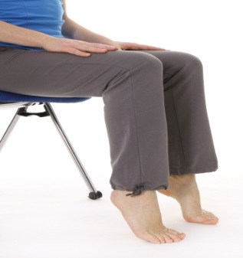 | Sitting upright, lift heels and tip toes alternatively.  Repetitions: 3 X 12 | 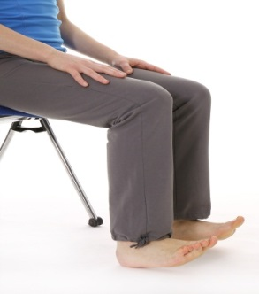
Exercise 2:
Sitting upright, move foot forwards and backwards alternatively („wipe“)
Repetitions: until tired
Exercise 3:
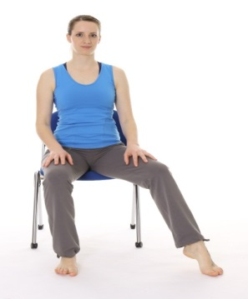 | Sitting upright, reach with the right foot as far as possible to the right. The same with left foot to the left.  Repetitions: 2 x 10 (for each side) | 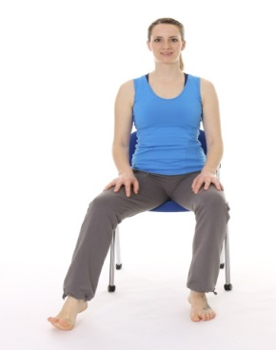
Exercise 4:
Sitting upright, stand up and sit down with the least possible arm support.
Repetitions: 3 x 12
Exercise 5 :
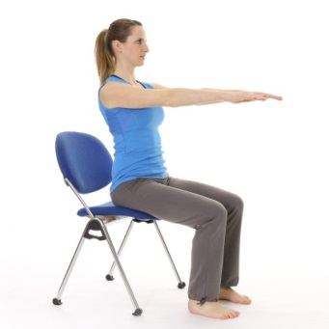 | Sitting upright, stretch arms forwards and move trunk as far as possible forward.  Repetitions: 3 x 12 | 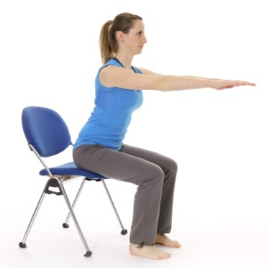
Exercise 6 :
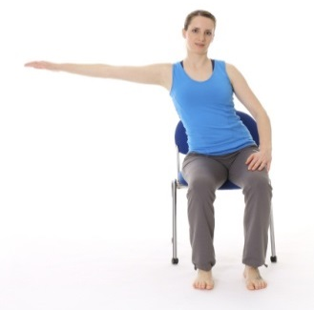 | Sitting upright, reach with the stretched arm as far as possible to one’s side.  Repetitions: 2 x 10 (for each side) | 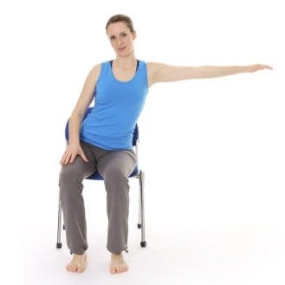
Exercise 7:
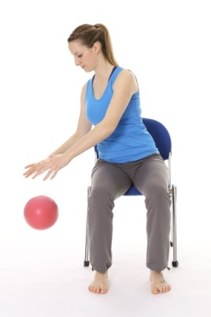 | 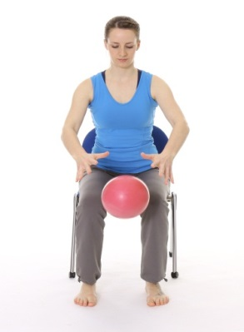 | 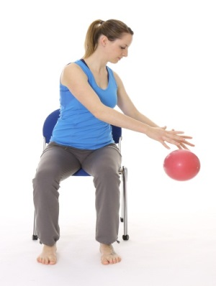
Sitting upright, dribble the ball with both hands in the front and on the sides.
Repetitions: 2 x 10 in each position

Conventional self-regulated exercises Level 2
45 ≤BBS <56, Exercises in standing

Name: Surname: Birthdate:
Exercise 1:
Alternate standing on toes and standing on heels.
Repetitions: 3 x 10
Exercise 2:
In step position, keep arms crossed and turn the head alternatively to the right to see behind the shoulder and to the left.
Repetitions: 3 x 10
Exercise 3:
Stand on a line with L toes as close as possible to the R heel.
Keep position as long as possible. Then alternate feet.
Exercise 4:
Touch each red spot with one foot. Then same with one foot.
Repetitions: 3 x with each foot
Exercise 5:
In step position, throw a ball from one hand to the other.
Repetitions: 2 x 10

Conventional self-regulated exercises Level 3
BBS =56, Exercises in walking

Name: Surname: Birthdate:
Exercise 1:
Walk forward on tip toes and backwards on heels.
Repetitions: 10 x 5 meters
Exercise 2:
Walk on a line with toes as close as possible to heel.
Repetitions: 10 x 5 meters
Exercise 3:
Arms crossed, step sideways on a line.
Repetitions: 10 x back and forth
Exercise 4:
Arms crossed, do cross steps on a line.
Repetitions: 10 x back and forth
Exercise5:
In walking, throw a ball from one hand to the other.
Repetitions: 5 x 5 meters

