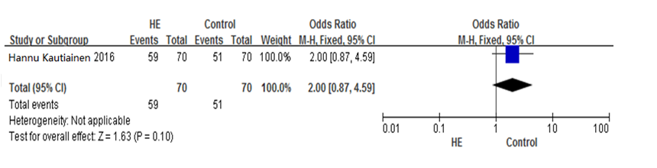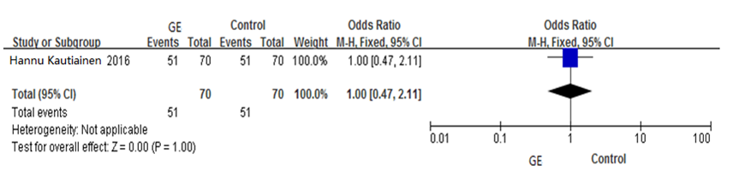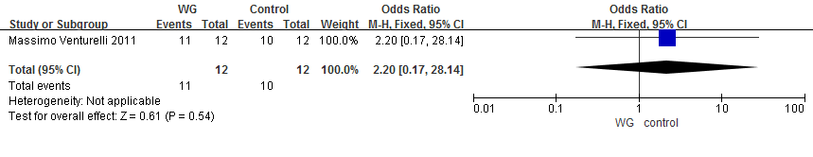
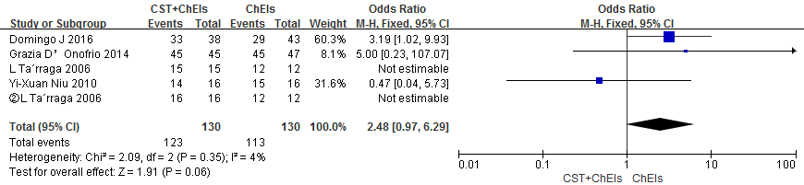
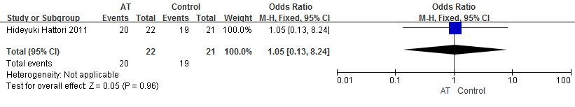
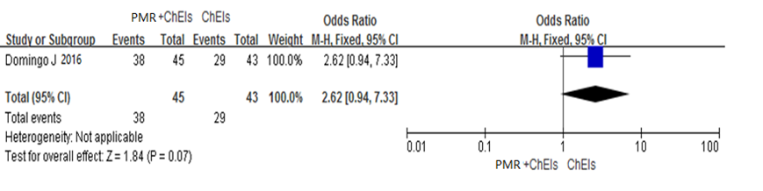
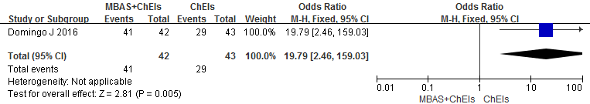

Additional file 4 Pair-wise meta-analysis of Compliance for Each Intervention

