Table S1. Number of missing values for variables of interest
Variable | Number of missing values
 | men | women
AGEs | 9 | 10
sRAGE | 9 | 10
SF-12 Physical functioning item 1 (moderate activities) | 23 | 9
SF-12 Physical functioning item 2 (climbing stairs) | 14 | 7
SF-12 Physical summary scale (PCS) | 55 | 45
Age | 0 | 0
Years of education | 0 | 0
BMI | 0 | 0
Alcohol consumption | 3 | 0
Smoking | 1 | 0
Food-Frequency Index | 2 | 0
Self-reported medical diagnose of diabetes mellitus | 1 | 0
Self-reported medical diagnose of osteoporosis | 6 | 14
Use of antihypertensive drugs | 0 | 0
Use of lipid lowering drugs | 0 | 0
Creatinine-clearance | 7 | 5
Notes. AGEs= advanced glycation end products; sRAGE= soluble receptor of AGEs; BMI= Body mass index

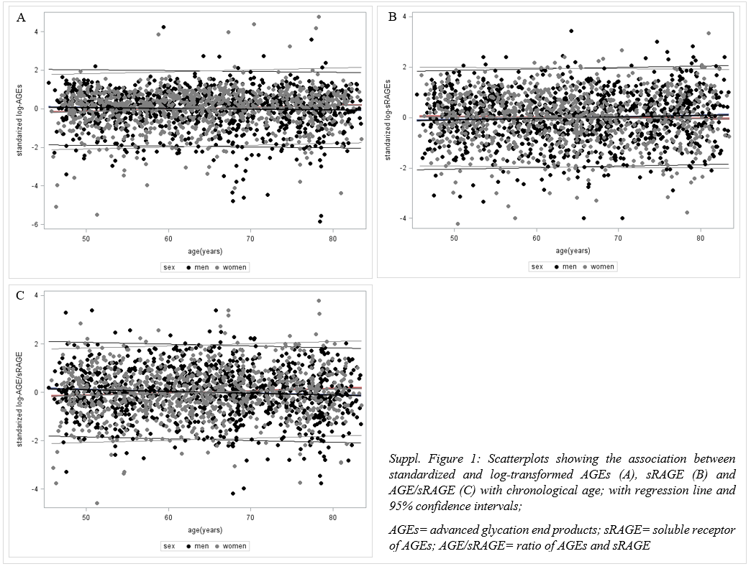
Figure S2: Physical functioning of the study population stratified for sex and age
N= men: 487 <65years; 480 >=65years; women: 455<65years; 357>= 65years

Table S2. Association between physical functioning (PF) and log-transformed, standardized AGEs, sRAGE and AGE/sRAGE ratio, Odds ratios (95 % confidence interval)
 | Raw |  | Model 1* |  | Model 2§
 | Men | Women | Men | Women | Men | Women
 | PF 0 = Ref.
Association between PF and AGEs
All | 0.99  (0.87; 1.11) | 0.84  (0.74; 0.95) | 0.96  (0.85; 1.09) | 0.88  (0.77; 1.00) | 1.03  (0.91; 1.17) | 0.86  (0.74; 0.98)
<65 | 0.87  (0.71; 1.06) | 0.93  (0.78; 1.11) | 0.85  (0.69; 1.05) | 0.95  (0.79; 1.13) | 0.87  (0.70; 1.08) | 0.86  (0.71; 1.05)
>= 65 | 1.03  (0.88; 1.20) | 0.82  (0.67; 0.99) | 1.04  (0.89; 1.21) | 0.80  (0.66; 0.97) | 1.15  (0.98; 1.35) | 0.89  (0.72; 1.09)
Association between PF and sRAGE
All | 0.96  (0.85; 1.08) | 1.10  (0.97; 1.25) | 1.00  (0.88; 1.12) | 1.10  (0.97; 1.25) | 0.97  (0.85; 1.10) | 1.06  (0.93; 1.21)
<65 | 1.08  (0.90; 1.30) | 1.09  (0.91;1.30) | 1.05  (0.88; 1.27) | 1.11  (0.93; 1.32) | 1.03  (0.85; 1.24) | 1.01  (0.84; 1.22)
>= 65 | 0.91  (0.78; 1.07) | 1.12  (0.93; 1.35) | 0.98  (0.83; 1.16) | 1.09  (0.91; 1.32) | 0.97  (0.82; 1.16) | 1.14  (0.94; 1.38)
Association between PF and AGE/ sRAGE
All | 1.02  (0.91; 1.15) | 0.81  (0.71; 0.92) | 0.98  (0.87; 1.11) | 0.84  (0.74; 0.96) | 1.05  (0.92; 1.19) | 0.86  (0.75; 0.98)
<65 | 0.86  (0.71; 1.04) | 0.89  (0.74; 1.06) | 0.87  (0.72; 1.05) | 0.88  (0.74; 1.06) | 0.91  (0.74; 1.11) | 0.90  (0.74; 1.08)
>= 65 | 1.09  (0.94; 1.28) | 0.79  (0.65; 0.95) | 1.05  (0.89; 1.23) | 0.79  (0.65; 0.96) | 1.13  (0.96; 1.34) | 0.83  (0.68; 1.01)
Notes: * Model 1: age; § Model 2: age, years of education ,BMI, alcohol consumption, smoking, diet, diabetes mellitus, creatinine clearance, antihypertensive drugs, lipid lowering drugs;
N= 967 men; 812 women;
AGEs= advanced glycation end products; sRAGE= soluble receptor of AGEs; AGE/sRAGE: ratio of AGE and sRAGE; PF= total score physical functioning (SF-12)

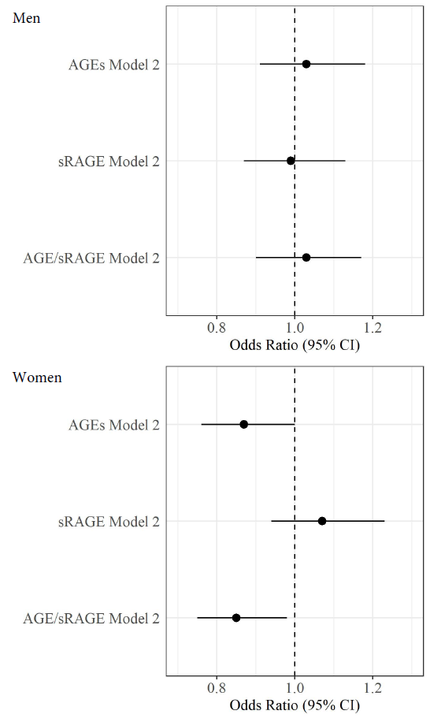
Figure S3: Association between physical functioning (PF) with advanced glycation end products (AGEs), soluble receptor of AGEs (sRAGE) and ratio of AGEs and sRAGE (AGE/sRAGE) for men (N=930) and women (N=792) in complete cases without missings in exposure, outcome or confounding variables; Odds ratios (95 % confidence interval)
Ref.: PF=0 (severe limitations in physical functioning)
Model 2: age, years of education, BMI, alcohol consumption, smoking, diet, diabetes mellitus, creatinine clearance, antihypertensive drugs, lipid lowering drugs;
CI= confidence interval
Table S3. Complete case analysis;
Association between physical functioning (PF) and log-transformed, standardized AGEs, sRAGE and AGE/sRAGE ratio, Odds ratios (95 % confidence interval)

 | Raw |  | Model 1* |  | Model 2§
 | Men | Women | Men | Women | Men | Women
 | PF 0 = Ref.
Association between PF and AGEs
All | 0.98  (0.87; 1.11) | 0.84  (0.74; 0.96) | 0.96  (0.85; 1.09) | 0.88  (0.77; 1.01) | 1.03  (0.91; 1.18) | 0.87  (0.76; 1.00)
Association between PF and sRAGE
All | 0.97  (0.86; 1.10) | 1.12  (0.98; 1.26) | 1.01  (0.90; 1.15) | 1.11  (0.97; 1.26) | 0.99  (0.87; 1.13) | 1.07  (0.94; 1.23)
Association between PF and AGE/sRAGE
All | 1.01  (0.89; 1.14) | 0.81  (0.71; 0.92) | 0.96  (0.85; 1.09) | 0.84  (0.74; 0.96) | 1.03  (0.90; 1.17) | 0.85  (0.75; 0.98)
Notes: * Model 1: age; § Model 2: age, years of education ,BMI, alcohol consumption, smoking, diet , diabetes mellitus, creatinine clearance, antihypertensive drugs, lipid lowering drugs;
N=930 men; 792 women
AGEs= advanced glycation end products; sRAGE= soluble receptor of AGEs; AGE/sRAGE: ratio of AGE and sRAGE; PF= total score physical functioning (SF-12)

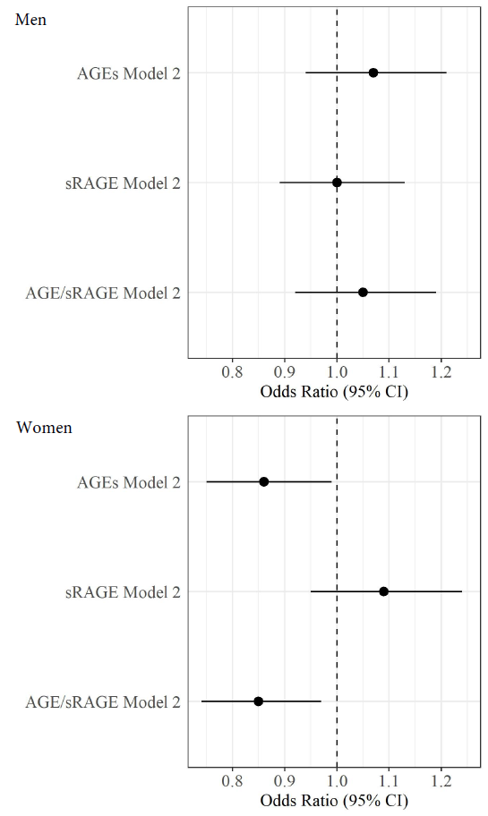
Figure S4: Association between physical functioning (PF) with advanced glycation end products (AGEs), soluble receptor of AGEs (sRAGE) and ratio of AGEs and sRAGE (AGE/sRAGE) for men (N=951) and women (N=797) in a subsample without AGE or sRAGE extreme values (higher 1%); Odds ratios (95 % confidence interval)
Ref.: PF=0 (severe limitations in physical functioning)
Model 2: age, years of education, BMI, alcohol consumption, smoking, diet, diabetes mellitus, creatinine clearance, antihypertensive drugs, lipid lowering drugs;
CI= confidence interval
Table S4. Analysis without AGE and sRAGE extreme values (higher 1%)
Association between physical functioning (PF) and log-transformed, standardized AGEs, sRAGE and AGE/sRAGE ratio, Odds ratios (95 % confidence interval)
Raw |  | Model 1* |  | Model 2§
Men | Women | Men | Women | Men | Women
PF 0 = Ref.
Association between PF and AGEs
1.05  (0.93; 1.19) | 0.86  (0.76; 0.98) | 1.03  (0.91; 1.16) | 0.89  (0.78; 1.01) | 1.07  (0.94; 1.21) | 0.86  (0.75; 0.99)
Association between PF and sRAGE
1.02  (0.91; 1.15) | 1.14  (1.00; 1.29) | 1.06  (0.93; 1.19) | 1.12  (0.98; 1.27) | 1.00  (0.88; 1.13) | 1.09  (0.95; 1.24)
Association between PF and AGE/ sRAGE
1.02  (0.90; 1.15) | 0.81  (0.71; 0.92) | 0.98  (0.86; 1.10) | 0.84  (0.73; 0.95) | 1.05  (0.92; 1.19) | 0.85  (0.74; 0.97)
Notes: * Model 1: age; § Model 2: age, years of education ,BMI, alcohol consumption, smoking, diet, diabetes mellitus, creatinine clearance, antihypertensive drugs, lipid lowering drugs;
N=951 men; 797 women
AGEs= advanced glycation end products; sRAGE= soluble receptor of AGEs; AGE/sRAGE: ratio of AGE and sRAGE; PF= total score physical functioning (SF-12)

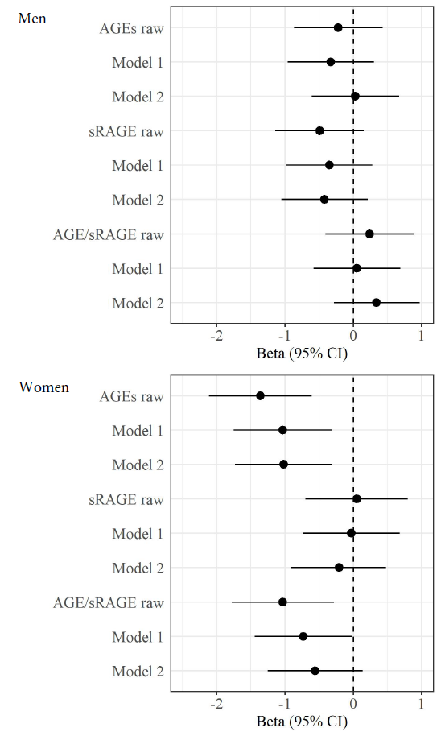
Figure S5: Association between physical component scale (PCS) with advanced glycation end products (AGEs), soluble receptor of AGEs (sRAGE) and ratio of AGEs and sRAGE (AGE/sRAGE) for men (N=967) and women (N=812), Beta (β) (95 % confidence interval)
Model 2: age, years of education, BMI, alcohol consumption, smoking, diet, diabetes mellitus, creatinine clearance, antihypertensive drugs, lipid lowering drugs;
CI= confidence interval

Table S5. Association between physical component scale (PCS) and log-transformed, standardized AGEs, sRAGE and AGE/sRAGE ratio, β (95 % confidence interval)
Raw |  | Model 1* |  | Model 2§
Men | Women | Men | Women | Men | Women
Association between PCS and AGEs
0.22  ( -0.87; 0.43) | -1.36  ( -2.11; -0.61) | -0.33  ( -0.96; 0.30) | -1.03  ( -1.75; 0.31) | 0.03  ( -0.61; 0.67) | -1.02  ( -1.73; -0.31)
Association between PCS and sRAGE
-0.49  ( -1.14; 0.15) | 0.05  ( -0.70; 0.80) | -0.35  ( -0.98; 0.28) | -0.03  ( -0.74; 0.68) | -0.42  ( -1.05; 0.21) | -0.21  ( -0.91; 0.48)
Association between PCS and AGE/ sRAGE
0.24  ( -0.41; 0.89) | -1.03  ( -1.78; -0.28) | 0.05  ( -0.58; 0.69) | -0.73  ( -1.44; 0.01) | 0.34  ( -0.28; 0.97) | -0.56  ( -1.25; 0.14)
Notes: * Model 1: age; § Model 2: age, years of education, BMI, alcohol consumption, smoking, diet , diabetes mellitus, creatinine clearance, antihypertensive drugs, lipid lowering drugs;
N= 967 men; 812 women
AGEs= advanced glycation end oroducts; sRAGE= soluble receptor of AGEs; AGE/sRAGE: ratio of AGE and sRAGE; PCS = physical sum scale (SF-12).

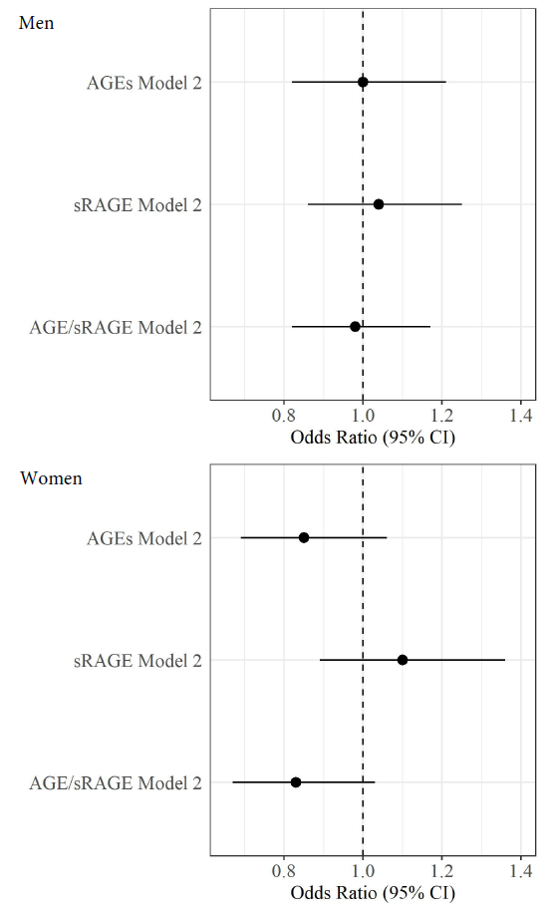
Figure S6: Association between physical functioning (PF) with advanced glycation end products (AGEs), soluble receptor of AGEs (sRAGE) and ratio of AGEs and sRAGE (AGE/sRAGE) for men (N=488) and women (N=340) in a subsample without diabetes mellitus or impaired renal function, Odds ratios (95 % confidence interval)
Ref.: PF=0 (severe limitations in physical functioning)
Model 2: age, years of education, BMI, alcohol consumption, smoking, diet, creatinine clearance, antihypertensive drugs, lipid lowering drugs;
CI= confidence interval
Table S6. Association between physical functioning (PF) and log-transformed, standardized AGEs, sRAGE and AGE/sRAGE ratio in a subsample without diabetes mellitus and impaired renal function, Odds ratios (95 % confidence interval)
Raw |  | Model 1* |  | Model 2§
Men | Women | Men | Women | Men | Women
PF 0 = Ref.
Association between PF and AGEs
0.98  (0.82; 1.17) | 0.94  (0.77; 1.14) | 0.96  (0.80; 1.15) | 0.94  (0.77; 1.15) | 1.00  (0.82; 1.21) | 0.85  (0.69; 1.06)
Association between PF and sRAGE
1.07  (0.89; 1.28) | 1.16  (0.95; 1.41) | 1.04  (0.87; 1.25) | 1.15  (0.94; 1.40) | 1.04  (0.86; 1.25) | 1.10  (0.89; 1.36)
Association between PF and AGE/ sRAGE
0.94  (0.79; 1.12) | 0.85  (0.70; 1.04) | 0.94  (0.79; 1.13) | 0.86  (0.70; 1.05) | 0.98  (0.82; 1.17) | 0.83  (0.67; 1.03)
Notes: * Model 1: age; § Model 2: age, years of education ,BMI, alcohol consumption, smoking, diet , creatinine clearance, antihypertensive drugs, lipid lowering drugs;
N=488 men; 340 women
AGEs= advanced glycation end products; sRAGE= soluble receptor of AGEs; AGE/sRAGE: ratio of AGE and sRAGE; PF= total score physical functioning (SF-12).

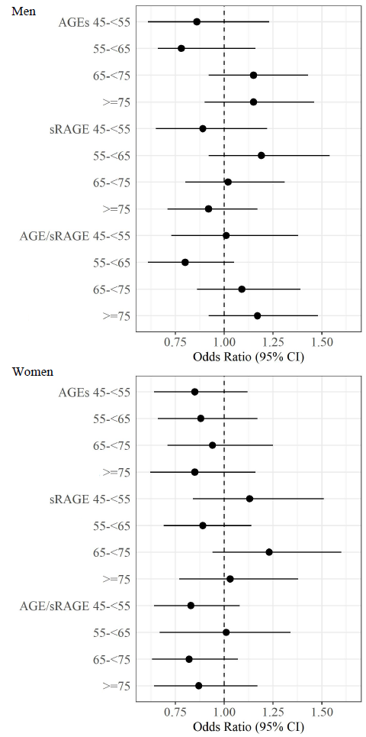
Figure S7: Association between physical functioning (PF) with advanced glycation end products (AGEs), soluble receptor of AGEs (sRAGE) and ratio of AGEs and sRAGE (AGE/sRAGE) for men (N=976) and women (N=812) stratified for 10-year age-groups, Odds ratios (95 % confidence interval)
Ref.: PF=0 (severe limitations in physical functioning)
Adjusted for: age, years of education, BMI, alcohol consumption, smoking, diet, creatinine clearance, antihypertensive drugs, lipid lowering drugs (Model 2);
CI= confidence interval
Table S7. Association between physical functioning (PF) and log-transformed, standardized AGEs, sRAGE and AGE/sRAGE ratio with and without adjusting for osteoporosis, Odds ratios (95 % confidence interval)
 | Model 2§ |  | Model 2a
 | Men | Women | Men | Women
PF 0 = Ref.
Association between PF and AGEs
All | 1.03  (0.91; 1.17) | 0.86  (0.74; 0.98) | 1.04  (0.92; 1.18) | 0.87  (0.75; 1.00)
<65 | 0.87  (0.70; 1.08) | 0.86  (0.71; 1.05) | 0.85  (0.69; 1.06) | 0.88  (0.72; 1.07)
>= 65 | 1.15  (0.98; 1.35) | 0.89  (0.72; 1.09) | 1.14  (0.97; 1.34) | 0.88  (0.71; 1.08)
Association between PF and sRAGE
All | 0.97  (0.85; 1.10) | 1.06  (0.93; 1.21) | 0.97  (0.85; 1.10) | 1.06  (0.93; 1.22)
<65 | 1.03  (0.85; 1.24) | 1.01  (0.84; 1.22) | 1.01  (0.83; 1.22) | 1.01  (0.81; 1.19)
>= 65 | 0.97  (0.82; 1.16) | 1.14  (0.94; 1.38) | 0.97  (0.82; 1.16) | 1.14  (0.94; 1.39)
Association between PF and AGE/ sRAGE
All | 1.05  (0.92; 1.19) | 0.86  (0.75; 0.98) | 1.06  (0.93; 1.20) | 0.86  (0.75; 0.99)
<65 | 0.91  (0.74; 1.11) | 0.90  (0.74; 1.08) | 0.91  (0.74; 1.12) | 0.91  (0.75; 1.10)
>= 65 | 1.13  (0.96; 1.34) | 0.83  (0.68; 1.01) | 1.14  (0.97; 1.35) | 0.83  (0.68; 1.01)
Notes: § Model 2: age, years of education ,BMI, alcohol consumption, smoking, diet , diabetes mellitus, creatinine clearance, antihypertensive drugs, lipid lowering drugs; Model 2a: Model 2 + osteoporosis as confounder
N= 967 men; 812 women
AGEs= advanced glycation end products; sRAGE= soluble receptor of AGEs; AGE/sRAGE: ratio of AGE and sRAGE; PF= total score physical functioning (SF-12).

