Additional file 4. Percentage of transcripts in which individual components were delivered fully, to some extent, or not at all per COTiD-UK sessions

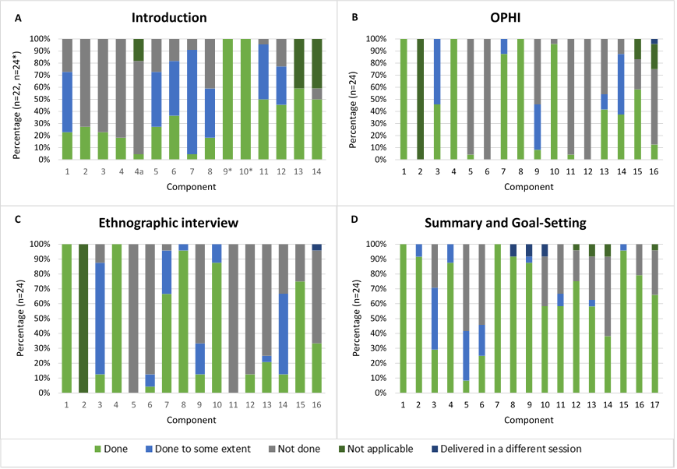
Additional file 4. Continued
