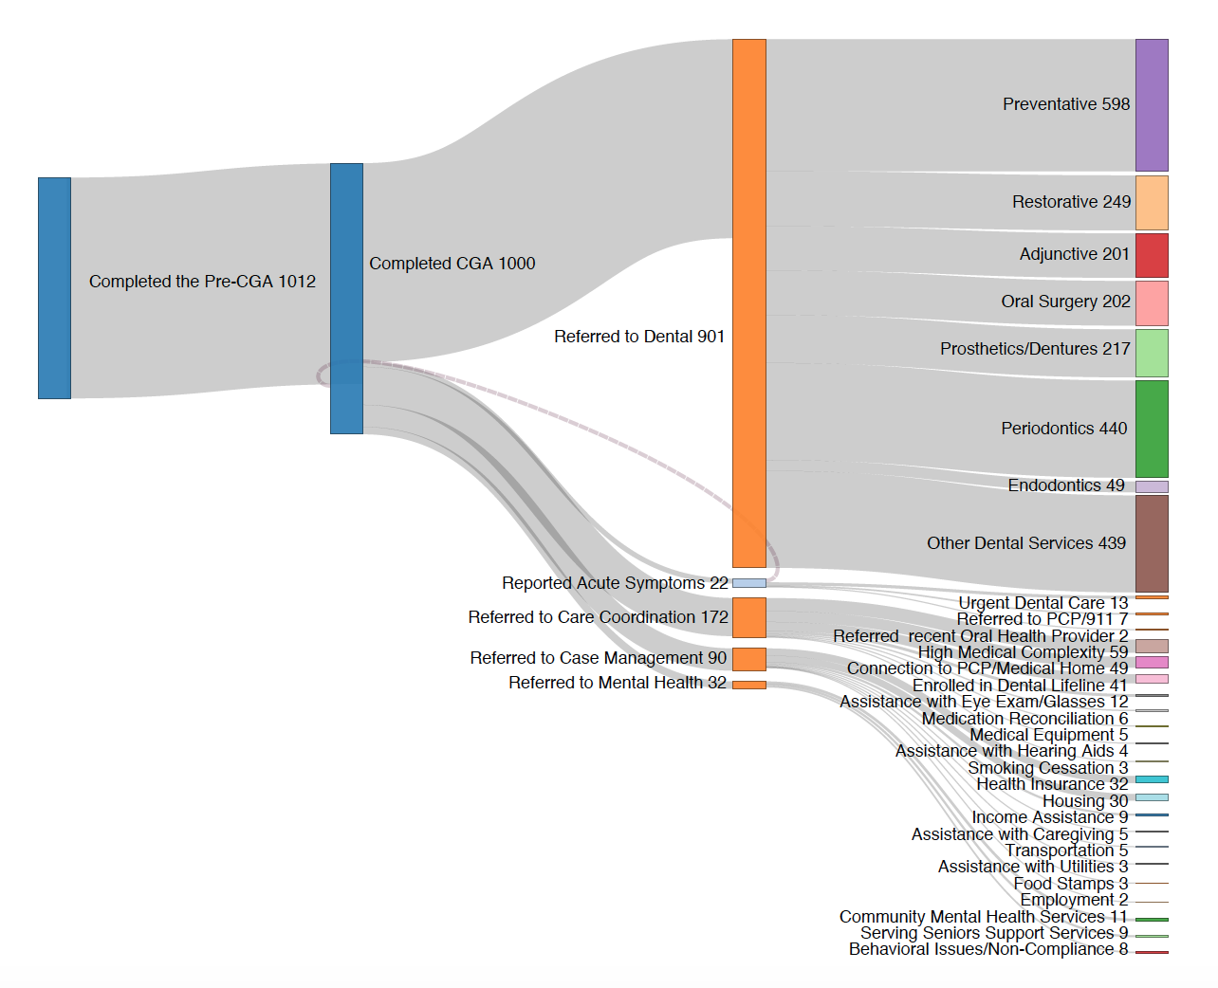
Supplemental Figure 1. Referral pathways and outcomes.

For 1335 clients screened, 1012 completed a pre-CGA and 1000 completed a CGA. For these clients, 901 dental referrals were made for services including restorative, periodontics, dentures, oral surgery and endodontics. 172 referrals were made for medical care-coordination, 90 for case management/social work and 32 for mental health.

