Incorporating foot assessment in the Comprehensive Geriatric Assessment
Rebecca K Iseli^{1,2}; Gregory Duncan³; Elton K Lee¹; Ellen Lewis⁴; Andrea B Maier^{1,5,6}

Affiliations:
¹ Department of Medicine and Aged Care, @AgeMelbourne, The Royal Melbourne Hospital, The University of Melbourne, Melbourne, Victoria, Australia
² Faculty of Pharmacy and Pharmaceutical Sciences, Monash University, Parkville, Australia
³ Eastern Health Clinical School, Monash University, Box Hill, Victoria, Australia
⁴ Podiatry Department, The Royal Melbourne Hospital, Parkville, Victoria, Australia
⁵ Department of Human Movement Sciences, @AgeAmsterdam, Vrije Universiteit Amsterdam, Amsterdam Movement Sciences, Amsterdam, The Netherlands
⁶ Healthy Longevity Translational Research Program, Yong Loo Lin School of Medicine, National University of Singapore, Singapore; Centre for Healthy Longevity, National University Health System, Singapore

Corresponding author:
Dr Rebecca Iseli
Department of Medicine and Aged Care, @AgeMelbourne, The Royal Melbourne Hospital, The University of Melbourne, Parkville, Victoria, Australia
ORCiD: 0000-0003-2403-5104
Email: rebecca.iseli@mh.org.au

Appendix I: the Queensland Foot Disease Form(18) 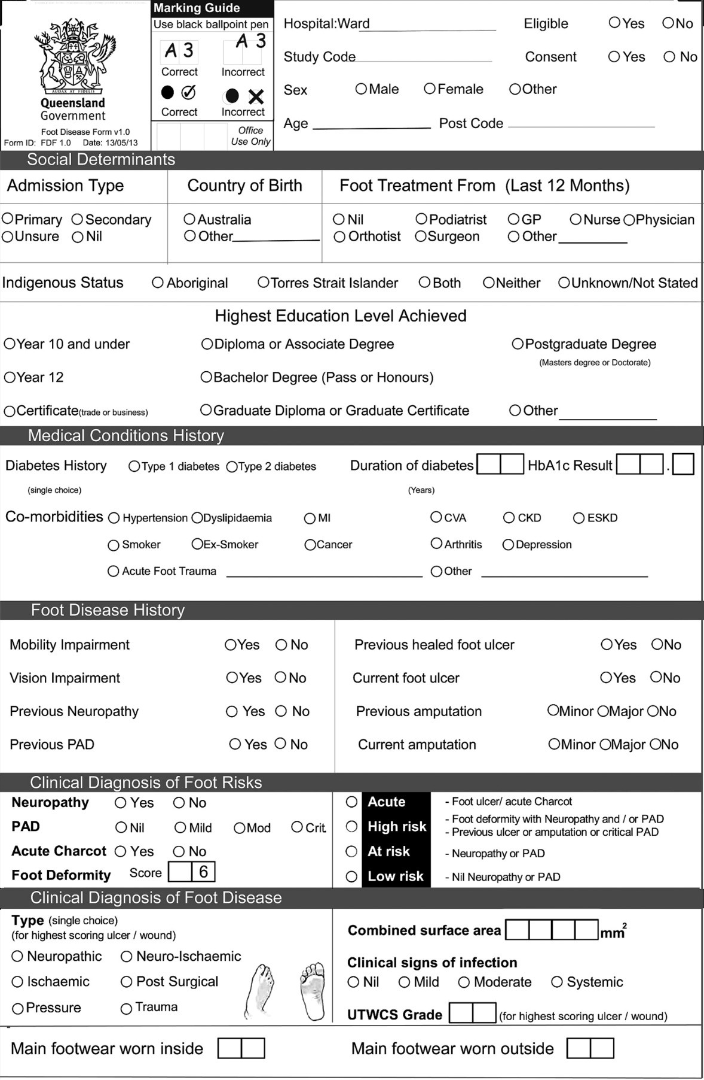
Appendix II: Hospital specific podiatry assessment form (2 pages)